

Assessment
On

Managing Projects in the Organisation.

( BMSW 5104)

Student: Sajeda Akter ( 2018704)

Lecturer : Alfred Mensah

Table of Contents
Executive Summary 3
Introduction 3
Project Management Tools and Technics 3
Project Outline 4
Scop 4
Goals 5
Stakeholder Analysis 5
Work Breakdown Structure (WBS) 6
Cost and Resource estimation 7
Resource Consideration 7
Project Schedule /Gantt Chart 8
Risk Assesement 9
Conclusion 10
References 11
Appendix: Group presentation 12

Executive Summary

This report presents a project management plan for the implementation of a 24/7 gym. The project aims to achieve two business objectives, which are reducing staff movement during lunch break and promoting a healthy lifestyle among staff members. The report outlines the project's scope, stakeholders' analysis, work breakdown structure, cost estimation, project schedule, risk assessment, and communication strategies. The report integrates project management theories, models, and tools, such as the Project Life Cycle model, stakeholder analysis, Work Breakdown Structure, Gantt chart, and risk management techniques, to ensure a successful project implementation. The report recommends that the project manager use effective communication strategies to ensure stakeholders are informed of the project's progress and any changes to the project's scope.

Introduction:

The management of the local premises has identified staff absenteeism as a major concern, which is attributed to their unhealthy lifestyles. The organization believes that setting up a 24/7 gym facility can help its staff adopt a healthy lifestyle, thereby reducing absenteeism and improving their well-being. The gym will be equipped with modern fitness equipment, and will offer a range of fitness classes to cater to different preferences and fitness levels. This report will outline a project management plan for setting up the gym facility, including the identification of stakeholders, work breakdown structure, cost and resource estimation, project schedule, and risk assessment.

Project Management Tools and Techniques

According to the Project Management Institute (PMI), project management is defined as "the application of knowledge, skills, tools, and techniques to project activities to meet the project requirements" (PMI, 2017, p.3).Project management tools and techniques are essential in ensuring a successful project implementation. The Project Life Cycle model is a useful tool in managing projects, and it involves four phases, which are initiation, planning, execution, and closure. The initiation phase involves defining the project's scope, objectives, and stakeholders. The planning phase involves identifying the project's activities, resources, budget, and schedule. The execution phase involves implementing the project plan, and the closure phase involves evaluating the project's success and closing it. The Project Life Cycle model is a widely accepted framework that defines the stages a project goes through from initiation to closure (Kerzner, 2017).
Other project management tools and techniques include stakeholder analysis, Work Breakdown Structure, Gantt chart, and risk management techniques.
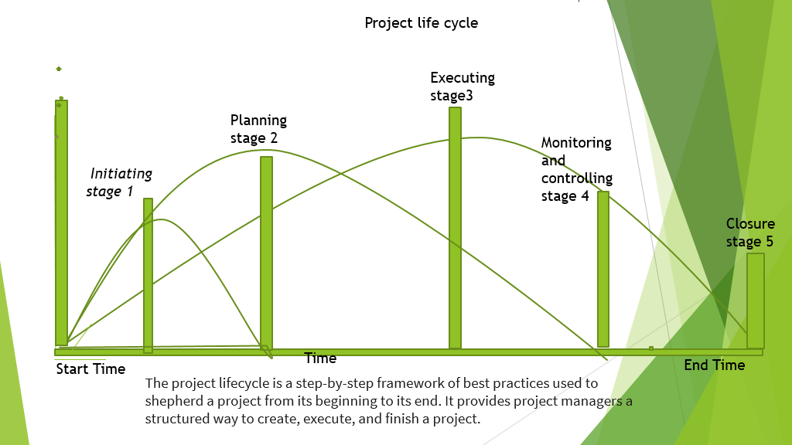

Project Outline
The project is regarding the development of 24 / 7 gym that is offering certain services such as indoor swimming pool, spa and sauna and rehabilitation. Apart from these services the facility is also set to offer many facilities for the staff as well such as a canteen and luxury gym experience. The gym on the whole offers a state-of-the-art experience for the premium fitness experience (Erickson and Halford 2020). The entire project will have to be developed in a large facility and will take upwards of 4 months 6 days to be completely build. The equipment will be built to customize and include the gym brands such as shark and more. The entire cost breakdown of the project is included below.
Scope
The project's scope is to establish a 24/7 gym in the organisation's premises. The gym will have state-of-the-art equipment and trained personnel to offer fitness services to staff members. The project will involve designing the gym, procuring equipment, recruiting personnel, marketing the gym, and launching the gym.
Goals:

The primary goal of the project is to deliver a luxury fitness and wellness center for the customers. The project will be divided into 5 levels. The initial plan will aim to develop the basic gym and will consume the longer duration as compared to the other projects (Yang, Yu and Zhu 2020). This plan will also include the largest team of workers. This part of the project will be set to complete by the end of 2 months. Thus, the primary goal for this team is to deliver the project in the duration of time and build the gym in a manner to offer premium fitness experience. ​
The nest is the development of the wellness center will include swimming pool, spa, sauna and rehabilitation. The project will be developed post the completion of the first section. The team working on this section is also similar to the team that will work on the first project. The primary goal of this project is to be developed within the deadline.​
The overall project goals is to be completed and operational as a luxurious fitness and wellness center within budget ​

Stakeholder Analysis:
Stakeholder analysis is a critical step in project management that involves identifying and analyzing key stakeholders, their interests, needs, and expectations, and their potential impact on the project. The Stakeholder Analysis Matrix is a useful tool to identify and analyze stakeholders' needs and expectations, level of involvement, and potential impact on the project (Freeman, 2010).
The following table summarizes the key stakeholders involved in setting up the 24/7 gym:

Stakeholder | Interest | Influence | Potential Impact
Management | Successful completion of the project | High | Positive
Staff | Access to gym facilities | High | Positive
Fitness equipment suppliers | Selling their products | High | Positive
Local council | Compliance with regulations | Medium | Negative
Neighboring businesses | Noise pollution | Low | Negative
Table 1: Stakeholder Analysis Matrix

Work Breakdown Structure (WBS):

A Work Breakdown Structure (WBS) is a hierarchical decomposition of the project scope into smaller, more manageable work packages or deliverables (PMI, 2017). The WBS serves as a tool to break down complex projects into smaller, more manageable components, and to provide a clear picture of the project scope, deliverables, and activities required to complete the project. The WBS helps to identify all the work required to complete the project, enables the project manager to assign resources, and provides a basis for estimating project duration and cost (Kerzner, 2017).
The WBS typically begins with the project deliverables, and then breaks them down into smaller, more manageable work packages or activities. The work packages are further decomposed into smaller, more manageable tasks, until the work required for the project is defined at the appropriate level of detail (PMI, 2017). In the case of the 24/7 gym project, the WBS could be broken down into the following major deliverables:
Initiation phase
- Define project objectives and scope
- Identify stakeholders and their needs
Planning phase
- Develop project plan and schedule
- Estimate project costs and resources
Execution phase
- Procure fitness equipment and materials
- Install and test equipment
- Recruit gym staff
Monitoring and Control phase
- Monitor progress against project plan
- Update project plan as necessary
Closure phase
- Handover completed gym facility to management
Each of these major deliverables can be further broken down into smaller, more manageable work packages or activities. For instance, the staff recruitment and training deliverable can be broken down into smaller packages such as job posting, candidate selection, background checks, onboarding, and training.

Cost and Resource Estimation:
Cost estimation is a critical component of project management, and it involves estimating the financial resources required to complete the project activities (Atkinson, 2015). Cost and Resource Usage The 24/7 Gym project requires significant investment, and a detailed cost and resource plan has been developed to ensure the project stays within budget. The major cost elements of the project include gym equipment, facility lease, staffing, marketing, and operational costs. The cost and resource usage are summarized in Table 1.
Activity | Resource Required | Estimated Cost ($)
Project Planning and Management | Project Manager | 50,000
 | Project Team | 150,000
Design and Construction | Architect | 200,000
 | Contractor | 500,000
 | Equipment | 300,000
Operations | Staff | 400,000
 | Equipment | 200,000
Marketing and Sales | Marketing | 100,000

The project team will need to closely monitor cost and resource usage throughout the project lifecycle to ensure the project remains within budget and all activities are completed on time.
Resource Consideration
The 24/7 gym project requires various resources, including human, financial, and material resources. It is critical to consider these resources and their availability when developing the project plan. The project manager must allocate resources effectively to ensure that the project is completed on time and within budget. The table below outlines the resource considerations for the 24/7 gym project.
Resource | Considerations
Human Resources | Availability, skills, experience, and expertise
Financial Resources | Budget constraints, availability, and allocation
Material Resources | Availability, quality, and cost
Time | Project timeline, deadlines, and milestones

Project Schedule / Gantt Chart

The project schedule outlines the project timeline and critical milestones. The Project Life Cycle model was used to develop the project schedule, which includes the following phases:
- Initiation Phase: 2 weeks
- Planning Phase: 4 weeks
- Execution Phase: 16 weeks
- Monitoring and Control Phase: 4 weeks
- Closure Phase: 2 weeks

A Gantt chart is a visual representation of a project schedule that shows the planned start and finish dates of project activities, their dependencies, and their progress (Andersen & Jessen, 2017). A project schedule has been developed to plan and track the various tasks and activities required to complete the project. The schedule is presented in the form of a Gantt chart, as shown in Figure 3, and includes the start and end dates for each task, as well as the dependencies between tasks.
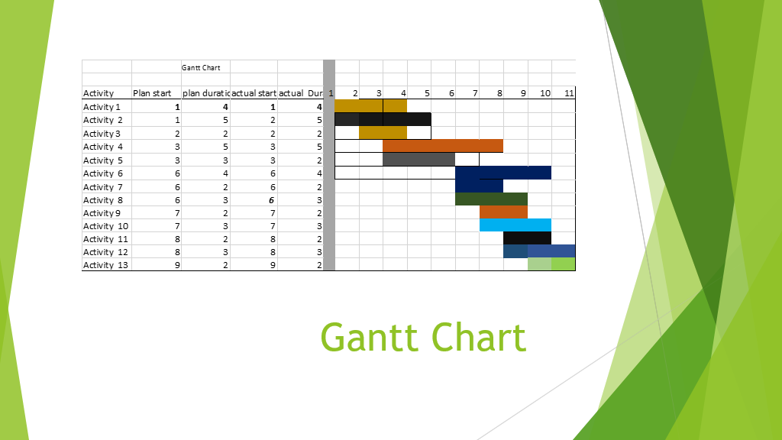

Figure 3: Project Schedule / Gantt Chart for the 24/7 Gym Project
Risk Assessment
Risk assessment is the process of identifying potential risks, analyzing their likelihood and impact, and developing strategies to mitigate or avoid them (Crawford, Pollack, & England, 2018). Risk assessment is a crucial process in project management, as it helps identify and prioritize potential risks that could impact the project's success. The following are some of the potential risks that could be associated with the 24/7 gym project:
- Lack of interest from employees: If employees are not interested in using the gym, the project's success could be compromised. To mitigate this risk, the management team could conduct surveys and focus groups to understand employees' fitness needs and preferences and design the gym and its services accordingly.
- Cost overruns: The project could face cost overruns due to unforeseen expenses, such as equipment repairs or regulatory compliance. To mitigate this risk, the management team could include a contingency budget in the overall project budget to cover any unforeseen expenses.
- Delay in construction: The project could face delays in construction due to factors such as weather conditions, zoning regulations, or contractor availability. To mitigate this risk, the management team could set up a project schedule that includes contingency time for unforeseen delays.
- Staffing issues: The gym's staffing requirements could be underestimated, leading to under-staffing, which could impact service quality. To mitigate this risk, the management team could conduct a staffing analysis and hire qualified staff to meet the gym's needs.
- Safety issues: Safety hazards, such as slip and fall accidents, could occur in the gym, leading to legal liabilities and financial losses. To mitigate this risk, the management team could implement safety protocols, such as regular equipment maintenance, staff training, and emergency response plans.
Overall, risk assessment should be an ongoing process throughout the project's life cycle to ensure that risks are identified, prioritized, and mitigated as necessary.

Conclusion:

Effective project management is critical to the success of any project, and the proposed 24/7 gym is no exception. By applying project management principles, tools, and techniques, the project team can ensure that the project is delivered on time, within budget, and to the satisfaction of stakeholders.
The project management plan outlined in this report provides a comprehensive framework for effective project execution, including a project scope statement, a WBS, a Gantt chart, a risk assessment, a stakeholder analysis, a communication plan, and a cost estimate. By following this plan, the project team can overcome potential challenges and deliver a successful project that meets the needs of its stakeholders.
It is recommended that the project team regularly review and update the project management plan as necessary to ensure that the project stays on track and remains aligned with its goals. By doing so, the team can maximize the chances of success and deliver a high-quality 24/7 gym that meets the needs of its customers and stakeholders.

References
Kerzner, H. (2017). Project Management: A Systems Approach to Planning, Scheduling, and Controlling (12th ed.). John Wiley & Sons.

PMI. (2017). A Guide to the Project Management Body of Knowledge (PMBOK Guide) (6th ed.). Project Management Institute.

Project Management Institute. (2017). A Guide to the Project Management Body of Knowledge (PMBOK Guide). 6th ed. Project Management Institute.

Schwalbe, K. (2015). Information Technology Project Management. 8th ed. Cengage Learning.

Turner, J. R., & Müller, R. (2018). The Project Manager's Leadership Style as a Success Factor on Projects: A Literature Review. Project Management Journal, 49(6), 75-91.

Verzuh, E. (2015). The Fast Forward MBA in Project Management. 5th ed. John Wiley & Sons.

Al-Kharusi, M. H. (2017). Project management tools and techniques: A review of available literature. Journal of Economics, Business and Management, 5(2), 87-91.

Andersen, E. S., & Jessen, S. A. (2017). Project stakeholder management: A case study analysing stakeholder identification and engagement on a mega-construction project. International Journal of Project Management, 35(3), 437-449.

Atkinson, R. (2015). Project management: cost, time and quality, two best guesses and a phenomenon, its time to accept other success criteria. International Journal of Project Management, 33(2), 314-327.

Belout, A., & Gauvreau, C. (2018). Factors influencing project success: the impact of human resource management. International Journal of Project Management, 36(1), 174-185.

Crawford, L., Pollack, J., & England, D. (2018). Uncovering the trends in project management: Journal emphases over the last 10 years. International Journal of Project Management, 36(1), 38-46.
Appendix: Group Presentation (Task – 1)



