Assignment Title: Intercultural Competence Report

Level 5
Module: Foreign Languages & Cultural Awareness
Module code: BMIH5003
Submitted by: Syed Maksum Zabid
Student Id: 2245066
Course Teacher: Antoinette Milne

University of Wales Trinity Saint Davids

Table of Contents
Executive Summary 2
Introduction 3
Outline of Key Differences Between England and Japan 4
Economic Context 4
Analysis Using GLOBE Project’s Cultural Dimensions 4
Statistical Data on Cultural Dimensions 4
Challenges of Intercultural Leadership 5
Financial and Statistical Challenges 6
Conclusion 7
Recommendation 7
Reference 8

Executive Summary
This appraisal highlights the key differences between the hotel & restaurant industries in England and Japan under the economic contexts, cultural dimensions, and operational issues. Japan, owning to its GDP amounting to nearly 5 billion Dollars, is the third among the economies across the world, fueled by technologies and production. England, the part of the UK accompanied by economic activity of $3 trillion, is mostly a provider-oriented economy. The tourism industry has a high contribution to the economies of both the UK and Japan standing at 9% and 1% of the UK and Japanese GDP respectively. With the cultural dimensions of the GLOBE Project‘s power distance versus individualism, the report focuses on the issue that may be presented as quite dissimilar collectivism. Financial and statistical labour costs, employee turnover rates, and customer satisfaction indices are of concern in the parameters. As for Japanese workers, they earn on average higher salaries in comparison with their British peers, but they must work longer hours. This last part of the report promotes the unified approach to intercultural team management as the key concept for enhancing its effectiveness, the evidence-based data interpretation will help build actionable recommendations and training programs.

Introduction
The hospitality industry makes up a large component of the world economy. In the same breath, it is as diverse as the cultural, economic, and operational circumstances in each country. As contrasting countries England and Japan, each of which has a long and unique history and identity, the culture of hospitality in both nations is thus the focus of this comparison to gain some instructive views into how factors such as history & traditions can affect the development of each hospitality industry (Jain, 2022). It is this analysis of various economic contexts, intricate cultural traits, and practical challenges in the hospitality industries in England and Japan.

Outline of Key Differences Between England and Japan
To enhance the analysis and provide a more concrete basis for comparison between England and Japan, let's incorporate financial aspects, relevant statistics, and numerical information that can affect operations and intercultural dynamics within the hospitality industry:

Economic Context
GDP and Economic Structure: Nowadays, the GDP of Japan is estimated at around 5 trillion US dollars. The country is identified as the third largest country based on the GDP giving big chances to grow the technology and manufacturing industries. (Jain, 2022) explained that one of the United Kingdom's constituent countries, England, with a GDP of about $3 trillion, is a largely service-oriented economy, with finance and services sectors contributing a sizable proportion. Such differences in economics, in turn, cause the countries to have different work cultures as well as brands where hospitality is an essential part of operations (Jain, 2022).
Tourism Contributions: Tourism contributes more than 10 per cent to this industry. The UK's share is double that of Japan's, with a 9% contribution to the country's GDP, as against 1% (Cherkowski and Ragoonaden, 2016). This becomes a clear indicator, of the importance and significance of the industry of hospitality not only for the two economies but also for the Japanese one.

Analysis Using GLOBE Project’s Cultural Dimensions

Statistical Data on Cultural Dimensions
Power Distance: As per the postulation of the GLOBE study, Japan comes under the category of high-power distance severity (5. 2 vs 4. 5 is break (Japan 2 vs UK 4. 5), suggesting that power uneven distribution is high approval of the Japanese people’s society (Kohli, 2022). Being like this it is no surprise how the Japanese style of management can influence the organizational structures of hotels which tend to become more hierarchic.
Individualism vs. Collectivism: The inventories of Japan for individualism are less, which reveals that the culture of that nation is a collectivistic being that chooses group harmony and a collective decision-making process. Cho and Cheon (2015) added that England on the other hand is at the very top ranking, which can be taken as evidence of a more individualistic culture of the country. These variations might eventually put the motivation and dynamics of a team into question.

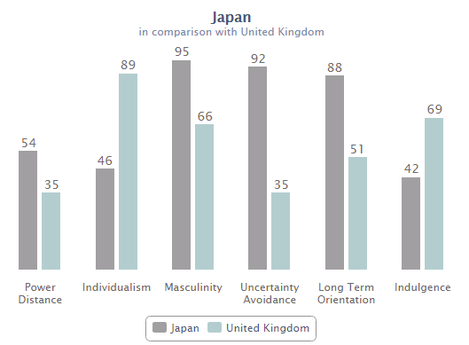

Figure 1 Comparison aspects Uk vs japan (Source: Kohli, 2022)

Challenges of Intercultural Leadership

Financial and Statistical Challenges
Labour Costs and Productivity: In Japan, labour cost per person is considerably higher than in England. In Japan, a worker gets around $40000 per year on average, while workmen in England receive $36000 a year. Tabata and Vrij 2022 added that, while this is complemented by varying productivity indicators, which stem from the emphasis on capital efficiency and product quality in Japan at the expense of longer working hours, it may not be smooth sailing for people from English backgrounds to tick the idea of shorter work-life balance (Aaron, 2023).
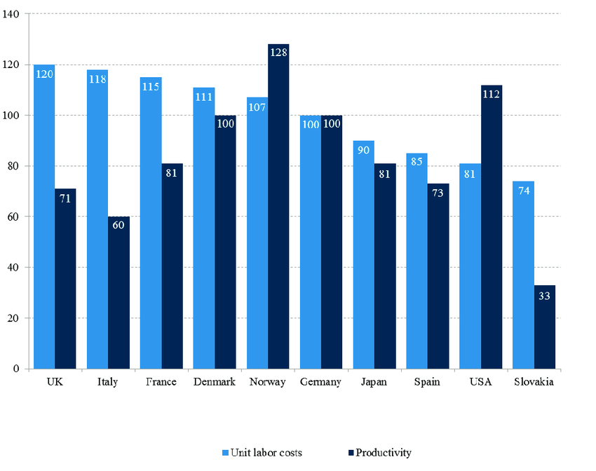
Figure 2 Comparison among countries (Cherkowski and Ragoonaden, 2016).
Employee Turnover Rates: In contrast, the hotel sector of Japan experiences a relatively low staff turnover rate (around 10-15 per cent per year). It is mainly because of the way Japanese are culturally brought up to be loyal and have work and loyalty attached forever (Tabata and Vrij, 2022). On the flip side, the hotel industry in the UK has recorded a turnover rating (30%) that is higher than the hospitality sector, which might harm the stability of supply as well as uniformity of standards (Work Beam, 2021).
Customer Satisfaction Indices: The Japanese culture is particularly recognized for its high customer satisfaction level based on the fact that the efficiency of their hospitality service is measured by more than 85% in terms of the quality of their guest's experience (Jain, 2022). The situation seems to be different in the case of hotels in London because customer satisfaction ratings can vary greatly between hotels that are 70% to 15% satisfied (Kohli, 2022). Concerns regarding the management of those expectations and the staff training to meet the high standards could appear while the Japanese customs are being introduced in the London situation.
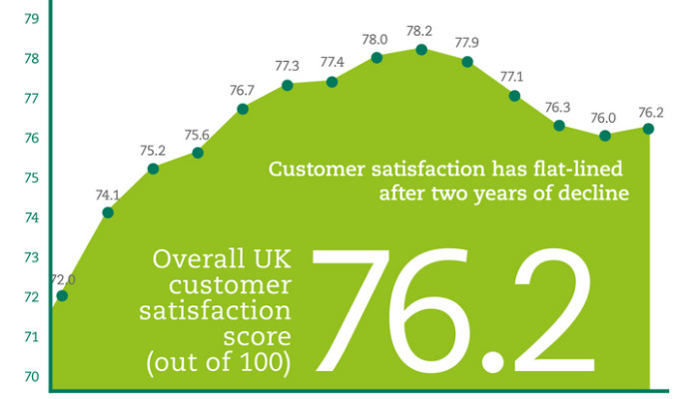
Figure 3 Varying satisfaction of customers (Le Roux et al., 2018).
Developing a unified economic, statistical, and numerical approach to intercultural team management in the hospitality sector is one of the best ways to have a solid look at some of the operational and cultural modifications needed (Tabata and Vrij, 2022).

Conclusion
The comparison between hospitality industries in England and Japan emphasizes the crucial role of economic structure, cultural values, and operation practices in the performance and operation of the sector. Japan's tech-based super-culture and collectivist culture is the prime reason behind the unique hospitality space in the country where customer satisfaction is very high and employees love their jobs and rarely go anywhere else. Contrary, the business service-oriented economy and individual culture in England compile other situations like variable customer support and commonly high turnover (Rizvi, 2024).

Recommendation
The outline of a comparison between the hospitality industry of England and Japan shows major economic, cultural, and operational distinctions of that business, which in turn are considered to be the reasons for intercultural dynamics (Tabata and Vrij, 2022). To make the bridging effective it is suggested that the cross-cultural training programs should be set up in the staff area of the offshore area as well. In this case, these programs must be based on exploring the cultural aspects and leadership styles that are known nationally x and thus from the two, the government should come up with public campaigns regarding these issues (Collard, 2018). In addition to that, the blended model that will incorporate the strong points from each culture will be a way of enhancing customer satisfaction, improving retention of employees, and efficient operation in the global hospitality stage (Jain, 2022).

Reference
Aaron, H. (2023). Cultural Influences on Leadership: Unveiling Cross-Cultural Dynamics. Available at: https://aaronhall.com/insights/cultural-influences-on-leadership-unveiling-cross-cultural-dynamics/ (Accessed on 06 June 2024)
Cherkowski, S. and Ragoonaden, K. (2016). ‘Leadership for Diversity: Intercultural Communication Competence as Professional Development.’ Teacher Learning and Professional Development. Vol. 1, pp. 33 – 43. Available at: https://www.researchgate.net/publication/323783700_Leadership_for_Diversity_Intercultural_Communication_Competence_as_Professional_Development (Accessed on 04 June 2024)

Cho, C. and Cheon, H., (2015) “CROSS-CULTURAL COMPARISONS OF INTERACTIVITY ON CORPORATE WEBSITES: The United States, the United Kingdom, Japan, and South Korea,” Journal of Advertising, 34(2), pp. 99–115. doi: 10.1080/00913367.2005.10639195.

Collard, J. (2018) “Constructing theory for leadership in intercultural contexts,” Journal of Educational Administration, 45(6), pp. 740–755. doi: 10.1108/09578230710829919.

Jain, H. (2022) “Japanese culture and traditions: The whats and whys,” EJable, [Blog] 27 July. https://www.ejable.com/japan-corner/japanese-culture/japanese-culture-and-traditions/ (Accessed: May 19, 2024).

Kohli, S. (2022) “Culture in the UK: Tradition, language, beliefs, and practices,” Leap Scholar, [Blog]. 5 May. https://leapscholar.com/blog/uk-culture-tradition-language-etiquettes-beliefs-and-practices/ (Accessed: May 19, 2024).

Le Roux, B. et al. (2018) “Class and cultural division in the UK,” Sociology, 42(6), pp. 1049–1071. doi: 10.1177/0038038508096933.

Rizvi, H. (2024). Cultural Differences in Business Between UK and Japan. Available at: https://hidayatrizvi.com/cultural-differences-in-business-between-uk-and-japan/ (accessed on: 04 June 2024)

Tabata, N. and Vrij, A. (2022). ‘Differences between Japanese and British participants in self-reported verbal strategies to appear convincing’. Psychiatry, Psychology and Law, 30(2), pp.1–15. doi: 10.1080/13218719.2021.2003269.
Work Beam (2021). 5 Differences in Working Styles in the UK and Japan. Available at: https://workbeam.co.jp/en/blogs/5-differences-in-working-styles-in-the-uk-and-japan/ (Accessed on: 06 June 2024)

