Coursework: Business Plan

Programme: BA Business Management
Module name: Entrepreneurship
Module code: LCBB5001
Lecturer name: Nishi Ramsurrun
Student name: Cerasela Lavinia Stoica
Student ID: 2125057

Table of Contents
Introduction 3
Demonstrating the Business description 3
Describing the industry analysis(VRIO framework, Porter's 5 forces model) 3
PORTER’s five forces model 4
Describing Operational management and team plan 5
Describing marketing plan (4 PS) 6
Evaluating Financial plan 6
Evaluating market Research 7
Conclusion 9
References 10

Introduction
Entrepreneurship can be defined as a process to create any new enterprises and to bear its risks in order to make profit. Any person willing to start a business and wish to face loss or profit in a business can be termed as an entrepreneur. This study deals with the retail business ‘Consumer PLC’ to frame its aims, objectives, size and location. This study will also discuss the business analysis by using the VRIO framework and Porter's five forces model. The study will give a description of the business Consumer PLC’s operational management, team and marketing plan. This study will also evaluate the financial plan of this retail business.

Demonstrating the Business description
The retail business of ‘Consumer PLC’ is involved with the selling of goods and services from the business or individuals to the end users. This business procures materials as per demand of the customers and can acquire information regarding the market and research. The retail industry of the UK has 300000 separate businesses and it is worth £439 billion Pounds. The competitors of the ‘Consumer Plc’ are Tesco, ASDA. The main aim of this business is to satisfy the customer’s demands and to store the merchandise and provide it as required by any customer (Anastasiu, Gavriş and Maier, 2020). The retail stores must be kept open and ready for selling the products according to the convenience of the customers. The aim of this business is to improve the communication and the sales target in the business. The ‘Consumer PLC’ have generated their image to serve various markets and the social responsibility is also improved in these retail industries.

Describing the industry analysis(VRIO framework, Porter's 5 forces model)
VRIO FRAMEWORK
The ‘Consumer PLC will use the internal analysis tool of VRIO framework to categorise their resources in the businesses by allowing the company to identify those resources to provide a competition. The VRIO model will use its four dimensions: valuable, rare, inimitable and organised to stay ahead of their competitors in the retail industry.
Valuable - The ‘Consumer PLC’ will use a valuable resource to provide benefit and to achieve a competitive uniformity. The resources if not have any value then it cannot provide any competition to their competitors and cannot be used in any other dimensions of VRIO framework.
Rare- The resources that are very uncommon and rare and not used by any other company will be used by the ‘Consumer PLC’ to bring profit to their industry. The competitive advantage can be achieved if the resource is both rare as well as valuable (Baxter, 2019).
Inimitable - The Consumer PLC will use the resources which are hard to imitate then only the industry can achieve its high standard. The industry will use expensive resources so that it cannot be imitated by other companies to get benefit.
Organised - The Consumer PLC will use organised resources to add value in the process, structure and culture of the company. An inorganized resource can make loss to the company and affect its processes.
The examples of financial resources include money, shares, bonds, human resources includes people, skill, knowledge, material resources includes equipment, machineries, non-material resources include property, brand name (Cuizon and Cuizon, 2022).
The Consumer PLC will use the valuable, uncommon, organised and inimitable resources so that they can give a good competition to their competitors and can bring profit in the retail industry.

PORTER’s five forces model
The Porter’s five forces model will help to determine the retail industry Consumer PLC in terms of growth, opportunities, competitiveness, rivalry and threats of new entrants. The five forces model consists of Threat from the Substitutes, Threat from Competitors, Bargaining Strength of the buyer, Bargaining Power of the supplier and the Intensity of the Competitive Rivalry.
Threat from Competitors - The Consumer PLC will face the threat of the competitors who have correct measures and improved strategies to gain a market position. There is an intense level of competition in the retail markets. The distribution network and the supply chain of the existing market can impose certain barriers for the new ones in terms of trade and economic regulations (Astawa, 2022).
Threat from Substitutes- The attractiveness of the retail industry gets affected and lowers in profit due to the existence of the substitutes. The prices and the demand for the product is influenced by the existing substitutes. The threat of the substitute is high in Consumer PLC with the availability of more alternative and substitute products. The buyers can get affected in terms of home services availability, online shopping, price, and quality of a product.
Bargaining Strength of the buyer- The bargaining power of the buyers are extremely high in Consumer PlC. as they buy large quantity products and switch from one supplier to another very quickly. This is due to the availability of plenty of substitute products which have best offerings in price, quality, brand loyalty, and volumes.
Bargaining strength of the supplier - The raw materials will be supplied to the Consumer PLC with some basic inputs like technology, man, finance, materials. The bargaining power of supplier is high because of the input’s quality, uniqueness, less pricing and more demand.
Intensity of the Competitive Rivalry - The Consumer PLC has a higher intensity level in the competitive rivalry which can lower the profit. The large number of new competitors emerges in the retail industry with various product offerings (Léonard, 2023). This can attract huge customers and can strengthen the loyalty power. The innovative products, strategies, discounts in prices can attract a lot of customers and can gain their position in the existing retail industry.
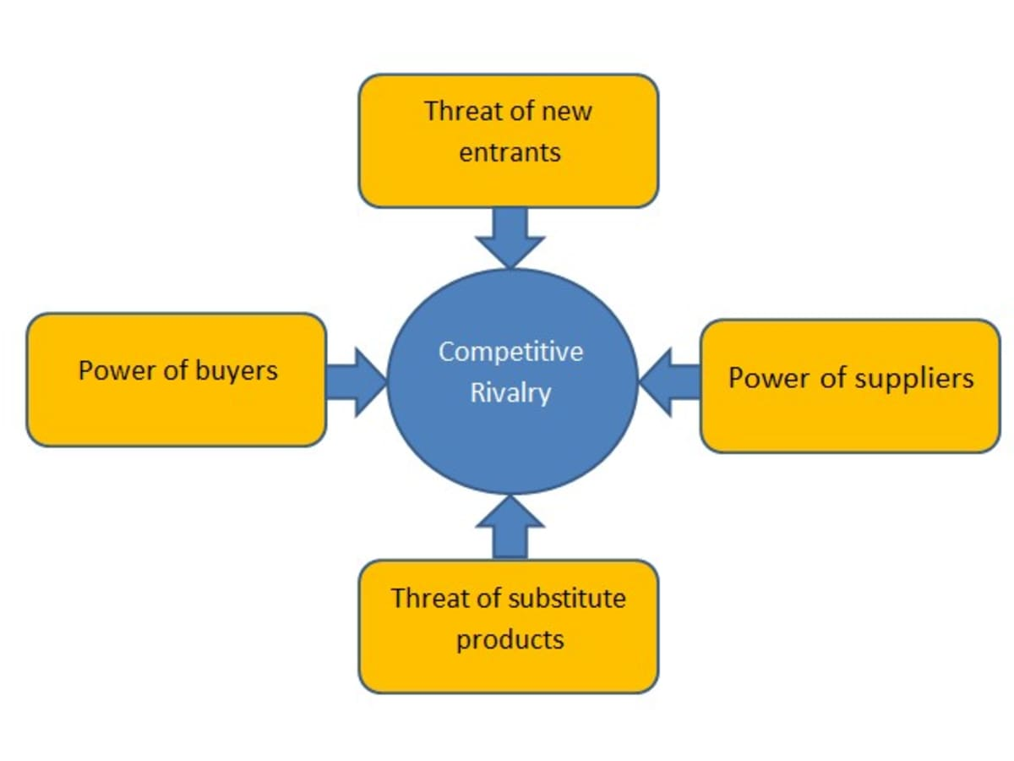
Figure 1 : Showing the porters five forces analysis
(Source influenced by Léonard, 2023)

Describing Operational management and team plan
As stated by Diaz (2021), the Operational Management in the retail industry can establish a strong relationship with the suppliers, manage inventory levels, and can optimise the processes of logistics. The well trained employees can bring success to the retail markets. The Consumer PLC will create effective processes and procedures to reduce loss and maximise profit. Consumer PLC will develop a positive customer experience by offering excellent customer services, high quality products services and also by giving personalised recommendations. The company will maximise its sales by availability of products and optimising the layout of stores. The company will reduce its labour costs, increase customer satisfaction, optimise supply chain processes and build a strong customer base for welcoming the customers for a positive shopping experience. The company will respond to quick change of demands and fluctuations in customer preferences and can enhance a brand image. This image can help the company to attract high level customers with alternative product offerings and discounts (Nandonde, 2019). The company will implement point of sale technology to offer online ordering and will train its employees to increase their sales and productivity.
The Consumer PLC will manage a team by providing reliable retail sales with a scheduled software to enhance the sale process. The company will build a team that can create a positive working atmosphere. The company will hire the best candidates with the right positive attitude who wish to adapt to new culture, things and values. The company will create a team that can drive the employees to engage in their work and also can increase the customer loyalty. The company will form a team who can achieve their goals by high salaries, good internal communication, and developed career plans (Christodoulou and Cullinane, 2019). The team will be provided with a lot of rewards and incentives for their conducts, achievements and attendances and a good leader in the team must be selected by Consumer PLC who will enhance the profit and productivity.

Describing marketing plan (4 PS)
The retail market can bring the products directly to the consumers in the retail stores and comprises to plan, promote and present the commodities. The 4ps of marketing includes Product, price, promotion and distribution.
Product - As stated by Saragih (2023), the product is the basic element of a retail market which is bought by the consumers. The Consumer PLC will launch a new product that will satisfy the customer’s demand. A new alternative product will be developed which can meet the consumer’s needs. The products must be available in the retail stores for the customers to buy. The product must have a good quality which can attract a huge consumers to purchase it. The consumers will buy the products and the market should gain profits only if the product has uniqueness and availability.
Price - The product's price will be kept reasonable and affordable for the customers to purchase it in Consumer PLC. The company must set the prices of the products according to their quality, quantity and brand. The reasonable price of a product can enhance the retail markets in terms of productivity and profit.
Promotion - The Consumer PLC will promote their products by various advertisements to attract the customer base. Several online campaigns of the product are also made by the company to promote it. The product in the company will be promoted by the television, media, print, and several advertising campaigns to attract the consumers and increase the sale processes (Ariwibowo, Saputro and Haryanto, 2021).
Distribution - The products of Consumer PLC will be distributed through various distribution channels to reach a lot of customers. The several distributing channels like retailers, wholesalers, internet will be used by the company to properly distribute their newly launched products to different people (Miethlich and Oldenburg, 2019).
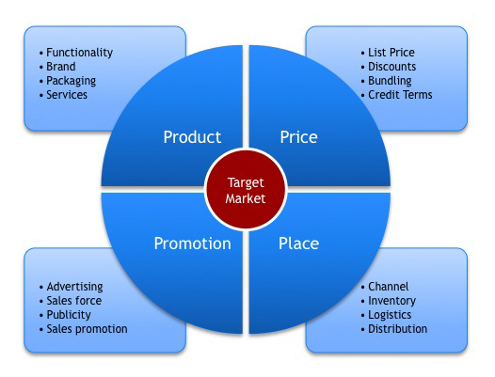
Figure 2 : Showing the 4PS of marketing mix
(Source Influenced by Saragih 2023)
Evaluating Financial plan

Particulars | Jan (£) | Feb (£) | March(£) | April(£) | May (£) | June (£)
Opening balance | 1100 | 1500 | 2500 | 4800 | 6700 | 9000
Receipts (Cash sales) | 9000 | 8000 | 7500 | 6000 | 4500 | 2500
Collection from debtors | 30000 | 32000 | 36000 | 38000 | 40000 | 43000
Total | 40,100 | 41,500 | 46,000 | 48,800 | 51,200 | 53,500
Payments (cash purchase) | 3500 | 2000 | 1500 | 1000 | 800 | 300
Credit purchase | 20000 | 30000 | 35000 | 45000 | 46000 | 51000
wages | 1150 | 1250 | 1350 | 1450 | 1500 | 1500
rent | 550 | 450 | 350 | 250 | 200 | 100
Other expenses | 4000 | 3000 | 2000 | 1000 | 700 | 400
Total | 29,200 | 36,700 | 40,200 | 47,800 | 49,200 | 53,300
All total | 10,800 | 4,800 | 5800 | 1000 | 2000 | 200
Table 1 : Evaluating the financial plan

Evaluating market Research

Political | The extent to which the government can influence the market economy by imposing a new tax and revenue generation.  The fiscal policy, trade tariffs are the factors that the government imposed upon the retail markets.
Economic | The high inflation rate can affect the retail market economy in terms of price and products.  The high interest rates can affect the retail market economy by the purchasing power of consumers and change of demand (bbc.co.uk 2023).
Social | The employment rate of the UK is 75.7% in 2023 that is affecting the retail market economy.  The number of consumers in the retail market economy is 300,000 in the UK .
Technological | The research and development technologies like automation, artificial intelligence will be used by the company Consumer PLC.  These technologies can protect the retail markets from leaking their innovative products to their competitors.
Legal | The consumer laws, safety laws can enable the company to protect the rights of their labourers.  The consumer law can be used to protect the rights of labourers in the company and the safety law can enable the labourers to be safe from any discrepancies (statista.com 2023)
Environmental | The pollution rate of the UK is 14% which has affected the retail market economy by the emission of 476 tons of CO2.  The climate change rate of the UK is 1.0 C% in 2022 that has affected the retail market economy in terms of humidity.

Table 2: Showing the Pestle analysis
(Source Influenced by statista.com, 2023)

The PESTLE analysis has been used to evaluate the market research. Through the Pestle Analysis the retail market is affected In Consumer Plc. in terms of pollution and climate change rates. The company will use the technological methods of AI to ensure the safety of their data. The consumer laws and safety laws will enable the company to protect the rights of the employees (Zhu and Gao, 2019). The high interest and inflation rate will affect the market economy by minimising the profit.

Conclusion
Thus, it can be concluded from the above study that the retail business of ‘Consumer PLC’ involves the sale of goods and services from the business or individuals to the end users. This business can procure the materials as per customer demand and can gather information regarding the market and research.

References
Anastasiu, L., Gavriş, O. and Maier, D., (2020). Is human capital ready for change? A strategic approach adapting Porter’s five forces to human resources. Sustainability, 12(6), p.2300.
Ariwibowo, P., Saputro, F.B. and Haryanto, H., (2021). Analysis of Strength & Weakness, Using the Concept of Resource-Based View with the VRIO Framework in Sharia Cooperatives. Jurnal Manajemen Strategi dan Aplikasi Bisnis, 4(1), pp.279-294.
Astawa, I.P.M., (2022), March. VRIO Model as a Framework for Developing Tourism Competitiveness. In International Conference on Applied Science and Technology on Social Science 2021 (iCAST-SS 2021) (pp. 173-178). Atlantis Press.
Available at : https://www.statista.com/statistics-glossary/definition/403/competitor_analysis/ [Accessed on 13th July 2023]
Baxter, G., (2019). A strategic analysis of Cargolux Airlines International position in the global air cargo supply chain using Porter’s Five Forces Model. Infrastructures, 4(1), p.6.
bbc.co.uk (2023) Critical thinking and problem solving Available at : https://www.bbc.co.uk/bitesize/guides/zcjhfcw/revision/2. [Accessed on 13th July 2023]
Christodoulou, A. and Cullinane, K., (2019). Identifying the main opportunities and challenges from the implementation of a port energy management system: A SWOT/PESTLE analysis. Sustainability, 11(21), p.6046.
Cuizon, A.L.D. and Cuizon, C.B.D., (2022). Conditional Cash Transfer (CCT): 4Ps in the Lens of Philippine Decentralization. Thammasat Review, 25(1), pp.202-223.
Diaz, R., (2021). Effects of Pantawid Pamilyang Pilipino Program (4Ps) and other Conditional Cash Transfer (CCT) Programs of Low and Middle–Income Countries on Human Development. Sapienza: International Journal of Interdisciplinary Studies, 2(1), pp.2-11.
Léonard, M., (2023). People-first PPPs for Services (4PS): A possible way of developing society. In ITM Web of Conferences (Vol. 55, p. 02009). EDP Sciences.
Miethlich, B. and Oldenburg, A.G., (2019). The employment of persons with disabilities as a strategic asset: A resource-based-view using the value-rarity-imitability-organization (VRIO) framework. Journal of Eastern Europe Research in Business and Economics, 1, pp.1-13.
Nandonde, F.A., (2019). A PESTLE analysis of international retailing in the East African Community. Global Business and Organizational Excellence, 38(4), pp.54-61.
Saragih, R., (2023). Usulan Model Strategi Dengan Pestle Framework Dan Vrio Framework Pada Industri Pariwisata. Jurnal Ilmu Manajemen METHONOMIX, 6(1), pp.1-13.
statista.com(2023) Definition Competitor analysis
Zhu, G. and Gao, X., (2019). The digital sales transformation featured by precise retail marketing strategy. Expert journal of marketing, 7(1), pp.72-76.

