
Module title: Diversity of Learning Part 1: Case Study Portfolio
Module Code: M6X02187
Name and Student No.: Amy Davies - 1000026

Table of Contents
Introduction 3
Statement of Special Educational Needs 3
Admissions Meeting and One Page Profile 10
Speech and Language Advice and PECS Programme 14
Speech and Language Programme – People Games 22
Occupational Therapy Sensory Integration (Sensory Diet) 27
Individual Education Plan (IEP) Targets 32
Communication Passport 35

Introduction

The following portfolio includes documents relating to a child in an autistic class in a mainstream primary school. The child is currently in the Foundation Phase and is learning through play-based activities. All documents have been anonymised to protect the identify of the child but for the sake of the case study, the child may be referred to as Charlie but their gender, age, identity and specific authority placement will remain confidential.

Statement of Special Educational Needs

The following document is a scanned statement of educational needs. It is written by the local authority and contains many sections including:

- Introduction and contact details
- Special educational needs of Charlie
- Special educational provision (including long term objectives)
- Placement
- Non-educational needs
- Non educational provision

The introduction and contact details have been removed and the entire document has been anonymised for Charlie, but also for the adults, external agencies and local authority name that have been involved in writing the statement. The statement is pages 4 through 9 of the portfolio.

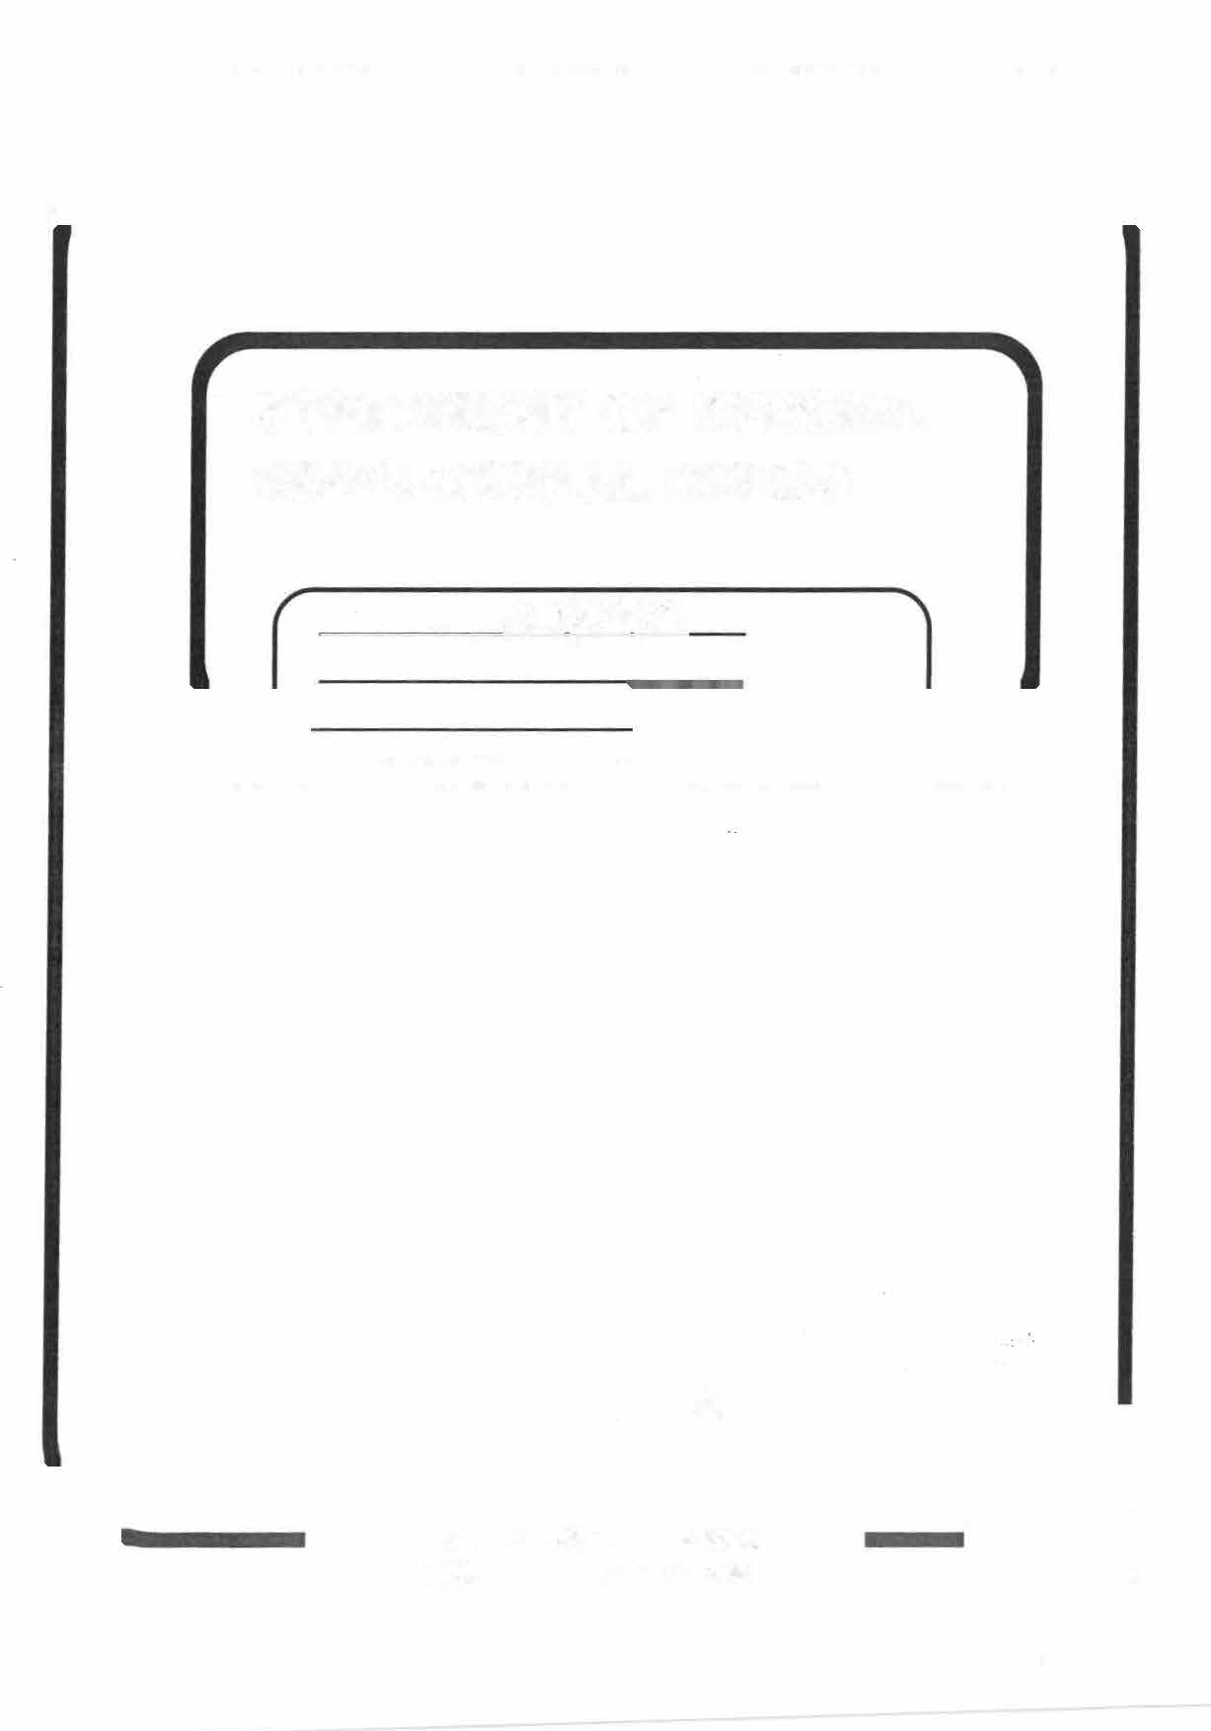
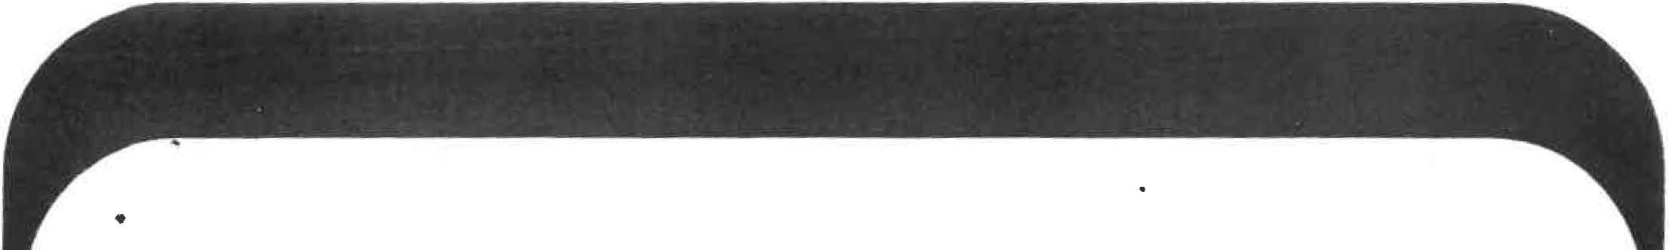
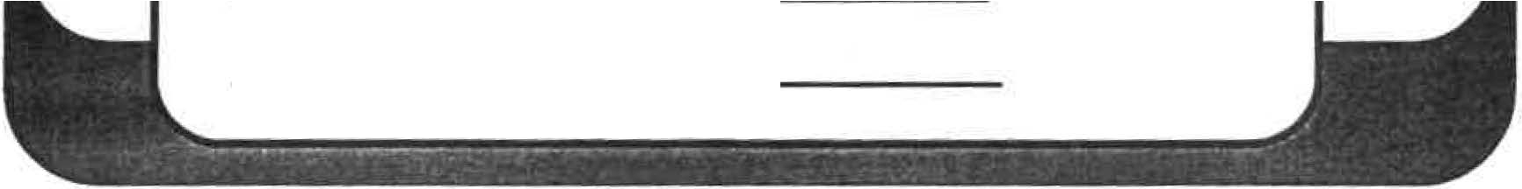



STATEMENT OF SPECIAL EDUCATIONAL NEEDS

DATE OF ISSUE= NAME
DATE OF BIRTH


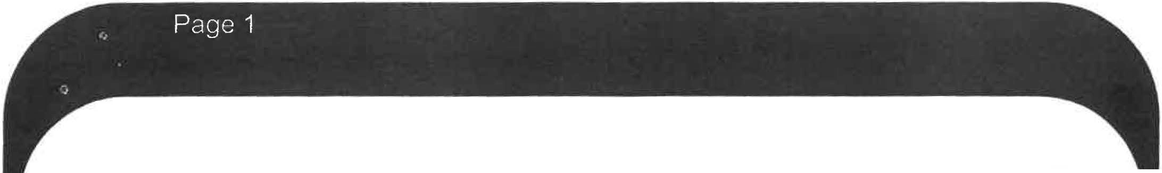



THE STATEMENT IS MADE UP
- . ....
PART 1: INTRODUCTiON
OF SIX PARTS

This section contains ______’s personal details.
PART2: SPECIAL EDUCATIONAL NEEDS.·

's special educational needs, as identified through

assessment are set out here. PART3: SPECIAL EDUCATIONAL. PROVISION
The Long term Objectives - This section sets out the long term objectives to address ______’s special educational needs.
Educational Provision to meet needs and objectives This section sets out the provision to meet ______’s needs.
Monitoring - This section states how _______’s progress will be monitored.
PART 4: PLACEMENT.
In this section the name and type of school for is recorded in the Final Statement. Schools are not recorded in Proposed Statement in case further discussion with parents is required before specifying the school or type of placement.
PART 5: NON-EDUCATIONAL NEEDS
This section sets out the non-educational needs of
as agreed between the health services, social
services or other agencies and the LA.

PART 6: NON-EDUCATIONAL PROVISION
This section sets out details of non-educational provision to meet the non-educational needs of as agreed between the health services and or social services and the LA, including the agreed arrangements for its provision.

Final


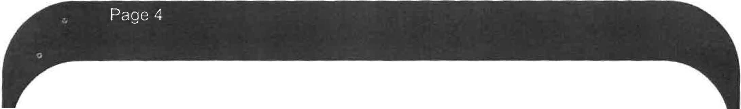



PART 2: SPECIAL EDUCATIONAL NEEDS
_____ is a very active, busy and happy little They have a diagnosis of Autism with high ASD related symptoms. They have global developmental delay with significant delays in all areas. They were slower to reach their
developmental milestones than expected. also has significant
difficulties with social communication. Their receptive and expressive language is limited due to NRXN1 gene, which has an impact on their speech and language development. has very little speech, with no recognisable words. They communicate through gesture. is very dependent on routine and dislikes noisy crowded places. does not tend to interact with others and plays alongside other children. Their play skills are very delayed. There is no evidence of pretend play. Their extremely self- directed; they find it very difficult to shift attention. They have no awareness of danger.
It is considered that has special educational needs in the following areas:
- Social interaction/communication skills.
- Receptive and expressive language skills.
- Symbolic play skills.
- Early learning skills.

PART 3: SPECIAL EDUCATIONAL PROVISION
Long Term Objectives
In order to meet the identified needs the following objectives should be addressed to:

- Develop their social interaction/communication skills with both adults and peers.
- Develop their receptive and expressive language skills.
- Develop their symbolic play skills.
- Develop their early learning skills.

Educational provision to meet needs and objectives

- ________ will follow the full National Curriculum. At the relevant time appropriate modification or disapplication of testing arrangements will be made, as necessary, by 's school.


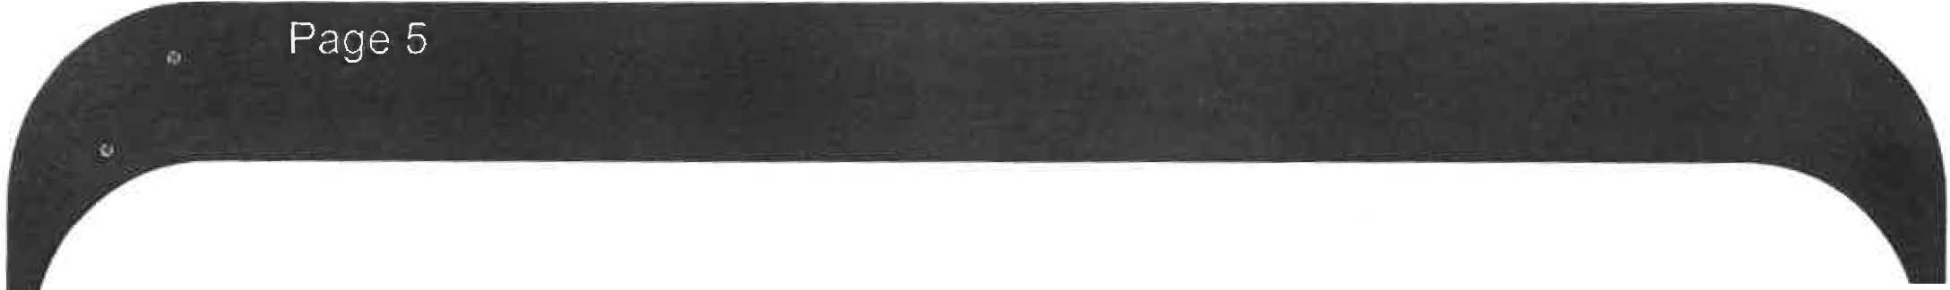



- will be provided with an Individualised Education
Plan produced by the school, and all staff will be made aware of
's needs.
- There is an expectation that programme planning and planning in general relating to 's education will take place collaboratively between 's parents and where applicable themselves, 's teachers and other relevant professionals.
- In developing the Individual Education Plan the school should initially have regard to approaches and strategies identified in the advice attached to the statement. Subsequently these strategies and approaches will be updated through the Annual Review process.
- will receive 6 hours of support per year from the Specialist Speech, Language and Communication Team. This time will be used to:
- Monitor speech, language and communication need
- Liaise with the SENCo and other staff as appropriate
- Assess the level of language skills
- Update strategies as necessary
- Attend reviews and write reports as necessary.
- Provide a programme of activities
- Share and demonstrate resources

- As from September Arrangements for Support:
will be supported in a small teaching group with a high adult to pupil ratio in a Specialist environment for pupils with autistic spectrum disorder. The class will be staffed with a suitably experienced and qualified teacher and have access to teaching assistant support which will allow for supported inclusion in mainstream lessons as determined by individual need.
Monitoring
's school should devise the first Individual Education Plan (IEP),
in consultation with their parents and, where appropriate This
should be done immediately after the statement is finalised if remains

in the same school, or within two months if
different school.
is placed at a

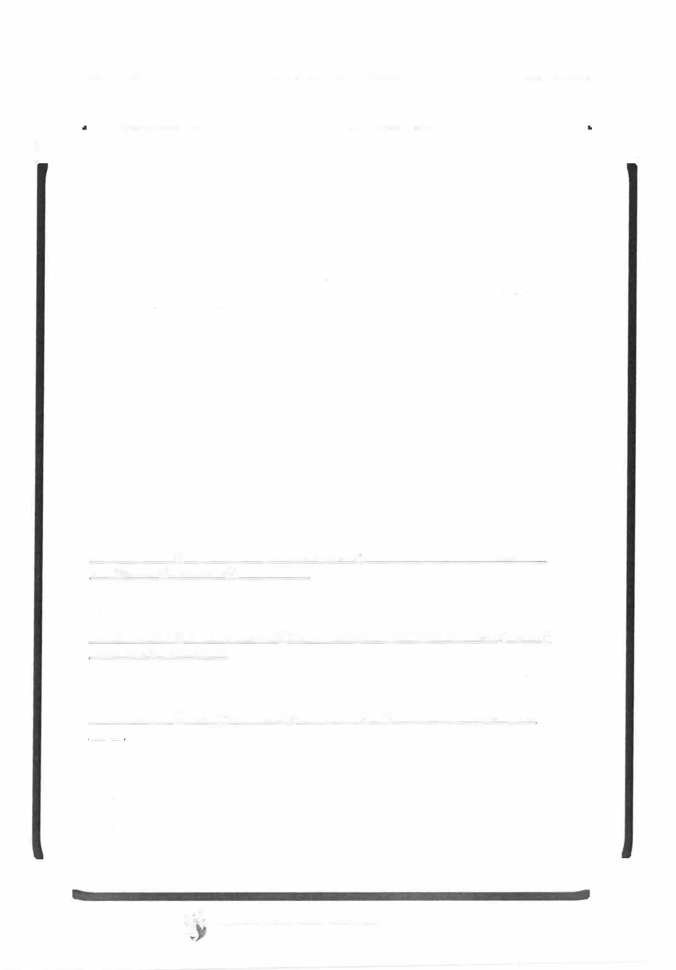
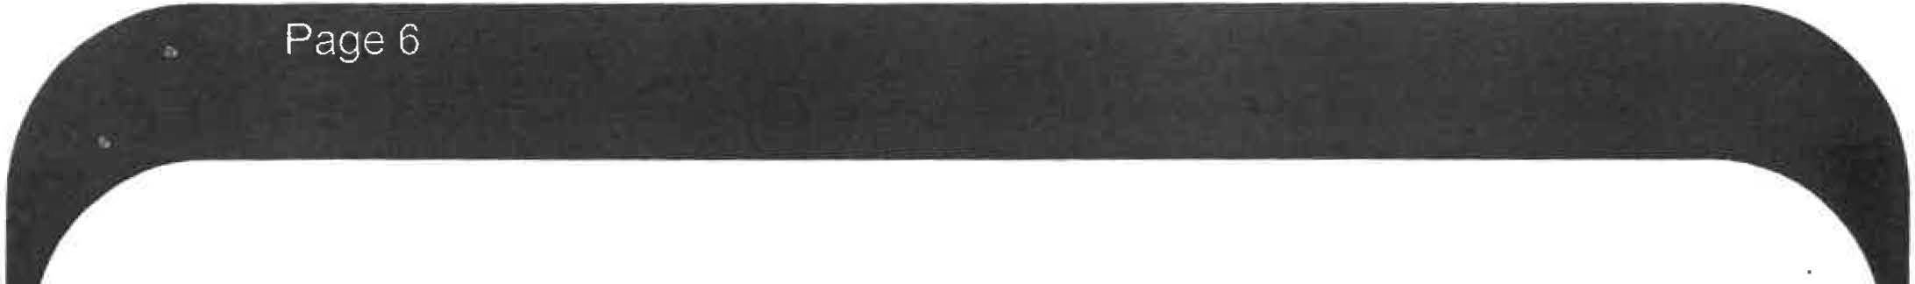



's achievements, in the light of the Individual Education Plan, should be reviewed at least twice a year by the school, and fully considered at the first and subsequent, annual reviews of the statement when further targets can be set.
The Individual Education Plan will specify learning targets as steps towards the long term objectives detailed above.
The Annual Review will monitor and record progress towards the achievement of the learning targets specified in the (IEP) and long term objectives specified in the Statement.

PART4:PLACEMENT
As from September
's needs can be met at an Autistic Spectrum Disorder Specialist Teaching Facility

PART 5: NON-EDUCATIONAL NEEDS
As advised by the Consultant Community Paediatrician
has a diagnosis of Autism with high ASD related symptoms.

- has developmental delay.

As advised by the Specialist Speech, Language and Communication Team
_______ has language and communication needs in the following areas:

  - To develop their ability to participate in simple shared activities with an adult such as ball games, stacking and action songs.
  - To develop the concept of turn taking in the above.


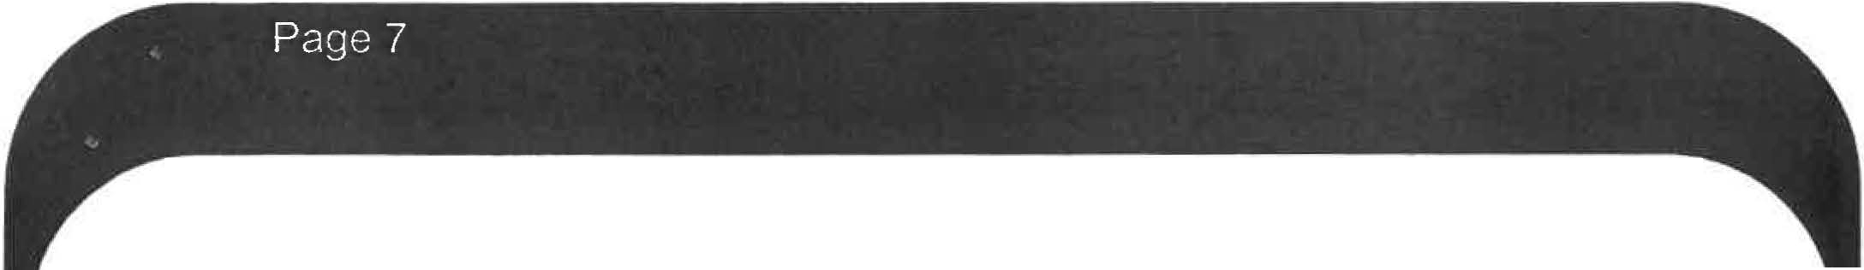



    - To become more responsive to their name and directions at a 1 word level.
    - To develop their motivation, and ability to request highly desirable items and activities, using a combination of pictures, signs and words as he progresses.
PART 6: NON-EDUCATIONAL PROVISION

As advised by the Specialist Speech, Language and Communication Team
________ will receive 6 hours of support per year from the Specialist Speech, Language and Communication Team. This time will be used to:
  - Monitor speech, language and communication need.
  - Liaise with the SENCo and other staff as appropriate.
  - Assess the level of language skills.
  - Update strategies as necessary.
  - Attend reviews and write reports as necessary.
  - Provide a programme of activities.
  - Share and demonstrate resources.

Date

Admissions Meeting and One Page Profile

Prior to starting school, Charlie’s family, new teachers and educational psychologist met to discuss Charlie’s needs, what is expected of Charlie whilst they are in school and Charlie’s interests. This also fed into writing Charlie’s initial one page profile. This was then written up by the educational psychologist and sent to all participating parties.

A one-page profile is a document that outlines how Charlie needs in order to develop, what other people like and admire about them and important facts that anyone would need to know about Charlie. It is updated if there are any changes or during an annual review. The following document is the outline of Charlie’s current one page profile. Admissions meeting minutes on pages 11 and 12. One page profile is on page 13.

Admissions Meeting

Present:
Educational Psychologist Headteacher of Primary School SENCo
Classteacher Parent

The meeting was held to discuss admission to where
they will be attending the Specialist Teaching Facility (STF) for Autistic Spectrum Disorder (ASD).
Information from the recently completed Statement of Special Educational Needs was shared. is an active and busy little _____ with a diagnosis of Autism with high ASD related symptoms. They also have Global Developmental Delay with significant delays in all areas. Their expressive and receptive language is limited and they communicate mostly through gesture. play skills are delayed with no evidence of pretend play yet. is extremely self-directed and finds it difficult to shift attention. They have not developed an awareness of danger at this point in time.
The main areas of need to be addressed are 's social interaction/ communication skills, their expressive and receptive language skills, symbolic play skills and early learning skills.
is also due to receive six hours of support per year from the Specialist Speech, Language and Communication Team.
Mum updated the meeting with changes since the Statement was produced. She is pleased that 's eye-contact is increasing gradually. They still have no speech and has been seen by the Speech and Language Therapist. They have also been referred for Occupational Therapy and are awaiting an appointment. They have recently finished attending creche.
is still not toilet trained but Mum has begun to work on this at home.
is generally co-operative when having their nappy changed.
continues to love being outdoors and also particularly likes animals.
has a good appetite and will eat a good range of foods. They use a cup with a lid otherwise they may tip the contents. With food they sometimes throw things, particularly if they have had enough. They have no known allergies and can eat and drink whatever is being offered.
still does not sleep through the night. They tend to wake in the night and come in to be with Mum. The family are having some help with sleep and toileting from Stepping Stones Outreach.___ still tends to sleep for an hour during the day.

Mum has started using some PEC symbols and photos on a key ring. likes lggle Piggle on the television and can watch this for short periods.
will be in a class with a Teacher and two Teaching Assistants. There
are changing facilities available as required. will follow an
individualised learning programme and Individual Education Plan (IEP) targets will be written after the first few weeks when has settled in. These will be shared with Mum.
It was explained that there will be frequent trips out and _______ will have access to an enclosed outdoor play area. There will be some inclusion into mainstream once has settled in and this will include concerts, assemblies and the dining hall. Further integration will be arranged as appropriate.
is entitled to a taxi to school but initially Mum would prefer to transport them. She would like to claim any relevant allowance that can be made. This will be considered at the Additional Learning Needs Panel when the request is sent in by school on the usual transport form.
It was agreed that would attend afternoon sessions, which run from 1:00pm to 3:00pm, with a gradual integration starting on Tuesday for a short session from 1:00pm to 1:30pm. For the rest of the week they will attend from 1:00pm to 2:00pm with the aim of doing a full nursery session the following week, starting Monday.
Parents are asked to provide £1.00 per week for snacks, mini-bus and other activities.
will be reviewed twice a year until they are five and is due to have their first review around April.

Educational Psychologist
My One-Page Profile
Things people like and admire about me…

- TA1 likes singing nursery rhymes with me.
- TA2 likes how happy I am.
- Mummy and Daddy like my sense of humour
- Class Teacher thinks I am funny.
- TA3 loves my smile.
- TA4 likes how laid back I am.
Anything else that is important for us to know in school?
I am under occupational therapy for my sensory needs and have a sensory programme.
I am currently still in nappies and won’t gesture if I need or have been to the toilet.
I use PECS at key points in the day and am currently on stage 2.
cv
Things that are important for me …
- To use simple language supported by gesture when speaking to _______.
- To ensure _______has a timeline to look at whilst at school. To make sure they are comfortable with all the adults in the setting.
- To give ______opportunities (daily where possible) to play outside in the continuous and enhanced provisions.
- To go on visits out in the community and to be included in assemblies in school.
- To have a chewie toy for ______if they need to bite something.
- For ______ to try a variety of different foods daily.
Things that are important to me

- It is important that I understand what you are saying to me.
- I need a routine to follow and feel safe in school.
- I really enjoy playing outside.
- I am trying to develop my social skills.
- I love sensory input.
- I love food.
cv

Speech and Language Advice and PECS Programme

Charlie has a rare gene (NRXN1) that affects the speech and language part of their brain. Therefore this causes Charlie to have a delay with their speech and language development and may never develop verbal speech. There is currently little research surrounding the gene but it is more prevalent in people with ASD and those who have a cognitive impairment. There are currently only around 9000 people in the world who carry the gene. Charlie was referred to speech and language therapy and had an initial consultation with the speech and language therapist. The following scanned documents contain the advice from the speech and language therapist from Charlie’s consultation. From that consultation, a PECS programme was devised for Charlie, starting from phase 1, but with reference to phases 2 and 3 once phase 1 was achieved. Charlie is non-verbal and finds communication with others difficult.

Both documents have been entirely anonymised for Charlie but also for the adults and therapists that have been involved in the writing the programme or who were present during the consultation. The consultation is from pages 15 to 16 and the PECS programme is situated from page 17 to 21.
SPEECH AND LANGUAGE THERAPY STATEMENT ADVICE
_______ was referred for Speech and Language Therapy by their family Health Visitor in October. They were referred for a Ruth Griffiths assessment at the same time. They were seen for an initial assessment by the community pre-school therapist on _____. On this occasion they presented as difficult to engage so no assessment of their language or play skills was possible because of their self-directed approach. Their presentation was very suggestive of ASD and an onward referral was made to assess for this.
Their Ruth Griffiths assessment was on December indicated significant delay in all areas, but set within the context of their very self-directed presentation.
They currently attends ______ and was seen for a follow-up appointment with myself at ______ on ______ in order to provide information for ________ as part of the ASD assessment process. The following is a copy of my report from that day: ·
______ came happily into the room and was willing to be sat at the table to begin addressing the inset puzzle there. They took the pieces out 1 at a time and examined each one carefully. After a very brief attempt to replace 2 of the pieces they began throwing all the others to the floor. They ignored my attempts to get their attention by calling their name or showing them what to do and focused totally on watching the pieces as they threw them.
I next introduced the pop-up zoo toy which _____ clearly liked as they made happy sounds as they operated the switches and smiled, jumped and flapped their hands. They still took very little notice of my attempts to engage with them, although they again smiled slightly when I attempted to get their attention by tickling them.
_____ was losing interest in being at the table at this point. I introduced a nest of stacking beakers but they again only wanted to throw these to the floor arid then got up and went to the sink where they wanted to play with the tap. Their mother and I were able to distract them from this by directing them towards vehicles on a floor mat and a box of Duplo.
When left by themselves with these items, _____ became very focused on simply taking items from the box, 1 at a time and throwing them across the floor. I briefly managed to engage them in a game pushing a toy bus back and fore between us and they watched the bus and anticipated my go when I paused in "ready, steady....go". On their turns I had to model them pushing it back to me to stop them from just throwing the bus away.
Bubbles held their attention for a short while and they watched the wand intently. They did not shift their gaze to me or respond with a nod when I asked if they wanted more. When I gave them the wand to put into the pot they examined it closely and then threw it. . They did not pop the bubbles but just watched them and again exhibited jumping and flapping mannerisms when excited.

Discussion

Their mother reports that they find it very difficult to shift their attention but does usually enjoys these sort of games more at home. They also likes to sit on her lap to look at favourite books but she has to stick to the same "script" all the time; and even the same intonation pattern or they get cross. They are also very dependent on routine and dislikes noisy crowded places. She also reports that they understand some key words and phrases and responds appropriately to them. These are "biscuit", the name of their favourite book and "time for bed".

I saw no evidence of functional or pretend play and ____ seems to be finding it difficult to move on from their enjoyment of throwing and watching toys.
____’s presentation today was extremely suggestive of ASD.

Aims and Objectives

_______ has language and communication needs in the following areas:
To develop their ability to participate in simple shared activities with an adult such as ball games, stacking and action songs.
To develop the concept of turn taking in the above.
To become more responsive to their name and directions at a 1 word level.
To develop their motivation and ability to request highly desirable items and activities, using a combination of pictures, signs and words as they progresses.

Provision
_______ will receive 6 hours of support per year from the Speech, Language and Communication Team. This time will be used to:
Monitor speech, language and communication needs.
Liaise with the SENCo and other staff as requested.
Update strategies as necessary.
Provide a programme of activities.
Share and demonstrate resources.
Attend reviews and/or write reports as necessary.
Prior to each review, the Speech, Language and Communication Team will consider if these recommendations remain appropriate. They will be amended in accordance with _______’s needs following discussion with parents and school staff. This will result in an amendment to the statement.

SPEECH AND LANGUAGE PROGRAMME: PECS Stage 1

Name: | DOB: | School: | ASD STF |  |  | Date:
Speech and Language Therapist: |  | Copies: | School | X | Parents | X | SLT file | X
Introducing PECS
PECS is a unique augmentative/alternative communication intervention package for individuals with autism spectrum disorder and related developmental disabilities. PECS has received worldwide recognition for focusing on the initiation component of communication.
PECS begins by teaching an individual to give a picture of a desired item to a "communicative partner" (Stage 1 & 2), who immediately honours the exchange as a request. The system goes on to teach discrimination of pictures and how to put them together in sentences (Stage 3). In the more advanced phases, individuals are taught to answer questions and to comment (Stage 4-6.

Recommended Structure
Duration 10-15 minutes (as you are introducing the PECS programme)
Location Preferred work station
Environment | Quiet area with limited distraction
Frequency | A minimum of 3 sessions per week, ideally avoiding activities and lessons that the children are motivated by and enjoy {as this is likely to affect their participation in the session)
If you need to contact the Speech and Language Therapist please do so at any time, otherwise please contact immediately 1
when the programme is complete:

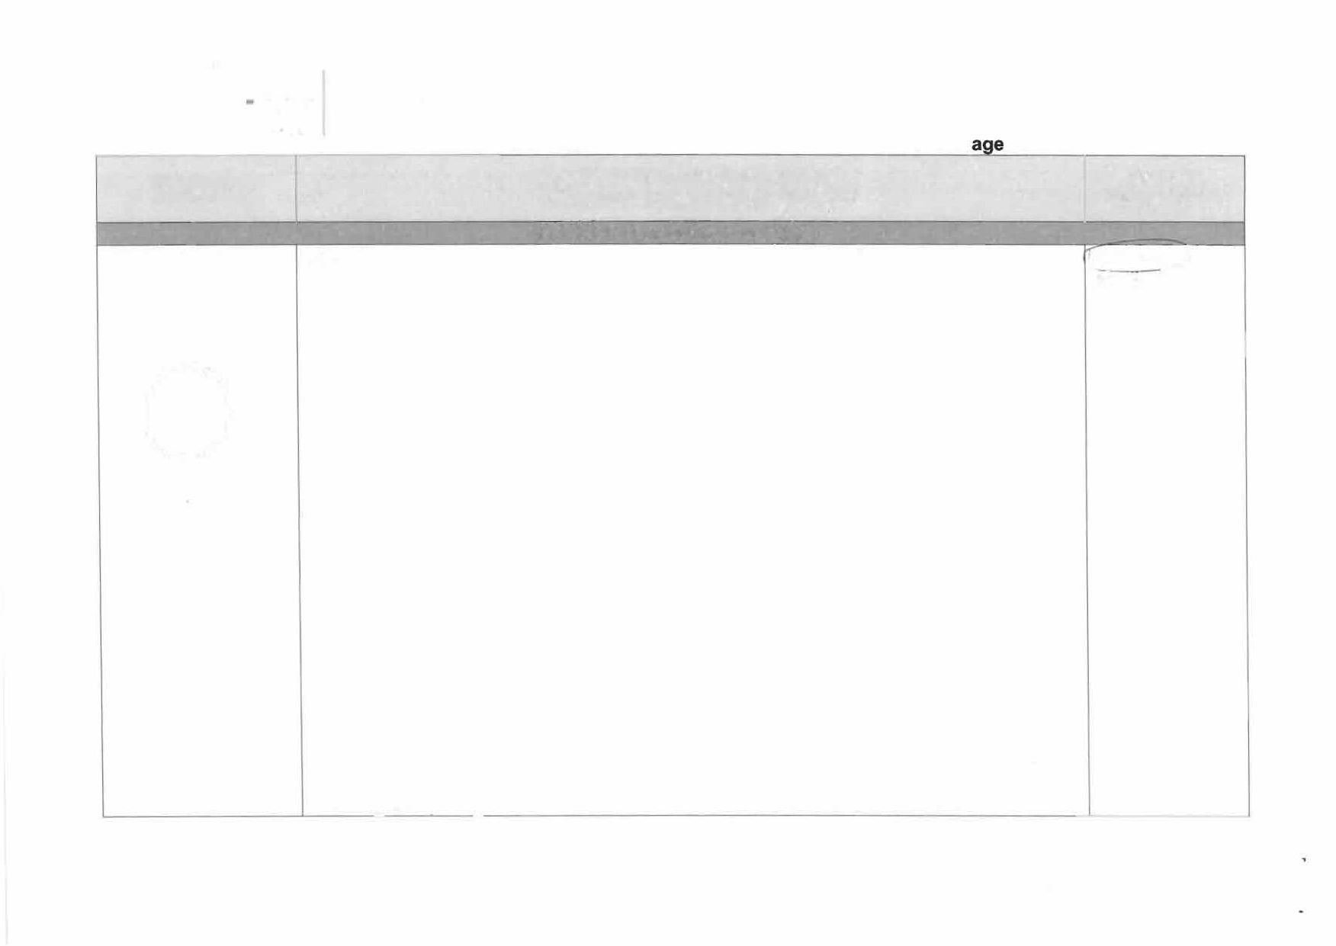

TARGETS

Your child will exchange single
SPEECH AND LANGUAGE PROGRAMME: PECS St 1
SUGGESTED ACTIVITIES/ADVICE
(Please use your own ideas too)
STAGE_ 1: How to Communicate
You MUST have two people in order to carry out stage 1. Each will have a specific role:
- Communicative partner - the person who will hold the desired object

Outcome (please circle)

lAchieved_) Mostly Achieved

pictures for items or 2) Physical prompter - the person who assists the child to pick up the picture and hand activities they want it to the communicative partner. A physical prompter MUST wait for the child to
0
Partly Achieved Not Achieved

initiate and 'make the first move'. This is a critical stage in the overall effectiveness of the programme and to avoid the child relying on an adult to present them with
pictures before making a choice.
The communicative partner will sit in front of the child and hold out the desired object. If the child does not look to it the communicative partner may move the object or pretend to play with it to draw the child's attention.
The communicative partner will then wait whilst holding their other hand open in anticipation of receiving a picture exchange. The communicative partner should hold their hand with the object close to the hand they will receive the picture.
When the child gives the communicative partner the picture (whether or not they are supported by the physical prompter) the object MUST be immediately passed to the child. This demonstrates to the child that their action - of handing the picture to the communication partner, has caused them to receive the desired object. This will hopefully motivate the child to repeat the action.
The communication partner will name the object e.g. 'bubbles' in an enthusiastic voice to reinforce the spoken label to the object.
The Physical prompter will sit behind the child and place one picture in front of them. The

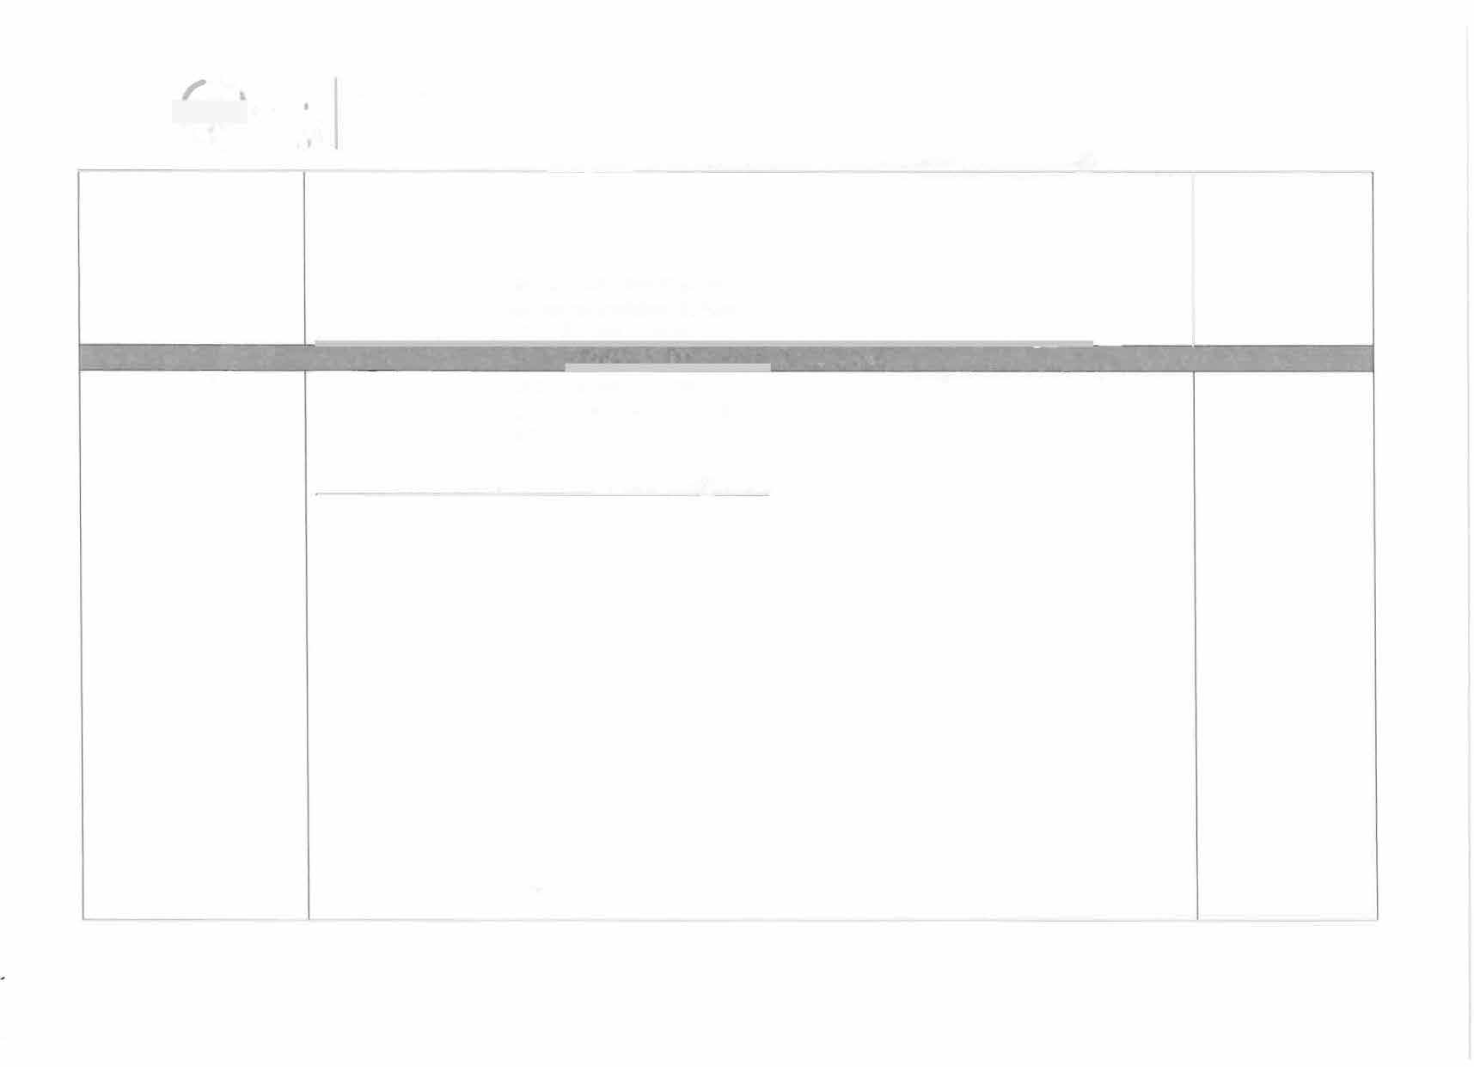
SPE_ECH AND LANGUAGE PROGRAMME: PECS Stage 1
picture should represent the desired object for good practice but it is not relevant for this stage. The purpose is instead for the child to pick up a picture - regardless of what the picture is.
The physical prompter will wait for the child to initiate. This may be by reaching for the object, pointing, vocalising of looking. When the child does this the physical prompter must

support the child to reach for the picture and hand it to the communicative
- -
STAGe-2:Distance & Persistence
p�artner. �

Your child will exchange in different environments and with different people
Still using single pictures, students learn to generalize this new skill by using it in different places, with different people and across distances. They are also taught to be more persistent communicators.
Par t 1 : Child to seek out communicative partner
The communicative partner will sit in front of the child and the physical promoter will sit behind (as in stage 1 ). After the first go at the activity the communicative partner will take the desired item off the child and move 2 steps/chairs distance back. The physical prompter will wait to see if the child gets up to move toward the communicative partner independently. If not, the physical prompter will assist the child to get up and move toward the communicative partner.
If the child needs assistance to move towards the communicative partner it is recommended that the communicative partner stays at that distance for the next turn and your focus will be on getting the child to get up independently and move towards the communicative partner.
If the child does not needs assistance or once the child achieves this stage, the communicative partner will move further away from the child for the next go and so on until the child is moving around the classroom with the symbols to make an exchange with the communicative partner.

Part 1 Achieved
Mostly Achieved Partly Achieved Not Achieved

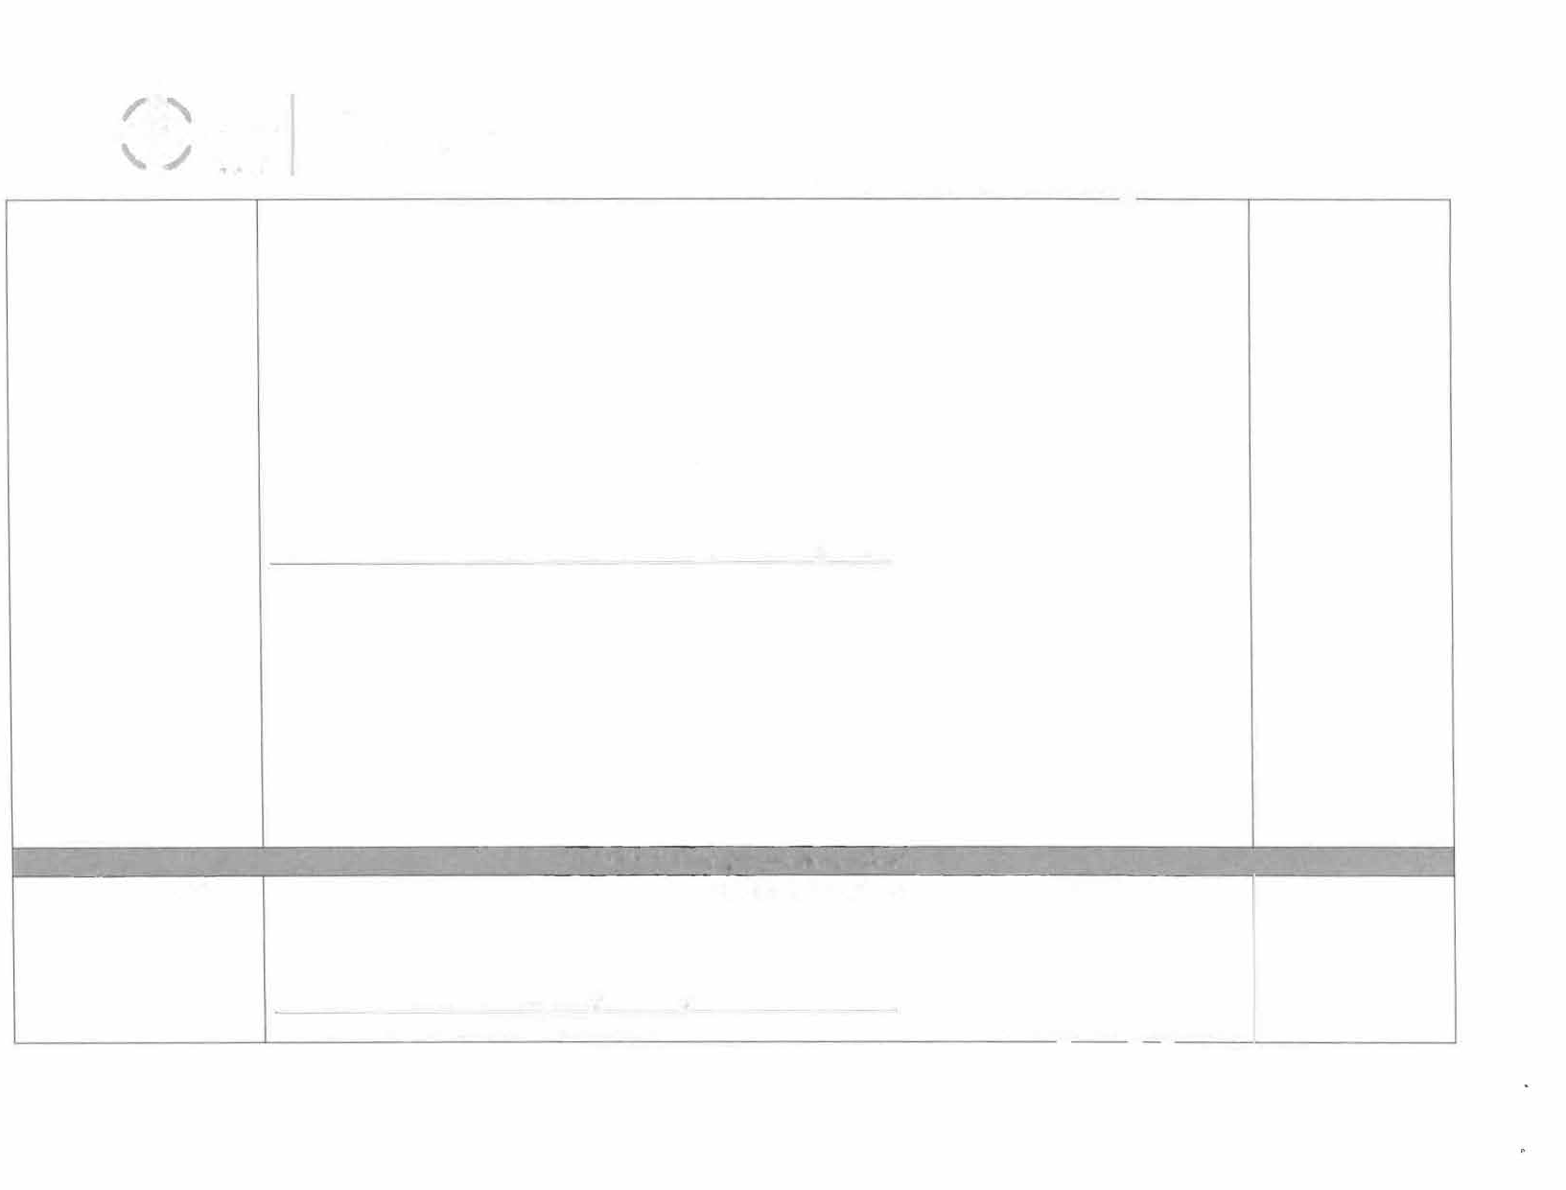

SPEECH AND LANGUAGE PROGRAMME: PECS Stage 1
Please ensure you practice the following movement sequences during the stage:
  - Communicative partner gradually moves further away from the child after each turn
  - If required, physical prompter to assist the child to get up and move toward communicative partner. Then gradually remove this support so that the child moves independently.
  - The symbol is moved to different locations as well as the communicative partner. This will ensure the child learns that they will have to seek out the required symbol for what they want and someone to initiate communication with and that these will not always be in the same place
  - The communicative partner and physical prompter will change roles so that the child does not learn that they only initiate exchanges with one person.
Part 2: Child to make self known to communicative partner
During this stage the communicative partner will turn away from the child or appear pre­ occupied when the child approaches them with the symbol to exchange. The communicative partner will wait to see if the child makes themselves known/ gains the attention of the communicative partner. This is typically achieved by:
  - Standing in front of the communicative partner and making eye contact
  - Tapping the communicative partner's arm/ leg etc
  - Placing the symbol in the communicative partners hand
This stage will help the child learn that they will have to make themselves known/ seek the attention of the communicative partner or teacher, parent etc

Part 2 Achieved
Mostly Achieved Partly Achieved Not Achieved

STAGE 3: Picture discrlminatiol"I _ _ _

Your child will select the correct symbol from two or more symbols to ask for
Students learn to select from two or more pictures to ask for their favourite things. These are placed in a communication book-a ring binder with Velcro strips where pictures are stored and easily removed for communication.

what they want Part 1: Discriminate between pictures presented on a table Part 1 The child will be provided with two desired items/activities and two corres2onding symbols. Achieved
\


SPEECH�AND LANGUAGE PROGRAMME: PECS Stage

The communicative partner will hold both items, one in each hand and away from each other, and wait for the child to initiate. Once the child picks up a symbol and moves it toward the desired item the physical prompter will look to see if the symbol matches the desired item.

If it does, the child will make the exchange and receive the item. If it does not, the physical prompter will intercept the child and support them to place the symbol back and select the correct symbol.
If this physical prompt works it is recommended that the remaining steps will involve the physical prompter reducing their support and the child selecting the correct symbol independently
If this physical prompt does not work it is recommended that the communicative partner gives the child the item that matches the symbol they present - even though it may not be the one the child wants. The communicative partner will show the child the symbol and name to object e.g. 'bubbles, you chose bubbles'. By drawing attention to the symbol the child will learn to look and discriminate between the pictures on the symbols.

After this the physical prompter may wish to draw the child's attention back to the correct symbol and show the child that the symbol for what they want e.g. 'playdough'. Repeat the activity until the child is able to discriminate independently.

Part 2: Introducing the PECS book
During this stage the PECS book will be introduced to the child. Here the symbols will be moved from the table and placed on the top (front cover) of the PECS book. The child will need to make future choices from the PECS book. The communicative partner will return the symbols to the book and the physical prompter will assist/direct the child to the book to select their desired s_ymbol.

Speech and Language Programme – People Games

The following document is an observation sheet based on a visit from the speech and language therapist. It outlines targets for Charlie, which includes playing people games to develop their communication and social skills during play activities. Charlie has difficulty with functional play; therefore in order to build initial play skills, they will play games such as peekaboo with familiar adults. Charlie learns best through tactile and visual activities. The document contains the speech and language therapists report and targets given based on Charlie’s learning style. It also gives examples of what people games are and what type of games to play. All people games are to be played with and modelled by an adult.

The reports have been anonymised for the child, but also for the adults and therapists that have been involved in the writing the programme or who were present during the observation. The report and targets written are from page 23 to 24. The examples of people games are situated from page 25 to 26.

Name: |  | DOB: |  | School: | ASD STF |  |  | Date:
Speech and Language Therapist: |  |  |  | Copies: | School | X | Parents | X | SLT file | X

UPDATE

I reviewed _______ in school on _______ and discussed them with teaching staff (Class Teacher and Level 3 Teaching Assistant). They discussed concerns that they haven’t had much success with PECS due to _______ being very passive and difficulty finding motivators outside of snack time.

I observed _______ playing on the carpet alongside their peers. They tolerated their peers around them but showed no functional or relational play. They moved some Lego pieces around, but didn’t attempt to put any pieces together or copy banging them together. ______ watched me and their peers play and occasionally vocalised. ______ enjoyed me rolling the toy cars on their leg/ arm and they indicated this by stopping what they were doing, looking briefly and smiling. This told me that they wanted more. I attempted to assess _______’s ability to discriminate between pictures using a motivator versus a non-motivator e.g. ‘bubbles’ and ‘Lego’. _______ was able to exchange the picture for the preferred item on around 4-5 occasions in this session. However, this was mostly prompted by an adult as ______ was easily distracted by the other toys and it was easy for ___ to select another item which was out on the carpet instead. I discussed building more interaction through people games with staff to increase their anticipation and motivation. We also discussed intensive interaction (following/ copying _______’s movements and sounds).

It is important that staff continue to provide opportunities for _______ to understand and learn through a communication friendly environment. The following targets have been agreed to focus on over the next few months. PECS phase 3 can be revisited further at any time. It is important that school staff contact us once their targets have been met or if there are any difficulties in achieving these. Further support can be provided at any point.

Provision

_______’s provision should remain unchanged. We will review their targets in the Autumn term.

TARGETS | SUGGESTED ACTIVITIES/ADVICE  (Please use your own ideas too) | Outcome  (please circle)
- People games  ______ to show anticipation and requests for ‘more’ (by non-verbal communication/ vocalising). - By the end of the Autumn term | - Increase anticipation through people games and familiar songs e.g. ‘round and round the garden’, tickle games, ‘this little piggy’.  - Stop the game/ song and wait….prompt ‘more?’ and then continue once ______ indicates that they want more. For example this could be a smile, looking, vocalising or hand movements.  - Use cause-effect toys and pause to see if ______ indicates that they want more.  - Use trigger words e.g. ‘ready…steady……PAUSE……go’ (encourage _______ to tell you they want more by waiting to encourage anticipation). Then reward them by letting the item go e.g. rolling a ball, a wind up toy, pushing a car along, blowing bubbles’. | Achieved  Mostly Achieved  Partly Achieved  Not Achieved
Modelling  - ______ to join in/ copy/ complete a simple relational or ‘in-out’ play task e.g. placing the last block on a tower, putting items in/ out of a box. - By the end of the Autumn term. | - Model lots of in-out play e.g. pouring sand in and out of a box, putting items in a basket/ box and then putting them back out. N.B keep this separate from the ‘tidy up’ routine. Praise any attempts of this type of in-out play during the day. N.B water play outside is a good opportunity for this – filling and emptying a cup.  - Use hand-over-hand to encourage _______ to place the last block on a tower and praise them. Each time, encourage _______ to do this on their own, reducing your prompts. This can later be extended to other task completion games e.g. the last piece of a simple puzzle. Praise all their attempts. | Achieved  Mostly Achieved  Partly Achieved  Not Achieved

Examples of People Games Given by SALT

People Games
People games are where play begins. Simple games like “peek a boo” or “tickle” help children learn important play skills, like engaging with others, paying attention to what they are doing, taking turns and keeping the interaction going. These skills will eventually transfer to everyday interactions and conversation. Initial People Games usually involve some PHYSICAL SENSATION that a child enjoys such as movement, sound or touch. For example if your child loves movement/running, they may enjoy playing “Chase”. If they seek out pressure, a game of giving “Bear Hugs” or “squishes might work.

- OBSERVING the child will help you understand which types of sensations the child seeks out and which they avoid.

- When playing People Games with the child, be FACE TO FACE so you are able to see the child’s facial expressions and their attempts to interact. Also the child can see your smiles and enjoyment of the interaction.

- You can create a People Game by IMITATING what the child is already doing. This can become a turn taking game by repeating a simple action (banging a table, clapping, blowing raspberries). Imitation shows the child that you are paying attention and engaging.
- It is helpful for you to INTERPRET what you think the child is trying to tell you. If they grab your hand and put it on their belly after being tickled, say “Tickles! You want more tickles!”

PROGRESSION OF PEOPLE GAMES
  - Looking at play partner.
  - Taking a turn with sounds or words.
  - Doing actions to continue the game (such as looking at play partner and moving their body back and forth).
  - Imitating actions (such as clapping hands during pat-a-cake).
  - Taking a number of back and forth turns with actions or sounds/words.
  - Staying engaged, smiling, laughing and having fun.
  - Playing games with other children.

Examples of People Games

Movement  Chase | Block the Way | Jumping on Bed
Blanket Swing | Row Row Row Your Boat | Ring Around the Rosie
Touch  Horsey Ride | Peek a Boo under pillows | Squish
Blanket Roll | Pat a Cake | Round and Round the Garden
Sound
Early Actions Songs – Insy Weensy Spider, Head and Shoulders, The Hockey Pokey, The Wheels on the Bus

Occupational Therapy Sensory Integration (Sensory Diet)

Charlie had difficulty with sensory processing showing signs of under stimulation such as chewing objects, getting excited when colouring videos were shown and lacked tone and tension whilst sitting. Charlie was referred to occupational therapy and a sensory diet was devised to support Charlie both at school and at home.

The following document outlines the sensory integration strategies to support Charlie written by the occupational therapist. Activities are completed as and when appropriate for Charlie throughout the day to support their attention and focus, and making sure they are in the right frame of mind for learning.

Occupational Therapy Programme for Sensory Integration (Sensory Diet)

Following the Home Visit on the ______. I have advised the following which forms part of a specific Sensory Diet to address the following to daily functions.
- Tactile input to prepare _____ prior to completing tasks for a calming effect.
- Proprioceptive and vestibular input to prepare _____ before going out walking.

Tactile input before completing tasks
Firm squeezes down arms, legs, and into feet
Deep pressure massage before tasks – arms and shoulders
Proprioceptive and vestibular input prior to going out walking.
Bouncing up/down on gym ball using same language Ready, Steady, Go 1,2,3,4,5,6,7,8,9,10. Stop. Repeat x3
Tummy on gym ball, rock ____ over gym ball back and forth til hands and feet touch the floor. Again use the same language-
Ready, Steady, Go, 1,2,3,4,5,6,7,8,9,10
Stop. Repeat x3
Crawling through tunnel filled with cushions and fleeces x3. Encourage _____ through with small healthy snacks.

Sensory Integration - Proprioceptive Awareness Strategies

Proprioception is the unconscious awareness of sensations from our joints, muscles and ligaments. It provides us with an internal awareness about where our body parts are moving in space. This is necessary so that we do not have to 'look' to 'know' exactly where our legs or arms are when we move.

Proprioceptive activities generally have a calming effect and are often combined with activities for tactile and vestibular stimulation.

- Hotdog: roll the child up in a duvet (the child is the 'sausage' and the duvet is the 'bread'!). Put 'toppings' on the 'sausage' by applying firm pressure with your hands down their back, arms and legs. If your child really enjoys this try varying the type of pressure with the topping e.g. tomato sauce could be firm squeezing, onions could be firm patting. Always stop and ask the child if they want more. This way they get to control the input you are giving to suit their needs.

- Strong Man Press Ups: child lies on their tummy on the floor and pushes up through their outstretched arms. Try doing press-ups against the wall or down on a desk

Considerations for Heavy Work Activities
- For children with poor proprioceptive awareness opportunity to engage in these heavy work activities should be given before focus tasks and not as a reward.
- Some of the more controlled activities can also be used at bedtime to help calm the child as part of a regular bedtime routine.
- If the child struggles with knowing which body part they are moving or needs a prompt to know what to move, give clues during activities by touching or gently tapping the body part.

Compression Garments
Compression sportswear are form-fitting garments often made from a spandex-type material and are usually worn by athletes to prevent muscle strain and fatigue and enhance athletic performance. They may be shirts, shorts, tights or underwear and are readily available online and in high street sportswear retailers. Children with poor proprioceptive awareness may also benefit from wearing these compression garments as they are designed to provide sensory information to the body. The greatest benefit would be to wear during gross motor activities to help improve the smoothness and accuracy of their movements, otherwise known as motor learning.

Wearing Regime
Take care to build up tolerance by initially putting the garment on for a short period of time beginning with 30 minutes (if tolerated) then for the duration of the activities being undertaken.

Precautions

- Compression garments should not be worn at night.
- Compression garments should not be worn when the child is ill either.
- The fit of these garments should be snug but not so tight as to be uncomfortable.
- Check your child daily for any redness or marking that does not disappear 20 to 30 minutes from removal of the garment.
- Check for skin irritation, soreness, numbness, swelling, pins and needles or any signs of pain, discomfort or changes in circulation.

Tactile input can also have a calming effect. Here are a few ideas:
- Wrap the child up tight in a towel or blanket;
- Roll the child up in a blanket and then unroll them;
- Give the child a brisk rub with a towel after the bath or rub them down with talcum powder or body lotion;
- Do actions along to "Row Your Boat" or play "Tug of War'';
- Give the child firm "Bear hugs".

The Vestibular Sense
The vestibular sense refers to information that is provided by the receptors in our inner ear. This system responds to motion or changes in our head position. It integrates our neck, eyes and body adjustments to movement and influences our balance, muscle tone and bilateral integration (the co-ordination of both sides of the body e.g. hands). It has an important effect on regulating our posture and movement in relationship to what we are doing and seeing.

If the child is sensitive to movement, it is very important that this is graded accordingly. The child's response to movement will enable you to know the appropriate type, duration and frequency of stimulation e.g. start with slow movement back and forth before more challenging rotational movements.

Activity Ideas:
- Swinging on swings or see-saws or in a blanket held by two people;
- Spinning e.g. on a swing or an office chair. As spinning provides a high amount of vestibular input it is important to let the child control the amount of movement. Watch carefully for changes in their complexion (i.e. the colour of their face from normal to pale) or distress and stop immediately if these signs are noted;
- Jumping on a trampoline or off something high to land on something soft e.g. from the sofa onto a pile of cushions;
- Rolling in a blanket;
- Rough and tumble play including tipping the child upside down etc;
- Riding bikes, trikes or scooters etc;
- Soft play areas, ball pools and playgrounds all provide excellent sources of vestibular input to help calm and regulate the child's sensory system.

Individual Education Plan (IEP) Targets

IEP targets are written once a term, or changed as and when Charlie has achieved a specific target. Targets are based on long-term objectives from Charlie’s statement and are agreed with their parents due to Charlie’s lack of understanding as of a result of their global delay. The targets also taken into account the way that Charlie learns best and activities are tailored to support Charlie in order to reach their targets. The following document is an example of Charlie’s current IEP targets.

IEP Targets

Statement Target – To develop their early learning skills
Literacy – B Steps
Numeracy – RfL - Shared attention

My Targets |  | How am I going to do it? |  | Who is going to help me? |  | How did I do and when?
I am able to respond to ‘Where?’ questions when accompanied by gestures.  I can participate in a shared activity session by participating in attention group sessions (stage 2). | I will choose an item from a selection when asked where. I will need an adult to help me using gestures/Makaton or modelling what I need to do. I will start with 2 items and build up to 4. I will also use games on the iPad to support my learning.  I will work with an adult for short periods of time. I will participate with one other pupil in a SALT attention group session (stage 2). I will focus my attention on the object and the adult without getting up off my seat. I will join in with the session where appropriate. |  | Teacher  Teaching Assistants  Mummy  Daddy

Long Term Statement Targets
To develop symbolic play skills.
My Target | How am I going to do it and who is going to help me? | Who is going to help me? | How did I do and when?
I will concentrate on exploring a toy for 1 minute. | I will be given lots of opportunities to explore different toys. Adults will help me by encouraging me to pick up a toy, look, touch and explore it in many ways. | Teacher  Teaching Assistants  Mummy  Daddy

Long Term Statement Targets
To develop expressive and receptive language

My Target | How am I going to do it? | Who is going to help me? | How did I do and when?
I will start to travel to exchange a picture for an object. | I will use PECs during snack times, lunchtimes and choosing play activities. My Teacher will encourage me to travel. My Teacher will use strategies specified by the SALT. | Teacher  Teaching Assistants  Mummy  Daddy

Long Term Statement Targets
To develop social interaction skills

My Target | How am I going to do it? | Who is going to help me? | How did I do and when?
I can seek an adult to engaging in physical people games. | I will look at an adult and point or touch to engage in the game. I will try to engage in this activity for a short period of time. I will show that I am enjoying myself by laughing, smiling and gestures. I will ask for more by touching or grabbing an adult’s hand. I will play a range of different games until I feel I have finished and move on. | Teacher  Teaching Assistants  Mummy  Daddy

To be reviewed July Signed ______________________ Parent
_______________________ Teacher

Communication Passport

The following document is an example of Charlie’s communication passport. As Charlie is non-verbal, it allows any person to come in to Charlie’s environment and understand how they communicate, what to do to communicate with Charlie and Charlie’s level of understanding. This can lead to more effective communication, relationship development and lead to less frustration in behaviour due to more awareness of how Charlie communicates.
Expressing myself
How I express myself

- I can use some Makaton signs during songs.
- I can usually understand some simple visual and non-verbal instructions or commands.
- I can ask for items using pictures or a communication board.
- I get frustrated when I cannot communicate and I will throw something I don’t like, tip chairs or refuse to do a task.
- I may sit on the floor when I have to wait or when I am anxious and I don’t know what is happening.
- I will enter your personal space and stamp my feet.
- I make loud noises when I am excited or bored.
- I have started to use a simple feeling symbols to indicate when I am sad or happy.
- When I am happy, I flap and run back and forth.
- I will look up when you call me.
- I will make eye contact when I am engaged in a task, when I don’t want to do something or when I’m anxious and want your attention.
- I don’t usually initiate contact with others.

Expressing myself
Ways to help me express myself
- I need you to use simple language when speaking to me.
- It helps me if I have visuals to make choices.
- Say my name before you speak to me.
- I can use simple visuals to communicate feelings of happy and sad.

My understanding
How much I understand

- I understand more than I can communicate.
- I can follow simple instructions, accompanied by gesture.
- During a new activity, I will need modelling by staff.
- Physical prompting.

My understanding
Things that can help my understanding

- Consistent boundaries.
- Visual supports.
- Makaton.
- Simple spoken words.
- Gestures.
- Modelling new activities.
- Timeline.
My communication routines

What people say to me at key points throughout the day.

- Sit down
- Come here
- Wait
- Stop
- Where’s _______?
- Good morning/afternoon
- What do you want?
- Get your book/bag/coat etc
- More
- Quiet/Shhh
- Do you want ______?
- No
- Work first – then ……
- Stop
- What

   | You can help me to communicate

Please do |  | Please don’t
- Sign simple Makaton.  - Use simple language.  - Prompt me to ask/move.  - Be patient.  - Praise my efforts and use lots of exaggerated facial expressions.  - Reinforce language with visuals.  - Offer a choice board.  - Talk to me and ask me questions even if I do not answer.  - Give simple verbal instructions. |  | - Rush me.  - Ignore my efforts.  - Leave me without visuals/gestures.  - Dismiss me I am listening.

