The World Is Our Lecture Theatre Conference Appraisal

Contents
Evidence 2
Post No.1 4
Post No.2 5
Post No.3 7
Post No.4 8
Post No.5 9
Post No.6 10
Post No.7 11
Post No.8 12
Post No.9 13
Post No.10 14
Post No.11 15
Post No.12 16
Post No.13 17
Post No.14 19
Post No.15 20
Post No.16 21
Post No.17 23
Post No.18 24
24
Post No.19 26
Story No.1 27
Story No.2 28
Story No.3 29
Story No.4 30
Story No.5 31
Post No. 6 32
Story No.7 33
Story No.8 34
Story No.9 35
Story No.10 36
Story No.11 37
Story No. 12 38
Story No. 15 39
Story No. 16 40
Story No.17 41
Story No. 18 42
Live Stories 43
Mtour Email Account 45
The Website 46
Flight Cancelation and Delayed Emails 49

Evidence

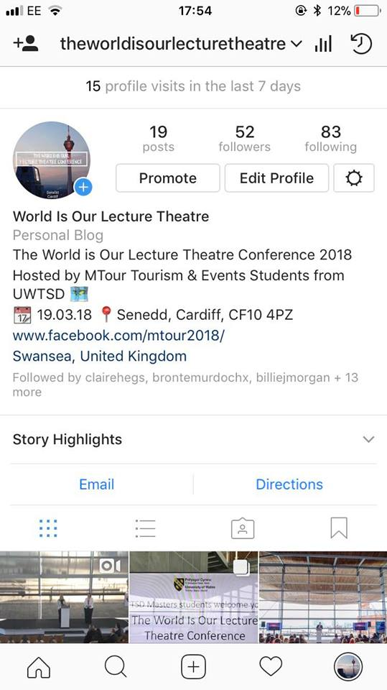
I created the official Instagram Account for The World is our Lecture Theatre Conference. Since creating the account I accumulated 52 followers and was following 83 people which included different organisations in Wales to get their attention about our Conference. I created 19 posts, each varying e.g. single photos, multiple photos, videos and a mix of the two. Then I also 17 different stories. See all of the posts and stories below.
I interacted with other accounts like their material if it was relevant to the what the conference was about for example any posts made by VisitWales etc…
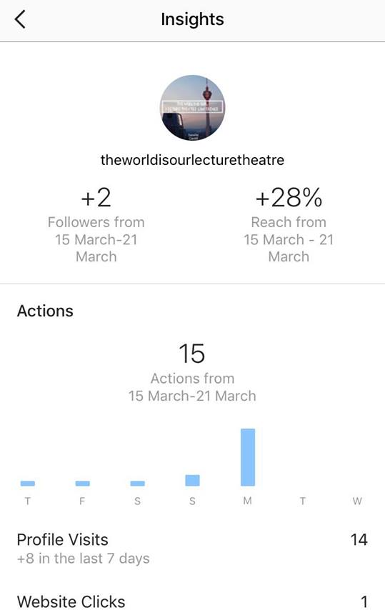
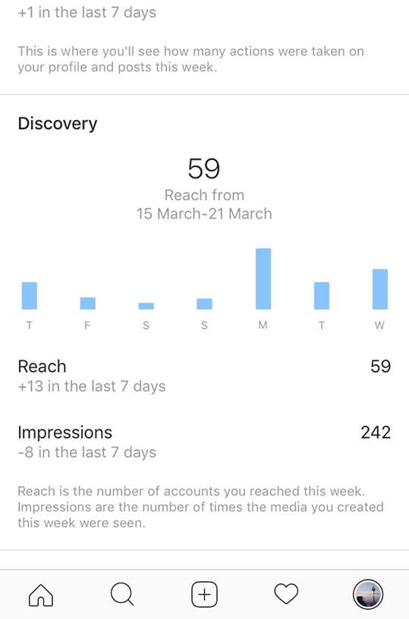
Instagram Insights
I created a business profile on Instagram so I would have access to the Instagram Insights which allows you to monitor the activity that your profile receives on a weekly basis. And see the benefits of using Instagram as a marketing tool.
1. Impressions
This insight represents how many times your ads appeared on users' screens.
2. Reach
This insight reflects the number of unique users that have seen any of your Instagram posts.
3. Website Clicks
This insight reflects the number of times any links you've included in your business profile have been clicked.
4. Profile Visits
This insight reflects the number of times your profile has been viewed.
5. Followers
This insight reflects how many followers you've gained or lost over the past week, as well as the average times of day when your followers are using Instagram -- data that can be highly beneficial when planning posts.

Post No.1

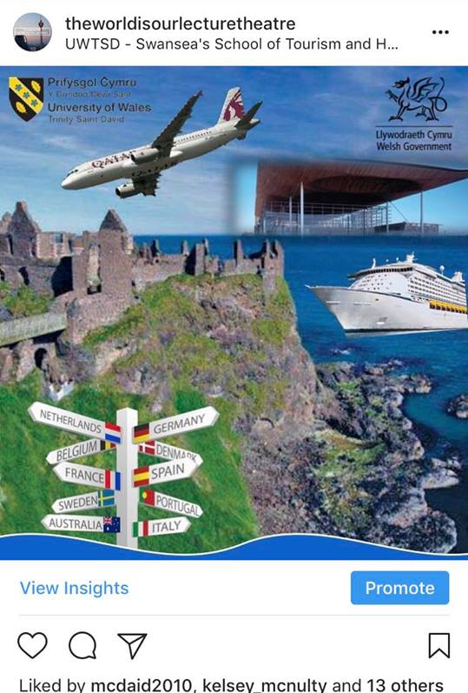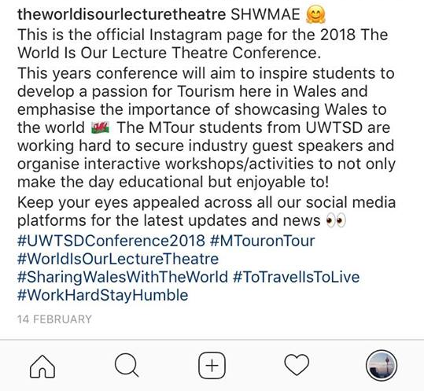

Post No.2

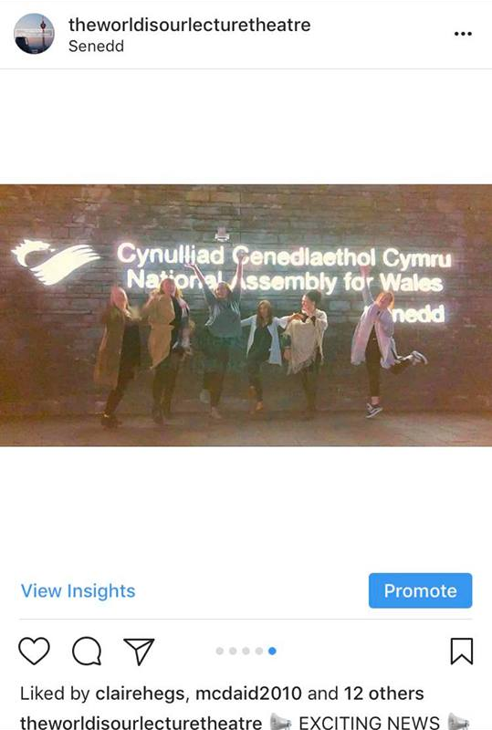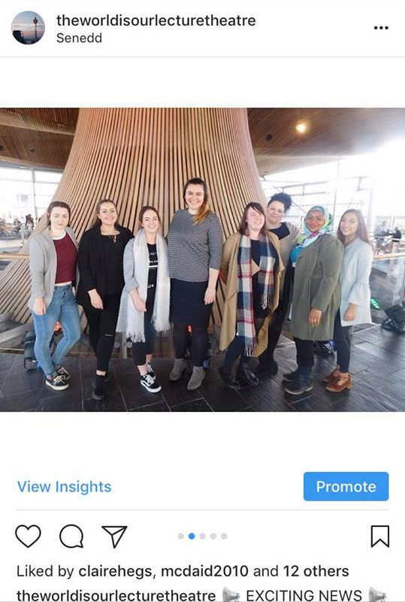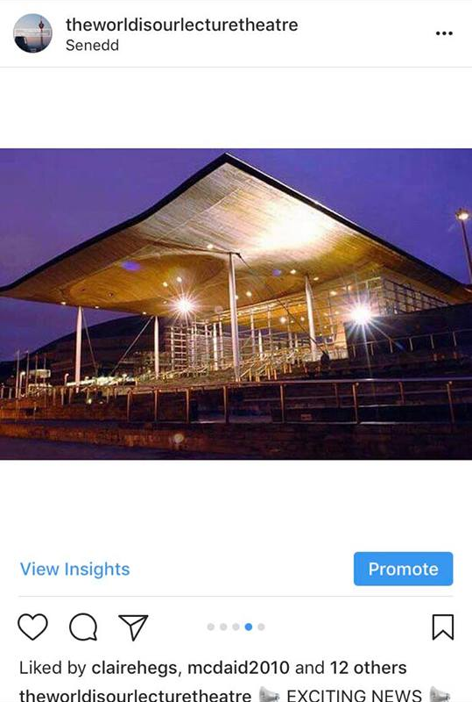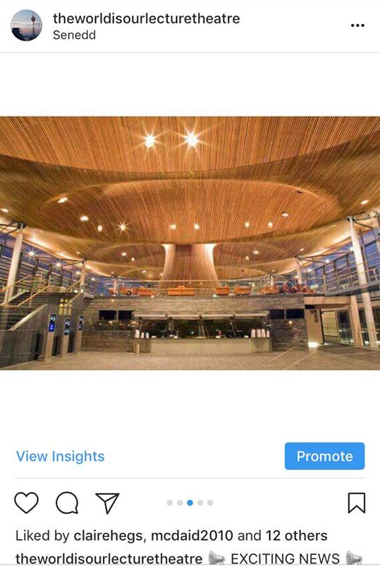
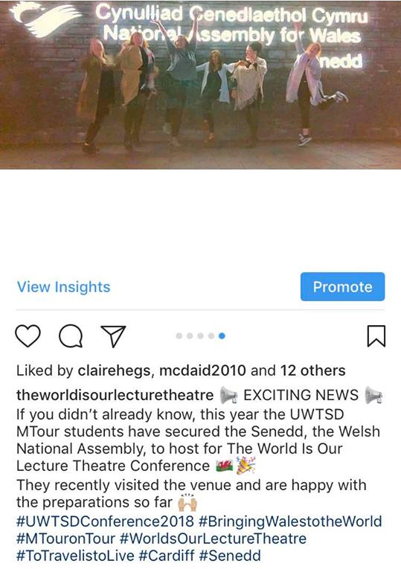

Post No.3

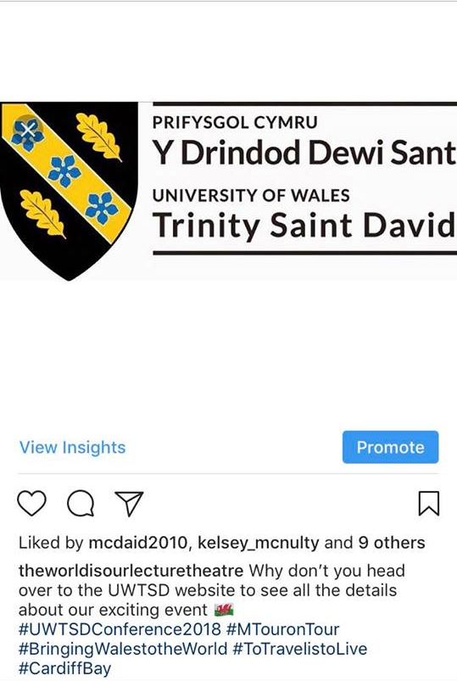

Post No.4

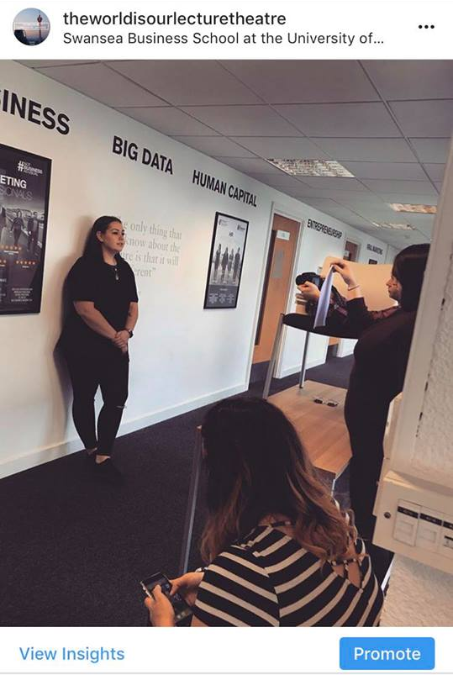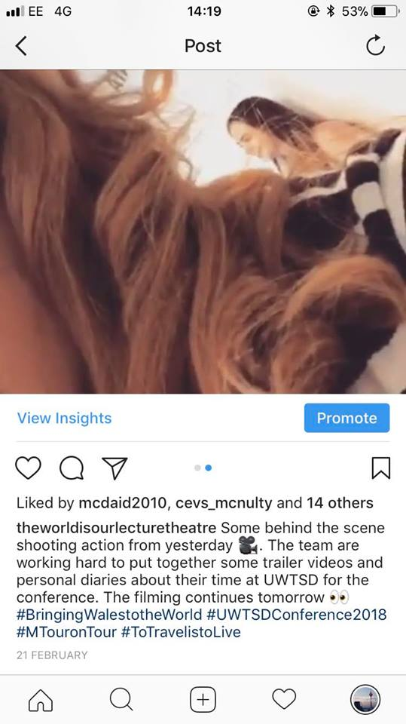
On this post I used a picture and then a short video clip to show users what we were up to during the filming

Post No.5

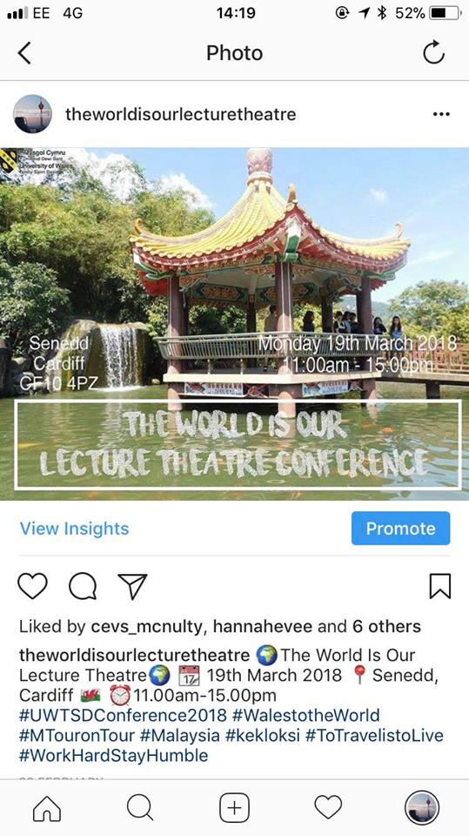

Post No.6

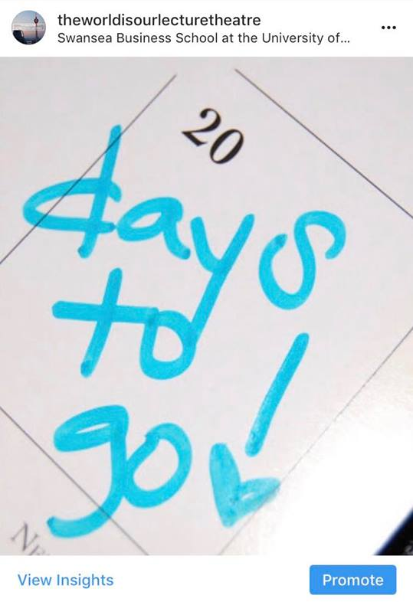
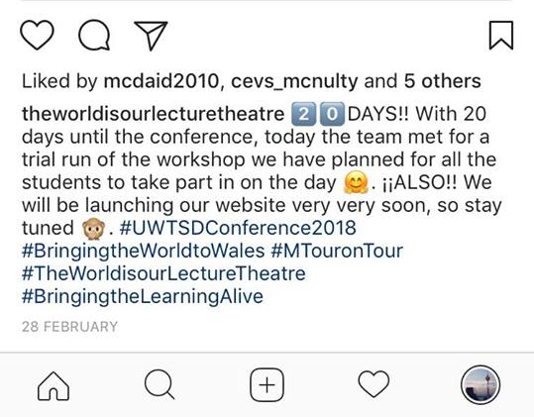

Post No.7

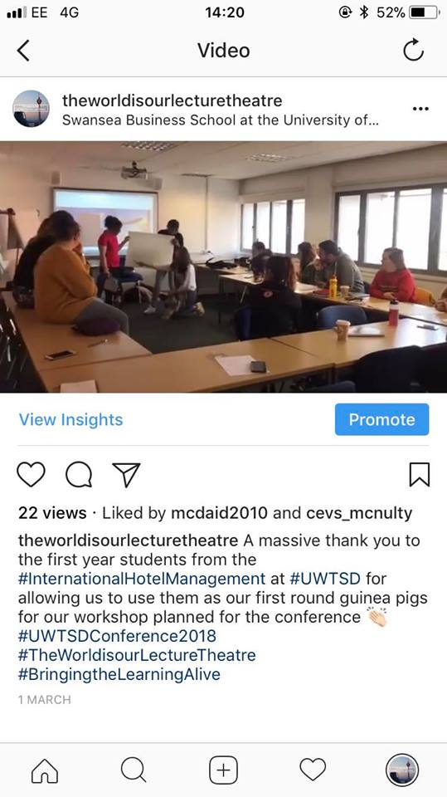
This post is a time lapse video of the IHM students during the first pilot run of the workshop.

Post No.8

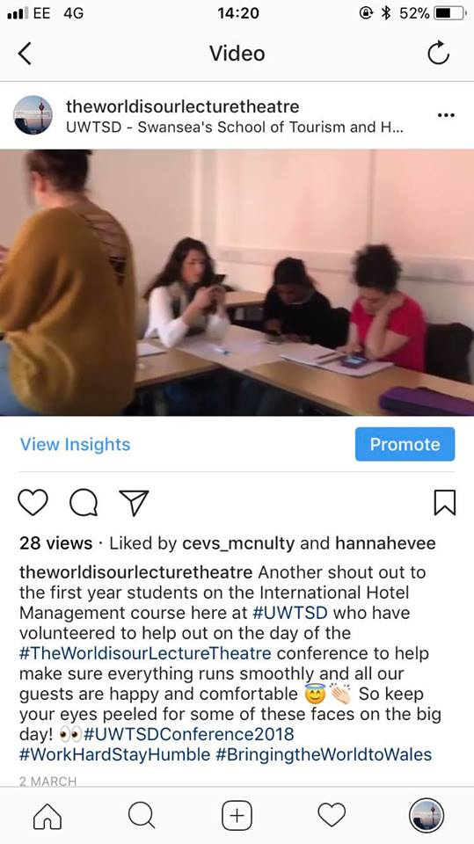
This post is just a regular video of the students working hard at the workshop

Post No.9

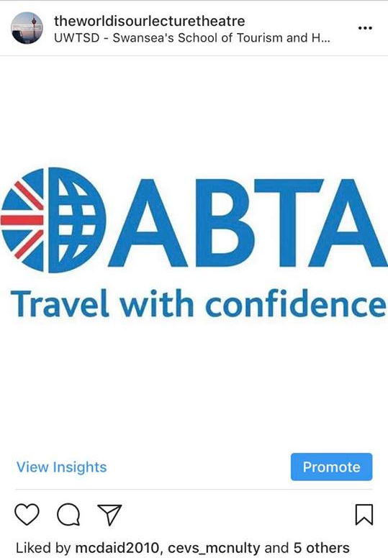
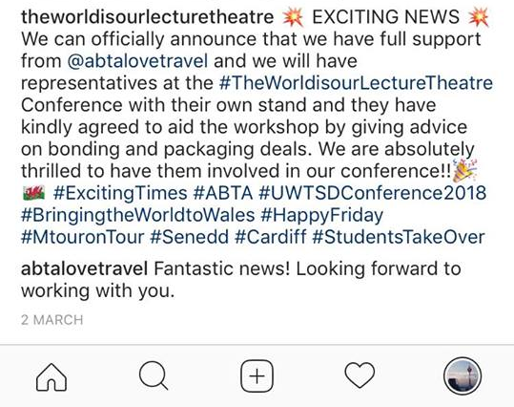
Got a very positive response from the official ABTA Instagram account!

Post No.10

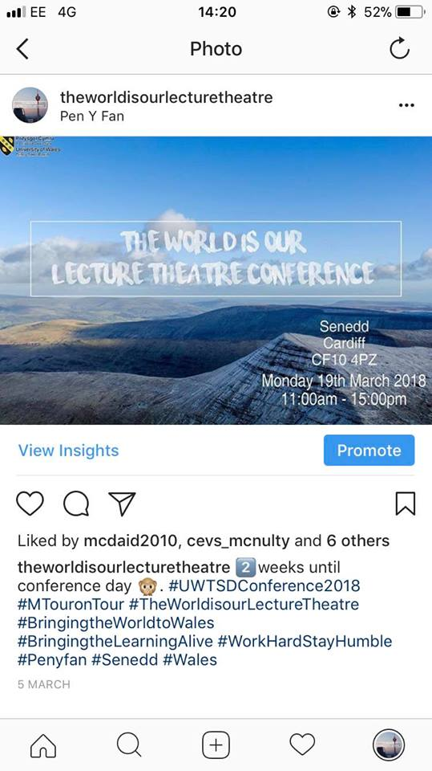

Post No.11

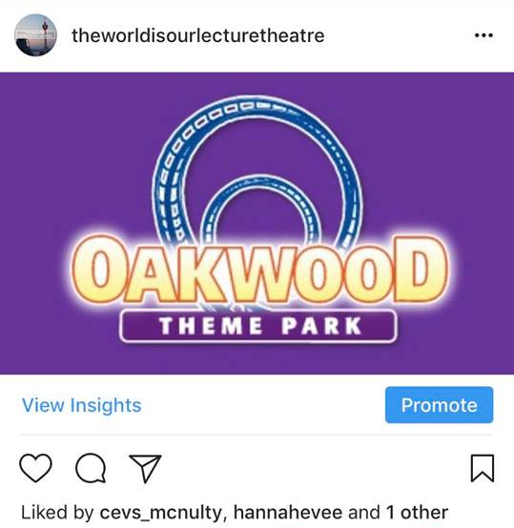
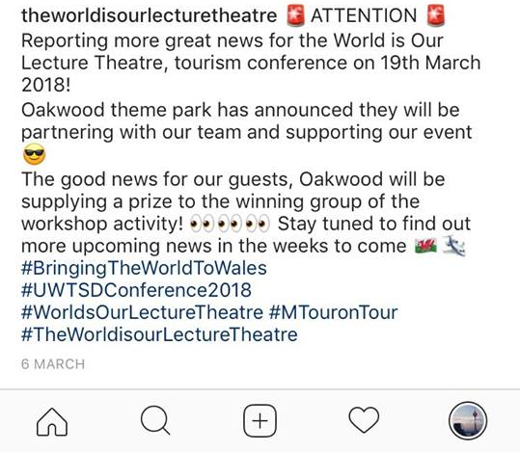

Post No.12

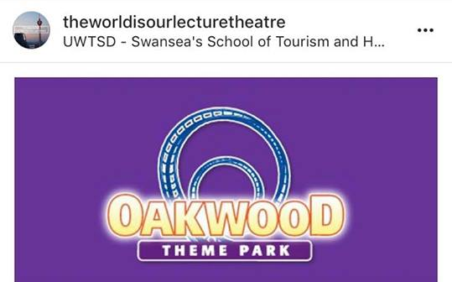

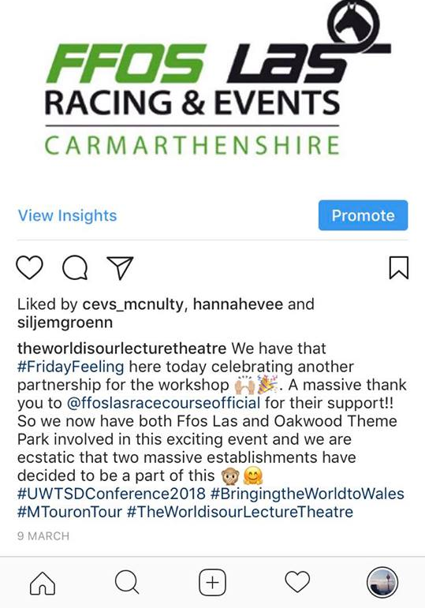

Post No.13
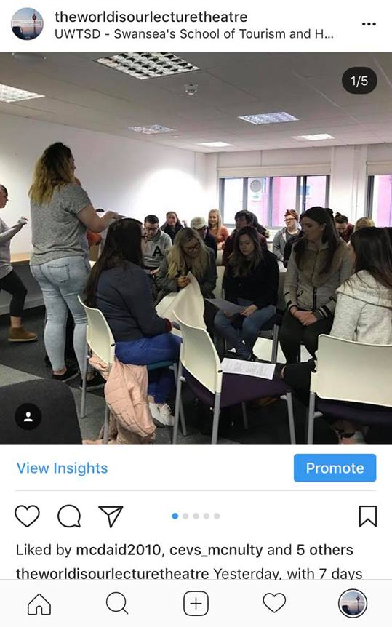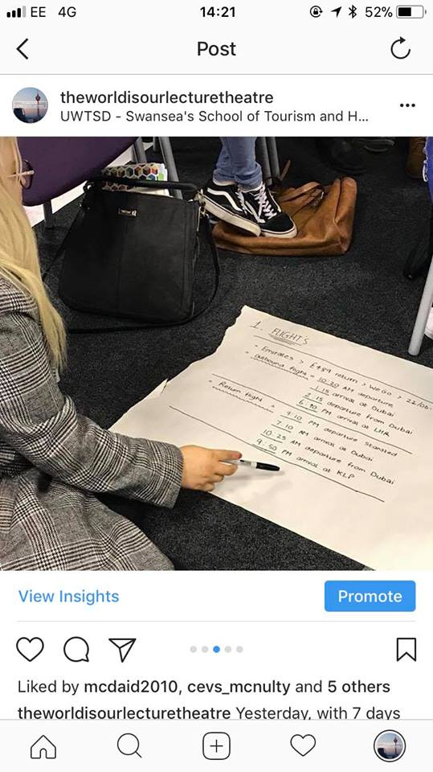

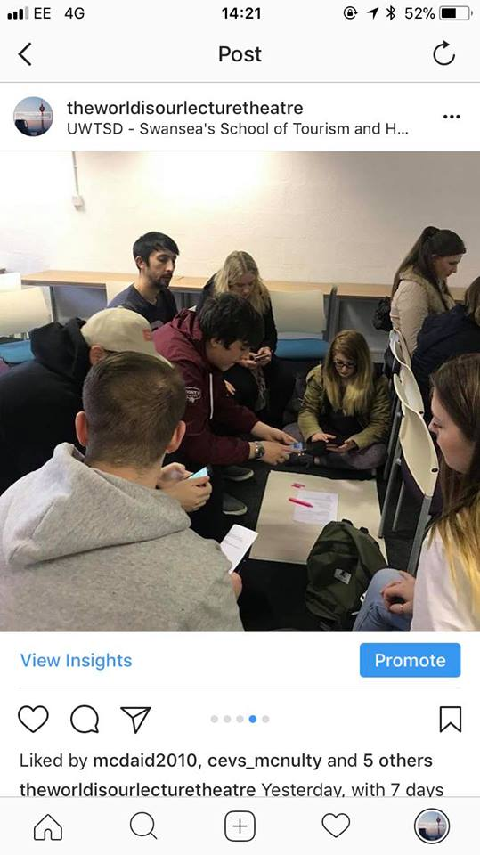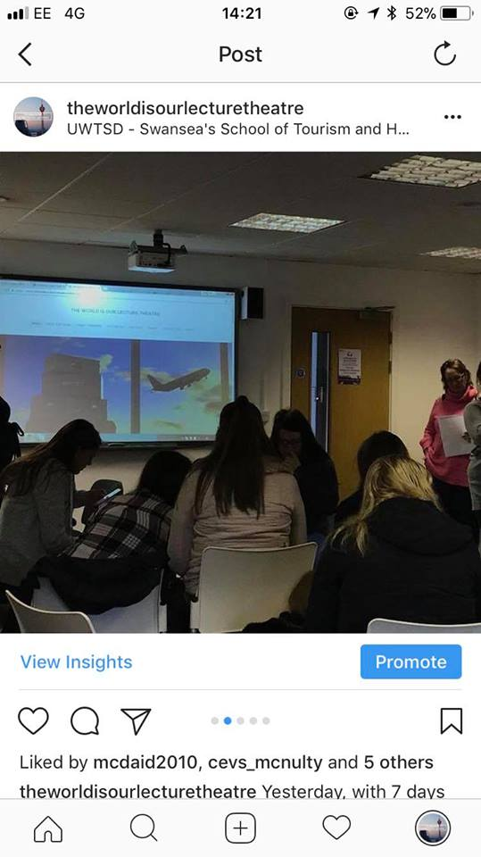

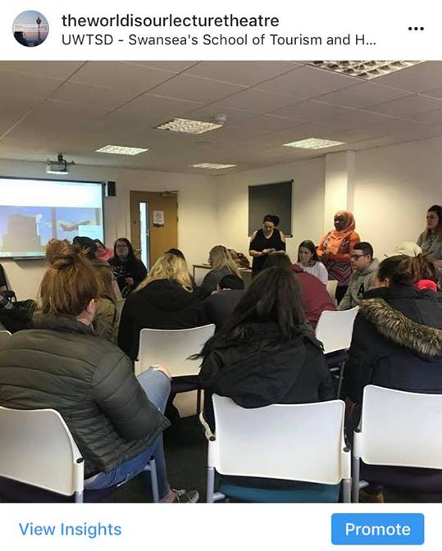
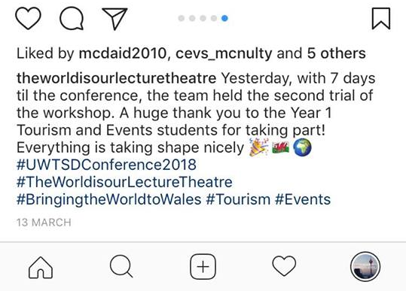

Post No.14

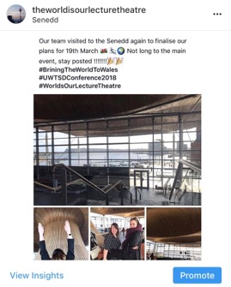
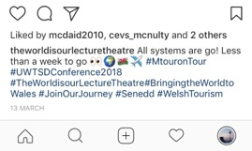

Post No.15
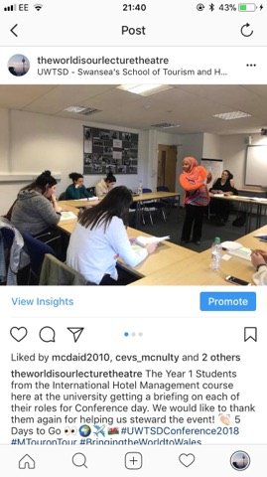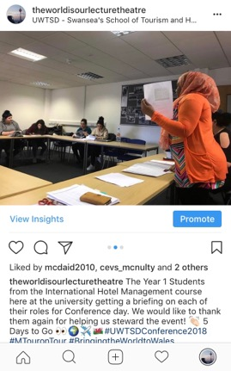
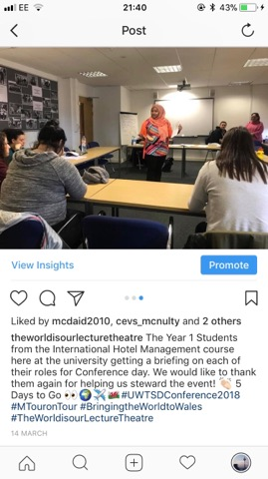

Post No.16

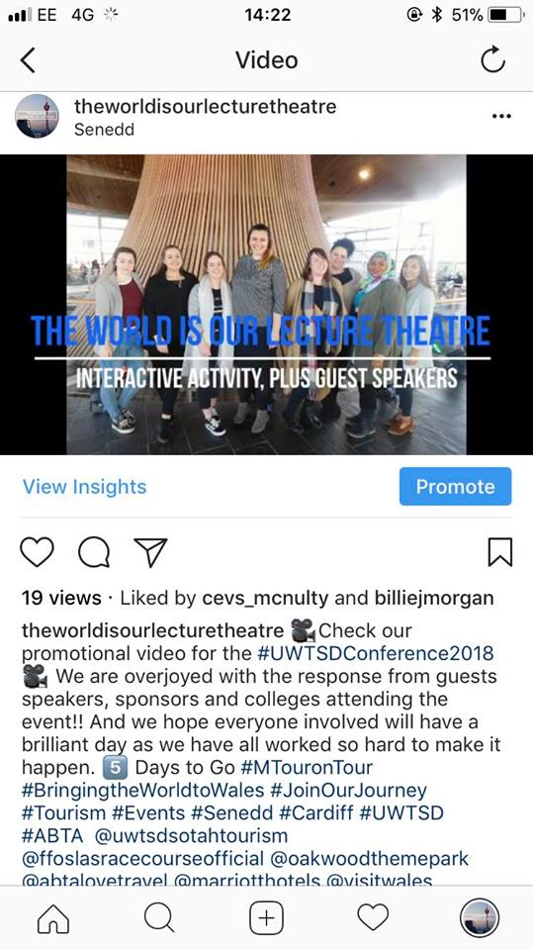
This is the trailer video that the UWTSD social media shared. (See below)

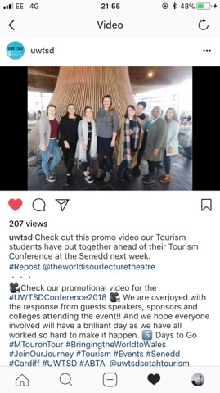

Post No.17

#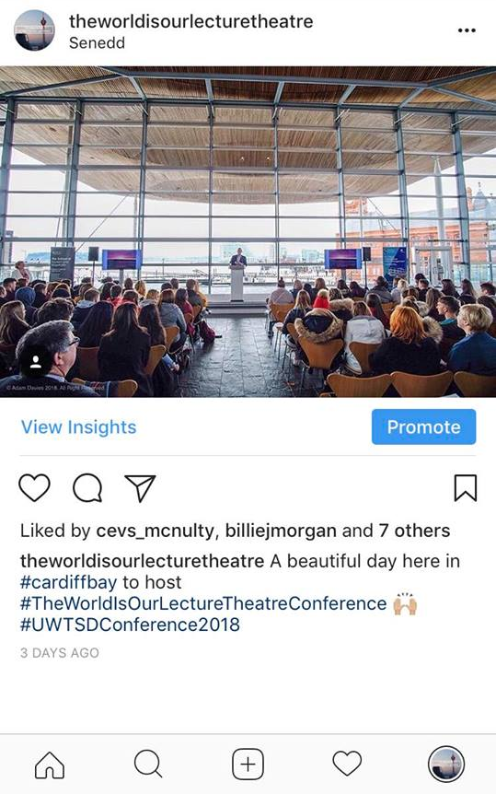

Post No.18

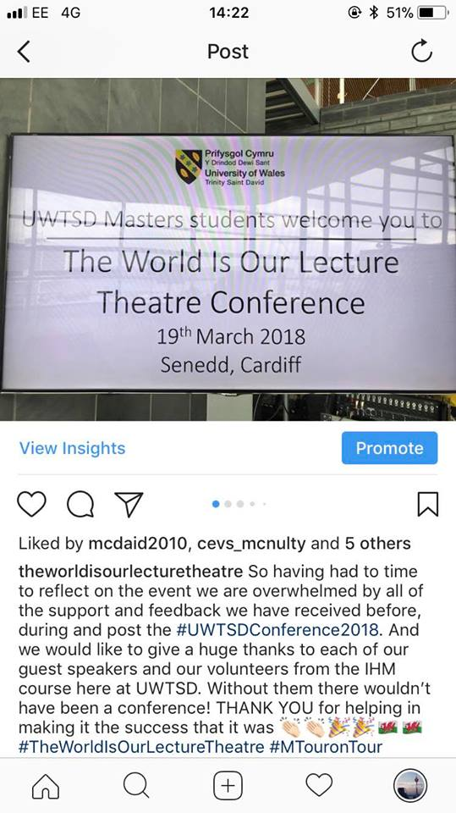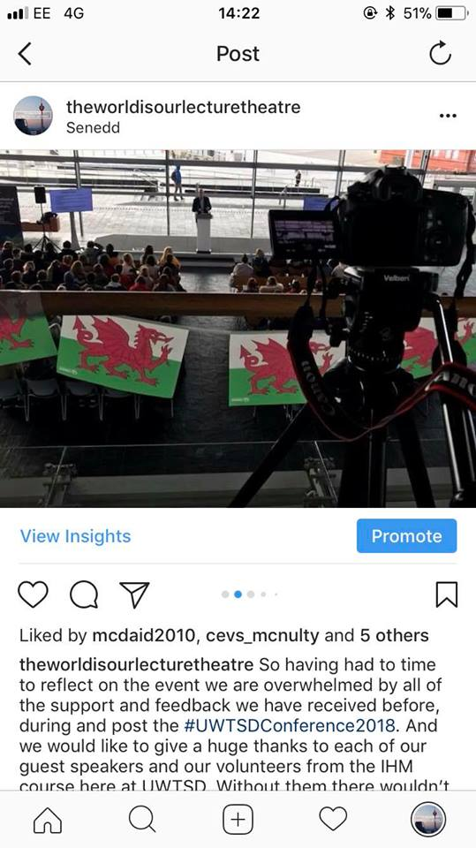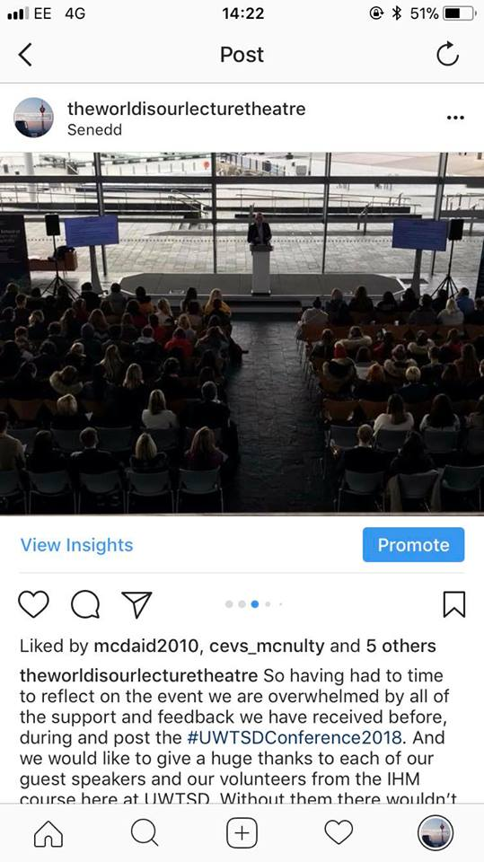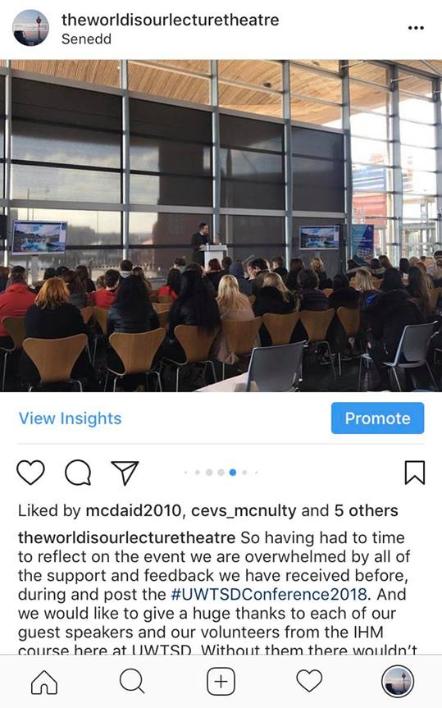
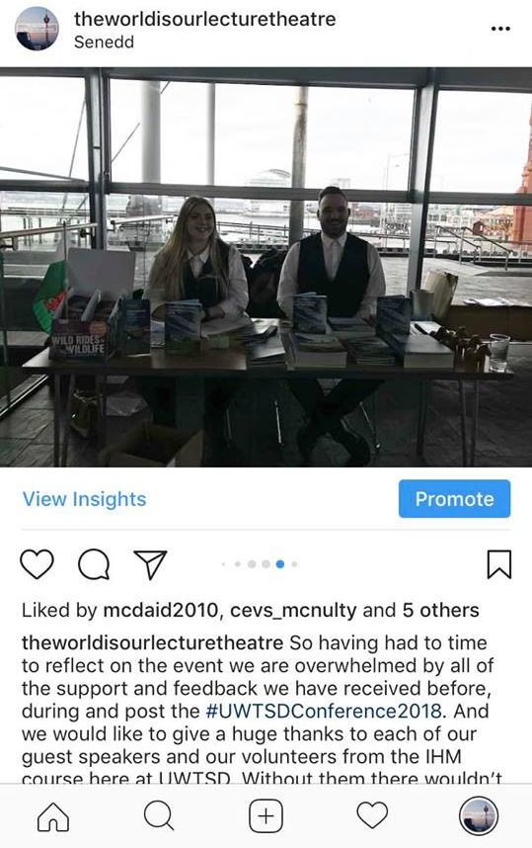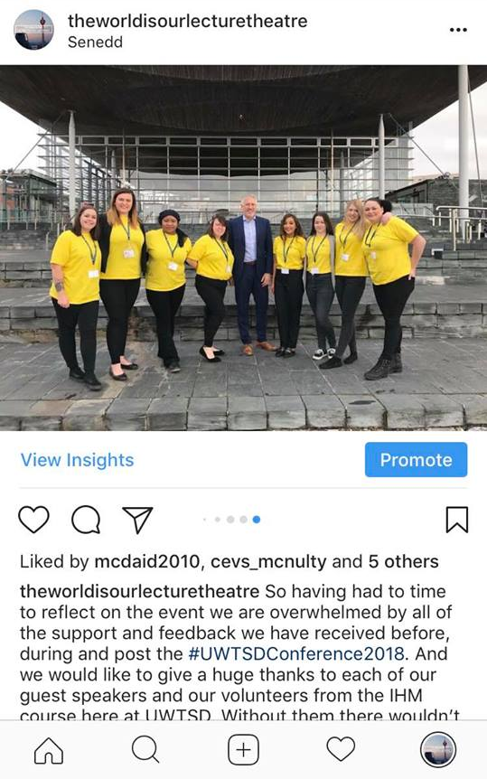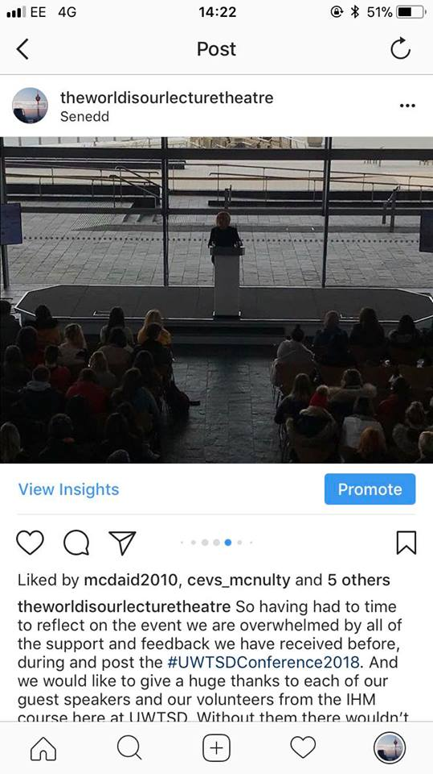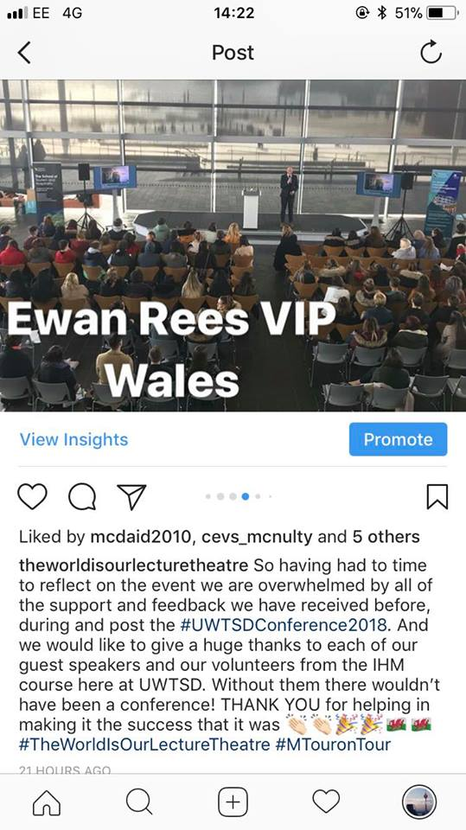

Post No.19

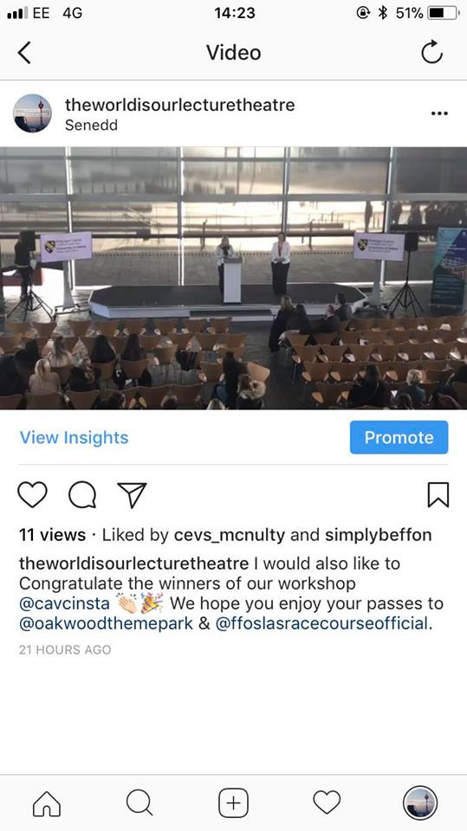

Story No.1

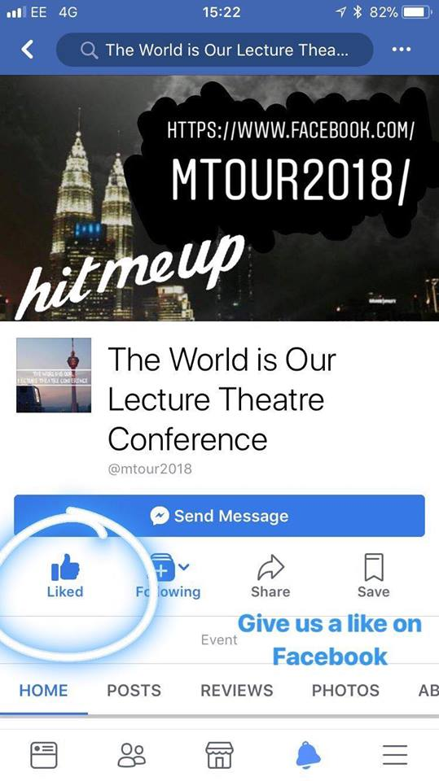

Story No.2

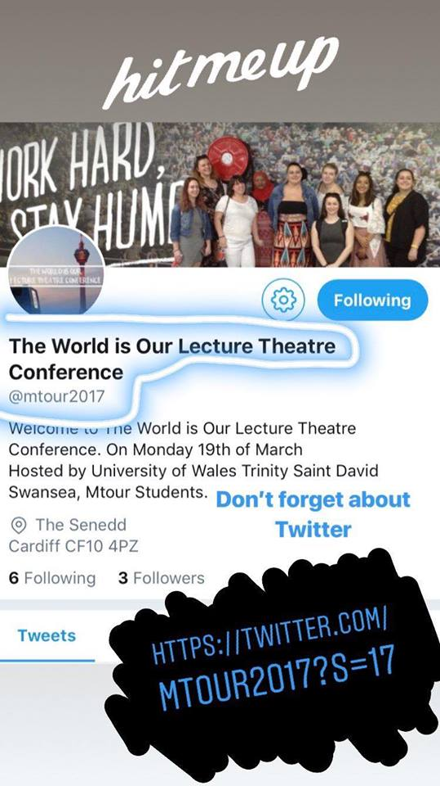
Stories 1 & 2 were the first stories I first created the Instagram account, encouraging followers to go follow our other social media platforms

Story No.3

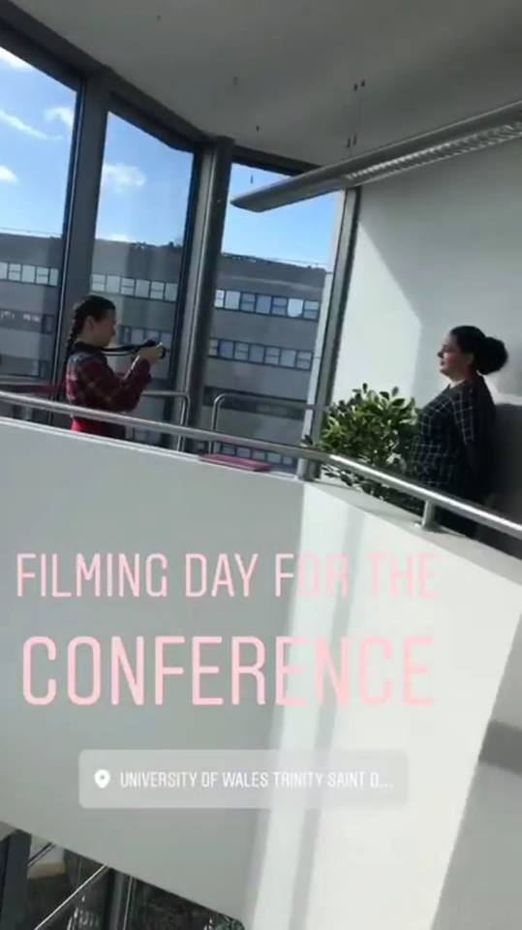
A boomerang video of the filming and the views from the university.

Story No.4

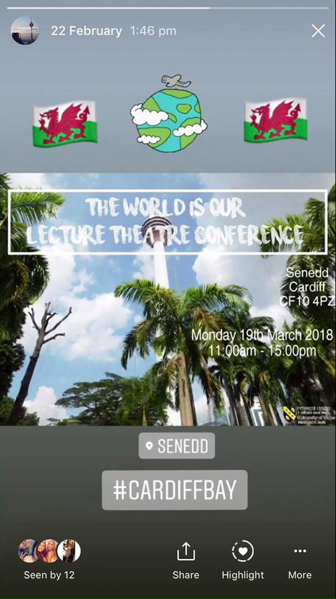
This post had a moving GIFF on it

Story No.5

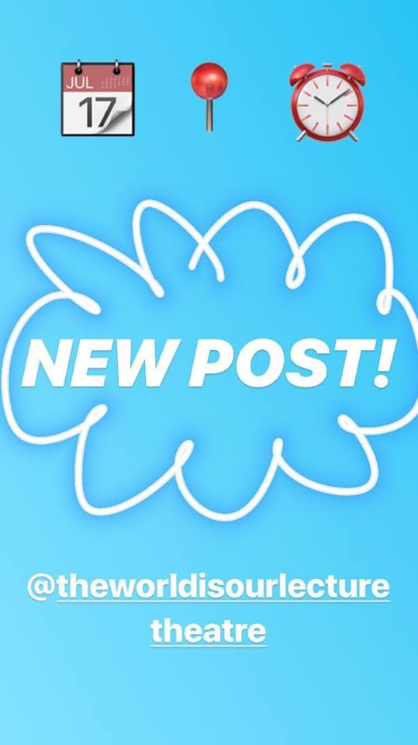

Post No. 6

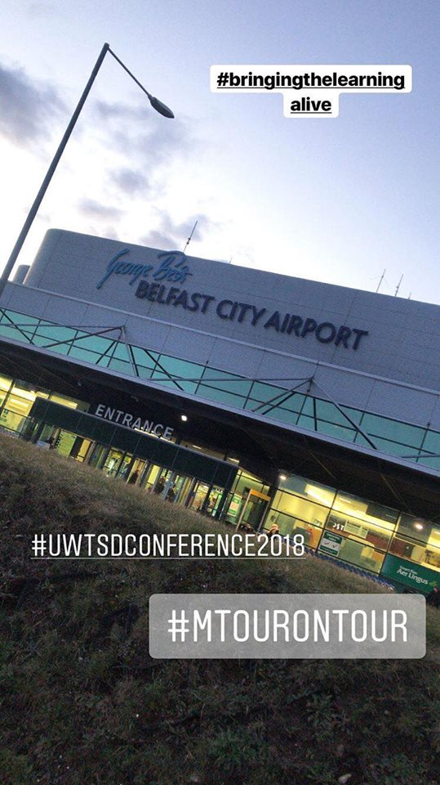

Story No.7

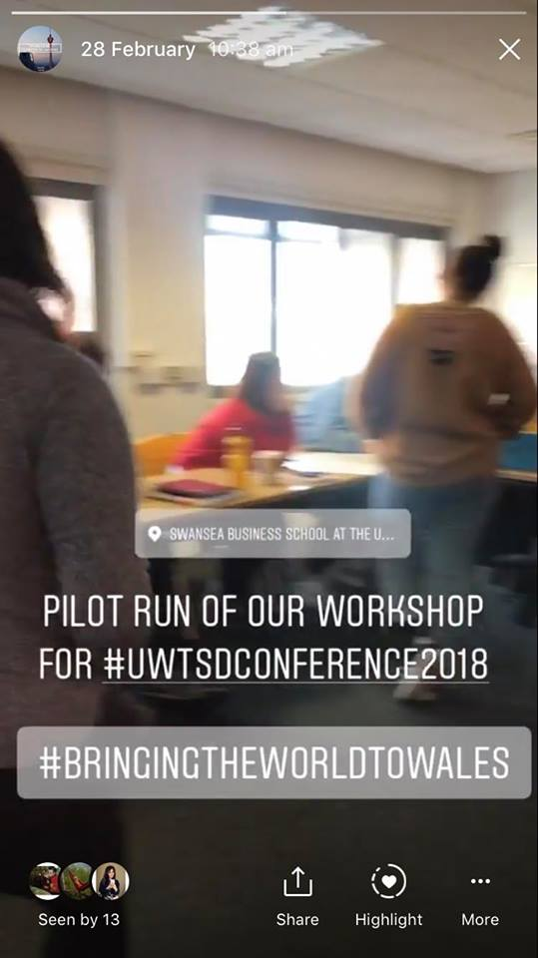
A boomerang video of the first pilot run of the workshop

Story No.8

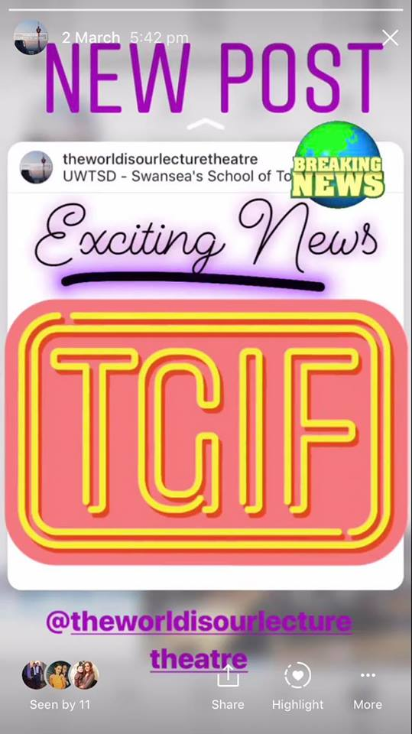

Story No.9

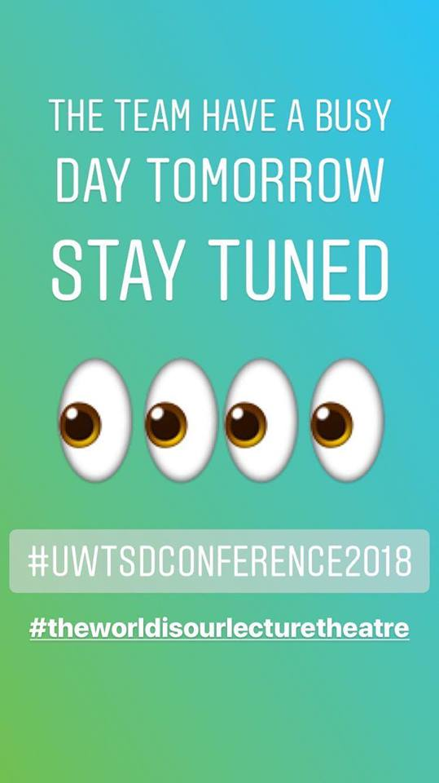

Story No.10

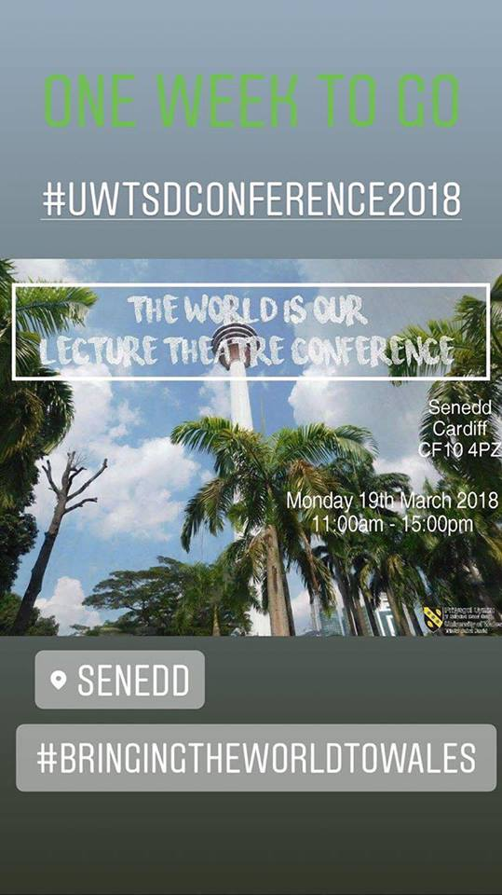

Story No.11

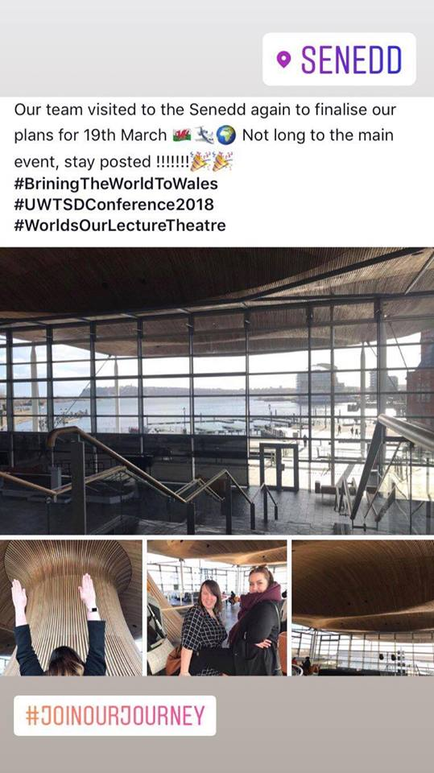

Story No. 12

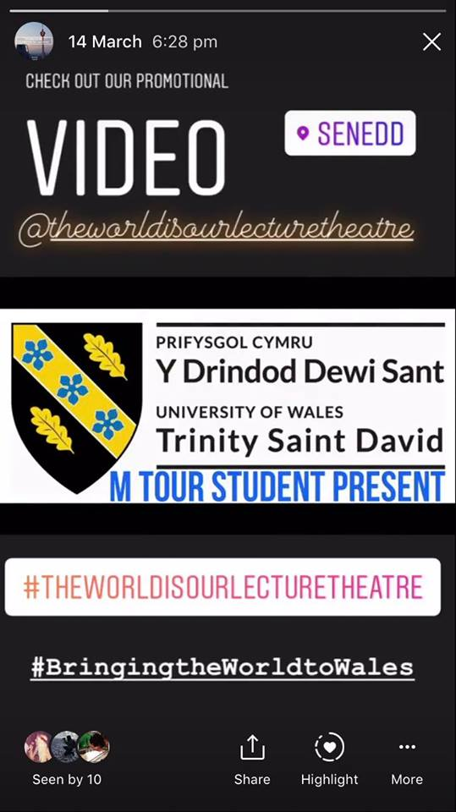
This is a short taster clip of the trailer video.

Story No. 15

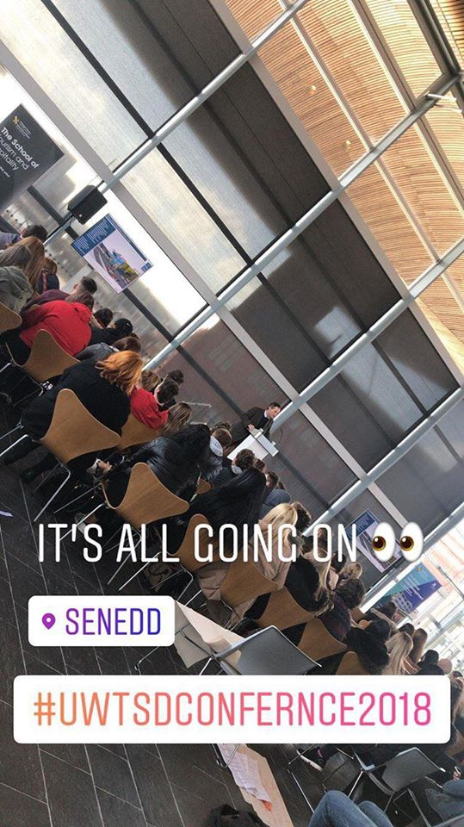

Story No. 16

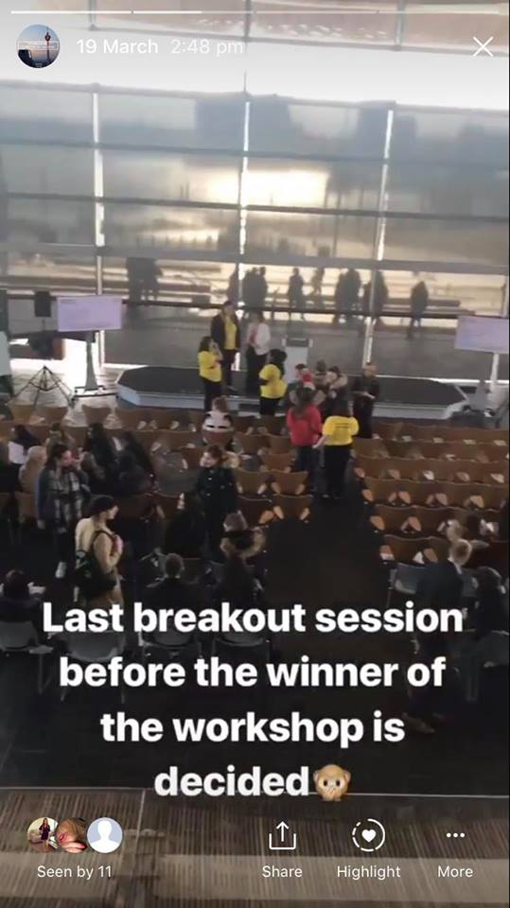
This story was a boomerang video of the colleges during the last breakout before having to present their itineraries to the judges

Story No.17
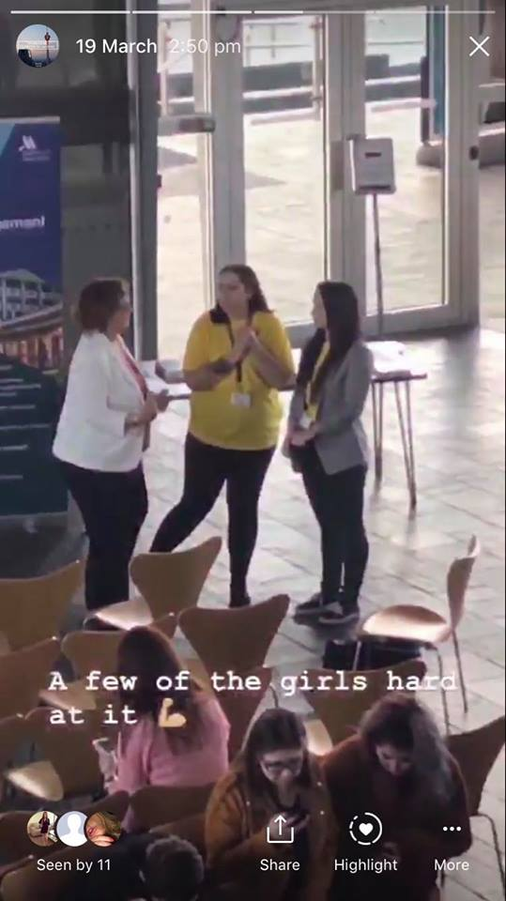
This is a ‘Beats Superzoom’ video.

Story No. 18
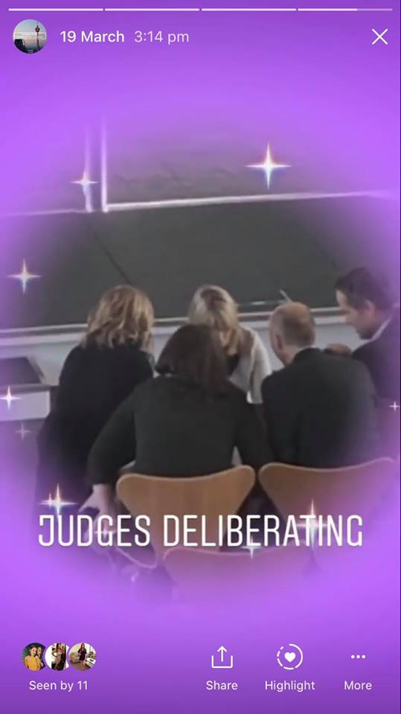
A ‘TV Show Superzoom’ video

Live Stories
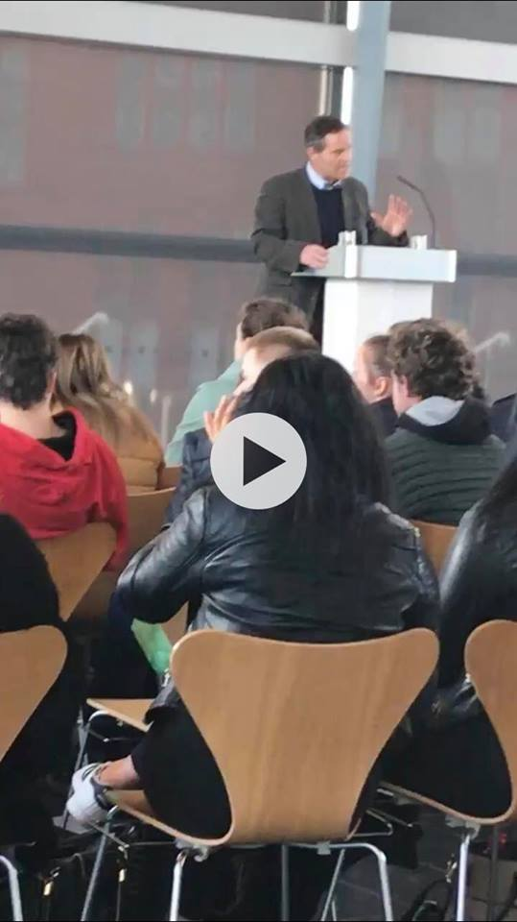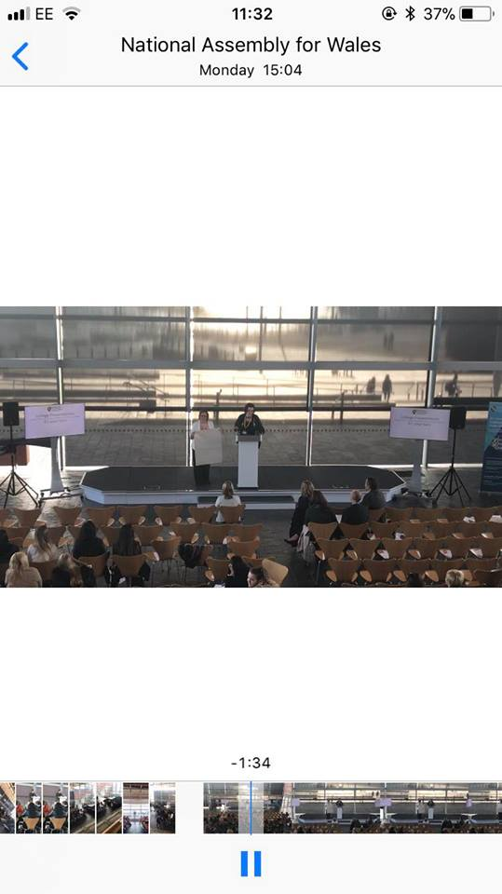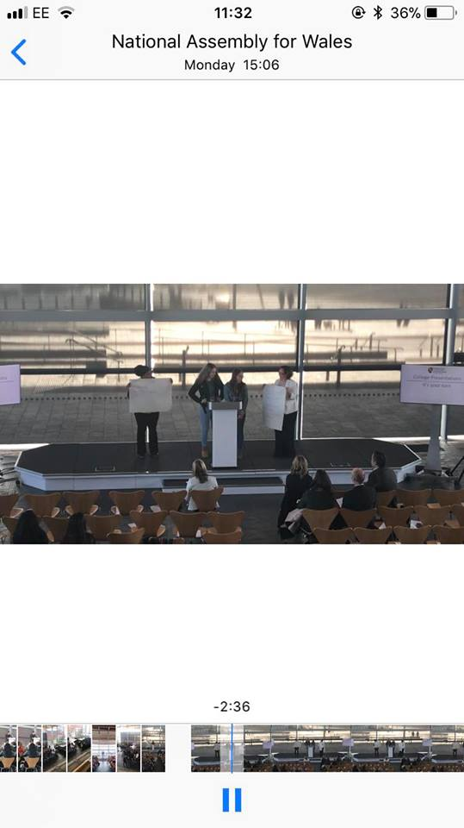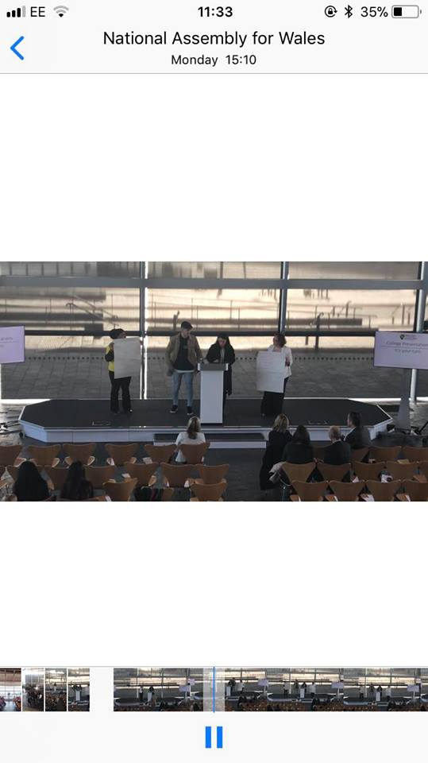
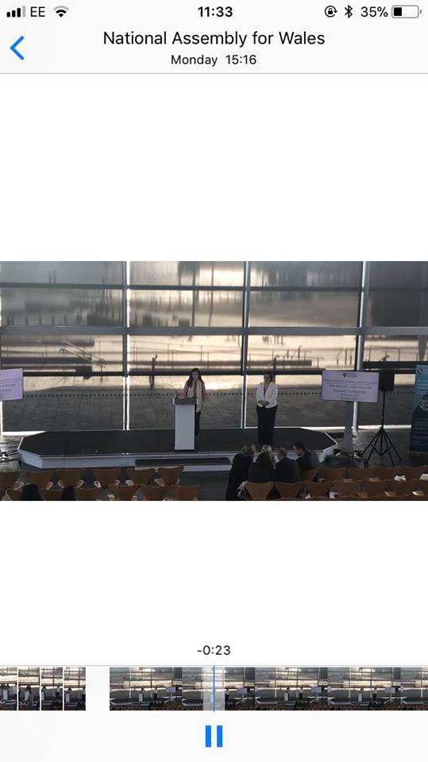
Live Stories
During the conference I recorded a number of live stories.
First was of Michael Davies during his presentation.
Then I recorded each of the colleges presenting their itineraries.
Followed by Sophie telling us about what opportunities the university has presented to her.
And finally I recorded head judge Maggie announce the winner of the workshop.

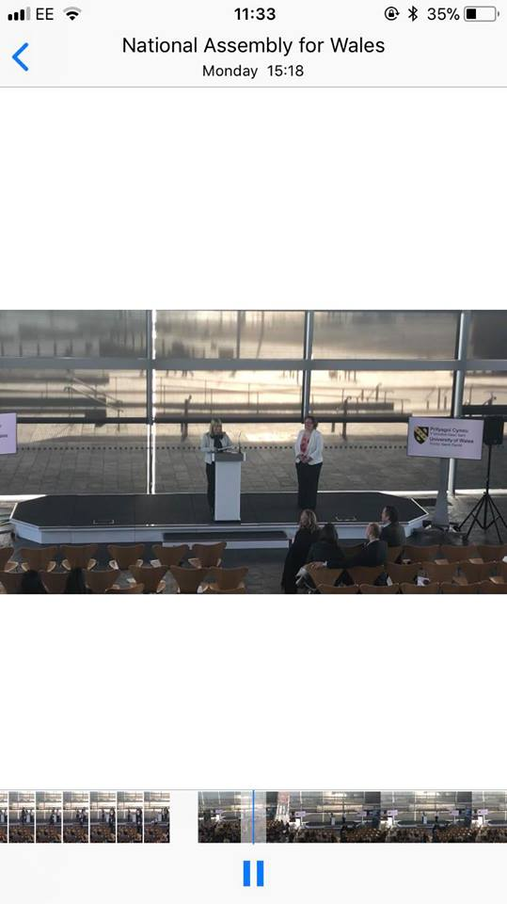

Mtour Email Account
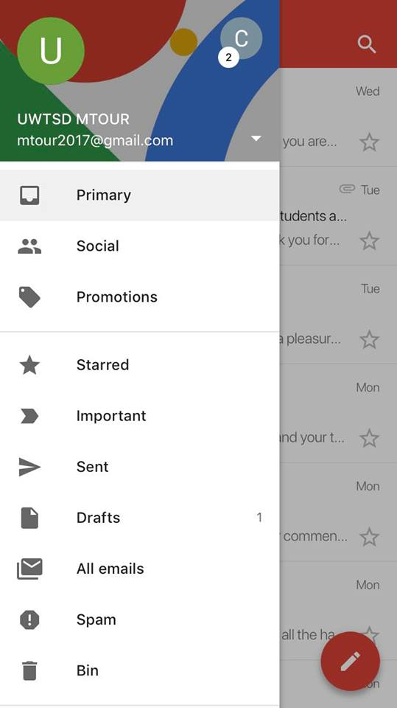
I created the MTour Gmail account because I thought it would a good idea to have a single email account for the conference and it also would look more professional when emailing colleges, guest speakers or whoever else needed to be contacted regarding the conference instead of getting a load of emails from maybe different email addresses.

The Website

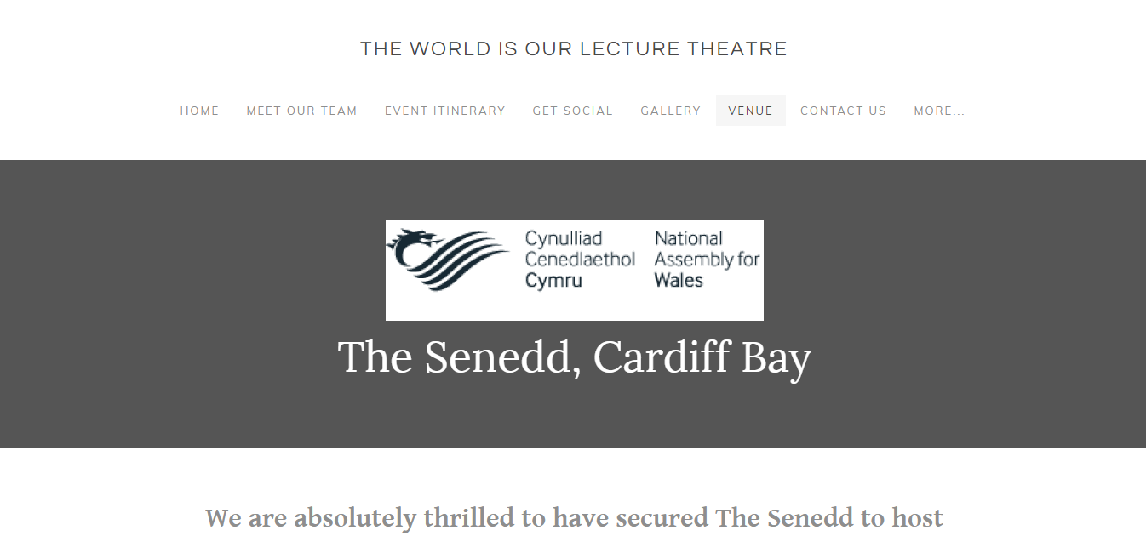
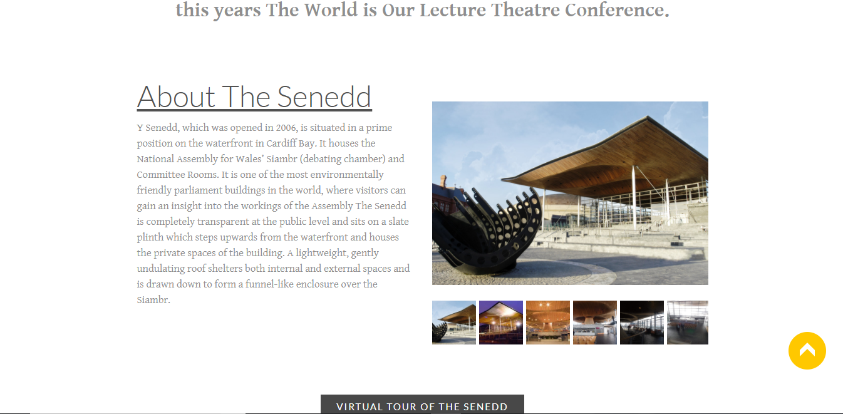

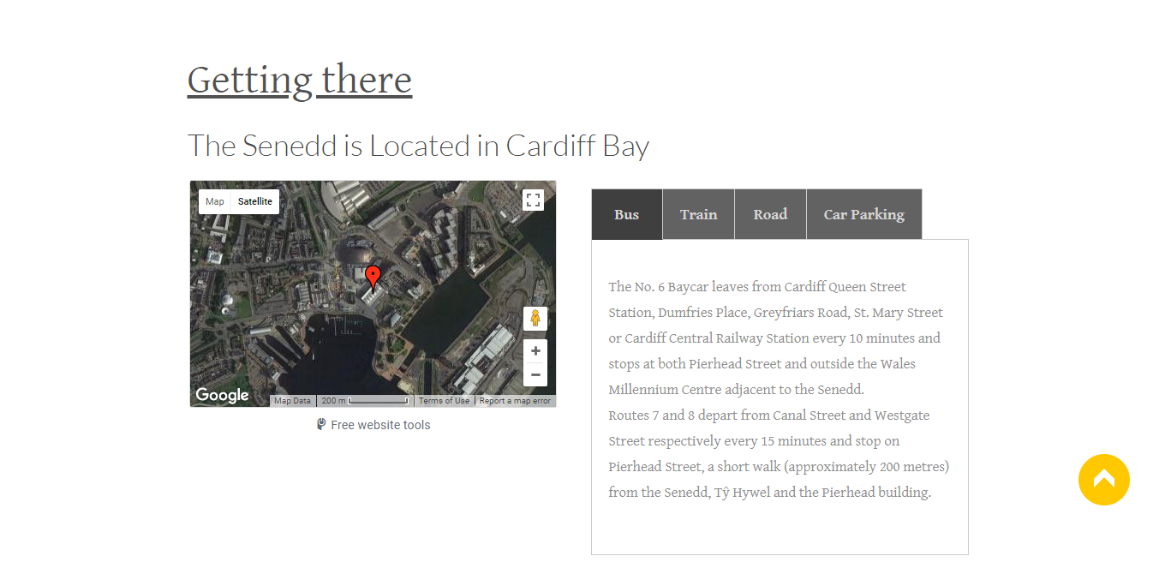

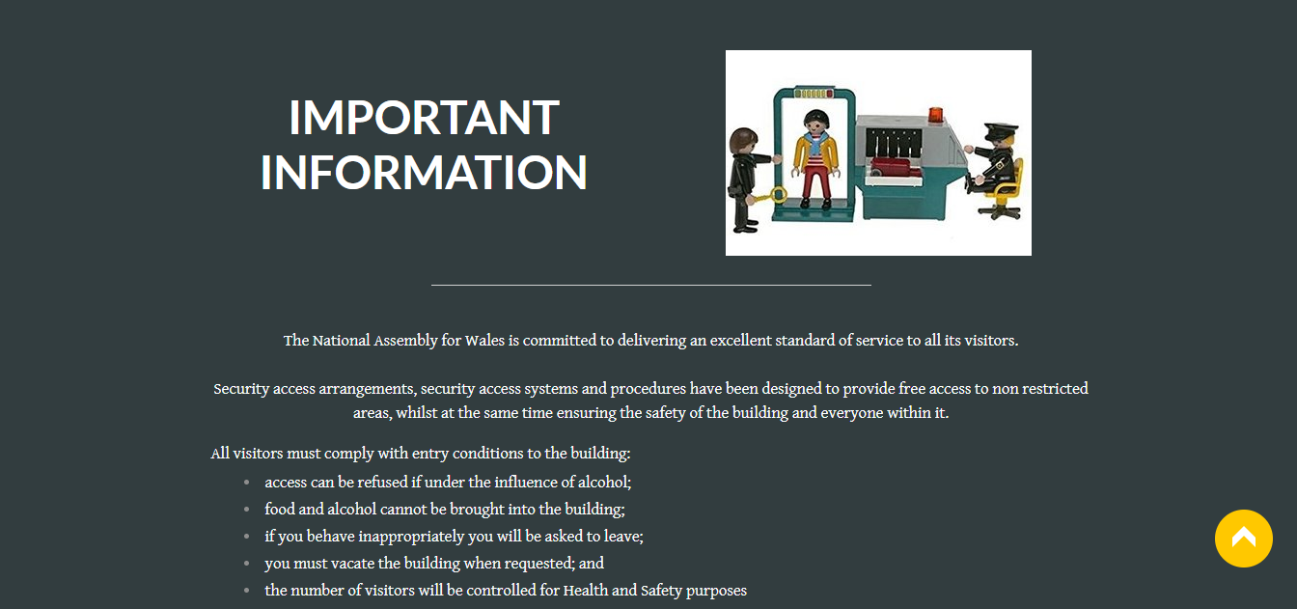
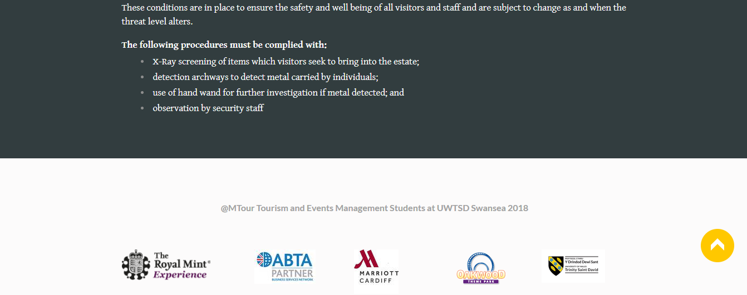

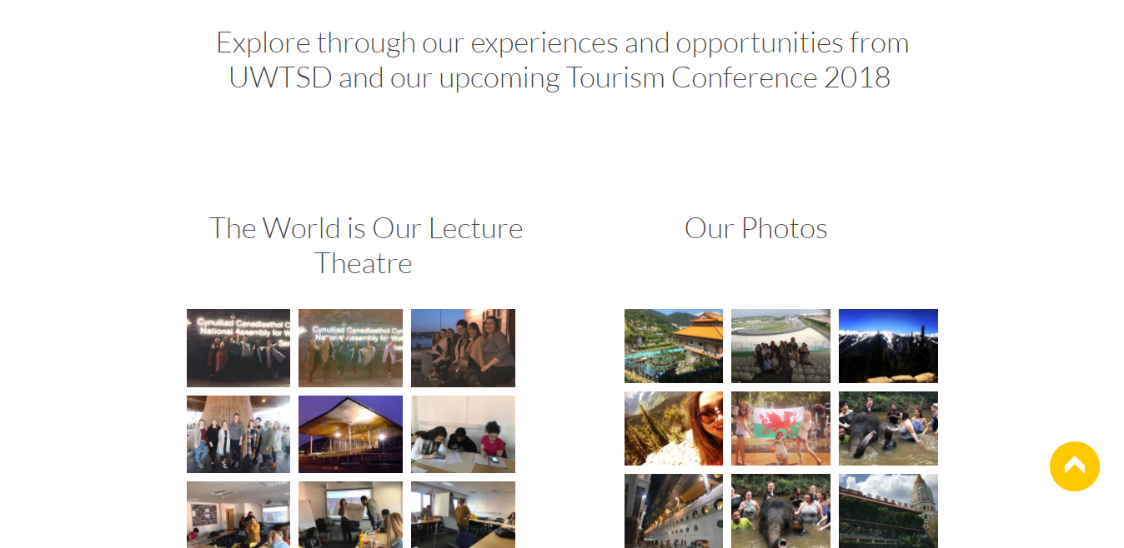
On the Website I created the ‘Venue’ page and also added pictures to the ‘Gallery’ and arranged the two different sections to be side by side.

Flight Cancelation and Delayed Emails



