Weeks 3 - 5: Decision Support tools for operational management (Part 2)

Introduction
We continue our investigation of decision support tools for operational management. Our focus in this second part is upon “associative methods” for the analysis of data relevant to forecasting. Time-series methods, investigated previously, generate forecasts based on one independent variable – time – and calculate rates of variation in the dependent variable from past data, through the present, into the future.
Operational managers, however, frequently need to base their forecasts on variations and rates of change in several variables, other than time. In a retail context, for example, a store manager may need to make forecasts of sales based on demand, price and ‘footfall’ (number of people entering the shop during particular periods). Such decisions need to be based on forecasts which “associate” changes in multiple variables – which is where “associative methods” of forecasting may be used.
These include:

- Use of “break-even” and “job sequencing” analysis to support optimal decisions about demand and resource allocation;
- Use of decision trees and decision tables to evaluate “expected monetary value (EMV)” of decision alternatives;
- Regression analysis (linear regression and multi-variate regression).
- Linear optimisation methods (simplex methods) – introduction to linear programming techniques for selecting optimal solutions to decision-making problems.

Associative methods:
Associative methods attempt to develop a mathematical relationship between one variable and the multiple factors that are associated with how it changes. [Note: as forecasters we are usually cautious about claims that specific variable factors “cause” changes in the variable of interest. “Causal relationships” are much harder to demonstrate than “associations” – correlations that demonstrate that quantities may vary together -- without inferring that one variation is causing the other variation. (Ask yourself why demonstrating cause and effect is more difficult than demonstrating an association? Discuss your thinking on the module discussion forum!)].
Sequencing and break-even analysis:
- A simple but key decision making problem: given X many customers to serve in various cities, how to find the route to deliver products to each of them in one tour?
- Minimise total distance traveled; minimise total travel time; minimise waiting time for each customer.
Routing problems are central to operational decision-making about logistics – whether they concern deliveries to customers or deliveries from depots to stores or deliveries from suppliers to manufacturers.
- A routing problem may have several variables – distance, time travelled, expected arrival time, workload on drivers (within regulatory limits), capacity of the vehicle.
- The general form of “routing problem”, historically, is discussed under the label “the travelling salesman (salesperson)” problem – and is known to be computationally hard for algorithms used even by the most modern software. Usually, calculated solutions have to rely upon a mixture of heuristics, common sense, experience and intelligent algorithms to provide optimal solutions.
The travelling salesman problem (TSP) asks the following question: Given a list of cities and the distances between each pair of cities, what is the shortest possible route that visits each city exactly once and returns to the original city?
The problem was first formulated in the 1930s and is one of the most intensively studied problems in optimisation. It is used as a benchmark for many optimisation methods. Even though the problem is computationally difficult, a large number of heuristics and exact methods are known, so that, in some instances, routes with tens of thousands of cities can be solved, though the computational time required to solve them may be extremely large.

We may address it more simply using the “vehicle routing problem (VRP)”, below.
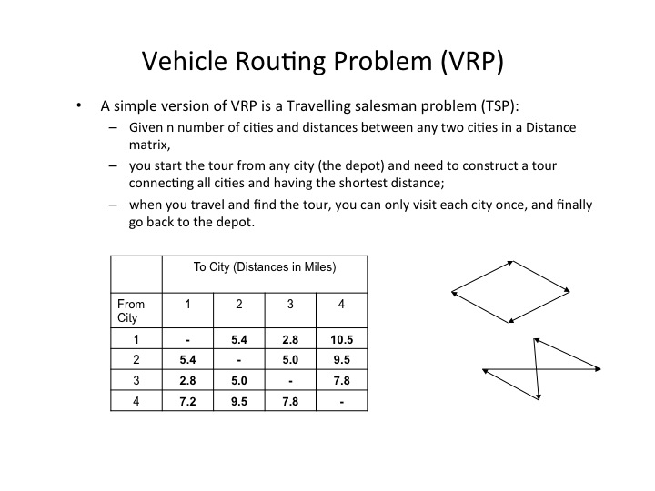
A model which (intuitively) appears to offer an optimal solution is known as the “greedy algorithm” (or “nearest neighbourhood”) approach:
- Only choose the next city closest to your current city.
- Repeat the process until all the cities have been visited.
- Often this provides a good solution, but will not always provide an optimal solution.
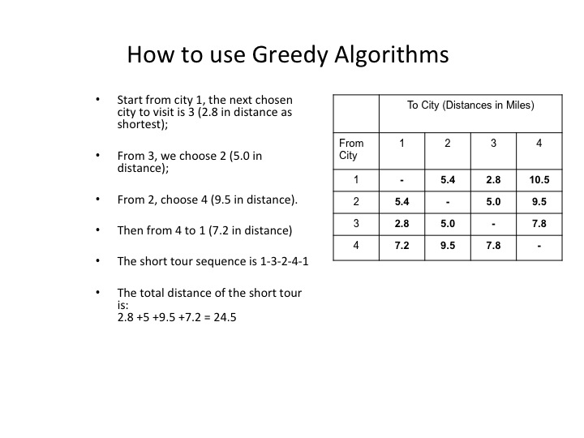

[By varying the distances in the example above, can you create a situation in which the “greedy algorithm” will not yield the shortest tour. Hint: In the following routing graph, the greedy algorithm recommends the route: A-B-C-D-B-A (116 miles (select nearest neighbour first)), yet the route A-D-C-B-A yields a shorter distance (97 miles) – Is there a shorter route?]:

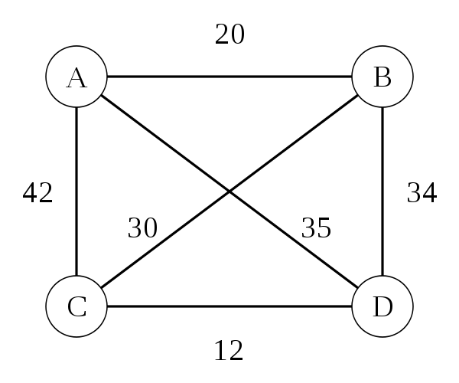

Such a small example may seem trivial to solve – at least in terms of the shortest distance. Frequently, however, logistics managers have to balance their decisions by taking into account variables other than “shortest distance” – for example:

- Find a best route to:
  - Not only minimise:
    - total distance traveled; total travel time; waiting time
  - But also minimise
    - number of vehicles required
      - since delivery quantities vary for different customers and different orders,
      - and the capacity varies for different vehicles
    - total distribution costs (least vehicle, least labour, least petrol, and so on).
There are many alternative solutions for TSP, other than “nearest neighbour” algorithms. For each method of solution listed below, a suitable reference is given.

Use of | Reference
Genetic algorithms: | Wall, M.W. (1996) – a thesis draft submitted to MIT, “A Genetic Algorithm for Resource Constrained Scheduling” – read Chapters 1 and 2, especially. (PDF download, Accessed: 29/07/2013)
Branch and bound search: | See ‘branch and bound’ and ‘branch and cut’ examples in Jaulin, L., Kieffer, M., Didrit, O., Walter, E., (2001). Applied Interval Analysis. Berlin: Springer. ISBN 1-85233-219-0
Ant Colony optimization: | Intriguing “naturalistic” approach to TSP problem solving: Dorigo, M., and L.M. Gambardella, L.M., (1997), Ant Colony System : A Cooperative Learning Approach to the Traveling Salesman Problem, IEEE Transactions on Evolutionary Computation, vol 1, No.1, pp. 53-66.
Other algorithms/heuristics: | See, for example (process control): Herrmann, J. W., (2006), Improving Production Scheduling, Maryland: PSU – PDF format (Accessed: 29/07/2013).

From the readings above, you will have noticed that these algorithms / heuristics are not simply for forecasting solutions to operational vehicle routing problems. They find applications also to many operational areas: job-scheduling in production, work-allocation scheduling, project planning and monitoring, process flow control, and many more business-related areas where resource-constrained operational decisions are required.

Job Scheduling:
Job scheduling (or job sequencing) involves specifying the order in which jobs (processes) should be carried out, in order to minimise cost, maximise production and make best use of available resources. Unlike time-series forecasting, it requires operational managers to balance multiple variables (e.g. current availability of staff, requisite skills, deadlines for completions, . . .), many of which fluctuate continually. Some typical “scheduling rules” deployed in making job sequencing decisions are:
  - FCFS: First come, first served.
  - SPT: Shortest processing time.
  - EDD: Earliest due date.
We can illustrate these in application to a simple job sequencing example:

Sequencing Example
Apply the three popular “sequencing rules” to the following five jobs:
Job | Work Time (processing days) | Due Date (days)
A | 6 | 8
B | 2 | 6
C | 8 | 18
D | 3 | 15
E | 9 | 23

The FCFS (first come, first served) sequence is A-B-C-D-E – leading to the following totals (in terms of job flow time and job lateness):

Job | Work Time (processing days) | Flow Time | Due Date (days) | Job Lateness
A | 6 | 6 | 8 | 0
B | 2 | 8 | 6 | 2
C | 8 | 16 | 18 | 0
D | 3 | 19 | 15 | 4
E | 9 | 28 | 23 | 5
Total | 28 | 77 |  | 11
1. In terms of forecasting using the average completion time and average job lateness, we can calculate as follows:
Average completion time = (Total Flow Time / No. of Jobs) = 77/5 = 15.4 days
Average no. of jobs in the system = (Total Flow Time / Total Job Work Time) = 77/28 = 2.75 jobs [This is used to identify capacity issues].
Average job lateness = (Total late days / No. of Jobs) = 11/5 = 2.2 days
2. The SPT (shortest processing time) sequence is B-D-A-C-E – leading to the following totals (in terms of job flow time and job lateness):
Job | Work Time (processing days) | Flow Time | Due Date (Days) | Job Lateness
B | 2 | 2 | 6 | 0
D | 3 | 5 | 15 | 0
A | 6 | 11 | 8 | 3
C | 8 | 19 | 18 | 1
E | 9 | 28 | 23 | 5
Total | 28 | 65 |  | 9
Computing average job completion time, jobs in system, and average lateness (as before) yields:
Average completion time = (Total Flow Time / No. of Jobs) = 65/5 = 13 days.
Average no. of jobs in the system = (Total Flow Time / Total Job Work Time) = 65/28 = 2.32 jobs.
Average job lateness = (Total late days / No. of Jobs) = 9/5 = 1.8 days.
3. Finally, using EDD (earliest due date), the sequence is B-A-D-C-E – leading to the following totals (in terms of job flow time and job lateness):
Job | Work Time (processing days) | Flow Time | Due Date (Days) | Job Lateness
B | 2 | 2 | 6 | 0
A | 6 | 8 | 8 | 0
D | 3 | 11 | 15 | 0
C | 8 | 19 | 18 | 1
E | 9 | 28 | 23 | 5
Total | 28 | 68 |  | 6

Average completion time = (Total Flow Time / No. of Jobs) = 68/5 = 13.6 days.
Average no. of jobs in the system = (Total Flow Time / Total Job Work Time) = 68/28 = 2.43 jobs.
Average job lateness = (Total late days / No, of Jobs) = 6/5 = 1.2 days.

Summary of Results:
Rule | Average Completion Time | Average Jobs in System | Average Lateness
FCFS | 15.4 | 2.75 | 2.2
SPT | 13.0 | 2.32 | 1.8
EDD | 13.6 | 2.43 | 1.2
[The Bold values indicate the lowest values for the schedule]

Interpreting the application of job sequencing “rules” (for this example) in terms of different operational criteria:

- SPT does well on minimising flow time and number of jobs in the system.
- But SPT moves long jobs to the end. This may result in dissatisfied customers.
- FCFS does not do especially well (or poorly) on any criterion but is perceived as fairer by customers.
- EDD minimises lateness.
- No one sequencing rule excels on all criteria, some trade-offs based on experience and local conditions may be needed.

In sum, although sequencing rules may assist in operational management decisions, job scheduling decisions will also have to take conditions in the local business context into account. This is explored further in this section’s Activities, below. [Ask yourself: for the example, above, if the priorities of the operational manager are changed (“fairness to customers” taking priority over “minimising lateness”), which sequencing rule would perform best?].

Decision Trees and Decision Tables:
We remain with operational decision-making – but move a little towards the medium- to longer-term decisions, at a more strategic planning level, to explain, illustrate and evaluate decision support tools to assist in reasoning under uncertainty – using probability measures to calculate optimal alternatives.
Historically, decision trees have been used extensively in both business decision-making and in computer science (software engineering). The comparable (though different) technique of “decision tables” develops out of the use of “truth tables” in logic, from the early 20th century onwards. A related form of decision tree analysis – popular in the 1980s and 1990s in business planning - is “Analytic Hierarchy Process (AHP)” modeling, which uses a “tree-like” approach to factoring out the weights to be associated with alternative choices.
Abstractly, a decision tree is a hierarchy of nodes in which the root (‘topmost’) node is the “decision” and subsequent nodes represent the alternative choices / probabilities of outcomes for each possible path through the “tree (hierarchy)”. In other words, a decision tree is made up of:
- Alternatives—a course of action or strategy that may be chosen by the decision maker;
- States of nature—an occurrence or a situation over which the decision maker has little or no control (measured by probability of outcome).
- (In some cases), marked by triangles, alternative final outcomes attached to the leaves (end points) of each decision tree path.
Typically, the following symbols are used in generating a decision tree for a decision-making problem:
Symbols used in a decision tree:
  - — decision node from which one of several alternatives may be selected.
  - — a state-of-nature node out of which one state of nature will occur.
  - Δ — a possible outcome.

Thus, a typical (simplistic) decision tree may look as follows:

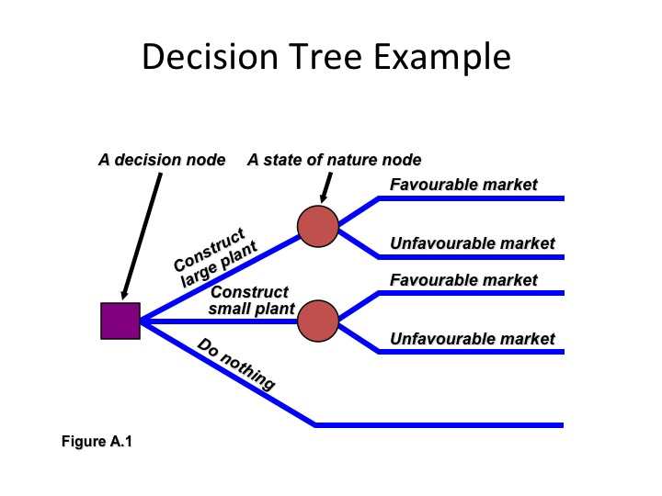

The decision tree analysis works by attaching (probability) weights to each edge between nodes, then using calculation of the most favourable outcome by multiplying probabilities.

For example:
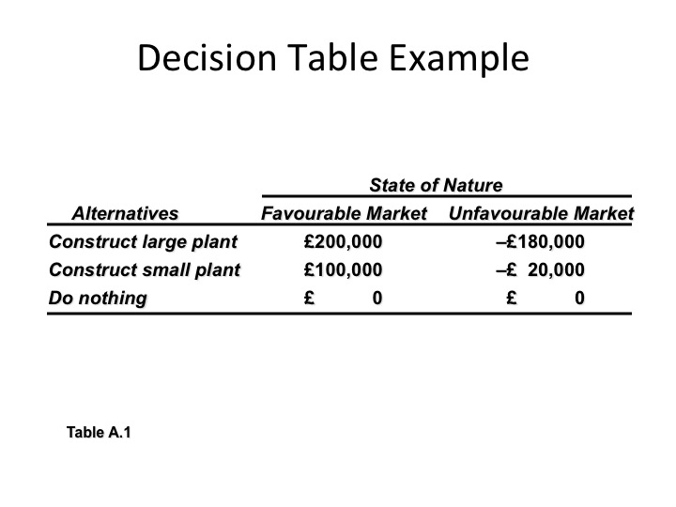
(Adapted from: Russell, R., Taylor, B.W., (2006))
Which is the optimal decision?
Largely, the best decision will depend upon the knowledge (information) decision-makers have at the time when the decision is made. This will tend to fall under one of the following sets of conditions:

- Decision-making under uncertainty:
  - Complete uncertainty as to which state of nature may occur.
- Decision-making under risk:
  - Several states of nature may occur.
  - Each has a probability of occurring.
- Decision-making under certainty:
  - State of nature is known.
Under condition 1, a decision maker may choose a (so-called) “Maximax” strategy:
  - Find the alternative that maximises the maximum outcome for every alternative.
  - Pick the outcome with the maximum number.
  - = Highest possible gain.
Under condition 2, a decision maker may choose the (so-called) “Maximin” strategy:
  - Find the alternative that maximises the minimum outcome for every alternative.
  - Pick the outcome with the minimum number.
  - = Least possible loss.
Under condition 3, a decision maker may choose the (so-called) “Equally Likely” strategy:
- Find the alternative with the highest average outcome.
- Pick the outcome with the maximum number.
- Assume each state of nature is equally likely to occur.
A decision table for the three conditions looks as follows:
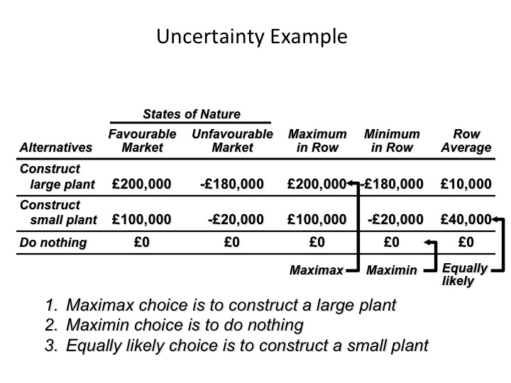

A way to break a deadlock amongst ‘maximax’, ‘minimax’ and ‘equally likely’ alternatives on a decision tree is to introduce an additional factor – for example, “expected monetary value (EMV)” to decide between maximising gain and minimising risk (loss):
In other words, consider “risk”:
- Each possible state of nature has an assumed probability.
- States of nature are mutually exclusive.
- Probabilities must sum to 1.
- Determine the expected monetary value (EMV) for each alternative.
For each “state of nature” (and associated probability), we associate an (estimated) monetary value (EMV). [Compare this with the notion of “expected utility” introduced by Bernoulli in Week 2].
For each alternative, we calculate the EMV of that option (assuming, perhaps improbably) an equal likelihood of the market being favourable or not):
EMV (Alternative_{i}) = | (Payoff of 1st state of nature) x (Probability of 1st state of nature)
+ | (Payoff of 2nd state of nature) x (Probability of 2nd state of nature)
+…+ | (Payoff of last state of nature) x (Probability of last state of nature)
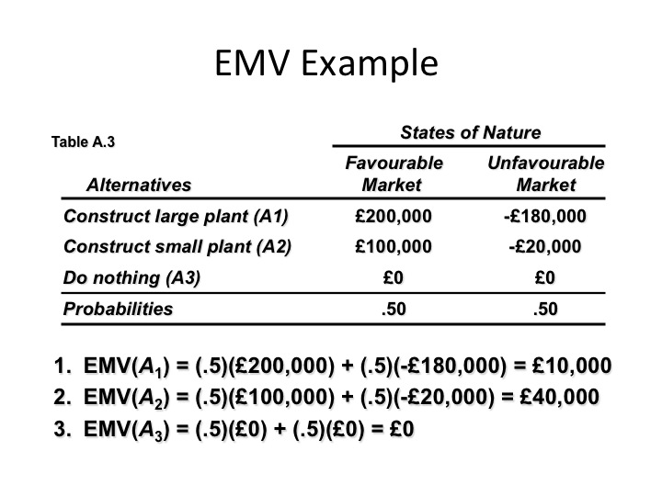
Given the 50::50 probabilities associated with each alternative, option EMV(A₂) [Construct small plant] becomes the (potentially) most profitable option. [Ask yourself: under what distribution of costs / benefits would (a) Do Nothing (A₃), or (b) Construct large plant (A₁) become a more profitable option?].

There is a complicating factor, however, for any business decision. Accurate prediction of EMV depends on the quality of information available to the decision-maker – especially in relation to the probabilities associated with each alternative. Thus, alongside EMV, is a second calculation which may affect the choice of alternatives from a decision tree. This second factor concerns the certainty with which outcomes may be predicted. Given perfect information about present and future conditions, then, of course, prediction of EMV is simply a matter of deduction from what is already known. This is rarely possible. So the accuracy of prediction of EMV (for a choice) depends also upon the (potential) value of the information about the past and current conditions available.
Expressed more simply: what would be the expected value (EMV) to the business if one had perfect information about the likely outcomes of a decision? (Of course, perfecting the information available, if it is even possible, comes at a cost; so what effect does this additional cost have upon the EMV of an alternative?)
The “Expected Value of Perfect Information (EVPI)” is represented by the difference between the expected payoff (outcome) under certainty and the expected payoff under risk – in other words:
EVPI = Expected Value under Uncertainty – Maximum EMV

Let us see how this factor changes our forecast:
Simply, in terms of EMV:
The best outcome for the state of nature “favourable market” is “build a large facility” with a payoff of £200,000. The best outcome for “unfavourable” is “do nothing” with a payoff of £0.
Now consider risk in uncertain business environments:
Expected value under certainty = (£200,000)(.50) + (£0)(.50) = £100,000

Compare this with the maximum EMV under uncertainty = £40,000, which is the expected outcome without perfect information. Thus:

EVPI = Expected Value under Uncertainty – Maximum EMV
£100,000 – £40,000 = £60,000

So, the most a company should expect to pay for better (risk-free) information (EVPI) is £60,000.

We have worked through this example to understand the basics of decision-tree analysis as a support tool for operational decision-making. You should work through a second example to appreciate the complexities of the decision support tool (Activity 1). This example is taken from “operations research” notes published by J.E. Beasley, Professor of Operational Research in the Department of Mathematical Sciences, Brunel University. It is supplemented by a reading with exercises from Scott Page’s online course at the University of Michigan.
Activity 1 (9 hours):
Readings on decision trees:
Exercise | Task
Decision Tree Example  J.E.Beasley  OR notes,  Mathematical Sciences  Brunel University. | Take time to work through the examples given – paying particular attention to the sequence of stages with which the decision tree is composed and the manner in which EMV is added to each path.  Make your own notes reflecting upon the utility (and the limitations) of this technique in the business context described. Share these notes on the module discussion forum. Can you find similar OR tasks to those described in your own business or organisational context?
Chapter 1 of his Online Course: “The Model Thinker, Making Sense of the Modern World”, (2012), [Accessed: 29/07/2013]:  © Scott E. Page, Professor of Complex Systems, Political Science, and Economics, The University of Michigan - Ann Arbor | Download the PDF file from Scott Page’s online course at the University of Michigan. Compare the approach explained with the stages and outcomes of the decision tree analysis in the Beasley reading, above. Which of the two readings provides greater clarity? Take the examples given and try to adapt them to operational decision-making in your own business / organisational context.  The Chapter ends with a long list of exercises of which you should try two or three to persuade yourself you understand the technique. Share these with others in your group to compare solutions and decisions,  You may wish to look at other chapters of Scott Page’s online course, but not all are relevant to the BDM module.  Share your opinions about what you have learned from these readings on the module discussion forum for these weeks’ activities.

Optimisation techniques: Regression Analysis
We touched upon regression analysis in our previous discussion (time series methods) of trend projection and the least squares method. At this point, it may be worth reviewing that material to refresh your understanding of the principles involved.
In ‘pure theory’ terms, regression analysis is a tool which enables decision-makers to evaluate (quantitatively) relationships between variable factors – typically two types of variable (linear regression):
- The dependent variable – the factor we wish to predict or explain;
- The independent variable – the factor used to explain or predict changes in the dependent variable.
The purpose of regression analysis is not to establish a causal connection (cause and effect) between the variables. It is, rather, to find evidence for a correlation on the basis of which to make a prediction, an estimate or to explain a trend. Its mathematical basis uses least square methods and standard deviations to provide estimates of the ‘best fit’ trend line for the data points that plot the values of the dependent and independent variable(s).
There is no better way to understand and appreciate the usefulness of regression analysis than to use it; practice how it may be applied to multiple business contexts in which “finding the best fit trend line” amongst variable data may contribute to estimating or predicting future changes.
The outcome of a regression analysis is a measure of the degree to which two (or more) variables are correlated – known as the “correlation coefficient” of the sample, normally symbolised as “r”.
- The sample correlation coefficient r is a measure of the strength of the linear relationship between two variables, based on sample observations:
  - It is unit free (a range value, not in the same units as the data).
  - It ranges between -1 and +1
  - The closer r is to -1, the stronger the negative linear relationship (inverse correlation)
  - The closer r is to +1, the stronger the positive linear relationship (positive correlation)
  - The closer r is to 0, the weaker the linear relationship
  - +1 or -1 are perfect correlations where all data points fall on a straight line
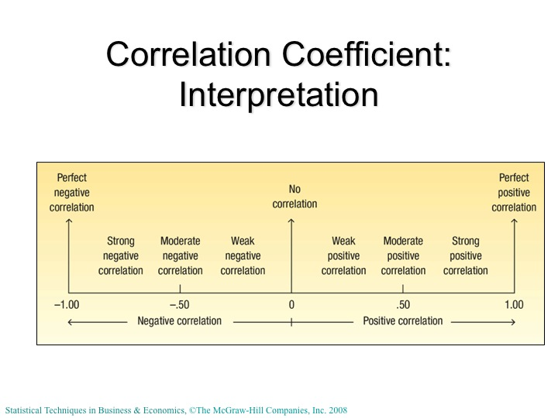

The values of r range from -1.00 to +1.00, with values within the interval representing the strength of the (positive or negative) correlation between the variables of interest. This defines the ‘line of best fit’ in a graphical representation of the trend line which best matches the dispersion of values in terms of their distance from the ‘best fit’. Some examples of possible r values and how these effect the slope and fit of the trend line are shown below:
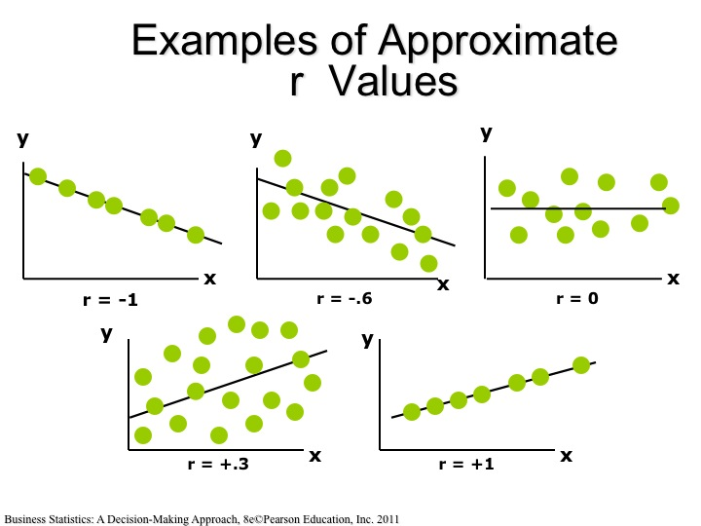
Values of r in the illustrations show that (a) a descending slope in the trend line indicates a negative (inverse) correlation between the dependent and independent variables; (b) a positive correlation is shown by an ascending slope; (c) no correlation is indicated by a trend line parallel with the x-axis (independent variable); (d) values of r equal to -1.00 or +1.00 indicate a prefect (negative or positive) correlation (all data points fall on the line).
Calculation of the regression involves three variables:
- The intercept = the value of the dependent variable y when x = 0 (the point from which the trend line starts.
- The slope = the amount by which the y-values increase or decrease (on average) for each change in the x-value.
- The deviation (or probability of error) = the measure of how far actual data points differ from the projected values (usually calculated using standard deviations).
Thus, the correlation coefficient is calculated using the following formula (the symbols x-bar, y-bar, represent the arithmetic means of the set of data values):
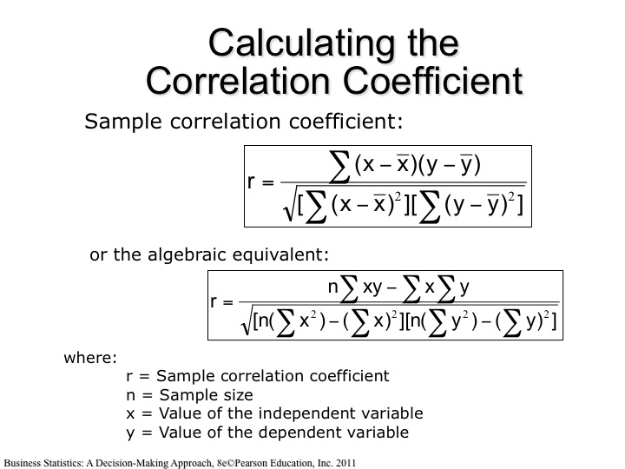
In other words, the correlation coefficient is the ratio r of the sum of the products of differences between each point (x, y) and the arithmetic mean (average) of all (x, y’s) divided by the standard deviations. (Compare the formula with that discussed earlier for the “least squares method”).
In order to represent the trend line of ‘best fit’ on a graph, we use the following simple regression equation for the estimated y-values – using the calculated intercept and slope (and, for some data sets, an estimate of random error in the dispersion):
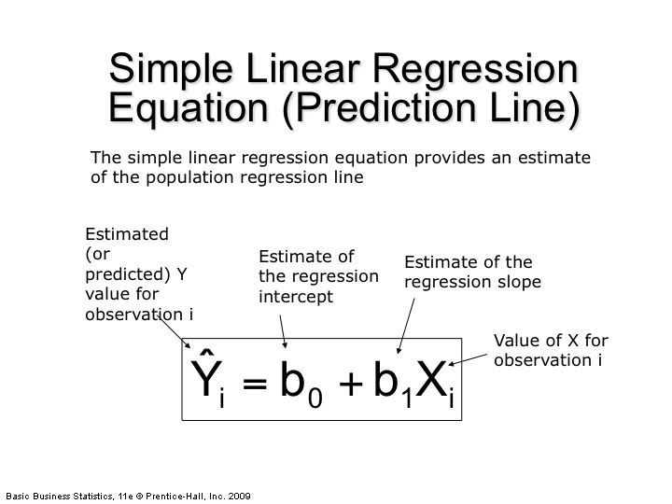
In this simpler version of the regression equation:
- b₀ is the estimated average value of Y when the value of X is zero (the intercept).
- b₁ is the estimated change in the average value of Y as a result of a one-unit change in X (the slope).
Example:
We can apply this simple regression equation to the following example from the estate agent house pricing sector:
- An estate agent wishes to examine the relationship between the selling price of a house and its size (measured in square feet) as one factor in determining a fair price for the property.
- A random sample of 10 houses is selected
  - Dependent variable (Y) = house price in £1000s
  - Independent variable (X) = size of house (in square feet).
The estate agent uses the following table of data values:
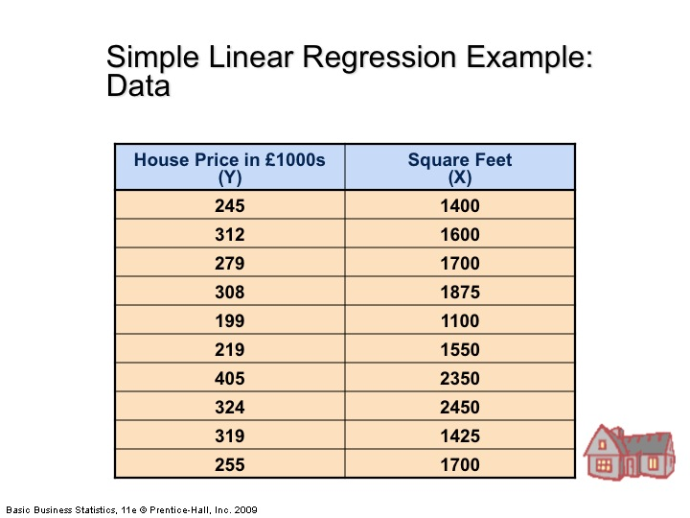
The purpose of the analysis is to project the relationship between house price (dependent variable) and size in square feet (independent variable). Obviously, many factors affect the price at which a property will sell: location, demand, condition of the property, availability of similar properties, and so on. The sole objective of this example, however, is to make a decision about the amount by which a house price will increase (presumably, it could decrease in certain circumstances) relative to the size of the house on the market.
The data can be modelled using the “Regression” function in Excel as follows:
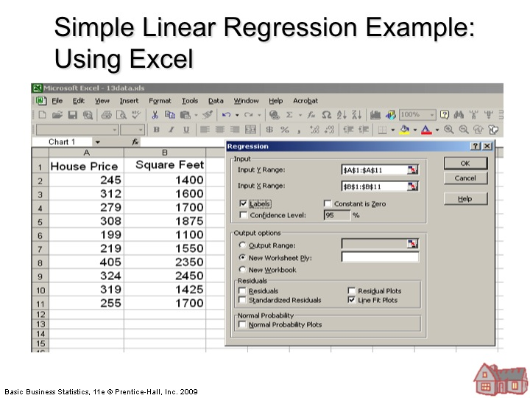
[Note: To use the “Regression” function in Excel, you will have to have downloaded and installed the statistical “Add-On” package available from MS Office™].
Using the Excel “Regression” function to plot a trend line for the relationship between house size and price yields the following:
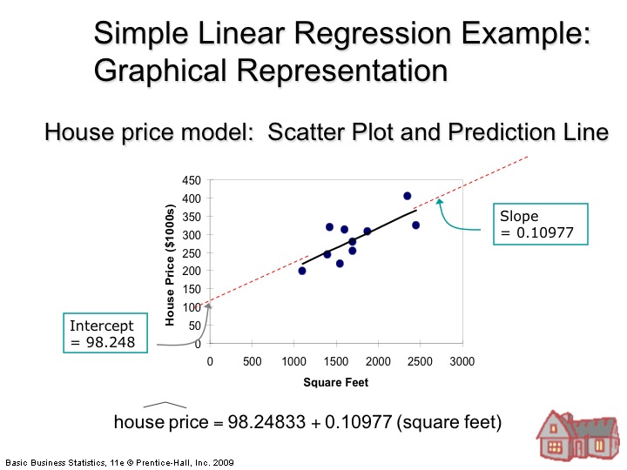
So the intercept is at (approx.) £98.25K when house size is at zero (which of course, has no practical meaning for this example, since a house cannot have a zero size (in sq. ft.)). The intercept is merely an indicator if the possible starting point of the trend. The slope is calculated to be about 0.11 * price per square foot.
The effect of the analysis is to predict (from this small sample) that:
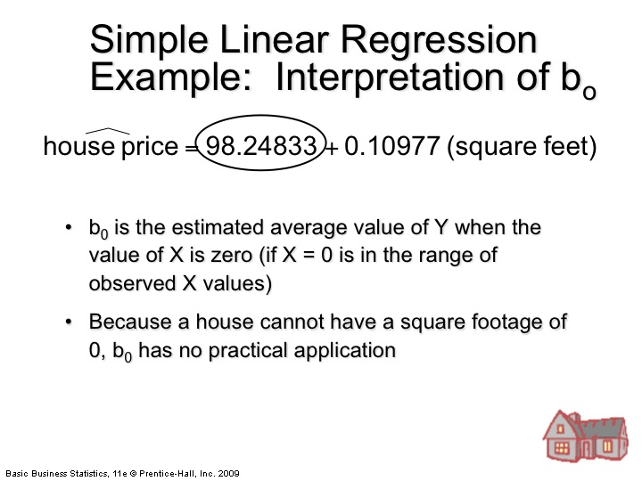

The intercept b₀ is circled, even though it has no practical meaning for this example. It serves only to indicate the start point of the trend line of interest.

Of more interest is the slope – correlating the increase in house size with increase in house price. For an estate agent, making an estimate of the likely selling price of a property, a linear correlation of house size with expected selling price forms one part of their advice to the seller as to a likely price at which a property may sell:

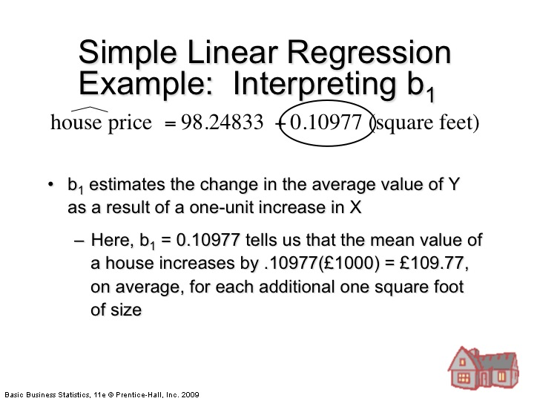

Since the regression analysis provides only an estimate, we can round these predicted values to predict that, on this model, a house price forecast will rise by about £110 per additional square foot of the property of interest.

If we apply the result of this analysis to a property coming on to the market that has a square foot area of 2,000 (sq.ft.), then we obtain the following:
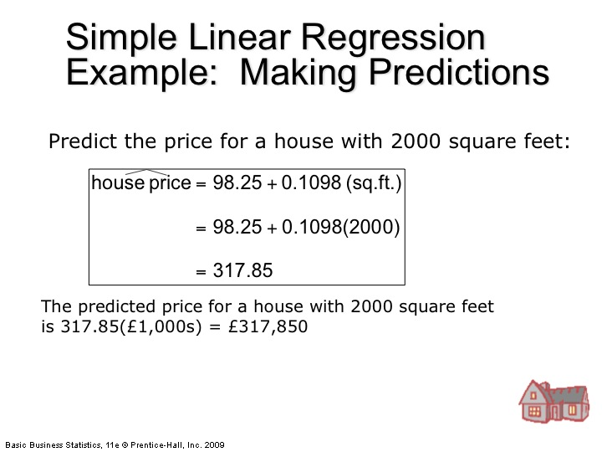

In reality (of course) an estate agent would decide upon a reasonable purchase price for a property based on considerably more data than a projection of values related only to square foot area. Nonetheless the example shows how a simple linear regression analysis may add to the decision support resources available to the agent to decide upon and to formulate a prediction as to a property’s likely worth.

Dealing with Error in Regression Analysis
The example above uses only the simple form of the regression equation (intercept and slope only). Greater confidence in predictions based on ‘the best fit line’ for sets of data values (X, Y) can be evaluated by considering:
- The assumptions that underlie the use of the simple form of the equation;
- The calculated degrees of error which may arise in large, highly dispersed data sets.
Assumptions
The simple form of linear regression relies upon the following assumptions about the distribution of data values (Y) for each value of X:
For each value of X, there is a group of Y values, and these
- Y values are normally distributed. The means of these normal distributions of Y values all lie on the straight line of regression.
- The standard deviations of these normal distributions are equal.
- The Y values are statistically independent. This means that in the selection of a sample, the Y values chosen for a particular X value do not depend on the Y values for any other X values.
If you are not familiar with the statistical concepts of normal distribution and standard deviation, then you should review their meaning and the methods of their calculation, here (SD) and here (ND).
Graphically we can represent these assumptions about the distribution of Y values as follows:
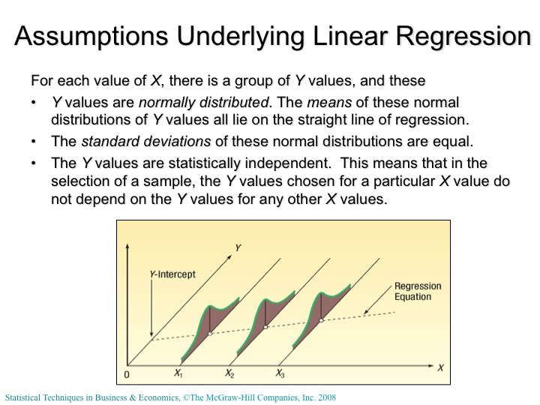
Considering the (possibly random) errors (or variations attributable to other factors) in matching the intercept and slope to a sample means taking possible errors or distribution and deviation into account. This introduces additional factors into the regression calculation.
To understand how we calculate the degree of error associated with a regression analysis, we add in an additional factor into the simple regression equation as shown:
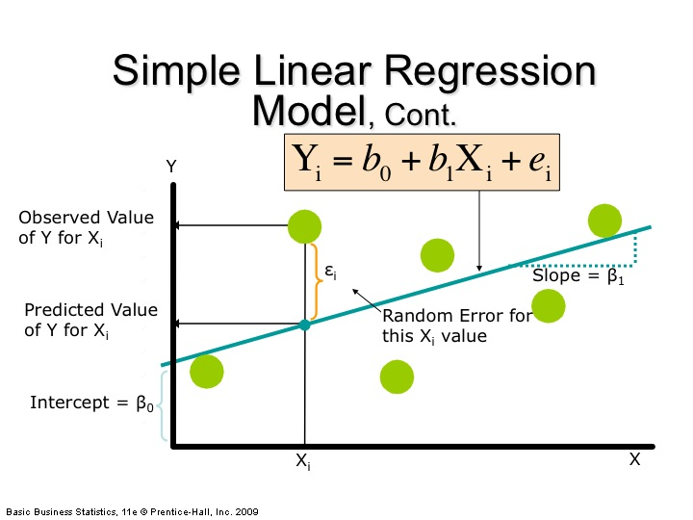

The random error term added in above corresponds to the likelihood that the deviation of Y values, for specific X values is accountable to random variation, rather than a failing of the linear regression to find the ‘best fit line’. We can think of the “error term” as represented in the following way (below):
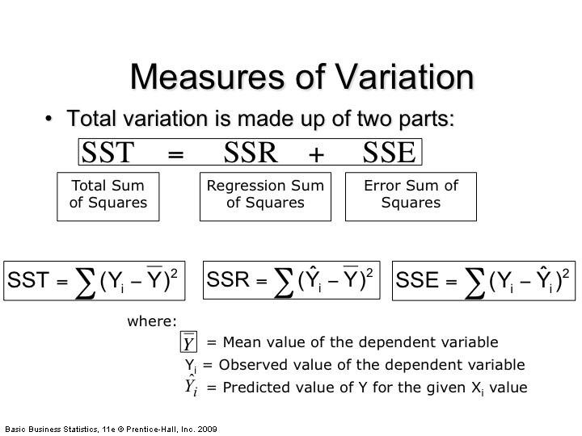
It is an activity (exercise 2) for this part of the module that you identify and define how these measures of variance may affect the reliability of a regression analysis forecast of a future trend line. They are summarised in the following two graphics:
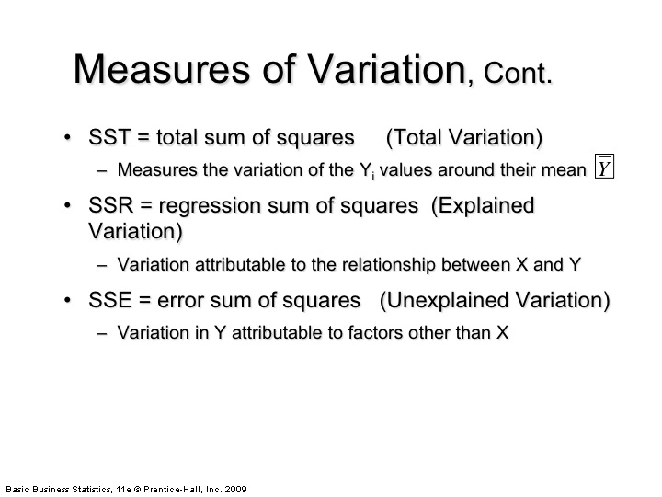
SST (total variation) represents the sum of the variances calculated from the “explained variation” and the “unexplained variation” (attributable to factors other than the X):
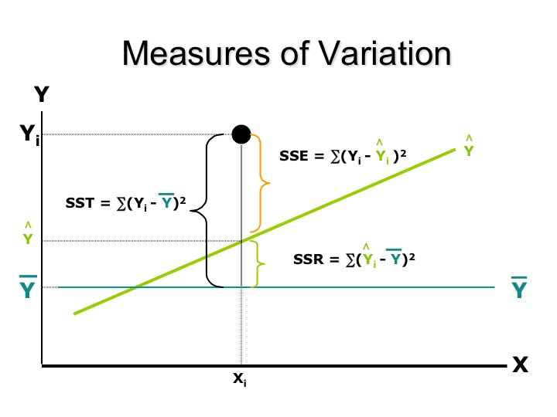

Activity 2 (6 hours):
Estimating the reliability of a linear regression:
Exercise 2 | Task
Using SSR, SSE and SST to evaluate the reliability of a linear regression analysis. | For the example of simple linear regression worked  through above, calculate the SST (by summing the  regression sum of squares (SSR) and the error sum of squares (SSE)).  Post your solution to at least one other participant in this module and request to see their solution.  Evaluate the extent to which you believe this measure of variance casts doubt upon the originally projected ‘line  of best fit’ as a predictor for the relationship between  property price and house area (in square feet).
Exercise 3:  Try it Yourself! | Consider the sample problems of least squares regression  analysis given here,  In each case, try to work out a solution yourself, before  you check your answers against the solutions given  on the web site.
Summary:
In these sessions we have extended the range of decision support techniques for operational decision-making based on (largely) quantitative data.

These exercises are not marked – but you should post your solutions (or any questions about how to reach a solution) to the module discussion forum.

Coming Next (Weeks 6 - 7):
- Linear optimisation methods (simplex methods) – introduction to linear programming techniques for selecting optimal solutions to decision-making problems.
- Overview of decision support systems; consideration of corporate governance and the ethics of responsible business decision-making.

Summary of Activities (3 – 5)
Guidance:
These activities recognise that you will better understand the techniques for forecasting based on associative methods by seeking to apply them in (semi-) realistic business contexts. Keep your focus upon what the core ideas of ‘linear trend’ projections are showing you about the difficulties any operational manager may face in seeking to forecast future relationships. Consider carefully which of the techniques provide a better basis for predicting future demand (or resource allocation) with due regard for the limitations and risks associated with ‘associative’ (probabilistic) approaches (e.g. decision trees). These exercises are not marked, so share your results and comments with other module participants. Often, there will not be a single “best answer” – so interpretation of the results of your calculations is central to understanding the benefits and limitations of the methods adopted.
Purpose:
The aim of these activities is to sharpen your skills in using standard forecasting techniques in operational management contexts – extending this to enable critical evaluation of the accuracy and reliability of these techniques. The aim of the second Activity is to invite you to find applications of these techniques in your own business or organisational context – and to share these with other participants in the BDM module.

Summary of Activities
Activity 1 (9 hours):
Readings on decision trees:
Activity 2 (6 hours):
Estimating the reliability of a linear regression:

References used:
Beasley, J. E., “OR Notes”, published online at http://people.brunel.ac.uk/~mastjjb/jeb/or/decmore.html (Accessed: 29/07/2013)
Galton, F. (1883, repr. 1989). "Kinship and Correlation (reprinted 1989)". Statistical Science (Institute of Mathematical Statistics) 4 (2): 80–86.
Render, B., Heizer, J., (2006), Operations Management, 8th edition, Prentice Hall
Saaty, T., (and others, 2008) – cited in Wikipedia at: Analytic Hierarchy Process models, http://en.wikipedia.org/wiki/Analytic_hierarchy_process , Accessed: 13/05/2013.
Schrijver, A., (2005), "On the history of combinatorial optimization (until 1960)”, Handbook of Discrete Optimization (K. Aardal, G.L. Nemhauser, R. Weismantel, eds.), Elsevier, Amsterdam, pp. 1–68
Von Wright, G. H., (1955). "Ludwig Wittgenstein, A Biographical Sketch". The Philosophical Review, 64, (4): 527–545 (p. 532, note 9).

See, for example, the quote from Karl Menger (1931): “We denote by messenger problem (since in practice this question should be solved by each postman, anyway also by many travelers) the task to find, for ﬁnitely many points whose pairwise distances are known, the shortest route connecting the points. Of course, this problem is solvable by finitely many trials. Rules which would push the number of trials below the number of permutations of the given points, are not known. The rule that one first should go from the starting point to the closest point, then to the point closest to this, etc., in general does not yield the shortest route.” in Alexander Schrijver's (2005) paper "On the history of combinatorial optimization (until 1960)”, Handbook of Discrete Optimization (K. Aardal, G.L. Nemhauser, R. Weismantel, eds.), Elsevier, Amsterdam, pp. 1–68
Further examples of sequencing rules may be found in: Barry Render and Jay Heizer (2006), Operations Management, 8th edition, Prentice Hall
Credited to Wittgenstein, L., (1914), - See Georg Henrik von Wright (1955). "Ludwig Wittgenstein, A Biographical Sketch". The Philosophical Review, 64, (4): 527–545 (p. 532, note 9).
For AHP it is well worth looking at the early work of Saaty and others – cited in Wikipedia at: Analytic Hierarchy Process models, http://en.wikipedia.org/wiki/Analytic_hierarchy_process , Accessed: 13/05/2013.
©J.E. Beasley, “OR Notes”, published online at http://people.brunel.ac.uk/~mastjjb/jeb/or/decmore.html (Accessed: 29/07/2013)
If you are puzzled as to why the technique is called “regression” analysis, then don’t be; it derives from history (so the story goes): the 19th century biologist Francis Galton developed and extended the technique to explain how inherited characteristics (e.g. peoples’ heights) over generations tend to ‘regress’ towards the normal (or average) height. (See: Galton, F. (1883, repr. 1989). "Kinship and Correlation (reprinted 1989)". Statistical Science (Institute of Mathematical Statistics) 4 (2): 80–86.

