Objectives:  What do I want to learn or become? | Actions:  What do I have to do to get there? | Recourses:  What resources will I need/access? | Criteria:  How will I know I have achieved this? | Outcome:  What would I like the outcome to be and how will I use it? | Target date:  ECEY4009  2308244  511 words
To become an ELSA  (Emotional Learning Support Assistant) | Research into an ELSA role and what courses there are in which I can enrol. | Pen, paper  computer /laptop, internet, books. | I will have a certificate stating that I am an Elsa and that I now have all the knowledge to start my role as an ELSA. | I would like to be fully qualified as and ELSA to be able to help and support the children that need a little more attention and that are struggling. I will help them with anything that may be worrying them and help them deal and understand their feelings. As well as giving them a safe place to talk and open up. | 18/7/2025
First aid | Attend first aid courses. | Paper and pen | A certificate stating that I am a fully qualified first aider. | I would like to be able to help in any way possible regarding first aid and be confident in doing so. | 10/3/2024
Real P. E | Take part in the courses that are on offer. | Computer/laptop, websites, I will need a log in password of the websites. Sports equipment. | I will have learned all the different criteria for Real. P.E and ill have all the information and posters to conduct Real P.E classes. | To help the children Learn basic P. E through fun and engaging activities also make sure that every child feels involved and not just only encourage them to take part but also to enjoy and interact with their friends and hopefully give them different opportunities to express themselves. To give the children chance to shine no matter how big or small. | 11/12/2023
BA (honours) in early years childcare | Enrolee in the course in university and attend lectures and complete different various assignments and essays. | Laptop, Paper and pen, student email, Module, Teams, Outlook, books, and websites. To be in a childcare setting. | I will receive a certificate as well as a better understand in the early year’s childcare. | I would like the outcome of this to make me into a more confident person working in early years as well as to have a better understanding and hopefully in the future become a teacher. To help the children become the best they can be and give them the best learning outcomes, experiences and skills for their future. | 23/7/2025
ADHD/Autism awareness? | Several types of courses e.g attention autism, visiting LRB | Laptop/computer, pen, paper, notepad. | By attending various courses I will be able to develop my knowledge and understanding further and put this to practise. | To be able to help those children that have ALN needs like ADHD and ASD and be able to understand them and give them opportunities like other children and be there to support them. | 15/5/24
My personal development plan (PDP)
Refection and Reflective practise  To begin with Reflection is thinking consciously about the ramifications of one’s behaviour and thought pattens. Furthermore, helps you to analyse and acknowledge positive experiences and better determine ways you can improve one’s practice. Secondly, reflective practise is considered a modern term it come from an ancient method of self-improvement. Jhon Dewey one of the first philosopher and educators to address the issue it goes back as far as the late 1890s. The meaning of reflective practice is thinking and reflecting on what you do. It is the capability to reflect on your actions and develop more of an understanding into them. Reflective practice requires learning by experience. It also includes understanding your own intentions, values and views on what has happened. As well as understanding it requires questioning what you did? what happened? What would you do differently? How did it make you feel? What was your role in that situation? Reflective practice is trail and error, what worked and what did not. Once you get familiarised with using reflective practice it will become natural to you. You will also find it practical to use in all aspects of life. Reflective Practice is a continuous prosses of learning. It is a part of being Human. | Importance of reflective practice in the early years.  ECEY4009 2308244 1120 words  In the early years reflective practice is important due to the knowledge that can help you in situations that may occur. Also helps you to revaluate on what can be done better nest time. Reflective practice in the early years comes with experience and learning from other colluges. It is critical when engaging with parents as well as children. It also helps develop reflective skills withing themselves. The importance of reflective practise in the early years is creating the skills to help your students progress to the highest and best they can be. It is a basic skill of learning. A reflective practitioner needs to have a balanced view along with the ability to recognize their strengths and weaknesses. For example, what worked well? What improvements can be made? Over time the benefits of reflective practice in the early years can strengthen your confidence withing practice. The skills needed to be a good reflective practitioner are to be able to critically think, have patience, be understanding and be able to evaluate.
Theories of reflective practice.
Firstly, I am going to talk about Jhon Dewey (1933) theory on reflective practice. Dewey (1933) believes that when we have difficulties or dilemmas during an experience that has happened our reflective thoughts begin. Dewey (1933) says that through having experiences and interactions with the world helps individuals to grow. He suggests that when students’ instincts are engaged that is when they learn the best. As well as the student’s emotional response. He points out that students should be engaged in active learning and inquiry. He maintains that authentic context and complications as educated experiences are valued. Dewey’s (1933) approach directed towards education and learning, over time has been significant internationally. Dewey’s theory is still relevant today he believes in routine action for example you just do it, don’t think about it. But also, reflective action where you do think about it before you do it.
Secondly, I am going to talk about Schön ‘s (1991) theory on reflective practice. Schön (1991) suggest that there are two distinct ways of reflection and those are Refection-in-action and Reflection-on-action. Firstly reflective-in-action means as you are doing a activity or in a situation, if something is not working then make adjustments how you are doing it there and then. You can reflect by adjusting the situation or activity. Secondly Refection-on-action is where you ask questions after it has happened for example What happened? Why did you act the way you did? What could you have done different? Reflective-on-action gives you the chance to consider other ways to better you practice. It’s a reflection after the situation or activity has happened. Schön ‘s(1991) theory is confident during practical situations. Also, it is a difference between during and after. By applying Schön (1991) structure it allows you to seize a certain aspect of reflective practice.

Jasper ERA Model  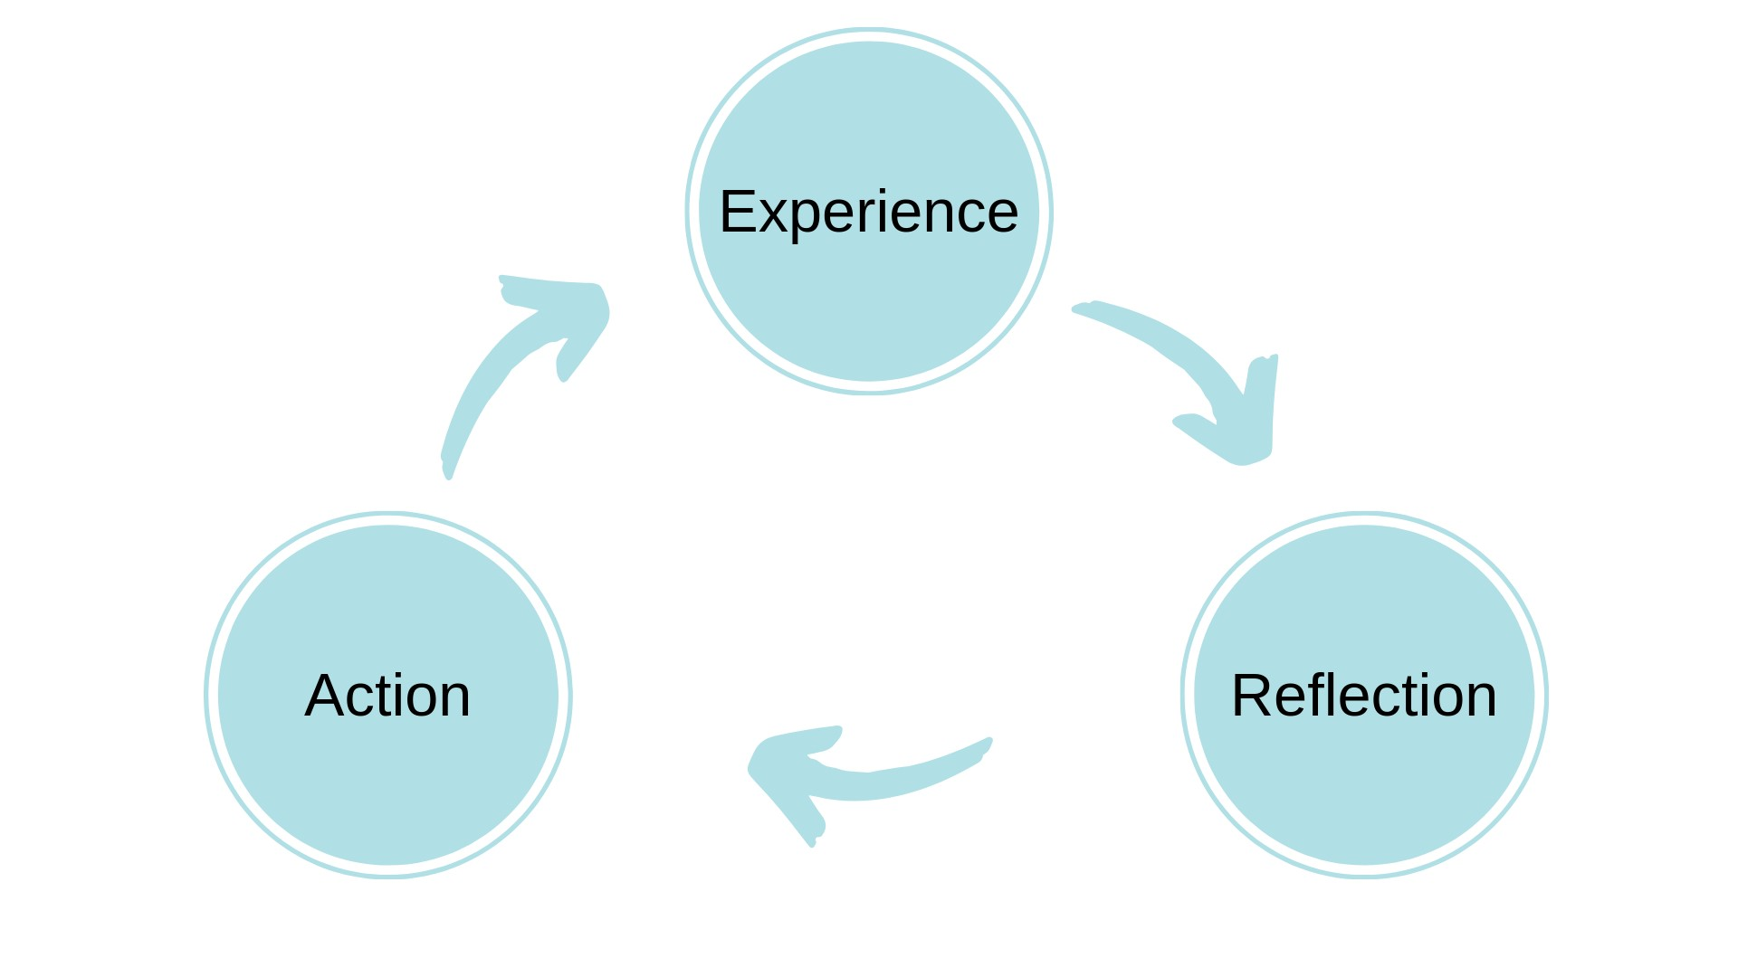  (2013) | Atkins and Murphys’ Model  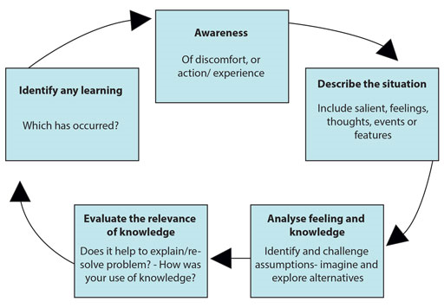  (1993)
The two models to compare, contrast and talk about advantages and disadvantages are Jasper (2013) ERA cycle model and Atkins and murphy (1993) model. To start with Jasper (2013) ERA cycle her cycle begins with experiences we have gone through that could be positive or negative as well as the possibilities of new experience’s. She states that after you have had an experience you automatically reflect on it which takes us to her nest step refection. You may reflect on the feeling you produced during the experience. The final step in Jasper’s (2013) cycle is action and can prepare you to consider what actions we can take next time to improve our experiences. The advantages of this are there are only three steps to consider. It is clear on what those steps are. It is a great starting point directed towards reflective practice. The simplicity is appealing. Disadvantages there is not enough information to help you along the steps.
Secondly Atkins and murphy (1999) model supports a further level of refection. It is critical to remain alert to avoid impractical responses. This model includes a more enthusiastic cycle to identifying challenges and expectations. To create and explore alternatives. Also, to assess relevance and impact. As well as benefits to analyse learning that has materialized as a result of the prosses. The advantages are it has a further instruction of understanding into reflective practise. It has been constructed by decades of work by other experts. Disadvantages of the model are it is very detailed it would recommend further time to gather information and prosses. Also is it a model that would need to be appointed to separately to understand the steps more clearly and perhaps be time consuming.
To compare these two models, they are comparable but also different in their own way. Jasper (2013) is more of a beginner’s model where as Atkins and Murphy (1999) is more time consuming and more for more qualified reflective practitioners. Jasper (2013) is more simplified and would best in active situations as for Atking and Murphy (1999) theirs is better delivered over time.
Conclusion
All the theorists and models stated in this briefing paper all make excellent points but also different ways to conduct reflective practice. The theorists are more of an understanding of how reflective practice was founded and the models are how we can conduct reflective practice in life as well as in the early years. These models give us a starting point to being a great reflective practitioner.

ECEY4009
2308244
1538 words

In this essay there will be information on professional practise as well as a professional. As well as on the importance of communication, in-depth knowledge and understanding, multi-agency, observation and planning when meeting the needs of children and the importance of the United Nations convention on the rights of the child principles as a professional practitioner in the early years.
To begin with professional practise is several things. It includes starting with the ability to meet the needs of children. Having the skills and knowledge in the profession. Knowing and having the responsibilities within the setting. It is knowing the values of the role. Professional practice has been overlooked and misunderstood in the past by parents and other professionals. Professional practice requires being a professional witch intake having knowledgably being open minded, assertive, and objective, it requires being a good role model and being able to create and obtain relationships. Communication and consistency are highly important to being a professional as well as having standards. There will be more information on these points through this essay.
Importance of values for a professional practitioner within professional practice are a variety of things. Here a four, first social justice it is political and social rights, opportunities that everyone equally deserves. Secondly trust and respect in an important value to help build authentic relationships and showing the felling and needs of people involved. Aldo respecting the recourses we have and the world around us. Thirdly the importance of integrity is showing strong morals as well as ethnical principles. It is also showing a consistent un-compromising adherence and honesty. Lastly making a professional commitment to learning and learners that is compatible with the aspiration of achieving a sustainable and equitable world embodies what it is to be a teacher. The importance of values needs to be regularly analysed and considered over ones individual career. Also, to understand what they mean in practise. Values helps us as individuals develop a deeper meaning to teacher professionalism. They are core to being a good professional practitioner. Last by not least by reflecting and considering our values helps us develop a professional insight and the skills to maintain relevance in education.
Communication is something that is essential when working with children. It is important to support the children’s well-being by building understanding and trust with both the parents, carers and children. Good communication requires an effective foundation of respect. Communication with parents, carers and children may require a few different things that may include an interpreter if they speak a different language. The possibility of giving them information that they can understand. Some key skills related to communication are listening to what they have to say, acknowledge that you are listening, so they feel like they have been heard and sensitivity to what you are being told of what you are saying. And always remembering that your shared goal is the child’s well-being and supporting the child.
The next discussion is about in-depth knowledge and aspects of safeguarding. Having the knowledge of how children develop and understanding what steps to take next in their development and learning are important. Also, the importance of in-depth knowledge leads to practitioners understanding each stage of a child’s growth as well as what can be done to help them. And understanding the diverse needs of children. In the early years a professional practitioner will develop in-depth knowledge though experience when working withing a childcare setting.
Safeguarding is vital to anybody working with children is it an important prosses that all schools must carry out. The meaning of safeguarding is protecting the children at all costs against physical abuse, emotional abuse, mental abuse, harm of any kind and neglect. Having safeguarding procedures ensure that schools are safe places for the children where they can feel confident and be open. It is something that is taken seriously and it in the best interest of the child/children.
Education Act 2002 section 175 says that not only does educational professionals have responsibility’s and roles to safeguarding the children but also local authorities, further educational institutes and governing bodies. The Welsh ministers have powers to safeguard children and to promote their welfare. Therefore, educational professionals need to work alongside local authorities such as the police, healthcare workers, social services and other agencies regarding safeguarding.
Safeguarding the children includes maintaining a safe learning environment to develop young children’s understanding, awareness and resilience throughout the curriculum. Safeguarding is done with our children rather than to them.
Partnerships and multi-agency are important to professional practitioners because it can help provide a range of services appropriate to the children’s needs. The importance of multi-agency is so that children and their families can gain access to a range of services throughout their child’s life. To gain a co-ordinated approach to support children practitioners must work together to gain a full overview of the child’s situation.
Partnerships between a professional practitioner and multi-agencies is vital to ensure everyone has the relevant information and all can understand that any risks that may arise, they are able to take appropriate action to keep the child safe. Anything that may effect a child’s welfare must be shared with the appropriate professionals as early as possible. Any professional that works with children has a responsibility to do so. The importance of sharing information with multi-agencies regarding a child’s welfare and safeguarding must be clear in what they are sharing as well as why they are sharing that information. It is important that they work together to benefit the child. Prioritising the child’s needs is most important.
Next discussion is about the observation and planning involved regarding meeting the needs of children. To meet the needs of children it is taking observations of the children which intakes watching them play or do an activity as well as documenting down relevant information and listening to the children. Observation helps us to identify specific care and learning needs of each child. The next step in meeting the child’s needs is planning. Ensuring that all areas in learning and developing are all covered. Also identifying the links between the different arears. In the early years is is important to recognize they key areas to support the children. To plan the next steps in the child’s development and learning requires what needs to be done from what observations that have been made. The development of each individual takes effective planning and reflecting to support the individuals needs. Professional practitioners must make observations and plan appropriate to each child needs to ensure they are getting the best possible education.
Lastly this discussion will be brief information on the principles of the UNCRC and why it is important. UNCRC is an agreement setting out the rights of children regardless of their race, religion or abilities. The UNCRC has 54 articles of which 42 are based on the child. And have been adopted by the Welsh government. Articles 43-45 are based on the implementations where adults and the government work together to ensure children get all their rights. There are four broad categories that include the right to welfare, the right to develop, he right to be protected and the right to participate.
Firstly the right to live. Children have the right to food, shelter and medical care.
Secondly the rights the develop which include giving children the rights to have education to learn and develop and equal opportunity. The right to play and recreational activities appropriate to the age of the child. Also, the right of freedom of thought to think freely and have a viewpoint and considerations of facts. The freedom to change religion or believe in another. Children have the right to participate in cultural life of a community. Also have the right to speak whatever language they want to speak.
Thirdly the right to develop in all aspects of life. And last the right to participate including the opportunities to be heard. To have the right to express and in making decisions with their lives.
The UNCRC is highly important to professional practise and is essential that it is understood when working with children.
To conclude professional practitioner is everything you know and learn when working with children in professional way. The importance of values, communication and in-depth knowledge and understanding is that to a professional practitioner are highly considered when working with children to help them as well as their families to grow and learn and become the best they can. Having a deeper knowledge gives us an understanding of how children grow and learn and helps us plan the best way to help each individual during their development. Professional practitioners need the knowledge of safeguarding the children and protecting them from any harm, abuse and neglect. Partnerships with multi-agencies also helps with the safeguarding of the children and vital to have those partnerships when working with children. When it comes to observation and planning it is important to do when you are an educational professional to ensure they can meet the needs of each individual and lead them to be exceptional. The UNCRC is important to not just educational professionals but to every professional involved with children to ensure that children get all the rights they deserve.

Reference list

