Module name: International Meetings Management for the Hotel Industry
Module code: BMIH6007
Assignment type: Report

Student name: Alexandra Staicu
Student number: 2222626

Lector name:Chris Wilkin

I confirm that I have not used any AI tools in the research and creation of this
assignment. I confirm that I have not presented any AI generated materials as my own
work. I confirm I have copies of my drafts, notes, and other resources I used, which I
may be asked to provide in evidence.
Executive Summary
Global Hospitality Inclusion Summit 2025 is aimed to make the Hospitality industry accessible and inclusive. It will convene industry leaders, policymakers, and advocates to share best practices, innovations, and policy moves to foster disability inclusion within the hospitality industry. The UK offers a stable environment, but economic limitations and increasing costs of business may curtail sponsorships and attendance. However, the country’s diverse population and strong digital engagement present opportunities for wider participation. Furthermore, sustainability continues to be a focus to encourage eco-friendly practices. The event will encourage meaningful conversations on financial, cultural, and environmental sustainability in the hospitality sector that can aid in ensuring disability inclusion and accessibility.

Table of Contents
1. Introduction 4
2. The Event Cycle 4
3. Event Concept 5
4. Aim and Objectives 6
5. Event Management 7
6. Event Budget 9
7. Industry Trends, Issues, and Impacts 10
8. Situational and Cultural Considerations 10
9. Conclusion 14
10. Reference List 16
Appendices 19
Appendix 1: PESTLE Framework 19

1. Introduction
Description
The Global Hospitality Inclusion Summit 2025 is a high-quality, internationally recognised industry conference aimed at helping the hospitality industry become more accessible and inclusive. With increasing experience in the field of global travel and tourism, hotels, event venues, and hospitality services must learn to adopt inclusive practices to become inclusive of guests of all abilities(Fresnozaet al. 2024). The hoteliers, policymakers, disability advocates and HR managers meeting at this summit will discuss the key challenges, exchange ideas on innovative solutions and look at fresh ways how technology can make it possible to offer and enjoy better accessibility in the hotel industry (Foxet al. 2014). The summit has been selected for the need for a dedicated event targeting the growing interest in a dedicated event focused on incorporating disability inclusion in the hospitality industry.
Background
There are a few general diversity and inclusion conferences, but few focused specifically on issues of authenticity, equal treatment under laws, and implementing strategies to enhance inclusiveness. It has been established to bridge this gap by bringing together discussions, showcasing assistive technologies, and inspiring collaboration between stakeholders to make change. The world-class accessibility infrastructure, transport links, and reputation as a global hospitality hub make London an ideal city for hosting this summit much like Qatar for hosting the FIFA world cup (Hajjaj et al. 2024). Many of the accessible hotels and conference venues like Westminster Assembly Hall and County Hall, which have ramps, elevators and hearing loops, and the wide-open public transport means are all here for the use of people with disabilities.

2. The Event Cycle
An event Cycle is an organised and structured framework which is used in event management to make the process of the event becoming, maintaining, and evaluating an event better. It has three phases: Planning, Delivery and Evaluation. This is a structured way in which all the aspects of the event will be strategically developed and executed to achieve the objectives of the event.
The Planning Phase (Feasibility & Preparation)
Planning Phase is important as it involves setting objectives, formulating strategies, and evaluating feasibility. The Global Hospitality Inclusion Summit 2025 strives for the same and urges attention to the accessibility problems in the hospitality industry, including disability inclusion and application (Chan et al. 2023). Financial, logistical and stakeholder considerations are evaluated in a feasibility study. The accessibility infrastructure and global hospitality reputation of London make it a desirable choice venue (Oluyisolaet al. 2022). Effective stakeholder and sponsorship management involves engaging industry leaders, policymakers, HR professionals, and disability advocates. Accessible features such as sign language interpreters, assistive technology, and step-free access are also catered in operational planning.
The Delivery Phase (On-Site Execution)
The Delivery Phase comes having planned activities and consists of delivering a smooth attendee experience. With event logistics and coordination, there is managing on-site registration, speaker sessions, and networking events. Accessibility management and technical management also take care of such aspects as assisting technologies, mobility support, and other real-time accessibility features ranging from sign language interpreters (Lahlou et al. 2022). It engages stakeholders from industry leaders, policymakers, disability advocates, and so on to have meaningful discussions and active participation. Additionally, the event team handles crowd flow, technical support and accessibility accommodations all in one inclusive event. The phase also makes sure that activities surrounding the Global Hospitality Inclusion Summit 2025 run smoothly and meet its objectives.
The Evaluation Phase (Post-Event Analysis)
The Evaluation Phase measures how successful the Global Hospitality Inclusion Summit 2025 was based on predefined metrics. Surveys and interviews with attendees, sponsors and speakers are done to gather feedback and know satisfaction. Attendance numbers, engagement levels and social media reach are analysed (Fox et al. 2014). The impact of the event on promoting inclusive hospitality practices is assessed in terms of how effective it is in fostering inclusiveness awareness. This phase helps with insights to know where to improve upon and make future events something more inclusive and impactful. Strategic enhancements to accessibility and industry engagement are recommended for use in upcoming editions.

3. Event Concept
The Global Hospitality Inclusion Summit 2025 is an event that will give participants the ability to engage and interact engagingly and interactively, with the dialogue focused on the foundation of great debate, insightful discussion, and networking (Getz and Page, 2019). The workshop will provide a scope of how accessibility innovations and inclusive practices exist in the hospitality industry.
Full Itinerary:
- 08:30 – 09:30: Registration & Welcome Breakfast
- 09:30 – 10:30: Keynote Speech – "The Future of Inclusive Hospitality"
- 10:30 – 11:30: Panel Discussion – "Legal Frameworks and Compliance in Hospitality"
- 11:30 – 12:30: Workshop – "Innovative Accessibility Technologies in Hotels and Venues"
- 12:30 – 14:00: Networking Lunch
- 14:00 – 15:30: Breakout Sessions – "HR Practices for Inclusive Hiring and Training"
- 15:30 – 16:30: Case Studies – "Success Stories from Accessible Hospitality Leaders"
- 16:30 – 17:00: Closing Remarks & Future Directions

4. Aim and Objectives
Aim
The aim is to promote and enhance accessibility and disability inclusion within the hospitality industry through collaboration and knowledge sharing.
Objectives
Objective | Specific | Measurable | Achievable | Relevant | Timebound
To Raise awareness of accessibility in hospitality | Organise expert-led panels and workshops on inclusive hospitality | Attract at least 300 industry professionals and accessibility advocates | Promote through digital marketing, partnerships, and industry networks | Enhances industry standards and inclusivity practices | Achieve by the end of the event
To increase accessibility initiatives in hospitality businesses | Encourage businesses to adopt at least one accessibility improvement | Secure commitments from at least 20 hospitality brands | Provide best practice guides, case studies, and expert consultations | Drives industry-wide change and improves guest experiences | Track commitments within 6 months post-event
To strengthen industry collaboration on inclusivity | Facilitate networking and partnerships between key stakeholders | Establish at least five industry partnerships focused on inclusivity | Organise networking sessions, roundtable discussions, and collaboration forums | Promotes long-term collaboration and innovation | Formalise partnerships within 3 months post-event
Table 1: SMART Objectives

5. Event Management
A structured framework for the process of arranging an event ensures it runs smoothly and provides the best service to the stakeholders. EMBOK Model fully embraces the Design, Operations, Marketing, Risk, and Administration as the core components (embok, 2025).
Design
An engagement and inclusive experience are the key focus of event design. Elements of lighting, sound, audiovisual effects, as well as accessibility are planned to the minutest detail for the staging of the Global Hospitality Inclusion Summit 2025 participation. For example, During the Opening Ceremony of the Paralympic Games (Tokyo 2020), a very inclusive stage design was applied, which included 360 Degree Accessibility, Sign language interpreters and a screen magnifier (Kolotouchkinaet al. 2021). Likewise, this summit will have signage, step-free access, and assistive technology stations for different attendants. It is the integrations that are based on accessibility in hospitality, with theming that is in line with the main trending words of this industry – branding, signage and set design (Dillette and Ponting, 2021). The layout of the event is planned out to enable smooth crowd flow, ease of access and engagement with attendees.
Operations
The operational planning includes the selection of a venue with a strong yet simple accessibility infrastructure to optimise space usage traffic flow, and store management. For example, In the World Economic Forum (Davos, Switzerland), there is a strict production timeline such that every session ends precisely at the time it begins (weforum, 2025). Similarly, this event schedule includes a run sheet and production programme to enable the coordination of speaker sessions, start of zones, assistive technology sets, and breakout rooms. Planning is made for logistics including load-in and load-out schedules, VIP access and catering in adherence with health, safety, and accessibility standards.
Marketing
A strategic marketing approach will guarantee high engagement as well as attendance. Social media campaigns, teaser content, and influencer collaborations complement traditional methods such as brochures, flyers, and even event websites for maximum outreach (Fox et al., 2014). With themed invitations and exclusive digital campaigns, the Met Gala does an excellent job of generating anticipation among mass globally (NYTimes, 2025). Drawing inspiration from this, unique invites will be sent, which will feature alternative formats such as Braille and audio invites to be inclusive.
Risk Management
Event management is an important aspect where safety and security play a key role. A plan for a risk assessment, including crowd congestion, accessibility challenges and emergency procedures, is carried out. Only to make sure the infrastructure, the sound systems, and the technical setups of the venue are not going to fail. For example, Mass stabbing occurred in a recent England event which left children and adults died and injured (Aniftos, 2024). To mitigate the problem, the Global Hospitality Inclusion Summit 2025 will have controlled audience flow, designated emergency exits and on-site medical teams.
Administration
The coordinator ensures to blend the teamwork so that the staff, volunteers, and economic management work in a smooth manner. Under a clear hierarchy, the event production team includes those who advise on logistics and accessibility consultants and IT specialists (Lahlou et al., 2022). Budgeting and financial planning for venue costs, speaker fees, marketing expenses and sponsorships are all covered. Contract management, application for permits and compliance with local regulations are also part of administrative tasks. Major costs of the Global annual conference 2024 of the “British Chamber of Commerce” were covered by brand sponsorships such as NatWest, BP, Microsoft, and Aviva (BCC, 2025). Similarly, in this event, looking for sponsors from hospitality brands and accessibility companies is required who will finance initiatives such as assistive tech booths and free guides.

6. Event Budget
Category | Amount (£)
Income
Collective Sponsorships from hospitality brands | 20000
Ticket sales | 10,000
Exhibitor fees | 10,000
Grants from government agencies and NGOs | 20,000
Total Income | 60,000
Expenditure
Venue rental | 6500
Speaker fees | 500
Marketing and promotions | 10,000
Accessibility accommodations (e.g., sign language interpreters, mobility assistance) | 800
Total Expenditure | 17,800
Net Profit/Loss | 42,200
Table 2: Revenue Sources
A well-planned budget is a necessity for the conducting of a Global Hospitality Inclusion Summit 2025, for it to be financially feasible (Getz and Page, 2019). The primary revenue streams were grants (government agencies, non-governmental organisations) of £20,000 (Conference news, 2025). Besides, ticket sales (£10,000), exhibition exhibitor fees (£10,000), and sponsorships from hospitality brands (£20,000), totals £60,000. Fees for venue rental of £6500 are planned to ensure accessibility and high-quality facilities (Tagvenue, 2025). Speaker fees include total price after calculating the number of equipments needed for a day around £500 for a 24-hour charge (Complete music and sound, 2025). Social media outreach, email campaigns and advertisements are supported by the marketing and promotions £10,000 (StreetPR, 2023). There are assistive technologies, interpreters, wheelchair friendly spaces within accessibility accommodations (£800).On this note. There is a net surplus of £42,200 from the total expenditure of £17,800 to enable analysis of the post-event and initiate future programs.

7. Industry Trends, Issues, and Impacts
Technological advancements, changing societal expectations and regulatory changes are changing the meetings and events industry. Additionally, hybrid events are on the rise, which is the combination of virtual and in-person experiences to make events more accessible and more global (Mullin et al. 2024). This trend is perfectly aligned with the Global Hospitality Inclusion Summit 2025, which focuses on digital engagement tools, live-streamed sessions, and interactive Q&A platforms for inclusivity. Diversity, Equity, and Inclusion (DEI) have become another critical trend from technological transition to social change (Mourtziset al. 2022). More businesspeople are aware that they need to create environments, yards, spaces, buildings, and venues that are accessible for people with different disabilities. This change reinforces organisations' legal and corporate social responsibility (CSR) obligations to adhere to the constantly changing accessibility rules. Sustainable practices can be adopted by the summit to reduce its footprint on the environment. Despite these advancements, challenges remain. This may limit participation due to economic constraints, such as the need for affordable ticketing and sponsorship models.

8. Situational and Cultural Considerations
PESTLE Framework
Political Factors
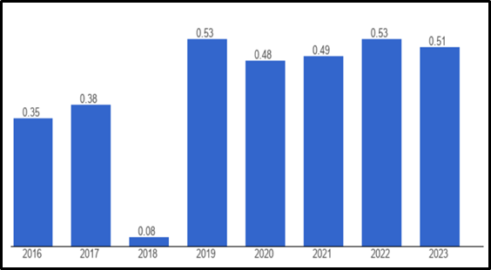
Figure 1: Political Stability in the UK
(Source: Theglobaleconomy, 2025)
The UK's political stability index of 0.51 in 2023, though slightly declining, remains above the global average, ensuring a stable environment for hosting the Global Hospitality Inclusion Summit 2025. Regulatory support and event security are as much a function of good government effectiveness (1.16) and a strong rule of law (1.40) (Theglobaleconomy, 2025). Nevertheless, minor political instability may impact international attendance and would need contingency planning to address the risks.
Economic Factors
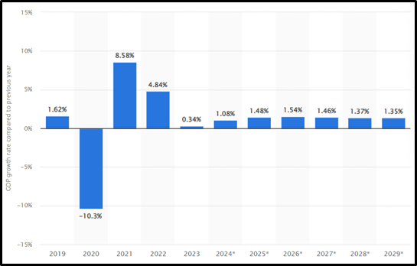
Figure 2: UK’s GDP Growth Rate
(Source: Statista, 2025a)
A low GDP growth rate of 0.34% in 2023 in the UK means that the economy is stagnant. This situation can impact corporate sponsorships and ticket sales because companies may cut discretionary spending (Statista, 2025a). Despite this, London’s economy is dependent on its strong financial sector, which continues to invest in service industries, so the city remains a viable choice for global hospitality events.
Social Factors
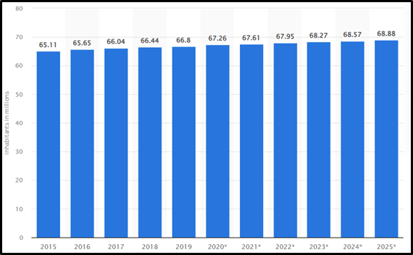
Figure 3: Total Population of the UK
(Source: Statista, 2025b)
The total population of the UK in 2024 was 68.57 million (Statista, 2025b). The event's significance is further reinforced by the UK's diverse and expanding population. Accessibility is becoming increasingly important as the number of senior people rises, and immigration-driven diversity means that a sizable section of the public is discussing cultural inclusion, which is something that many industry professionals need when looking for hospitality methods.
Technological Factors
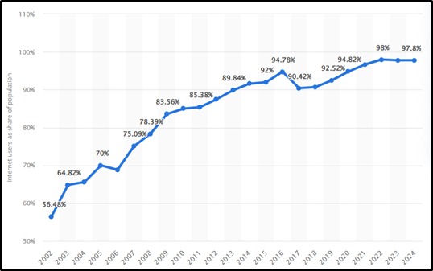
Figure 4: Internet Penetration in the UK
(Source: Statista, 2025c)
The Global Hospitality Inclusion Summit 2025 is backed by the 98% internet penetration in the UK since digital engagement is strong (Statista, 2025c). Accessibility and reach can be improved through virtual participation and online marketing along with digital networking opportunities. The integration of assistive technologies, live streaming, and interactive platforms is made easier with high internet usage, which in turn makes the event more inclusive to a wider audience.
Legal Factors
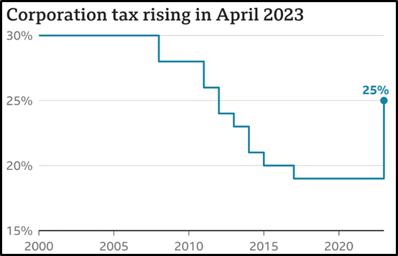
Figure 5: Corporation Tax in the UK
(Source: BBC, 2025)
Businesses may find it more difficult to sponsor a discretionary event like the Global Hospitality Inclusion Summit 2025 because of increased tax obligations, which could reduce the opportunity for sponsorship of the event. The corporate tax rate was raised from 19% to 25% (BBC, 2025). In addition, companies may reduce their budgets for staff training and making contributions to the event through conference attendance.
Environmental Factors
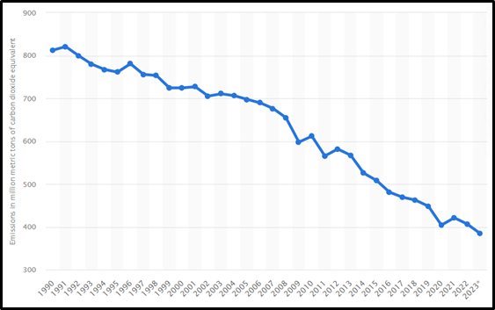
Figure 6: Annual Greenhouse Gas (GHG) Emissions in the UK
(Source: Statista, 2025d)
In 2023, the UK has seen a decline in greenhouse gas emissions by 5.4%, down to 384.2 million metric tons of CO2e, indicating a shift towards sustainability. As the event should reflect such ongoing environmental trends, it needs to support low-carbon transport options and utilise green energy venues (Statista, 2025d). The event is receiving more expectations to be sustainable, and adding some eco-friendly practices would improve prestige as well as satisfy attendee's expectations.
To sum up, based on the PESTLE analysis, it is evident that the UK’s multicultural society is important and should be understood very carefully regarding the various requirements such as dietary requirements, accessibility, and cultural sensitivities. The expectations of hospitality and inclusivity may also vary for international guests. These factors must be in place so that the experience of visiting this global event is welcoming and appealing for all.

9. Conclusion
In Conclusion, the Global Hospitality Inclusion Summit 2025 is an important move in ensuring the hospitality industry is accessible and inclusive. Through strategic planning, all is done to be sure that finances are made through sponsorship opportunities and cost-effective operations. This fits well within the industry trends such as demographic shifts, technological improvements, and sustainability. Due to its strong infrastructure and global connectivity, the selected venue for London will encourage participation. In addition to raising awareness, it offers feasible solutions for accessible hospitality committed to businesses and guests. The event encourages collaboration with policymakers, industry leaders, and advocates for long-term change.

10. Reference List
BBC, 2025. What is corporation tax, and who pays it? Available at: https://www.bbc.com/news/business-63255747 [Accessed on 04 February 2025]
BCC, 2025. Sponsorship Opportunities, Available at: https://www.britishchambers.org.uk/events/global-annual-conference-2024/ [Accessed on 18 February 2025]
Chan, W.W., Luo, J.Y., Tang, I.L., Chan, I.L. and Lau, C., 2023. Enabling the adoption of innovative mask in hotels: adapted diffusion model. Journal of the Knowledge Economy, 14(4), pp.4754-4779.
Complete Music and Sound, 2025. Sound Equipment Hire. Available at: https://completemusicandsound.co.uk/dry-hire-rates/ [Accessed on 18 February 2025]
Conference news, 2025. Government funding available to help bring international events to UK, Available at: https://www.conference-news.co.uk/news/government-funding-available-help-bring-international-events-uk/ [Accessed on 18 February 2025]
Dillette, A. and Ponting, S.S.A., 2021, June. Diffusing innovation in times of disasters: considerations for event management professionals. In Journal of Convention & Event Tourism (Vol. 22, No. 3, pp. 197-220). Routledge.
Embok, 2025. Event Management Body of Knowledge Project, Available at:https://embok.org/juliasilvers/embok.html [Accessed on 18 February 2025]
Fox, D., Gouthro, M.B., Morakabati, Y. and Brackstone, J., 2014. Doing events research: From theory to practice. Abingdon: Routledge.
Fresnoza, E.P., Balcombe, D. and Choo, L., 2024. Social justice in tourism recovery: examining equity, diversity, and inclusion in Canadian tourism restart policies. Tourism Critiques: Practice and Theory.
Getz, D. and Page, S.J., 2019. Event studies: Theory, research, and policy for planned events. Abingdon: Routledge.
Hajjaj, M., Borodin, V., Perțicas, D.C. and Florea, A.G., 2024. Qatar's FIFA World Cup odyssey: A quest for legacy transforming a small nation into a global destination. Heliyon, 10(9).
Kolotouchkina, O., Llorente-Barroso, C., García-Guardia, M.L. and Pavón, J., 2021. Disability narratives in sports communication: Tokyo 2020 Paralympic Games’ best practices and implications. Media and Communication, 9(3), pp.101-111.
Lahlou, S., Heitmayer, M., Pea, R., Russell, M.G., Schimmelpfennig, R., Yamin, P., Dawes, A.P., Babcock, B., Kamiya, K., Krejci, K. and Suzuki, T., 2022. Multilayered Installation Design: A framework for analysis and design of complex social events, illustrated by an analysis of virtual conferencing. Social Sciences & Humanities Open, 6(1), p.100310.
Mourtzis, D., Angelopoulos, J. and Panopoulos, N., 2022. A Literature Review of the Challenges and Opportunities of the Transition from Industry 4.0 to Society 5.0. Energies, 15(17), p.6276.
Mullin, C., Gould, R., Harris, S.P. and Jones, R., 2024. Updated trends in disability, diversity, and corporate social responsibility. Journal of Vocational Rehabilitation, 61(2), pp.157-174.
Nytimes, 2025. 2024 Met Gala: The Biggest Names and Biggest Moments From the ‘Garden of Time’, Available at: https://www.nytimes.com/live/2024/05/06/fashion/met-gala-2024 [Accessed on: 18 February 2025]
Oluyisola, O.E., Bhalla, S., Sgarbossa, F. and Strandhagen, J.O., 2022. Designing and developing smart production planning and control systems in the industry 4.0 era: a methodology and case study. Journal of Intelligent Manufacturing, 33(1), pp.311-332.
Statista, 2025a. United Kingdom: Real gross domestic product (GDP) growth rate from 2019 to 2029. Available at: https://www.statista.com/statistics/263613/gross-domestic-product-gdp-growth-rate-in-the-united-kingdom/ [Accessed on 04 February 2025]
Statista, 2025b. Total population of the United Kingdom (UK) from 2015 to 2025. Available at: https://www.statista.com/statistics/263754/total-population-of-the-united-kingdom/ [Accessed on 04 February 2025]
Statista, 2025c. Share of individuals using the internet in the United Kingdom (UK) from 2002 to 2024. Available at: https://www.statista.com/statistics/1124328/internet-penetration-uk/ [Accessed on 04 February 2025]
Statista, 2025d. Annual greenhouse gas (GHG) emissions in the United Kingdom (UK) from 1990 to 2023. Available at: https://www.statista.com/statistics/326902/greenhouse-gas-emissions-in-the-united-kingdom-uk/ [Accessed on 04 February 2025]
StreetPR, 2023. How much does experiential marketing cost. Available at: https://streetpr.co.uk/how-much-does-experiential-marketing-cost/ [Accessed on 18 February 2025]
Tagvenue, 2025. Assembly Hall at Church House Westminster,Prices. Available at: https://www.tagvenue.com/rooms/london/6/church-house-westminster/assembly-hall [Accessed on 18 February 2025]
Theglobaleconomy, 2025. United Kingdom: Political stability. Available at: https://www.theglobaleconomy.com/United-Kingdom/wb_political_stability/ [Accessed on 04 February 2025]
Aniftos, R. 2024. Mass Stabbing at Taylor Swift-Themed Event in England Leaves 2 Children Dead, 9 Injured. Available at: https://www.billboard.com/music/music-news/mass-stabbing-taylor-swift-themed-event-southport-england-1235742388/ [Accessed on 18 February 2025]
Weforum, 2025. What is Davos? 7 things to know about the World Economic Forum's Annual Meeting, Available at: https://www.weforum.org/stories/2024/12/davos-annual-meeting-everything-you-need-to-know/ [Accessed on: 18 February 2025]

Appendices

Appendix 1: PESTLE Framework
Factor | Description | Impact
Political Factors | - The UK political stability index is 0.51 in 2023, above the global average.  - Strong rule of law (1.40) and government effectiveness (1.16). (Theglobaleconomy, 2025) | - Negative: Minor instability may affect international attendance.
Economic Factors | - UK GDP growth rate 0.34% in 2023, indicating slow growth (Statista, 2025a).  - London’s strong financial sector supports hospitality investment. | - Negative: Economic stagnation may impact sponsorships and ticket sales.
Social Factors | - UK population is growing to 68.57 million, increasing demand for accessible hospitality (Statista, 2025b)  - The ageing population needs inclusive services and accessibility. | - Positive: Immigration-driven diversity promotes cultural inclusivity.
Technological Factors | - 98% internet penetration ensures strong digital engagement (Statista, 2025c).  - Assistive technologies and live streaming. | - Positive: Enables virtual participation and online networking.
Legal Factors | - Corporation tax increased from 19% to 25% in 2023 (BBC, 2025). | - Negative: Higher taxes may reduce event sponsorships.
Environmental Factors | - UK GHG emissions fell by 5.4% in 2023 (Statista, 2025d). | - Positive: The event should promote low-carbon transport options.

