

Overview of why the NHS is changing

By Saba Rejaee
Student number: 1705223

Community Care
Karen Burton
University of Wales Trinity Saint David
Swansea, UK
2018-2019

Contents
Introduction 3
Prudent healthcare agenda 3
Ageing society 3
Bringing care out into the community 4
WHAT ARE PROBLEMS IN NHS? 4
Community hubs: 5
Bed blocking 5
What changes being considered 6
Financial implications 6
Streamlining of services 6
The reasons positive or negative 7
Summery 7
REFRENCES 8

Introduction

‘’The National Health Service, provides the large part of health care services to the UK residents in 1948 that everyone living in the UK can use without being asked to pay the full cost of the service’’( What is the NHS, 2017).
The NHS is a very large and multiple organisation, and always will be changed in some way to have better services.
NHS is the process of making decisions about what services and benefits will be available for everyone in society. Government have a responsibility to make sure that the health services that are provided meet the needs of the population. According to the Health and Social Care Act, the commissioning process is going to change. These changes are due to the fact that the structures are old. GPs, dentists and pharmacists used to be managed by local primary care which worked with local authorities. Now the old structures changed to primary care and strategic health authorities.
(Overview of the key changes to NHS structures, 2014).

Prudent healthcare agenda
Walsh Government presented the prudent healthcare principles proposed by the independent Bevan Commission, in NHS Wales.
Professor Mark Drakeford explained prudent healthcare as: “healthcare that fits the needs and circumstances of patients and actively avoids wasteful care that is not to the patients benefit.”(Bradley, P. & Willson, A, 2014).
The Bevan Commission believes that NHS Wales should only deal with the needs of people in a continuous way and declares that ‘‘Simply Prudent Healthcare- achieving better care and value for money in Wales’’. (Welsh Government, 2014).
The purpose of Prudent Healthcare in Wales should ensure that:
- Health services completely fits the needs of people.
- Prevention of harm and waste.
- Release treatments that have not any benefits.

Most goals of prudent healthcare are included: improving health by changing the way health services are used and provided. Successful organisational change results in people behaving and is most likely to happen if expectations, roles and rewards are aligned to support people make and sustain those behaviours.

Ageing society
The phenomenon of aging society is due to the fact that reducing mortality due to advances in medical sciences, health, and education.
NHS in Wales recognised one of the problem in health include ageing population, Wales has an ageing society and this is expected to rise in future. As more people need help with day to day living, social services and local authorities, are increasing. Ageing is a reality and became a problem in society. (Baxter, J, Boyce, S (2016).
Ageing society affects or will effect on pension schemes in at least two ways: beneficiaries will be more numerous and they will claim benefits over a much longer period than at present. (WORLD OF WORK, 2009).

Bringing care out into the community
Society facing a challenge of ageing population, because of the population ages, people live longer, government need to provide healthcare and support. Bringing care out into the community can help patient to have an independent life by taking care out of a hospital. (Orion Health, 2018).
‘’Bringing more healthcare services closer to home rather than hospitals is a new sector. This idea can help local health economies manage capacity and may help avoid costs in the long time’’. (GOV.UK, 2015).
Bringing care out into the community will support patients to manage their conditions and helping them to understand their conditions. Will reduces anxiety for patients with long-term conditions in hospitals. (GOV.UK, 2015).

WHAT IS THE GOVERNMENT AND PEOPLE DOING?

Responsible about their health

Government ask people to be responsible about their health:
Matt Hancock said: ‘’People must take more responsibility for their own health, focusing on the responsibilities of patients isn’t about penalising people. It’s about helping them make better choices, giving them the all the support we can, because we know taking the tough decisions is never easy.” (Independent, 2018).

Activated patient
If someone being active about health, activated patient called. Is a patient who has the knowledge, skills, and confidence for managing their health and health care. They are doing better and present less demands on health systems. According to the cost of healthcare, it is really better that patient take control of their own health. An activated patient always use knowledge and advice for have an active role about their health. When patient have high and right information, this cause society to provide better services. Also activated patient cause better experiences with patient healthcare provider, improved outcomes and decreased costs for society. (What is an activated patient? 2013).
Some organisation have been created to make NHS working better, NHS always have changing to provide better services, also GP Clusters is a group of GPs that working together with healthcare to making plan and provide better services. (Clusters, 2018).

GP Clusters
GP Clusters working together and supporting futures plan, also GP Cluster Wales will be working with Welsh Government and Health Boards around Wales to meet local patient needs, and support the ongoing work of a locality network. The benefits of GP Clusters includes: enable people to keep themselves well and being independent for a long time, quality of services that are provided in the community will improved and share information’s and knowledge between different health, social care and voluntary sector professionals.
There are 64 GP clusters that they bring local GPs together with pharmacies, physiotherapist and counselling services. The Cluster Network in Swansea has 4 dental practices, 8 pharmacies, 5 Opticians, 1 nursing home and 20 schools. (Three Year Cluster Network Action Plan Penderi Cluster, 2017).

Community hubs:
In addition to GP Clusters, Community Hubs are an organisation that will provide higher local community activity and bring residents and patients, the local business community, and smaller organisations together to improve the quality of life in their areas. It is a Community Centre providing a high quality and cost effective services to the local community, and develop new services. (Octopus Community Network, 2012).

WHAT ARE PROBLEMS IN NHS?
Nursing shortage is one of most important problems in NHS. NHS everyday faces more problems such as pharmacies, dentist, bed blocking, the lack of staff and the implications for the NHs and service users. The Nurse Staffing levels (Wales) Act 2016 became law on 21st March 2016. According to Nurse Staffing Levels (Wales) Act, ‘’NHS organisations have a duty to use the triangulated approach to calculate the nurse staffing levels in adult acute medical and surgical inpatient areas, take all reasonable steps to maintain the nurse staffing levels and report compliance in maintaining the nurse staffing levels as a means of providing assurance to the public, the Board and Welsh Government’’. (The Nurse Staffing Levels, 2018).

Bed blocking
Statistics in NHS shows that while the average number of beds has decreased, the percentage occupancy has increased. When request for NHS care is growing, the number of beds has continued to decrease automatically.
Average length of stay in hospital has decreased while every patient has different situation, but for elder people long stays in hospital still continue.
Bed blocking cause huge pressure and operations are being cancelled and taking time for booking another appointment.
Also Service and bed for mental health problems, released over the last two decades.
The following graph (figure 1) show the number of hospital beds in wales decreasing but the rate has increased. (Beds in the NHS, 2016).

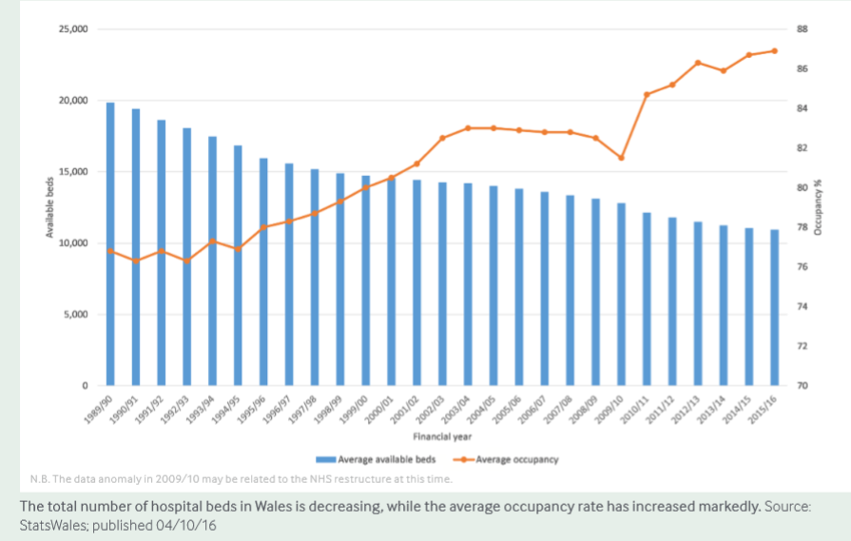

Figure (1)

What changes being considered:

Financial implications
A report carried out by Labour peer, Lord Carter, shows the growing trend to pay private hospitals to do NHS work, as well as the growing waiting times, and could also contribute to the overall cost of bed blocking.
Always is a better idea that provide care and support to patients in care homes or their own home, rather than accept them to a hospital for an assessment and block a bed and this cause a saving money and time for society and patients as well.

Streamlining of services
One of best solution about bed blocking is that people or patients who require continuous care may not necessarily need hospital. They can stay in Care home although they may not be well enough to stay in their own home without care assistance, there are a lot of patients who would benefit more from being in an environment where they can have some activities. (The Cost of Bed Blocking to the NHS, 2017).

The reasons positive or negative
One of the Positive reason about bed blocking is about bed is only for patients who they strictly need the bed and also End Bed Blocking.org is the campaign to stop people being kept in hospital for longer than they need to be, as said Extra days in hospital cost the NHS time and money.
Bed blocking cause:
• End the use of the term bed blocking.
• Find new solutions.
• Collect more data about the problem.
Researchers has found that bed blocking it’s in highest level in four years, and the doctors and nurses are, on a daily basis, unable to discharge in excess of 1000 patients who no longer require hospital treatment as there is no further care available for them in the community or at home.
And also some people don’t like the term bed blocking, saying it blames the patients, and stops patients to be an activated patients.
Bed blocking results in a blockage in the departments and ambulances not being able to deliver patients, and can also undermine an older person’s chances of recovery and be profoundly upsetting for them and their families too. (Health News UK, 2014).

Summery
Things in NHS need to change, because NHS wants to improve the quality of the services, and health services going to be modern day to day.
Nowadays NHS facing with problems. Bed blocking is one of these problems, and this cause government to find solutions and find real problem and measure it and bringing care out of hospitals and keep patients who needs long term treatments in care homes. Government improve the interface between hospitals and other services.
As said, Bed blocking has few negative results: such as: some operations are being cancelled, and pressure on patients and health staff, taking long time and wasting money.
In addition of negative points, bed blocking has more positive result, like: Bed blocking cause to bringing care out into the community and people being more responsible about their health, try to being an active and also government supporting people to manage their own health.

REFRENCES

- Ageing societies: (2009). The benefits, and the costs, of living longer. Advancing social justice, promoting decent work. Available at: https://www.ilo.org/wcmsp5/groups/public/---dgreports/---dcomm/documents/publication/wcm_041914.pdf. Page 9, 52.

- Baxter, J, Boyce, S, (2016). The ageing population in Wales. Key Issues for the Fourth Assemble, P66, 104.

- Bradley, P. & Willson, A. (2014) Achieving prudent healthcare in NHS Wales Cardiff: Public Health Wales.

- British Medical Association. (2016) Beds in the NHS: Wales. P 5-6, 20. Available at: file:///C:/Users/Saba/AppData/Local/Packages/Microsoft.MicrosoftEdge_8wekyb3d8bbwe/TempState/Downloads/NHS-bed-occupancy-report-feb2017-Wales%20 (1).pdf.

- Centre for Health Information Activation (CHIA). 2013. What is an activated patient? [ONLINE] Available at: http://www.pachia.org/. [Accessed 10 January 2019].

- GOV.UK. (2015). Moving healthcare closer to home case studies: Admission avoidance and length of stay reduction. [ONLINE] Available at: https://assets.publishing.service.gov.uk/government/uploads/system/uploads/attachment_data/file/459229/Case_study_collection_-_AA_and_LOS_reduction.pdf. [Accessed 10 January 2019].

- GOV.UK. (2015). Moving healthcare closer to home. [ONLINE] Available at: https://www.gov.uk/guidance/moving-healthcare-closer-to-home. [Accessed 10 January 2019].

- Health News UK. (2014). Bed blocking having negative impact on the NHS. [ONLINE] Available at: https://www.healthnewsuk.co.uk/nhs-news/bed-blocking-having-negative-impact-on-the-nhs/. [Accessed 10 January 2019].

- Independent. 2018. Responsibility health prevention. [ONLINE] Available at: https://www.independent.co.uk/news/health/nhs-responsibility-health-prevention-matt-hancock-a8617501.html. [Accessed 9 January 2019].

- 1000 Lives Improvement. (2018). The Nurse Staffing Levels. [ONLINE] Available at: http://www.1000livesplus.wales.nhs.uk/news/48041. [Accessed 10 January 2019].

- Mencap, the voice of learning disability. 2014. Overview of the key changes to NHS structures. [ONLINE] Available at: https://www.mencap.org.uk/sites/default/files/2016-06/Overview%20of%20the%20key%20changes%20to%20NHS%20structures.pdf. [Accessed 8 January 2019].

- Orion Health. (2018). Bringing care closer to home for patients with complex health issues By Gavin Young –Technology Programme Manager, Shared Care Planning, Canterbury Clinical Network Aug 03, 2018 Subscribe Now. [ONLINE] Available at: https://orionhealth.com/uk/knowledge-hub/blogs/bringing-care-closer-to-home-for-patients-with-complex-health-issues/. [Accessed 10 January 2019].

- The GP One. 2018. Clusters. [ONLINE] Available at: http://www.gpone.wales.nhs.uk/clusters. [Accessed 10 January 2019].

- The UK’s independent fact checking charity. 2017. What is the NHS? [ONLINE] Available at: https://fullfact.org/health/what-is-the-nhs/?gclid=Cj0KCQiAjszhBRDgARIsAH8KgveApA1T0Tn2JRE3jAOPycF76iGpzfpeKNveLjy8Ww9tRWXmA4TTyegaApF1EALw_wcB. [Accessed 7 January 2019].

- Three Year Cluster Network Action Plan 2017-2020 Penderi Cluster, (2017) Available at: www.wales.nhs.uk/sites3/Documents/480/Swansea%20-%20Penderi%20Cluster%20Plan%20FINAL%202017-20.pdf (Accessed: 10/01/2019).

- Walsh Government, (2014) Prudent Healthcare. Available at: file:///C:/Users/Saba/AppData/Local/Packages/Microsoft.MicrosoftEdge_8wekyb3d8bbwe/TempState/Downloads/Provisional-Prudent-Healthcare-Principles%20(1).pdf (Accessed: 9/01/2019).

- Octopus Community Network. (2012). what is a Community Hub? [ONLINE] Available at: http://www.octopuscommunities.org.uk/our-projects/community-hubs/what-is-a-community-hub/. [Accessed 10 January 2019].

