MA Philosophy - Dissertation
How Jesus’ race has been erased to favour a White European Christ deliberately and resists change/new facts
Why do we know what we know? Investigating the purposeful and continued racialisation of Jesus as White by Mormons as an instance of epistemological challenge
RQ:
- How and why has Jesus been racialised as White by Mormons?
- What epistemological questions does this raise for philosophy and theology?

Abstract
This dissertation investigates the epistemological implications of white supremacy and its appropriation of the image of Jesus Christ. The investigation explores how racial prejudices function within the framework of theology and philosophy. I have chosen to focus on the epistemologies of ignorance and racial embodiment. I will evidence that racial embodiment and epistemology have an interconnected relationship which creates a tool for the acquisition and the termination of knowledge which operates via the bodily senses. I also have incorporated the Mormons as a case study to demonstrate how racialised epistemologies can be used to facilitate and uphold racial inequalities. The consequences of racism interrupts healthy intersubjective relationships and causes the oppressed’ s experience to became invisible and the oppressor to lack empathy. By investigating Christs role in history in upholding racial hierarchies, I hope to show that by interrogating race in philosophy it can help dismantle white supremacy.

Contents
Introduction 3
A brief History on Race and its implications in academic study 14
Background 21
The history and process of racialisation of the Mormons 35
The Old Testament and the Curse of Cain 41
State of Mormonism and White Jesus today 45
Mormons and Imagery of Jesus 46
Why is White Jesus pervasive beyond Mormonism and what does Philosophy say about this? What is interesting about this from a philosophical point of view? 53
Conclusion 62

Introduction

Whilst studying for a Philosophy degree over twenty years ago, one question has always stayed in the back of my mind: Why was this subject consumed with all things Greek? Were there not other philosophers of colour worth discussing.
I found the answers unexpectedly to this epistemological quandary in my research journey questioning how and why the image of Christ was appropriated and racialised to present as a European looking Christ.
The example of Jesus’ race and image being appropriated and portrayed as a white European raises two questions:
Firstly, why is it that we accept Christ’s universal image as a white European when logic suggests that he would have had localised features akin to a Middle Eastern man? Secondly why has society resisted so ardently to new facts about his appearance?
This essay serves as an epistemic inquiry into the idea that Christ has been appropriated and used to maintain racial hierarchies.
As a case study to attest to this, I have also chosen to incorporate Mormonism in my investigation in order to show how racial epistemologies can be deployed to facilitate oppression in the quest for white supremacy.
Epistemology is “concerned with evaluating the multifarious ways in which circumstances under which thinkers attempt to fit mind to world, with a guiding interest in which ways are better than others.”
I am interested in how the prejudices function within the form of racism and how this dynamic is linked to the appropriation of Christs image. I am making a case that the Western inference that Christ was white is apocryphal.
One reason Joan E. Taylor gave for the refutation of her proposed image of Christ was that religion was deeply personal and spiritually triggering to its receptor. This reason I will return to later in the essay as I will argue that racism operates as a phenomenon which is inter-connected to our physical bodies as well as our meta-physical minds.
To attempt to answer one of my questions, How Jesus’ race has been erased to favour a White European Christ deliberately and resists change facts?
One must refer to a recent anthropological investigation and ground-breaking book by Joan E. Taylor on what Jesus most likely looked like.
Taylor explains that the Bible does not contain a physical description of Jesus at all and highlights to the reader that this omission is largely ignored by Christians and this is due to the fact that people feel they know his image so well, that it is almost accepted as a historical fact that he was fair skinned, with nut brown hair and a beard, dressed in a white robe and sandals.
Taylors investigation posits after an interrogation into the study of bones and biology of Judean men that Jesus was not white looking and she offers up a description of Jesus that challenges the credibility of Christ universal image. Taylor describes Jesus as the following.
“Nowhere in the Gospels, do we have mention of anything about what Jesus looked like, in terms of his facial features, hair, tallness or physical characteristics. The most likely reason for this is that he was average in every, and there was nothing distinctive about his appearance that it made it worthy of comment.

We have therefore explored what we can know of averages at the time of Jesus, largely from excavated bones, but determined then that he would have been about 166 cm 5 feet 5 inches) tall, with olive-brown skin brown black hair and brown eyes he was a man of Middle- Eastern appearance his ethnicity can be compared to Iraqi Jews of today.”

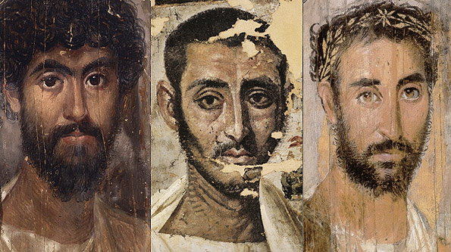

Eastern Depictions of Christ based on Joan E. Taylors Description, curtesy of Google Images
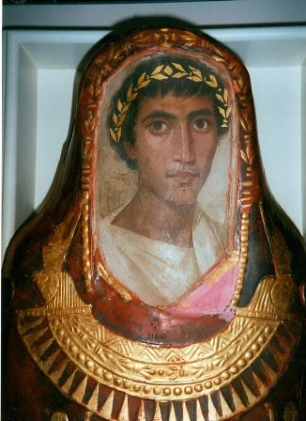
Joan E. Taylor displays this image to depict the likely colour of Jesus skin pp161 Joan E. Taylor, Flesh and Bone What did Jesus Look Like?

The portrait above is – Mummy portrait of a youth named Artimodorus (c. 100. CE), encaustic. From the Fayyum, Egypt. British Museum, no. EA21810, curtesy of Google Images
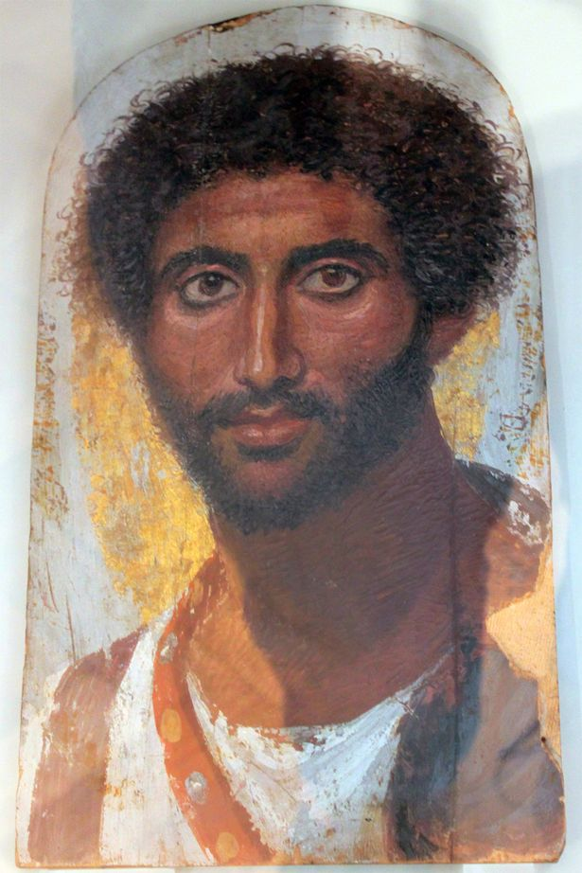

A male akin to Taylor’s description of Christ. I ask the reader to envision this image as Jesus as an exercise I hope will bring to light how incompatible this image is with today’s epistemological discourse surrounding theological discourse, race and white supremacy.

Taylor’s image had a mixed reception, some were curious others were outraged. Taylor even says “They will find it shocking that Jesus was probably not a tall man with perfect, shoulder-length nut brown hair and pale skin, dressed in long robes. I have been told by people by email that they have seen Jesus in visions and dreams, and therefore my study is pointless.”

The staunch outrage piqued my interest as a philosophical inquiry into how and why we believe what we believe even when logic is presented in a sound format, how could people be so strong in their convictions on what Christ looked like?

When rationality would suggest that he would have had features akin to the Middle Eastern rather than Northern European male. I believe that Taylor’s image of Jesus was too “foreign” for some Western Christians. For example, X. I am proposing that race was the key factor in its rejection. A non-white son of God was just too challenging of a concept for some individuals to accept as an epistemic truth.

In order to understand how individuals and groups can hold onto dogma in the face of new facts, led me to the epistemology of ignorance. The epistemology of ignorance studies how ignorance can navigate through generations of society largely undetected and unchallenged.

Shannon Sullivan and Nancy Tuana best articulate what is meant by ignorance “ignorance often is thought of as a gap in knowledge, as an examination of the complex phenomena of ignorance, which has as its aim identifying different forms of ignorance, examining how they are produced and sustained, and what role they play in knowledge practices.”

Ignorance can work in two ways when studying the human relationship with acquiring knowledge. Firstly, it can take an active method of prohibiting others from knowing certain things, Sullivan and Tuana give the example of enslavers not allowing their slaves to read. Or it can be a white person’s impotence at having the ability to see racism, white privilege and domination. These “unknowledges” are consciously produced, while at times unconsciously re-produced. The authors set forth to discuss this type of ignorance when it comes to upholding white supremacy.

It is the belief system and ideology of white supremacy that I feel is incompatible with Taylors image of Christ. The refusal to accept Taylors Christ serves as a microcosm for bigger things at play when interrogating our relationship with knowledge and reality specifically in human relationships where prejudices lay.

What, then, do I mean by “whiteness”? It is best described by Linda Marie Alcoff in “The Future of Whiteness.

” We need to understand what whiteness is as a social and historical identity among other such identities, whether this single term can even make sense grouping so impossibly varied, and how its utility as a term can survive its constantly changing boundaries. We also have to understand how whiteness is lived, and not just how it is ideologically represented or manipulated. It is especially important to consider how it is lived today by those who are coming to repudiate the ideology of white supremacy.”

It may be disconcerting to some that being a white skinned European in America in the 19th century did not necessarily make you qualify to be considered a member of the white race. Race classifications were complex in the 1800s.

What, then, did make someone qualify as white and what does the term whiteness mean in the context of this thesis?
Within this dissertation, I will be referencing the term “whiteness” as an inherited characteristic of the benefits which come with the attributes of the white identity affiliated to those with white skin and to those who present as “white”, lastly, I refer to it as a description for a social group of people and attitudes.

However, it is important to note that I understand Alcoff’s points that “whiteness” is not monolithic but fragmented and a veneer for multiple identities. In summary I ask the reader to interpret whiteness as a privilege associated to benefit white people.

I would also like to add my own note that I interpret “whiteness” also to have an additional meaning of being predominantly chauvinist in its nature. Whilst I acknowledge that white privilege extends to all persons who are white, I do acknowledge there is a sinister characteristic to it also which involves the oppression of women. This is not what I am focusing on however in my essay as white male dominance is an inescapable common theme throughout this thesis.

For my contention however, I am interested in “whiteness” as its pervasive variability and its ontology as a biological and cultural identity. I also approach this subject from a Western stance point and will discuss the emergence of white identity from American history and how this intertwines with our relationship with theological discourse and imagery.

I will then transition to discuss the American born religion of the church of Latter-Day Saints, Mormonism whose communities experienced direct discrimination from the dominant white Anglo- Saxon protestants for not being “white enough” under the umbrella of American 19th century racial standards. Reference here would be helpful

Mormon scholar Paul W. Reeve argues that “In many regards the Mormon struggle for whiteness is microcosm of the history of race in America, this time taught through the lens of religion. Mormons were conflated with nearly every other “problem” group in the nineteenth century – blacks, Indians, Immigrants, and Chinese – a way to colour them less white by association. In telling the Mormon racial story, one ultimately tells the American racial story, a chronicle fraught with cautionary tales of religious freedom and racial genesis.”

The microcosm Reeve is highlighting reveals the fluidity of the white identity and racial classifications, race is socially constructed, the dominant group has to agree as to what classifies someone as “white” or “non-white.” The idea that a white skinned person can be classified as “non-white” may be a frightening notion for many, but more importantly it is evidence that one could assert that race is socially constructed. Reeve confirms from analysing this part of history that “whiteness” was cultural and not biological. This proposition will be discussed later, within the paper as race as a social construction versus biological reality is still a contention in philosophy of race.

Reeves statement of white skinned Mormons striving for “whiteness” in the 1800’s divulges just how complex the relationship is between race, skin colour and lineage.
Reeve highlights that even white skinned people can be placed in opposition to “whiteness” and evidences that racial standards have been blurred and evolutionary in American history.

This, I will discuss later because Reeve reveals that “whiteness was a powerful mediator.” between the Protestants and the Mormons.

It is the Mormon struggle for whiteness that gives rise to their ban of black males into the Mormon priesthood which lasts for 126 years. But the build up to this ban is complex, compelling and mirrors racist characteristics I argue are embedded within the philosophical and theological scholarship even today.

This composite relationship is what I will discuss further when it comes to biological and cultural racism. It is the inter-related components of race, skin colour and lineage that penetrates the imagery and representations of Jesus’s universal image of a fair skinned white male with blue eyes and nut- brown hair.

I will argue that this universal image is not an accident but essential for the operational needs of white supremacy and western epistemological dominance.

I will focus on the physicality of white bodies versus non- white bodies acknowledging the implications of racial embodiment and how the body also plays a role as an epistemological source of “knowing” in conjunction to the mind.

“The hemogenic power of racism is solidified when one’s racist attitudes and behaviours are experienced as a gut reaction – a visceral reflex, an automatic and unintentional reaction to fear, distrust, discomfort, or disgust in response to the presence of the racialised Other.” “For racism to live on, not only does it have to be reproduced ideologically but also it must be habituated into the bodies, forming collective and regenerative community of bodies that feel, move, and resonate with racialised and racist stereo-types.”

A modern-day example cultural example is emphasised by Paul C. Taylor in “Race A Philosophical Introduction) where the name or “Karen” or “Becky” is meant as an insult following the Central Park incident from May 2020 where being labelled a “Karen” implies that you are a bully and at times a racist.

This example shows how some American white people take offense at Black people not showing deference to them and feeling they have the right to report them to the Police despite no criminality being implied or taken place.

I feel these epistemic concepts matter to my thesis and philosophy because philosophers need to interrogate knowledge in the context of race and reality. I will argue that much of what one accepts to be true was born out of a landscape where race and politics clashed and the dominant groups who disseminated information as knowledge had racially motivated agendas to maintain power.

Shawn Kelley in Racializing Jesus, Race, Ideology and the Formation of Modern Biblical Scholarship whereby he offers an answer to why Philosophy is obsessed with all things Greek.
“racial values of modern, imperial Europe (and the United States) have found their way into the discipline of modern biblical scholarship.”
I will argue that we need to interrogate the dominant “knowers” of information which created the foundations of biblical and philosophical discourse.

Epistemology controls human interactions, it controls our belief systems and consequently determines events in the material world and the material mind. Why race, racism and its implications are so integral as a philosophical and moral inquiry is because it all goes back to philosophy’s key mantra “How should one live?”

My concern is that if we do learn how and why racism was invented then history will continue to repeat itself. If there are not good working relationships amongst society as a collective force for good then one can only consider the opposite consequence, this leaves society in a grim future, divided and competitive.

This paper largely explores how key classic philosophical topics such as the Social Contract, Descartes skeptism, Plato’s allegory of the cave, epistemology, Mormon dogma, Black Liberation Theology and the racialisation of Jesus through imagery and media have an interconnected relationship. The main theme of the relationship lies the pursuit for power.

I must state that I will not be focusing gender and class within this paper, whilst I respect and acknowledge these have a significant impact on the balances of paper, I will not be addressing them today but fully respect that to expand on my thesis these would be key concepts to debate.

The image of Christ was deliberately manufactured and mass produced within 19th and 20th century America to aid white domination and enforce segregation by perpetuating false hyperboles about American black people in order to enable slavery, lack of civic rights, the banning of inter-racial relationships and segregation.
I will draw parallels to specific branches of epistemology where there is an interconnectedness of race and philosophical concepts. I am interested in social epistemologies and how it intersects with racial embodiment.

I will be focusing on American racism because it intertwines with the methods used by the dominant white society in America to assign non-whites as inferior. I will show the interconnectedness between the mass-produced images of a white skinned Christ and how Christs image as a symbol of whiteness became inadvertently involved in the treatment of people of colour.

This created a white focused theology ascribing white people as physically and morally superior and people of colour as inferior, the weaponization of skin colour using Christs image to justify discrimination is what I am interested in as it signposts how racially motivated white supremacist rhetoric for the purpose of domination over others

For the sake of context and acknowledging this subject is deeply nuanced. I will be making my case from discussing race in the form of American racism mostly between whites upon blacks but I will also highlight European racism on occasion because “racial values of modern, imperial Europe ( and the United States) have found their way into the discipline of modern biblical scholarship.”
In “The Mormon Church & Blacks, A Documentary History authors Matthew L. Harris and Newell G. Bringhurst (Bringurst, 2015) look to Three Mormon Scriptural Works which was used to provide canonical framework for Mormons and their stance on race, slavery and as time passed how they were to manage Black people in their church and socially related black social justice issues.
The Book of Mormon, the Doctrine and Covenants, and the Pearl of Christ are canonised by the Mormon Church and hold the same authority as the Old and New Testament. I am aware linguistically that the Mormon Church i.e. The Church of Jesus Christ of Latter-Day Saints prefer to refer to themselves as the latter in official terminology, however I will be referring to the church as Mormon for somatic streamlining.
I will also discuss the scriptures interpreted by the Mormons that were used to enforce discrimination against blacks in the Mormon Church resulting in the banning of the ordination of black males into the church, I discuss “Let’s Talk About Race and Priesthood” by Paul Reeves who dedicates extensive work into why and how the ban took place.
The Colour of Christ, The Son of God and The Saga of Race in America by Edward J. Blum and Paul Harvey take on several myths about Jesus’s image, one being that Americans throughout history inherited iconography through European artwork and imitated it. They argue that this fabrication under-estimates Americans influence on the mass production and distribution of Jesus’s image, Americans were key players in producing influential pictures of Jesus which were used and sold with various hidden meanings amongst a racially charged landscape through the 19th century to present day. The authors showcase how the image of Christ was employed as a political tool in American racial politics.
I will bring in the theological works of James H. Cone who is highly influential in the black liberation movement when it comes to discussing Jesus and his role in the black power movement. Black liberation saw a kindred spirit in Jesus, like them Christ was subjected to violence and death for being marginalised. Black theology felt white Christian theology had forgotten Christ message i.e. Why where their Christians carrying out public lynching’s of black men? Why did so many Christians not take help in the black civil rights movement? Jesus associated with the stigmatised and oppressed whereas so many white Christians didn’t.
I will be discussing a key book in philosophy regarding racial discourse. The racial contract by Charles Mills which scrutinizes the traditional concept of the Social contract introduced by Kant and Hobbes and adds a new dimension to it, in summary arguing that in reality there is no collective society who engage in agreements on morality and how to rule themselves because when one introduces race, the collective group becomes divided by race and the ruling dominant elites who are white engage in their own collective system of self- rule for self-interest at the expense of the oppression of the non-whites which creates an inequality amongst society, this is in contrast the Kant and Hobbes social contract which implies a premise of equality amongst the collective within the realm of their concept of the Social Contract.
Mills infamous chapter within the Racial contract on “White Ignorance” will inspire further epistemological philosophy which focus on the epistemology of ignorance.
The epistemology of ignorance which makes a good bed fellow with race and the senses is a relatively new field within social epistemology which I feel should be considered more often when discussing knowledge and questioning how we know what we know?

A brief History on Race and its implications in academic study

“It will be necessary not only to rethink the fundamental bases of “Western Civilisation” but also too recognise the penetration of racism and “continental chauvinism” into all our historiography, or philosophy of writing history.”

What do I mean when I say Race? The history of Race is complex and shape shifts through the centuries to mean different things. Many centuries ago, the ancient and medieval world had no classifications of race. There were prejudices but these were more cultural prejudices against “barbarians” or against other creeds such as hatred for the “Jew.”

One can see elements of these prejudices for example in “Plato’s Republic.” Plato displays a clear disdain for non-Greeks who he labels as “Barbarians” In Book 3 of the Republic Plato allocates the Greeks as the true rulers and educators of the city whereas he relegates the non-Greeks as the brutes who need ruling and educating.

In contrast to Plato however Aristotle linked “racial superiority” to the right to own slaves justifying that some had a “slavish disposition.” Aristotle did hold a belief that the Greeks were superior to the other European races particularly those in the colder regions of Europe.

The Greco – Roman empire skin colour and colourism did not exist. In fact, many dark-skinned Africans namely “Ethiopians” for example were very much present in these times, integrated with the Greeks and Romans. People of African heritage had many diverse jobs and important roles with the communities. There was not a stigma attached to their skin colours but what stereo-types were attached were positive, they were discussed as containing good characters, moral, wise and lovers of freedom.

What is remarkable is that these stereo-types of the Africans and Plato’s relegation of the non-Greeks were not exclusively racial but more cultural. It had nothing to do with skin colour.

It isn’t until the 1500’s that people start to build large ships and set sail throughout the seas looking for new lands, trade opportunities and the chance to build and increase their empires.

This age was known as the “Age of Exploration” and the introduction of racialised discourse and racism is born.

The travellers viewed the people they encountered in these far-off lands as something to be suspicious of and to fear. It is in this time and context that voyagers link skin colour with savagery.

As the Western world built its wealth on the backs of black poverty, the slave trade was introduced and so was racial thinking. In order to justify the kidnapping and killing of millions of African men, women and children, their humanity had to be erased to justify the industry. It was then that modern racism was born.

Karl Marx was sensitive and critical to the notion that the pursuit of power shaped by economic structures has a pernicious way of infecting our sensibilities as humans in a destructive way.

“For Marx capitalism dehumanises and alienates people because it reduces the richness of human senses into a one sided “orientation to the object” in which things – including human beings can be possessed, used, and consumed.”

The introduction of capitalism into the West and the birth of slavery sets forth a wave of new philosophical concepts. Kelley explains that in modernity a new way of deciphering and thinking about the world took place as a direct result of capitalism. The concept of reason, rationality and science dominated philosophical thought.
For black people particularly, Africans these concepts would group them into a socially constructed classification as irrational beings, without reason and science would label them as sub-human and more akin to animals than humans. This would justify the appropriation of their resources within their rich continent of Africa.
For whites in the West this would group them into the role of “masters” over the black race, as they were racially ranked at the top.
Kelley explains that the racial discourse of the past which is in fact racism is developed and matured within the new intellectual world of philosophy and theology.
This point helps build upon my thesis. Most undergraduates of philosophy will have to study Immanuel Kant (1724 – 1804). Kant is celebrated as one of the greatest philosophers of Western thought. Kant’s most important book is “The Critique of Pure Reason, first edition, 1781; second edition, 1787)
The book in summary is an intellectual investigation into how knowledge is obtained. Kant posits that whilst knowledge has a relationship with our experiences this is not exclusively where knowledge is derived or induced from.
Kant argues that knowledge in part is “a priori” and not dependant on experience, this part of our knowledge which is “a priori” includes logic and other things which logic does not comprise of.
For example, mathematics, knowing 2 plus 2 equals 4 is drawn from experience but the knowledge that 2 plus 2 equals 4 is produced outside of the experience. I do not physically have to see 2 balls to know what 2 balls are or look like. This knowledge lies within an abstract experience known to my mind alone and I do not need to rely on a physical example of having 2 balls placed in front of me.
The knowledge from a maths lesson from infant school built into my mind is a faculty of knowledge which becomes stored and built into my mind. Therefore, all mathematical theories are “a priori.”
“A Posteriori” knowledge which is empirical by nature, i.e. knowledge obtained through experience and through the human senses such as sight, smell and touch. This sort of knowledge is obtained through observation and relies on it to form conclusions and ascertain fact from fiction.
In this empiric knowledge-based group science experiments rely on “a posterior” knowledge i.e. carrying out the experiment, observing it and reporting the results. Anything which involves surveying something in the material world would produce knowledge which is “a posterior.”
Kant who was religious and a believer in God also had a strong relationship with the concept of morality. His infamous “categorical imperative” from “Metaphysics of Morals (1785) details that all morality has its roots in “a priori” knowledge and anyone acting morally just because the law ascribes them too is not behaving virtuously. Moral worth exists only when a man acts out of a sense of duty not because duty has prescribed him to. Kant wanted an objective study into the metaphysics of morality whereby it was tainted with concepts from theology and science.
Kant postulated that the essence of morality is results from the concept of law. Only a person of a sound rational and reasonable mind had the faculties to exercise a choice to follow such laws and to the idea of the law. This ability to act, Kant attributed to “will,” The notion if an objective code facilitating this “will” was called the command of reason, and the blueprint of this command of reason is an imperative.
How Kant connects to my thesis regarding the racialisation of Christ? I want to demonstrate how the most revered philosophers and the works are interconnected to race and racial discourse.
Kant who is credited as a leading ethicist had racist views. His analysis on the human mind, reason and rationality did not extend to all people, only white people, because like other views of the time black people were considered intellectually inferior.
“Americans i.e. (Indians) and Blacks are lower in their mental capacities than all other races.” Immanuel Kant (quoted in Gilman 1982)
“This fellow was quite black from head to foot, a clear proof that what he said was stupid.” Immanuel Kant (quoted in Gates 1985:11)
The above racial tropes one sees reappear later in my thesis when it is argued that Africa Americans should not have the right to vote because they are incapable of self-rule. The language about black people and their lack of intelligence throughout history has been a key theme in justifying the organisational side of oppression, i.e. restricting black people from civil rights.
Kant stating that black people are stupid and have lower mental capacities than other races evidences my case that even in our modern education we cannot escape the shadow of racism and a lack of critical analysis on whether what we are learning is really from one of the greatest ethicists in the philosophy field.
The implications of Kant’s views on race are interesting and should be included in our academic study of him, instead these assertions on only whites having reason and rationality seem unimportant, epistemically irrelevant.
I also think it is important to mention that racism is racism. Some critics of my point may argue that Kant reflected his time, however I rebuff this statement as it fails to acknowledge those who fought and spoke out against racism. There were many allies to the anti-racism movement through the abolitionist movement.
During the 1840’s African American abolitionist Frederick Douglas and Sarah Parker Remond educated millions of people all over America and the UK of the horrors of slavery creating a mass movement in anti-slavery movements.
Philosopher - John Stuart Mill (1806 -1873) wrote in the first chapter of “On Liberty” said “The only purpose for which power can be exercised over any member of a civilised community, against his will, is to prevent harm to others.”
Appiah states that although Mill recognised the mis-treatment of others for what it was. Mill believe that all humans should be given the right for self-development and when debating slavery Mills said “I have yet to learn that anything more detestable than this has been done on earth by human beings towards human beings in any part of the earth” finally concluding even slaves are “human beings, entitled to human rights.”
I want to articulate that I recognise that both philosophers have scope for critique when it comes to racial discourse in their works however I want to evidence when highlighting Kant that racism is not “accidental nor peripheral to modern thought, that it permeates the perception and reasoning for modern thinkers and modern institutions.” .
In the beginning of my essay I pondered on why philosophy as a discipline was so committed in educating its undergraduates on Greek Philosophy.
Historian Martin Bernal in Black Athena confronts this question by asserting that the sophistication we attribute to Greek antiquity is owed largely to the effects from African and Asian civilisations and to the fact that the Greeks were colonised by Egyptians. Bernal controversially argues that Western history and academics have written this out of history or failed to acknowledge it.
Bernal references that there are two volumes concerned with Greek history. He references them as the “Ancient” model and the “Aryan” model.
The “Ancient” model holds the view that Greek culture had developed due to the colonisation around 1500 BC by Egyptians and Phoenicians who enlightened the native Greeks. To clarify, Phoenicians were an ancient Semitic- speaking community who lived in the East of the Mediterranean what one would refer to areas in Syria, Lebanon and Israel.
The “Aryan” model which Bernal labels as an extreme model was created in the first half of the 19th century. This model rejects that were Egyptian immigrants and Phoenician communities. Bernal argues that the reason the “Aryan” model flourished was due to the anti-Semitism in the 1890’s, 1920’s and 1930’s.
The narrative of the “Aryan” model was that there had been an influx of immigrants but not from Egypt, instead it came from the north, from European immigrants. This mass invasion from the north of Europe resulted in the refinement of the Greeks and the sophistication of the language and culture.
Bernal calls the “Aryan” model a fabrication of the truth. The “Ancient” model, Bernal states was thrown out for a racialised agenda to suit a white supremacist narrative.
“For the 18th and 19th century Romantics and racists it was simply intolerable for Greece, which was seen not merely as the epitome of Europe but also as its pure childhood, to have been the result of the mixture of native Europeans and colonising Africans and Semites. Therefore, the Ancient Model had to be overthrown and replaced by something more acceptable.”
By now race within the 18th and 19th century matters. Due to Egyptians having an African lineage this is a reason why they have been disregarded, racial language by now is loaded with racial undertones, largely with non-whites relegated as inferior. At the beginning of the 18th century Greeks were attributed as having a superior intellect when it came to philosophy and the arts. They were now assigned as founders of philosophy pp440 Blk Athena
By the time the 19th century appeared the idea that Greece could have been a diverse culture with influences from Africans and Semites in their culture was considered an impossibility. This was incompatible with science and reason because non-whites were of less intelligence than whites.
This is how Greek philosophy came to be rated the most superior in the discipline of philosophy. The repercussions of this is to question whether our educational system is objective and free from white chauvinistic ideals.
I feel this omission in history, the failure to acknowledge African and Semite influences within Greek culture is motivated by the same reasons why Christ’s ethnicity has been erased to favour whiteness. It all leads to the operation of white supremacy.
An interesting intersection between white supremacy and male chauvinism was that in the pursuit of domination, the attack on the mental capabilities of marginalised groups such as women and the ability to reason equally to men was questioned and rejected in a form to oppress women from having access to education and the right to vote.
Here one can trace the same persuasions by men being used racially. That black people could not reason to the superior faculty as white people, gender disappears when it comes to racial discourse and the differences between white people and black people.
However, it is the same male white constructions of knowledge being manipulated and weaponised as a form of oppression and control.
This racialised history creates an an abstract exclusion and invisibility of black history and people. Black history by Western standards is dominated with the slave trade and fails to celebrate the positive intellectual contributions black people have influenced throughout the centuries.
This I shall cover later in epistemologies of ignorance.
Finally, I learnt curious point from Paul C. Taylor who references Philosopher Michael Root who made the statement that race does not travel. This highlights like Alcoff did earlier with the concept of “whiteness” that race is not a fixed category, it saturates differently depending on what country you are in.
For example, my hairdresser who is from the Congo refers to me as “white” which is likely mind blowing to anyone who has seen me. As a person of mixed-race heritage both black and white, in the Congo because I have a white biological parent this “others” me into the race of “white”. My daughter who has fair hair and blue eyes and white skin would be classified as “white” upon seeing her physically but she has mixed race heritage and Afro Caribbean genetics. The practicalities of race are blurred when physical traits deceive the audience in knowing possible genetic traits.
Human make-up shows that race is not as distinct as eugenics, the Nazis or the white supremacists would like to argue.
Taylor explains that racial identification does not work for the same people everywhere. The biological category of race and the social construction of race can be at odds and convoluted, from a physical perspective and abstract perspective. This will be discussed further on the paper.
For the purpose of my thesis, I will be referencing race in a manner that is obvious, I will be grouping non-whites mostly black Americans and whites as two distinct racial groups. This simplification is needed to make my case for my thesis in a concise fashion.

Background

What’s been written on the process of racialisation of Jesus in religion generally?
What’s been written on the process of racialisation of Jesus in Mormonism specifically?

“In the book of Genesis, God creates humans in his own image: in the United States, Americans have created Jesus, over and over again in theirs.” Religious Scholar Stephen Prothero

The racialisation of Jesus in America offers a compelling example of how truth can be manipulated in the pursuit of power and hegemony.

Jesus' image became a persuasive symbol within the realm of racial politics. I argue that understanding the historical context leading to this shift is crucial to my thesis that Christ's racial identity was erased in order to promote "whiteness" as the ultimate ontological ideal.

“The Colour of Christ” by Edward J Blum and Paul Harvey is the most impressive book I encountered because it provides a comprehensive overview of America’s history, diligently exploring how and why Christ was racialised.

Before I discuss Jesus race however, it is important to consider another factor that influenced the portrayal of Jesus in images today which had a profound impact. There was a letter circulating which was believed to have been written within the 10th and 14th century which was rumoured to contain a description of what Jesus really looked like.

This letter is known as the Publius Lentulus Letter. It is believed to have been written by an eyewitness who was present during Jesus' trial. Taylor also discusses the letter in her book What Did Jesus Look Like? where she confirms that the letter is fraudulent. The primary evidence of its falsity is the fact that Lentulus was not a real person, in fact, historical records show no record of a Roman official named Lentulus ever existing in Judea, which is significant because, during that period, meticulous records were being kept.

A snippet of the Lentulus letter reads…

“He is man of medium size…. He has a venerable aspect, and his beholders can both fear and love him. His hair is the colour of the ripe hazel nut, straight down to the ears, but below the ears wavy and curled, with a bluish and bright reflection flowing over is shoulders. It is parted in two on the top of his head, after the pattern of the Nazarenes. His brow is smooth and very cheerful, with a face without a wrinkle or spot, embellished by a slightly ruddy complexion. His nose and mouth are faultless. His beard is abundant, of the colour of his hair, not long, but divided at the chin. His aspect is simple and mature, his eyes are changeable and bright. He is terrible in his reprimands, sweet and amiable in his admonitions, cheerful without loss of gravity. He was never known to laugh, but often weep. His stature is straight, his hands and arms beautiful to behold. His conversation is grave, infrequent and modest. He is the most beautiful among the children of men.”

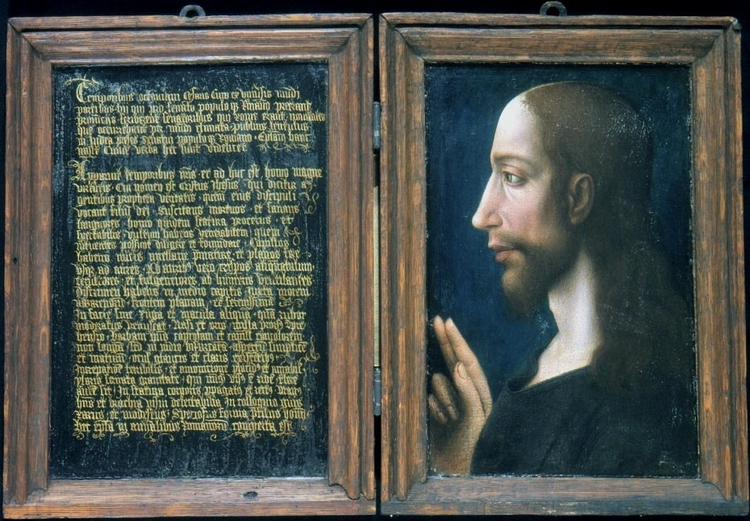
Diptych with the Letter of Lentulus and Christ in Profile (c. 1500), oil on wood. Utrecht Museum Catharijnconvent, MCC BMR s2, curtesy of google images, Joan E. Taylor “What did Jesus look like ”The European Jesus ,pp20

Before the First World War, the Lentulus letter rose to fame as a legitimate source confirming Jesus appearance. The letter was still receiving notoriety in the 20th century when a group of White Supremacists made white Jesus the face of their cause and relied on the letter as an epistemic truth, biographers of Jesus also referenced it when describing Jesus physically and lastly western iconography continued to churn out images that took inference from the letter regarding Christs appearance.

Another powerful image of Jesus, carrying additional significance for the anti-slavery movement, appeared on the back of American author infamous book “Uncle Tom’s Cabin” this book whilst fiction featured a black enslaved man named Tom as the protagonist, set prior to the Civil War, Tom who is a kind patient man is subjected to violence at the hands of his enslaver, this repeated brutality ends up killing Tom. The book was read by whites and ignited a new wave of sympathy towards enslaved people.

Shadowing the books notable impact Northern artist Hammett Billings drew Tom crouched down in submission whilst his enslaver is about to unleash a beating, appearing as an apparition in the background on the side Tom is Jesus depicted as white, silently communicating a message with a raised hand and finger poised in what appears to be admonishment to Toms enslaver, this image was created to show opposition to slavery and violence.

This must have broken through some racial stereo-types to ignite a wave of sympathy in the backdrop of mass slavery within America. Historian Mark Smith describes how white people believed that the black body was physiologically different to white bodies. Whites not only believed that blacks had an inferior set of sensibilities to whites, meaning that blacks did not have the sensory constructions to enjoy fine food and music, but they also believed that “black skin was thick and numb, whereas white skin was sensitive thin and sensitive to pain.”

The butchery of black slaves and the belief that they felt less pain was likely an invented construction to justify the immoral behaviour of the white enslavers. One sees a link between the butchery of slaves and the butchery of farm animals.

In as far back as the 1680’s it was believed that black people were only one link away from apes.

Harriet’s brother, Henry Ward Beecher also a writer, had aligned himself with the abolitionist movement. In the 1870s he too had a significant impact in the interpretation of Jesus. Beecher wrote a biography of Jesus

In 1871 called “The Life of Jesus, The Christ.” And whilst Beecher knew that Jesus was not akin to a” white” Beecher enlisted European artists to create five images of Jesus. The images were supposed to communicate that this was a Jesus for all people. However, the Jesus depicted was a very white-looking male, explicitly conveying the message that Jesus was white.

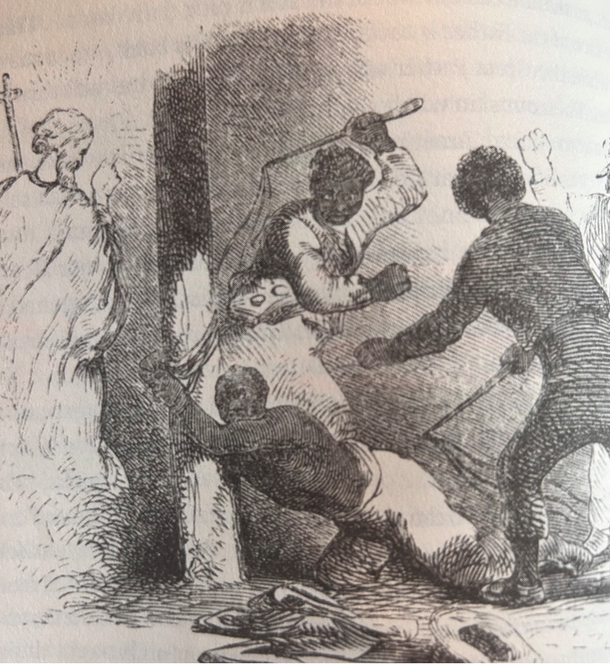

Jesus stands in disapproval of a slave being whipped, illustrated by Hammett Billings

The irony was that Beecher had tried to diversify Christs image and hoped that the audiences of all races would find some physical similarities between themselves and Jesus, but whilst Beecher was hopeful his images would be diverse, they only conveyed the message that Christ was not diverse from white Americans but very much like them. One could argue Beecher failed in his mission or had some confirmation bias himself that he had not recognised.

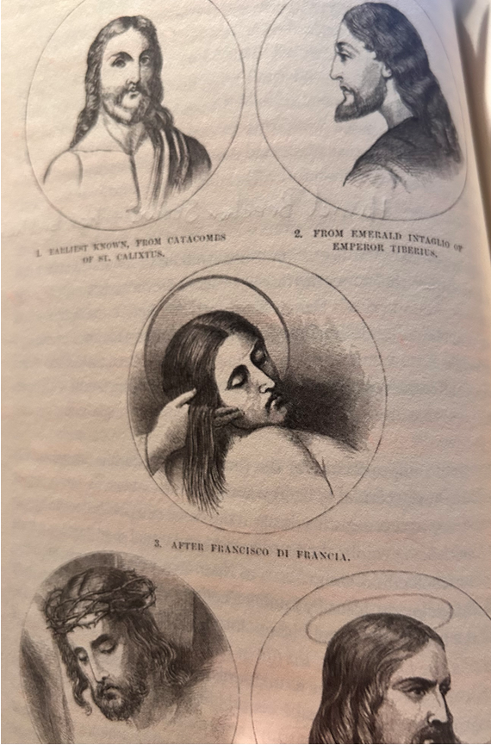
Five Depictions of Christ by numerous artists in Henry Ward Beecher, The Life of Jesus, 1871

Another image of Jesus that Americans worshipped in the late nineteenth century was by French Artist Jacques Joseph Tissot’s watercolour exhibition The Life of Our Saviour Jesus Christ. This picture presented Jesus as fair skinned with Anglo- Saxon features. In contrast to Jesus are his Jewish counterparts which appear to be questioning him, their features more middle eastern, the men have a stereo-typical larger protruding news. Here one can infer there are two messages being communicated. That whiteness is equal to goodness and that non- whiteness is fringing on immoral, the stark differences in features portray two camps of good versus bad. One can infer that the artist is taking ownership of Christ as “one of his race” and the Jews are being “othered.”
Unlike the 18th century’s age of visions when Jesus came in binding light and the Publius Lentulus letter was largely unknown, Jesus now conformed to that myth. For these Christians, he appeared almost uniformly as a white man with brown eyes, a beard, and long straight hair parted in the middle. Even more, his whiteness became embedded as part of his moral and ethical identity.”
An international favourite image of Jesus was painted in 1940 by Warner Sallman. Whilst Sallman was not guided by the Lentulus letter it was standard to view Jesus in America as handsome, fair and blue eyed.
There were mass reproductions of Sallman’s Christ. This image could be found everywhere in homes and the Sunday schools throughout America.
Young persons and children had this image thrust upon the walls of their learning spaces.
The power of imagery in the minds of young people should not be underestimated.
Lucius T. Outlaw (Jr) points emphasises that ignorance can be mass produced within the educational systems. He largely focuses on education as a primary space where ignorance is cultivated and shaped. “From the nineteenth century onward schools have been institutions of “Americanization”, “ a process of teaching, a hierarchical racial ontology in which white people dominate all others.”
In the article “Jesus was a White Man Too!” The Relationship Between Beliefs About Jesus’s Race, Racial Attitudes, and Ideologies That Maintain Racial Hierarchies by Simon Howard, Kaylen T. Kennedy, Kalen C.
This work interrogates social psychology and the relationship between Christianity and racism. An outcome of their study evidenced that in earlier decades, case studies revealed that their was a relationship between higher levels of prejudice and racism towards black people from individuals who identified as either Catholic or Protestant. The people who displayed no religious preference housed less prejudices towards black people Footnote Relationship Between Christianity and Prejudice.
Also found via empiric study was that Jesus and his iconography had lasting impactive impressions on children as young as four years of age. The exposure to a white depicted Christ helped establish a belief that God was white and even contributed to racial ideologies which complimented white supremacy. This is due to the association that Godliness is linked to “whiteness”
The pernicious effects of this idea is that children and adults’ associate power with White people particularly men. White people who displayed a belief that Jesus was white felt that this gave them a proximity to positions of power. The opposite is that children of colour may feel undeserving and restricted from positions of importance. Implications, Limitations and Future Directions.
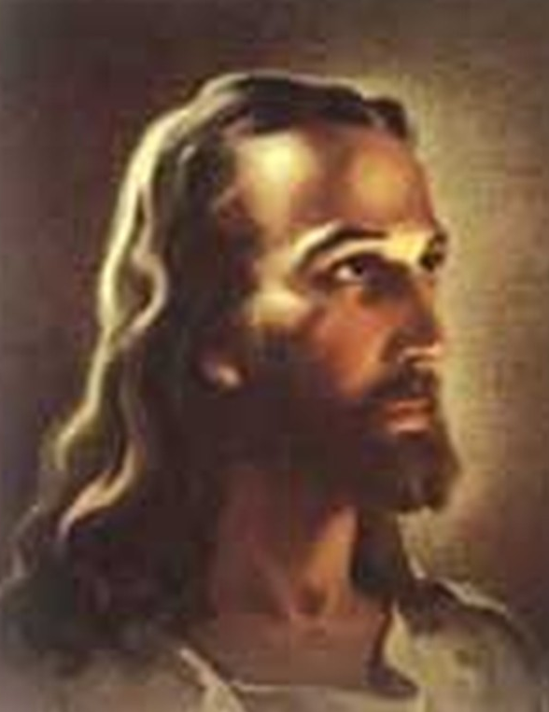
Head of Christ (1940) Warner Sallman, curtesy of Google images
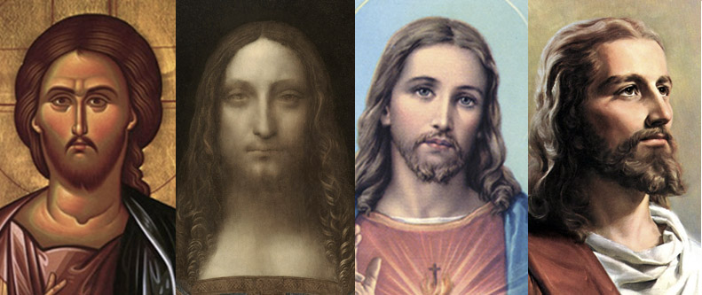
Universal Western Depictions of Christ, curtesy of Google Images upon search for Jesus Christ
Civil rights and the Colouring of Christ p205,206, 1957 to 1960s.
In 1957 Dr Martin Luther King whose PHD was in systematic theology was well versed in theological epistemology. He received a letter to his popular advice column which featured in Ebony Magazine.
The letter questioned King on the colour of Christ’s skin “Why did God make Jesus white, when the vast majority of peoples in the world are non-white?”
King answered the question indifferently choosing to focus on the abstract, stating that the colour of one’s skin is irrelevant to the content of one’s character. This failure to address colourism and racialisation of Jesus as overwhelmingly white upset a lot of the magazine’s readers. The omission to acknowledge that Christ was non-white and that colourism did matter, was rather un-empowering to its audience, race did matter and so did colour.
If one does not see race and colour, then it renders one invisible.

Sixteenth Street Baptist Church Bombing
“Four little girls
Who went to Sunday School that day
And never came back home at all –
But left instead
Their blood upon the wall “
American Poet, Langston Hughes – 1901 – 1967
In 1963 just three weeks before Martin Luther King’s infamous “I Have a Dream” speech, horror erupted at the Sixteenth Street Baptist Church. White supremacists planted a bomb in a bid of opposition at the prospect of African Americans being granted the right to vote.
The African American church was blown up and so were four children, all girls, who were inside of the church that day. This terrorist attack sparked international outrage but also scholarly debate on the face of Jesus.
As a consequence of the explosion, rather astonishingly, Jesus face was blown perfectly out of his image in the church glass window leaving him faceless.

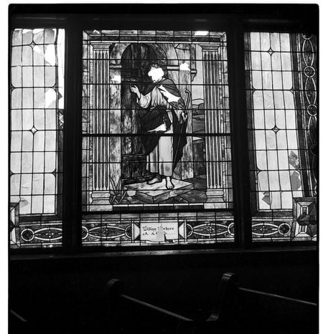
Faceless Jesus post bombing of the Sixteenth Street Baptist Church Bombing , 1963, curtesy of Google Images
This was rather profound in many ways “Here was a white Jesus at a black church. Here was a centre of civil rights activism targeted by white supremacists who destroyed a white icon.”
What followed was the key question who would replace this anonymous figure in the window.
A rather hopeful ending to this event came from Wales itself. It was in Cardiff that children had received news of this terrible attack. The “penny campaign” was started to help raise money for the remediation of the window and artist John Petts was elected to design a new window for the church.
The Wales Window for Alabama was designed as an icon of black empowerment. The words “You Do it Me “ are peppered around the feet of a black Jesus.
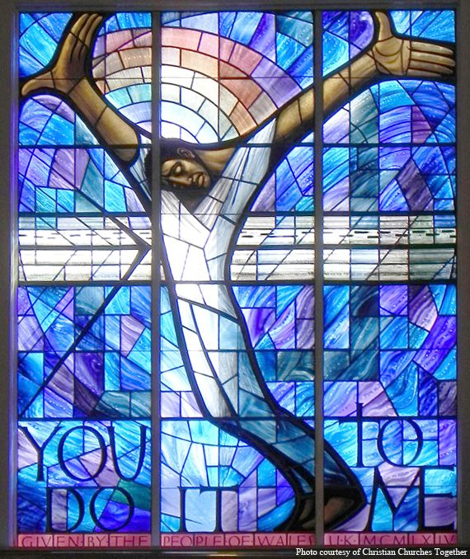
The Wales Window for Alabama, curtesy of Google images

Blum and Harvey explain that, despite this image being created out of care and respect from the people of Wales, some white Americans raised a problem with it. The image was criticised for implying that Christ had his fist raised as a symbol of Black Power.
Even after a terrible event, the notion that people who were not associated with the Church felt empowered to criticise the new image evidences how race and depictions of Jesus are fuelled with racially motivated appropriation, some felt that even an African American church should not have an image of a non-white Christ. This signifies that politics has a deep - rooted seat in the power dynamics of religion.
Some other infamous depictions of Jesus come from Leonardo Da Vinci who painted Jesus as “Salvator Mundi” Latin for “Saviour of the World” dated around the 15th or 16th century Wikipedia
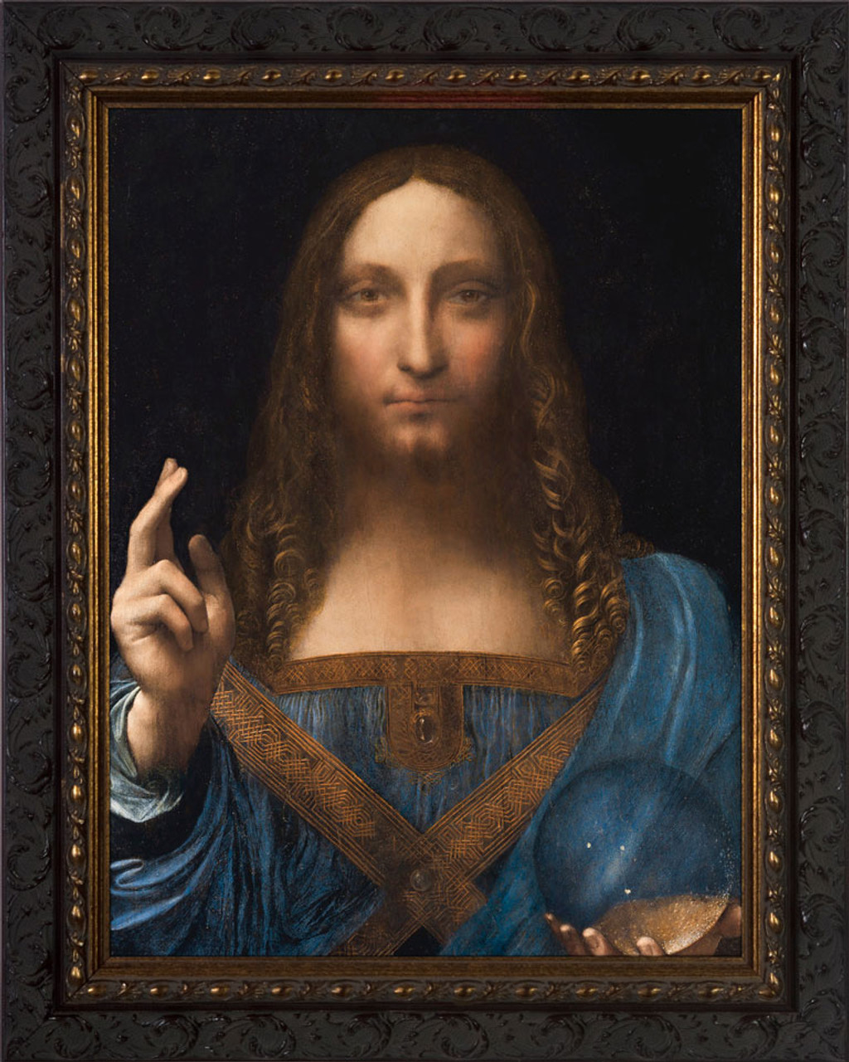
One of the most famous images called “Salvator Mundi” by Leonardo Da Vinci circa 1499 -1510, curtesy of Google Images

The history and process of racialisation of the Mormons
There has been no other Christian group that matches the commitment and rigour of the Mormon church when it comes to upholding the concept that Jesus Christ was white.
When I first heard of the Mormons, I had always heard rumours that the Church was anti-black, as an American born and dominant religion my interactions with the Mormons have largely been influenced through culture.
However, I came across some incredible Mormon scholars who have documented Mormon history with such precision, it makes a fascinating case study.
Mormon history offers a lens on how the paradigm of racism works via operating through the dissemination of flawed epistemologies. It shows how epistemologies can shape and shift through time depending on the social political agendas at the time.
The Mormon story is the perfect storm of what happens when the discriminated become the discriminators and how Western society position Christ within their epistemological framework to justify their behaviour to uphold white supremacy.
Mormon scholar and historian Paul W. Reeve explains that the backdrop of the 19th and 20th century was a complex transitional period for the Mormon church and this transition was largely racial.
The Mormon church was founded by the prophet Joseph Smith circa 1830.
New Yorker, Joseph Smith had his first religious experience with God around 1820, Smith claims that God spoke to him.
Smiths reported religious experience has gone under many revised versions of what was said, all revised by himself over the years. I think this it is important to note, because Smith was the ultimate orator of the Mormon religion, even his words today carry testimonial meaning, what he says is that of God.
I think it’s notable from an epistemological tale that the interaction he states he had with God was subject to many interpretations and alteration over the years.
Here we see the start of where words and interpretation in Mormonism can change over the years to suit its orator.
Smith says he saw a “pillar of fire.” But then this changed to a “pillar of light” then Smith writes “I saw the Lord and he spake unto me saying Joseph thy Sins are forgiven thee.” However, Smith felt this was not a true reflection so he states he saw the “crucified Lord” who had actually said upon further thoughts “Joseph my Son thy Sins are forgiven thee.”
In 1835 Smiths religious encounter became revised again. This time Smith stated he saw two “parsonages” from the “piller of light” these “two parsonages, whose brightness and glory defy all description, standing above me in the air.”
What comes next sets a racial precedence and life changing ripple affect that continues to affect race relations in the church even today.
Smith described Jesus in 1844 as a man with a “light complexion and blue eyes.”
“What had been painstakingly penned as binding light, as consuming fire, as defying all description, was now in the form of a white man with blue eyes. In less than twenty years, Smith’s account of seeing Jesus had shifted from one of lightness to one of whiteness.”

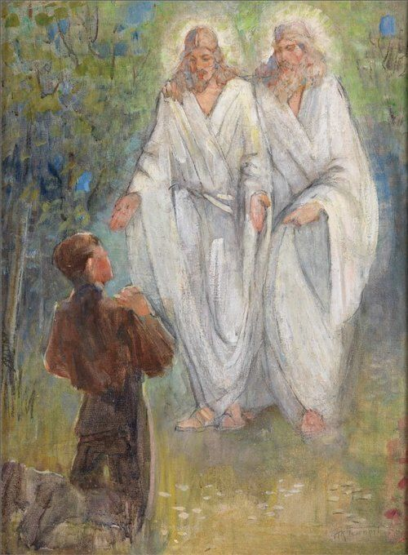
Minerva K. Teichert, The First Vision (1934) Joseph Smith sees Jesus Christ, curtesy of Google Images

Before I delve into the racialisation of Jesus by the Mormons, its imperative to understand how the Mormons became discriminated against themselves, and labelled as “non-white” despite being American born.
To understand the context of race in the 19th century. Historian David R Roediger describes how race was managed in American history.
“In the United States of a century ago people did not talk about race in the way we do. Ever shifting and frequently contradictory definitions of race and racial hierarchies functioned at all level’s American society. Race operated as a hierarchical system designed to create order and superiority out of the perceived disorder of the confluence of peoples in America. Race could be variously marked by language, national origin, religion, laws and government, marital relationships, and a variety of cultural characteristics. In general, “race” was a loosely used word that sometimes referred to nationality more than skin colour, especially in reference to immigrants from Europe. Nineteenth – century writers did not simply refer to “the Irish,”
What is remarkable about the Mormons is how they were persecuted by mainstream society despite their physical proximity to being white.
Reeves explains that one of the main reasons Mormons experienced discrimination was because some Mormon’s chose to engage in polygamy and plural marriage. From conservative Christians looking in this was immoral and akin to what they imaged non-white “savages” to behave like. This behaviour was not an American ideal or aspiration and it disgusted many people.
For those that did practice polygamy, the result was high numbers of children. Anti- Mormon writers wrote of how the unnatural practice of polygamy produced deformed children both physically and morally.
Before the Civil War an Army Doctor described the children of polygamous Mormon marriages as a physically new and deformed race “the yellow, sunken, cadaverous visage, the greenish-coloured eye: the thick protuberant lips, the low forehead, the light, yellowish hair, the lank, the angular person, constitute an appearance so characteristic of the new race, the production of polygamy, as to distinguish them at a glance.”
Reeves explains that this sort of Anti – Mormon propaganda was what ignited the notion that Mormons were not just a different religion and culture but their physical bodies were different too.
We see this method throughout history, African American bodies being likened to apes and therefore classified as sub-human to justify the inhumane treatment of slavery. Jewish people in the Second World War being drawn with cartoon hooked noses.
Mormons were “racialised” with the derogatory term “Mormonite” this term was created to distinguish Mormons from non-Mormons, after all Mormons looked white. This created a challenge in “racialising” them by 19th century standards.
An 1831 report described “Mormonite’s” as “ignorant” followers of Joseph Smith, “silly sheep,” and “a community of vagrants, lovers of idleness,” “haters” of manual labour, “strange people” and “deluded when they decided to follow the “false prophet of Joseph Smith.”
Discrimination and racism have a “Modus operandi” which houses Heterophobia which was coined by Sociologist Zygmunt Bauman.
Heterophobia is the fear of the “other” and it arises from the anxieties that can occur in social settings where one cannot control or influence the situation.
“Heterophobia may appear as either a realistic or irrealistic objectification of such anxiety – but it is likely that the anxiety in question always seeks an object on which to anchor, and that consequently heterophobia is a fairly common phenomenon at all times.”pp15 kelly footnote
Kelley highlights that this objectification of anxiety takes form in the manifestation of racism which is fuelled by housed ideas from exaggerated stereo-typical hyperboles often used in a negative way.
What is note-worthy about stereo-types is that they can derive from a lack of direct interactions with the said group being stereo-typed meaning that they are derived from a non-empiric way arguably they are derived from “a priori” means but based upon no credible experience.
For example, George Fredrickson argues that stereo-types reveal little truth about the group being defined but reveals a lot of truth about the persons doing the defining.
I think this is impactive because black people in America were subject to many false stereo -types for example that they were lazy, dangerous, stupid and sub-human. Yet if the really sub-human then why would so many white women use black women as wet nurses to bring up and feed their children.
If black people were lazy and dangerous why did they live in the households of white families as house-keepers and clean and tidy their homes, these postulations are at direct odds with each other.
One also parallels this with the prejudice experienced from the Mormons. The same “MO” occurs in the ambition to discredit the Mormons through racial stereo-typical propaganda. Mormons were framed as different biologically and morally. This is what allowed the continued discrimination from the dominant groups.
As previously discussed I have noted how the Mormons were marginalised and “othered” by mainstream society because of the religion and decision to engage in polygamy.
Another remarkable catalyst to preface the discussion of how and why Mormons banned black males from ordination into the church came in an example of an incident involving Latter Day Saint newspaper editor, William Wines Phelps.
In “Let’s Talk About, Race and Priesthood, W.Paul Reeve introduces a catalyst in Mormon history which alters the Mormon stance on black issues.
Reeves discloses that in Jackson County, Missouri in July 1833, Mormon journalist Phelps wrote an article titled “Free People of Colour” This article was inspired by Prophet Joseph Smiths recent vision of a Zion society, a utopia in Jackson County where all men would be welcome “with no poor among them.” Moses 7:18) This Zion place would be a place of inclusivity.
Phelps article triggered a monstrous backlash. The industry of human slavery was rife as well as racial tensions. The United States President Andrew Jackson had just enforced the removal and forced relocation of indigenous Native Americans in a bid to solve “the Indian problem.”
Phelps call to free people of colour upset the white majority and as a consequence the Mormons were criticised and turned upon as race against the American constitute.
In the 1830s “amalgamation” meaning the mixing of metals, also known as “race mixing” was an abomination and seen as “anti- white.”
Phelps in a panic and unprepared for the backlash published a revised article, stating that his article was solely aimed at Black Mormon as a means to educate them on the laws of Missouri. Black Mormons were welcome in Zion, Phelps stressed was all he was trying to communicate.
Phelps made believed that there should not be racial barriers in the church at Zion. However, members of the public felt Phelps was inviting all Black Americans to gather at Zion at partake in race war via a rebellion.
Reeves explains that the outrage and anger of public opinion was too much to bear for Phelps and the Mormon community. Phelps caved under pressure and did not stand his moral ground. Instead he published a statement saying that the article “FREE PEOPLE OF COLOUR had been misunderstood, we feel duty bound to state, in this Extra, that our intention was not only to stop free people of colour from emigrating to this state, but to prevent them from being admitted as members of the church.” Ppp44 race and priesthood
This was a potent decision for Phelps and the church. They no longer took a public stance in the anti-slavery discourse, instead they added a further chain to it metaphorically by turning away their support for the freedom of black individuals.
This decision was a metaphor for what was to come in relation to Mormons earning their reputation for being hostile to blacks.

The Old Testament and the Curse of Cain
One of the most helpful books in Mormon theology I read is The Mormon Church & Blacks by Matthew L. Harris and Newell G. Brington. It sets a documented history on Mormon Theology and scripture.
Much like Joseph Smiths revised accounts of his religious encounter with God, his stance on racial issues were equally changeable. He fluctuated between supporting slavery and denouncing it.
One of the most influential reasons for Smith ultimately deciding to support slavery was for self – interest. As previously highlighted Smith saw Jackson County in Missouri as a gathering place for his Zion community. Missouri was a slave holding county.
It was a state aligned with Southern views, no race mixing and that black people should remain as property.
Smith rested on his theological beliefs that declared blacks were cursed with servitude. Smith did however welcome black members of the church but he did not view them as equal. Smiths views on race adapted with the context of the times and he altered his politics in view of what would benefit himself and the Church.
The Book of Mormon does not explicitly address issues of race relations nor slavery. Instead it tells the story of an ancient civilisation in America, where immigrants from the Holy Land settle in North America around 600 BCE. The protagonists of the story are a community called the “Nephites” lead by a man named Nephi. He builds a successful civilisation which lasts for hundreds of years.
Nephi has two evil nephews, named Laman and Lemuel who are labelled as “Lamanites”, the Lamanites set out to destroy the “Nephites” and Nephi through war. The Lamanites win and the Nephites are wiped out leaving only the Lamanites. The Lamanites are those who God cursed with dark skin. Smith and his followers believed that Native Americans were descendants of the Lamanites and that the Mormons were descendants of the Nephites.
The Book of Mormon alludes that those who fell out of divine favour with God such as the Lamanites would be “cursed” with a dark skin. The Mormons did use the term black and red interchangeably to describe African blacks and Native Americans when referencing the “curse” of dark skin.
“21.And he had caused the “cursing to come upon them, yea, even a sore cursing, because of their iniquity. For behold, they had hardened their hearts against him, that they had become like unto a flint; wherefore, as they were white, and exceedingly fair and “delightsome,” that they might not be enticing unto my people the Lord God did cause a “skin of blackness to come upon them” 2 Nep 5: 15-24
The Mormons also refer to another unfavourable group in the Book of Mormon called the “Jaredites.” This group pre-dated the activities of the Lamanites. “While the Book of Mormon references to the Jaredites precise ethnic background are somewhat vague, it states that this people originated in a region near the Tower of Babel before moving to the valley of Nimrod – areas identified with the descendants of Ham.”
In the 19th century Mormons believed that Africans were descended from Ham. Influential Mormon apostle Parley P. Pratt went on record to assert that the “genealogy of the Jarodites” could be traced directly to Ham.
Pratt stood in opposition at the proposal to allow black Mormons to be ordained into the Priesthood of the Mormon church. Pratt justified his views from drawing an inference from a text that Joseph Smith published in 1842 which spoke of the book of Abraham. This book tells the story of a King of Egypt who is descended from Ham, and mentions a woman named Egyptus whose son becomes a pharaoh but he carries out idol worship and tries to mirror priesthood through worshiping physical representations of God, he also was not the first born of the ruling leader but the son of Egyptus. This king of Egypt had no lineage to be worthy of being in the Priesthood, both by birth, being a descendant of Ham and also by lack of virtue. This Old Testament story was used by Smith when ordaining his father to the priesthood and brother.
The Pearl of Great Price was a theological scripture written by founder Joseph Smith. It was his efforts to correct some of the information found in the Old and New Testament.
This scripture focuses on Mormon opinions regarding black people. In this scripture some Mormons believe Ham’s wife Egyptus produced an heir of Ham which preserved the curse in the land. Egyptus was believed to be a descendant of Cain and she was herself cursed. Many Mormons utilised this scripture to justify their discrimination against blacks receiving the honours of priesthood.
Whilst Smith did not explicitly use this story as a literal means to ban blacks from ordination. Some Mormons interpreted this tale as evidence that those descended from Ham were not worthy of the priesthood.
Following Smiths death, Brigham Young was the church’s leader. Young becomes a hugely influential prophet both in the past and of today. The Brigham Young University (BYU) the leading university for Mormons is named after him.
It was in 1852 that Brigham Young enforced the Priesthood Ban against black males into the Mormon Church. Young however chose to justify his ban upon the story of Cain and Abel. Young believed that when Cain murdered his brother Abel it was then that God cursed Cain’s descendants with dark skin, he said in 1849 “ the curse remains on them (Black people) because (Cain) cut off the lives of Abel to hedge up his way & take the lead but the Lord has given them blackness, so as to give the children of Abel an opportunity to keep his place with the descendants in the eternal worlds.” Pp 86, 10 Brigham Young Openly Articulates a Racial Restriction, Race and the Priesthood
Another reason why Young is thought to have denied black people lineage to the Priesthood is because Young believed that Mormons themselves were direct descendants of the chosen people of God i.e. the Nephites and
“Mormons emphasised their “ethnicity” as divinely chosen people characterised by their “whiteness”
Young believed that white Mormons who had a lineage to the Holy Land and were the chosen pure race who had a lineage connected all the way back to Abraham. Abraham was one of the most important figures in the Old Testament who had made a covenant with God that he would be the father of a great nation, this later came true through his descendants who were the Israelites.
The priesthood ban would transcend 126 years until in the year of 1978.
Prophet Spencer W. Kimball became president of the Mormon Church between 1973 until his death in 1985. In 1978 Kimball had a revelation from God to reverse the decision to ban blacks from the priesthood. This revelation Kimball reports was a difficult one to accept, as he has deep rooted Mormon epistemic truths that “Negroes should not have the priesthood and I was prepared to go all the rest of my life until my death and fright for it and defend it for what it was.”
As the true orator of God, Mormons had to accept this revelation as fact and truth. The Church re-opened its doors to black men and returned to an all-inclusive church who welcomed people of every race and colour.

State of Mormonism and White Jesus today
Today the Mormon church distances itself from theories related to curses and dark skin. Church leaders are openly aligning themselves as allies to the anti-racism cause.
The Mormons are choosing to abide to the scripture that “all are alike unto God.” 2 Nep 26:33.
To explain the problems of the past, Mormons state that the references of light and dark in the bible are more metaphorical rather than literal and that the verses were more “idiosyncratic” and subjective.
However, the shadow of racism has bred into the epistemologies of the younger Mormon generations evidencing that the power of language and dogma is very embedded within Mormon culture.
In 2012, Professor Randy Bott from Bringham Young University carried out an interview with the Washington Post. Upon the ground floor of BYU Religion department is a picture showing dark skinned Lamanites, bearing the cursed skin from God. Bott explains that there is a possible theological connection which justified the banning of blacks from the priesthood because according to Mormon scripture he states the descendants of Cain who killed Abel were black. To make matters worse he claims that “God has always been “discriminatory” when it comes to who he grants spiritual authority to. Bott goes on to compare liken black people too children who may prematurely ask for the keys for the parent’s car but are not fit enough to drive it. He states blacks were not ready until 1978 for the responsibility of the priesthood. Bott contemplates on what this discrimination from God meant and concludes that it was merely God protecting blacks from not making into the afterlife, he protected them from abusing their would-be priesthood rights, concluding that Gods ban of blacks from the priesthood was a blessing from God to blacks.
Washington Post article on black priesthood ban spurs concern, outrage - BYU Daily Universe
Further problematic incidents reported by Black Mormons are a Mormon bishop asked a black woman to run a basketball programme, she believed this was because of her race, some white BYU students proposed holding a “slave auction” of black students, an English BYU Professor complained that parents of students were still teaching their children racial stereotypes and negative racial views. A black Mormon actress reported that she was told that she would be “white” in the next life.
These are a few examples and there is more of the epistemologies of ignorance being handed down through generations.

Mormons and Imagery of Jesus
Mormons did not start creating their artwork until later in the 20th century. The beginning of the 20th century saw Mormons use the traditional universal images of Christ. Mormons a traditionally conservative religion and highly gendered to favour male superiority avoided depictions of Christ where he looked too feminine or sad and homo erotic. They favoured a highly masculine Christ.
Mormons who had been subjected to so much prejudice and cast outside of the normative standards of what it meant to be a member of the white race, really concentrated on taking back their “whiteness” and their imagery was a factor in how they communicated this to outsiders.
In 1969 John Scott painted a highly esteemed image of Jesus Christ that Mormons would feature in the Book of Mormon as well as in their homes and churches.
Scott’s image details Jesus as white, with blond hair and blue eyes interacting with Anglo- looking native Americans who are dressed in Wester sixties fashion rather than their traditional wear. Jesus is showing them his wounded hands as they look up to him in awe. 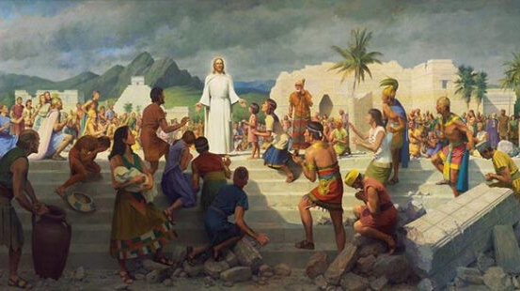
1969 John Scott Image, favoured by Mormons , curtesy of google images
Here we see a white Jesus as a white saviour to the non- whites. When it comes to Mormon depictions of Christ he is always fair skinned, fair haired with blue eyes.
Mormons also exploited an old Danish statue that was called Christus which was crafted in 1821 by Danish sculptor Bertal Thorvaldsen. It as in 1966 that a white replica was commissioned and placed at the Temple Square in Salt Lake City. It has become a beacon of Mormon iconography.
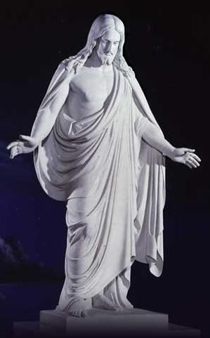
“Christus” 1821 by Danish sculptor Bertal Thorvaldsen, curtesy of google images
The Mormon image of Christ carries an important and subtle but abstract message. The message being that Mormons held membership to the white race, not just by physical appearance but by legitimate biology itself. The Mormons were not just “white” but they wanted to communicate they had a lineage of “white purity.”
Upon visiting the Mormon website of The Church of Jesus Christ of Latter-Day Saints – ChurchofJesusChrist.org , LDS Art | Images of Christ | Jesus Pictures, Art & Paintings of Jesus – LDSArt.com
I have included below present day Mormon artwork that I found on the LDS (Mormon) website.
Del Parsons a popular Mormon artist painted a famous image of Christ used by millions of Mormons today. This picture is titled “Christ in Red Robe” Parsons presents a fair skinned Christ with fair features.
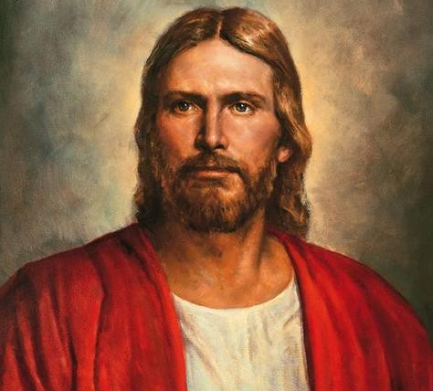
“Christ in Red Robe” by Del Parsons, curtesy of LDS.org Artwork

Other Mormon artwork of Jesus for sale on the current LDS Mormon website.

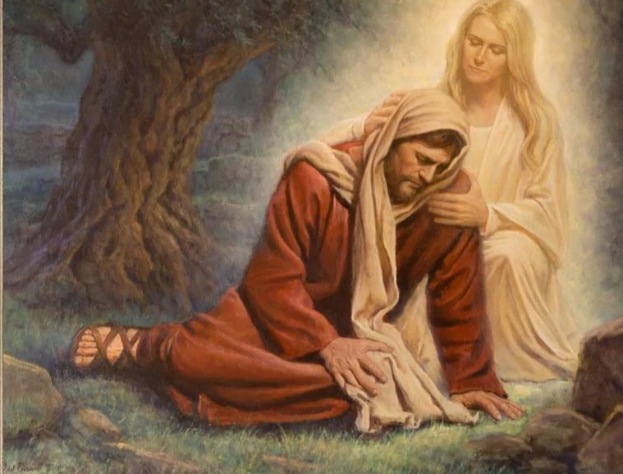
“Heavenly Mother” by Del Parsons – Here we see Jesus mother as blond and blue eyed. curtesy of LDS.org Artwork
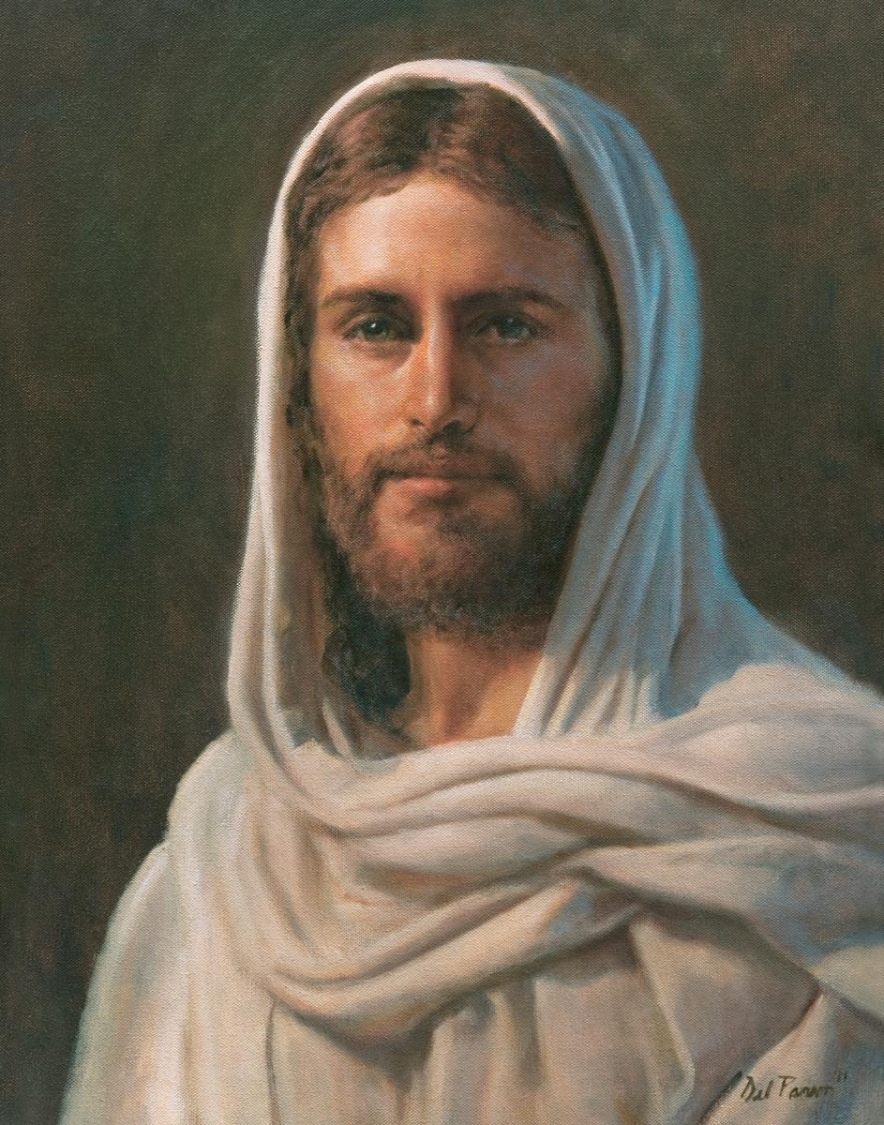
“The Light of Christ” by Del Parsons, curtesy of LDS.org Artwork
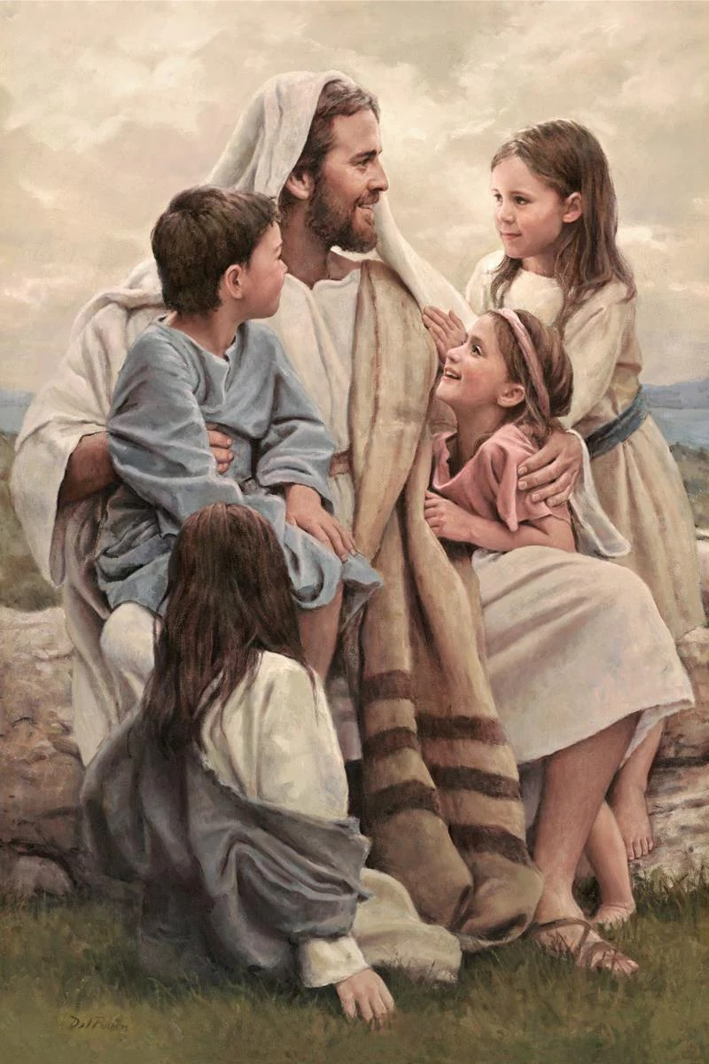
“Perfect Love” By Del Parsons – curtesy of LDS.org Artwork

I think it would be apt to re picture Taylors image of Christ and view it against the problematic history of Mormons and race. Taylors image would bring down the foundations of Mormon dogma that the Israelites were not necessarily white skinned and favoured by God. The Son of God according to Taylor was dark skinned. This concept would be a difficult epistemic hypothesis for Mormons to accept.
However, it is not just the Mormons who would find the idea of accepting Taylors image of Christ at odds with their beliefs.

Why is White Jesus pervasive beyond Mormonism and what does Philosophy say about this? What is interesting about this from a philosophical point of view?

“White Ignorance…
It is a big subject. How much time do you have?
It’s not big enough.
Ignorance is usually thought of as the passive observe to knowledge, the darkness retreating before the spread of Enlightenment.
But…
Imagine an ignorance that resists
Imagine an ignorance that fights back.
Imagine an ignorance militant, aggressive, not to be intimidated,
An ignorance that is active, dynamic, that refuses to go away quietly – not at confined to the illiterate and uneducated but propagated at the highest levels of the land, indeed presenting itself unblushingly as knowledge. Charles W. Mills
This quote from Charles W. Mills encapsulates the challenge of being heard and seen in a world where white supremacy reigns as the dominant political agenda.
The Mormon story and its relationship with race is similar to the Western world’s relationship with race. There is a commonality of dysfunction and false epistemologies ascribed to people of colour that relegates them as inferior or excludes them from having a role in the collective social set up of the dominant parties.
Mills asserts that an “officially sanctioned reality is divergent from actual reality”
Mills suggests that the realities constructed by the dominant group create an illusionary false reality whereby false assessments are validated and accepted as truth because these false perceptions have an agenda, to actively engage and absorb these false perceptions is to assume an epistemology of ignorance.
“These patterns are functional in the sense that the dysfunctions do important work for the people who “suffer” from them. The devotees of racial supremacist ideologies – both oppressor and oppressed, master and servant will construct for themselves an “invented delusional world, a racial fantasyland.”
One can draw parallels between Mormon ideologies referencing the curse of Cain and the priesthood ban, here, one can see the oppressors creating changeable epistemologies to suit certain wants and desires by reducing black people to be undesirable partakers in their collective community, reducing them to outsiders with no powers.
To make his point Mills clarifies that “ the social contract” is actually several contracts in one. Contemporary contractarians usually distinguish, to begin with, between the political contract and the moral contract, before making (subsidiary) distinctions within both. I contend, however, that the orthodox social contract, also tacitly presupposes an “epistemological” contract, and that for the Racial Contract is crucial to make it explicit.” Charles W. Mills
In the Racial Contract, Mills argues three points. That white supremacy is “local and global”, secondly that it is embedded and is in fact our Western political system and lastly that it has been that way for hundreds of years. Mills is asserting that white supremacy can be theorised as a “contract” between whites only, this is the Racial Contract.
Charles W. Mills is dismantling the normative “social contract” by arguing that to have a “social contract” one must all be socially invited to partake in it. There is an assumption that all of society is invited to partake in this contract. Mills is pointing out that within the structures of white supremacy there is no “we” only “I”. White supremacy by its operational needs is intrinsically exclusive.
Mills highlights that society is not equal because of race, race acts as an organisational model of exclusion. Therefore, the normative “social contract” we are taught in philosophy for example is by its nature, is deeply flawed, because it fails to address the inequalities within society.
The normative “social contract” is for whites only.
This can be linked back to Kant’s observation on blacks and a lack of intelligence. This idea that black people lack the equal faculties of reason and rationality which was embedded in Western thought, one saw this in Black Athena, the proposition that the Greeks were influenced by African philosophies seems nonsensical in the Racial contract. Furthermore, Mormon dogma that blacks were inherently flawed by nature with a wickedness due to their alleged descendants all evidence this dysfunctional reality that Mills speaks of.
The narratives that blacks were inferior both in mind and body, is what excluded them from being given civil rights, the right to vote and the right to freedom.
The idea that blacks can now “partake” in this “social contract” is naïve to a degree. There are still huge inequalities amongst the races even today.
Mills in summary is stating that when it comes to race the Racial Contract offers a thought-provoking postulation on the consequences of this inverted epistemology where whites have created a dysfunctional exclusive society which favours one group over others. The outcome will be the ironic reality whereby whites will create a world that they will fail to understand themselves.
A good example of this is in Elizabeth V. Spelman’s work entitled “Managing Ignorance” Spelman references that white Americans are struggling to grasp the true horrors of what they went through in America historically. She argues that white Americans remain unable to believe that Black grievances are real because it will force them to “face what this fact says about themselves and their country.”
Spelman explains that ignorance holds a certain currency for white America. That there are certain benefits to upholding ignorance. If whites do not believe that the black experience is real, and they do not want it to be real, then whites will believe that the black experience is indeed not real, and therefore whites will end up concluding that the black experience of racism is illusory.
An additional problem that one could concur from Spelman, is that in modernity there is an expectation for racism to be overt and out in plain sight. Whereas, racism in this day and age is often subtle and covert. This aids the rejection of the black experience being taken seriously, because civil rights have been granted and segregation no longer exists.
Robin DiAngelo wrote a book called “ Why I am No Longer Talking to White People about Race” within this book she brings forth the concept of “white fragility” to describe reoccurring patterns of behaviour within white people when confronted with the topic of race and the black experience. DiAngelo explains that one us usually met with denial and silence and what Charles Mills referenced earlier in his description of “white ignorance.”
When it comes to making the experiences of the black identity visible, the structure of white supremacy is designed to shut it down, silence it and reduce it to invisibility. An example of this would be when people of colour are accused of playing “the race card.”
“The use of “playing the race card” is the transference of a false equivalence of privilege to Black people that has no substance or bearing in the real world.” Dr Shola Mos – Shogbamimu.
If whiteness was a personality disorder then it would be akin to covert narcissism which houses elements of gaslighting.
The concept of white privilege as a form of “knowing” is a form of epistemological ignorance.
As Dr Shola MOs- Shogbamimu states “White privilege is also a demonstration of how you cannot recognise and understand what you don’t experience. Today we find White people (not all) often demand for racism to be proven to them – they place an unreasonable burden on Black people to explain it to them and propose solutions” pp15 This Is Why I Resist, White privilege is fact not fiction, Does White Privilege Whitewash Racism?
Another form of ignorance can travel in the form of “a priori” knowledge which some argue is embedded into the DNA of white people based upon the residual effects of white supremacy.
Alexis Shotwell highlights that in opposition to propositional knowledge i.e. where knowledge is verbalised and delivered explicitly there is another type of knowledge which is tacitly communicated implicitly. This type of knowledge is felt within the body and it facilitates the “conditions for things to make sense to us”
The physical body acts as a tool for the absorption of knowledge. This assertion is stating that our body can assume feelings viscerally and produce meaning.
This is paramount when it comes to the concept of race and how human relationships are governed.
Racial embodiment at its core is a visual means to the exchange of information within society.
Shannon Sullivan in “Pedagogy of the Sensuous” recalls an incident in the classroom where she asked her students to address stereo-types of African American men as sexual predators.
One female student said “I am scared of black men! If I pass one in the street at night, I can’t help it. I tense up and get knots in my stomach.”
Here we can see the residual damage of racial stereo-types and its perpetuation within the white political reality created in Western thoughts.
This is powerful because knowledge is being replicated within our DNA, racism is such a powerful facilitator of emotion that not only is it lurking in the human mind but it also has a seat in its physical body and can be awoken when confronted by bodies who are not white.
Sullivan points out that for racism to function and live on it has to be ideologically embodied within the physical body. This housing of racist ideology within the physical senses of our bodies forms a collective and “regenerative community.
Racism is such a clever mastermind that it targets the colour of one’s skin because it is a visual reminder of difference and allows for an organisational tool to enforce it.
In Race and the Senses in its conclusion Sekimoto and Brown cleverly assign two meanings to skin colour, one physical and one metaphysical. They highlight that racialised subjects embody two skins, one skin as the bodily organ which experiences touch as an organ and as a biological cover to the body and the second meaning being that it gives the subject an additional awareness of being different from the dominant group, it can make the subject feel self-conscious, in danger and controls the receptivity of how some whites may perceive them.
The implications of race and skin colour are far reaching because it ignites an exchange of feelings between humans.
Rather profoundly Edith Stein in “Feeling Empathy in Intersubjective Encounters” Race and the Senses, theorises that empathy involves the process of the ability to be able to see oneself in the others.
Racism takes that faculty away creates a barrier which prohibits people from having the experience of being able to imagine the feelings and lives of others.
Stein declares that “individuals develop empathy through the process of viewing the emergence of the Others experience, situating oneself in the place of the Other, and by providing a comprehensive account of the Other’s experience”
Empathy unlike forms of sympathy add an additional dimension, an additional hoop so to speak for the subject to jump through to penetrate the understanding, emotions and feelings of others.
Stein states that empathy as an exchange between two persons is a “foreign consciousness” and “the experience which an “I” as such has another “T” as such.”
Sekimoto and Brown in “Race and the Senses” want to argue that that intersubjective experiences are integral to the studies of racial embodiment, epistemology and race.
If humans are unable to engage in an intersubjective way based upon the barrier of race then this is an explanation as to why Charles W. Mills’s Racial Contract functions so effectively and to why members of the dominant collective group i.e. white supremacy ae unable to accept the possibility of a non-white Christ.
This implications of racism and the appropriation of a white Jesus matters, because it infringes on our sensibilities and affects our ability to develop empathy for people who are different to us.
White supremacy builds an intersubjective barrier to the sensibilities that allow human relationships to function successfully.
As Charles W. Mill’s states “The Racial Contract “ constructs a dysfunctional reality for the collective dominant group to inhabit, which is at the detriment of erasing the oppressed groups experiences.
In a chapter named “Racism 101” Brown who is a black American man interviews white men in leadership positions. He interviews a man named Greg who discloses that he and his wife, both white, have adopted a “very dark skinned” girl from India who is 1 years of age.
Greg recounts to Brown, an experience whilst in a grocery store shopping with his daughter where an elderly white woman approaches them and touches his daughters face and looks to Greg and his wife in bewilderment. She then mutters “Is this your daughter?” to which Greg says yes and explains they had just adopted her.
The elderly lady’s response was “Oh my, she is so dark. How could you kiss her?”
This encounter horrified Greg and it gave him a metaphysical slap in the face on what it is like to step into a reality where race is a target by the dominant collective. Greg said it was like a welcome induction to “racism 101.”
Brown writes that he had sympathy for Greg, but Greg’s story triggered in Brown his own “bodily reactions that felt a target of racist epithets and acts.”
This example highlights that a white man and a black man live in two realities, the white man predominantly shielded from the experiences of the black man.
One can see that racism produces two realities, one reality for the white experience which allows “whiteness” to move within in it largely unseen by its white members enjoying a freedom of movement.
In contrast to this, is another reality of the black experience where racial embodiment prevents a freedom of movement without being seen, in contrast to being visible due to racial embodiment, the metaphysical side of the experience is largely unseen and unaccredited.
Invisibility of the non-white experience and the lack of genuine intersubjective relationships within the reality created by the dominant white collective is arguably another method why the erasure of Jesus race was enabled to re-generate throughout the centuries and why Joan E. Taylors image was so troublesome for some.
Black Liberation Theology is an American theological movement where black theologians argue a similar point.
James H. Cone one of the leading theologians in this movement focuses on how black Americans throughout American history found a kinship in Jesus Christ despite his image being distributed as exclusively white.
Cone wants his audience see that Christianity is dominated by white supremacy which has forgotten the abstract teachings of Jesus Christ in favour of his physical iconography for its own political self interests.
The Mormons are a good case study for how Christianity can be created as exclusively for the elevation of whites.
In “The Cross and The Lynching Tree” James H. Cone who is also a preacher and an academic, meditates over Christianity and recalls what it was like growing up in Arkansas in the segregation of the 1940s and 1950s.
Cone has an issue with the American white Christian community condemning them as a force that wants to destroy the dignity of a black person’s soul and body.
Cone likens white supremacy to a “war on terror” and wants white Americans to observe and assess the terror they have inflicted on the black population through segregation, slavery and lynching.
It is the mass use of lynching that Cone finds most painful growing up in the South “the pain of remembering – visions of black bodies dangling from southern trees, surrounded by jeering white mobs – is almost too excruciating to recall.”
Cone draws parallels between the lynching of black people and the execution of Christ on the cross. Both seeped in suffering at the hands of angry mobs who attack unjustly and with cruelty.
Cone argues that in Jesus Christ black Americans find a kindred spirit who inspires black people to empower themselves into liberation.
In “A Black Theology of Liberation” Cone asks his reader “to have empathy for the depth of my anger regarding the presence of racism in theology, with white theologians trying to deny it and then justify it.”
Cone wants accountability from Christianity predominately white Christians who have stood in silence through the centuries of black violence. Cone is questioning how so many “Christians” could enjoy the bank holidays created to enjoy the spectacle of a black man being lynched. Why were so many white Christians silent in civil rights movement? Jesus would not have been. If Jesus aligned himself with any group of people it was those who were marginalised in society.
Cone states that the task of Christianity is for the “liberation of mankind.” Christian theology should be the act of liberating the world on behalf of the oppressed.
The Mormons in contrast used their theology as a tool to oppress much like mainstream American Christians.
Cone argues that the history of Israel and the New Testament show Jesus identifying with Israel because it was an oppressed community.
Cone states black people have mostly not heard of philosophies of Aristotle, Descartes or Kant and neither should they care for it. Cone invites his black audience to only care about the liberation of black people because white humanity has created a reality where their God only cares about their humanity.
Here we can see how the hypothesis of “The Racial Contract” in theology is present via Cones interpretations of white supremacy in Christianity.
Cone is angry that some white Christians choose silence in the plight of black civil rights and a right to a quiet life.
Cone raises the point that Jesus was not a white man but an oppressed Jewish man who made his plight universal for the benefit of all men.
Cone philosophises that black theology respects and comprehends the true message of Jesus, that Jesus is not a man to be moulded into what society thinks he should be.
Cone brings forth the point of Christs legacy, that he is not an academic historical quandary to be debated about but Christ was a metaphor for a larger existential question. That Jesus was a liberator of mankind, who died on the cross in opposition to the oppression of others.
Cone was writing in the context of growing up in the racist backdrop of segregation in the 1960’s. He recognised that the black experience was disregarded by fellow white Christians and he wanted to draw upon the metaphysics of religion and what it was supposed to stand for, racism and oppression.
Cone was bringing home the point that oppression has no place in theology and yet the Mormon’s capitalised on it earlier within this paper.
Epistemologies create and structure different realities, theology has been guilty of being manipulated to oppress and elevate certain groups of people.
The oppression of others via theological scripture and the exclusion of others via mis-representations of Jesus in iconography is what I liken to an epistemic injustice.
It is an injustice because it betrays the truth of Jesus’s abstract message and the truth of who he was via his race.
He was Jewish and middle eastern, this avoidance to acknowledge him enables his message to disappear and allows white supremacy to operate within a false distorted reality where truth does not matter.

Conclusion
White supremacy creates a space which erases the experiences of those subject to racism. It can do this directly by actively shutting the oppressed person down from speaking or it can do this indirectly through the epistemologies of ignorance.
The notion of a lack of empathy across racial groups mainly from white to black via the concept of “othering” one another, causes a blockage in humans engaging in truly meaningful relationships amongst different racial groups.
This in its extreme form, can create acts of terror and violence. Following on from 9/11 whereby the Twin Towers were targeted by Jihadist extremists, white terrorist organisations have been largely ignored.
Daniel Byman in “Spreading Hate, The Global Rise of White Supremacist Terrorism” explains that for the white majority the prospect of violence being carried by people who are like them is not a frightening concept in contrast to contemplating a Jihadist attack.
Byman expresses the idea that mass violence being proposed by the mass dominant group should be a concern. There is danger in high numbers of people who hold power doing harm.
Christian Identity became an influential political group in the 1980s, formed within the white supremacist world. The group believes in 19th century anti-Semitic views born from Anglo-Saxons.
Christian identity claims that Jews are not the true “chosen” people but they are instead spawned from Satan, whilst Blacks and non-whites are “mud people”. The Jews control the “mud people” into carrying out evil acts on white people. Christian Identity believe their will be a race war between whites and non-whites.
By 1996 Christian Identity churches made numbers into the thousands and were dotted throughout America. Whilst the congregations mostly rejected violence many sub – white supremacist organisations formed within them who were pro-violence.
These groups were Aryan Nations, the CSA and The White Aryan Resistance. Bernal describes them as more extreme than the KKK. One of the main motivations of these groups is to return to a model of the past in American history when there were no civil rights for blacks and the white men had full control.
The consequences of dysfunctional human relationships are what enables the likes of Anders Behrig Breivik to start a civil war in honour of white people as he proceeded to kill 77 people, mostly young people at a camp of left-wing political affiliates. This attack was in defiance to an attack carried out by Muslim Uzbek asylum seeker who hijacked a truck and drove into crowds of people in Stockholm, Sweden.
Next in 2019 Brentan Tarrant walked into a mosque armed with an assault rifle and gunned down 51 Muslims at the Al Noor Mosque and Linwood Islamic Centre in Christchurch. Tarrant claimed he was raging a war on behalf Christian civilisation against the depraved Islamic creed.
This example serves as a reminder why the idea of a white Christ can be pervasive within society and beyond case studies like the Mormons.
“The number of white nationalist groups has soared in recent years, increasing by more than 50 per cent between 2017 and 2019, an increase often cited as an indication of a greater danger.”
Byman explains however that Governments are less pro-active in targeting white supremacist groups. Muslim terrorist groups although less of a threat receive five times more attention than white terrorists.
White terrorist are more likely to be labelled as “mentally ill” rather than a terrorist.
Where race and gender intersect, worrying findings on social media reveal “misogyny is “almost foundational” to the white supremacists of today who are calling for “rape or otherwise glorify violence against women.”
Th problem with white supremacy is that a lack of empathy is not exclusive to races but extends to other vulnerable groups in society. This is why it matters that we study and scrutinise the effects of racism and white supremacy.
The fact that Christianity is interconnected to both issues is also of importance because groups such as Christian Identity, Mormons and white Christians house their covert prejudices behind the idea that Christ was white and akin to themselves.
Joan E. Taylors image could assist in the dismantlement of white racist ideologies if it was to be taken more seriously and celebrated within scholarly theological debate.
If we take the idea of God seriously. How can it be that an all-powerful omnipotent God was a non-white male?
If we take the concept of God seriously and Joan E. Taylors image seriously then a huge epistemic injustice has been committed against God himself.
In Miranda Fricker’s “Epistemic Injustice” Power & Ethics of Knowing she investigates the implications the above injustice.
Fricker is interested in the injustices done to “knowers” by means of disregarding their capacity as credible “knowers”
At the heart of the causation of this injustice is the concept of social power and its influences within epistemology. Fricker’s premise is that the function of power is a socially situated capacity to control people’s actions. Fricker labels this as identity power.
Fricker states that the key elements in identity power are a form of social power which is “directly dependant upon shared social – imaginative conceptions of the social identities of those implicated in the particular operation of power.
I believe Fricker’s supposition can be related to Mill’s postulation regarding “The Racial Contract”, the shared conceptions amongst the collective of their identity is the imagined concept that “whiteness” is the superior identity.
Fricker is troubled with the interference of how power can affect our mental faculties when engaging in reasoning and exchanging knowledge.
Within this essay I have shown how people of colour have been negated as credible “knowers” throughout history by means of being written out of history, or by discrimination.
In Elizabeth V. Spelman’s work entitled “Managing Ignorance” Spelman highlights that white Americans fail to acknowledge and grasp the black experience because of the implications it may mean to them. One can see a hole opening where the failure to engage in productive conversations about race and racism causes a type of hermeneutical injustice.
This hermeneutical injustice is created via the inequalities of power amongst various groups of people in a collective society.
In this essay I attribute race as the contributor to the lack of equality within the shared space where the “knower” i.e. the black person with a black experience” is restricted in its ability to make sense of their experiences because the dominant group namely the whites have set up a system which is “unfriendly” to the testimonies from people of colour.
If we reference Mills quote on “White Ignorance” where he asks us to imagine an ignorance which fights back?
I argue that the political system of white supremacy is set up to mass produce experiences of epistemic injustices because the dominant group that exercises power within the system hold innate prejudices which affect their capacity to engage with a neutral exchange of knowledge.
For example, where a black man is pulled over by Police whilst driving a Range Rover. The Police Officer may not believe that the Range Rover belongs to the black male because of innate biases towards the notion that black people are criminals or poor and cannot afford nice cars. The black male may be a Doctor who legitimately owns the car yet his statements are disregarded as being true because the “hearer” is prejudice and in a position of power. This is an epistemic injustice.
There are many avenues to build upon regarding this infinite topic within the traditional realms of philosophy such as Coherentism, how well do white supremacist beliefs dovetail one another? How legitimate are racial inferences? Do these inferences justify a true belief? One could also study the epistemology of perception in contrast to coherentism? How can perception change and challenge our belief system? Is there ever a reason to justify our beliefs without having to support or back up our beliefs?
This would lead to the study of Foundationalism. I would also like to draw in Lorraine Code’s study on Epistemic Responsibility. I feel that we have an ethical and epistemic responsibility in philosophy and theology to interrogate race and its shadows within the academic discipline.
Code advocates that knowledge is key in influencing our relationships with other people, one should also exercise an ethical methodology in sharing information with others objectively, this can be linked back to the white dominant group enabling a safe space for the black experience to be heard and felt.
This essay is largely skeptic because of my correlation to blackness in a white dominated reality. I think Descartes inquiry into knowledge and his method of hyperbolic doubt fits quite well into the structured reality of white supremacy.
It would be interesting to interrogate the structural belief ideology of white supremacy and liken to the metaphor of Descartes evil demon.
Descartes “Cogito ergo sum” “I think therefore I am” delivered a certainty that he existed. Descartes could not doubt that he was a thinking agent in existence. Descartes however wanted to explore the idea of justified beliefs and reality, could we trust our bodily senses to give us a true representation of the outside world? Descartes knew that senses could be deceiving and appreciated that our empirical experiences cannot be relied upon to deliver true factual events.
Descartes introduced the idea of an “evil demon” that was external and hypothetical which tricked him into believing certain things were true even when they were not. I think this would be a good metaphor for white supremacy being akin to an “evil demon”. Like the “evil demon” white supremacy invents a smoke screen which distorts truth and reality tricking its receptor into believing certain occurrences are real, like the notion of a negative stereo-type.
One key question remains however, if the truth about the Son of God’s appearance has been supressed for the operation of white supremacy. Then how much more does it fit into as an epistemological inquiry?

Clayton Littlejohn and J.Adam Carter, This is Epistemology, An Introduction, (John Wiley & Sons, Inc) 2021, Intro, pp7
Joan E. Taylor, What Did Jesus Look Like? Behold The Man, The Missing Picture of Jesus’ Appearance, pp1
Joan E. Taylor, What Did Jesus Look Like? What Jesus Looked Like? Bloomsbury Publishing PLC, 2018, Pp194
Joan E. Taylor, What Did Jesus Look Like? What Jesus Looked Like? Bloomsbury Publishing PLC, 2018 Pp194
Joan E. Taylor, What Did Jesus Look Like? What Jesus Looked Like? Bloomsbury Publishing PLC, 2018Pp196
Shannon Sullivan and Nancy Tuana, Race and Epistemologies of Ignorance, University of New York, 2007, Intro, pp1
Linda Marie Alcoff, The Future of Whiteness, Polity Press, 2015, Intro, The Unbearable Whiteness of Being, pp1
W.Paul Reeve, Religion of a Different Colour, Race and the Mormon Struggle for Whiteness, Oxford University Press 2015, All “Mormon Elder-Berry’s Children” pp3
W.Paul Reeve, Religion of a Different Colour, Race and the Mormon Struggle for Whiteness, Oxford University Press 2015, All “Mormon Elder-Berry’s Children” pp4
Sachi Sekimoto & Christopher Brown, Race and the Senses, The Felt Politics of Racial Embodiment, quoting Sharron Sullivan, Pedagogy of the Sensuous
Paul C. Taylor, Race, A Philosophical Introduction, third edition ,Polity Press 2013, Knowing and Being, Taking race Seriously, pp14- Relates to Amy Cooper… who became a “ Karen” in social media after she was recorded having an argument with a black male who asked her politely to put her dog on a leash, in accordance to park regulations, she responded outraged saying she would call the police on him.”
Shawn Kelley, Racializing Jesus, Race, Ideology and the Formation of Modern Biblical Scholarship, Routledge 2002, Preface ix
George Yancy, Taylor & Francis Group, 2012, ProQuest Ebook Central, Oxford University SOLO, Chapter 6
Shawn Kelley, Racializing Jesus, Race, Ideology and the Formation of Modern Biblical Scholarship, Routledge 2002, Racialised Discourse
Martin Bernal, Black Athena, The Afroasiatic Roots of Classical Civilisation, Vintage 1991, Introduction pp2
Shawn Kelley, Racializing Jesus, Race, Ideology and the Formation of Modern Biblical Scholarship, Routledge 2002, Racialised Discourse pp26
Plato’s, Republic, Book 3
Martin Bernal, Black Athena, The Afroasiatic Roots of Classical Civilisation, Vintage 1991, Hostilities To Egypt in the 18th Century, pp202
Shawn Kelley, Racializing Jesus, Race, Ideology and the Formation of Modern Biblical Scholarship, Routledge 2002, Racialised Discourse pp26
Shawn Kelley, Racializing Jesus, Race, Ideology and the Formation of Modern Biblical Scholarship, Routledge 2002, Racialised Discourse pp27
Sachi Sekimoto & Christopher Brown, Race and the Senses, The Felt Politics of Racial Embodiment, quoting Sharron Sullivan, Introduction, pp13
Bertrand Russell, A History of Western Philosophy, George Allen & Unwin Press, 1946, Kant p677 -690
Bertrand Russell, A History of Western Philosophy, George Allen & Unwin Press, 1946, Kant
Shawn Kelley, Racializing Jesus, Race, Ideology and the Formation of Modern Biblical Scholarship, Routledge 2002, Introduction pp2
Shawn Kelley, Racializing Jesus, Race, Ideology and the Formation of Modern Biblical Scholarship, Routledge 2002, Introduction pp2
David Olusoga, Black and British, Hostile Environment, Macmillion 2016 pp533
Kwame Anthony Appiah, The Ethics of Identity, Princeton University Press 2005, The Trouble with Culture, pp144
Kwame Anthony Appiah, The Ethics of Identity, Princeton University Press 2005, The Trouble with Culture, pp144
Shawn Kelley, Racializing Jesus, Race, Ideology and the Formation of Modern Biblical Scholarship, Routledge 2002, Introduction pp3
Martin Bernal, Black Athena, The Afroasiatic Roots of Classical Civilisation, Vintage 1991, Introduction, pp2
Edward J Blum & Paul Harvey, The Colour of Christ, Born Across The Sea, The University of North Carolina Press, 2012, pp20
Edward J Blum & Paul Harvey, The Colour of Christ, Born Across The Sea, The University of North Carolina Press, 2012, pp20
Edward J Blum & Paul Harvey, The Colour of Christ, Body Battles in Antebellum America, The University of North Carolina Press, pp118
Sachi Sekimoto & Christopher Brown, Race and the Senses, The Felt Politics of Racial Embodiment, The Visceral is Political, Bloomsbury Academic 2020 ,pp30
Martin Bernal, Black Athena, The Afroasiatic Roots of Classical Civilisation, Hostiles To Egypt In The 18th Century,Vintage 1991, pp203
Edward J Blum & Paul Harvey, The Colour of Christ, Body Battles in Antebellum America, The University of North Carolina Press, pp118 – Picture curtesy of book
Edward J Blum & Paul Harvey, The Colour of Christ, Body Battles in Antebellum America, The University of North Carolina Press, Christ in the Camps, pp138, picture curtesy of book
Edward J Blum & Paul Harvey, The Colour of Christ, Body Battles in Antebellum America, The University of North Carolina Press, Nordic and Nativist in an Age of Imperialism, pp146
Shannon Sullivan and Nancy Tuana, Race and Epistemologies of Ignorance, University of New York, 2007, Introduction pp7
Edward J Blum & Paul Harvey, The Colour of Christ, Prologue, The University of North Carolina Press, pp5
Edward J Blum & Paul Harvey, The Colour of Christ, Prologue, The University of North Carolina Press, From Light to White In The Early Republic, pp77
Edward J Blum & Paul Harvey, The Colour of Christ, Prologue, The University of North Carolina Press, From Light to White In The Early Republic, pp77
W. Paul Reeve, Religion of a Different Colour, All “Mormon Elder-Berry’s Children” Oxford University Press 2015, pp3
W. Paul Reeve, Religion of a Different Colour, Black, White, and Amalgamation” Oxford University Press 2015 pp135
W. Paul Reeve, Religion of a Different Colour, The New Race” Oxford University Press 2015, pp20
Shawn Kelley, Racializing Jesus, Race, Ideology and the Formation of Modern Biblical Scholarship, Racialized Discourse, Routledge 2002, pp17
W. Paul Reeve, Let’s Talk About , Race and Priesthood, Race Relations in Jackson County, Missouri, Deseret Book Company , pp40
Matthew L. Harris and Newell C. Bringhurst, The Mormon Church & Blacks, Board of Trustees of the University of Illinois, Introduction, pp7
The Book of Mormon, Another Testament of Jesus Christ, Published by The Church of Latter Day Saints, First English published, New York, USA, in 1830, Translated by Joseph Smith, 2 Nephi 5;15-24
Matthew L. Harris and Newell C. Bringhurst, The Mormon Church & Blacks, Board of Trustees of the University of Illinois, Introduction, pp7
W. Paul Reeve, Let’s Talk About , Race and Priesthood, Old Testament Curses and the Book of Abraham, Deseret Book Company pp175
Matthew L. Harris and Newell C. Bringhurst, The Mormon Church & Blacks, Brigham Young, the beginning of Black Priesthood Denial, and Legalisation of Slavery in Utah, 1844 – 1877, Board of Trustees of the University of Illinois pp31
W. Paul Reeve, Let’s Talk About , Race and Priesthood, The 1978 Revelation, Deseret Book Company pp133
The Book of Mormon, Another Testament of Jesus Christ, Published by The Church of Latter Day Saints, First English published, New York, USA, in 1830, Translated by Joseph Smith, 2 Nephi 26:33.
Matthew L. Harris and Newell C. Bringhurst, The Mormon Church & Blacks, Brigham Young, Confronting The Church’s Problematic Racial Past After 1978, Board of Trustees of the University of Illinois pp138-pp139
Matthew L. Harris and Newell C. Bringhurst, The Mormon Church & Blacks, Brigham Young, Confronting The Church’s Problematic Racial Past After 1978, Board of Trustees of the University of Illinois pp132
Shannon Sullivan and Nancy Tuana, Race and Epistemologies of Ignorance, Charles Mills, White Ignorance University of New York, 2007, pp13
Paul C Taylor, Race, A Philosophical Introduction, Third Editions, A Funny Thing Happened, Polity Press, pp195
Paul C Taylor, Race, A Philosophical Introduction, Third Editions, A Funny Thing Happened, Polity Press, pp195
Charles W. Mills, the Racial Contract, Overview, Cornell University, 1997,pp9
Dr Shola Mos-Shogbamimu, This Is Why I Resist, Don’t Define my Black Identity. Who’s Playing The Race Card? Headline Publishing, pp83
Sachi Sekimoto & Christopher Brown, Race and the Senses, The Felt Politics of Racial Embodiment, Pedagogy of the Sensuous, Bloomsbury Academic pp131
Sachi Sekimoto & Christopher Brown, Race and the Senses, The Felt Politics of Racial Embodiment, Feeling Empathy in Intersubjective Encounters, Edith Stein, Bloomsbury Academic pp113
Sachi Sekimoto & Christopher Brown, Race and the Senses, The Felt Politics of Racial Embodiment, Feeling Empathy in Intersubjective Encounters, Edith Stein, Bloomsbury Academic pp113
Sachi Sekimoto & Christopher Brown, Race and the Senses, The Felt Politics of Racial Embodiment, Feeling Empathy in Intersubjective Encounters, Edith Stein, Bloomsbury Academic pp116
James H. Cone, The Cross And The Lynching Tree, Orbis Books, Intro, iv
James H. Cone, The Cross And The Lynching Tree, Nobody Knows DE Trouble I See, Orbis Books, pp3
James H Cone, A Black Theology of Liberation, Preface, xiv,
Daniel Byman, Spreading Hate, The Global Rise of White Supremacist Terrorism, Becoming Revolutionaries, Oxford University Press, 2022, pp46
Daniel Byman, Spreading Hate, The Global Rise of White Supremacist Terrorism, The Mismeasurement of Terrorism, Oxford University Press, 2022, pp167
Miranda Fricker, Epistemic Injustice, Power & the Ethics of Knowing, Oxford University Press, 2007, Introduction, pp3 , Socially situated is a term widely used in feminist philosophy.
Miranda Fricker, Epistemic Injustice, Power & the Ethics of Knowing, Oxford University Press, 2007, Introduction, pp2.
Bibliography Alcoff, Linda, The Future of Whiteness, Polity Press, 2015 Appiah, Anthony Kwame, The Ethics of Identity, Princeton University Press, 2005 Bernal, Martin, Black Athena, The Afroasiatic Roots of Classical Civilisation, Vantage, 1991 Blackburn, Simon, Plato’s Republic, A Biography, Atlantic Books, 2007 Blum, J. Edward & Harvey, Paul, The Colour of Christ, The Son of God and The Saga of Race in America, The University of North Carolina Press, 2012 Byman, Daniel, Spreading Hate, The Global Rise of White Supremacist Terrorism Code, Lorraine, Epistemic Responsibility, by Trustees of Brown University, 1987 Cone, H. James, A Black Theology of Liberation, Twentieth Anniversary Edition Cone, H. James, Black Theology & Black Power, Orbis Books, Maryknoll, 1997 Cone, H. James, The Cross and The Lynching Tree, Orbis Books, 2011 Fricker, Miranda, Epistemic Injustice, Power & the Ethics of Knowing, Oxford University Press, 2007 Harris, L. Matthew, Bringhurst G. Newell, The Mormon Church & Blacks, A Documentary History, Board of Trustees, University of Illinois, 2015 Howard, Simon, Kennedy T. Kaylen, C., Kalen, Jesus Was a White Man Too! The Relationship Between Beliefs About Jesus’s Race, Racial Attitudes, and Ideologies That Maintain Racial Hierarchies, SOLO, Oxford University Kelley, Shawn, Racializing Jesus, Race, Ideology and the Formation of Modern Biblical Scholarship, Routledge, 2002 Littlejohn, Clayton, Carter, J. Adam, This Is Epistemology, John Wiley & Sons, 2021 Mills, W. Charles, The Racial Contract, Cornell University Press, 1997 Mos-Shogbamimu, Dr. Shola, This Is Why I Resist, Don’t Define My Black Identity, Headline Publishing Group, 2021 Olusoga, David, Black and British, A Forgotten History, Macmillan, 2016 Reeve, Paul. W, Religion of a Different Color, Race and The Struggle for Whiteness, Oxford University Press, 2015 Sekimoto, Sachi & Brown, Christopher, Race and the Senses, The Felt Politics of Racial Embodiment, Bloomsbury Academic, 2020 Smith, Joseph, The Book of Mormon, 1830 Sullivan, Sharon & Tuana, Nancy, Race and Epistemologies of Ignorance, University of New York, 2007 Taylor, C. Paul, Race: A Philosophical Introduction, Polity Press, Third Edition, 2013 Taylor, E. Joan, What Did Jesus Look Like? Bloomsbury Publishing PLC, 2018 Yancy, George, Christology and Whiteness: What Would Jesus Do?, Taylor and Francis Group, 2012, ProQuest, Ebook

