Leading in Action

Reflective Diary

2017/18

Name: Elis Park
Student number: P149475

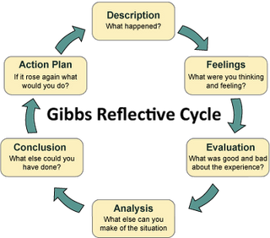

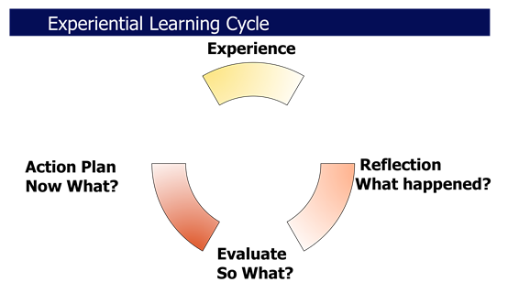

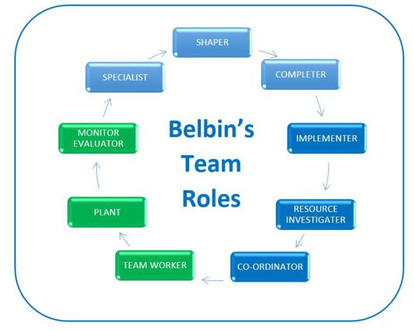

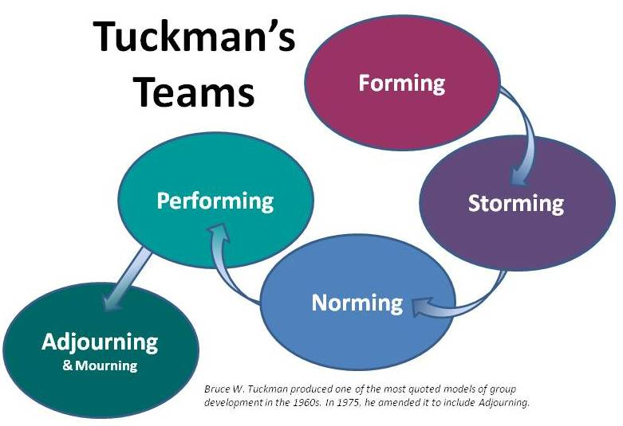
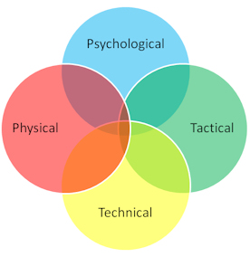

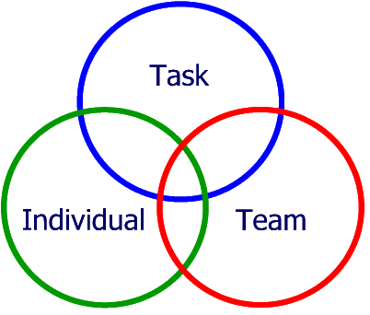John Adair

Tasks:
Task One:
Using the reflective models and models of teamwork you need to reflect on how the activities undertaken, critically evaluate your role in that activity, how well you worked as a team and your leadership skills.

You need to apply the theories discussed and any other theories you wish to use. Make sure you Harvard reference.

Use this electronic version of the diary to submit your reflective writing.

Task Two:
You need to keep a reflective diary of your fitness. There are 20 fitness sessions per semester, 50% of the mark is attendance for all of those sessions. The diary is a record and evidence that you attended these sessions.
In the diary you will need to reflect on your performance, what level you started at, how has your fitness changed and developed during the year.
You will need to show the use of reflective theory in your answers.

Record all your entries in this electronic diary and submit through turnitin by 4th May 2018.
Outdoor Session One: 13/11/2017
Activity: Outdoor living
Performance Evaluation: First day of my outdoor actives which was survive skills, first the thing with outdoor survive was great the person who was leading us with the activity was helpful for example he was giving the pointers we needed. The first task we did was too turn a ground sheet over the other side without leaving it one and going on the mud. This task was hard but however with great leadership we were able to do it, the type of leadership we used was laisses-fair as we wanted everyone to take make feel the happy. The second task we did was to make fire to cook food on, the person was leading us wanted us to teach the first year how to make a fire.
The type of leadership I used was autocratic as I felt this right leadership to use as we were doing task which is very dangers e.g. starting fire which could get someone injured if the person was not listening.
The good thing about me using autocratic leadership was first years listen to me and knew what I wanted them to do. The only downside of using autocratic leadership is does make me look like a mean person which I’m not it can also show that I don’t respect people, but however whiles I was analysis the task it was only type of leadership I could only use to make sure people felt safe during the task. In conclusion in this task I should of use another type of leadership style.
The third task was to make a whistle from wood during this task I used democratic as I wanted the first years to be able to work as team learn from each other. In conclusion the actively went well as a group as we worked together to teach the first years how to whistlers from them pieces of wood went really well; the only down side of activity is we did not plan what we were going to teach to the first years so the actively leader gave us a task to do.
Actions for next time: Next time I do something like this I want to make sure I use the correct leadership style, make sure I speak clean enough for people to be able to listen to me whiles showing them task. I should always take pointers from other as it will able to help become a better leader during the task. I should also make sure I have task for people to follow instead of not having plan for people to follow as takes more to during the activity which means we as a group are wasting people’s time all together which means their less time to other things such cooking food.

Outdoor Session Two: 14/11/2017
Activity: Mountain biking
Performance Evaluation: I left University around 8:00 am to go off mountain biking somewhere in Swansea area, we as a team took the mini bus to get too our location we arrived at the location around 09:00 am.
When starting off mountain biking I felt excited as I feel I’m a good bike rider but however when told we were doing a challenging route instead I felt bit nervous as we as a group were goanna down mountain and ride along cliffs. The first task we did before anything was warmup games to help get an understanding how to ride a bike I felt this was great as we need make sure we didn’t fall off the bike.
The person who was leading took use to pump track we spit up into teams to show how the other person was doing with their pumping, the leadership style the instructor used was laisses-fair as he left us to it and only come help us when we needed it, after food the instructor said me and another person was to lead the group to the next point we both agreed to use the leadership was democratic as we wanted to work as team to make sure the first year were safe as leader we made should we were at front to make sure they knew where were and we also made everyone was with us and no body was left behind in the group.
When analysis the last two task I know why the instructor made sure we did those two warm ups as the final task was dangerous he wanted make sure we were capable to finish the task, during the final one of the members fell the bike and the chain came off as a good leader I tried to help them by fixing their bike but however I did not do a very good job of it but luckily someone else was able to fix it for team member this show I was being a good team leader as I was supporting this person with their problem. In conclusion biking was great fun and I felt was better as a leader than yesterday I took pointer down from my instructor and team mates along the way.
Actions for next time: Next time I will make sure improve myself with knowledge of the activity for example making sure I know to fix a bike which could help me to be able to fix the person bike and another I could do is use another type of leadership as I feel I have used to much laisses-fair, which means I’m easy leader to get along with but however I should be more Autocratic as the activity was dangers because members were at high risk of breaking bones as they could fell off their bikes, so being Autocratic could be useful as they would have been in safe hands.

Outdoor Session Three:08/05/2018
Activity: Rock Climbing
Performance Evaluation: On the 08th of May I under go a rock climbing activity; in the morning we as group went to do rock climbing around 10:00 am around the Rhossili Gower area, on the day I felt excited as I love doing rock climbing during my days as a scout I learnt how to climb which meant I could show off my skills and to help other people may be stuck or nervous with the active.
The good thing about the rock climbing was we were able to set up the equipment quickly around 10 minutes maxes; I felt I was good climber as I took two routes during the activity and were able to reach both the top, I was also a good relay when other people climbing as I made sure they felt safe and combatable whiles taking their route.
The only downside of the rock climbing was there being only three routes and we only climbing for an hour due to being harsh weather, this meant I was able to climb the hardest route which would have been nice for me to climb. The leadership style I used was Autocratic as this was activity where someone can easy to break a bone or worst lose their life if someone is not paying attain to them; my job whiles doing rock climb was to relay people which meant they could climb if they fall they would just stay in the air without them felling all the way down to the ground.
When making of the satiation I saw a lot of people in our group were not taking due to it being harsh weather or they were worried about the heights; the seconds years tried their best to get first years to rock climb up the rocks. Only three people climb out 10 first years making out the satiation it seems the first years did not want to take which was a shame for us. In conclusion I find rock climbing really fun but however I found it hard to climb some routes as I very short person which meant I had to jump or move in very uncomfortable area; this meant afterwards I felt little bit of pain in my body.

Actions for next time: Next time I will bring a pair of gloves when claiming which will help me to climb better as I found my hands was cut after rock climbing ;also with the gloves it will help to get a better grab on the rocks I kept slimming off the rocks because it was wet; I should also listen to people when going as I nearly hurt one my teams when he was coming down because I was day dreaming. I should also wear a coat when raining because I felt cold during the activity as well.
Outdoor Session Four:09/05/2018
Activity: Walking
Performance Evaluation: On the 9th of May I lead of group of people on a walk along the Rhossili coastal path; the path I lead the group to was called “Rhossili Down, Hillend and beach walk” (Natural Trust,2018). The walk was meant to take around 2 hours 15 minutes but however due to time we were not able to finish it on time only did half the walk; with the first group I felt nervous as I was unsure how to lead the group plus I was not too sure if with the route as I or the activity leader never under go the route. Along the walk I gave three facts about the local area which were about the worm head, Rader station and Gower being the 7th place in the world for photos of the sunset (Gower Coast Ltd,2018). The fact helps me to make the walk more enjoyable for people.
The good thing about taking the first group for the walk was I knew everyone name as they were in my year, which meant I could tell them if they where going the wrong I was able to call them by name. The only downside of taking the first group on the walk was I did not feel I was acting like I leader on the walk as I tend to be at the back which I should have not of been. During the first walk I leant how to read a map and how to use a compass which help me to improve my map skills for later in the future of my life.
The second group I took for a walk I felt more a leader as I lead from the front most of the time as I felt more confident with myself as I knew the path we were under taking, whiles on the walk I help anyone in my group who seem to be lacking behind, for example some people found the hill hard to walk as it was very steep because it was the highest point of the Gower so as a leader I made sure people were not left behind. The second thing I did as a leader for the second walk I point to people in the group where were so the knew how we were going to take for example from worm head (Highest point in the Gower) to the WWII radar stations it took us 25 minutes.
The only downside about the second group was I did take people names down as I knew half the group, but I didn’t know the other of people as they were the first-year student on the public services course. The leadership style I took was Laissez Faire reason why I picked this type of leadership because it suited the actively as we were only walking and there were not dangers things to happen to the group part coming down the hill, which I help people to come down slowly by giving them my body to lend on.
The only time I needed to raise my voice was when to tell first year student we were going the wrong way. I think the actively I lead was great because I planned everything before hand which saved us time to plan a route, I did not lose anyone on the walk plus I didn’t get the group lost along the walk; both groups came back safely e.g. no came back with broken bones and felt everyone learnt something new about the local area. In conclusion I think both walks went well, and I think I have learnt from my first walk to fix my many mistakes e.g. don’t leave people behind make sure you know the way on the map.
Actions for next time: The actions I should take for next time should be to learn everyone name before the walk as it key for health and safety so if someone was to go missing I would be able to tell the teachers/ actives leader their names. The second action to take for next time is to be more confident as leader and lead from the front. Third action to take was to pre-walk the route you taking as the walk route I picked for my group was 2 and 15 minutes and we had to cut it half way due to timing; so next time I plan walk I should make sure about the time and how fast people can move as people have different paces.

Fitness Diary:
Date:02/10/2017
Activity: Hit training

Performance Evaluation: On the 02 of October I under took Hit training which is one of the hardest training in my view as you got keep up with the speed of other people. I feel I did okay for the hit training as I just got back from the summer holidays. Hit training means high-intensity interval this when the person working out to their maximum limit, this why it’s called hit training; it helps the person to push themselves to the limits which will help to improve with fitness in general. The equipment we used were dumbbells and bars bells and mats; this was part of training hit training.

Actions for next time: Next time I will push myself to the limit as this is only way to gain more strength for example I need to lift more than 10kg which means I will be able to keep to the speed of the other people, as they were on hole new level to compare to me I felt like I didn’t do the best I could as I just got back from the summer holidays and there no local gym around my area to walk too.

]
Fitness Diary:
Date: 9/10/2017
Activity: Hit training

Performance Evaluation: I push myself to my limit keep with same paste with everyone else which was great with me even though I had pain in my legs the next day. I’m also starting to lift more for this fitness session I started to lift 20kg which is good as I’m pushing myself to gain muscles weight which will help to in the future career
Actions for next time: Actions for the next time is keep pushing myself to the limit as this only way to become fitter and to ready myself to become an officer.

Fitness Diary:
Date: 12/10/2017
Activity: Hit Training

Performance Evaluation: I felt hit training was great but however I am feeling little unwell, so I took my time with it. I decided to use 5kg weights during the Hit training
Actions for next time: Just keep myself with everyone else paste during the training. Make sure I’m going to gym after university which will help me to

Fitness Diary:
Date:16/10/2017
Activity: Bleep test starting off with a Zumba

Performance Evaluation: I hate Zumba as I feel terrible whiles dancing around the studio, whiles with the bleep test I got 8.9 which I was happy with as I passed the fitness levels to become an officer and a dog handler as well.
Actions for next time: the bleep test I want keep pushing myself as I want to get 9.4 which armed police level as I want to be an armed dog handler.

Fitness Diary:
Date:16/10/2017
Activity: Hit training

Performance Evaluation: I’m slowly getting better with hit training now and I can see myself improving e.g. I’m losing weight. I’m lifting more weights which means I’m gaining more muscle weight, this will help me in the future when I become a dog handler. The equipment I used were bar bell and dumb bells which were 15kg and 10kgs
Actions for next time: keep pushing myself to higher levels to improve my cardio as I’m finding it hard to keep up with other people in my class

Fitness Diary:
Date:23/10/2017
Activity: Hit training

Performance Evaluation: Hit training was great but however I’m slowly getting fed of the Hit training now as I feel we are doing it nonstop. to stop make me feeling board I should push myself to new limits as I feel I am slacking behind people as my cardio is getting worst now. The kit we used during the sessions was dumb bell and bar bell which I had 15kg for the bar bell whilst having 10kg for the dumb bell, I also used a matt as well which is there to help me to have better grab when doing fitness excuses.

Actions for next time: I believe I’m at the level now were I feel I don’t need to push myself to limit now; however, I should keep pushing myself to new limits as this will help to lose weight and to gain more muscle which will help me to lift heaver objects

Fitness Diary:
Date: 30/10/2017
Activity: Hit training
Performance Evaluation: Hit training is becoming boring now as I feel that we been doing it over 4 weeks now. I felt that this hit training sashing was good was I seen more improvement from the passed couple of weeks. I need keep pushing myself to improve on my cardio which will help to join the police force. The gear I used was dumb bells which were 10 kgs and the bar bells I used 20kg which is good I also had a matt to make sure I feel constable whiles doing my fitness session, I also brought water which help me a lot as kept myself hydrated during the session.
Actions for next time: I would say keep pushing myself and use higher weight e.g. move myself from 20kg to a 25kg which will help to gain more muscles in my body next time as I feel the weights I’m using now are light on my hands. Which was I’m gain more strength in my arms which good because I’m now improving my body.

fitness Diary:
Date: 06/11/2017
Activity: Dodge ball
Performance Evaluation: I listen to my teams and was able to win couple games of dodge ball. We would work well as team which meant we were able to win the games. The equipment we used balls and cones which is to set up to play for the game. The leadership we used as team was democratic which meant everyone gave their view on how we should take out the other team; this help us lot as we planned a team which meant we were able to win more gamers compared to the other as they didn’t plan as team like we did so they lost more games. This showed talented team work as we all know what roles are were.
Actions for next time: Keep listening to team mates and make sure to help during the game for example give team players tips when throwing the dodge balls. Which help them to improve with their aims and hopefully give them a chance to take someone during the games as I found I was one top player for my team. If I was able to help my teams more it would of mean, we could have won more games as their aiming and throwing would inmoved they could take more people out of the game.

Fitness Diary:
Date:09/11/2017
Activity: Matt fitness

Performance Evaluation: The Mat fitness was good as it was something different from Hit training, I push myself to the limit which is great. The equipment I used where weights which were used to Russian twits and the sits ups. I notice my fitness for Russian twist and sits ups are improving as I was able to go faster compared to last which I took my time which meant I was able to more e.g. Last year I was doing 10 per minutes compared to this year I’m doing 20 plus per minute. This shows I have been improving with my Russian twist and with my sit-ups I’m doing 30 compared to last year I was doing 20, this shows major improvement with my mat fitness.

Actions for next time: Next time keep up with other people on my course make sure I’m doing the right moves during the exercise. I should also keep up with my Mat fitness as this one of my strengths this year as I seem to be good with it; I enjoy it really much I could use this type of fitness when I go to the gym in the Swansea as it easy to setup and doesn’t take long to do.

Fitness Diary:
Date:20/11/2017
Activity: Zumba
Performance Evaluation: I really did not enjoy Zumba as I’m bad dancer and I could not keep up with paste with everyone else; the reason why I dislike Zumba is because I do not have good body conditioning is bad. I personally don’t feel Zumba has any benefits with my fitness as I’m terrible dancer find it hard jus to do similarly dances I also find it very embarrassing as well in front of my year group as well. I used no equipment as the activity did not want needed any what so ever; which is useful as it saved us time with pack up as we just needed music playing in the back ground.

Actions for next time: Try and keep up with everyone else and maybe learn some dances moves ready for the next time we do it. I also must bring a bottle water as I find it hard sessions because I needed a drink ever 5 minutes. I should go on YouTube and learn some of the simply dances moves as this could benefit me to become a better dancer which might let me enjoy it more, I could see more impermeant with my fitness then and I could see why Zumba is usefully.

Fitness Diary:
Date:24/11/2017
Activity: Cancelled

Performance Evaluation:

Actions for next time:
Fitness Diary:
Date: 27/11/2017
Activity: Dodge ball

Performance Evaluation: I enjoy playing dodge balls as we able to work as team. The equipment we used were balls and crones. We as team should have had plan as last time we played dodge ball we were able to win more games but however because it was different team we didn’t picked a team leader which meant we were unsure what was going. This had resulted us in losing more games than normal as I tend be on the winning team; I felt I was ready as I brought the right kit e.g. shoes with grab and a bottle water and we used cones and balls as equipment.

Actions for next time: The first thing we should have done was picked a caption as this would benefit us big time as could have had plan in action ready for us so everyone knew there role and who they were going to take aiming for; I should of picked myself as team leader as I could benefited the team well as I could of told them who to take first on the other team as they could lost more games as their best players were taken out first. This would have meant we would of won more games as team.

Fitness Diary:
Date:30/11/2017
Activity: Cancelled

Performance Evaluation:

Actions for next time:

Fitness Diary:
Date: 04/12/2017
Activity: Weight training

Performance Evaluation: I found weight training great fun and I also found hit training help me a lot because I was lifting around 20 kg which great as it shows the hit training be working on me. The gear we used was bar bell as we were doing fitness routes such as doing squat with weight which was great fun as it felt I was carrying a dog on my back which I need to do to become a dog handler because it part of the fitness test to carry a dog on my back and do a mile and half with in couple of minutes doing fitness routines like this helps me a great lot.
Actions for next time: Next time I will start lifting more for example I can push myself to do 20kg weight training instead of lifting my normal which is 15kg this means than I will be gaining more muscle weight which will help me in the future doing the police e.g. lifting and pulling test which I need to pull and lift 32kg which is minimum for a male police officer in training.

Fitness Diary:
Date: 7/12/2017
Activity: Cancelled

Performance Evaluation:
Actions for next time:

Fitness Diary:
Date:11/12/2017
Activity: Cancelled

Performance Evaluation:

Actions for next time:

Fitness Diary:
Date: 14/12/2017
Activity: Cancelled

Performance Evaluation:

Actions for next time:

Fitness Diary:
Date:29/01/2018
Activity: No session

Performance Evaluation:
Actions for next time:

Fitness Diary:
Date: 02/02/2018
Activity: No session due to flu
Performance Evaluation:

Actions for next time:
Fitness Diary:
Date: 19/02/2018
Activity: Hit Circuits

Performance Evaluation: Hit Circuits was hard as this was my first training session back from holidays, I found the session hard as I was not able to work out over the Xmas holidays, I also took my time as I was just got back from my illness. This meant I was using lowest which was 10kg as I did not feel up to be lifting my normally which is 25kg which I normally for my Hit training. I felt I did not enjoy this session as I just got back from the doctors and they said not to push myself of my limits or I could become ill again. I had the right gear for this fitness sessions e.g. water.
Actions for next time: Action for next time I will push myself to the limits as I felt was lacking during that fitness session, I will also make sure to do exercises correctly; as Bron had to correct me with some of the moves as I was doing them wrong; this benefit me as I know I was doing them right instead of doing them wrong which could have ended me having pains in my body.

Fitness Diary:
Date:26/2/2018
Activity: No fitness due to having blood tests

Performance Evaluation:

Actions for next time:

Fitness Diary:
Date:
Activity: Dodgy ball
Performance Evaluation: We as team lost couple games due to us not working together but however after a team talk we started winning couple of games, I took out five people; which help the team out as the other team had more players on their team. We didn’t use any type of leadership in the first half of the game as liked in the last game we didn’t have a team leader but however in the second half of the game I started taking controlling of the game and giving out team orders this resulted us winning the second half of the game which helped us a lot.
Actions for next time: I should listen to teams’ players; this will benefit us major as we know who doing what role, we should also pick a team leader as they would have been able to plan the attack which would make the other team lose the game more. The type of leadership we should use is Democratic as this means everyone could give their views on things. I should also have offered other people on my team see if they wanted to be the team caption instead of me taking control from the start of the second half of the game.
Fitness Diary:
Date:19/03/2018
Activity: Bleep Test

Performance Evaluation: I did okay on the bleep test but however I did not beat my last results which was 9.2; I got 7.0 which good as I still passed the dog handler entry level which was 5.7, but however with the bleep test we started to 15 meters one instead of 20 meters one which we were used too. I did feel disappointed with my results as I should be scoring higher results because last I would have been able to join the armed police unit with my results on the bleep test however this shows I need to work on my cardio fitness as my bleep test score as gone down by two levels which means my cardio is going down slowly so I need work on it asap.

Actions for next time: I am going to be working on my cardio at gym as this will help me reach a higher level in the bleep test, I’m hoping next time I do the bleep test it will be a higher result than last time; I type of this workouts I will being will be using bikes, rowing and running as theses type of fitness will help to improve my cardio big time.

Fitness Diary:
Date:26/03/2018
Activity: Cancelled (last day of term)

Performance Evaluation:
Actions for next time:

Final Evaluation on fitness.
In 500 words give an evaluation of how you feel that your fitness has changed and developed over the last year.
When looking though my fitness during the two years of studying at the University of St David’s; I found my fitness to be great as I was able to do the bleep test with the score of 9.2 level this meant I would be able to join the armed force united as their bleep test entrance is 9.0 this was lasted in my first year of university (College of Policing, 2016).
Comparted to my fitness this year I scored 7.2 and then give up as I felt tried; with the scored I got I could join the dog handler unit as they only need to 6.9 to pass the bleep test (College of Policing, 2016). To help me improve to get higher scores I should go running as this will benefit my heart to pump more blood around my body (BBC, 2018).
When looking Muscular Strength in my first year of university at the end of the year I was lifting around 15kg now at the end of my second year I am now able to 25kg; this shows the Hit training as help me to gain more muscular strength which will benefit me when I join the police services as I want to become a dog handler and one of the fitness test is to lift your dog and run for a mile. The muscular strength will help to gain my goal which is to lift 34kg as that is the weight of a normal German sheared which one of the biggest dogs the police services use (MOD,2018). Comparing both of my results I am happy how my musicale strength is going as I know it going to benefit me in my future career as police dog handler and it’s also helps me with my ice hockey training too. The only thing I can do keep improving my strengths is to go to the gym and lift weights over time it will help to reach my goal. When looking at my Cardio Endurance I found it hard this year compared to last year as my bleep test shows my score as gone down by two levels; this is bad as it shows my Cardio Endurance is becoming weak which means I need to improve on it soon as within two years I’m wanting to join the police and if I cannot pass the bleep test which level 5.3 I have failed the police it may take me some time to gain back my fitness back up (Dorset Police, ND).
The way I can improve my Cardio Endurance is to go to the gym and do rowing, Bikes or running those types of fitness equipment will help to improve my cardio endurance, and it will benefit me when playing ice hockey as I can skate longer on the ice. When looking at my Flexibility the twos at being at the university I would say it stays the same as I’m I able to do the stancher in the being and the end of year fitness sessions, being flexible benefits me as I am to score goals in ice hockey that might to be done to a normal person because they’re not able to do it to stanch that far as they not flexible.
In conclusion I would say my fitness has gone down very far and it needs improving fast before I leave for university as I know what my level of my fitness is as I know I can pass the police entrance level; with good fitness level it will help with ice hockey to and over the summer holiday I will start training off season which it will help me to reach with my goals.
References
National Trust (2018) Rhossili Down, Hillend and beach walk, Available at: https://www.nationaltrust.org.uk/trails/rhossili-down-hillend-and-beach-walk (Accessed: 11 May 2018).
BBC Bitesize (2018) The heart, Available at: http://www.bbc.co.uk/schools/gcsebitesize/science/triple_aqa/transport_systems/blood_system/revision/2/ (Accessed: 15 May 2018).
College of Policing (2016) Fitness standards, Available at: http://www.college.police.uk/What-we-do/Standards/Fitness/Pages/default.aspx (Accessed: 15 May 2018).
Dorset Police (ND) Fit to Pass, Available at: https://www.dorset.police.uk/media/1096/fitness_testing_advice_guide_recruits_nov14.pdf (Accessed: 15 May 2018).
Gower Coast Ltd (2018) Historical Facts, Available at: http://www.gowercoast.com/?page_id=67 (Accessed: 11 May 2018).
MOD (2018) DOG SECTION, Available at: http://www.mod.police.uk/specialist/dog-section.html (Accessed: 15 May 2018).

