Community Engagement

Assignment 1 – Essay

Community Engagement (LCBB4002_BIRM)

Lecturer:Dale Clarke

Student:Alexandru Eros

Table of Contents
Introduction 2
Discussions 2
Nestle’s overview 2
Customer analysis in terms of services 3
Micro and macro analysis 5
Training and development, and its importance 7
Selected role in the organisation and its importance 7
Skills and knowledge required for role 8
Training and development need to consider 8
Conclusion 9
Reference list 10
Appendix 11

Introduction
Organisational analysis is an important part of business management in a wider context of a particular organisation. It helps to determine and analyse required information and data to implement and improvise a new business plan within a framework to increase sales and achieve the targeted profit goals set by an organisation. In this essay, the overview of the multinational food and drink processing company Nestle and its growth will be discussed. Moreover, a customer analysis in terms of services, micro and macro analysis, required training and development within the organisation and my roles as a marketing manager will be further discussed.

Discussions

Nestle’s overview
Nestle is a Swiss multi-national food and drinks processing company that is constantly making a progress in expanding the market worldwide as well in the UK. Nestle believes in their slogan which is "Good food, Good life" which ensures their product quality and standards of services spread all over the world. Nestle main motive in the business to provide a quality service with perfect implementation of marketing plans and improvisation in business modules to expand their business. Nestle owns around 2000 brands in 187 countries globally. They are serving since 1866 and created products that have to enhance the quality of life. Nestle’s success globally has been achieved with its developing strategy which focused on producing quality products to achieve the targeted profits (nestle, 2021). The organisational structure of nestle is a mixed structure where two or different structures or elements of the different structure are used. More relevantly Nestle has distinct characteristics of a global matrix structure. Nestle has its own local companies in every country which means that they might initiate their own organisational structure which may or may not be the same as the parent company. Nestle uses global geographic structures and divides its system geographically and each regional division is accountable for reporting to the CEO (Lee, 2014).

Customer analysis in terms of services
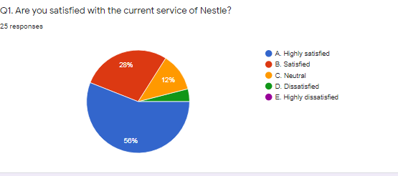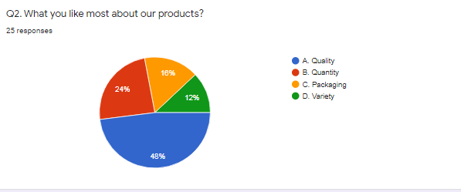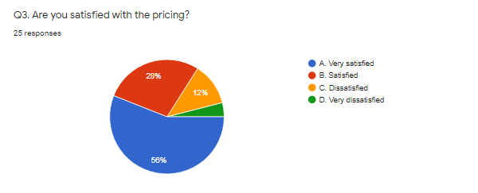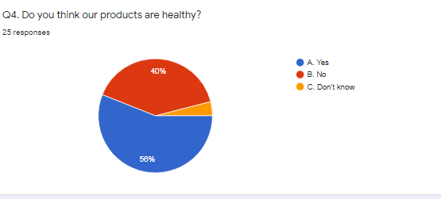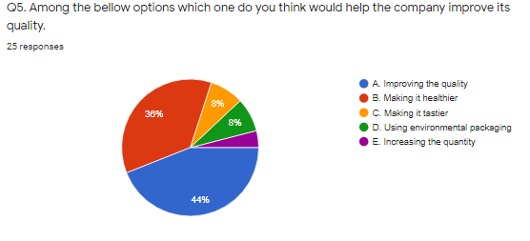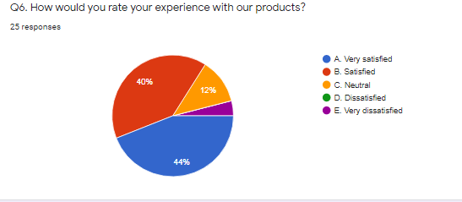
The primary analysis from the customer survey from 25 customers is recorded and evaluated to enhance the customer service of Nestle effectively. From the customer analysis survey, it is evident that 56% of customers are satisfied with the products of Nestle, and some of them are moderately satisfied maybe for the availability of other brands but only 4% of the customers are dissatisfied with the products. Customers highly appreciate the quality and quantity of the products where 48% of customers like the quality and 24% of them like the quantity Nestle provides in its products. The packaging is not a serious concern according to the customers. The pricing of the products is affordable to 56% of the customers and 28% of them are moderately satisfied with the price range of the products. Health concern to the product of Nestle is a serious issue as in the current scenario of pandemic customers are health conscious. Though 56% of the customers think Nestle’s products are healthy 40% of customers are not satisfied with the health standards of Nestle’s product. Customers think improving the quality and upgrading health standards can improve the overall quality of the products. Most of the customers are very satisfied and moderately satisfied with the experience of Nestle.

Micro and macro analysis
According to Gürel and Tat (2015), SWOT analysis is an ideal framework to determine the microanalysis of Nestle. The SWOT analysis of Nestle is described below:
Strength- Nestle has enriched research capabilities, which enhances product development. It also has strong brand recognition and geographic presence with the best diverse revenue sources. Its brand management is so better that it merely has any competitive rivals. Nestle makes environmentally sustainable efforts. It has ownership over some of the famous brands globally (Jurvecious, 2013).
Weakness- Nestle has faced much criticism over high water usage, selling contaminated food, unethical use of labour, child labour, etc. These criticisms have the potential to hamper the brand recognition Nestle has achieved over the years globally.
Opportunities- Nestle uses clear and accurate labelling to recognise any harmful products. It has the transparency in material resourcing. It has increased the number of small food start-ups they are based on silicon valleys. It is also introducing new product concepts such as Ready to drink tea and coffee in markets.
Threats- Nestle uses a lot of water thus it faces poor quality and scarcity of water. It may face competition in the beverages and food industry. The rise in the price of coffee beans due to weather disasters can be a serious threat to Nestle’s business (Jurvecious, 2013).
Macro analysis for Nestle will be a PESTLE analysis framework
Political factors- Nestle has its business impact over 190 countries thus it has a greater risk of producing bottlenecks due to changes in governmental policies in some countries. The Brexit situation also hampers Nestle’s business in Europe (Frue, 2021). Nestle also has to follow the food standards given by each country they are operating in and should produce accordingly marinating all the ethics. If they do not follow the food standards, they may face a ban on the products.
Economic factors- As nestle has its business globally the ups and downs in the foreign exchange rates may affect Nestle’s business. This can have both positive and negative impacts on the company's profit growth (Frue, 2021). The cost of raw materials for Nestle is increasing day by day due to the difficulties in the trade between countries such as the USA and China. This results in the slow progression of growth in Nestle.
Social factors- The growth of a multinational company like Nestle can be affected by changing trends. A company like Nestle will have to remain up to date with the changing trends and develop products according to the people's choice. Many health-concerned groups have decided to promote products with low fat, which acts as a challenge to develop products according to the health choices of the customer. On the other hand, the current situation of the pandemic has made people more health conscious and enhanced them to use products, which are nutritious and safe to consume.
Technological factors- Nestle has its business both online and offline. The development of technology in day-to-day life has increased the scope of business for the companies like Nestle. It has also opened its way for using different marketing media such as social media marketing, online advertisement, digital marketing, and many others. Technology also allows connecting directly to customers without any barriers, which helps in educating people about the products.
Legal factors- Legal factors determine different labour laws, laws related to the health and safety of the employees, quality, and hygiene of the products, and environmental laws that need to be followed. Different countries have different labour laws that Nestle needs to follow to survive their business in a particular country. Moreover, the trademark and IPO rules need to be under constant supervision. Nestle has also issued with the shape of the chocolate products being identical which is an important legal challenge Nestle needs to overcome.
Environmental factors- Nestle believes in producing products that have zero environmental impact. The environmental factors include some of the environmental laws for the benefits of producing eco-friendly products. This includes in production of low plastic products, environmentally sustainable processing of products, and zero pollution levels of natural resources, and many others. If this Nestle fails to follow these environmental standards given by the government then it could face a ban on overproducing in that particular country. Nestle was once suspended by RSPO for failing to submit palm oil sustainability reports.

Training and development, and its importance
According to Kumar, (2015) training and development is a vital part of the organisations, which determines its success in the market. The human resource departments in Nestle hire and train the newcomers accordingly as required for the market scenarios. Rapid changes in the environment have made the job for the human resource department more complex and challenging, as they have to identify and train only those employees who will be effective in the production of new products. Nestle follows the philosophy to make a strong performance-based work culture where workers will benefit the company as well as themselves through their work. This helps in better management and has helped Nestle grow globally.

Selected role in the organisation and its importance
I am designated as a marketing manager in Nestle. While working as a marketing manager I have to overcome several marketing challenges Nestle faces in the current market scenario. Marketing is an important part responsible for the expansion of business within an organisation. In 2017, Nestle faced the lowest organic growth of 2.4% for many decades (Markovic, 2018). This is because of the external factors such as Threat of new entrants in the industry, substitute competitive products, bargaining power of suppliers and buyers, and competitive rivalry by the organisations such as Mondelēz International, Pepsico, and Unilever. Introducing high marketing budgets and maintaining good distribution channels will help Nestle to overcome threats of entrance in the global market whereas locally this can be overcome by lowering switching costs. Improvisation in customer service and gaining new heights in customer satisfaction and loyalty will help Nestle to compete against the substitute products. Improvement in quality control can overcome the bargaining challenge from both suppliers and buyers. To increase its business and maintain decent organic growth Nestle design and sells its products geographically by comparing regions and identifying suitable customers. Identifying the market by understanding, the psychographics and social factors of a particular region and adapting promotional styles according to will results in an increase in sales (Reza, 2020).

Skills and knowledge required for the role
Nestle has its business spread over 118 countries across the world and generates sales of approximately CHF 83.6bn in 2011. This figure depends on the sales, which is the responsibility of the marketing teams. Marketing in Nestle focuses on maintaining and building the future of the brand with satisfying customers, consumers, and shoppers. The vital three skills required for the role of marketing are reflected in three areas which are consumer insights, communication, and brand management. Thus, the skills such as customer relationship management (CRM), clear and effective communications, brand management, category management, channel development field sales, and consumer insights are some of the skills one should have as a marketing manager in Nestle. The marketing skills should be consumer-focused that should initiate insights-driven marketing strategies within the marketing teams to integrate innovating and renovating commercial teams (nestle, 2021).

Training and development need to be considered
The human resource department in Nestle aims in providing the required training to employees effectively for the benefit of the company. Properly initiating all the ethics of employment such as conventions concerning employee rights, protection of children against child labour, Nestle aims in a policy of long-term employment. Human resource development trains every employee according to the company's needs and standards, which are required to achieve the goals and mission of the company (nestle, 2021). Training of the employees in the marketing departments is organised in purpose to improve relevant skills in the employees. Formal training to develop skills such as communications, customer relationship management, innovative ways to promote products, identifying customers in specific market scenarios are provided, and based on this progress the capable employees are selected. The employees are trained in a framework of individual development programs. Each employee works in an environment where they can increase their capability of self-learning. Certain opportunities to develop their skills are provided where they discuss their problems with transparency. This motivates and inspires the employees within the organisation. The human resource department also supports and provides planning tools for implementation and necessary flexibility to survive in unforeseen situations.

Conclusion
Organisational analysis has always been an important part of marketing. It helps to determine the progress and growth of a company with certain frameworks and helps to initiate all the necessary marketing plans accordingly. The customer analysis and micro and macro analysis had given a brief idea of internal and external factors affecting the growth of Nestle. My role as a marketing manager had described several steps and measures required to improvise and implement the marketing development within the organisations. The training and development process of Nestle’s human resources department had been briefly analysed and discussed in order to get a brief idea of the required development necessary in the training and development of the employees.

Reference list
Dr.MarkA.Lee 2014Organizational Analysis[online] Available at< http://imba.tjufe.edu.cn/__local/E/FF/41/0768DE2F22A3FF59F3BD86E8D7C_09CFBC16_8A3D8.pdf?e=.pdf> [Accessed 15 February 2021].
nestle.com2021 Strategy [online] Available at <https://www.nestle.com/aboutus/strategy> [Accessed 15 February 2021].
Gürel, E. and Tat, M., 2017. SWOT analysis: a theoretical review. Journal of International Social Research, 10(51).
Jurevicius, O. 2013 Nestlé SWOT analysis - Strategic Management Insight, Strategic Management Insight[online] Available at <https://strategicmanagementinsight.com/swot-analyses/nestle-swot-analysis.html> [Accessed 15 February 2021].
Frue, K. 2021 PEST Analysis of Nestle: How politics and social culture affect its growth, PESTLE Analysis[online]. Available at <https://pestleanalysis.com/pest-analysis-of-nestle/> [Accessed 15 February 2021].
Vinod Kumar 2015 TRAINING AND DEVELOPMENT PROGRAMME AT NESTLE [online]Available at< http://ijariie.com/AdminUploadPdf/TRAINING_AND_DEVELOPMENT_PROGRAMME_AT_NESTLE__A_Case_Study_of_Samalkha__Patti_Kaliyana__ijariie5276.pdf> [Accessed 15 February 2021].
Markovic, M., Strategic Analysis Report Nestlé SA.
Reza, M., 2020. Analysis of Marketing Strategy and Quality Policy of Nestlé. [online] Available at: <https://www.researchgate.net/publication/344071059_Analysis_of_Marketing_Strategy_and_Quality_Policy_of_Nestle> [Accessed 17 February 2021].
nestle.co.nz 2021 Marketing & Sales [online]. Available at< https://www.nestle.co.nz/careers/our-business/marketing--sales> [Accessed 17 February 2021].
Nestle.com 2021. The Nestlé Human Resources Policy[online] Available at< https://www.nestle.com/sites/default/files/asset-library/documents/jobs/humanresourcespolicy.pdf> [Accessed 17 February 2021].

Appendix
Survey questionnaire for the curtomers
Q1. Are you satisfied with the current service of Nestle?
A. Highly satisfied
B. Satisfied
C. Neutral
D. Dissatisfied
E. Highly dissatisfied
Q2. What you like most about our products?
A. Quality
B. Quantity
C. Packaging
D. Variety
Q3. Are you satisfied with the pricing?
A. Very satisfied
B. Satisfied
C. Dissatisfied
D. Very dissatisfied
Q4. Do you think our products are healthy?
A. Yes
B. No
C. Don’t know
Q5. Among the bellow options which one do you think would help the company improve its quality.
A. Improving the quality
B. Making it healthier
C. Making it tastier
D. Using environmental packaging
E. Increasing the quantity
Q6. How would you rate your experience with our products?
A. Very satisfied
B. Satisfied
C. Neutral
D. Dissatisfied
E. Very dissatisfied

