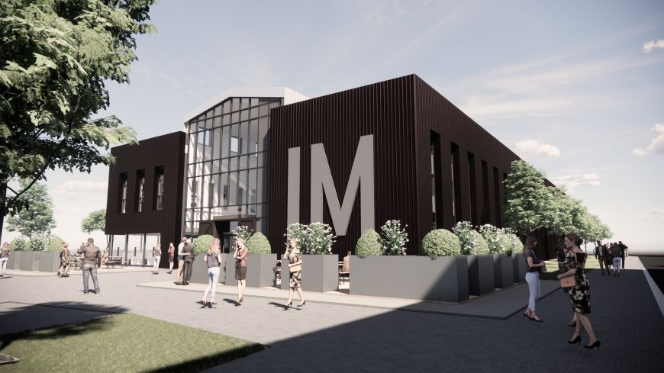  PREPERATION OF A BILL OF QUANTITIES  Dr. Deborah Hughes | 17.01.23  ABIGAIL JOHNSON (2114475)  Principles of Measurement and Estimating

A bill of quantities of specific elements was produced for the proposed Innovation Matrix that is set to be built at the University of Wales Trinity St. David SA1 Swansea Waterfront campus. To complete the bill of quantities an estimate was done of the specific elements and some assumptions where made and prices were taken from Spon’s Architects’ and Builder’ Price Book

Elements include Windows, External Doors, Internal Doors, and Cladding (Façade)

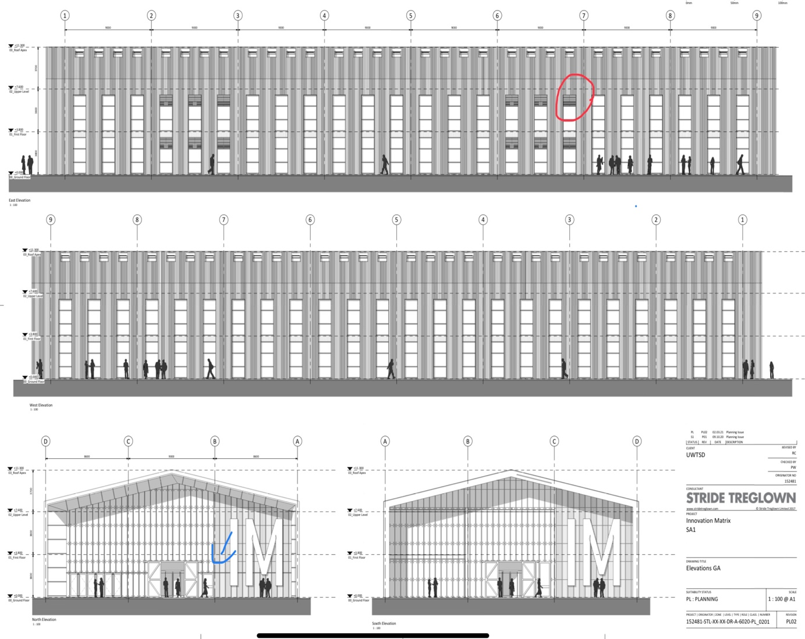
Figure 1 An elevation of the proposed Innovation Matrix building (STRIDE TREGLOWN, 2021)

Windows

There are 48 external windows on the building 12 on the East and 12 on the West Elevations, however on the East elevation it is noted that six windows have louvers on them. This was ignored and the prices did not reflect the louvers nor was a separate estimate made for them. The louvers can be seen in figure 1 highlighted in red.

Purpose made windows were also chosen because of the style of the windows which may have to be specially made to suit. Spon’s gave a range of £540-£660 and £650 was priced due to the windows being quite large and must be specially made to suit.

External Doors

There were three different types of external doors priced: Revolving door
Wheelchair access door
Manual door

The assumption was made for the wheelchair access door in figure one where there is a wheelchair access door located in the North Elevation it is depicted to be much smaller than the Revolving door that is adjacent to it. In the South elevation the revolving door and the wheelchair access door are depicted as having the same height. An assumption was made and the wheelchair access door in the North elevation will be giving the same height as the revolving door adjacent to it.

Internal Doors

The internal doors chosen which are fire doors with up to 60 mins fire resistance were chosen and priced at the £950 which is the highest price. This is because fire doors are very effective during fires specially for. This building will house a lot of people (students and staff) so the best fire door will be needed to help protect the occupants as well as possibly lessening the effects of the fire on the building.

It should be noted that all prices given were to the higher side of the range due to the buildings purpose of being a school. Buildings such as schools will need the most durable elements to keep up with the number of persons using the building as well as being a sustainable project and a technologically advanced building these aspects make the building more more expensive.

The overall price for the elements and materials estimated to be £ 383,933.00.

 |  |  | Windows |  |  |  | Rainscreen (Façade)
48/  2/ | 1.00  1.00 | _______  48.00  _______  2.00 | External windows Stweel windows (U-Value = 1.6 W/m2K) purpose made windows double glazed; powder coated.  Size (1.45mx7.05m)  Area=(7.05x1.45)=10x48=480m²  Wheelchair Access Doors  External Door Stainless steel entrance screens and doors  Purpose-made screen; double glazed with automatic doors  Size =(1mx3m)  Area=3x2m= 6m² |  |  |  | (North and South Elevation)  Aluminium Reynobond rainscreen cladding; aluminium composite material cassettes with thermoplastic cores, back  ventilated, including insulation, vapour control membrane and aluminium support system 4mm thick cladding; fixed to walls  North elevation
3/ | 1.00 | 3.00 | Double Glazed Manual External Door  External Doors Stainless steel entrance screens and doors  Purpose-made screen; double glazed with manual doors  Size (1.821m x 2.175m)  Area=(1.82x2.175)=4x3=12m² |  |  |  | Aa  B
 |  |  |  |  |  |  | Area of A
2/ | 1.00 | _______  2.00 | Revolving Doors  Automatic revolving door, structual glass. ASSA ABLOY automatic glass revolving door system providing hands free operation and Hi-Tech functionality. Modern modular design comprising four door leaves, curved glazed outer walls, glass ceiling/canopy, complete with in-floor mounted operator and imbedded digital control 3 or 4 wing 1800 mm dia., 2200mm internal height  Size (2.45mx3m)  Area=(2.45x3)=7.40x2=15 | 2/0.5/  2/ | 26.20  2.34  7.60  26.20 | _____  61.308  398.24  460.00 | Area of B  Total area of North Elevation with doors is A+B  North Elevation multiplied by 2 is = total area of North and South Elevation  Total area of all external doors
 |  |  |  |  | 6.00
 |  |  |  |  | 15.00
 |  |  | Internal Fire Doors |  | 12.00 | _____
88/ | 1.00 | 88.00 | Standard fire doors; cellular core; softwood lining; softwood architrave; aluminuim ironmongery (locable, self-closure); painting or polishing; single leaf; Oak veneered; 60 min fir resistance; polished  Size (0.626mx2.04m)  East and West Elevation  Timber Western Red Cedar tongued and grooved wall cladding on and including treated soft wood battens on breather mambrane, 10 mm  Eternit Blueclad board and 50 mm insulation board; the whole fixed to Metsec frame system; including sealing all joints etc. 26 mm thick cladding to walls; boards laid horizontally |  |  | 33.00  460.00  (33.00)  427.00 | Total area of North and South elevation without doors = to the subtraction of all external door areas.
2/ | 7.60  76.00 | _______ | Total area of East Elevation with windows
 |  | 1155.00 | East and West elevation = East Elevation multiplied by 2
 |  | 1155.00  (480.00) | Total area of East and West elevation without windows
 |  | 675.00
Reference

- STRIDE TREGLOWN (2021). ELEVATIONS GA.
‌

