Student Name: Ingke Terry
Student Number: 2515265
Wordcount: 4009
Contente:
Page 2 Photo
Page 3-4 Learning Story Introduction
Page 4-10 Learning Story
Page 11-15 Risk-Benefit Assessment
Page 16 Introduction Academic Writing
Page 16-19 Academic Writing
Page 19-20 Conclusion
Page 20-23 Refence List

Unit ECEY500
The Picture I Chose
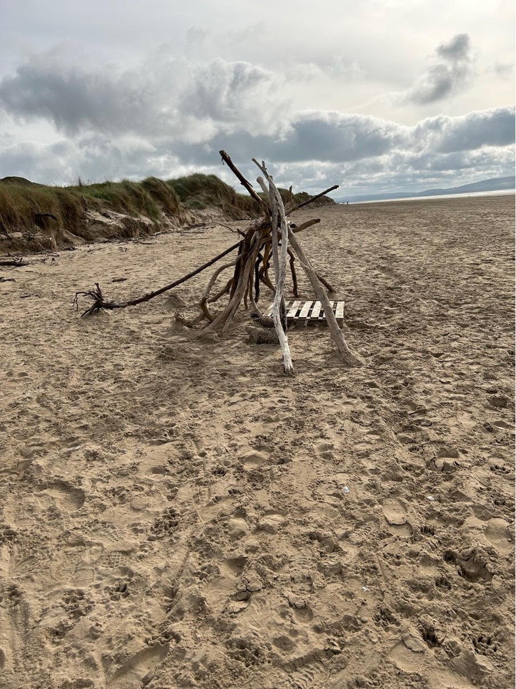
Terry I. (2024) Personal Image

A Learning Story to the Photo
Introduction
I chose this photo because this is one of the environments i often take children to as it gives them so much to play with and experience. The dunes are great for learning physical skills such as walking up and down and using their balance and muscle tone and strength. It also teaches that it is harder to get up the hill then down and gives plenty of teaching moments. There are always things that have been swept ashore which can be used in different ways such as big, long branches that the children balance on, climb on, sit and bounce on. Sometimes we find things like jellyfish, cuttlefish, crabs, sandfleas and even dead small sharks which get them to ask questions. We talk about what the animals eat and how they are different from each other but also teach that we never touch jelly fish with our bare hands or feet as they can sting. We often see blackberry bushes on our way to the beach and they always have spikes, so we talk about being careful and looking out for things like nettles too. We do pick the blackberries and wash and eat them or take them home and make a pie with them. We play with the water and sand to experience the different textures and how textures change from when they are dry to when they become wet. Things like building a sandcastle with dry sand compared to wet sand. Wet sand sticks better and therefore let us shape and mould things better and easier with it. I give opportunities to take shoes and socks off to experience what the dry and wet sand feel like, cracking the shells under your feet, splashing in the water and maybe even getting tangled in seaweed. The driftwood always gets children's interest as it is a tool that can be used in so many ways. We also go in different weather, so they experience the sand blowing around their noses and most don’t like it and want to come of the beach and go to the park instead where it is a bit more sheltered from the wind. We talk about sizes and shapes of the rocks and shells we find and sort them into groups. I sometimes challenge them to find the smallest shell or the biggest rock. We have made Journey sticks before with a stick and string wrapped around it and they could put anything they found of interest between the stick and the string for their journey. Another activity we like doing is nature crowns or wristbands, which are just sticky tape on a crown or wrapped around the wrist and they can decorate them with plants or leaves. All of these link back to science and maths in the Curriculum for Wales for the early years. (2022) The next step in this learning story could be talking about radio waves or sound waves. We have seen that the bounce travelled, maybe sound and light can travel too.

Learning Story
Today i went to the beach with Child A, B and C. As it was very warm the children wanted to take their shoes and socks off. They put them in our beach bag and went to discover what the water had swept ashore. They found several longer sticks and dragged them along the beach.
Child A said:” Look i am making a long snake!”
Me: "That is a long snake, I wonder if it is going all the way around me to catch me?”
Child A grins and says:” It is. It is locking you up!”
Me:” Ahhh heeeelp!”
Child B and C come running, shouting: "We save you Inky!”
They start breaking the line and Child A laughs. The game continues and Child A now draws a line around Child B and C shouting:” The snake is catching you hahaaa! Sssssssss!”
Child B and C are screaming:” Nooooooo Heeeeelp!”
I ask:” What do you think snakes eat?”
Child A: "Children?”
I laugh: "No they eat other animals like mice, rabbits and those kinds of things! They are meat eaters and animals who eat meat are also called carnivores!”
Child A:”But i do not eat meat but. I eat bananas and apples?”
Me:”Then you are a plant eater and they are also called Herbivores! What do you eat?” asking child B.
Child B:” I like both.”
Me: "Then you are an Omnivore! They are funky words don't you think?”
Child A:” yeah. I’m hungry! Have you got a snack Inky”
Me: "Of course but we need to find a snack place first. Where shall we go?”
The Children look around and spot an already built den.
Child B points and shouts:” There is a den. Can we have snack in the den?”
Me: "Of course we can.”
The children run ahead to the den. They see a log. Child A tries to roll the log to the den, but it is too heavy. Child B and C watch for a moment and then decide to help child A as they can see child A is struggling. They notice the Log is very heavy and hard to roll in the sand. Together they are rolling the log to the den. On the way they see a small pallet and try and lift it but can't quite manage. They ask for help and together we manage to take it over. The children sit on the log and I ask:” What do we need to do before we have snack?”
Child A:” Clean hands!”
Me: "that's right. Why do we need to clean hands?”
Child A: "So, we don't get bugs and worms.”
I nod and get the bottle of water out to get sand residue of their hands and then hand out wet wipes and squirt some antibacterial gel on their hands and my own role modelling how to rub it all over the hands and in between fingers. The children choose their snacks and eat them. I always bring 2 or 3 choices of snack depending on what I know they like. After they finish, they go off and find more sticks to extend the den. I can hear them talking about that they need a certain length of stick otherwise they are too small and fall through into the den. They talk about the length of the sticks using words such and small, big and huge.
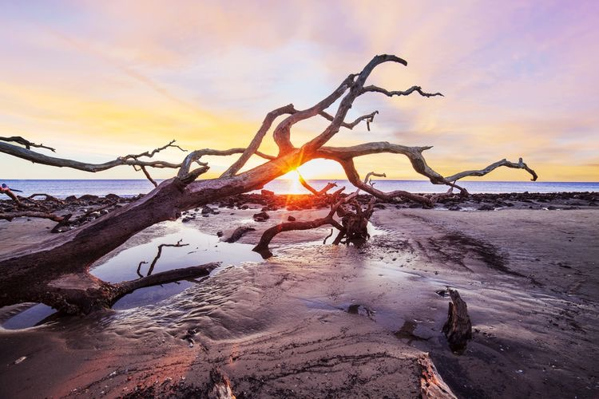Brad McGinley Photography / Getty Images

After a while they find a huge branch, almost a tree which is very wonky and when they climbed on it, bounces up and down. They start hanging on it and trying to make it bounce more. Child B finds a dip in the branch and starts to fill it up with pebbles and shells of different colours and sizes.
Child A asks:’ What are you doing?”
Child B:” Its Ice cream. Do you want one?”
Child A: "Yes please. I have the pink one.”
Child B:”5 pounds please.”
Child A slaps Child Bs hand and counts to 5 and child B passes the required shell to child A. Child C bounces the branch and some shells fall off. Both child A and B shout:” Heyyy you bounced the ice cream off the shelf. Be careful!”
Child C:” oops sorry, how did that happen?”
Child A: "You bounced and they fell off!”
Child C:” But i was over here and not over there.”
Child B:” But it bounced here as well.”
Child C:” I didn't know. Sorry.”
Me: "I think your bounce travelled along the whole branch! Put some sand all along the branch and bounce it again. Let's see if we can see the bounce travel.”
All the children help put sand all along the branch and the child C bounces the branch again. We can all see how the sand bounces off the branch everywhere along the branch.
Me: "Wow did you see that? The bounce travelled all along the branch. This is called vibration”
The children are engaged in the play. They put sand on the branch again and repeat the process. Next, they try putting shells on the branch and bounce it again. Last the try putting pebbles along the branch and bounce it again. They try to bounce the branch harder to make the pebbles jump higher. Next, they try different size pebbles (again talking about the sizes) and different size shells to see if they jump more or less when the branch is bounced.
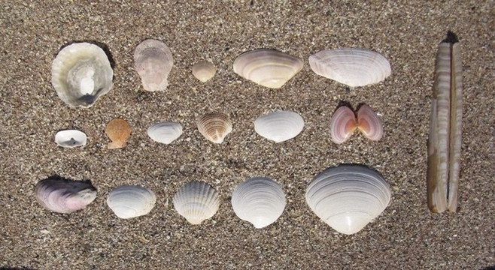Photo by David (2017)
I say: "The big pebbles are not jumping as high as the small ones, are they? Why do you think that is?”
Child C:” maybe they are too big.”
Child C puts only small pebbles on and bounces the branch again. They jump quite high.
Me:” Guys 5 more minutes and we need to go, ok?”
All:” Awwwww.”
Me:” I know it is sad, because you had so much fun, but maybe we can do something fun after the school pick up and try and show the big children what we discovered today at the beach?!”
The children found some sticks to take back to the house, and they collected some shells and pebbles to take too.
Later in the house we found lots of different things to bounce on the branches such as coins, buttons, small pieces of cloth, pens, conkers, small cars and even pretend food. We found that some things bounced higher than others. We also decided to do a craft with the things we found like this picture below.
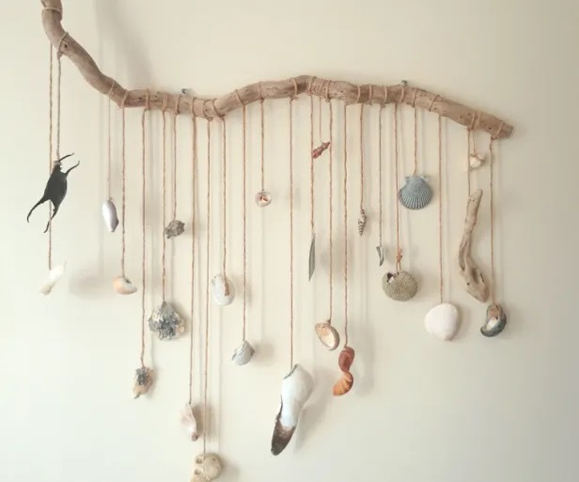Photo by Kids of the Wild (View; L. 2016)

Risk Benefit Assessment
Where did we go: Pembrey Beach
Date:10/09/26
Any additional needs: 1 child with asthma, took pump with us and mobile phone, contact details of all children. First aid kit in bag.
How do we get there: We went in the car, all children in age-appropriate car seats as requested by the parents. All parents signed consent forms for outings to the beach.
Activity | How will  Children  Benefit from  The activity? | Hazard/Risks | Who is at risk? | Control Measures taken? | Risk rating
Walking to the beach and crossing the road on the way from car park to the beach | Children learn to listen to instructions when crossing roads and  Assess the risk of cars | Cars may come and children may run onto the road | The children | Children are taught to hold hands, to stop look and listen for cars, may need reigns for very young ones | medium
Plants with prickles, nettles or poisonous plants | Children will learn to always ask an adult about plants first to make sure they are safe plants | Children may get pricked, stung by nettles or may put poisonous plants in their mouth | Children and adults | Always keep an eye on children, do a quick sweep of the area to see what is there, explain not to eat plants | medium
Strangers, how to keep safe and stay alert to your surrounding area and people in it. | Children will learn not to talk to strangers and walk away with strangers (Stranger danger) | They could get hurt or taken away by someone they do not know | Children | Explain stranger danger to them, stay with the group, wear high vis vests to easily spot them. | Low to medium
Animals and how to approach them or how to keep save in a possible dangerous situation. | Children learn to respond to animals in a safe way by us teaching and role modelling, always asking the owners first if they are safe to touch. Ask adults first if they are unsure. | Children could get bitten or stung by those animals/insects, snacks may be snatched out of their hands by seagulls. Looking out for dog or animal faeces and dogs peeing in places we are. | Children and adults | Talk to children before about animals that we don’t know and how to stay safe. Rule ask first and adult, don not run away but freeze instead, do not touch jellyfish with bare hands or feet as they sting. Keeping an eye out for animals. | Low to medium
Using the wood on the beach for building, drawing, creating | Its loose parts and children can use their imagination to pretend it’s anything they want | Splinters or a child using it to hit or poke | Children and adults | Talk to the children and explain we do not use sticks for hitting or poking and to look out for splinters | low
Rocks and shells of different sizes and different colours to group and be creative with | Again, loose parts to learn to group into different categories, create pictures with and measure | Depending on size they could be a choking hazard, if broken there is a possibility of cuts. | Children | Explain that things that were on the floor should not go in your mouth, because of germs and dirt | low
Bouncing the big branch and swinging and balancing on it | It is a huge loose part and can teach balance and using muscle tone and different amounts of strength | Children could lose balance and fall, could hurt themselves when the branch bounces back at them | Children | Talk to the children about the dangers, let them try and see what happens, step in and help balance if needed | Low to medium
Waterplay, splashing with the feet in the see water, but staying in the low water to minimise risk, taking water to the dry sand and see the changes in the materials | Experiencing the changes from dry materials to wet materials, changes from not sticky sand to becoming sticky and being able to shape and mould sand easier. Looking at which materials sink and float. | Drowning could be a risk and sharp objects like broken shells could cause cuts. Possible jellyfish in the water or crabs which may harm children or adults. | Children and Adults | Always keeping an eye on children in the water and staying in the very low water to keep risks as low as possible. Looking out for crabs and jellyfish that may get swept ashore. | medium
Using Wipes and Hand gel to promote health and wellbeing even on the beach after playing and before having snack on the beach | Children learn that it is important to clean hands before having snacks even when out and about. We may not be able to wash hands but at least we can clean them as best as we can and still kill the germs to the best of our ability. | Germs and dirt that could make us poorly and give us bad stomachs | Children and adults | Always taking a bottle of water, wet wipes and antibacterial hand gel with us to promote hygiene and cleanliness even when there isn’t a sink nearby. The possibility of washing hands in the sea water is an option to, with combination of the antibacterial gel being used after the sea water. | low

Introduction
One of the important things to understand is that the Adult and the environment have a significant impact on what children learn and how they learn it. Vygotsky (London school of Childhood studies 2021) saw the adult as the more knowledgeable other who guides the learner gently through their own thinking. Vygotsky talked about the zone of proximal development, which refers to the gap between a child’s ability to learn something independently and what they can accomplish with guidance from a more knowledgeable other. Piaget (BSA 2026) sees the adult as the facilitator who prepares an engaging environment for students to engage with, learning independently through experience. The Adult is the observer and enhancer of the environment. Piaget describes four stages of development as children’s thinking changes while they grow. Froebel (Froebel Trust 2022) sees the adult also as the facilitator, gentle guide and the child’s biggest encourager but also includes the natural places as a facilitator for learning. Froebel was the inventor of the “kindergarten” which translated is a garden for children. His view is that children learn through hands on experiences in the natural environment. They should not just experience animals and plants, but all aspects of the wider natural environment. The Adult is there to help if needed and to observe. They only step in if necessary to keep the child safe. Children are allowed and encouraged to take risks.

Main Body:
Piaget’s view is that the environment is a teacher in which children build their own knowledge through hands-on experiences. According to Piaget (by Johnson, Christie and Wardle 2005), children engage in types of play that reflects their level of cognitive development such as: Functional play, constructive play, symbolic / fantasy play and games with rules. All of these are so much easier to do outside. Froebel calls it freedom with guidance. The adult is a gentle helper guiding and challenging the child by asking open-ended questions such as what shapes can you see? How do you know that is a square? What colours can you see? I wonder if you can draw a circle around me! Strasser, J. (February/March 2019) talks in her article about how big open ended questions support language development and critical thinking. It helps children to plan when we ask about the materials they used or how they built something. In turn we can extend or correct their language through conversation in a non-discriminatory way, by just using sentences correctly. This ties in with Bruner (Bruner, 1957; Wood, Bruner, & Ross, 1976; Vygotsky, 1978) who claims anyone can be taught anything at any point in life; we just need to scaffold their learning from what they already know. Scaffolding is a metaphor referring to a particular way adults (More knowledgeable other) support children with their learning. Bruner also talks about the repetition of an activity and adding difficulty or another layer to it, to add to children’s learning and experience. This is also called the Spiral Curriculum. Maria Montessori (Montessori Children’s House 2025), Waldorf (King;R., Waldorf School 2018) and Te Whariki (Nzare 11/11/2020) all see nature as that third teacher. The outdoors and how natural things work and grow can be used in a variety of ways such as looking at shapes, patterns, sizes, colour and natural cycles (water cycle, life cycles, food cycle). Louve; R. (2016) describes in his book that children nowadays become increasingly disconnected from nature. He calls it a nature deficiency disorder and states that as important as it is for children to have a healthy diet and enough sleep to develop well, it is also vital for them to be connected to nature. Rosenow; J. (2013) states in his article, “growing tree planters”, that in short we need to help children love the earth, before we can ask them to save it. Helen Torey (Froebel Trust 2022) agrees with Louve and Rosenows views that children are increasingly disconnected from nature, but also that nature is the place which helps them understand how things grow and how they are connected. Playing outdoors also greatly improves physical development, health and immune system (Frost, 2010; p261). Outdoor play of any kind helps prevent obesity and related diseases, nurtures physical fitness and improves development, learning and over all well-being. Frost went as far as saying that not taking children out into nature should be classed as child abuse.
Unicef (2025) explains that a growing body of research shows that children have better physical, mental and emotional health, and improved learning, when playing outdoors. It increases mental and emotional well-being, helps with focus, lowers stress and increases emotional resilience. It may even decrease ADHD symptoms. Children are also more likely to take risks, which improves resilience, creativity and social skills. Outdoor play has also been linked to increased school readiness. Lane (et all 2000) comments that movement is the single most powerful tool we have for helping regulate a child’s nervous system. This tool is also the most natural, most available and most frequently taken away. Guardado and Sergent (2022) state that the body has been treated as a vehicle for the brain -something to be kept still and quiet so the “real work” of thinking can happen. Yet decades of research make abundantly clear that this is backwards. The brain does not regulate itself in isolation. It regulates itself through the body, and movement is the primary language the brain and the body use to communicate with each other. Systems that are helping with nervous system regulation through movement are:
-Proprioceptive system, which lives in the muscles, tendons and joints and lets the person know how much force is being used.
-Vestibular system, which lives in the inner ear and governs balance and special orientation.
-Cardiovascular system, which gets flooded by BDNF (Brain derived neurotrophic factor) by aerobic movement, which primes the nervous system for learning, emotional regulation and focused attention (Latomme et al 2022). It acts like a biological reset button.

These three systems together form the foundation of a regulated nervous system, and they can only be developed and maintained through whole body movement.

Using Observations and assessment tools (Kinderly, Rigby D.; 2024) in connection with the guidance of The Curriculum for funded non maintained nursery settings (2022) helps keep track of children’s developmental stages in Maths, science and other areas. The Curriculum is connecting development with the outdoors. Using Gibbs (University of Cumbria, 2020) model of reflection as how activities, environments and staff work together helps with new ideas to change and make the environment and staff more effective for children to develop and learn more effectively. Staff become more aware of their own preferences and feelings and how these may hold back children in their learning. Staff also get to know each other better and can support each other effectively in their workplaces. Using Risk-Benefit assessments (National education nature park, 2026) is important to keep safety in check but at the same time allow children to take risks and become more resilient and aware of their own capabilities. The Adult (Playworker) only steps in if there is danger or if children need help and ask for it. We can often observe a play cycle in which children connect with each other to play sometimes adults need to step in to maybe add a tool or something the children are looking for and can’t find to the let the play continue or an adult might start the play off and then removes themselves from the play as the children just continue by themselves. These are different ways of intervention without disrupting the children’s play or adulterate their play (KLion; 2022). By observing we learn the children’s likes and dislikes, their interests at any given time and what they already know about it. We can then scaffold the new experiences on what they know and extend their learning with it by enriching the environment or completely changing it. Changing the environment could mean changing from summer to autumn decorations or having water instead of sand, ice instead of water, bringing new materials in for them to discover and experience or new tools to figure out how to use. Maybe it is changing the colour scheme or bringing out playdough instead of building blocks or mix them together.

Conclusion
To understand what a child has learned and how much of it the best way is to observe and record. As Froebel says himself: “Play is the highest expression of human development in childhood, for it alone is the free expression of what is in the child’s soul.” (The Education of Man 1826, by Froebel). Play is education if educators allow children the freedom to choose and discover the world at their pace and in their way. Educators should enrich environments and stand back to let children do the natural thing of exploring. They can extend children’s learning without adulterating play and extend their play and enrich it by adding difficulty or materials. The adults document what they see children do by taking photos or videos and writing a learning story to it following government guidance on how to report such learning. This report should form a holistic picture of the learner, their strengths, the ways in which they learn, their areas of development -in order to inform next steps in learning and teaching (Welsh Government, Assessment Arrangement 2021). Educators responsibilities lay in helping children to become:
-ambitious and capable learners, ready to learn throughout their lives
-enterprising, creative contributors, ready to play a full part in life and work
-ethical, informed citizens of Wales and the world
-healthy, confident individuals, ready to lead fulfilling lives as valued members of society (Curriculum for Wales 2022)

Reference List
Bronner, S.J. (2010). A history of children’s play and play environments: Toward a contemporary child-saving movement. Choice Reviews Online, [online] 47(12), pp.47–6935–47–6935. doi:10.5860/choice.47-6935.

BSA (2026). How Piaget’s theory of cognitive development shapes early years learning? [online] Britannia School of Academics. Available at: https://schoolofacademics.co.uk/how-piaget-theory-of-cognitive-development-shapes-early-years-learning [Accessed 26 Sept. 2026].

Community Paythings (2013). The wisdom of nature. [online] Available at: https://sites.lsa.umich.edu/elizabethgoodenough/wp-content/uploads/sites/206/2014/12/Wisdom-of-Nature.pdf [Accessed 12 Sept. 2026].

David (2017). Beachcombing – Shell collecting in the north-west. [online] Assynt Field Club. Available at: https://www.assyntwildlife.org.uk/2017/04/beachcombing-shell-collecting-in-the-north-west/ [Accessed 26 Sept. 2026].
Department for education (2021). Key concepts in 2 minutes...Scaffolding. [online] Stronger Practice Hubs. Available at: https://www.strongerpracticehubs.org.uk/hubs/ldn/brighter-start-e-ldns-eysph/resources/key-concepts-2-minutesscaffolding [Accessed 26 Sept. 2026].

Froebel Trust (2022). Children and nature. [online] Froebel Trust. Available at: https://www.froebel.org.uk/training-and-resources/children-and-nature [Accessed 19 Sept. 2026].

Guardado, K.E. and Sergent, S.R. (2022). Sensory integration. [online] PubMed. Available at: https://pubmed.ncbi.nlm.nih.gov/32644581/ [Accessed 27 Sept. 2026].

Iliano, E., Beeckman, M., Latomme, J. and Cardon, G. (2022). The GRANDPACT project: The development and evaluation of an intergenerational program for grandchildren and their grandparents to stimulate physical activity and cognitive function using co-creation. International Journal of Environmental Research and Public Health, 19(12), p.7150. doi:10.3390/ijerph19127150.

King, R. (2018). Waldorf School of Cape cod. [online] Waldorf School of Cape cod. Available at: https://www.waldorfschoolofcapecod.org/blog/the-benefits-of-outdoor-free-play [Accessed 19 Sept. 2026].

KLion (2022). What is the play cycle? | Smartkidz play and learn. [online] Smartkidz Play and Learn. Available at: https://www.smartkidzplayandlearn.co.uk/2022/01/29/what-is-the-play-cycle/ [Accessed 26 Sept. 2026].

London School of Childcare Studies (2021). The lev Vygotsky Education Approach - London school of Childcare Studies. [online] London School of Childcare Studies. Available at: https://childcarestudies.co.uk/blog/the-lev-vygotsky-education-approach/ [Accessed 26 Sept. 2026].

Louv, R. (2016). Last child in the woods - overview - Richard Louv. Richardlouv.com. [online] doi:https://richardlouv.com/books/last-child.

Mansel, L. (2025). This otherworldly stretch of Georgia shoreline might be the most unique beach in the South. [online] Southern Living. Available at: https://www.southernliving.com/driftwood-beach-on-jekyll-island-11750195 [Accessed 12 Sept. 2026].

Montessori (2025). Montessori children’s house. [online] Montessori Children’s House. Available at: https://www.themontessorichildrenshouse.net/blog/the-role-of-outdoor-play-in-montessori-learning [Accessed 19 Sept. 2026].
national Education Nature Park (2026). Risk-benefit assessment toolkit for EYFS settings. [online] Available at: https://www.educationnaturepark.org.uk/sites/default/files/2026-01/EYFS%20risk-benefit%20assessment%20toolkit.pdf [Accessed 12 Sept. 2026].

NZARE (2020). Exploring the connection between Kaupapa Māori, outdoor play, and children’s wellbeing. [online] Ipu Kererū. Available at: https://nzareblog.wordpress.com/2020/11/12/kaupapa-maori-play/ [Accessed 19 Sept. 2026].

Rigby, D. (2024). Top tips for observations to inform planning in early years. [online] Kinderly. Available at: https://kinderly.co.uk/2024/02/07/top-tips-for-observations-to-inform-planning-in-early-years/ [Accessed 26 Sept. 2026].

Strasser, J. (2019). Conversations with children! Asking questions that stretch children’s thinking | NAEYC. [online] Naeyc.org. Available at: https://www.naeyc.org/resources/pubs/tyc/feb2019/asking-questions-stretch-children%27s-thinking [Accessed 26 Sept. 2026].

Thayer, J.F. and Lane, R. D (2000). A model of neurovisceral integration in emotion regulation and dysregulation. Journal of Affective Disorders, 61(3), pp.201–216. doi:10.1016/s0165-0327(00)00338-4.

UNICEF (2025). The importance of outdoor play (and how to support it). [online] Unicef.org. Available at: https://www.unicef.org/eca/stories/importance-outdoor-play-and-how-support-it [Accessed 19 Sept. 2026].

University of Cumbria (2020). Gibbs’ reflective cycle. [online] University of Cumbria, University of Cumbria, pp.1–4. Available at: https://my.cumbria.ac.uk/media/MyCumbria/Documents/ReflectiveCycleGibbs.pdf [Accessed 26 Sept. 2026].

View, L. (2016). How to make driftwood decorations & seashell art. [online] Kids of the Wild. Available at: https://kidsofthewild.co.uk/2016/09/23/driftwood-seashell-decorations-tutorial/ [Accessed 12 Sept. 2026].

Welsh Government (2020). Mathematics and numeracy: Introduction - HWB. [online] hwb.gov.wales. Available at: https://hwb.gov.wales/curriculum-for-wales/mathematics-and-numeracy [Accessed 12 Sept. 2026].

Welsh Government (2021). Assessment arrangements: Subordinate legislation resultant of the curriculum and assessment (wales) act 2021.
Welsh Government (2022a). A curriculum for funded non-maintained nursery settings. [online] Available at: https://hwb.gov.wales/api/storage/b1801d78-38c3-4320-9818-d9996c21aef8/220914-a-curriculum-for-funded-non-maintained-nursery-settings.pdf [Accessed 26 Sept. 2026].

Welsh Government (2022b). Science and technology: Statements of what matters - HWB. [online] hwb.gov.wales. Available at: https://hwb.gov.wales/curriculum-for-wales/science-and-technology/statements-of-what-matters/ [Accessed 12 Sept. 2026].

