Data Handling & Business Intelligence

Module code: LCBB5000

Assessment 2 – Current Trends of Business Intelligence

Student Name: Svetoslav Hristov Radev
Student ID: 2030542

Table of Contents
Introduction 3
Business Intelligence Trends 3
Artificial Intelligence (AI) 4
Internet of Things (IoT) 4
Big Data 5
Real-time Data & Analytics 5
SaaS and Cloud Computing 5
Conclusion 6
References 7

Introduction
Business Intelligence helps certain businesses to enhance their knowledge about their competitors' actions and make sure that they are informed about their upcoming plans, which helps them to make planned decisions. Over the last few decades business intelligence helps certain organisations to take faster and effective decisions by successfully completing accurate reporting, analysis and planning. In this study, 5 effective business trends have been discussed that help to develop more insight knowledge about BI tools and strategies so that these certain companies can use BI dashboard software effectively.

Business Intelligence Trends
Business Intelligence and analytic tools help business organisations to manage all business-related problems by analysing their business reports with this software. In addition, this software also secures primary competitive advantages through business intelligence by making effective forces to shape the market and business. This below mentioned graph shows how BI software helps businesses to achieve several benefits in which manner.
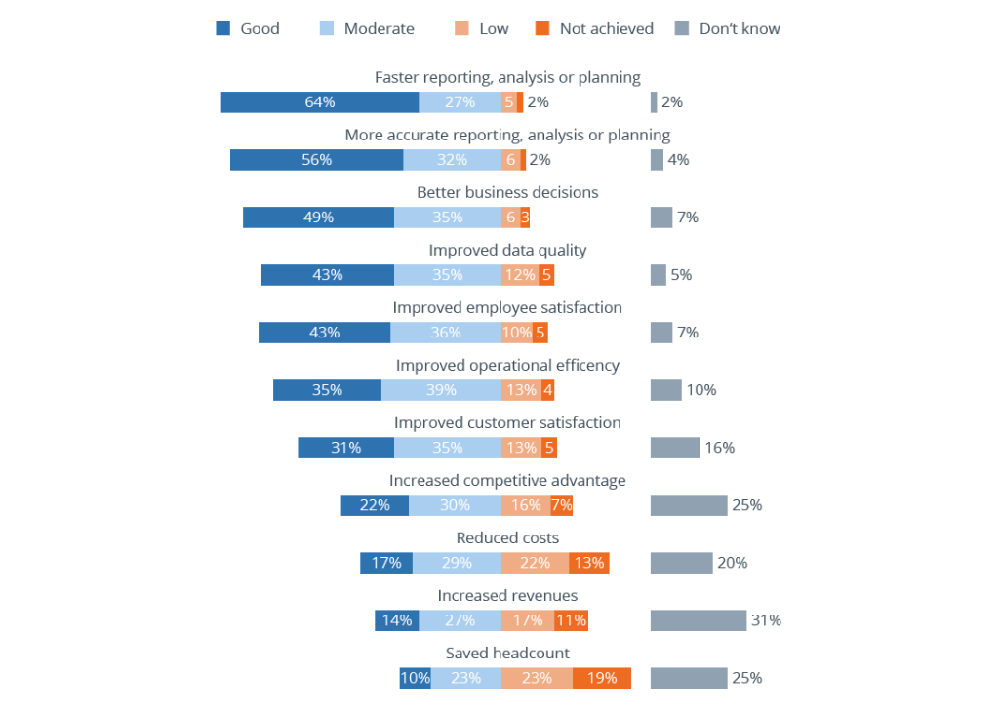
Figure 1: Different levels of achieved following advantages with Business Intelligence
(Source: Janoschek, 2022)

Artificial Intelligence (AI)
AI has been introduced in this current trend of BI that helps to cover business reports widely by combining AI with engineering and hyper automation, which also concentrates on the level of security so that AI increases the concern about vulnerable points and attacks. With the help of AI, it becomes easy to execute machines which were previously done by complex human intelligence (Azevedo, 2014). Although some scientists and tech entrepreneurs warn that it might destroy human effectiveness, it could not be avoided that business management was not as effective as before. As per observation, after Covid-19 the business landscape has completely changed where historical data will no longer exist and AI-based technologies and software become the main driver in business analysis.
Most importantly, ethical AI aims to improve organisations legal practices so that these organisations can maintain their business improvements within legal implications. It is important to collect data ethically as in one example of the Facebook and Cambridge Analytica Scandal seems to collect data illegally from users. According to the latest report of the Global AI Adoption Index, AI adoption rate in the UK was more than approximately 20% in 2021 (CyberCrew, 2022). It seems different applications of AI helps in maintaining smart email categorisation, providing online customer support, in process automation, ensuring security surveillance and many more.

Internet of Things (IoT)
Internet of Things helps certain business organisations to reach their business objectives by optimising their data that help these business organisations to take effective decisions. It seems solutions provided by IoT helps in manufacturing, supply chain analysis to gather the data in the current production process (Azevedo and Santos, 2020). It needs to be mentioned that this streamline operations reduce production costs and downtime for their project. As IoT successfully optimised workflows by automation, certain business organisations can become cheaper, faster and more efficient business actions. Besides, it also reduces wasting man-hours in their business so that they can improve their operations efficiently.
Moreover, it also promotes optimal asset utilisation in which it connects with different units, devices and machinery with a single network. It seems these smart sensors can also track assets where real-time insights and autonomic processes control waste management and stimulate workflow of the business. The IoT market is expected to expand by USD 21.81 billion from 2021 to 2026 in the UK (Technavio, 2022). Moreover, IoT based solutions also help to manage supply chain and logistics where such business organisations manage customers on demand pick-up and delivery along with tracking their manufacturing process to ensure quality products, temperature sensitive products and accessing critical information through IoT.

Big Data
Big data is maintaining a significant role in business where certain business organisations use big data to enhance their operations, increasing personalised marketing campaigns, ensuring better customer service and taking effective decisions to increase revenue and business profits. The certain environment of Big Data also helps to manage different types of data by using customer databases and internet clickstream records, social information sensitive data and many more. Although previously it was limited to structured data, now the use of Big Data has increased to increase better business strategies and effective decisions to improve their profitability chances.
Through evaluating current business scenarios, it seems most of the organisations use Big Data to better stream their process applications, for predictive modelling, machine learning and many more. It also provides a 360-degree review of their customers so that certain business organisations can stimulate their market demand by increasing their business sales. It also helps to manage agile supply chain operations so that they can easily make better decisions in managing their business requirements. Furthermore, the data-driven innovative procedures also help to improve business functions (Lim and Teoh, 2020). Whereas Big Data also helps to manage operational improvements by reducing their production costs and proactive equipment maintenance.

Real-time Data & Analytics
Real-time data has become another famous trend in 2022 as its requirement is being increased after a pandemic situation. Some business organisations use real-time data to make effective decisions so that in this pandemic they can easily survive this pandemic (Zhang et al., 2022). Real time data also seems to create hoc analysis which enables businesses to ensure their place by staying on top of changes and also manage immense challenges that this year brought towards them. The primary use of real time data is to increase analytics by analysing raw data into insights as it is collected from different sources.
It also has a significant place in managing business cases so that these organisations can take effective and immediate actions, ensuring proactive business processes by grabbing the right opportunity which also help them to be safe from any kind of problems. It also helps to detect and address operational issues quickly so that these business organisations won’t suffer after.

SaaS and Cloud Computing
SaaS (Software-as-a-service) ensures business solutions by helping these organisations to receive their business updates, ensuring knowledge about new functionalities and software updates as soon as they are introduced in the market. On the other hand, cloud computing helps both small and big businesses to analyse their accessible data, ensuring collaboration and better access to latest technologies (Saini et al., 2019). Whereas, their team members can access the same document at the same time by being present in different locations which improve their business collaboration and ensure positive outcomes. Cloud computing guides virtually unlimited storage capacity than hard drives and it is also flexible to use.
On the contrary, with the help of SaaS business managers can reduce their application cost where it makes a bigger impact on business by providing solutions to IT infrastructure cost, manufacturing cost and maintenance cost by reducing this. Therefore, it becomes easy to effectively use business capital and ensure investments. Such a cloud-based application SaaS model is in high demand in business nowadays. It transforms traditional business applications and improves IT plans for organisations. Approximately 80% of businesses use SaaS applications worldwide which increase the value of cloud-based supply chain market solutions up to $ 11B by 2023 effectively (Enable.com, 2022).

Conclusion
In conclusion it can be said that in current days these data driven businesses are no longer ideal where business managers need to adopt certain trends and these latest Business analytic software so that it can ensure maximum profit towards their business. Through ensuring these latest trends in business analytics it helps them to take effective decisions immediately by grabbing the opportunity. It is equally crucial to understand the market requirements to ensure their business developments. These trends also help business organisations to become future ready while enhancing business insights and many more.

References
Azevedo, A. and Santos, M.F. eds., (2020). Integration challenges for analytics, business intelligence, and data mining. IGI Global, US.
Azevedo, A. ed., (2014). Integration of data mining in business intelligence systems. IGI Global, US.
CyberCrew, (2022). Curious Artificial Intelligence Statistics UK [2022]. [online] CyberCrew. Available at: <https://cybercrew.uk/blog/artificial-intelligence-statistics-uk/> [Accessed 30 August 2022].
Enable.com, (2022). 10 statistics that show SaaS is not going anywhere | Enable blog. [online] Enable.com. Available at: <https://www.enable.com/blog/10-statistics-that-show-saas-is-not-going-anywhere> [Accessed 30 August 2022].
Janoschek, N., (2022). Benefits of Business Intelligence - 2,500 Projects Analyzed. [online] BI Survey. Available at: <https://bi-survey.com/benefits-business-intelligence> [Accessed 30 August 2022].
Lim, Y.Y. and Teoh, A.P., (2020). Realizing the strategic impact of business intelligence utilization. Strategic Direction.
Saini, H., Upadhyaya, A. and Khandelwal, M.K., (2019, October). Benefits of cloud computing for business enterprises: A review. In Proceedings of International Conference on Advancements in Computing & Management (ICACM).
Technavio, (2022). IoT Market in UK by Technology and End-user - Forecast and Analysis 2022-2026. [online] Technavio. Available at: <https://www.technavio.com/report/iot-market-industry-in-uk-analysis#:~:text=The%20IoT%20market%20share%20in,at%20a%20CAGR%20of%2011.80%25.> [Accessed 30 August 2022].
Zhang, H., Zang, Z., Zhu, H., Uddin, M.I. and Amin, M.A., (2022). Big data-assisted social media analytics for business model for business decision making system competitive analysis. Information Processing & Management, 59(1), p.102762.

