Community Engagement
NAME: GEOVANNI LELIS
STUDENT NUMBER: 1907386
LECTURE’S NAME: TANJA NATHAN
Reflective Evaluation: HR Manager at KPMG

Contents
Introduction: Nature and purpose of Reflective practice and evaluation: 2
Applying the reflective theory to the case: 2
Conclusion: 6
References: 6

Introduction: Nature and purpose of Reflective practice and evaluation:
In general terms, reflective practice relates to an assessment and examination of one’s own thoughts and actions. Such thoughts and actions are assessed and examined necessarily for the purpose of personal learning, improvement and development. In management science, reflective practice and evaluation can be used to support learning and development of the self as well as that of others. Reflective practice and evaluation is an effective method that has been used in management science to bring about significant improvements in the skills and competency levels of professionals. Such a practice is supported by self-reflection as well as learning from a 360 degree feedback model (Bruno and Dell’Aversana, 2018). Reflective practice and evaluation is used by professionals in the management field to improve their own working practices and behaviour based on the evaluation of their past performances, experiences, actions and thoughts. Such a practice is essentially supported by an action plan meant for the identification and assessment of the areas of improvement and chalking out a timeframe-based plan to undertake activities and actions meant for the improvement of the same. Reflective practice and evaluation is of great help when it comes to learning throughout life and is also significant as far as continuous improvement is concerned. In this reflective evaluation paper, the case of the HR Manager with KPMG will be considered.

Applying the reflective theory to the case:
Reflective practice and evaluation is important as far as self-awareness and lifelong learning is concerned. The importance of Reflective practice and evaluation and how it relates to practical experiences and improvement can be understood from the fact that it is associated with emotional intelligence. Emotional intelligence has a significant role to play I enabling professionals understand their own thoughts and actions as well as those of their peers, superiors and juniors. Reflective practice and evaluation is hence used actively in the field of management to develop critical thinking skills and active engagement of the professionals in the working practices and processes that lead to continuous improvement and lifelong learning (de Souza Teixeira, et al., 2015).
Working as the HR Manager with KPMG, I have had many experiences which merit introspection and reflective evaluation. The roles and responsibilities of the HR Manager with KPMG are diverse and aligned with the working practices and functioning of other departments and the organisation as a whole. It entails that my activities and ways of working need to be assessed and evaluated keeping in mind the broader perspectives of the organisation’s corporate and business strategy. Therefore, for the purpose of an effective and thorough reflective evaluation of my practice as the HR Manager with KPMG, I will use the reflective theory. The use of this theory will not just help me assess my own actions and thoughts but also my experience, associating it deeply with the practical aspects and situations I have faced during the course of my working as the HR Manager with KPMG (Gould, 2016). The application of the reflective theory to my experiences will also help relate the theory with the practical experiences.
The reflective theory is based on the central idea of basing the knowledge of an individual on the activities, trends and phenomena of the real world. It is based on the premise that the ideas and knowledge we possess and reflect are essentially the objects in the real world they emanate from. According to this theory, the ideas of an individual and the thoughts that dictate action are developed from a sensate interpretation and a conscious analysis of forms reality around us. As such, observation is regarded as a physical process that gives rise to such ideas and thoughts and helps relate such subjective ideas to the objective real world. Applying this theory to the case of me working as the HR Manager with KPMG illustrates that it is the conscious and sensate interpretation of the real world that leads to the generation of subjective ideas and thoughts which dictate how I behave in the piratical scenario in the given role (Abrahams and Singh, 2019). It is important to be assessed and examined in the sense that such ideas and thoughts are responsible for urging me to conform to certain behavioural and attitudinal attributes and ways of working. My working as the HR Manager with KPMG in all spheres and scenarios can hence be assessed using this theory which seeks to draw a link between subjective thoughts and ideas I generate and the objective real world where I used them. However, it is also necessary to be kept in mind that the ideas and thoughts that are generated and the actions I undertake are in fact reflections of what the real world hold.
As has been discussed earlier, reflective practice and evaluation is essentially based on analysing how ones emotional intelligence is shaped and how it leads to individuals assess and interpret problems and situations in a certain way and respond to the same in a manner which they deem to be the most effective. Applying the reflective theory to the reflective practice and evaluation of my experience and practice as the HR manager with KPMG has shown me the underlying aspects and emotional intelligence related factors that shape, define and explain my actions and decisions in the practical scenario. The reflective theory is based on the concept of the real world and opines that the ideas and concepts we generated as individuals are essentially reflections of the real world. The trends and phenomena of the real world and the ways they reflect the ideas and thoughts we design in decision making and working are as such, important to be considered as far as reflective practice and evaluation is concerned. Linking this idea to the practical case is important so as to explore the aspects that seek to explain why I behaved in a certain manner in a givens scenario and to what extent the real world reflected what I believed in or what my ideas and approaches were (Colomer, et al., 2018)\.
In this regard, it is important to note that reflection in this regard is necessarily done in a cyclic manner. In other words, it means that reflection occurs in the form of e cycle wherein the key components can be categorised as action, reflection and ten again, followed by subsequent action. Reflection on experiences and assessing ones ideas, thoughts, actions and practices with regard to the situation at hand therefore holds the key to successful reflective practice and evaluation in the practical scenario. This paves the way for the development of the concept of experiential learning, reflection and education. The role of the HR manager with KPMG demands continuous improvement and strengthening of the knowledge and skills on my part, in this regard the use of the reflective theory is of great help to enable me to understand how the external environment or the situation at hand is linked with the roles and responsibilities I take care of as the HR manager (Gould and Taylor, 2017). I believe that reflective practice and evaluation in this regard is of great significance as far as improving my own skill level, knowledge and competencies are concerned and can of be great help in supporting me undertake lifelong learning and continuous improvement.
The role-play of the HR manager with KPMG has been challenging and intriguing for me. The roles and responsibilities of the HR manager with the said company were essential to have been developed a deep knowledge about before progressing with the activity. The various stages of the role-play activity need to be identified and discussed before delving deeper into exploring the success area and areas for improvement in the said activity. The various stages in setting up the role-play activity can be identified as identifying the situation and introducing the problem, adding necessary details, assigning the roles, acting out of the givens scenario, encouraging open discussions and exchange of information and discussing the learning outcomes from the said activity (Johns, 2017).
In the case of the present activity, the role play was signed by the supervisor and the various stages reviewed to ensure that I met all the necessary requirements and complied with all applicable standards and ethical considerations involved in the said activity. The role-play as the HR manager with KPMG has been exciting for me and has exposed me to new experiences and learning opportunities which had not been explored by me so far. The role-play activity as the HR manager with KPMG has provided me information about the various roles and responsibilities of the HR manager and the ways they monitor the processes of the organisation and manage human resources, aligned with the broader organisational strategy. Experiencing the activity has also been a crucial achievement for me as far as learning from reflection is concerned. The vast and diverse roles and responsibilities of the HR manager with KPMG have been studied and reflected on in the course of the activity and has provided me with an opportunity to relate appropriate theory and concepts with the practical scenario and practices that are intrinsically related to the working and approaches of the HR manager with KPMG (Gould and Taylor, 2017).
The success area of the role-play activity as the HR manager with KPMG can be associated with the fact that the very essence of a role-play activity is to expose practitioners to a piratical scenario and urge them to engage in social interactions to understand the scenarios the imagined professional needs to work in. it also helps explore and understand the different actions and thoughts that are part and parcel of the decision making process and how the situation at hand defines how they act and decide from time to time. Therefore, the success area of this particular exercise can be associated with the identification of the situation and the definition of the problem which were done at the outset of setting up the role play activity. The identification of the situation and the introduction to the problem set the tone for the entire activity and helped me, my peers and the supervisor plan and coordinate the various stages of the role-play activity effectively and efficiently. The success with which the need for reflective practice and evaluation was communicated wand linked to the real life scenario, practices and roles and responsibilities of the HR manager of KPMG paved the way for the success of the activity in meeting the envisaged aims and objectives (Abrahams and Singh, 2019). It also played an important role in ensuring that the appropriate theory was linked to the practical experience and working of the role-play professional. Linking such theories and concepts with the practices and approaches and ensuring the identification and assessment of the same has provided the researcher with information about how reflective practice and evaluation helps professionals improve their own working and performance through the analysis and evaluation of their own ideas, thoughts, actions and activities.
However, alike any other activity, in the course of the role-play activity, I did encounter impediments. The problem was in the form of the need to define the attitudes and actions of the HR manager of KPMG in response to different situations. The response of such professionals is determined by the situation at hand and they tend to adapt to the situation and respond differently in different situations. Therefore, it was challenging to assess the thoughts and ideas of the professional without taking into account the forces of the external environment that shaped such responses. It is owing to this aspect that the reflective theory was used. The reflective theory explained how such ideas and constructs are essential reflections of the real world a professional operates in.

Conclusion:
Reflective practice and evaluation is essential for professionals in all sectors and ensures that the professionals and learner continue to learn from their actions, thoughts and ideas as well as past experience. The use of appropriate theories to link theories with practical experience provides useful inputs with regard to working of professional and how they seek to meet their own professional and career advancement goals.
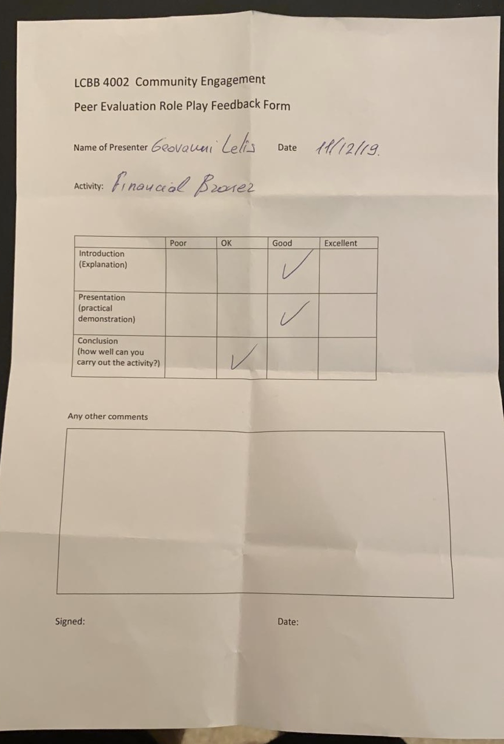

References:
Abrahams, A.S. and Singh, T., 2019. An active, reflective learning cycle for e-commerce classes: Learning about e-commerce by doing and teaching. Journal of Information Systems Education, 21(4), p.6.
Bruno, A. and Dell’Aversana, G., 2018. Reflective practicum in higher education: the influence of the learning environment on the quality of learning. Assessment & Evaluation in Higher Education, 43(3), pp.345-358.
Colomer, J., Serra, L., Cañabate, D. and Serra, T., 2018. Evaluating Knowledge and Assessment-Centered Reflective-Based Learning Approaches. Sustainability, 10(9), p.3122.
de Souza Teixeira, C.R., Alves Pereira, M.C., Kusumota, L., Pirani Gaioso, V., Lima de Mello, C. and Campos de Carvalho, E., 2015. Evaluation of nursing students about learning with clinical simulation. Revista brasileira de enfermagem, 68(2).
Gould, N. and Taylor, I., 2017. Reflective learning for social work: research, theory and practice. Routledge.
Gould, N., 2016. Introduction: the learning organization and reflective practice–the emergence of a concept. In Social work, critical reflection and the learning organization (pp. 11-20). Routledge.
Johns, C. ed., 2017. Becoming a reflective practitioner. John Wiley & Sons.

