CertHE ASSIGNMENT SPECIFICATION
SCHOOL OF HOSPITALITY & TOURISM MANAGEMENT
Student name: |  | Student number:
Programmes: | CertHE International Hotel Management
Module: | Food & Beverage Operations | Module Level (4, 5, 6): | 4
Module code: | BMIH4002 | Contribution to Overall  Module Assessment (%): | 25%
Lecturer: | Ryan Peters Kathryn Roberts  Samantha Birdsell | Internal Verifier: | Melissa John
Assignment Title: | Student Journal (Learning Log)  Minimum 750 words (+/- 10%) | Assignment No: | 1 of 3
Hand Out Date: | w/c 20th September 2021 | Submission deadlines: Return date of provisional marks & written feedback: | 21st October 2021  18th November 2021

LEVEL 4 – Student Journal
Student Name:  Student Number: | Module:  Lecturer:

Topic of choice: Food Safety Fundamentals (The 4C’s) | Date Completed:
Food safety fundamentals refer to the essential principles that are obligatory to maintain regarding the food preparing process to ensure the safety and health aspects of the food. The safety and hygiene fundamentals can be stated through the 4C's that stands for cleaning, cooking, chilling and contamination. In this week of the class lectures, we have discussed the various aspects of the food safety and hygiene factors that need to be maintained in the cooking process, or while preparing any sort of food. The examples that were discussed throughout our lecture was more industry-related and we have been able to learn about the industry fundamental actions that are taken to ensure food safety.
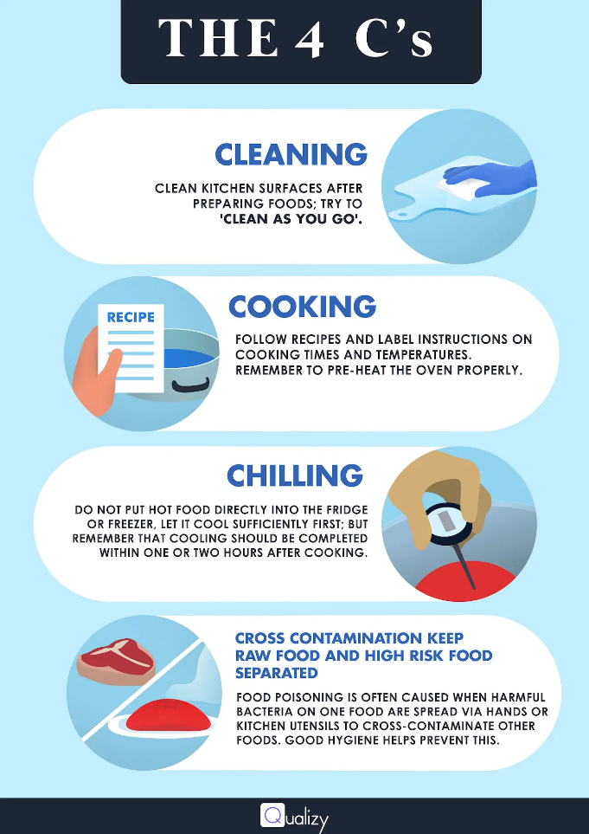
Figure 1: The 4C’s of Food Safety Fundamentals
Source: (Hong and Lim, 2015)
The first topic that regarding food safety that we discussed was Cleaning, which was before and after the cooking process. From the study of Shaw (2018) we got to learn about the fact that due to the cleaning factors, there could be a significant impact on the safety and hygiene of the food prepared in the kitchen. About cleaning we came to know that, before starting the cooking procedure in the kitchen should be neat and clean and all the kitchen surfaces needed to be cleaned with detergent or other types of cleaner. Along with the kitchen surface, the kitchen instruments and utensils should also be cleaned to remove the germs from the surfaces of the equipment and utensils. Once the cooking is complete, the used equipment and utensils further need to be cleaned properly with cleaning liquids so that there are no chances of germs being there (Healey, 2016). Kitchen surfaces to some extent also get noisy during the process of cleaning, once the procedure is finished kitchen surfaces also should be recleaned.
During the process of Cooking, certain cautionary actions are essential to maintain so that the cooking process go safe. The burners and the heaters need to be well connected, and about the leakage of gas, any errors in the electric connections of the heaters need to be well checked, so that there are no chances of catching fire (Alldrick, 2014). We have learned that in the cooking process the food should be kept under the heat of between 70°C to 75°C for at least 120 seconds which is the optimum temperature and timing for killing all the bacteria. During the cooking process, the instructions of the recipes should be followed maintaining all the steps, without crossing over. Along with the cooking process, the person who will be cooking needs to ensure that all the ingredients are ready and stored through proper hygiene maintenance (Choi, 2012). Also, the raw meats, vegetables, fishes etc. needs to be kept in proper safe ways for the safety of the foods.
The third C of the food safety fundamentals that learned about was Chilling, regarding which we had discussed different factors of food chilling after the cooking. Once the meal or food is ready to eat, the food needs to be chilled through maintaining proper procedure for further eating. To chill the food, it is a very important fact that the hot food direct from the burners should not be chilled, rather once the food is off-the burner, needs to be cooled down (Schmidt and Rodrick, 2013). After the food has turned cold, then it can be kept in the freezer to save for later eating. While cooling the food it should be held on a dish and let enough time to cool it down, rather than hurrying the process of cooking. But if there is a lack of time, a speed cooling procedure can be initiated by cutting the entire food item into smaller pieces and putting the pieces into a side dish.
The final factor regarding food safety and the last C that we had discussed was Contamination or Cross-contamination. Contamination is the process of the food getting attacked by bacteria or germs during the cooking process, or when the food is kept to the dishes. The contamination happens during the cooking process from the equipment, hands, gloves or utensils of the kitchen. In this process, cleaning is very important which should be emphasised (Hong and Lim, 2015). Few other cautionary actions also need to be taken such as holding the foods in clean dishes, avoiding the food to be kept on the dishes that were along with the raw ingredients. The person who will be cooking should wash always hands after holding or touching the raw foods, or anything that is not cleaned enough.

REFERENCE LIST
Choi, J. 2012. Standardization of Identification-number for Processed Food in Food-traceability-system. Journal of Food Hygiene and Safety, 27(2), pp.194–201.
Eldrick, A. 2014. Chemical safety of cereal-based foods: risk management considerations. Quality Assurance and Safety of Crops & Foods, 6(1), pp.3–14.
Healey, J. 2016. Food safety. Thirroul, N.S.W.: The Spinney Press.
Hong, J. and Lim, S. 2015. Microbial Contamination in Kitchens and Refrigerators of Households. Journal of Food Hygiene and Safety, 30(4), pp.303–308.
Schmidt, R. and Rodrick, G. 2013. Food safety handbook. Hoboken, N.J.: Wiley-Interscience.
Shaw, F. 2018. The importance of food safety and hygiene. Journal of Food: Microbiology, Safety & Hygiene, 03.

