Managing Projects in The organization

MPO
Tutor: Dan Hart
Author: Mohammed Arif Khan
Student ID: 1818579

Table of Contents
1. Introduction 3
2. Project Management Tools and Techniques 3
2.1 Gantt Chart 4
2.2 Critical Path Method 4
2.3 Monte Carlo Method 5
2.4 Agile Methodology 6
2.5 Project Evaluation Review Technique 7
3. Proposed Project 7
4. Project Implementation Plan 8
4.1 Project Initiation 8
4.2 Project Planning 9
4.3 Project Execution 11
4.4 Project Monitoring and Closure 11
5. Project Communication Plan 12
6. Pre and Post Covid Changes 14
7. Project Management Capabilities 15
8. Strengths and Weakness Identified through Feedback 16
9. Self-Development Plan for Enhancing Project Management Skills 17
10. Conclusion 18
11. Reference 20

Introduction
Previously, project management was used in the construction industry, large financial firms and consulting organisations. Now project management has expanded to many other areas of activity. This area of ​​knowledge has had the greatest impact on the field of information technology. This is due to the fact that an IT project requires a calendaring of a large number of interdependent work performed by different companies. That is why high-quality project management is impossible without the use of software tools. Planning and managing the work of a project is complex and often controversial. Estimation of the time and cost of the project, carried out within the framework of this task, is made by various methods (Radujković and Sjekavica, 2017). One such method is the project duration management method. Duration management is an integral part of any project, and an IT project in particular. Such a project, like no other, needs competent planning and time management, since it is often IT projects that have a direct negative impact on the business in the form of production downtime, interruptions in the supply of products, non-fulfilment of obligations to customers or customers, losses from lost profits.
Currently, not all company management is familiar with the "project management" area of ​​expertise. As a result, their organisation lacks specialists with the skills to use specialised software for project planning. In the 21st century, the information society is developing more and more. The role of information and information technologies in the life of modern society is increasing, the number of IT projects is increasing (Chofreh et al., 2020). The risks of meeting deadlines, exceeding labour costs and failing to achieve planned results for IT projects are especially high. Today, businesses are rapidly impacted by the evolving crises due to COVID-19 virus (Coronavirus) (Chofreh et al., 2020). The businesses around the world are at high risk due to this virus and companies are adopting new trends in their projects management. The influence on the worldwide economy might upsurge depending on the geographic extent of the virus. This paper therefore critically assesses the usefulness of project management tools and techniques that a British fashion retailer “All Saints” can adopt to overcome the potential economic barriers set by Covid19.

Project Management Tools and Techniques
A number of methods are used to estimate project duration, such as: Gantt chart, critical path method, critical chain method, resource levelling method, statistical test method (Monte Carlo method), plan evaluation and revision method (PERT), graphical evaluation and analysis method (GERT), critical chain method, etc. Some of these are briefly described as under (Mazlum and Güneri 2015):

2.1 Gantt Chart
One of the most effective examples of techniques in project management is the Gantt Chart (Schwalbe, 2015). It clearly specifies the task of project management that are overdue, in progress or the tasks that need to be done in future. In general, the Gantt chart is a consistent scale with sliders demonstrating all tasks incorporated in the project (Mazlum and Güneri, 2015). This benefit to evade constant explorations on the to-do list for all those tasks that should be done now or are already completed.
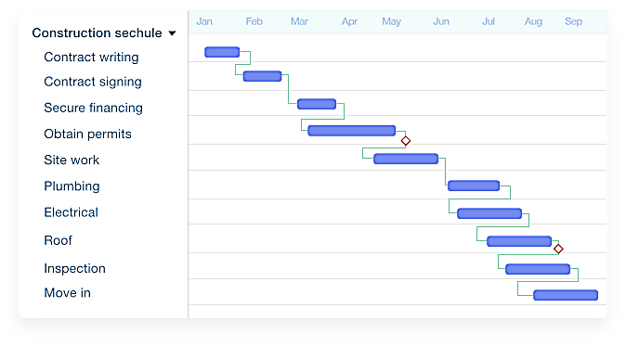
Figure 1: "Gantt Chart"

2.2 Critical Path Method
The Critical Path Method is a project modelling method that identifies critical timelines and ensures that the project is delivered on time. This method shows the "critical path" - the path between the beginning and the end of the project, including the most important tasks and their duration. The critical path is one of the tools managers use when creating a project plan and schedule. Once the “map” has been built, they can start building a timeline in their planning software and begin the process of managing their project (Heldman, 2018). With its help, the theoretical dates of early and late start and finish are calculated, during which resource constraints are not taken into account. The critical path plays an important role in scheduling in project management. It is used in conjunction with PERT (Program Evaluation and Verification Method) to determine the longest amount of time it will take to complete a task. The critical path is a way to streamline the seemingly chaotic complexity of any project. It not only shows the duration of the tasks, but also prioritises them (Mazlum and Güneri, 2015).
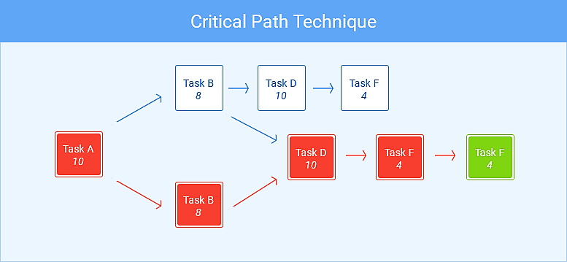
Figure 1: "CPM Technique"

2.3 Monte Carlo Method
When using this method, an answer is given to the question: “What will happen if the situation develops according to a certain scenario?” A miscalculation of various options is carried out (for example, a delay in the delivery of raw materials, an increase in the duration of certain engineering operations) or the influence of unforeseen external factors is simulated (for example, a strike or changes in legislation) (Marcelino-Sádaba, González-Jaen and Schwalbe, 2015). The results of the analysis are used to assess the feasibility of a project under adverse circumstances and to draw up contingency plans, response plans to overcome or mitigate the consequences of unexpected events.
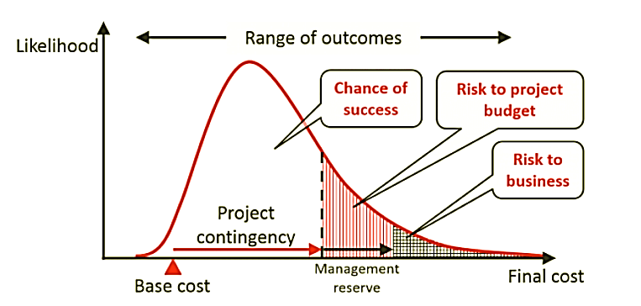
Figure 2: "Monte Carlo Analysis in Project Management"

2.4 Agile Methodology
Agile is an iterative approach to projects in which requirements and solutions change over the course of collaboration between customers and development teams. The term was coined in 2001 when the "flexible manifesto" was drawn up (Mazlum and Güneri, 2015). Agile means you create the deliverables ahead of time and improve them in a few steps with the client. However, some stakeholders may view this negatively. More and more companies are adopting agile development practices in response to customer demands to make change faster and cheaper (Conforto et al., 2016). However, there is skepticism in the Agile community about organisations achieving the desired benefits.
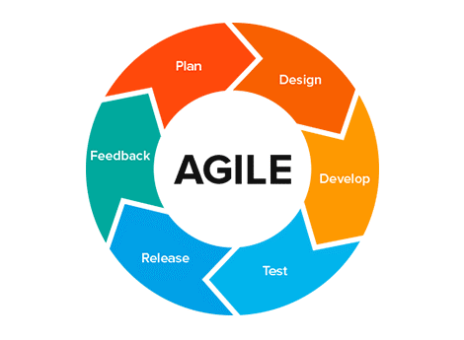
Figure 3: "Agile in Project Management"

To succeed in agility, organisations must first understand the basic goals of agility and then decide if the agility is right for them. Most of the problems with agile projects stem from organisations not understanding the underlying goals of agility. Agile projects are considered to be less time-consuming, less expensive, and less risky. This misconception comes at a cost. For many organisations, agility requires significant cultural and process changes that cannot be accomplished by adopting Agile. True agility requires questioning existing processes, management hierarchies, and governance that many companies are often reluctant to do (McVay Lynch and Roecker, 2019).

2.5 Project Evaluation Review Technique
Program (Project) Evaluation and Review Technique (PERT) is a program (project) evaluation and analysis technique used in project management. PERT is a way of analysing the tasks required to complete a project, and especially analysing the time required to complete each task. Allows you to determine the minimum required time to complete the project. PERT is a type of critical path analysis. At the same time, each of the stages of the project is assessed in more detail (McVay Lynch and Roecker, 2019). The method involves determining the optimistic, pessimistic and most likely duration of the project. The PERT method allows for the influence of uncertainty in determining the duration of activities and analyses its impact on the duration of the entire project.
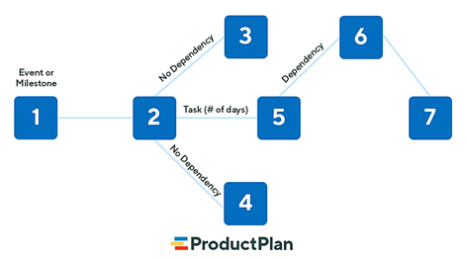
Figure 4: "PERT in project management"

Proposed Project
All Saints must transform its project management strategies in view of the ongoing pandemic circumstances. By adopting dynamic strategies, All Saints can encounter and extend the limits for conventional flexibility plans. The probable standard strategic alternatives in this respect comprise work transfer to alternate sites, and design of alternate supply chain vendors. Furthermore, restricted accessibility or degradation of infrastructure like mass travel, internet, and broadcast communications may present further difficulties to initiating plans and systems. To offer consistent and appropriate business messaging, All Saints must create a vigorous communications approach that evidently lays out progression and conventions to participate with an extensive set of investors (e.g., counterparties, customers, regulators, third parties, employees, governments, health officials, and media), with the help of online platforms, all-encompassing any jurisdictional or legal attentions.

Project Implementation Plan
According to Ma et al. (2018) the Project Life Cycle (PLC) is based on four major steps which the project managers and the staff members use in order to achieve the objectives that were designed to enhance the efficiency and performance of the staff and boost the output of the firm. The PLC for All Saints resolves around the major 4 stages of project initiation, project planning, project execution, and project monitoring and closing (Thomson, El-Haram and Emmanuel, 2011). The figure below highlighted the stages of the PLC for All Saints which could enhance the sales improvement plan for All Saints Company could be made achievable.

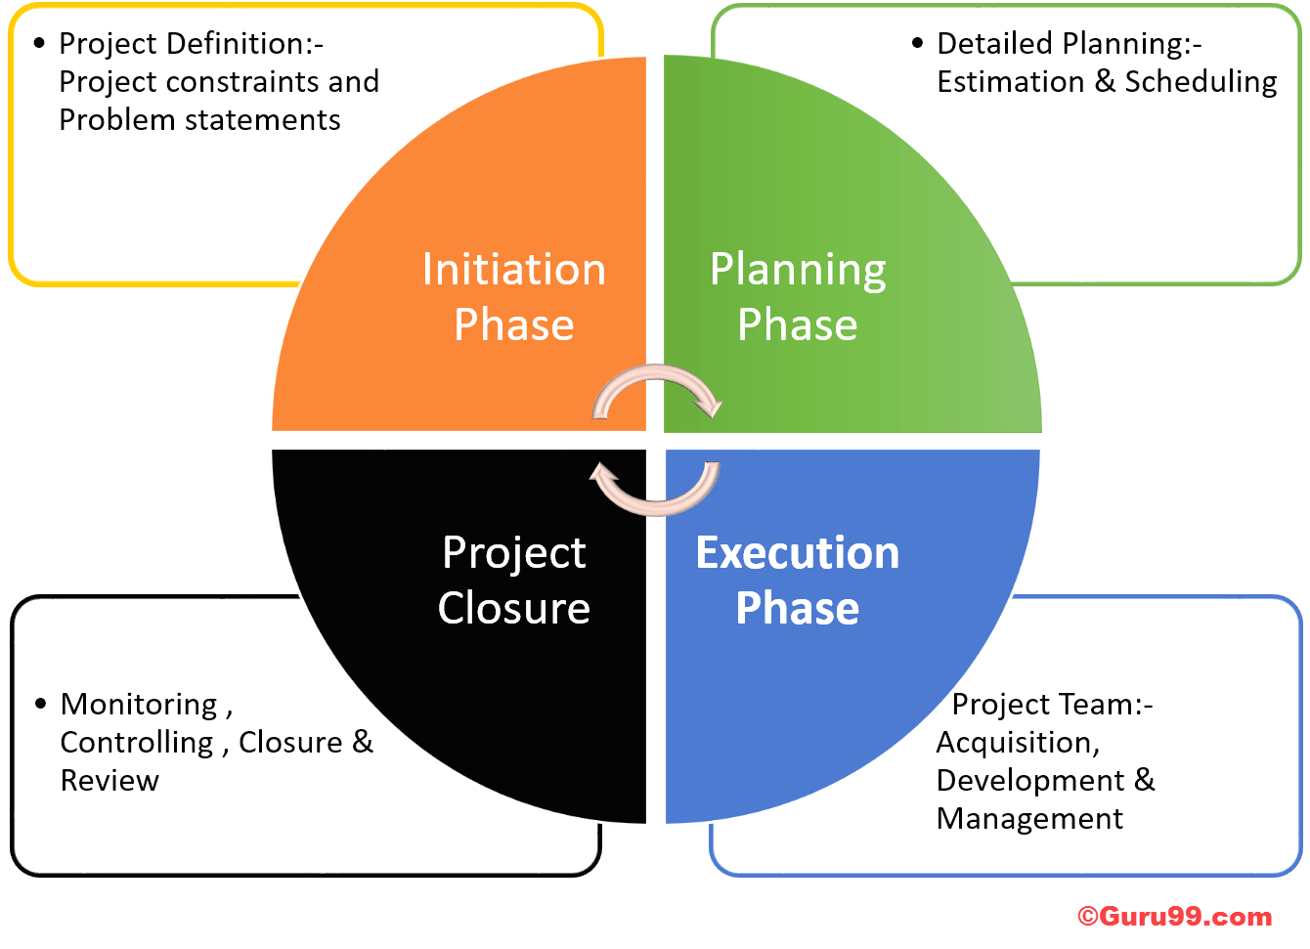
Source: Oellgaard, 2013

4.1 Project Initiation
The project initiation includes the identification of scope, feasibility, and the business need and care which will be delivered through the project (Aaltonen and Kujala, 2010). Due to the pandemic, different companies and businesses have experienced the closure of workplaces and workers facing troubles in having and communicating with their customers and other staff members while staying at their homes. Since the retail industry sector is mainly affected by the covid and the lockdown scenario due to social distancing as well (Yemini, Oplatka and Sagie, 2018). The stores are closed and customers could not visit for shopping and customers are facing delays in delivery due to lockdown in every area of the country. Therefore, the objective is to set the same day delivery concept which increases the online presence and online sales by highlighting its scope and importance.
- Grab more sales during covid-19 situation
- Enhance customer experience through fast delivery service
- Same day delivery of goods
- Employee training to enhance communication with customers

4.2 Project Planning
The project planning determines the necessary steps including resources, budget, responsible personnel and duties to achieve the objective and goal of the project. The work breakdown structure will be as follows:
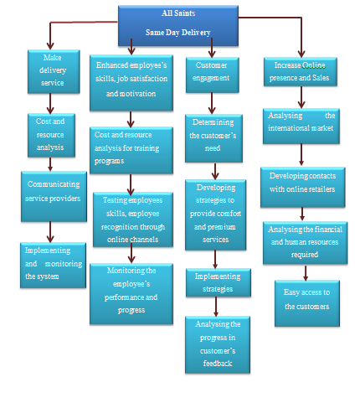

Other stakeholders will be delivery service providers, employees, online customers and management staff of the company. The table below shows the relationship with stakeholders and handling.

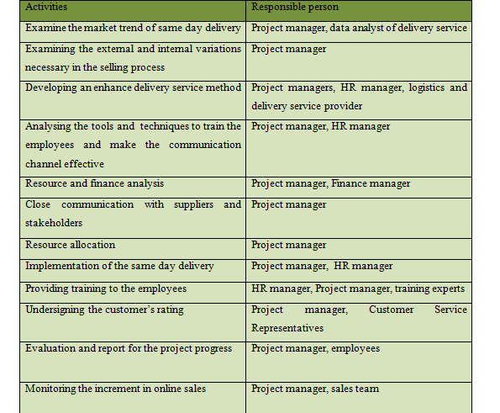

Moreover, the project will be completed within five months and the unidentified factors and activities prevailing pandemic will be delayed and hence the delay margin will be ten present.

4.3 Project Execution
With the correct utilisation of the steps and procedures mentioned in the above stage of the PLC for All Saints, the project of making an online shopping delivery and same-day delivery which will increase the digital presence and now could be executed. In this step, the project manager needs to communicate with the HR and finance managers about the on-going charges in the same day delivery procedures towards employees especially the selling and logistics team effectively. The managers will be needed to monitor the sales and delivery performance on regular basis in order to critically analyse the effectiveness of the project plan (Mir and Pinnington, 2014). Furthermore, the sales and marketing team and logistics team of All Saints need to fully concentrate on the same day delivery procedures and online selling and purchasing methods and enhance every touch point of All Saints customers. During the execution stage, the managers will monitor every step in-depth and analyse the reviews of customers about delivery service so that necessary changes could be made at the initial stage which will enhance the customer experience and promote the sales of the company (Howe, 2012).

4.4 Project Monitoring and Closure
At the last stage of project manager, the sales manager and project manager of the company will require to monitor the progress of the project and make the appropriate documentation that will highlight the increment or decrement in sales (Iyer and Banerjee, 2016). These managers will be required to examine the factors which will enhance the sales and need to focus on the advancement in further. Furthermore, the project and sales manner will be required to highlight the several risks which could be related to the deigning of an online application and expanding the online presence (Dunmade et al., 2018). When the project is executed, the online sales and logistics team will conduct a survey for the delivery service in which they would examine how the concept of same-day delivery is working in order to sustain in the covid situation. With the positive feedback of customers, the company will continue this practice, and if not, the company will make necessary changes to successfully accomplish the project.

Gantt Chart
ACTIVITIES | Week 1 | Week 2 | Week 3 | Week 4 | Week 5 | Week 6 | Week 7 | Week 8 | Week 9 | Week 10 | Week 11
Project proposal Writing
Proposal approval
Specify project requirement and stakeholder
Recruit project team
Calculate project budget
Train staff for same day delivery

Project Communication Plan
The communication plan is mandatory in order to enhance the communication among the company and internal and external stakeholders which is the critical factor for the success of the project (Szeberenyi, 2015). The effective communication plan for the All Saints project contains data and information related to methods, personnel, and intensity of various types of communication that will help in the project life cycle of All Saints. From weekly to daily meetings which have an impact on the implementation of the project that is included in the communication plan. As per the studies related to communication, a project communication plan makes the firm communicate effectively with every stakeholder which makes the project run smoothly and avoids the risk of failure. Furthermore, other perks of an effective communication plan include the better management of stakeholders and managing and setting stakeholders' demands and expectations, and assisting them with the procedure of planning. This communication plan enables All Saints to align the objective and project tasks which will in return enhance the sales and revenue for the company (Ziehrock, 2020). Considering the strict lockdown situation, the plan will make the company efficiently negotiate with every stakeholder through an effective communication channel/ The project communication plan will enable the team to remember to understand the on-going proceedings in the same day delivery in order to expand the online presence and online sales which will help them to forecast the future communication risk as well. Moreover, the plan would be helpful to analyse the deadline, budget deliverable and every requirement which will be required to accomplish the project successfully. The below mentioned communication plan will assist to identify the frequency, nature, and time of meetings which will be necessary for the project implementation and give growth to the online sales and increase revenue for the company before and after covid pandemic days.
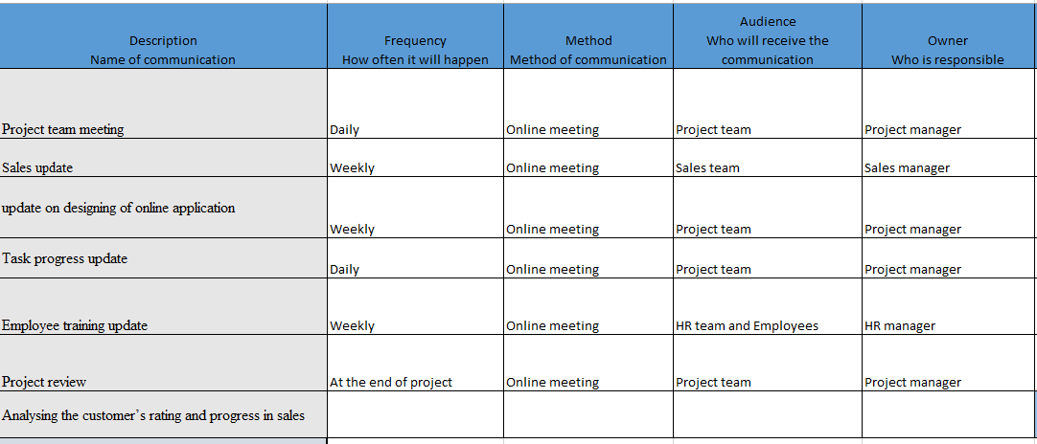

Pre and Post Covid Changes
The project of creating same day delivery and application in order to enhance and promote online presence which will benefit the All Saints company in various manners. As stated by (Mason et al., 2020), the marketing and sales in the pre-vovid situation seemed to be high and the spreading of the corona virus deadly impacted the sales and marketing of every company, and due to these sales of retail companies rapidly down. Before the covid-19 pandemic, the stores were operating perfectly and their team was selling their leather jackets through stores (Cindrich et al., 2021). Customers could easily visit the store and buy the goods through experience the high quality of products. But, the increment of Covid 19 every market is now close and the government of every country has implemented strict lockdown regulations in their country. Due to the strict policies regarding social distancing, customers of All Saints have become unable to visit the stores and even in the online shopping from All Saints, they were facing delays in their orders. The trend of same day delivery has now grown rapidly in the retail and fashion industry and different firms are working to enhance online customer experience through implementing same day delivery to maintain the sales in the covid-19 pandemic (Mason, Narcum and Mason, 2020). Furthermore, customer buying behaviours have been changes in a pandemic as well and now they try to buy services and products while not moving an inch at home in order to prevent the spreading of the virus.
However, not customers but employees are also dealing with challenges and the lockdown impacted the life of every employee and due to this, the idea of same day delivery will promote sales and ultimately provide job security t valuable employees of All Saints. The communication gap between the managers and sales team due to covid also impacted the sales of products and therefore the planned project will enhance online sales by giving an enhanced online purchasing experience to the customers of All Saints. With the initiation of same day delivery, All Saints could provide an improved and advanced channel for customers to make an online purchase without much delay of order shipment. With the assistance of same day delivery customers of All Saints will not need to go to other channels to make purchases (Sharma et al., 2020). By enhancing the online purchase experience and enhancing the availability of delivery concepts on retail websites and ad on social media platforms and pages of the company would be effective in successfully implementing the project. In order to limit the risk of order delay or inappropriate order delivery, the management will redesign and improve the website details and description of products and options available so that customers and also employees do not face hurdles in order-making and order delivery.

Project Management Capabilities
In order to perform as a manager, or project, or planner, an individual needs to have specific capabilities and abilities to organise the position and people as per the activities and tasks in order to accomplish the project (Irfan, Hassan and Hassan, 2019). With the use of appropriate capabilities, the project manager becomes able to control all of the tasks and form collaboration through effective communication among the various members and manipulate the needs and demands of the customer and implement those needs in the project so that the accomplishment of the project will meet the customer expectations (de Melo et al., 2020). I had been a project manager and I believe I posse specific capabilities which I feel fruitful in performing different projects for a firm to efficiently overcome the period of covid and combat the challenges arises during this situation. The most essential capability that a project manager needed is to have the capability to lead the staff members and team and set a proper clear vision for them and motivate them during working from their home and enhancing the online shopping and same day delivery concept for retailers (Yazici, 2020). I have earlier leaded the staff in this context and as a good team leader, I do not only managed the team, but I also acquired various leadership skills in managing the team members during a different situation which polished my skills as a team leader (Zhang et al., 2018).
From the last experience, I have become able to manage the project with expertise as I have discovered the ability regarding dealing with various team members to enable the clear and smooth flow of data and information from one team member to another team member. I obtained the capability to describe the different tasks to individual team members if they feel any difficulty in analysing and understating the activity (Davies and Brady 2016). I have also attained the capability to manage the schedule of tasks which will formulate through different techniques and tools of project management. My previous experience helped me to become aware of every technique and tool of project management such as Gantt Chart, Agile, etc and with the use of these tools, I could make the best project schedule which will help the firm in promoting its working effectiveness while performing for same day delivery for the firm and work from home from their remote areas as well (Zubizarreta et al., 2021). Furthermore, I have also become good at managing risk associated projects and as a project leader, it is part of the duty to analyse and keep eye on the issues which can bring risk and problems or the project in the future. Therefore it is mandatory to have the capability to manage these problems and curb them in the initial stages so that no problem will occur for the complete system in the future.

Strengths and Weakness Identified through Feedback
While playing a different task in the course of life, I have realised that the actual abilities which I attain and the weaknesses that exist in me which has resisted me from playing an effective role. As I have always being a team leader in every organisation, the project manager of the firm appreciated me as per my critical thinking ability and project execution skills. I can analyse and evaluate problems or issues before deciding the situation or issue which benefitted me a lot in managing and controlling my emotions and provided unbiased judgment related to the issue. Since the organisation is facing different problems and issues due to the lockdown of the economy in every country so with the proper analysis of this issue from various perspectives and could assist All Saints in resolving issues while considering various available options at the table. Since the covid-19 pandemic impacted the mental health of individuals so as an effective project manager and team leader will require to give an environment of content to their employees which will reduce their stress and tension which occurred due to various issues regarding the covid-19 pandemic.
When it is about the weakness the main is to level up the communication skill which is basically needed for an effective project manager. I have attained feedback regarding that the project manager for not communicated well with the staff related to the need and requirement of the project. Due to the lack of communication skills, I have attained troubles in representing my comments and arguments during presentations and meetings which I considered the major drawback for my skills and personality as a project manager. Because when the project manager does not communicate the requirements and task properly, then they will deal with issues and troubles in fulfilling the project and task. Leading the project refers to the leader who is constantly in negotiation and communication with various stakeholders and as a communication subset, I was not an effective negotiator. Therefore, I found difficulties in resolving disputes between the stakeholders and the company, and with regular practice, I have enhanced my negotiation and communication skill and working for further improvements as well.

Self-Development Plan for Enhancing Project Management Skills
It is mandatory to work on personal development in order to enhance project management skills. For the enhancement of project management, this is required to follow some structured procedures and methods which will promote the skills and abilities with the implementation of various strategies.
S. No | Skill | Information | Time framework
1 | Communication and Interpersonal Skills | Ineffective interpersonal skills and communication are noticed as the major factor that lower the chances of the effective implementation and success of project objective. Therefore, these two skills are mandatory for the proper execution of the project. To enhance communication and interpersonal skills, it is recommended to watch videos and join various programs and seminars to enhance communication and interpersonal skills. Furthermore, it is also recommended to practice with workers and colleagues and gather their feedback and make appropriate changes and improvements accordingly. | Three to four months
2. | Planning and Execution | Since the planning and execution stages are the heart of project management, the project managers require to plan all of their activities as per the priority and need of the specific project. The correct plan and execution results in saving cost, time, resources for the project. The planning stage also assists in fulfilling the customer need and expectations with the timely delivery of services or products to them. To make the correct planning and execution skills and techniques, it is recommended to divide the task as per the priority of the project and then maintain the flow of the work on every activity by following the deadlines of each activity strictly. | Three months
3. | Learn about Project Management techniques and tools | In order to finish the activity efficiently and effectively, it is mandatory to scheduled activities by using various techniques and tools of project management, and therefore, the proper understanding of each and every tool and technique of project management is necessary. So, it is recommended for project managers to learn about project management tools and techniques and their usage as per the need and situation of the project. | Four to eight months

Conclusion
This has been concluded that the covid-19 pandemic impacted the business sector and this completely changes the working environment framework for every organization, and every organization has developed a new working environment to sustain during this situation. The change in the working environment will require new planning and strategies to deal with the end of the major stakeholders of the firm. This report has been developed with different project management techniques and tools for the project manager of the All Saints Company. When the project managers of All Saints will implement the mentioned tools and techniques of project management, the company would be able to minimise the problems facing during managing and adjust the workforce and working conditions according to the newly developed working environment for the company. This report also pointed out that with the use of mentioned project management strategies, the company could be able to enhance its sales and enhance its customer relationship and customer satisfaction along with attaining huge financial benefits during the covid-19 pandemic. Therefore, this report will be helpful for project managers of All Saints and they can take advantage of this report and make appropriate changes in order to bring fruitful benefits for the company in long term.

Reference
Aaltonen, K. and Kujala, J., 2010. A project lifecycle perspective on stakeholder influence strategies in global projects. Scandinavian journal of management, 26(4), pp.381-397.
Chofreh, A.G., Goni, F.A., Klemeš, J.J., Moosavi, S.M.S., Davoudi, M. and Zeinalnezhad, M., 2020. Covid-19 shock: Development of strategic management framework for global energy. Renewable and Sustainable Energy Reviews, p.110643.
Cindrich, S.L., Lansing, J.E., Brower, C.S., McDowell, C.P., Herring, M.P. and Meyer, J.D., 2021. Associations between change in outside time pre-and post-COVID-19 public health restrictions and mental health: brief research report. Frontiers in public health, 9, p.8.
Conforto, E.C., Amaral, D.C., da Silva, S.L., Di Felippo, A. and Kamikawachi, D.S.L., 2016. The agility construct on project management theory. International Journal of Project Management, 34(4), pp.660-674.
Davies, A. and Brady, T., 2016. Explicating the dynamics of project capabilities. International Journal of Project Management, 34(2), pp.314-327.
de Melo, J.C.F., Salerno, M.S., Freitas, J.S., Bagno, R.B. and Brasil, V.C., 2020. From open innovation projects to open innovation project management capabilities: A process-based approach. International Journal of Project Management, 38(5), pp.278-290.
Dunmade, I., Udo, M., Akintayo, T., Oyedepo, S. and Okokpujie, I.P., 2018, September. Lifecycle impact assessment of an engineering project management process–a SLCA approach. In IOP conference series: materials science and engineering (Vol. 413, No. 1, p. 012061). IOP Publishing.
Heldman, K., 2018. Project management jumpstart. John Wiley & Sons.
Howe, J., 2012. Project Initiation and Control. The Definitive Handbook of Business Continuity Management, pp.137-153.
Irfan, M., Hassan, M. and Hassan, N., 2019. The effect of project management capabilities on project success in Pakistan: An empirical investigation. IEEE Access, 7, pp.39417-39431.
Iyer, K.C. and Banerjee, P.S., 2016. Measuring and benchmarking managerial efficiency of project execution schedule performance. International Journal of Project Management, 34(2), pp.219-236.
Ma, X., Xiong, F., Olawumi, T.O., Dong, N. and Chan, A.P., 2018. Conceptual framework and roadmap approach for integrating BIM into lifecycle project management. Journal of Management in Engineering, 34(6), p.05018011.
Marcelino-Sádaba, S., González-Jaen, L.F. and Pérez-Ezcurdia, A., 2015. Using project management as a way to sustainability. From a comprehensive review to a framework definition. Journal of cleaner production, 99, pp.1-16.
Mason, A., Narcum, J. and Mason, K., 2020. Changes in consumer decision-making resulting from the COVID-19 pandemic. Journal of Customer Behaviour.
Mazlum, M. and Güneri, A.F., 2015. CPM, PERT and project management with fuzzy logic technique and implementation on a business. Procedia-Social and Behavioral Sciences, 210, pp.348-357.
McVay Lynch, M. and Roecker, J., 2019. Project managing e-learning: A handbook for successful design, delivery and management. Routledge.
Mir, F.A. and Pinnington, A.H., 2014. Exploring the value of project management: linking project management performance and project success. International journal of project management, 32(2), pp.202-217.
Oellgaard, M.J., 2013. The performance of a project life cycle methodology in practice. Project Management Journal, 44(4), pp.65-83.
Radujković, M. and Sjekavica, M., 2017. Project management success factors. Procedia engineering, 196, pp.607-615.
Schwalbe, K., 2015. Information technology project management. Cengage Learning.
Sharma, M., Luthra, S., Joshi, S. and Kumar, A., 2020. Developing a framework for enhancing survivability of sustainable supply chains during and post-COVID-19 pandemic. International Journal of Logistics Research and Applications, pp.1-21.
Szeberenyi, A., 2015. Project Communication Plan (No. AIDA-2020-MS4).
Thomson, C.S., El-Haram, M.A. and Emmanuel, R., 2011, June. Mapping sustainability assessment with the project life cycle. In Proceedings of the Institution of Civil Engineers-Engineering Sustainability (Vol. 164, No. 2, pp. 143-157). Thomas Telford Ltd.
Yazici, H.J., 2020. An exploratory analysis of the project management and corporate sustainability capabilities for organizational success. International Journal of Managing Projects in Business.
Yemini, M., Oplatka, I. and Sagie, N., 2018. Project Initiation. In Project Management in Schools (pp. 23-42). Palgrave Pivot, Cham.
Zhang, Y., Liu, S., Tan, J., Jiang, G. and Zhu, Q., 2018. Effects of risks on the performance of business process outsourcing projects: The moderating roles of knowledge management capabilities. International journal of project management, 36(4), pp.627-639.
Ziehrock, C.J.E., 2020. Consulting Project: communication plan for the Fashion Studio Agency (Doctoral dissertation).
Zubizarreta, M., Ganzarain, J., Cuadrado, J. and Lizarralde, R., 2021. Evaluating Disruptive Innovation Project Management Capabilities. Sustainability, 13(1), p.1.

