David Rapado
Student ID:2221960

Personal reflection
Support-Link

Contents
Project Reflection: Support Link 2
My Role and Contributions 2
Fig 1 meeting Schedule in Room 103 2
Team Contributions 3
Conclusion 3
Fig 2 Example of how we used Discord 4
References 5

Project Reflection: Support Link
As the project lead for the development of Support-Link, I responsible for several key areas of the project, including the creation of the business plan, communications with external organisation, and the organisation of group meetings. This reflection outlines my contributions as well as the collaborative efforts made by the rest of group.

My Role and Contributions
My Primary responsibility was to develop the business plan for Support Link. This document served as the foundation of the project, detailing the platforms goals, financial model, market research, and sustainability. Key local data was referenced to inform the plan, including poverty rates and digital access in Swansea. [1], [2]
I contacted several local charities and public organisations-Shelter, The Salvation Army, Swansea City Council, Swansea Foodbank, Mind and Age UK Wales-introducing the project and requesting if they would like to participate. I made it clear that it was part of a university-led initiative to improve social service access in the region. As of yet we have had no response from the outreach e-mails.
As the project manager, I scheduled and booked meeting room 103 in the university library for several planning and testing sessions. These meetings ensured that the development timelines were maintained and provided us with a space to collaborate and test. See Fig 1

Fig 1 meeting Schedule in Room 103
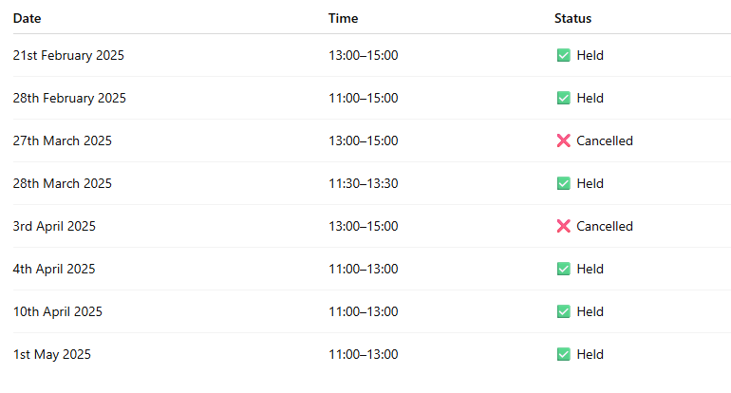

I also took part in test the support link website, which was primarily conducted during our in-person meetings. This real-time, collaborative approach to testing allowed the developers to receive immediate feedback. The face-to-face format made it easier to solve any technical issues that arose and it allowed the team to align in understanding each other’s strengths and weaknesses, which accelerated progress and refinement of the project. [3]
In addition to the in-person meetings, we used a Discord channel for ongoing communications and coordination. This was the preferred space to let the group know that the meeting room was booked as it was a quick drop of a message and the whole group would see it. We also maintained a shared folder, which acted as a shared platform for ideas, design drafts and other templates, it’s also where we put together our Power point presentation, we could all work on our individual bit and it stayed consistent as Ellis was constantly editing it. The digital space was crucial in supporting the team with our productivity and transparency. [4] see Fig 2

Team Contributions
- Ellis Christie and Daniel Thomas led the design and visual development, focusing on accessibility including things like using a Dyslexic-friendly font [5], selecting the colour palettes, structuring user-friendly page layouts.
- Faiz Khan managed the social media side. He set up and maintained the platform’s Facebook and X (formerly Twitter) accounts, and created a questionnaire to gather feedback [6]. He also helped in creating the early Skeleton of the website and participated in testing the site.
- Che Morris served as the Lead Developer, coding the majority of the Platform in PHP and JavaScript, and implementing Medo as the database framework [7]. He also established a domain and used GitHub to manage team collaboration and source control.
- Kia Probert focused on user registration and data security, helping to maintain and stabilise the platform. His work was instrumental in ensuring GDPR-compliant user management.

Conclusion
This project would not have been successful without the interdisciplinary collaboration of all the members. My leadership and planning laid a foundation for the project while the combined technical, design and outreach efforts ensured that support link became a fully realised web application. Working in close proximity during meetings helped streamline communication and foster a strong collaborative environment. The addition of our Discord server and shared folder enabled the team to stay connected and organised, even outside of scheduled meetings [4]

Fig 2 Example of how we used Discord
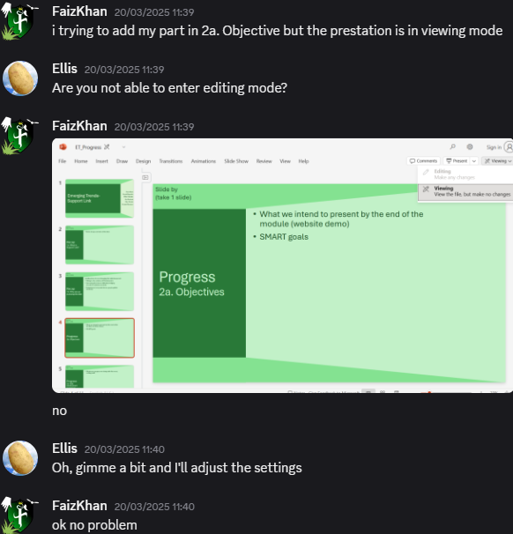

References

[1] | S. Council, “Swansea Poverty Facts and Figures,” [Online]. Available: https://www.swansea.gov.uk/povertystrategy.
[2] | Ofcom, “Connected Nations: Wales Report,” [Online]. Available: https://www.ofcom.org.uk/_data/assets/pdf_file/0020/234701/connected-nationswales-2022.pdf.
[3] | N. Johnson, Effective Group Work 2nd edition, London: Sage, 2018.
[4] | D. Inc, “Discord: Your Place to talk and hang out,” 2023. [Online]. Available: https://discord.com/.
[5] | B. D. Association, “"Dyslexia-Friendly Style Guide,” 2022. [Online]. Available: https://www.bdadyslexia.org.uk/advice/employers/creating-a-dyslexia-friendly-workplace/dyslexia-friendly-style-guide.
[6] | SurveyMonkey, “Best Practice for Questionnaire Design,” 2021. [Online]. Available: https://www.Surveymonkey.com/mp/survey-guidlines/.
[7] | M. P. D. Framework, “Introduction to Medoo,” 2023. [Online]. Available: https://medoo.in/.

