

Programme: BA (Hons) Business Management
Module: Introduction to Business
Module code: LCBB4014
Module Leader: Dudley Ofori
Submission deadline: 13th August 2026
Student Name: Dumitru Raducanu
Ana Maria Raducanu Roxana Simulescu
Student ID:2532880
2531008 2528753

Table of Contents
Company Overview 3
SWOT Analysis 4
PEST Analysis 7
Impact of Globalisation 9
Influence of Innovation 10
Recommendations 11
Conclusion 12
Reference list 13

Company Overview
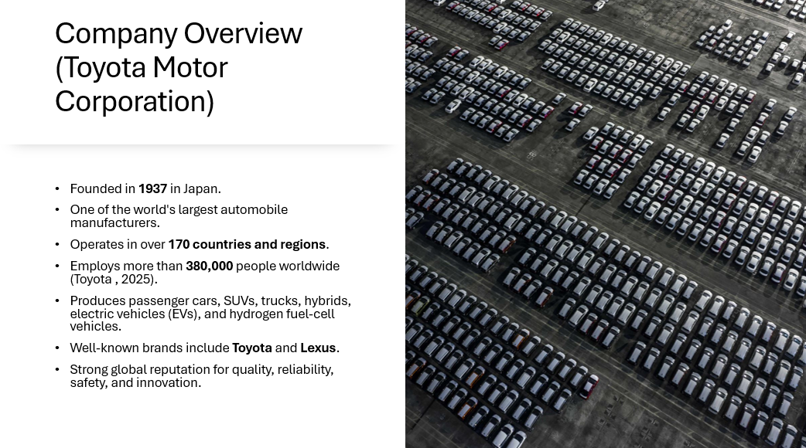
Toyota Motor Corp. was founded in 1937 in Japan and is one of the biggest automotive groups in the world. The company has a presence in over 170 countries and regions with an extensive global production and distribution network that serves millions of customers. Toyota employs over 380,000 people; it has production facilities in Asia, locations in Europe and North America, as well as in South America, in Africa and in Oceania.
Toyota has a wide range of products such as passenger cars, sport utility vehicles, commercial vehicles, hybrid electric vehicles, battery electric vehicles and hydrogen fuel-cell vehicles (Umbrex, 2026). The company also owns the prestigious Lexus brand which makes it more powerful in the luxury segment of the car market.
Toyota has won a good reputation in the international market, due to its high quality, reliable, safe and durable cars. The company has been able to respond to the changing customer needs and technological innovations through continuous investment in research and development thus staying competitive. This market presence will create a good footing from which analyses of Toyota's own capabilities and the business environment surrounding it can be made.

SWOT Analysis
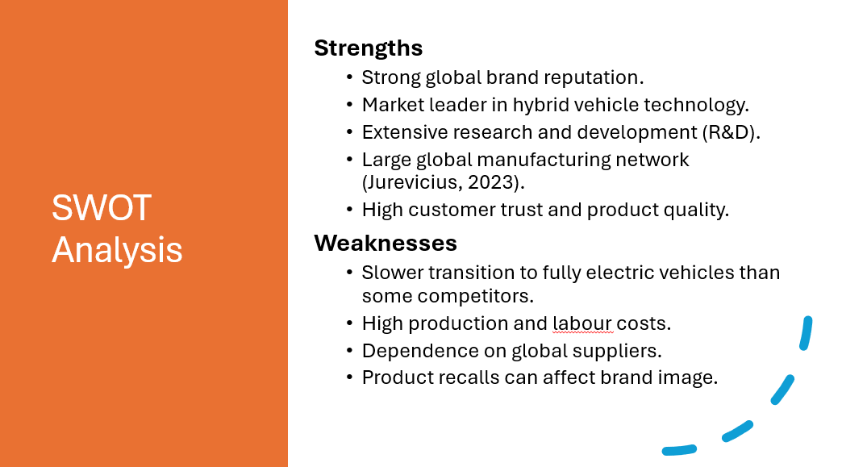
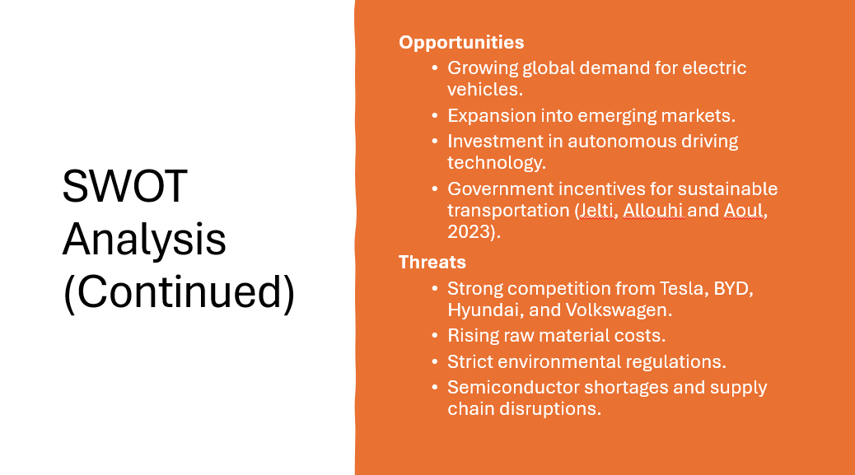
In the SWOT analysis of Toyota, firms' internal strengths and weaknesses, external opportunities and threats that impact the firms' competitive forces in the world automotive industry will both be analyzed. This discussion gives a broad knowledge of what the company is able to do presently and what it has to do to be successful in the long-term.
The greatest asset of Toyota is their internationally recognised brand, established over decades of manufacturing quality, reliable and long lasting cars. It is reputed well, which has led to high levels of trust and loyalty among products customers, bringing the company with a very good competitive strength both in developed and emerging markets. The other significant strength is that of hybrid car technology led by Toyota. Thanks to model development among others, such as the Toyota Prius, Toyota has emerged as a leader in the transport industry that cares about the environment, and a brand that is perceived as innovative. Moreover, Toyota constantly allocates enormous funds towards research and development, which allows it to guarantee constant upgrades in the performance of its vehicles, their manufacturing process, safety measures, and state-of-the-art mobility. It also has a large global manufacturing network which helps it to manufacture efficiently, afford economies of scale and it can serve the international markets with its products effectively (Jing Wu, 2025).
In spite of these strengths, Toyota has a number of internal weaknesses. Compared to Tesla and BYD the company has not done as well as it could get, when it comes to diversifying their all-electric vehicle lineup, which could erode its competitiveness in an advanced EV industry. Quality production also means that Toyota is faced with relatively high manufacturing and labour costs. Also, the company relies heavily and extensively on a complex global supply chain, which puts the company at a greater risk of being affected by raw material shortages, transport problems, and geopolitical uncertainties (Hou et al., 2024). While product recalls don't happen very often, they can also cause a decrease in consumer trust and potentially damaging for the company in the eyes of consumers in the short term.
In the external environment too, there are great opportunities which Toyota can tap. The growing trends of electric cars across the globe give it a lot of prospects of growth in the future. Financial incentives, tighter regulation of environmental conditions, as well as investment in infrastructure for supporting electric vehicles have all been the preferred measures of all the governments of the world to favour sustainable transport. Not far behind is the party in emerging markets which are also in Asia, Africa and Latin America, where not only is the rate of income growth rising, but their population is on the increase as well, and so as is the number of vehicles per capita. Furthermore, with the development of autonomous driving technology, artificial intelligence and smart mobility services, Toyota has opportunities to further raise the level of innovation and develop new generation transportation solutions.
Nonetheless, there are also numerous external threats that Toyota needs to take care of. The rivalry in the automotive sector has been increasing with companies such as Tesla, BYD, Hyundai, and Volkswagen still heavily investing in electric technologies and innovation in the automotive sector. The prices of raw materials, particularly lithium and battery materials will be rising, which impacts on manufacturing profitability. Besides, there are heavier environmental regulations and always need to spend money on new technologies to meet them. Rocking operational risks include global shortages of semiconductors and supply chains, which could either put installation signs on the slowdown or make manufacturing more expensive. Accordingly, Toyota needs to continue to leverage their strengths, stabilize their internal weaknesses, leverage their emerging opportunities and deal with outside threats effectively in order to stay on the cutting edge around the world and realize long-term sustainable growth.

PEST Analysis
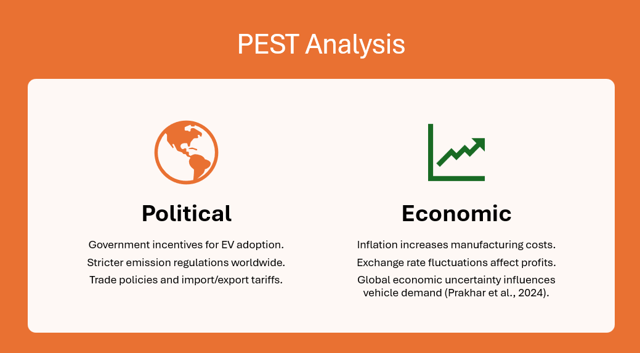
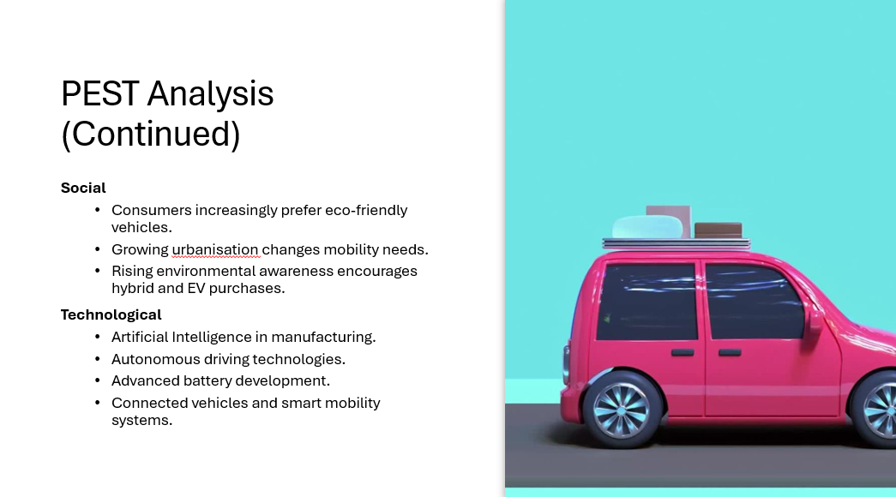
Using the PEST framework, the external macro-environmental factors that affects Toyota's business activities and the strategic decision making for Toyota. Political, economic, social and technological issues should clearly be understood so that the company can cope well with the changes in the global auto industry.
On the political level, the world's political authorities are implementing stricter environmental regulations to reduce carbon emissions and are promoting sustainable transport. Some nations also offer financial yearly incentives, tax incentives, and subsidies to promote EV adoption. Also, Toyota needs to be flexible during the international operations since the international trade policies, tariff, and geopolitical changes also influence Toyota's global manufacturing and supply chain operations as well as export activities.
There are many challenges to be addressed from an economic perspective for Toyota because of inflation, raw material costs and production costs (Pérez-Moure et al., 2023). The fluctuations in the exchange rates could also have an effect on the profitability of the company as the company has a larger number of revenues and interests on the international market. Moreover, economic uncertainty in the world could decrease consumer purchasing power, hence less demand in products of high value like automobiles.
Today and in the future, the social aspect will remain more significant in the automotive market. The consumer is greatly concerned about eco-sensitivity and more and more models are built with a low carbon footprint with high fuel efficiency. In addition, the high rate of urbanisation has also affected people's preference for transportation mode, which requires sustainable, reliable and technologically advanced mode of transportation.
Toyota is still influenced by technological factors in its competitiveness. The company is investing a large sum of money in artificial intelligence, autonomous driving, new battery technology, connected cars and intelligent manufacturing processes. Such technological developments boost output, improve product quality, the customer experience and the long-term competitiveness of Toyota.
Overall, it can be concluded that, according to a PEST analysis, Toyota is operating a dynamic external environment. Helping the company to stay ahead of new risks and avaricious chances in the automotive sector every time, is a way in which the company can guarantee sustained growth, while observing the political, economical, social and technological happenings all around the globe.

Impact of Globalisation
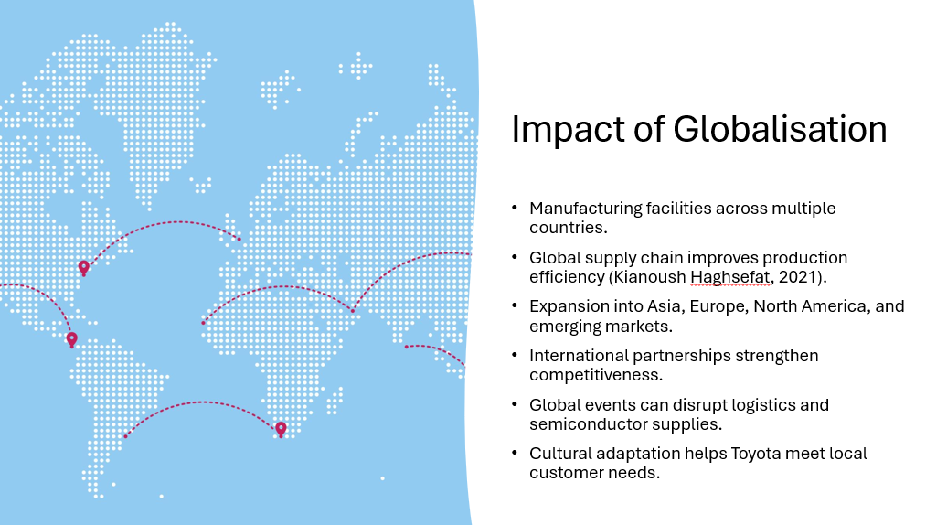
Since globalisation has given Toyota more opportunities to expand Toyota vehicles, it has also helped in facilitating their growth and competitiveness. With many countries opened up, Toyota has been able to set up manufacturing plants and selling chains, enabling it to target various classes of customers and save transportation fees as well as enhance business efficiency. Such an international character enables the company to distinguish its product according to the local customer needs and regulations in every region, through local production and region specific approach. International cooperation, foreign investment, and the exchange of knowledge and expertise between the partners also enhance the innovations capacities and competitiveness of Toyota in this field.
Nevertheless, there are also some challenges of globalisation. Toyota is also dependent on the global supply chain to get components supplied by specialised suppliers all over the world. While this can help to drive down costs and improve production quality, it can also increase the risks facing the company. The result is disruptions in one region of the world can have significant reverberations throughout the world – lessons that were learned during these global crises. Hence, Toyota should continue to improve the supply chain's robustness, and adopt the best possible risk management strategies to ensure smooth operations.

Influence of Innovation
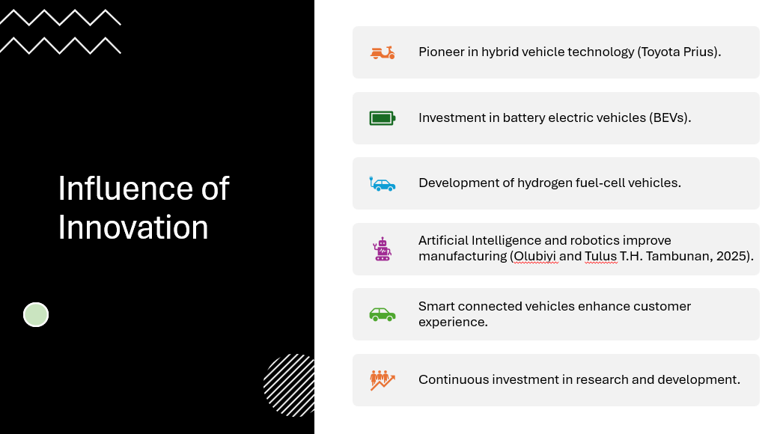
One of the key competitive advantages that Toyota enjoys is innovation. Successfully introducing the Toyota Prius, one of the first mass-produced hybrid vehicles introduced worldwide, the company has helped it become its leader on the path to sustainable mobility. Following this success, Toyota has been striving to invest in battery electric cars and hydrogen fuel-cell technology to serve the transportation needs and sustainability of the environment in the future.
Furthermore, in all of Toyota's manufacturing processes, the company applies artifcial intelligence, in-depth robotisation and automation to improve its processes of efficient production, attentive quality control and precise operations. The firm is also developing technology for autonomous driving that makes the art of driving a better and safer experience. Further, vehicle technologies, including advanced infotainment, wireless software updates and digital connectivity are seamlessly connected to improve the overall experience of using the vehicle, and enhance vehicle convenience and functionality. By sustained investment in research and development, Toyota is nevertheless in a good position to counteract any changes in technology, enhance its competitiveness in the global market and attain sustainable long term growth in the fast changing automotive sector.

Recommendations
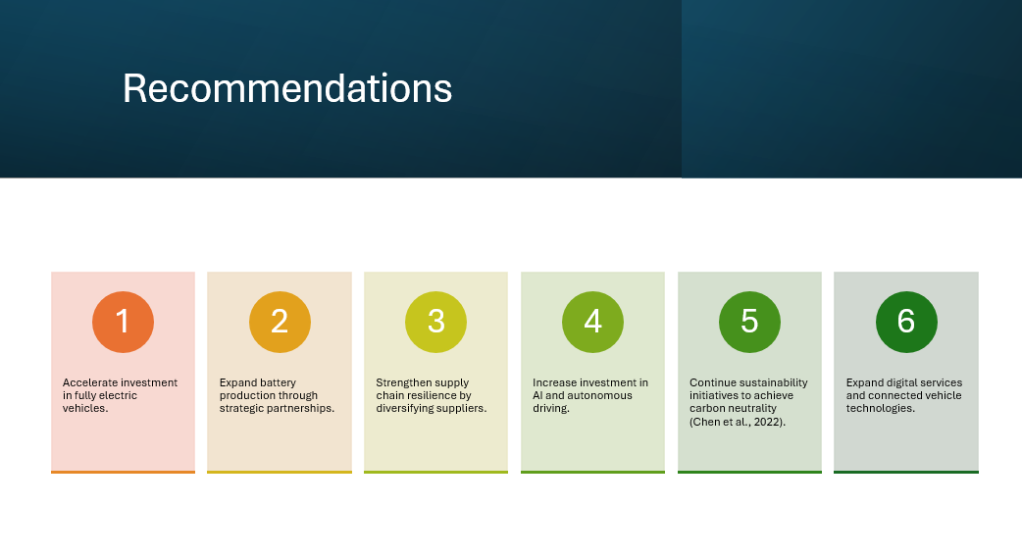
Toyota has a lot of strategic recommendations that it can implement to improve the competitiveness of its business in the automotive industry in the future on all over the world. First, the company should accelerate its research and development into the BEVs, helping it continue to respond to the burgeoning global market of sustainable transportation. An expansion of the cooperation with producers of batteries would be of great benefit to produce larger batteries and reduce the risk in supply chains.
Second, Toyota should branch out its supply base and not have to rely on specific suppliers or areas. If they had a more robust supply chain, they would be able to overcome interruptions related to geopolitical tensions, natural disasters or the absence of necessary components.
Thirdly, the company should continue to invest in AI, self-driving cars, and cutting-edge production processes. The innovations will improve the productive processes, product quality, operation performance, satisfaction of customer and keep Toyota's technological lead.
Finally, sustainability has to be one of the many strategic concerns. Additional funding for the carbon neutrality programmes, renewable energy sources, the battery recycle programmes and environmentally friendly manufacturing will strengthen Toyota's corporate image, and assure that environmental requirements meet new and evolving regulations. These recommendations will enable Toyota to be resilient, facilitate innovation and retain their competitive advantage on the global car market in the long term.

Conclusion
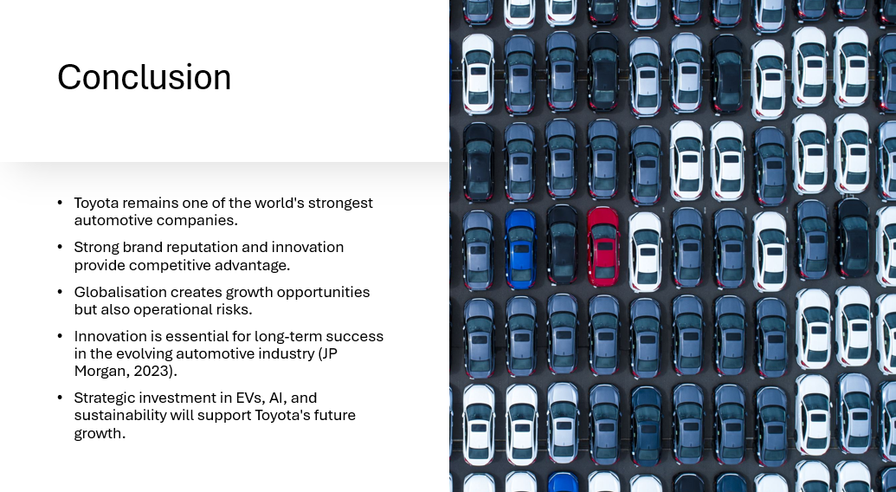
In short, Toyota is one of the most influential and powerful organisations in the world of automotive in general. The SWOT analysis shows that the brand reputation and technological processes, and a global network of manufacturing, make the company competitive, but there are weaknesses in terms of the expansion of the electric vehicle and dependence on the supply chain.
The PEST analysis also shows that the automotive industry is still changing as a result of the effect of these political, economic, social and technological factors. The globalisation has provided large avenues in the market growth and at the same time, it has resulted in the creation of complexities in operations and exposure to external risks.
The next steps for long-term success will be grounded in innovation, further developments in electric mobility, AI and sustain technologies and much more at Toyota. Under Toyota's prudent guidance and anticipatory adaptation to the ever-changing market conditions, it is highly likely that Toyota will continue to be the global leader and enjoy ongoing success.

Reference list


