THERMODYNAMICS EXAM 2016-17

- QUESTION FOUR / Closed System: (15 marks)

An insulated rigid tank initially contains 0.7 kg of helium at 27°C and 350 kPa. A paddle wheel with a power rating of 0.015 kW is operated within the tank for 30 min. Determine,
- The final temperature of the helium gas. [10]
- The final pressure of the helium gas. [5]

Tank filled with helium

Assumptions:
- Helium can be considered as an ideal gas.
- Constant specific heat values and gas constant can be found in Table A-2.

- QUESTION FIVE / Open system, steady-flow process: (15 marks)

A house has an electric heating system that consists of a 300 W fan and an electric resistance heating element placed in a duct. Air flows steadily through the duct at a rate of 0.6 kg/s and experiences a temperature rise of 7°C. The rate of heat loss from the air in the duct is estimated to be 305 W. Determine the power rating of the electric resistance heating element.

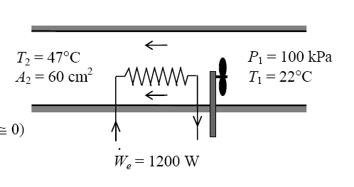

T₂ = T₁ + 7°C

T₁

$$\dot{Q}$$
$${\dot{W}}_{elec}$$
$${\dot{W}}_{fan}$$
Assumptions:
- Air can be considered as an ideal gas.
- Constant specific heat values can be found in Table A-2.
- Kinetic and potential energy changes are negligible.

- QUESTION SIX / Open system, unsteady-flow process: (20 marks)

An air conditioning system is to be filled from a rigid container that initially contains 5 kg of saturated liquid R-134a at 24°C. The valve connecting this container to the air-conditioning system is now opened until the mass in the container is 0.25 kg, at which time the valve is closed. During this time, only liquid R-134a flows from the container. Thus, at the final state the container encloses a saturated liquid - vapour mixture. Presuming that the process is isothermal (that is constant temperature) while the valve is open, determine,
- The final quality of the remaining liquid-vapour mixture of the R-134a in the container. [10]
- The total heat transfer. [10]
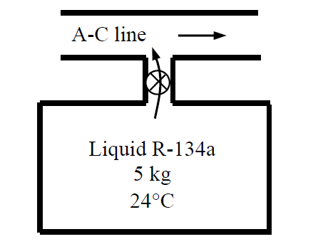
$$h_{e}=84.98 kJ/kg$$

Assumptions:
- Kinetic and potential energy changes are negligible.
- There are no work interactions involved.
- The system is isothermal therefore T₂ = T₁.
- Specific enthalpy of the exit is $h_{e}=84.98 kJ/kg$.
- You will need to use Table A-11.
- In a saturated liquid-vapour mixture, the mass fraction of vapour is called the quality and is expressed as:
$$x=\frac{m_{vapour}}{m_{total}}$$
Quality may have values between 0 (saturated liquid) and 1 (saturated vapour). It has no meaning in the compressed liquid or superheated vapour regions. In the saturated mixture region, the average value of any intensive property y is determined from:
$$y=y_{f}+x.y_{fg}$$
where f stands for saturated liquid, g for saturated vapour and y stands for v, u or h.
- For specific volume, $v_{fg}=v_{g}-v_{f}$

