IMPACT OF ARTIFICIAL MANAGEMENT ON GLOBAL EMPLOYEE MANAGEMENT: A CASE STUDY OF THE UK-BASED IT INDUSTRY

ABSTRACT
In the former section, the impact of artificial management on global employee management has been discussed. A significant discussion on the background of the topic, and the research rationale of the research has been done. Research aim and objectives has been mentioned to give a clear view to the readers. The next portion has presented a brief piece of literature in respect of this research context. In this segment all the benefits, significance and challenges of artificial intelligence in respect of employee management have been critically analysed and understood. Using different but relevant themes, this segment has presented a profound observation and understanding of the research context throughout a literary work. The methodology section has discussed about choices employed such as positivism philosophy, deductive approach and descriptive research design. It has highlighted the importance of secondary and primary data collection and its impact on this research work. An integration of primary quantitative and secondary qualitative data pieces has been included in this research, which has been maintained by the adoption of mixed methodological approach. Findings and analysis has been including the discussion on the impact of artificial management on global employee engagement. Findings have included the analysis of both primary and secondary method. This section includes the evaluation of significance and rile of AI technologies playing in global workforce environment. The benefits of AI in global employee management have been analysed. It includes the advantage and disadvantage of artificial management and provided the ethical implications of the artificial management on the IT industry. Conclusion and recommendation has included the conclusion of overall study about the impact of artificial management on the global employee management in the UK-based IT industry. The recommendations regarding the challenges that AI faces in the context of global employee management is given.

Acknowledgement
I would like to show my deepest appreciation for the member of the research team who has continuously assisted and supported me in completing the research. Without their guidance, it would have been impossible for me to achieve this kind of result. In addition, I would like to thank my professors under whose guidance I was able to research in an adequate manner for justifying the context along with getting hold of the permissions to achieve copyright subjects. Lastly, I would also like to appreciate the efforts and support given by my peers, families and friends for the completion of this project.

TABLE OF CONTENTS
CHAPTER 1: INTRODUCTION 7
1.1 Introduction 7
1.2 Research rationale 7
1.3 Background of the research 8
1.4 Aims and objectives 8
1.5 Research questions 9
1.6 Proposed structure of the dissertation 9
1.7 Research outline 10
1.8 Summary 10
CHAPTER 2: LITERATURE REVIEW 11
2.1 Introduction 11
2.2 Significance and role of artificial intelligence in global workforce management 11
2.3 Benefits of artificial intelligence in global employee management 12
2.4 Impact of artificial intelligence in performance management of global employees 14
2.5 Challenges in using artificial intelligence in Respect of global employee management 15
2.6 Strategies to mitigate critical complications and challenges faced in using Artificial intelligence in a global context 15
2.7 Ethical Implication and Possible Consequence of Artificial Management System Theme 15
2.8 Impact of artificial intelligence on employees working in UK-based IT industry 17
2.9 Theories 18
2.10 Literature gap 19
2.11 Conceptual Framework 20
2.12 Summary 20
CHAPTER 3: RESEARCH METHODOLOGY 22
3.1 Introduction 22
3.2 Research onion 22
3.3 Research philosophy 23
3.4 Research approach 24
3.5 Research design 25
3.6 Research Strategies 27
3.7 Research choices 27
3.8 Research time horizon 28
3.9 Data collection method 28
3.10 Data Analysis Method 30
3.11 Ethical consideration 30
3.11 Summary 31
CHAPTER 4: FINDINGS AND ANALYSIS 32
4.1 Introduction 32
4.2 Primary Analysis 32
4.3 Secondary Analysis 38
4.4 Discussion 45
4.5 Summary 46
CHAPTER 5: CONCLUSION AND RECOMMENDATION 47
5.1 Conclusion 47
5.2 Linking with Objectives 47
5.3 Recommendation 51
5.4 Future Scope 53
5.5 Research limitation 53
Reference list 54
Appendix: Survey questionnaire 62

LIST OF FIGURES
Figure 1.1: Annual production of the IT industry in the UK from 2009 to 2018 7
Figure 1.2: IT market revenue in the UK from 2016 to 2021 8
Figure 1.3: Dissertation structure 10
Figure 2.1: Artificial Intelligence application by HR management 12
Figure 2.2: Conceptualisation of AI-based digital assistance 13
Figure 2.3: Possible consequence of using artificial intelligence 16
Figure 2.4: Impact of artificial intelligence on employees 18
Figure 2.5: Conceptual framework 20
Figure 3.1: Research onion 23
Figure 3.2: Key factors Positivism philosophy 24
Figure 3.3: Path of Deductive approach 25
Figure 3.4: Descriptive research design 27
Figure 3.5: Data collection sources 30
Figure 4.1: Response 1 33
Figure 4.2: Response 2 34
Figure 4.3: Response 3 34
Figure 4.4: Response 4 35
Figure 4.5: Response 5 36
Figure 4.6: Response 6 36
Figure 4.7: Response 7 37
Figure 4.8: Response 8 38
Figure 4.9: Response 9 38
Figure 4.10: Response 10 39
Figure 4.11: Global artificial intelligence market size 2021-2030 40
Figure 4.12: Conceptual framework of the application of AI in different areas of HR 41
Figure 4.13: Adoption rates of AI in UK IT and telecom sector 43
Figure 4.14: Challenges of artificial intelligence in employee management 44
Figure 4.15: Influence of AI on employee and organisation 45

CHAPTER 1: INTRODUCTION

1.1 Introduction
The chapter is going to analyse the impact of artificial management on global employee management and here the whole research will be based on the case study of the UK. AI provides the team with in-moment insights and optimises the impact by learning from prior target results. In this section, the research rationale and background of the research will be discussed briefly. The aims and objectives of the research will be included in this section and appropriate research questions will be developed based on the aims and objectives. The proposed structure of the dissertation will be demonstrated and the significance of the study will be discussed to improve the authenticity of the research.

1.2 Research rationale
AI is useful for the employee management processes and increased efficiency of the workplace has been observed. It also enhances the speed of higher levels of tasks and improved the accuracy of employees. The issue with the usage of AI is the long team strategy has been changed and teams become smaller and fewer resources are available to workers (BBC.com, 2023). Hence, unbearable workloads are seen due to small team management and employees are given a multifaceted role in the organisation. The issue remains an issue now as a lack of justified solution has been associated in this regard. As opined by Abdeldayem and Aldulaimi (2020), the trends and opportunities are high in using AI in the working medium and the output of the public sector has been improved. AI also improves worker safety and health and reduces the possibility of placing workers at risk.
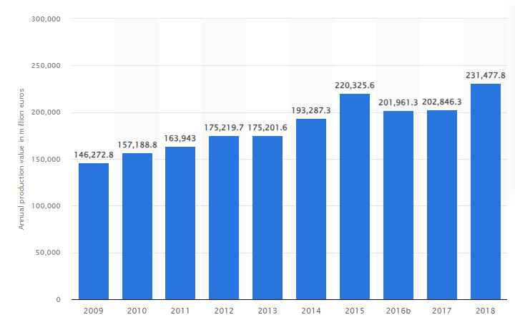

Figure 1.1: Annual production of the IT industry in the UK from 2009 to 2018
(Source: Statista.com, 2021)
The number of employees in the IT industry of the UK was 113,068 in the year 2015 and the numbers of employees are at its peak in the same year. The production value increased during the same year. In addition to this, the production of the IT industry was 231.5 billion Euros in the year 2018 (Statista.com, 2021). The stock and re-sales of goods have been improved during this year. The study sheds light on employee management with the help of AI implementation and it also focuses on employee management programs. As stated by Pan et al. (2022), AI has been used in employee recruitment processes nowadays and a co-constitutive relationship has been maintained in this regard. The issue of recruiting staff is also reduced and better financial management has been required to lessen the issues. New jobs are created in the field of machine learning, information security and digital marketing sector.

1.3 Background of the research
AI helps to identify the key drivers of employee engagement and recommended actions will be included to improve employment engagement. Higher productivity, job retention rate and job satisfaction have been improved by the use of AI. As opined by Vrontiset al. (2022), artificial intelligence has been incorporated into any business medium to improve the human resource management system. The IT industry of the UK has employed 63% of the total population in this sector and it has generated 86.44 billion UK billion dollars in the year 2021.
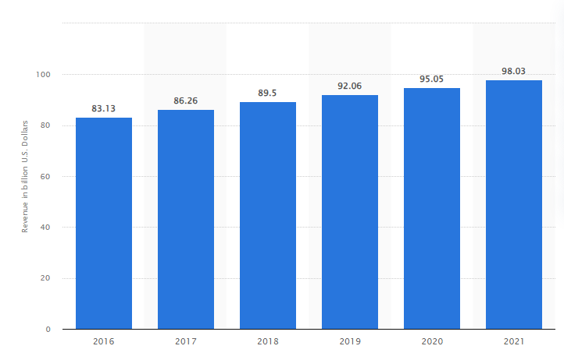

Figure 1.2: IT market revenue in the UK from 2016 to 2021
(Source: Statista.com, 2021)
The statistics display the IT market revenue from 2016 to 2021 in the UK and the turnover of the IT market was projected to be 89.5 billion US dollars. The operations of the industry were projected to be expanded to 98.0 billion US dollars by 2021 (Statista.com, 2021). The subcategory of the IT sector includes various equipment, IT software and IT services. The UK tech sector has retained a 1st spot in Europe and 3rd spot in the global.

1.4 Aims and objectives
Aim
The aim of the study is to investigate and assess the influence of artificial management on worldwide staff management.
Objectives
- Examine how artificial intelligence technologies are being adopted and used in Human resource management method
- Consider the advantages and disadvantages of using artificial intelligence management systems in the context of global staff management
- Examine the impact of artificial intelligence management on essential aspects of global staff management including recruiting, performance management, and training and development
- Determine the ethical implications and possible consequences of using artificial management systems in global workforce management.

1.5 Research questions
- What role do artificial intelligence technologies play in global workforce management practices?
- What are the advantages and disadvantages of using artificial management systems in the context of global workforce management?
- What is the worldwide influence of artificial management on major areas of employee management including recruiting, performance management, and training and development?
- What are the ethical implications and possible consequences of using artificial management systems in global workforce management?

1.6 Proposed structure of the dissertation

Figure 1.3: Dissertation structure
(Source: Self-Created)

1.7 Research outline
The study is useful to provide appropriate knowledge regarding the employee's autonomy while using AI in the work environment. AI provides employees with desired autonomy and also meets the work requirement as needed. The automotive repetitive and mundane tasks will be easier with the help of AI and this research provides additional knowledge on critical thinking and creativity of employees. The alleviated administrative burdens in the workplace have been successfully mitigated with the help of AI. AI also reduces the risk of human errors in the workplace and increased productivity and efficiency.

1.8 Summary
Based on the above analysis, it has been summarised that AI is needed to enhance productivity in the workforce and also correct employee management processes. The issue of the UK IT industry has been identified in the research rationale and the background of the research has been analysed based on the research topic. In addition to this, a set of objectives has been prepared on the basis of the research topic and the significance has been analysed for further progression.

CHAPTER 2: LITERATURE REVIEW

2.1 Introduction
Artificial management refers to the management system that takes many procedural and management decisions. Global employee management refers to supporting, managing and engaging employees worldwide. IT technicians in the UK IT industry are in high demand due to growing the need for technology solutions. The aim of the literature review segment is to focus on previous literature and address gaps in past studies regarding global employee management through artificial management. The section will increase knowledge about artificial management in global employee management. Scientific management theory and the general theory of artificial intelligence will be also included in the segment. A literature gap is also going to be found after studying the past literature. A conceptual framework and summary of the literature review will be also incorporated into the segment.

2.2 Significance and role of artificial intelligence in global workforce management
In this modern generation, the importance of artificial management has been undeniable. It can be considered a huge revolutionary technological aspect that has been changing the world towards innovation. AI tools play a crucial role in improved accuracy and decision-making in the context of global employee management. As stated by Kshetri (2021), HRM practices have been largely influenced and improved by the potential of AI tools in respect of staff management. In the association of artificial intelligence technologies, the HRM departments have been allowed to automate mundane tasks as well as reduce the bias associated with the screening process. Machine learning has been an effective AI tool that has been practised by modern organisations and HRM departments in order to monitor and measure employee performance. As argued by Fallucchiet al. (2020), machine learning has been a significant subset of artificial intelligence by which employees’ engagement time and their different efficiencies can be uncovered as well as suggesting improvements. For example, the immense usage of machine learning in IBM can be mentioned, wherein the company has achieved the ability to measure and examine employee performance effectively in the association of machine learning. In respect of this piece of literature, it can be criticised that artificial intelligence has not only been beneficial for improving organisational performance, but also it has been effective assistance of the HRM departments in modern organisations.
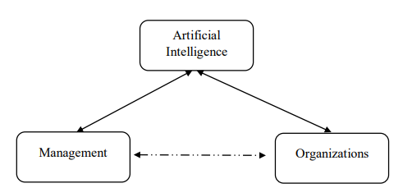

Figure 2.1: Artificial Intelligence application by HR management
(Source: Yawalkar, 2019)
The above image has denoted that artificial intelligence has linked with two variables of human resource management, such as organization and management. It has been identified that artificial intelligence helps organization to manage their human resource worldwide. In this digital era the human resource management departments have been practicing with artificial intelligence in respect of workforce management. As stated by Yawalkar (2019), in increasing business pressure the significance of the AI technologies has been understood by the tough managers. Nowadays the AI technologies in the workplace has replaced the human involvement in different areas alignment, screening recruitment and so in. therefore it can be understood that the Human Resource Management departments have been proactive inadopting and using AI technologies for workforce management.On the other hand, the Human Resource Management departments adopt AI technologies to forecast plan and workforce needs. As argued by Anton et al. (2020), AI technologies play a large role in empowering their workforce and assessing the needs of workforce. Therefore it can be criticized that AI technologies have been adopted by HR managers for workforce management.

2.3 Benefits of artificial intelligence in global employee management
Artificial intelligence technologies have been found to be largely impactful and effective with beneficial attributes in respect of employee management in the global context. In this field, AI tools have been proven to be beneficial in different areas. Reduction in human error has been one of the major benefits of artificial intelligence. As stated by Bharadiya (2022), increasing the accuracy and precision of AI tools has been able to reduce errors as in business practices, the decisions taken by AI, have been based on the information gathered previously. Similarly enabling organisations to manage knowledge more effectively has been another significant role of artificial intelligence. Knowledge-sharing behaviours among employees have largely influenced customers' perceptions of employees' service quality. As argued by Nguyen (2022), all the functional domains of this digital era have been influenced by AI-enabled knowledge-sharing platforms including international marketing as well as in the global MNEs such as hospitality, and information technology industries. In the association of chatbots, virtual and digital services, in respect of AI-enabled applications, these MNEs share knowledge and information and interact with employees and customers worldwide.
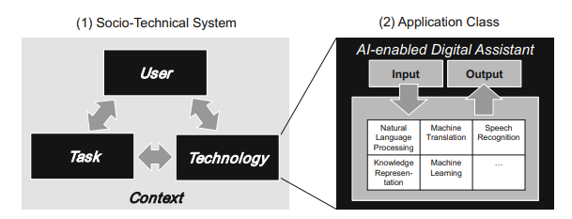

Figure 2.2: Conceptualisation of AI-based digital assistance
(Source: Maedcheet al. 2019)
The above image has shown the relation between User, task and technology in international employee management. Artificial intelligence digital assistant has helped in natural language processing that help in the international communication. According to this piece of literature, artificial intelligence can be considered a beneficial aspect in respect of employee management in the global context. Digital assistance has been another undeniable benefit in modern IT-based organisations that can be availed by the use of AI tools. As stated by Maedche et al. (2019), with the association of further technological advances in AI, more sophisticated scenarios can be realised in the future with both negative and positive consequences for humans, which has been a great sign of digital assistance. On the other hand, faster decision-making has been another effective attribute of artificial intelligence. As argued by Stone et al. (2020), the significance of AI in strategic marketing decision-making has been undeniable as the AI tools have effectively been able to process risk identification, marketing analysis of targeting customers. Contract centre response management involves in design and selection of the advertisement copy, by which the HR managers have been able to manage and direct employees by making accurate decisions regarding the marketing activities.Higher quality decision-making mechanism can be managed within an organisation by adopting effective strategies. Marketers can adopt latest technologies to manage work and present their work more quickly.In this area, AI-powered predictive analytics has been a great example of an AI tool for processing faster decisions. For instance, the marketers of Amazon use predictive analytics to observe the marketing insights accurately.

2.4 Impact of artificial intelligence in performance management of global employees
Recruitment, performance management, training and development of employees have been some major parts of global competency management. Modern organisations have been practising different AI technologies in order to be accurate and effective in these competencies. As stated by Pan et al. (2022), HR recruitment practices have been under the significant influence of technological adoption, wherein most of the technological elements have been based on artificial intelligence. The AI recruiting technologies allow managers or employers to better leverage their ATS, screening resumes of employees with more fairness, and short listing more accurately. Aside from recruitment, AI also plays a crucial role in the performance management of employees. As argued by Tong et al. (2021), the usage of artificial intelligence has been generally increasing in IT companies in order to provide performance feedback to the employees, by which job improvements can be recommended tracking employee behaviour at work and automating performance evaluation. The AI tools like data-driven appraisal or review systems effectively associate with avoiding any sort of doubts or misunderstandings as well as maintaining transparency.
One of the most significant benefits of AI has been raised as the capability to provide customised feedback to the employees' performance, which has been necessary for the training and development processes of employees. As stated by Wijayatiet al. (2022), the ways have to be identified by the companies in order to facilitate the leaders and managers to provide training to the employees using AI-based technological platforms. AI tools have been found to be able and effective to analyse, aggregate and calculate big data scientific sources in respect of an individual's knowledge gap, by which the managers have been allowed to prefer training procedures for each employee accurately. However AI systems promote continuous learning of employees and lack of transparency and ability to explain of AI tools can bring negative impacts on employee training using AI methods. As argued by Komorowski (2019), furthermore lack of transparency has been a significant complexity with AI tools that may bring inaccurate discussions and undesirable outcomes. Similarly, this issue can bring negative effects on employee training and development using AI tools.

2.5 Challenges in using artificial intelligence in Respect of global employee management
The ongoing development of information technology has been enabling organisations to be digitalised. However this has been observed as a beneficial operation for organisations to operate their business in a digital process, it may effectively decrease the rate of employees' personal interaction, which has been renowned to be a significant disadvantage of AI. As stated by Mirbabaieet al. (2022), employees’ identifications of their job roles may be negatively affected by the introduction of artificial intelligence, as AI has been generally proposed to fundamentally change professions and workplaces. The IT industry has been increasingly practising employing AI robotics, which has been increasing the rate of anxiety, depression and other psychological issues. This has not only been an issue for the UK-based Moreover, lack of empathy has been another significant issue of using artificial intelligence. As argued by Ameenet al. (2022), the issues encountered by customers while interacting with AI technologies, lack of empathy, emotional intelligence and so on have been significant. Aside from the customers, the AI tools have to be improved with empathy for making better decisions regarding employee management.

2.6 Strategies to mitigate critical complications and challenges faced in using Artificial intelligence in a global context
There have been different issues and complications identified in this context of artificial intelligence in respect of employee management. Lack of empathy has been a highlighted issue in respect of artificial intelligence usage. In this situation, the AI tools have to be built along with an input of prioritisation of human emotions. As stated by Yoon (2021), prioritising human empathy and emotions during the development of artificial intelligence can significantly generate decisions by maintaining ethics. On the other hand, model visualisation, and feature importance analysis can be suggested to AI development in order to increase its transparency. As argued by Daneshjouet al. (2021), transparency has been essential for repeatability, experimentation, and explains ability, wherein the use of model visualisation has been proven to be effective. Therefore it can be used during the development of artificial intelligence in order to increase its transparency.

2.7 Ethical Implication and Possible Consequence of Artificial Management System Theme
Artificial intelligence will change the global labour market in the future. UK IT organisations have been using artificial management systems for employee wellbeing and employee safety. As stated by Stamate et al. (2021), the adoption of artificial intelligence might lead to dreadful consequences for workers, for example, many fear they could lose their jobs. The ethical implication of the artificial management system is to promote employee well-being. Artificial intelligence has been increasing the hiring efficiency of IT organisations in the UK. The Algorithms of the artificial management system have been effectively analysing resumes and determining the most qualified candidates. As argued by Malik et al. (2021), it has been identified that artificial intelligence or artificial management systems have helped in the decision-making of hiring teams which is the possible consequence of artificial intelligence. The productivity and efficiency of workers have been increased by the application of artificial management.
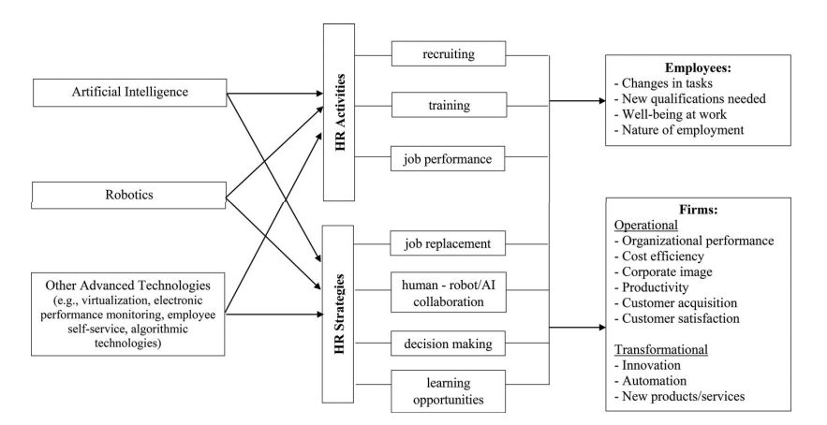

Figure 2.3: Possible consequence of using artificial intelligence
(Source: Vrontiset al. 2022)
The above image has shown that artificial intelligence has been used by HR managers regarding training, recruiting and job performance. The possible consequences of the application of artificial intelligence include changes in tasks, and maintaining wellbeing at work. The IT organisations of the UK have been using the artificial management system for reducing health hazards at the workplace, not psychosocial health hazards. As opined by Malik et al. (2021), Artificial management systems have been included in training to take care of the mental health of employees. Artificial management systems have been used in several areas of management, such as flexibility of work, creativity and innovation, transparency of information, enhanced decision-making, and better work-life balance. Employees have saved commuting time and also can work from home by using artificial intelligence technology. As argued by Arnold (2022), artificial intelligence has integrated physical infrastructure with digital communication technology. Management of IT organisations have maintained their ethical policies and norms while managing global employees by using artificial management systems. The artificial management system has allowed management to manage the overall working process while employees work remotely. Technology advancement has helped to create a more flexible workplace and allow a diverse career path (Charlwood and Guenole, 2022). Artificial management systems have helped in employee management by facilitating the prediction of future and faster judgement.

2.8 Impact of artificial intelligence on employees working in UK-based IT industry
Artificial intelligence has streamlined and facilitated organisational management processes, especially in IT organisations. Management has used artificial intelligence technology to improve employee performance by adding more informed decision-making. As stated by Vrontiset al. (2022), information technology has been changing HR practice by introducing e-training, e-recruitment, and e-competency management systems which are known as artificial management systems. AI cloud saves employees about 390 hours of working time in yearly basis. Number of jobs could be increased by using latest technologies effectively I business area. The artificial management system has been contributing positively to employee management by improving HRM service quality. As argued by Malik et al. (2021), job automation can be possible through the artificial management system. It has been identified that artificial intelligence adoption in human resources also has negative aspects in terms of the creation of techno-stress among employees. Therefore it has been addressed that there has been both positive and negative employee experience due to the adoption of AI. It has been determined that AI has helped to enhance the intelligence of employees. Techno-complexity and techno-insecurity have been the factors of techno-stress over the employees (Budhwaret al. 2022). It has been identified that artificial intelligence in global human resource management has increased both employee efficiency and employee stress. The application of artificial intelligence has been too complex to understand for many employees. Amazon has been using artificial intelligence management in their business operation to improve their productivity level (Amazon.com, 2023). AI has been helped in human resources management process to improve organisational productivity.
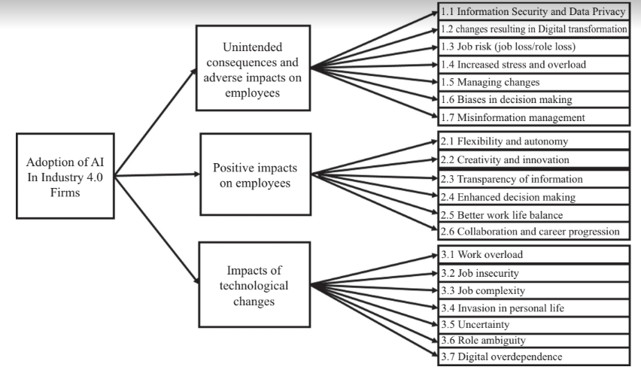

Figure 2.4: Impact of artificial intelligence on employees
(Source: Malik et al. 2021)
The above image has helped to understand the positive impact of artificial intelligence on employees. As opined by Malik et al. (2021), Flexibility and autonomy, innovation, transparency of information, and enhanced decision-making have been the positive impact of the adoption of artificial intelligence. It has been also observed that job risk, increased stress overload and bias in decision-making have been the negative impact of AI in employee management. As argued by Tambe et al. (2019), the wave of technological advancement has disrupted employee equilibrium. It has been identified that AI technologies have collaborated with humans to improve decision-making. Artificial management systems have helped to improve decision-making issues of management that enhance the quality of global employees' performance. IT and AI technology have helped to increase employee productivity to a certain level (Pan et al. 2022). Artificial intelligence-based communication systems have helped artificial management for solving long-distance issues in the context of global employee management.

2.9 Theories
Theory 1: Scientific management theory
Scientific management theory supports the theory of artificial management systems improving the efficiency of global employees. As per the theory, training and development have been the most significant objects that produce maximum efficiency. As opined by Tambe et al. (2019), In the artificial management system, the E-training process has also improved the performance of global employees. Managers are unable to give training through their traditional process to the global employees. In the training process, the distance of global employees has been a barrier for the management of ITR organisations. The adoption of Artificial intelligence has helped in e-training which can effectively increase the performance of an organisation. As per the theory, UK's IT organisations have to scientifically select, train and teach their workers. Artificial management has also maintained the scientific management theory while dividing work and responsibility among global workers. As argued by Merkle (2022), the theory is unable to provide solutions for all managerial problems. For example, the theory has not provided a clear view of how to manage employee stress through scientific management. It has been defined that the application of the theory in artificial management systems has helped to increase global employee efficiency through E-training.
Theory 2: The general theory of artificial intelligence
The general theory of artificial intelligence has provided ideas of generalised human cognitive abilities in software. The theory has helped to find solutions regarding artificial intelligence technology. As stated by Vrontiset al. (2022), the artificial management system has been capable of solving issues in global employee management, such as long-distance, and language issues. As per the theory, artificial intelligence has mathematical, linguistic and mechanical abilities that support management teams to manage global employees. Artificial management systems have been made by following the theoretical concept of increasing the efficiency of the workforce. The theory has helped to make artificial management systems or software that enables machines to think and act likes human beings. As argued by Budhwaret al. (2022), the application of the theory in the global employee management system has been very costly though IT organisations have tried to adopt the artificial management system for managing their global workforce. It has been identified that proper planning can be possible by using the theory to implement the artificial management system in an organisation.

2.10 Literature gap
Published literature has covered different ideas and concepts, such as the impact of artificial intelligence on employee work, artificial intelligence on employee performance, and the role of artificial intelligence in knowledge sharing. The previous literature has also covered the rise of artificial intelligence and the use of artificial intelligence in human resource management. The lack of sufficient knowledge regarding the use of artificial management in the IT sector has been considered a literature gap. Very little information has been found from the previous literature regarding the global employee management process by adapting artificial intelligence technologies. There is a gap in research regarding the ethical implications and consequences of artificial management systems which has been considered as a literature gap.

2.11 Conceptual Framework
Impact Of Artificial Management On Global
Employee Management in the UK-Based IT Industry
The General Theory of Artificial Intelligence
Global
Employee Management in IT industry
Global Competency Management
Improved Accuracy and Decision Making process of global marketing
Employee Wellbeing and Employee Safety in global management
Artificial Intelligence in Performance Management
Artificial Intelligence in Recruiting
Use of Artificial Intelligence
Artificial Management

Scientific Management Theory

Figure 2.5: Conceptual framework
(Source: Created by author)

2.12 Summary
The above discussion has summarised that artificial intelligence in artificial management systems has had both positive and negative impacts. IT organisations in the UK have been effectively using artificial intelligence technology to manage the employees of remote teams. It has been defined that the previous literature has described the role of artificial intelligence in global employee management. The lack of data regarding the impact of artificial management on global employee management has been considered a literature gap. Very little data or information about the application of artificial management has been also considered as a literature gap. The scientific management theory and general theory of artificial intelligence have been included in the literature review segment.

CHAPTER 3: RESEARCH METHODOLOGY

3.1 Introduction
Artificial management system refers to the term of management which involves computers and expert systems. UK-based IT industries have turned to artificial management systems to reduce management effort and save the time of managers. The research methodology has consisted of special procedures and techniques that have been used to identify, process, and select information about artificial management systems. Both qualitative and quantitative data collection methods have been used for collecting relevant data regarding the management of IT companies. Positivism research philosophy, descriptive design and deductive approach have been mainly followed to maintain the reliability and validity of the research. Both primary quantitative and secondary qualitative methods have been applied as artificial management is a new term in IT management.

3.2 Research onion
Research onion refers to a framework for research methodology which has helped to organise the research on artificial management. Saunders Research Onion has been used for designing the research in a proper way to meet the research questions. As opined by Bleiker et al. (2019), this research onion has six layers, including philosophies, approaches, strategies, choices, time horizons, and techniques and procedures. The framework of the research onion has suggested different philosophies, approaches, strategies, choices, and time horizons.
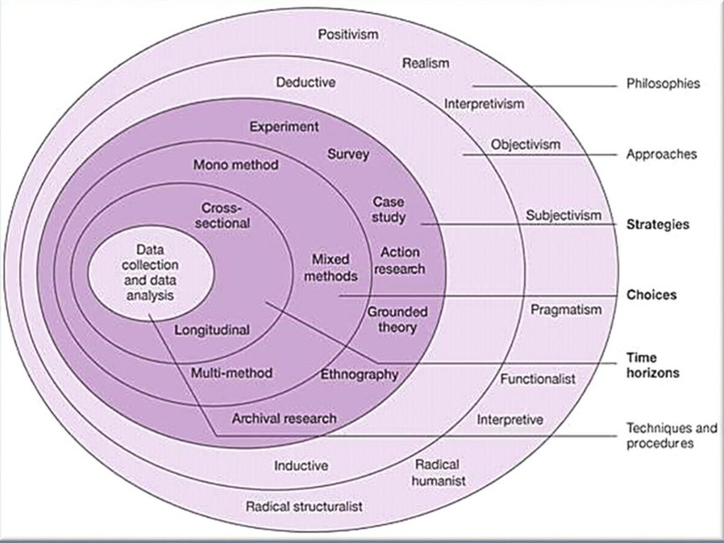

Figure 3.1: Research onion
(Source: Saunders et al. 2015)
Positivism research philosophy has been selected from the first layer of the research onion. A deductive approach has been chosen for selecting appropriate data to meet the aim of the research. Descriptive research design and qualitative and quantitative data collection methods have been derived from the research onion framework. Saunders Research Onion has been an appropriate framework which provides step-by-step research processes and methods in a single structure. The research has been conducted logically and systematically because of the application of Saunders Research Onion (Saunders et al. 2015). The above-mentioned framework creates a series of stages in which data collection methods can be understood. Saunders Research Onion has been a useful tool for thinking holistically about methodology. This research onion has helped to illustrate the states that are required to be covered when developing research strategies for evaluating the impact of artificial management on global employee management.

3.3 Research philosophy
Research philosophy has been associated with the assumption, nature and knowledge of the study. As per Saunders Research Onion, positivism, interpretivism, objectivism, subjectivism, and realism has been the common form of research philosophy. In this particular research, positivism research philosophies have been selected. As stated by Chivanga and Monyai (2021), Positivism philosophy is rooted in the belief that knowledge can be gathered through objective observation and measurement. The selection of the research philosophy has been appropriate as positivism philosophy assumes that an answer can be found by careful analysis and measuring data. The concept of qualitative and quantitative data collection methods has been taken from the concept of positivism philosophy.

Figure 3.2: Key factors Positivism philosophy
(Source: Created by author)
Positivism refers to a paradigm that relies on reason and measurement which ensure the reliability of research. As opined by Coy (2019), the rest of the research philosophies have not been appropriate as the philosophies have not supported both qualitative and quantitative data collection for meeting research questions. As artificial management has been a new term in the area of global employee management, both primary and qualitative research have been required to get information about artificial management. A wide range of employee management situations in the IT industry has been covered in a short period of time based on the positivism research philosophy. The disadvantage of positivism is that positivism relies on experience as a valid source of knowledge. However, the Positivism philosophy has been an appropriate selection as it encourages the adoption of a measurable and observable approach (Greening, 2019). The chosen philosophy has been appropriate for the primary quantitative data collection method that's why the positivism philosophy has been used. Primary quantitative data collection has been selected based on the measurable approach whereas the secondary qualitative data collection method has been chosen as an observable approach.

3.4 Research approach
The research approach refers to the procedure of data collection, analysis and interpretation. As stated by Hafidz and Elihami (2021), as per the above research onion, deductive and inductive have been the common form of research approaches. A deductive research approach has been used for observing and collecting data. The deductive approach has been a suitable approach for the research as it starts with a general idea and then tests through specific observation. The general idea has been gathered from secondary sources whereas specific observation has been dependent on primary data. The application of the deductive approach has supported scientific investigation through both primary and secondary data (Newman and Gough, 2020). The inductive approach has not been appropriate for the study as it starts from specific observation and concludes with a general theory. The deductive approach starts from general theory and concepts and then ensures a specific conclusion which has been also reliable.

Figure 3.3: Path of Deductive approach
(Source: Created By author)
The Deductive approach has been very effective as it helps to explain the causal relationship between variables. As stated by Vebriantoet al. (2020), this approach has been also a time-saving method as it helps to get straight to the point. Changes in global employee management have been effectively identified based on the concept of deductive approach which has created insights about the impact of artificial management. There is no need to develop a new theory, one only needs to apply theories which save time. The existence of theory regarding global employee management or artificial management has given strong support to generalisation based on the approach. The application of the research approach has helped to explain research questions simply and quickly (Zawacki-Richter et al. 2020). The structure of the deductive approach is grounded in scientific principles that have been used for conducting the research logically and systematically. The chosen approach has guided the path of the research to establish a proper conclusion. Deductive approach has been used for analysing the concept of artificial management. Management process of IT organizations has been also observed based on the deductive approach.

3.5 Research design
Research design refers to a strategy for answering research questions by using empirical data. As stated by Pereira et al. (2021), Descriptive, explanatory, and exploratory have been the common form of research design. In the specific research study, descriptive research design has been used for gathering information about the artificial management process of the IT industry. It has been an appropriate selection as it has helped to provide an accurate and detailed picture of the characteristics and impact of artificial management. Observation, case study analysis and survey have been the three forms of descriptive design (Varpio et al. 2020). A case study of the UK-based IT industry has been observed to demonstrate the artificial management process. The impact of the artificial management process has been observed based on primary survey data which has been a reliable source. Observation of qualitative data has helped to make concepts about the global employee management processes of the IT industry and also the artificial management process (Mardiana, 2020). The concept of the descriptive research design has been beneficial for achieving the aim of the research.

Figure 3.4: Descriptive research design
(Source: Created by author)
Descriptive research design has been appropriate for the research as it helps to observe and measure data without manipulating variables. Current trends in global employee management have been effectively identified based on the descriptive research approach. As opined by Alharahsheh and Pius (2020), the purpose of the descriptive approach is to measure data trends, compare variables, define the characteristics of subjects, and verify existing conditions. The descriptive approach has been used for verifying existing management conditions of UK-used IT organisations to gather information about internal challenges of management. Current management trends in the IT industry have been observed and described based on the descriptive research design (Van der Walt, 2020). The concept of artificial management has been gathered based on the data based on observations, case study analysis and survey data.

3.6 Research Strategies
A research strategy is a plan by which the activity of relevant data searching and accessing information is carried out. As stated by Varpioet al. (2020), Research strategies involve a number of stages, including surveys, case studies, experiments, grounded theory, and action research. Survey and secondary methods including case study strategies have been used for meeting the aim of the research. A survey strategy has been chosen as it is easy to administer and can be developed in less time. This strategy has been selected to support the research with primary data to make the study more reliable. The survey has been conducted remotely which can reduce and prevent geographical dependence (Van der Walt, 2020). A secondary method or case strategy has been used for getting information about global employee management of UK-based IT organisations. Both strategies have been appropriate as the strategies have provided support in qualitative and quantitative analysis. The chosen strategy has been beneficial for analysing research questions as the artificial manager has been a new term in the IT industry. Knowledge about the impact of artificial management has been gathered from the survey data (Pereira et al. 2021). Information about the concept of artificial management and IT industries employees’ management has been gathered from analysing the data of case studies of UK-based IT companies.

3.7 Research choices
Research depends on research choice which helps to determine the overall success and quality of a research study and its documentation. As per the above-mentioned research onion framework, mono method, mixed method and multi-methods have been the main form of research choices (O’Kane et al. 2021). A mixed-method research choice has been applied as the study follows both quantitative and qualitative methods. The rest of the research choice has not been appropriate for conducting the research based on qualitative and quantitative research methods. The mixed method has been an appropriate section as it combines elements of qualitative and quantitative research in order to answer research questions. The selected method has helped to gain a more accurate picture than a standalone qualitative and quantitative study. The applied research choice has enabled investigation analytically and conceptually (Vindrola-Padros and Johnson, 2020). Both qualitative and quantitative methods of research are required to meet the research questions. The mixed method research choice has been a very useful tool for researching and investigating qualitative and quantitative data.

3.8 Research time horizon
The time horizon layer of the research onion defines the time frame for data selection, collection and analysis. As opined by Zawacki-Richter et al. (2020), Cross-sectional, and longitudinal time horizons have been the common form of this method. In this particular research, a cross-sectional time horizon has been used to ensure the time of data collection and analysis. A cross-sectional time horizon has been a suitable selection for the research as it is a short-term study and also involves the collection of primary and secondary data at a single point in time. The longitudinal method has not been appropriate as the process involves the collection of data repeatedly over a long time period which is not a requirement of the study. A cross-sectional time horizon has provided a concept by which data for the research has been gathered just once in order to answer research questions (Vindrola-Padros and Johnson, 2020). The selected methods have been very time-saving and also systematically conducted the research.
In the method of time horizon, more than one sample has been collected at one point in time. The selected method has been beneficial for collecting numerous data to support the concluding statements (Vebrianto et al. 2020). This method of time horizon has been relatively quick to conduct and saves time that's why the cross-sectional time horizon has been applied in the research. A cross-sectional time horizon has been appropriate as it is not a costly method to perform. Primary and qualitative data for the study has been gathered based on the time frame of the Cross-sectional time horizon.

3.9 Data collection method
Data collection is one of the major parts of a research methodological segment that describes the type of collecting relevant data in research. More specifically, a data collection method in research effectively determines how the relevant information in research has been collected and integrated and what explanations can be generated by the gathered data sets (Bougie, 2019). Through an appropriate adoption of data collection methods, the variables and concepts of this research have been effectively interpreted.
There have been two types of data collection methods including primary and secondary data collection which have been followed by different sub-methods. This research has been followed by a mixed methodological approach, wherein both primary and secondary data collection methods have been applied. The inclusion of primary quantitative data has been gathered through a survey among 101 employees of the UK IT industry. On the other hand, for collecting and presenting secondary qualitative data, secondary data collection methods like PDFs, Journals, Books, and Online websites have emerged as the most unique technique (Studysmarter.co.uk, 2023). The application of secondary data collection sources has been beneficial in this research to gather secondary data sets regarding artificial management.

Figure 3.5: Data collection sources
(Source: Self-created)
The primary data collection in this research has been accomplished with the association of a survey method. Surveys have been found to be the most beneficial primary methods in order to collect usable, reliable quantitative data sets in research (Ncbi.nlm.nih.gov, 2023). Through performing this technique the researcher has successfully observed the behaviour, experience, and perspective of the employees in the IT organisations regarding the usage of AI management systems. It has also been an advantageous method to identify the issues faced by employees in the convenience of AI management systems, which has been a significant objective of this research. However, this data collection technique has been more time and money-consuming than the secondary method; the application of this method has been highly appreciated to determine the real experience of the employees concerning the usage of AI management systems.
Secondary data collection has been a more easy-to-access technique for collecting relevant data in this research. The secondary data collection method simplifies the comparison between the variables and concepts in research as well as measuring the data trends (Ethics.grad.ucl.ac.uk, 2023). The utilisation of this method has been appreciated in this research alike the primary data collection for assuming unbiased and up-to-date data sets regarding the impact of AI management systems on global employee management. Integration of high-quality data sets on the impact of AI management systems has been a major goal of this study, which has been well maintained by this technique.

3.10 Data Analysis Method
The necessity of data analysis methods in research has emerged as an essentiality of every research study. The data analysis method in research allows the researchers to interpret and analyse the collected data sets, using an adequate method (Fox, 2022). The research data analysis method has been of two major types including primary and secondary data analysis. As this has been mixed methodological research, an integration of both primary data analysis and secondary data analysis has been applied to this research.
The gathered quantitative data sets in this research have been analysed by graphical analysis. Graphical analysis has been an effective method to analyse primary quantitative data, making the information easy to understand for the readers (Kabacoff, 2022). The application of graphical analysis has simplified the analysis of performed survey results in this research. This technique has enabled the researcher to visualise the responses collected from the survey regarding the impact of artificial management systems.
The gathered qualitative information regarding the impact of artificial management systems has been analysed by thematic analysis. Thematic analysis has been a reliable technique to describe the secondary data sets in research, identifying data-related themes and measuring data patterns and trends (Files.eric.ed.gov, 2023). The utilisation of this method has allowed the researcher to present a flexible analysis of the impact of the artificial management system on employee management by aligning the research objectives.

3.11 Ethical consideration
Ethical consideration has emerged as an integral part of the methodological segment. This has been a valuable part of every research methodology in order to protect the rights, dignity and welfare of the research participants as well as the trustworthiness of identified data sets (Ahsan Ullah, 2022). The validity and reliability of the data sets have been well maintained in this research to provide trustworthiness of the performed discussions. All the activities and processes regarding the data collection method in this research have been adhered to and guided by the Data Protection Act 2018 (Legislation.gov.uk, 2023). Adherence to this legislative act has also been beneficial in keeping the respondents' personal data secure from any external threats. Moreover, all the respondents of this research have been provided with a copy of informed consent, wherein they have declared their approval of the data collection process. On the other hand, the anonymity and confidentiality of performed discussions have also been well maintained by the researcher.

3.11 Summary
The above-presented methodological section indicates a mixed methodological approach. In this research primary and secondary methods have been applied in this research. This integrated methodological adoption has helped this research to be more accurate and free from errors. However, in some areas, it has been seen to be difficult to apply both individual methods with respect to mixed methodological approaches. The integration of primary and secondary methodological choices has bright different individual results in some areas of this research, which has been problematic in aligning the objectives accurately. Despite this issue, the mixed methodological approaches have been beneficial to this context. Although the generation of separate results has been accelerated by the adoption of this technique, it has also been beneficial in presenting different effects of a specific aspect related to AI management systems in IT organisations. Therefore it can be summarised that the application of mixed methodological approach along with the integration of quantitative and qualitative data sets has provided this research a unique pathway to cover the goals and objectives.

CHAPTER 4: FINDINGS AND ANALYSIS

4.1 Introduction
This section of the study provides the results and findings of the data collected. The collected data of the study is to be analysed in this chapter. The information gathered from both primary quantitative and secondary qualitative sources is to be analysed here. For primary quantitative data analysis survey was conducted with 101 employees of the UK IT industry. In order to collect secondary qualitative data journals, books, articles, government websites and company websites are to be used. This section of the dissertation has been held important as the readers get to know the findings the researcher has got while the data collection method.

4.2 Primary Analysis
Question 1: Please specify your age group
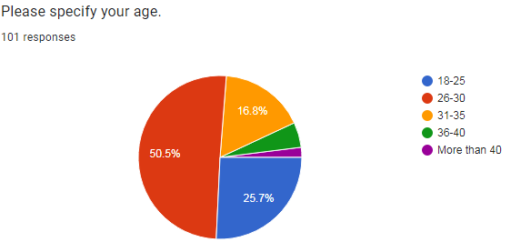

Figure 4.1: Response 1
(Source: Derived from Google form)
The age group pie chart has shown that most of the respondents are from the 26 to 30 age group. It has indicated that the younger generation has shown interest in artificial intelligence-based employee management topics [Refer to Appendix]. Secondly, the lower middle age group (31 to 35 years) and the teenage group (18 to 25 years) have shown interest in global employee management topics. More than 40 years age group people have given least response, maybe they do have not had idea or they did not have an interest in the topic.
Question 2: Please specify your gender
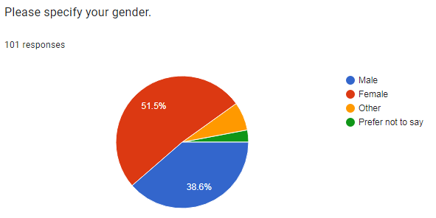

Figure 4.2: Response 2
(Source: Derived from Google form)
Maximum respondents belong to the female category and the second highest respondent’s percentage has come from male group. This figure has shown that mostly female and male people have worked in management organisations and have shown their interest in this topic [Refer to Appendix]. Some people have chosen not to say option, since they may not want to disclose their gender and overall responses have mainly focused on male and female gender groups.
Question 3: Do you think incorporation of artificial intelligence is needed in IT companies?
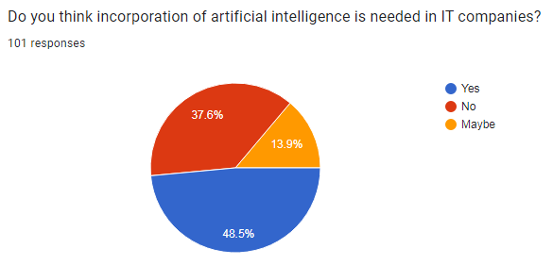

Figure 4.3: Response 3
(Source: Derived from Google form)
Artificial intelligence needed by information technology-based companies has been agreed by approximately 48% of participants. It has indicated that respondents have wanted improvement and incorporation of AI technology in IT organisations. 37.6% of participants have chosen no option which means that they do not agree with incorporation of artificial intelligence in the information technology sector [Refer to Appendix]. Those participants may want different kinds of development or management processes instead of artificial intelligence improvement.13.9% of participants have not gathered proper ideas about AI implementation in global employee management of the IT sector.
Question 4: How far do you agree that use of artificial intelligence has been helping in shaping the IT industry of the UK?
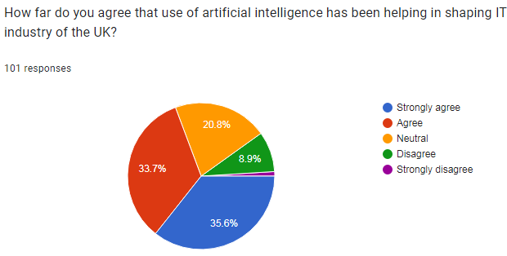

Figure 4.4: Response 4
(Source: Derived from Google form)
Information technology sector mainly depends on new efficient quality technologies and implementation of new technology. Due to this reason most of the respondents have chosen a strongly agreed option and 33.7% have chosen an agreed option. Based on the chart data it can be said that improved artificial intelligence can help the global employee management process in UK-based IT organisations [Refer to Appendix]. 8.9% of respondents may think artificial intelligence cannot improve IT organisations' market position and cannot create an impact on employee management and due to these reasons they have been chosen to disagree.
Question 5: Do you agree that proper management of artificial intelligence is necessary in IT companies?
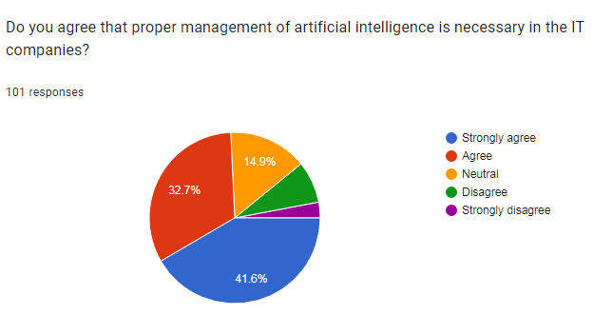

Figure 4.5: Response 5
(Source: Derived from Google form)
Artificial intelligence implementation cannot give proper results in global employee management until an appropriate management process has been included in information technology organisations. 41.6% of participants have chosen a strongly agreed option; so it has described that proper management process of AI can help to improve IT organisations' performance quality. Improper management cannot handle artificial intelligence efficiently and for this reason, 32.7% of people agreed with the question [Refer to Appendix]. 14.9% of people have not been given any feedback on this question and have chosen a neutral option; maybe they have not had any idea about the study topic.
Question 6: How far do you agree that employee management has become easier with the involvement of artificial intelligence?
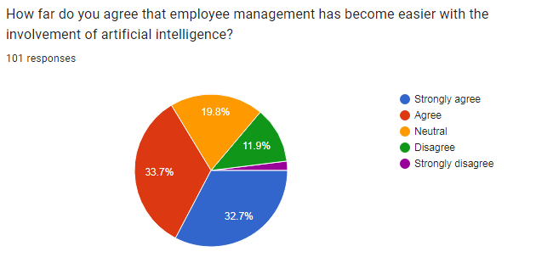

Figure 4.6: Response 6
(Source: Derived from Google form)
Artificial intelligence may help to collect employee management-related data quickly and for this reason, the organisation management process may become easier. Strongly agreed option has been chosen by most of the respondents and the second highest percentage has agreed. This response percentage has indicated that artificial intelligence can help in the employee management process [Refer to Appendix]. 11.9% of participants did not agree with the involvement of artificial intelligence in global employee management of IT companies.
Question 7: Do you agree that improper understanding and use of artificial intelligence in employee management practice can negatively affect firm performance?
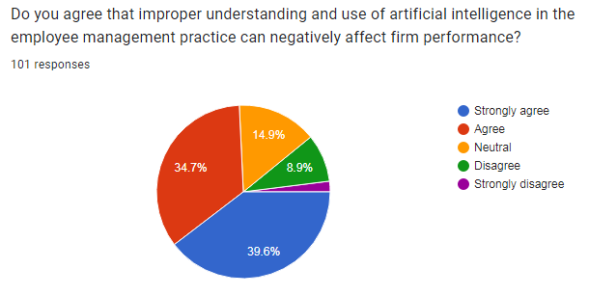

Figure 4.7: Response 7
(Source: Derived from Google form)
Improper management processes of information technology organisations can harm employee management. Negative organisation management process may not develop positive value in employees' behaviour and for this reason; employees' management has developed a negative impact. Above 39% of participants have chosen a strongly agreed option and 34.7% have chosen an agreed option to support the question [Refer to Appendix]. 8.9% have chosen to disagree, since they may think negative management cannot develop a negative impact on employees' performance and firms' performance.
Question 8: Do you agree that the use of AI can be effective in recruitment and selection process?
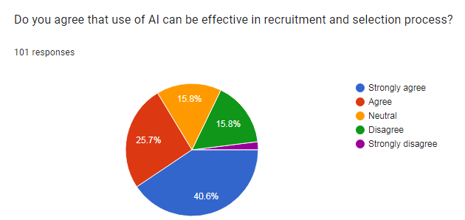

Figure 4.8: Response 8
(Source: Derived from Google form)
AI-based recruitment processes can help information technology organisations to recruit employees properly. Due to this reason 40 and 25% of respondents have been chosen to strongly agree and agree [Refer to Appendix]. The maximum respondents have thought that AI can help to improve the employee recruitment process in the UK IT industry. 15.8% have chosen the neutral option and the same percentage have chosen the disagree option.
Question 9: How far do you agree that AI can help enable organisations to manage knowledge more effectively in the global IT industry?
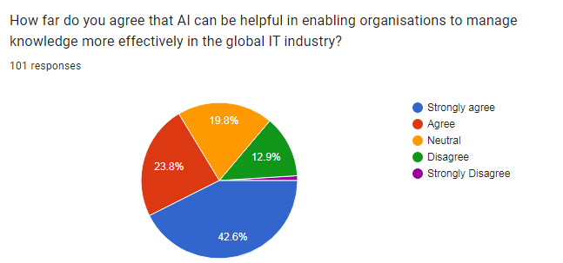

Figure 4.9: Response 9
(Source: Derived from Google form)
Artificial intelligence has included different types of new technologies and employee development has to be done properly through AI-based technologies. Participants have also thought the same thing and for this reason, a total of 65% of respondents have been chosen as a strong agree and agree option [Refer to Appendix]. Neutral has indicated that approximately 19% of participants did not have any idea about the question.
Question 10: Which of the following can be a limitation of AI as per your understanding?
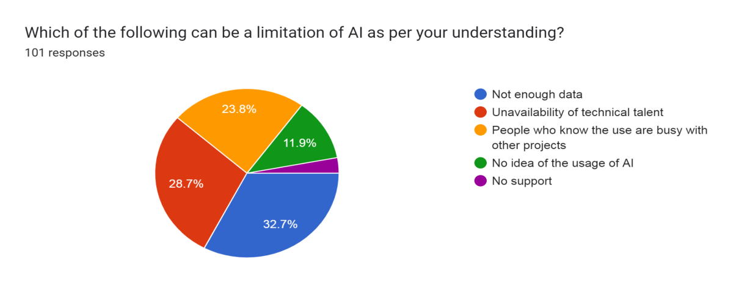

Figure 4.10: Response 10
(Source: Derived from Google form)
Enough data, a lack of technical talent and a maximum number of employees busy with different kinds of projects. These factors have been chosen as the limitation of artificial intelligence and no idea about artificial intelligence this option has been chosen by 11.9% of participants [Refer to Appendix]. Most people have identified a lack of data and efficient talented employees’ problems that can create limited impact of artificial intelligence.

4.3 Secondary Analysis
4.3.1 Evaluate the significance and role of artificial intelligence technologies play in global workforce management practices
Artificial intelligence has been playing a crucial role in every aspect of human lives, both personal and professional. As stated by Jain et al. (2023), AI can be considered as the huge digital aspect that is changing and shifting the whole world towards digitisation and innovation. The tools of artificial intelligence play an important role in improving accuracy and efficient decision-making within an organisation. With the use of artificial intelligence organisations can streamline their management solutions for employees. As opined by Wach et al. (2023), the workforce management of the business organisations can be streamlined with the application and implementation of AI in HR processes. The improved decision-making process has been beneficial for organisations as it increases organisational productivity and saves costs.
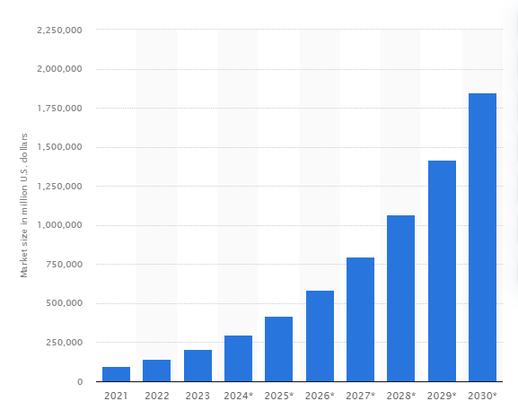

Figure 4.11: Global artificial intelligence market size 2021-2030
(Source: Statista.com, 2023)
In every kind of industry artificial intelligence has been seen to expand its hold in all the organisational aspects. The above statistical data shows the increase in the global market size of AI which is showing strong growth in the compiling decade. By the year 2030, the value of AI has been expected to grow from $100 billion to $2 trillion (Statista.com, 2023). The market of AI shows growth in every industry including the IT industry of the UK. The departments of organisations including supply chains, product marketing, research and employee management have the role of AI within them. Machine learning has been considered to be a significant subsidiary of artificial intelligence that assists various aspects of employee engagement. As stated by Budhwar et al. (2022), this aspect is beneficial for uncovering employee engagement time and different efficiency of the workers. AI has been used by various companies to manage employees to make their daily work easier and value them. For example, a national healthcare provider in the UK, the British NHS, uses a chatbot which is known as CoachBot for employee management (England.nhs.uk, 2023). This element of the company conducts small interviews with the staff to gather information regarding the challenges and problems they face in their daily work.
4.3.2 Analyse the benefit of artificial intelligence in global employee management
The technologies and tools related to artificial intelligence have been proven to be effectively impactful in the process of employee management. As stated by Charlwood and Guenole (2022), the aspect applies its significant and beneficial attributes in the process of retaining employees for a longer period of time. The main area in which AI has been the most beneficial has been improving the errors connected to humans. AI helps the organisation to make the processes much more automated, hence, reducing human errors.
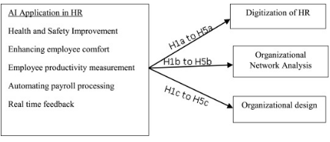

Figure 4.12: Conceptual framework of the application of AI in different areas of HR
(Source: Murugesan et al. 2023)
HR has been playing the most important role in recruiting, on-boarding and retaining employees for organisations. The implementation of AI in the processes of AI has been the most crucial in the context. As stated by Murugesan et al. (2023) the above figure shows three different kinds of digitisation applied in the process of HR. The increased precision and accuracy of AI techniques and tools have been helpful in decreasing human errors in organisational processes. The AI tools make decisions that are based on the data collected regarding the employees and organisational processes.
With the help of the implementation of AI in the organisational process, the management has been enabled to manage knowledge more effectively. As stated by Mohammed (2021), the behaviours of sharing knowledge among the employees of any organisation has a great influence on the perception of customers regarding the organisation. The service quality provided by and to the employees can also be improved with the help of artificial intelligence tools.
4.3.3 Evaluate the ethical implication and possible consequences of artificial management system
Artificial intelligence has been found to be able to change the global labour market in the coming future. As stated by Pan et al. (2022), the IT industry of the UK has been involved in utilising tools and techniques of AI to elevate employee safety and well-being. There have been various consequences that can take place in organisations after the implementation. The employees of organisations using AI in place of humans can be suffering from the insecurity of jobs and displacement of job roles. As per the statement of Votto et al. (2021), this has been the greatest consequence related to AI which creates employee dissatisfaction. It has been evident that the labour market has been prone to significant transformations in the coming time.
Approximately 23% of the current jobs will undergo changes by the year 2027. This transition has been expected to create 69 million new jobs and 83 million job losses by the next five years (Statista.com, 2023). Ethical standards and considerations have to be kept in mind while implementing AI in employee management. As stated by Budhwaret al. (2022), AI has been data-driven and cannot be able to make emotional decisions. This has been the reason for biased decisions taken by AI. In order to mitigate this condition the management of organisations needs to upgrade the data sets of employees frequently and with precision.

4.3.5 Analyse the impact of artificial intelligence on employees working in UK based IT industry
Artificial Intelligence has been effectively impacting the employee management of the UK-based IT industry. It has been helping the industry to monitor the performance of employees regularly by using various tools. As stated by Pan (2022), artificial intelligence technologies have been helping companies to customise training and development programs for employees to develop better opportunities. It has been allowing the industry to analyse data such as employee profit, performance reviews and feedback surveys to provide personalised learning paths for each employee. It has been identified that approximately 29.5% of the IT and telecommunication sector of the UK has adopted AI (Forbes.com, 2023). Artificial intelligence technologies have been helping employees to improve their skills and knowledge to create better performance. The UK IT Industry has been accepting or adopting artificial intelligence technologies to create a more engaged and motivated workforce. It has been identified that AI has been contributing up to 15.7 trillion pounds to the global economy by 2030 (Forbes.com, 2023). It has been impacting the engagement of employees within the workplace and increasing their quality of work that provides benefits to the industry.
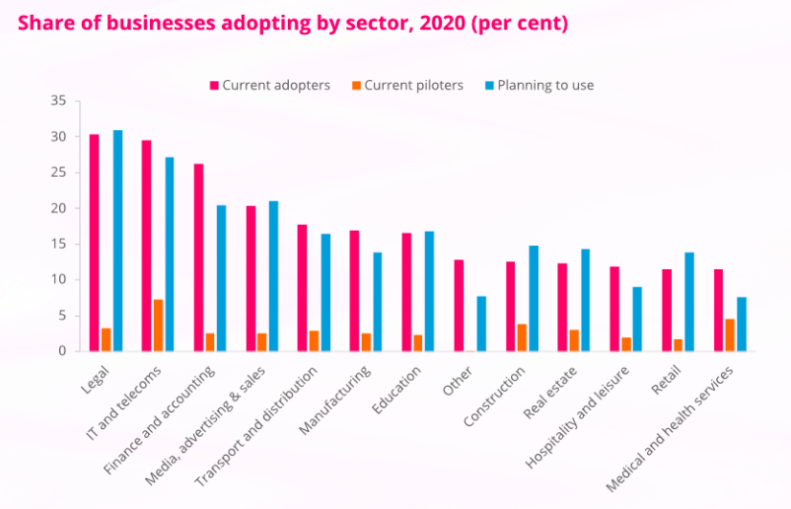

Figure 4.13: Adoption rates of AI in UK IT and telecom sector
(Source: Forbes.com, 2023)
Artificial management has been used to help employees in performing tasks effectively and be more organised to increase workflow. As opined by Malik (2021), it has enabled managers and team members to focus on meaningful work and drive better customer engagement and satisfaction. AI has been helping companies to boost employee engagement and help in managing risks and challenges by using artificial tools including machine learning and automation. Artificial intelligence has been helping the IT industry to build equal and diverse workplaces to create more effective collaboration and teamwork. It has been identified that the UK has provided more than 1.64 million jobs for employees to increase their growth rate within the industry (Assets.publishing.service.gov.uk, 2022). The UK rate of adopting artificial management within the workplace has been continuously growing and has been expected to grow by more than 20% in upcoming years.
4.3.6 Identify the challenges in using artificial intelligence in global employee management
Artificial intelligence has created the challenge of lack of interaction among employees including human interaction and emotional intelligence. As stated by Budhwar (2022), implementing artificial intelligence reshapes job roles and responsibilities. It has been used to create ambiguity and confusion among employees and create poor communication among employees within the workplace. Artificial management technologies have been creating the challenge of a lack of empathy for employees as emotional intelligence and empathy have not been truly understood by employees. It has been identified that approximately 45% of employees have a negative impact of AI on their mental health (Hbr.org, 2022). The UK IT industry has been impacting artificial intelligence for monitoring employee performance that decreased their morale and motivation. The core issue of artificial intelligence in the workplace has been a loss of employment.

Figure 4.14: Challenges of artificial intelligence in employee management
(Source: Self-Created)
AI robots and machines have been far more intelligent and smarter than human resources that have led to the loss of employee jobs and their displacement. It has been expected that by 2030 more than 45 million employees will lose their jobs due to artificial intelligence implementation within the workplace (Assets.publishing.service.gov.uk, 2023). The machines and AI tools require less time to conduct work and have more skills as compared to human employees and this has been a challenge for employees to save their jobs. For Example, telecom giant BT has removed more than 50 thousand employees from the company and replaced them with artificial intelligence in the UK (Bbc.com, 2023). Artificial management has been presenting the challenge of the lack of data privacy of organisations and individuals due to the complexities of algorithms used in AI systems. It has been creating complexities for employees to work effectively and provide better working performance that creates job loss. It has been predicted that AI can replace approximately 30 million full-time employees by 2030 (Bbc.com, 2023). Artificial intelligence has been creating the effective challenge of biases in the data used for the AI algorithm that has been creating unintentional discrimination against certain groups in the workplace. It has ultimately led to discrimination and negative social consequences and impacted the flow of work in organisations.
4.3.7 Recommend strategies to mitigate the critical components and challenges faced by AI technologies in a global context
Employees have been facing various challenges due to the implementation of artificial intelligence within the workplace that can be mitigated by adopting various strategies. The UK IT industry has been implementing artificial management creating a lack of interaction among employees. This critical challenge can be mitigated through re-skilling and up-skilling programs, prioritising employee wellbeing and privacy and balancing automation with human interaction and empathy. The industry can drive greater trust and transparency in hybrid organisations for employee's better interaction. Artificial intelligence has been creating a lack of data privacy that can be mitigated through investing in continuous improvement of algorithms to enhance artificial management capabilities over time. The UK IT industry can adopt strong data security protocols to avoid the issues and ensure federal regulations. The industry can develop transparency within its workplace to make the employees engaged with the company development and create better workflow.
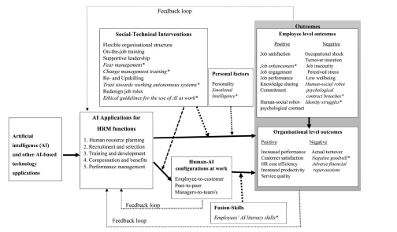

Figure 4.15: Influence of AI on employee and organisation
(Source: Budhwar, 2022)
The UK industry has been facing increasing cases of biases due to artificial intelligence that has been creating discrimination in the workplace. They can mitigate these issues through considering the biases and facilitating collaborative learning. Ensuring high-quality data can help companies address the biases and lead to more reliable AI outcomes. For Example, Manchester, the largest IT Company in the UK, has been creating a sustainable environment and an inclusive and diverse economy for employees to avoid biases (Manchester.gov.uk, 2023). Regular auditing and validation of AI models can help companies to identify and correct discriminatory behaviour. The industry has been facing a lack of employment that can be mitigated through adopting automation within the workplace. The UK-based IT Industry can develop smart and targeted strategies to address future job displacement challenges. They can provide better opportunities for employees and create jobs to manage the issue of lack of employment.

4.4 Discussion
4.4.1 Primary discussion
From the above survey, it can be said that artificial management has mostly been an advantageous programme for IT organisations concerned with employee management. In the survey, most of the respondents answered the questionnaires with positive responses for AI management tools. A response rate of 48.5% has been found for incorporating AI management in IT organisations, which defines the significance of this programme. The effectiveness of artificial intelligence in IT organisations has been highly appreciated, but it needs proper managerial control and maintenance (Ribeiro et al. 2021). More than 40% of the respondents agreed with this statement, whereas only 14.9% of the respondents stayed neutral with this questionnaire. In IT organisations the essentiality of AI management systems has been found to be beneficial for simplifying the workforce management process (Nelson, 2023). A positive response rate of more than 60% has been found that declares that AI tools have simplified the workforce management loads for the HR managers in the IT organisations.
The positive responses also have cleared that AI tools have been the most performable programs in IT organisations for knowledge management. More than 65% of responses have been collected that have agreed that AI management effectively associates in employee recruitment and selection. Therefore based on this survey report it can be understood that AI tools have been beneficial in IT organisations for employee management, as most of the participants have responded positively with the impact of AI.
4.4.2 Secondary discussion
Artificial management systems in IT organisations have emerged as a beneficial program for managing global employees. According to the data findings it has been observed that the AI tools in this modern generation have been playing a crucial role in the IT organisations to manage their employee engagement and performance. The British NHS has emerged as an adequate example in this area with its usage of ChatBot for employee management concerns. The AI management systems have been effective in automating and digitalising the different business processes regarding employee management (Vrontis et al. 2022). The HRM departments have been the centric role players in the recruiting, hiring and training processes of employees, wherein the usage of AI tools and different AI-related management systems have been proven to be effective. The range of adopting and implementing AI management systems in the UK IT and telecommunication industry has been adopted at a rate of 29.5% (Techuk.org, 2023). The IT industry in the UK has successfully created a more motivated and engaged workforce that has been ensuring an increased level of productivity in the industry.
According to the above analysis, AI management systems have been found to be a great empowered of business organisations in order to plan and forecast their workforce needs more accurately, which has been occurring in the UK IT industry with the association of AI management systems. However there have been different challenges like lack of data privacy, biases and so on regarding AI usage, yet it has attracted the IT organisations largely to manage their workforce more ethically and effectively.

4.5 Summary
The above study has summarised that artificial management has been playing an important role in the global employee management of the UK-based IT industry. It has concluded that artificial management has been helping manage automotive repetitive tasks, reduce errors and provide effective insights. It has been summarised from the study that artificial management technologies have been helping in the employee management of the UK-based IT industry. The study has summarised the primary and secondary analysis and included 10 questions asked to 50 employees in a survey about their perspective on the research phenomenon. Secondary analysis has been included in the study to discuss the role played by artificial intelligence technologies in managing the employees of the UK-based IT industry.

CHAPTER 5: CONCLUSION AND RECOMMENDATION

5.1 Conclusion
From the above discussion, it can be concluded that artificial management has been playing an impactful role in the global employee management of the UK-based IT industry. Artificial management has been used to leverage the power of artificial intelligence and machine learning to streamline the organisational process. The management system has been helping organisations in managing automotive repetitive tasks, reducing errors and providing effective insights. It has been seen from the study that artificial management technologies help in managing employees in the UK IT industry. The study conducted the survey and asked 10 questions to 50 employees about their perspective on artificial intelligence technologies' impact on employee management. The study has also analysed the research phenomenon with the help of secondary analysis including articles, journals, books and websites. It has included an analysis of the role played by artificial intelligence technologies in managing the employees of the UK-based IT industry. The study has identified that artificial intelligence has been helping employees in improving productivity and performance for better working quality. It has also concluded that artificial intelligence technologies have been creating various challenges for the UK-based IT industry that have been impacting the overall management. Strategies have also been recommended in the study for mitigating the mentioned challenges.

5.2 Linking with Objectives
5.2.1 Objective 1 Role of artificial intelligence technologies in global workforce management practice of UK IT industry
Artificial Intelligence technologies have been playing an impactful role in managing data-driven decisions for the organisation and minimising errors in workforce planning. As stated by Hughes (2019), it has been used to automate the processes of organisations to minimise the risks and create better outcomes. Artificial intelligence has been helping the IT industry to support the career growth of employees and helps in better employee engagement. It has been used to increase the standard of the organisational strategies and provide better results. As opined by Yawalkar (2019), artificial intelligence has helped the employee to moderate their performance, productivity and creativity level to provide better workflow to the organisation. Artificial intelligence has been used to create better opportunities for employees to increase their productivity levels and provide better growth opportunities.
The UK-based IT industry has been used to adopt artificial intelligence to improve their decision-making and create beneficial outcomes. As stated by Johansson (2019), it has been playing an impactful role in automating the manual tasks of organisations and increasing efficiency and productivity. Artificial intelligence has been used to help companies to manage, recruit and engage their workforce. It has been able to automatically identify the needed skills and training for employees based on their job position. For Example, IntellecsoftCompany has been an IT industry that adopted artificial intelligence to increase the productivity and job satisfaction of employees (Intellectsoft.net, 2023). It has been playing an impactful role in decreasing the workload for employees and facilitating a stress-free environment. AI provides effective advantages to companies in operating employee performance and regularly monitors their productivity for better improvement and outcomes.
5.2.2 Objective 2 Advantages and Disadvantages of using AI in the context of global workforce management
Artificial intelligence has been beneficial in reducing errors (human error) and increasing accuracy and precision. As stated by Ambati (2020), it has helped employees reduce errors during work and helps in providing accurate and precise work. Artificial Intelligence has been used to overcome many risks in the workplace. It has been helping the employees to mitigate complex risks and challenges with effective solutions. It has helped in fostering collaboration and teamwork through virtual aspects and also provides effective inventions. Artificial intelligence has helped perform repetitive tasks without delays and effectively automates menial chores. It has been used to make faster decisions for the development of the UK IT industry and helps them mitigate effective challenges in less time by using fewer expenses. As opined by Yawalkar(2019), artificial intelligence requires plenty of time and resources and can cost a huge deal of money. The UK IT industry needs lots of money and resources to adapt AI and implement it in their workplace. Artificial intelligence has been working on command and it has not been able to provide creativity in the work. It has been displacing occupations and increasing unemployment or loss of jobs that impact the economy. It has been creating additional opportunities for humans to work and also replacing humans to increase efficiency.
5.2.3 Objective 3 Major areas of employee management influenced by AI in the UK IT industry
Artificial intelligence influences employee recruitment and hiring as it allows recruiters to use the power of data to make better decisions. As stated by Black (2020), it has been used to assist in the sourcing and screening of candidates, analyse resumes and job applications, conduct pre-assessment tests for employees and even predict the success rates of employees. It has been automating the high volume of tasks and improving the quality of hiring through standardised job matching. As opined by Spisakova(2019), artificial intelligence has an impact on employee benefits and compensation as it reduces human bias in compensation decisions, promoting fairness and equity across the organisation. It has the benefit of automating routine tasks like benefits enrolment and payroll processing to focus on strategic incentives and employee well-being. It has helped the employees in automating repetitive and time-consuming tasks, allowing employees to focus on more complex and strategic activities.
AI has been used to increase the productivity and efficiency of employees in the workplace by streamlining processes and reducing manual labour. As stated by Vrontis et al. (2022), artificial intelligence has a great influence on employee performance management as it analyses the level of employee performance to provide actionable insights into employee strengths, weaknesses and areas for improvement. It has enabled more informed decision-making and the ability to address performance gaps effectively. The leverage capability of AI has been used to help the employee reduce mundane tasks and focus on more significant challenges that lead to increased efficiency. As opined by Lee (2019), artificial intelligence has included employee training and development that has been helping in analysing huge data sets and deriving conclusions using technologies like machine learning. It has been helping employees to improve their skills and knowledge by creating training and development programs.
5.2.4 Objective 4 Ethical implications and possible consequences of using an artificial intelligence system in global workforce management
Ethical concern has been one of the most integral and necessary aspects of an artificial management system. It has been largely required in every artificial management system to amplify unfair discriminatory outcomes in employee management programs like hiring, recruiting, paying, rewarding and training. The study has significantly aligned this objective with the displayed findings and discussions. The UK IT organisations have been found to be the users of artificial management systems for the purpose of employee safety and employee wellbeing, concerning an employee management process. Emerging organisational issues like biased programming, unclear legal regulations, danger to humans and much more concerning employee management have been included in the possible consequences of an artificial management system (Vrontis et al. 2022). The ethnicity of AI management systems in organisations includes protection of human rights, accountability, transparency, and protective privacy, which have been found in this study. However, the study has also aligned some ethical issues of AI management systems such as accountability issues, privacy concerns, and the potential for bias and discrimination. The effectiveness of using AI management systems for the purpose of global workforce management has been analysed in this study along with accuracy and transparency.
According to the survey results, it has been revealed that AI tools have been cooperating and ultimately conquering the decision-making process in IT organisations by maintaining enough ethnicity. Despite this effectiveness, AI systems in organisations have often been found to be less reliable which ultimately leads to distrusted and inaccurate decision-making capabilities (Siau, 2020). This has been a major possible consequence of the AI management system in organisations, perfectly aligned with this study.
5.2.5 Objective 5 Challenges in using artificial intelligence in global employee management
Artificial intelligence has been seen to impact global employee management in many ways. As stated by Vrontis et al. (2022), AI is changing the way in which management of companies manages employee selection, recruitment, training, on-boarding, performance management and managing workflow. There have been various challenges related to global employee management that have to be faced by organisations. The first challenge of using AI in this context is potential discrimination and bias in algorithms. As opined by Kshetri(2021), this has been one of the biggest risks associated with artificial intelligence that harms employee management. This issue can occur in the situation when the algorithms are trained on some biased data.
The second challenge is the risk of employee displacement and job loss. In case of high automation in the task of employee recruitment, there is a potential chance of loss of some job roles. As per the statement of Yawalkar (2019), there is an issue of displacement of some employee from their current job roles. This has a negative impact on employee retention and morale. The next challenge is the threat to data security and employee privacy that harms the personal data of the employees. More automation results in violating the privacy of employee information. As stated by Jaiswal et al. (2022), the private data of employees that is stored in organisational systems are vulnerable to cyber attacks. Lack of emotional intelligence and human interaction is another challenge. Artificial intelligence has been creating a lack of emotional intelligence and human interaction challenges that impact the overall performance of employees. AI has been reshaping the job roles of employees and their responsibilities which creates misunderstanding and loss of connection (Budhwar, 2022). It has been creating ambiguity and confusion among the employees that affect the employee engagement and performance.

5.3 Recommendation
In the context of the impact of artificial management on global employee management, there are several recommendations that can be given.
- The global IT industry of the UK can be recommended to implement transparent and ethical AI practices. As stated by Jain et al. (2023), the challenge of discrimination and bias in algorithms can be mitigated with this strategy. This strategy includes regular audits of algorithms to ensure the non-biased decisions of the outcomes. The management needs to be sure about the transparency of variables and data sources that are used in the algorithms. As opined by Votto et al. (2021), in order to achieve this management needs to implement certain processes such as co-design, involving the design process of the end-users of the same and soliciting their feedback. The managers need to know and deliver transparent explanations of the working process of AI systems. As per the statement of Strich et al. (2021), all the explanations and information regarding the working process of the AI system need to be registered and documented. All these methods can be of great help that ensure a transparent and fair system of AI in employee management.
- The implementation of AI has been responsible for job loss and displacement of employees to other roles. As stated by Pillai, R. and Sivathanu et al. (2020), this issue can be mitigated with the recommended strategy of up skilling and reskilling programmes for the employees. This has been proven to be a great help for transitioning employees to some new job roles. Organisations need to implement certain training and developmental programmes for their employees. As opined by Pan et al. (2022), this would prove to be helpful for the employees to understand their job roles and thrive in the same. In the increasingly digitalised workplace, employees need to be provided with training by HR professionals to help them gather skills and knowledge. The gathered skills and knowledge would be helpful for the employees in case of displacement of them from their current roles to any new job roles.
- The next recommendation that can be suggested to the global-based IT companies of the UK is to give priority to employee privacy and well-being. As stated by Mohammed (2021), in the world of digitisation where every process within the organisations is automated and based on AI, there has been a prevalence of the issue of cyber attacks. The employees have to share their personal data with the employers which have to be kept personal and protected. As opined by Kshetri(2021), the managers of organisations need to give priority to the privacy and well-being of the collected personal data of the employees. The management of the company needs to be transparent regarding the process by which the personal data of employees are collected. They can be recommended to become transparent regarding the way in which the data will be stored and used for organisational purposes. According to the statement of Yawalkar (2019), the management of organisations needs to take part in providing training and resources in order to help employees protect their personal data. These kinds of training would be very helpful for the employees to learn the process of protecting their personal data in any other ventures they shift.
- No matter how much the process of employee management becomes automated and supported by AI, there has been a requirement of human touch in some circumstances. As stated by Vrontiset al. (2022), the management of organisations can be recommended to balance automation with empathy and human interaction. Organisations that have totally automated employee management programs have the issue of lack of human assistance and touch of emotional intelligence. Automation has been proven to be helpful in streamlining organisational processes and improving efficiency. As said by Jain et al. (2023), there are no chances of replacing a human touch totally and the requirement of performance management and conflict resolution is always there. In this context, the HR professional needs to play a crucial role in balancing automation and human empathy and interaction. As stated by Strich et al. (2021), this needs to be done in order to make the employees feel valued and supported. The valued and supported employees tend to perform well in their job roles and retain themselves for longer. This would be beneficial for the overall performance of the organisation and can be helpful for cutting out costs. The human interactions implemented in the process of employee management in the global IT industry of the UK have signified the fact that employee privacy is protected. The HR professional has to ensure regarding the fact that the employees have easy access to empathy and human support whenever required. As per the statement of Pillai and Sivathanu (2020), all these need to be done by the management of organisations while keeping pace with automation in the same process. This would be beneficial for the IT organisations of the UK to improve their accuracy and efficiency of employee management process.

5.4 Future Scope
The research can be well regarded as a valuable piece of work along with a profound discussion on AI management systems for the purpose of global workforce management. The research objectives have been significantly aligned with the performed discussions and data findings of this research. These segments of an in-depth analysis regarding artificial management systems can be observed by IT organisations for managing their employees. There has been an appropriate analysis of AI-related ethical considerations and possible consequences, which will be beneficial for companies to adopt an AI system, considering and maintaining AI ethics in the future. Moreover, these broad sets of discussions also represent a scope or opportunity for other researchers to present similar research on AI management systems in future.

5.5 Research limitation
Although artificial intelligence and its related informational data have been available in the secondary sources, the artificial management system has been a partially different subject, which is lacking in the secondary sources. This can be taken as a major limitation of this research. On the other hand, the research could be made better if appropriate honesty had been maintained by all of the survey respondents. In some areas of this research, dishonest answers of the respondents have led to inaccurate presentation.

Reference list
Ahsan Ullah, A.K.M., 2022. Ethics and Empirics: Essence of Ethics in Social Research. In Principles of Social Research Methodology (pp. 471-482). Singapore: Springer Nature Singapore.
Alharahsheh, H.H. and Pius, A., 2020. A review of key paradigms: Positivism VS interpretivism. Global Academic Journal of Humanities and Social Sciences, 2(3), pp.39-43.
Amazon.com, 2023. About company. Available at. https://www.amazon.com/?&ext_vrnc=hi&tag=googhydrabk1- [Accessed on 02.09.2023]
Ambati, L.S., Narukonda, K., Bojja, G.R. and Bishop, D., 2020. Factors influencing the adoption of artificial intelligence in organizations–from an employee’s perspective.
Ameen, N., Sharma, G.D., Tarba, S., Rao, A. and Chopra, R., 2022. Toward advancing theory on creativity in marketing and artificial intelligence. Psychology & marketing, 39(9), pp.1802-1825.
Anton, E., Behne, A. and Teuteberg, F., 2020. The humans behind Artificial Intelligence–An operationalisation of AI competencies.
Arnold, B.B., 2022. Surveillance Machines in Ivory Towers? Surveillance Capitalism, Dignity and Learning Management Systems. Canberra L. Rev., 19, p.70.
Assets.publishing.service.gov.uk, 2022. Growing The Artificial Intelligence Industry In The Uk. Available at: https://assets.publishing.service.gov.uk/media/5a824465e5274a2e87dc2079/Growing_the_artificial_intelligence_industry_in_the_UK.pdf [Accessed on: 05.10.2023]
Assets.publishing.service.gov.uk, 2023. AI ACTIVITY IN UK BUSINESSES. Available at: https://assets.publishing.service.gov.uk/government/uploads/system/uploads/attachment_data/file/1045381/AI_Activity_in_UK_Businesses_Report__Capital_Economics_and_DCMS__January_2022__Web_accessible_.pdf [Accessed on 10.08.2023]
Assets.publishing.service.gov.uk, 2023. The Potential Impact of Artificial Intelligence on UK Employment and the Demand for Skills. Available at: https://assets.publishing.service.gov.uk/media/615d9a1ad3bf7f55fa92694a/impact-of-ai-on-jobs.pdf [Accessed on: 05.10.2023]
BBC.com, 2023 As layoffs bite, teams are becoming smaller – and fewer resources mean remaining employees are spread thin and overburdened. Available at.https://www.bbc.com/worklife/article/20230217-how-shrinking-teams-are-pushing-workers-to-the-brink [Accessed on 13.07.2023]
Bbc.com, 2023. AI could replace equivalent of 300 million jobs - report. Available at: https://www.bbc.com/news/technology-65102150 [Accessed on: 05.10.2023]
Bbc.com, 2023. BT to cut 55,000 jobs with up to a fifth replaced by AI. Available at: https://www.bbc.com/news/business-65631168 [Accessed on: 05.10.2023]
Bharadiya, J.P., 2022. Driving Business Growth with Artificial Intelligence and Business Intelligence. INTERNATIONAL JOURNAL OF COMPUTER SCIENCE AND TECHNOLOGY, 6(4), pp.28-44.
Black, J.S. and van Esch, P., 2020. AI-enabled recruiting: What is it and how should a manager use it?. Business Horizons, 63(2), pp.215-226.
Bleiker, J., Morgan-Trimmer, S., Knapp, K. and Hopkins, S., 2019. Navigating the maze: Qualitative research methodologies and their philosophical foundations. Radiography, 25, pp.S4-S8.
Bougie, R. and Sekaran, U., 2019. Research methods for business: A skill building approach. John Wiley & Sons.
Budhwar, P., Malik, A., De Silva, M.T. and Thevisuthan, P., 2022. Artificial intelligence–challenges and opportunities for international HRM: a review and research agenda. The International Journal of Human Resource Management, 33(6), pp.1065-1097.
Budhwar, P., Malik, A., De Silva, M.T. and Thevisuthan, P., 2022. Artificial intelligence–challenges and opportunities for international HRM: a review and research agenda. The International Journal of Human Resource Management, 33(6), pp.1065-1097.
Charlwood, A. and Guenole, N., 2022. Can HR adapt to the paradoxes of artificial intelligence? Human Resource Management Journal, 32(4), pp.729-742.
Chivanga, S.Y. and Monyai, P.B., 2021. Back to basics: Qualitative research methodology for beginners. Journal of Critical Reviews, 8(2), pp.11-17.
Connect.comptia.org, 2023. 30+ Artificial Intelligence Statistics and Facts for 2023. Available at: https://connect.comptia.org/blog/artificial-intelligence-statistics-facts [Accessed on 10.08.2023]
Coy, M.J., 2019. Research methodologies: Increasing understanding of the world. International Journal of Scientific and Research Publications, 9(1), pp.71-77.
Daneshjou, R., Smith, M.P., Sun, M.D., Rotemberg, V. and Zou, J., 2021. Lack of transparency and potential bias in artificial intelligence data sets and algorithms: a scoping review. JAMA dermatology, 157(11), pp.1362-1369.
England.nhs.uk, 2023. NHS England. Available at: https://www.england.nhs.uk/#:~:text=If%20you%20are%20looking%20for,services%20please%20visit%20NHS.uk. [Accessed on 10/10/2023]
Ethics.grad.ucl.ac.uk, 2023. SECONDARY DATA ANALYSIS. Available at: https://ethics.grad.ucl.ac.uk/forms/Secondary-data-analysis-file-note.pdf [Accessed on 11.10.2023]
Fallucchi, F., Coladangelo, M., Giuliano, R. and William De Luca, E., 2020. Predicting employee attrition using machine learning techniques. Computers, 9(4), p.86.
Fenews.co.uk, 2023. Demand for AI Skills Triples in UK Labour Market. Available at: https://www.fenews.co.uk/skills/demand-for-ai-skills-triples-in-uk-labour-market/ [Accessed on 10.08.2023]
Files.eric.ed.gov, 2023. Thematic Analysis Approach: A Step by Step Guide for ELT Research Practitioners. Available at: https://files.eric.ed.gov/fulltext/ED612353.pdf [Accessed on 11.10.2023]
Forbes.com, 2023. UK Artificial Intelligence (AI) Statistics And Trends In 2023. Available at: https://www.forbes.com/uk/advisor/business/software/uk-artificial-intelligence-ai-statistics-2023/ [Accessed on: 05.10.2023]
Fox, N.J. and Alldred, P., 2022. Doing new materialist data analysis: A Spinozo-Deleuzian ethological toolkit. International Journal of Social Research Methodology, 25(5), pp.625-638.
Greening, N., 2019. Phenomenological research methodology. Scientific Research Journal, 7(5), pp.88-92.
Hafidz, M.A. and Elihami, E., 2021. Learning The Nonformal Education Through Research Methodology: A Literature Review. JurnalEdukasi Nonformal, 2(1), pp.47-55.
Hbr.org, 2022. AI Isn’t Ready to Make Unsupervised Decisions. Available at: https://hbr.org/2022/09/ai-isnt-ready-to-make-unsupervised-decisions [Accessed on: 05.10.2023]
Hughes, C., Robert, L., Frady, K. and Arroyos, A., 2019. Artificial intelligence, employee engagement, fairness, and job outcomes. In Managing Technology and Middle-and Low-skilled Employees: Advances for Economic Regeneration (pp. 61-68). Emerald Publishing Limited.
Intellectsoft.net, 2023. Enterprise Artificial Intelligence Software. Available at: https://www.intellectsoft.net/solutions/ai [Accessed on: 05.10.2023]
Johansson, J. and Herranen, S., 2019. The application of artificial intelligence (AI) in human resource management: Current state of AI and its impact on the traditional recruitment process.
Kabacoff, R., 2022. R in action: data analysis and graphics with R and Tidyverse. Simon and Schuster.
Khang, A., Jadhav, B. and Birajdar, S., 2023. Industry Revolution 4.0: Workforce Competency Models and Designs. In Designing Workforce Management Systems for Industry 4.0 (pp. 11-34). CRC Press.
Komorowski, M., 2019. Artificial intelligence in intensive care: are we there yet?.Intensive care medicine, 45(9), pp.1298-1300.
Kshetri, N., 2021. Evolving uses of artificial intelligence in human resource management in emerging economies in the global South: some preliminary evidence. Management Research Review, 44(7), pp.970-990.
Lee, J., Suh, T., Roy, D. and Baucus, M., 2019. Emerging technology and business model innovation: the case of artificial intelligence. Journal of Open Innovation: Technology, Market, and Complexity, 5(3), p.44.
Legislation.gov.uk, 2023. Data Protection Act 2018. Available at: https://www.legislation.gov.uk/ukpga/2018/12/contents/enacted [Accessed on 11.10.2023]
Maedche, A., Legner, C., Benlian, A., Berger, B., Gimpel, H., Hess, T., Hinz, O., Morana, S. and Söllner, M., 2019. AI-based digital assistants: Opportunities, threats, and research perspectives. Business & Information Systems Engineering, 61, pp.535-544.
Malik, N., Tripathi, S.N., Kar, A.K. and Gupta, S., 2021. Impact of artificial intelligence on employees working in industry 4.0 led organizations. International Journal of Manpower, 43(2), pp.334-354.
Manchester.gov.uk, 2023. Manchester Digital Strategy 2021 – 2026. Available at: https://www.manchester.gov.uk/info/500002/council_policies_and_strategies/8356/manchester_digital_strategy_2021_%E2%80%93_2026#:~:text=The%20strategy%20is%20built%20on,Future%20Prosperity%20and%20Sustainable%20Resilience. [Accessed on: 05.10.2023]
Mardiana, S., 2020. Modifying Research Onion for Information Systems Research. Solid State Technology, 63(4), pp.5304-5313.
Merkle, J.A., 2022. Management and Ideology: The legacy of the international scientific management movement.Univ of California Press.
Mirbabaie, M., Brünker, F., Möllmann, N.R. and Stieglitz, S., 2022. The rise of artificial intelligence–understanding the AI identity threat at the workplace. Electronic Markets, pp.1-27.
Mohammed, I.A., 2021. The interaction between artificial intelligence and identity and access management: an empirical study. International Journal of Creative Research Thoughts (IJCRT), ISSN, 2320(2882), pp.668-671.
Murugesan, U., Subramanian, P., Srivastava, S. and Dwivedi, A., 2023. A study of Artificial Intelligence impacts on Human Resource Digitalization in Industry 4.0. Decision Analytics Journal, p.100249.
Ncbi.nlm.nih.gov, 2023. A quick guide to survey research. Available at: https://www.ncbi.nlm.nih.gov/pmc/articles/PMC3964639/ [Accessed on 11.10.2023]
Nelson, S.M., 2023. The purpose, prevalence, and legal pitfalls of AI in workforce management. Artificial Intelligence (AI).
Newman, M. and Gough, D., 2020. Systematic reviews in educational research: Methodology, perspectives and application. Systematic reviews in educational research: Methodology, perspectives and application, pp.3-22.
Nguyen, T.M. and Malik, A., 2022. Impact of knowledge sharing on employees' service quality: the moderating role of artificial intelligence. International Marketing Review, 39(3), pp.482-508.
O’Kane, P., Smith, A. and Lerman, M.P., 2021. Building transparency and trustworthiness in inductive research through computer-aided qualitative data analysis software. Organizational Research Methods, 24(1), pp.104-139.
Pan, Y., Froese, F., Liu, N., Hu, Y. and Ye, M., 2022. The adoption of artificial intelligence in employee recruitment: The influence of contextual factors. The International Journal of Human Resource Management, 33(6), pp.1125-1147.
Pereira, L., Santos, R., Sempiterno, M., Costa, R.L.D., Dias, Á. and António, N., 2021. Pereira Problem solving: Business research methodology to explore Open Innovation. Journal of Open Innovation: Technology, Market, and Complexity, 7(1), p.84.
Ribeiro, J., Lima, R., Eckhardt, T. and Paiva, S., 2021. Robotic process automation and artificial intelligence in industry 4.0–a literature review. Procedia Computer Science, 181, pp.51-58.
Saunders, M.N., Lewis, P., Thornhill, A. and Bristow, A., 2015. Understanding research philosophy and approaches to theory development.
Saunders, M.N., Lewis, P., Thornhill, A. and Bristow, A., 2015. Understanding research philosophy and approaches to theory development.
Siau, K. and Wang, W., 2020. Artificial intelligence (AI) ethics: ethics of AI and ethical AI. Journal of Database Management (JDM), 31(2), pp.74-87.
Spisakova, E.D., 2019. Position of employee benefits in remuneration structure. Transformations in business & economics, 18(2), p.47.
Stamate, A.N., Sauvé, G. and Denis, P.L., 2021. The rise of the machines and how they impact workers' psychological health: An empirical study. Human Behavior and Emerging Technologies, 3(5), pp.942-955.
Statista.com, 2023 Annual production value of the information and communication technology (ICT) services sector in the United Kingdom (UK) from 2009 to 2018(in million euros.)Available at: https://www.statista.com/statistics/290638/it-industry-employment-in-the-united-kingdom-by-sub-sector/Accessed on 12.07.2023]
Statista.com, 2023 IT market revenue in United Kingdom from 2016 to 2021 (in billion U.S. Dollars) Available at: https://www.statista.com/forecasts/961413/it-revenue-in-united-kingdom [Accessed on 13.07.2023]
Statista.com, 2023. Global artificial intelligence market size 2021-2030. Available at: https://www.statista.com/statistics/1365145/artificial-intelligence-market-size/ [Accessed on 10/10/2023]
Statista.com, 2023. Global business and HR leaders. Available at. https://www.statista.com/statistics/1120120/global-business-and-hr-leaders-use-of-ai-to-assist-workers/ [Accessed on 23.08.2023]
Statista.com, 2023. Leading uses of AI to assist workers in their organization according to global business and HR leaders as of 2020. Available at. https://www.statista.com/statistics/1120120/global-business-and-hr-leaders-use-of-ai-to-assist-workers/ [Accessed on 24.08.2023]
Statista.com, 2023. The double-edged sword of AI: Will we lose our jobs or become extremely productive?. Available at: https://www.statista.com/site/insights-compass-ai-future-ai-work#:~:text=This%20transition%20is%20expected%20to,over%20the%20next%20five%20years. [Accessed on 10/10/2023]
Stone, M., Aravopoulou, E., Ekinci, Y., Evans, G., Hobbs, M., Labib, A., Laughlin, P., Machtynger, J. and Machtynger, L., 2020. Artificial intelligence (AI) in strategic marketing decision-making: a research agenda. The Bottom Line, 33(2), pp.183-200.
Studysmarter.co.uk, 2023. Sources of Data. Available at: https://www.studysmarter.co.uk/explanations/social-studies/theories-and-methods/sources-of-data/ [Accessed on 11.10.2023]
Tambe, P., Cappelli, P. and Yakubovich, V., 2019. Artificial intelligence in human resources management: Challenges and a path forward. California Management Review, 61(4), pp.15-42.
Techuk.org, 2023. AI Adoption in the UK: Putting AI into Action. Available at: https://www.techuk.org/resource/ai-adoption-in-the-uk-putting-ai-into-action.html [Accessed on 11.10.2023]
Tong, S., Jia, N., Luo, X. and Fang, Z., 2021. The Janus face of artificial intelligence feedback: Deployment versus disclosure effects on employee performance. Strategic Management Journal, 42(9), pp.1600-1631.
Van der Walt, J.L., 2020. Interpretivism-constructivism as a research method in the humanities and social sciences–more to it than meets the eye. International Journal of Philosophy and Theology, 8(1), pp.59-68.
Varpio, L., Paradis, E., Uijtdehaage, S. and Young, M., 2020. The distinctions between theory, theoretical framework, and conceptual framework. Academic Medicine, 95(7), pp.989-994.
Vebrianto, R., Thahir, M., Putriani, Z., Mahartika, I. and Ilhami, A., 2020. Mixed Methods Research: Trends and Issues in Research Methodology. Bedelau: Journal of Education and Learning, 1(2), pp.63-73.
Vindrola-Padros, C. and Johnson, G.A., 2020. Rapid techniques in qualitative research: a critical review of the literature. Qualitative health research, 30(10), pp.1596-1604.
Votto, A.M., Valecha, R., Najafirad, P. and Rao, H.R., 2021. Artificial intelligence in tactical human resource management: A systematic literature review. International Journal of Information Management Data Insights, 1(2), p.100047.
Vrontis, D., Christofi, M., Pereira, V., Tarba, S., Makrides, A. and Trichina, E., 2022. Artificial intelligence, robotics, advanced technologies and human resource management: a systematic review. The International Journal of Human Resource Management, 33(6), pp.1237-1266.
Wach, K., Duong, C.D., Ejdys, J., Kazlauskaitė, R., Korzynski, P., Mazurek, G., Paliszkiewicz, J. and Ziemba, E., 2023. The dark side of generative artificial intelligence: A critical analysis of controversies and risks of ChatGPT. Entrepreneurial Business and Economics Review, 11(2), pp.7-24.
Wijayati, D.T., Rahman, Z., Rahman, M.F.W., Arifah, I.D.C. and Kautsar, A., 2022. A study of artificial intelligence on employee performance and work engagement: the moderating role of change leadership. International Journal of Manpower, 43(2), pp.486-512.
Yawalkar, M.V.V., 2019. A study of artificial intelligence and its role in human resource management. International Journal of Research and Analytical Reviews (IJRAR), 6(1), pp.20-24.
Yoon, N. and Lee, H.K., 2021. AI recommendation service acceptance: Assessing the effects of perceived empathy and need for cognition. Journal of Theoretical and Applied Electronic Commerce Research, 16(5), pp.1912-1928.
Zawacki-Richter, O., Kerres, M., Bedenlier, S., Bond, M. and Buntins, K., 2020. Systematic reviews in educational research: Methodology, perspectives and application (p. 161). Springer Nature.

Appendix: Survey questionnaire
Question 1: Please specify your age.
- 18-25
- 26-30
- 31-35
- 36-40
- More than 40
Question 2: Please specify your gender.
- Male
- Female
- Other
- Prefer not to say
Question 3: Do you think incorporation of artificial intelligence is needed in IT companies?
- Yes
- No
- Don’t know
Question 4: How far do you agree that use of artificial intelligence has been helping in shaping IT industry of the UK?
- Strongly agree
- Agree
- Neutral
- Disagree
- Strongly disagree
Question 5: Do you agree that proper management of artificial intelligence is necessary in the IT companies?
- Strongly agree
- Agree
- Neutral
- Disagree
- Strongly disagree
Question 6: How far do you agree that employee management has become easier with the involvement of artificial intelligence?
- Strongly agree
- Agree
- Neutral
- Disagree
- Strongly disagree
Question 7: Do you agree that improper understanding and use of artificial intelligence in the employee management practice can negatively affect firm performance?
- Strongly agree
- Agree
- Neutral
- Disagree
- Strongly disagree
Question 8: Do you agree that use of AI can be effective in recruitment and selection process?
- Strongly agree
- Agree
- Neutral
- Disagree
- Strongly disagree
Question 9: How far do you agree that AI can be helpful in enabling organisations to manage knowledge more effectively in the global IT industry?
- Strongly agree
- Agree
- Neutral
- Disagree
- Strongly disagree
Question 10: Which of the following can be a limitation of AI as per your understanding?
- Not enough data
- Unavailability of technical talent
- People who know the use are busy with other projects
- No idea of the usage of AI
- No support

