11/21/2025
University of Wales Trinity Saint David
London campus
E-Portfolio Link: https://alokdhariwal2.wixsite.com/e-porfolio-3

Module Name: Learning In the Digital Era
Module Code: ACCA 4025

Student Name: Alok Dhariwal
Student ID: 2512876
Group: 2

Lecturer’s Name: Koushik Modak

LDE Assignment 1
E-Portfolio
Table of Contents
Task 1: Essential Academic and Employment Skills for the future career Path 3
Task 1 (a): Report on Essential Academic and Employment Skills 3
Introduction 3
Main Body 3
References: 3
Task 1 (b): Evaluation of Task 1 (a) based on Similarity report 4
Task 2: Collaborative Mind Map and Individual Poster 5
Mind Map (Collaborative) 5
Poster (Individual) 6
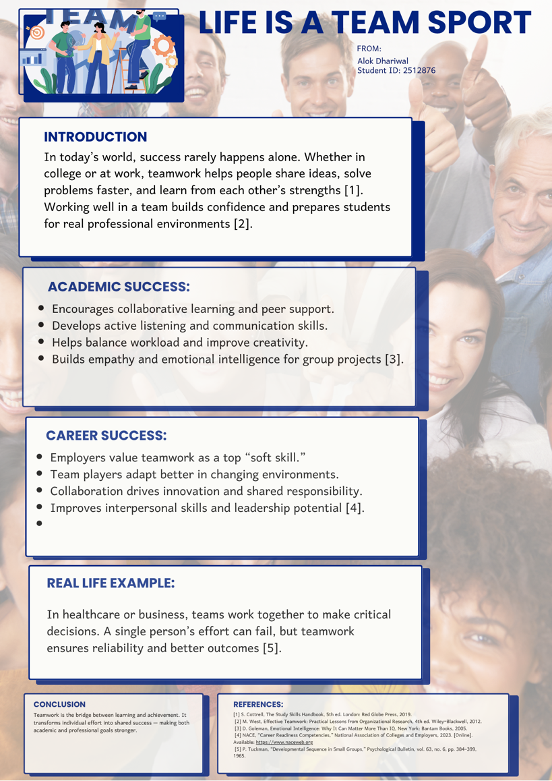 6
Task 3: Virtual Collaboration and RefWorks 7
Report on Virtual Collaboration 7
References: 7
Step-by-step process of using RefWorks with visuals 8
Task 4: E-Portfolio Creation and Evaluation 10
Task 4 (a): E-Portfolio Creation 10
Task 4 (b): Illustrative Review of E-Portfolio tool Selection 11
Conclusion : 14

Task 1: Essential Academic and Employment Skills for the future career Path

Task 1 (a): Report on Essential Academic and Employment Skills

Introduction
I’ve come to see that doing well in college or at work isn’t really about being the smartest person in the room. It’s more about using what you already know in the right way. When I actually plan my week and don’t leave things for the last minute, I feel a lot calmer [1]. Working with people also helps — you learn new ways of thinking just by talking and sharing ideas.

Main Body
One thing I’ve picked up is that it’s worth stopping to think before jumping to answers. Asking questions or checking facts usually makes my work stronger [2]. I also try to write in my own style and give credit to others properly. It shows I’ve done the work myself and that I respect other people’s ideas [3].
Since I want to go into health and social care, understanding people is a big deal for me. You meet all kinds of situations, and being kind, patient, and steady really matters [4]. On top of that, digital skills help with nearly everything now — writing reports, keeping notes, or finding information [5]. Together, these skills make me feel ready for both college and a real job later on.
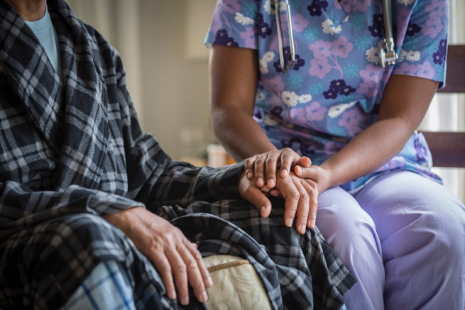

References:
[1. 1. 2. 1. 2. 3. 1. 2. 3. 4. 1. 2. 3. 4. 5] Skills Handbook, 5th ed. London: Red Globe Press, 2019.
[2] M. Thompson and L. Thompson, The Critical Thinking Toolkit. London: Routledge, 2018.
[3] NACE, “Career Readiness Defined,” National Association of Colleges and Employers, 2023. [Online]. Available: https://www.naceweb.org/career-readiness/competencies/career-readiness-defined/
[4] D. Goleman, Emotional Intelligence: Why It Can Matter More Than IQ. New York: Bantam Books, 2005.
[5] J. Andrews and H. Higson, “Graduate Employability, ‘Soft Skills’ Versus ‘Hard’ Business Knowledge,” Higher Education in Europe, vol. 33, no. 4, pp. 411–422, 2008.

Task 1 (b): Evaluation of Task 1 (a) based on Similarity report
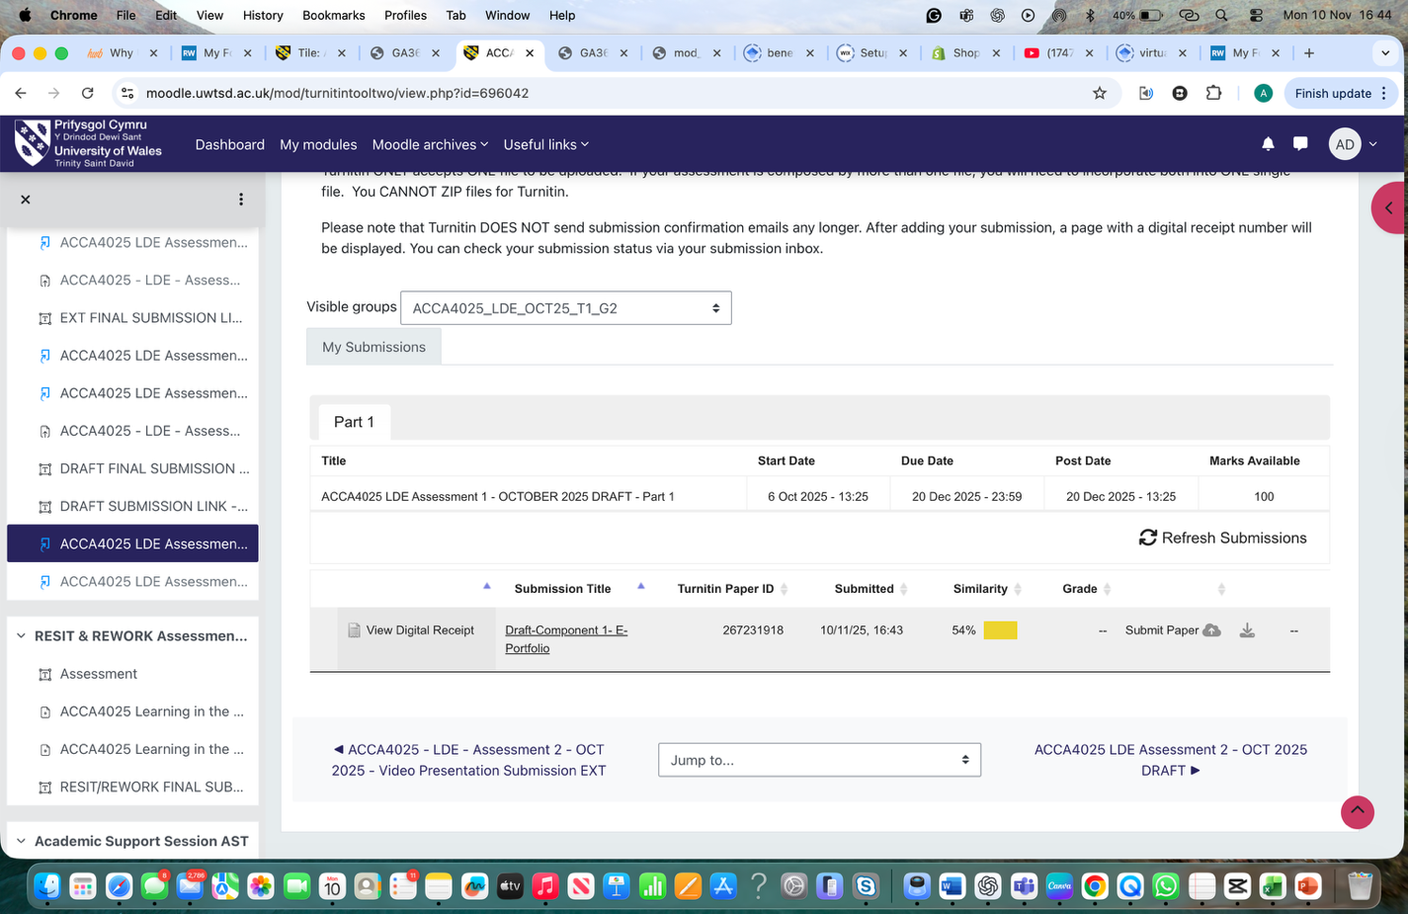

Evaluation of Task 1 (a) based on Similarity report
To be honest, when I saw my Turnitin report and it showed 54% I felt a bit upset. I didn’t think it would be that high. I think some parts matched because of short common lines and the reference list. Next time I’ll try to write more in my own way, maybe mix my sentences a bit and not follow the same pattern as examples. I’ll read it again before I submit to make sure it sounds more like me. If I had to grade myself, I’d give around 74 or 75 because it’s good but not perfect yet.

Task 2: Collaborative Mind Map and Individual Poster

Mind Map (Collaborative)
Mind Map Link:
https://mm.tt/map/3845109642?t=ogm85BPttV

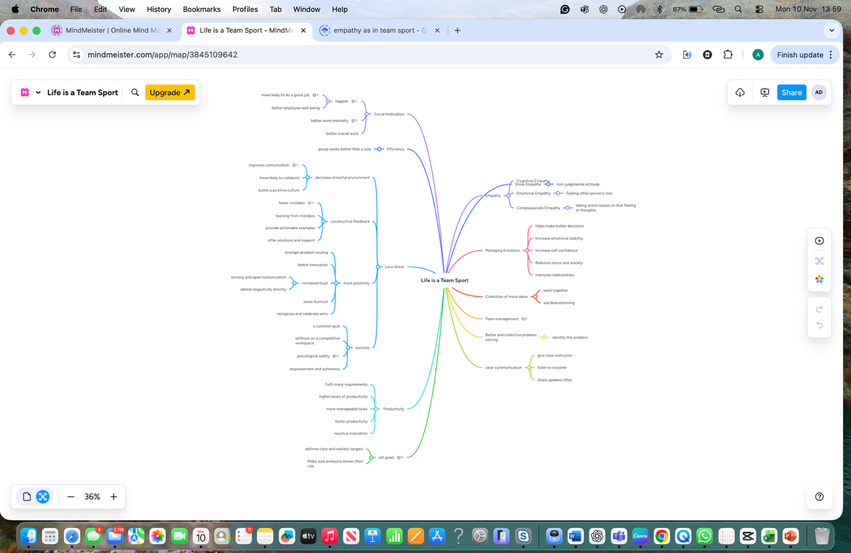

Poster (Individual)

Here is the link to see Poster Online:
https://www.canva.com/design/DAG4TvTdfVU/L2s3P6X3vaz_s-ajI3nioQ/view?utm_content=DAG4TvTdfVU&utm_campaign=designshare&utm_medium=link2&utm_source=uniquelinks&utlId=h57941f2fc7

Task 3: Virtual Collaboration and RefWorks

Report on Virtual Collaboration
When a new team starts forming, everything feels a bit uncertain at first. People are still figuring out how to work together and who’s good at what. Good communication right from the start makes a huge difference [6]. It helps everyone understand the main goal and what part they’ll play in reaching it.
Working in a virtual team is even trickier. Some people may live in different time zones, so most conversations happen online [7]. That’s why tools like Teams or Zoom become the only link between members. Still, it’s not just about using apps — people also need to pick up on tone and emotions through text or video so they don’t misunderstand each other.
Early on, it really helps to set simple ground rules such as how often to meet, how to share work, and how decisions will be made [8]. Clear roles avoid confusion later. I’ve seen that when roles aren’t clear, tasks overlap and deadlines slip. Trust is also something that builds slowly. Teams that spend a bit of time getting to know one another — maybe through short chats or quick check-ins — usually work more smoothly later [9].
Virtual teamwork works best when there’s a mix of structure and friendliness. A good balance between technology and real connection makes people feel part of something, not just another username on a screen [10]. In the end, teamwork is less about fancy software and more about people understanding each other, supporting one another, and aiming for the same goal.

References:
Duarte and Snyder, [10]. . Larson and LaFasto, [9]. . West [8]. . Lipnack and Stamps, [7]. . Cottrell [6]

Step-by-step process of using RefWorks with visuals

To manage and insert my references, I used RefWorks Citation Manager in Microsoft Word. First, I logged in to RefWorks through the university library and added my sources manually and by using the “Export to RefWorks” option from Google Scholar. Then I opened RefWorks Citation Manager (RCM) in Word and selected the IEEE style. By clicking “Cite this,” I inserted in-text citations like [1], [2], etc. Finally, I pressed Insert Bibliography, and the full IEEE reference list appeared automatically at the end of the document. This process saved time and ensured all my references were correctly formatted.

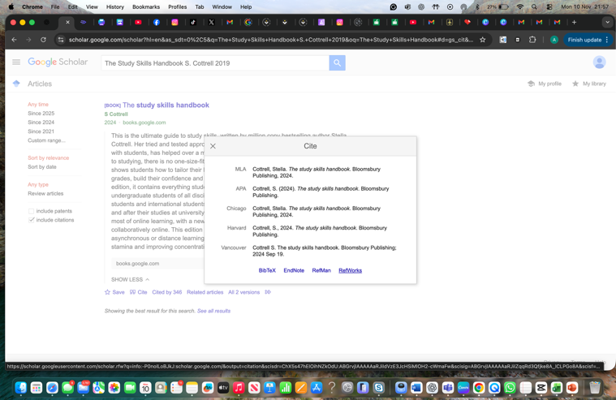
Cottrell [6]

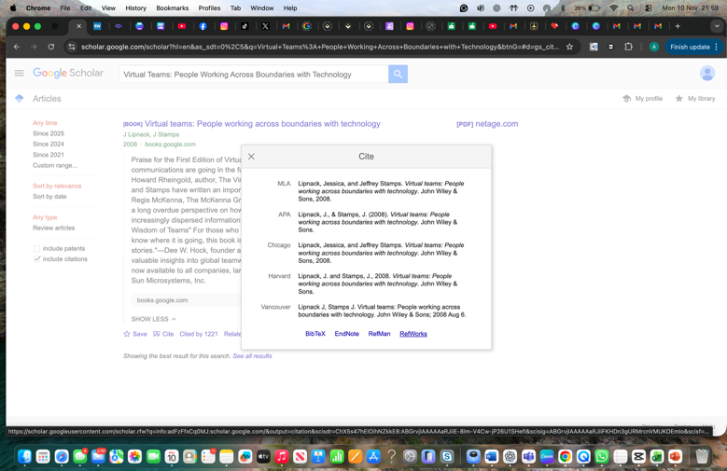
Lipnack and stamps, [7]

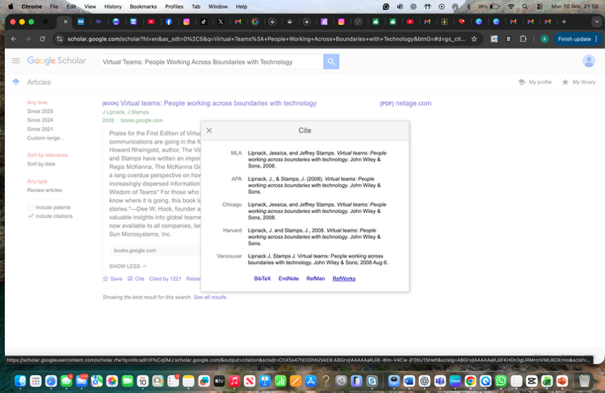
West [8]

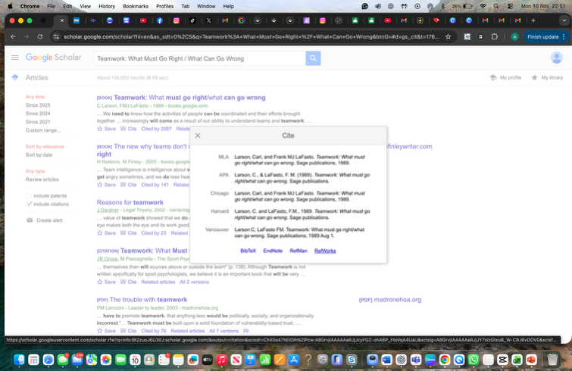
Larson and LaFasto, [9]

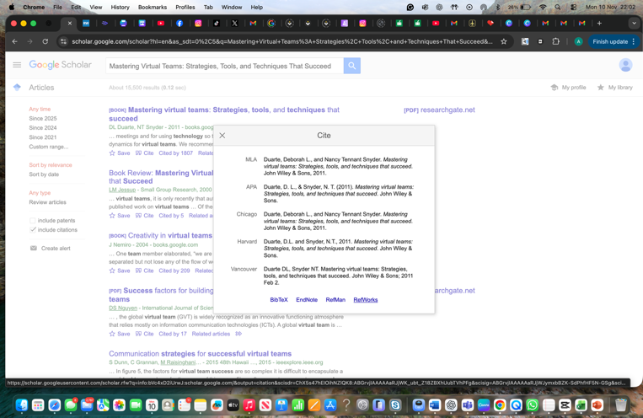
Duarte and Snyder, [10]

Task 4: E-Portfolio Creation and Evaluation

Task 4 (a): E-Portfolio Creation
For the e-portfolio, I just used Wix because honestly it was the first thing that came to my mind and I’ve played with it before. I didn’t follow any proper design idea. I just opened a blank site and started putting things wherever they seemed fine. First I made a small home page, nothing fancy, just a little intro about the module and what things I am adding in the portfolio.
Then I made a page for Task 1, and I copied my summary and reflection there. I also added the visual. After that, I created another page for Task 2 where I put my mind map picture and the poster. I just dragged things around until it looked okay. I didn’t try to make it perfect or anything.
For Task 3, I added one more page and pasted my virtual collaboration report. I uploaded the screenshots showing RefWorks and wrote quick notes below each one so I remember what they show. Wix made it pretty simple because I could move stuff around easily.
By the time I added everything, it looked decent enough. Each task has its own page, and the whole thing is easy to click through. That’s basically how I put the whole e-portfolio together.

Task 4 (b): Illustrative Review of E-Portfolio tool Selection

I made this on Wix.com
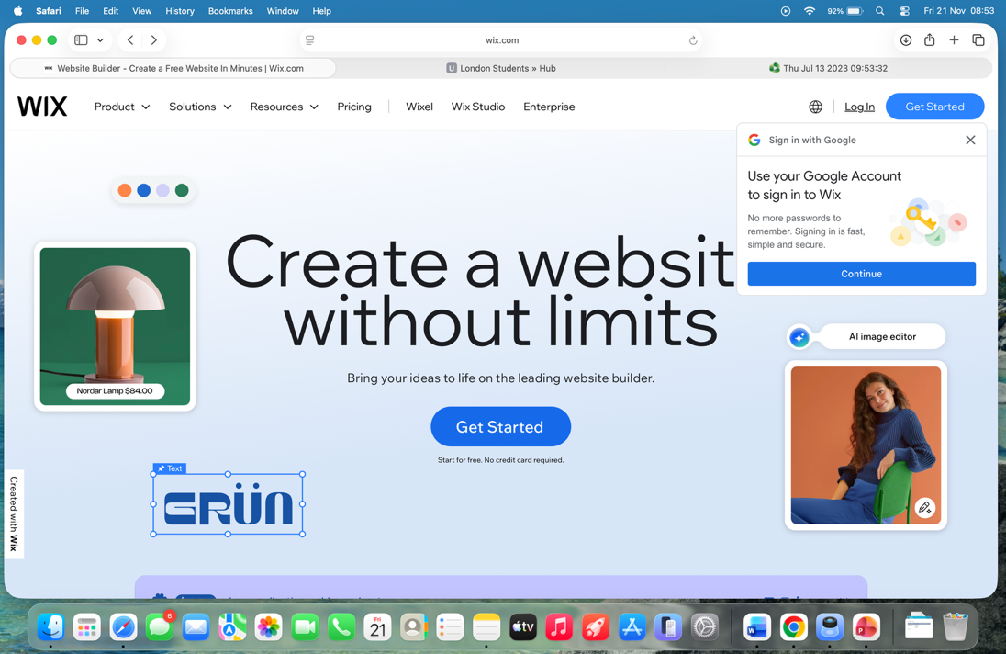

Sign up using your email
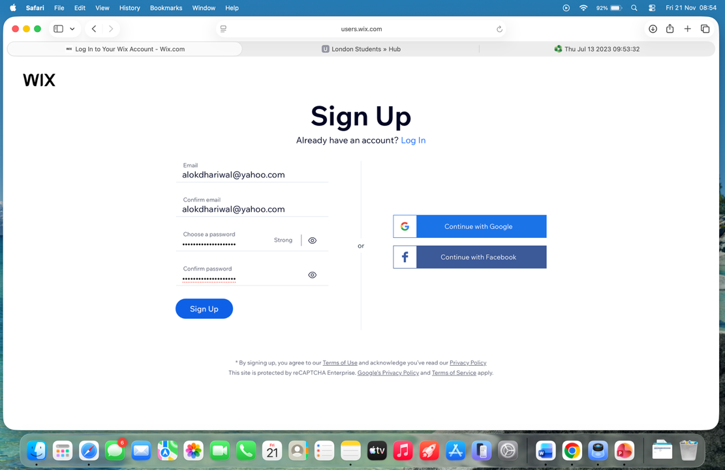

Give a name to website

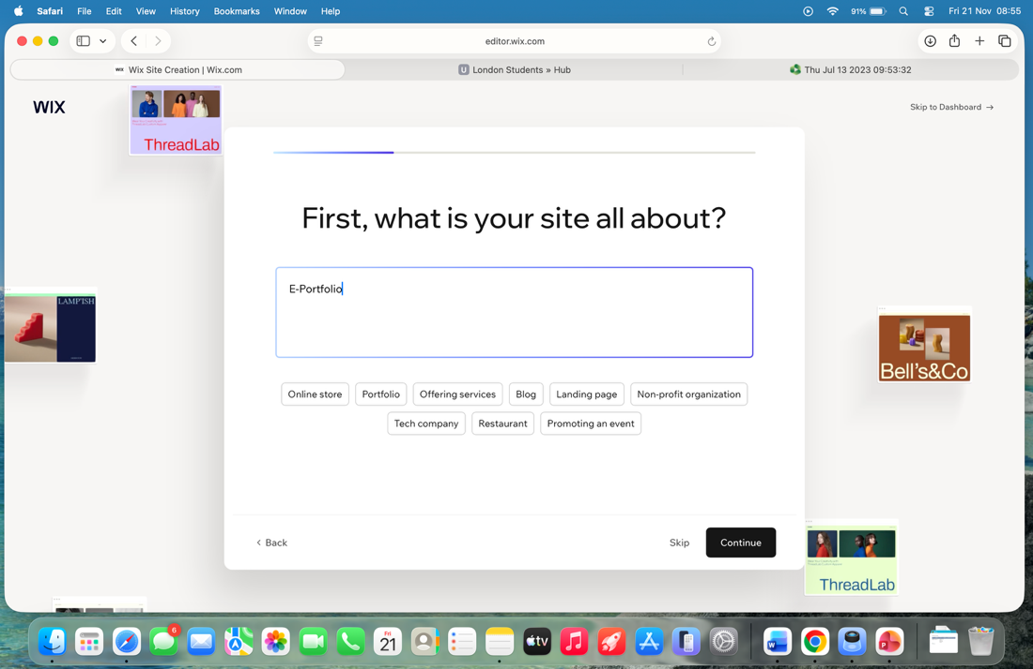

Design the site
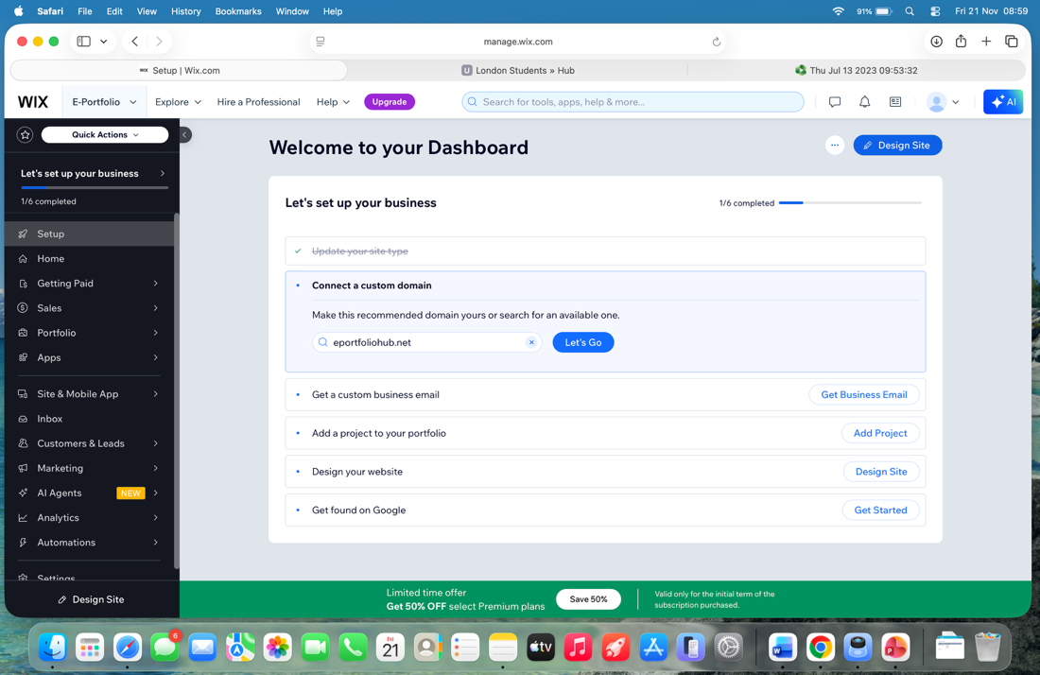

Choose a template
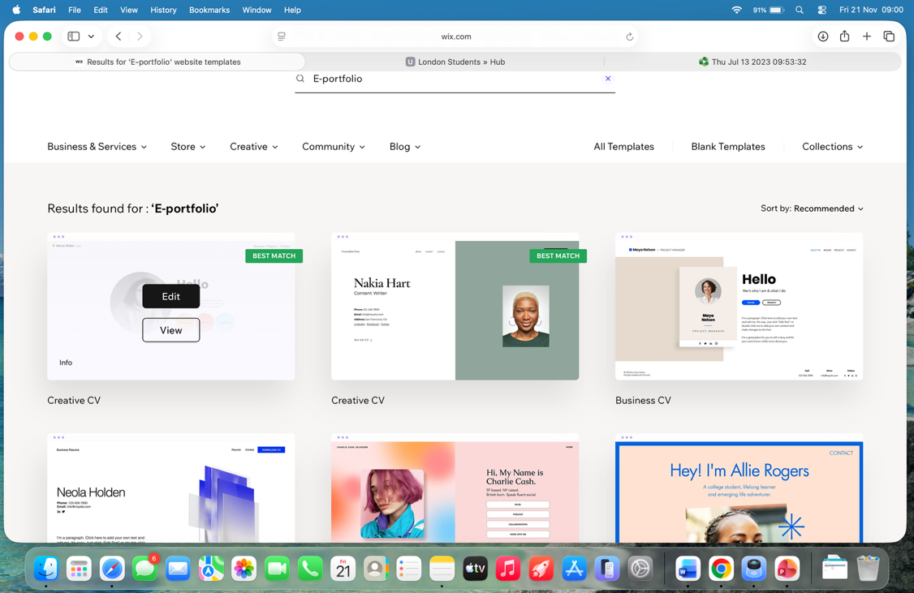

Edit it to your needs
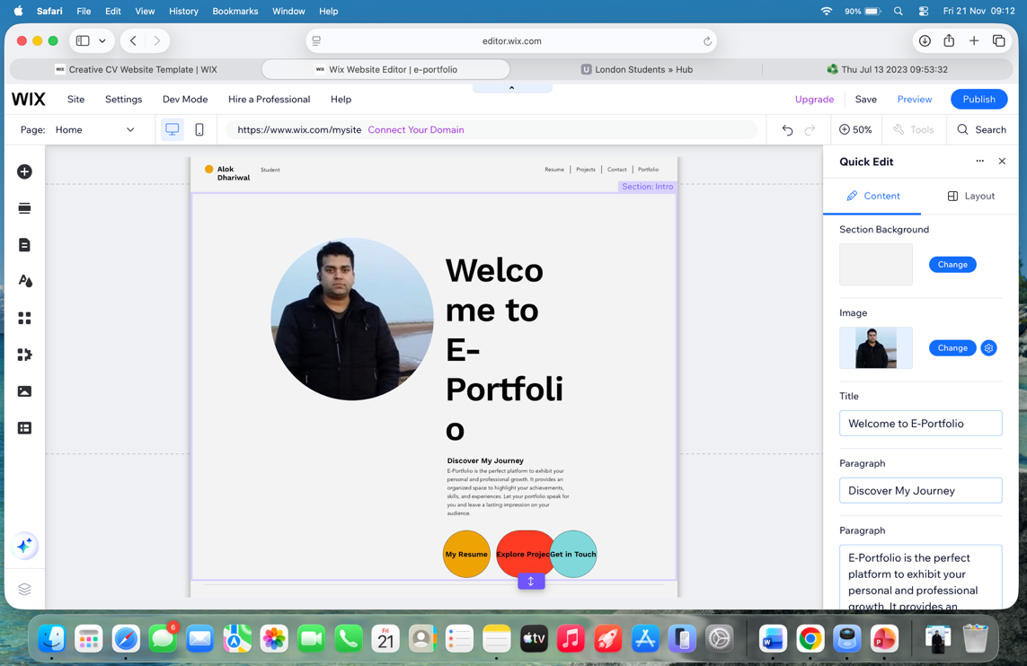

Here is the link to visit my website
https://alokdhariwal2.wixsite.com/e-porfolio-3

Conclusion :
Honestly, after doing all this work, I kind of see virtual teamwork differently now. At the start I didn’t think it would matter so much, but when you actually try to write about it, you realise how many small things can go wrong. The beginning of a team is always a bit confusing and everyone is just guessing their part. But when people talk a little more and explain what they are doing, the whole thing becomes easier. Even online, it’s really just about people trying to understand each other. The tools help, sure, but it still depends on how we communicate and how we deal with each other.

