fWhat are the motivations that drive collectors of battlefield relic material – critically assess the
activities of one example.

Historical conflict zones have become a growing interest of archaeologists in the past three decades (Scott, 2011). The two most important wars in British history are the First and Second World War. These wars had lasting effects on the country and still today ripples can be seen. This can be highlighted by what was left behind by the soldiers and the ‘artefacts’ found on the battlefield by archaeologists later. Items that have entered into circulation can be seen as collectors items. The focus of this essay is ‘Trench Art.’ ‘Trench Art’, as stated by Saunders (2001), is ‘the dazzling array of objects made by soldiers, prisoners of war and civilians from the waste of industrialised war’. This term can be rather misleading, because trench art does not only relate to the work of the men in the trenches but anyone in the space or place of conflict (Gordon, n.d.). This paper will have a focus on World War One but trench art can be seen throughout history and even in the present. There are many items which fall into this category, many of which today can be seen in antique shops and on market stalls as well as online sites such as Ebay. Even though such items have fallen out of fashion today, during the 1940s and 50s they were quite popular which highlights the shift in trends of collecting ‘Trench Art’. This form of battlefield relic is the ‘whiter’ side of collecting, compared to certain items such as grenades. ‘Trench art’ can be beautiful and is often the aftermath of an item of destruction which has been manipulated into something else. Collectors are driven by different motivations which are explored below in relation to trench art.

Trench art is a term that encompasses a number of different types of objects and therefore understanding the motivations of collectors is complicated. Overwhelmingly, trench art refers to the objects created in the battlefield trenches of World War One.The specifications of different items are due to who made them and what they are made from and what into. There are three main subsections as identified by Isyanova (2009),

Category 1 includes objects made by World War One soldiers. There are three subsections to this category which are:
1A) Trench art made by active soldiers in WWI
1B)Trench art made by Prisoners of war
1C) Trench art made by injured soldiers.

Category 2 is trench art made by civilians

Category 3 is commercially produced trench art (Isyanova,2009).

For many collectors only category one is classed as ‘proper trench art’. This may be due to the fact that it was made by the men on the front line who were in the thick of the war. They were the ones literally in the trenches facing the worst aspects of the conflict. The items made by them could be their way of processing the situation but also a way to control their own fears as they took something deadly and made it beautiful. This sentiment has been studied in depth by Elisabeh Gordon. In their work they state that ‘engraving and etching rendered the shells useless as a weapon of war and reclaimed their materiality for domestic remembrance’ and that is it a ‘three-dimensional form of scrapbooking’ (Gordon, n.d.)). This gives trench art even more complexity as it may have been so much more than just art but it could have been therapy for the soldiers but also the civilians alike. It could have given the soldiers a sense of control in a world that was chaotic. They could have also created these items as a way to be remembered as many soldiers were never identified and creating this art gave them something to be remembered by. Art could have also been a creative response to the war and since materials were lacking, shell casings and other detritus of war was utilised. Soldiers on the front line could undergo this activity which may have been of therapeutic benefit as they waited to pass the time.

As for the civilians a similar approach can be taken as they also experienced the war but in a slightly different way as they were not fighting but still part of the conflict. The civilians at home again could have used this art form as a way to control their narrative in even a small way. Everyday people were faced with an uncertain future and the horrors of warfare. The motives for creating such art will never fully be understood since many people today, especially in the UK, will have never experienced such uncertainty.

The third category brings up the most issues and contentions as the mass production of commercial trench art shows a darker side to 20th century production. Such enterprises were profiting off of death and destruction. This highlights that the production and collecting of certain artefacts can be rather ghoulish and distasteful. These items have very little meaning in common with the trench art produced in the trenches by soldiers and none of the personal stories attached to them which the objects the other categories have. Category 3 is the most displaced from the conflict both spatially and in time.

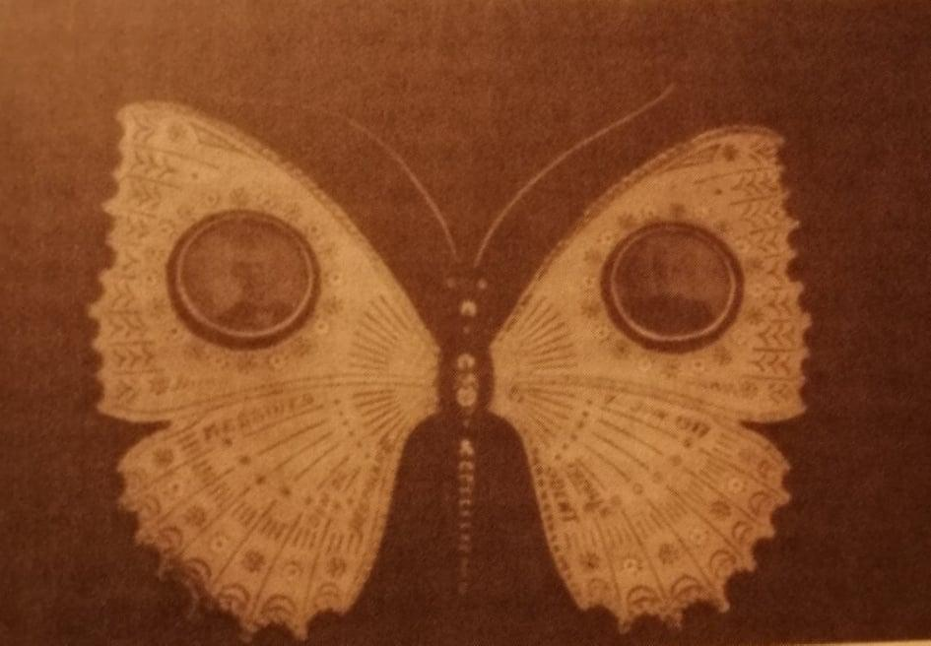
Trench art can have many meanings. In terms of the Butterfly memory piece for the Odent family it shows collecting in a way of remembrance. This is part of emotional collecting and pieces such as this piece were common in the Wars. This specific piece is dated to the 7th June 1917. This date is significant as it is the opening of the Messines Phase of the Third Battle of Ypres (Passchendaele)(Saunders, 2003).
Figure 1 Odent family butterfly trench art (Saunders,2003)

This item is very personal. Personal items were collected by the people who had a close link to them and even today collecting personal trench art can be seen. The importance of this piece of trench art is in the form it takes. The butterfly has many connotations all of which are in contrast to the violence of war. Butterflies link to childhood and chasing them through the fields, they offer hope and beauty. Butterflies are also transformative. The action of going from a caterpillar to a butterfly could be a metaphor for trench art as it is taking something dangerous and turning it into something beautiful and eye-catching. The butterfly is in stark contrast to the conflict. Objects such as this are powerful mediators between the living and the dead, Saunders notes that ‘they are the mediators between personal experiences, landscapes and memories’ (Saunders, 2016). It is this property of mediation that makes these items so popular and valuable with collectors.
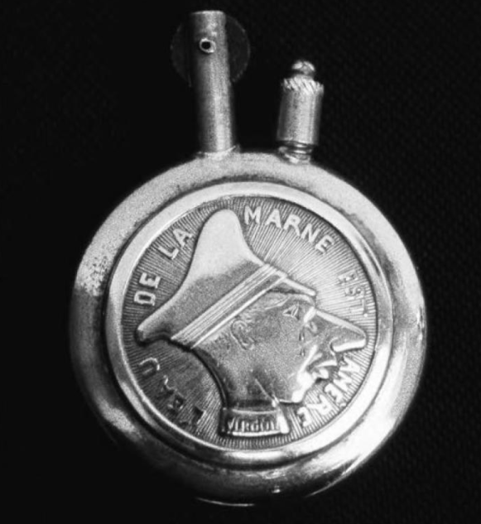
This final item is a French cigarette lighter or Briquet. The image shown is a caricature of Prince Wilhelm (Crowned Prince of Germany). This item is rather satirical and offers a sense of humour to the great conflict. The French might have made this sort of item to keep them occupied on the front line and making ‘offensive’ art of the enemy must have felt like a morale booster. It gave the soldiers an outlet for their creativity whilst also attacking the Germans in a non violent way.
Figure 2 French cigarette lighter (Isyanova,2009)

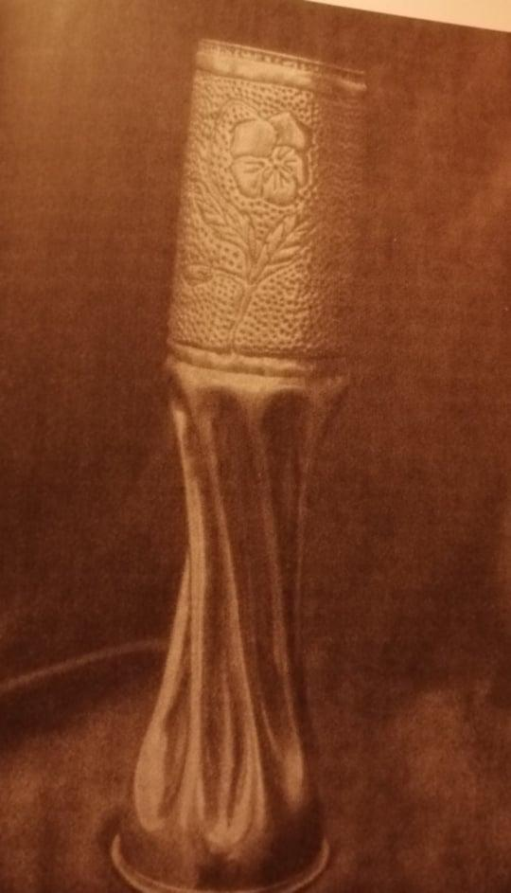
Non personalised trench art is more common. Items such as this shell (Figure 3), can be seen quite often. These are collected partially due to them being more easily accessible but also practical; the shape and form of these items lend themselves to be flower vases (Isyanova, 2009 ) or even umbrella stands depending on the size. The practicality adds another element of why one would collect such items. They are also decorative due to the patterns which are beaten into the metal. It is not clear in this image but the shell here has been designed with an art nouveau style floral etching.
Figure 3 flower embossed shell art (Saunders,2003)

Shell art is common. The over representation in antique shows may actually show the falling trend of collecting such artefacts. This could be because most ‘shell art’ is made from brass which up until about a year ago was no longer a desirable material in homes. Fashion trends influence the appeal of such objects for a certain group of collectors for whom the connection to the battlefield is of secondary significance. Articles such as the one in Realtor Magazine have headlines such as ‘Home Furnishings Trend: Brass is Back’. This article was written in 2020 so the trends of collecting ‘shell art’ may have become more favourable again in recent years (Realtor Magazine, 2020).

Besides being used as ornaments or in place of household items, ‘shell art’ might be collected due to power. These items were once weapons of violent destruction which have been manipulated and designed into something beautiful. This process negates some of the destructive nature of the item but a sense of power may still may be felt by anyone who owns such an item due to the connotations of a shell. Collecting transfers some of that power to the collector. This point, again, can be evidenced by Gordon (See above).

Collectors have a range of drives. Some of these are for emotional, psychological or monetary reasons.

Emotional collectors may have some sort of connection to the item whether it be a relationship to the creator or with the situation the item was created or found within. Even with the items out of context they are still strongly connected to their past. Whittingham states that trench art is still ‘laden with symbolic meaning’ (Whittingham, 2008). This could also link to the idea of empathy. Empathy plays a role in emotional collection as it allows the collector to relate to the item and its creator in some way. Items with such clear meanings as trench art allows the collector to think about the history of such a piece and the people involved. Having that level of empathy makes the items and collections feel even more personal to the collector and offers a stronger emotional bond.

Saunders states that trench art ‘plays with definitions of materiality and intent, as well as with human emotions’ (Saunders, 2003). Trench art does play with emotions because of the very entanglements of the items. Being able to hold or view a piece of history which is so embedded with conflict and death could make the viewer feel sad or even anxious about viewing the art at the same time as appreciating the more elegant and beautiful side of the items.

Whittingham (2008) agrees with Saunders saying ‘Trench art manipulated memories of war into collectible yet confounding artefacts.’ The items classed as ‘trench art’ have been manipulated and highlight a different, more hopeful side to the war. Maybe it is due to the metamorphosis of such items that plays on the human psyche that makes trench art throughout history desirable.

A further motivation of collecting put forward by Fredrick Beakeland is that collecting is something that starts from a young age and is influenced by adult collectors in the family. They state that ‘ all the collectors I know collected something when they were children.’ This shows that collecting can be a natural part of people's existence and is something that stays with them from childhood. Also, this could infer that people collecting war memorabilia may be a continuation of a previous area they collected as a child.

Another branch of emotional collecting could be collecting to feel included. Isyanova states that collecting can be a by-product of ‘Intention and sharing a common identity’ (Isyanova, 2009). Not only are there single collectors of war memorabilia and trench art but there are also clubs and groups where like minded people can meet and discuss items they have collected or aspire to collect. This gives people a common interest and conversation starter, whilst forming a community. But this could lead to psychologically driven collecting. Psychological collecting is when collecting reaches points of hoarding or control. Werner Muesterberger states that psychological collecting can be due to a ‘fantasised omnipotence’ (Muesterberger , 1994). The drive to need to be better than someone else or have a larger collection could lead to someone collecting trench art and war related items. If external influences are present, such as a club, a person may go to great lengths to prove themselves to a group. While emotional and psychological collecting may motivate people they do not specifically link to the motivations for collecting trench art.

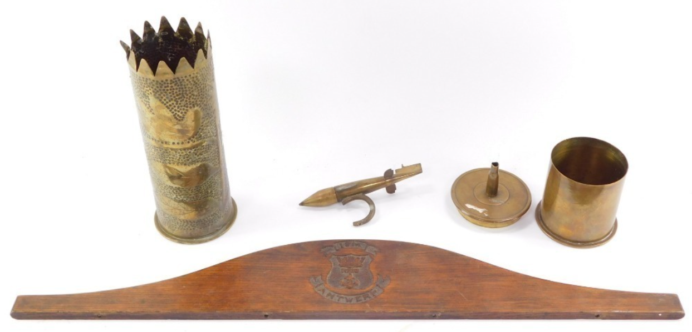
Collecting for monetary gain is perhaps the more distasteful side of collecting and has been understood as connected to Marx’s idea of commodity fetishisation, whereby the object is alienated from its original context of production. ‘Unemotional commerce’ can be seen on shows such as Bargain Hunt and The Antiques Road Trip. Trench art is quite often shown in relation to Paul Laidlaw who is a specialist in militaria. These items can appear in many different locations. Due to the historical significance of ‘Trench art’ it is most commonly seen in auction houses and in the antiques market. In 2021, Lot 541 at GoldingYoung Auction House was a collection of trench art pieces made in Antwerp in 1914 by prisoners of war who were interned in Holland (GoldingYoung, 2021). The presence of items being in such situations asks questions of ethics and need. On the one hand the action of selling such items is cold and for money but on the other this allows collectors who will appreciate the items to be able to purchase them. With items that have such a clear story and history the collectors may feel a connection to the items or want to research further into them. This asks the question of whether commerce is always ‘ unemotional’ or does that depend on the situation surrounding the purchases. Stated in Isyanova’s chapter, ‘academically very little is known about the market of trench art and the objects’ movements’. This makes an educated judgement into the movement and selling or buying habits of such items difficult as there are so many pieces and little documentation especially if sold in antique stores or on markets.
Figure 4 Lot of trench art (GoldingYoung, 2021)

Trench art, though it is portrayed as the outcome of past conflict, can also be seen being produced in current conflicts such as in Syria (Kobialka, 2019). This offers another line of collecting as people may be more enticed by modern trench art rather than that seen in the First and Second World War.

Trench art appeals for a plethora of reasons. One such reason may be ‘mortality capital’ (Stone, 2012). Connections can be identified between collecting trench art and dark tourism in the sense that both provide a link to a dark heritage and the experience of death. A part of dark tourism is that people get to experience places of death and destruction and question and ponder their own mortality. Stone (2012) says that dark tourism has ‘the capacity to expand boundaries of the imagination and to provide the contemporary visitor with potentially life changing points of shock’ (Stone, 2012). This could be the same with trench art. Data is not available but perhaps there is an overlap of these groups as it takes a similar mindset. Both activities focus on disturbing and harrowing events and experiences and offer some level of insight to the viewer. The idea of a mortality capital lets the people involved vicariously explore their mortality and sites such as Ground Zero, as investigated by Stone, act as sites of mediation between the living and the dead. Stone puts it as, ‘Dark tourism provides an opportunity to contemplate death of the Self through gazing upon the Significant Other Dead’ (Stone, 2012). This same ideology can be applied to Trench art and battlefield relic material. Behind every piece of trench art lies the wounded soldier.

These items can also become fetishised. Meskell describes the fetishisation in relation to sites of death, such as Ground Zero. ‘Yet the fetishization of the site and the objects within it has been left unchecked, they are simply "artefacts of anguish’ (Meskell, 2002 ). For many collectors, the personal story of the object has been lost but the object retains its poignancy because of its connection to the war. Figure 3 could also represent the power of objects and their agency. A shell is the result of something deadly and even after human manipulation the item still has some power. The delicate craftwork does not take away from the item's violent purpose but rather enhances it and even holding the item would make most shiver because of the connotations of what such an item represents. Once again this can be brought back to Gordon (n.d.). Gordon’s argument is in disagreement with this idea and believes that the manipulation does render the previous meaning useless.

Trench art as fetish objects is an idea explored in the scholarship. Marx describes commodity fetishism in his work Capital (1867), as connected to the alienation of an object from its origin. He describes fetish objects as ‘an object invested with supernatural powers by those who worship it’ (Marx, 1867). In a Marxian sense trench art becomes fetishised when it becomes a commodity to be traded in the world of collecting. The objects are alienated from their original context of production and the personal nature of the creation. In another sense the objects are fetishised because of their power to connect the collector to the horrors of war. They have become a memento mori, a mediator imbued with mortality capital.

Trench art is not the first item that comes to mind when thinking of commodities but it could be seen as such, as quite often there is a disconnect from the producer. As there are many collectors of trench art the idea of fetishism becomes clearer as the items to a certain degree are being worshipped.

Overall, trench art can be seen in many different forms with many different origins. Ranging through time, but a focus on the World Wars, these items have had varying trade throughout the past century. The drive of collectors also varies leaving much room for discussion. The best way to look at drives for collecting such work is on an independent basis. Each item and collector is different so their drives will also be different as will the story of the items that they collect.

There are many different types of trench art but overall the category that is most desirable to collectors is that made by World War One soldiers. Trench art is created individually and therefore has a very personal individual meaning for the soldier who created it. Where this is known objects become extremely desirable for collectors. However, much tench art does not come with a known personal history. Common forms of trench art include ornaments and household items fashioned from shells. The motivations of collectors are varied and there is some evidence that they are collected due to power. The object carries with it associations of death, violence and the horrors of war, which are claimed by the collector. The commodity trading of trench art within the collectors and antiques world can be understood as fetishising the objects which are alienated from their origin. In another sense the object becomes imbued with a power associated with death and the horrors of war. They carry with them a mortality capital which allows the owner to experience vicariously and explore their own mortality. Trench art is usually associated with World War One but the circumstances of conflict continue to produce art works as a response.

Bibliography:
Baekland, F. (1994) ‘Psychological aspects of art collecting’ in Pearce, S.M. Interpreting Objects and Collections. Oxen: Routledge, pp. 205 - 219
GoldingYoung (2021) The Bourne Celective Sale. Available at: https://auctions.goldingyoung.com/lot-details/index/catalog/768/lot/500083/A-collection-of-Trench-Art-to-include-carved-wooden-Royal-Naval-Brigade-crest-1914-Antwerp-Made-By-Prisoners-of-War-Interned-In- (Accessed on: 14th January 2022)
Gordon, E. (n.d.) ‘Trench Art as Art Therapy During Wartime‘. Boulder Honours Thesis.
Isyanova, G. (2009) ‘The Consumer Sphinx From French Trench to Parisian Market’ in Saunders, N.J. and Cornish, P (2009) Material Memories of the Great War. Oxen: Routledge, pp. 130 - ?
Kobialka, D. (2019) ‘Trench art between memory and oblivion: a report from Poland (and Syria)’, Museum and Heritage Studies, pp. 4-24
Marx, K. (1867) Capital, Germany: Verlag von Otto Meisner.
Meskell, L. (2002) ‘Negative Heritage and Past Mastering in Archaeology’, Anthropological quarterly, 75(3), pp. 557–574.
Muensterberger, W. (1994) Collecting : an unruly passion : psychological perspectives. Princeton, N.J. ;: Princeton University Press.
Realtor Magazine (2020) Home Furnishings Trend: Brass is Back. Available at: https://magazine.realtor/home-and-design/feature/article/2020/03/home-furnishings-trend-brass-is-back (Accessed on: 14th January 2022)
Saunders, N.J. (2001) Trench Art: A brief History and Guide, 1914 - 1939. Barnsley: Leo Cooper.
Saunders, N.J. (2000) ‘Bodies of Metal, Shells of Memory: ‘Trench Art’, and the Great War Re-cycled’. 5(1), pp. 43 - 67
Saunders, N.J. (2003) Trench Art Materialities and Memories of War. Oxford: Berg.
Saunders, N. (2016) ‘Pearl’s Treasure’: The trench art collection of an Australian Sapper’. in L Slade (ed.), Sappers & Shrapnel: Contemporary Art and the Art of the Trenches. Adelaide: Art Gallery of South Australia, Adelaide, pp. 12-39.
Scott, D.D. and McFeaters, A.P. (2011) ‘The Archaeology of Historic Battlefields: A History and Theoretical Development in Conflict Archaeology’, Journal of Archaeological Research, 19(1) pp. 103-132
Stone, P. (2012) ‘Dark tourism as ‘mortality capital’ The case of Ground Zero and the Significant Other Dead’ in Sharpley, R. and Stone. P, Contemporary Tourist Experience. Oxen: Routledge. Pp.71 - 94
Whittingham, C. (2008) ‘Mnemonics for War: Trench Art and the Reconciliation of Public and Private Memory’, Past Imperfect, 14, pp.86-119

