MODULE NAME: Independent Project (LCLM6005)

INFLUENCE OF CYBERSECURITY THREATS IN THE UK HOSPITALITY INDUSTRY- A COMPARATIVE STUDY IN THE UK HOSPITALITY SECTOR

STUDENT NAME: Ana Maria Miclea
STUDENT NUMBER: 2230349
MODULE LEADER: Samuel Ofori
SUPERVISOR NAME:Chinomso Nwagboso

{Dissertation submitted as part of the requirements for the award of BA Leadership and Management}

Table of Contents
Chapter 1: Introduction 9
1.1 Introduction 9
1.2 Background 10
1.3 Rationale of the research 11
1.4 Research Aim 11
1.5 Research Objectives 12
1.6 Research Questions 12
1.7 Dissertation structure 12
1.8 Chapter Summary 13
Chapter 2: Literature Review 14
2.1 Introduction 14
2.2 Themes 14
2.2 1 Cybersecurity threats affecting the UK hospitality industry, such as finance and reputation 14
2.2.2 Impact of cybersecurity threats on service delivery and customer trust 15
2.2.3 Differences in challenges faced by large hotels and SMEs 16
2.2.4 Mitigation strategies adopted by firms 17
2.3 Theoretical underpinning 18
2.4 Conceptual framework 18
2.5 Literature Gap 19
2.6 Summary of the chapter 19
Chapter 3: Methodology 20
3.1 Systemic LR 20
3.2 Search Strategy 20
3.3 Terms 20
3.4 Keywords 20
3.5 Databases 21
3.6 Inclusion/Exclusion 22
3.6.1 Inclusion 22
3.6.2 Exclusion 23
3.7 Search results 24
3.8 Ethical considerations 24
3.9 Summary 24
Chapter 4: Results and Discussion 26
4.1 Results 26
4.1.1 Presentation of Data 26
4.1.2 Data Analysis 32
4.2 Discussion 36
4.2.1 Interpretation of Results 36
4.2.2 Comparison with Existing Literature 37
4.2.3 Answering the Research Questions 38
4.2.4 Implications of the Findings 38
Chapter 6: Conclusion and Recommendations 39
6.1 Summary of Key Findings 39
6.2 Contributions to this Field 39
6.3 Practical Implications 39
6.4 Recommendations 40
6.5 Linking with objectives 40
References 42

DECLARATION

I, Ana Maria Miclea declare that this dissertation has been composed by myself, that the work contained herein is entirely my own except where explicitly stated otherwise in the text, and that this work has not been submitted for any other degree or qualification, in whole or in part, except as specified.

Signature: ........Ana Maria Micles..............................................
Date: …20.11.2025……………………………............................

ACKNOWLEDGEMENTS
I would like to share my sincere gratitude to my parents, supervisor, and peers for their valuable guidance, which helped me to complete this work. Without their support, it could not be done.

Abstract
Chapter 1 introduced the background of the topic and identified the growing use of digital technologies in the UK hospitality industry. It also explored the significance of the study by identifying vulnerabilities that have created the problem of major data breaches including the Marriott. This chapter also explored the aim and rationale for the research to determine the increasing number of cyberattacks on the different hotel chains.
The second chapter had evaluated the themes in which where different scholars have opined their findings. It was observed that despite cybersecurity measures, many firms are still exposed to threats. Cybersecurity threats were observed to have a negative impact on customer engagement and trust. Mitigation strategies for cybersecurity threats were also discussed.
Chapter 3 highlighted the strategies adopted in the research. It highlights the use of keywords, Boolean operators, and search strategies, including exclusion and inclusion criteria. Participants were given consent forms before the survey.
The fourth chapter has stated that the cybersecurity threats impact the hospitality sector of the UK by disrupting the delivery of services. Various hotel chain has demonstrated a strong readiness to structure their policies. However, SMEs have remained vulnerable to these threats due to their constraints in resources.
Chapter 5 has highlighted the effect of cybersecurity threats on the UK hospitality industry in both SMEs and hotel chains. This study concluded that cybersecurity must have a strategic undertaking. Some recommendations of this study suggested staff training, adopting the cybersecurity Framework, and real-time monitoring.

Abbreviations
DDoS: Distributed Denial of Service
TAM: Technology Acceptance Model
TRA: Theory of Reasoned Action
CAGR: Compound Annual Growth Rate
GDPR: General Data Protection Regulation
MFA: Multi-Factor Authentication
NCSC: National Cyber Security Center

Chapter 1: Introduction

1.1 Introduction
The UK hospitality business is an important sector of the national economy, which involves hotels, resorts, and other accommodation businesses that accommodate millions of local and international tourists. Over the last 6 years, the hospitality sector has contributed £90 billion to the UK economy, generated £20 billion in exports since 2022, and is expected to reach up to 3.51% CAGR by 2030 (UK Hospitality, 2024).
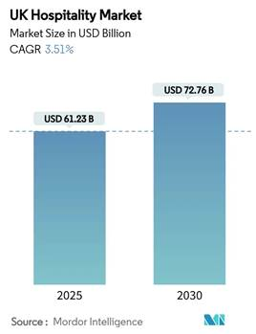
Figure 1: UK Hospitality Market
(Source: Motor Intelligence, 2025)
With the digitalisation of processes and online booking services, client databases, payment systems, and connected devices of the IoT have become increasingly more integrated; this industry has undergone considerable improvements in its operations (Anwar et al. 2024). However, this online reliance has opened hospitality enterprises to a growing category of cybersecurity risks, which have grown more advanced and expensive. 39% of the UK businesses identified cyberattacks via phishing (GOV.UK, 2022).
This study seeks to identify the major cybersecurity threats across famous hotel chains in the UK, particularly in Marriott. It will also explore the defensive strategies against the common vulnerabilities that affect millions of global customers.

1.2 Background
Marriott International is one of the largest and most well-known chains in the industry, which illustrates the cybersecurity issues that the industry is exposed to. In 2018, Marriott revealed a data breach which affected the personal data of around 339 million customers across the globe. It was observed that the violation had resulted in a fine of £18.4 million under the GDPR regulations (BBC, 2020). This cyberattack was caused by vulnerabilities in the hotel systems that was acquired by Marriott without proper cybersecurity audits (BBC, 2020).
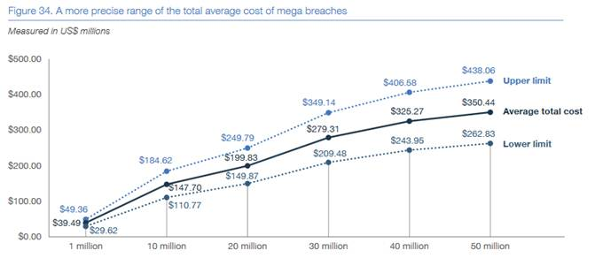
Figure 2: Total average cost of Marriott's data breaches
(Source: Dignan, 2018)
It has been observed through a survey that over 50 million records of customers, which included personal data of customer, have been revealed due to breaches in cybersecurity (Dignan, 2018). Such cyber breaches have a negative effect on the brand reputation by minimising the trust of customers.
Various hotel chains in the UK have reported cases of cybersecurity beyond Marriott. For instance, it has been observed that Radisson Hotel has experienced a data breach that had affected its global turnover by over 2% (GDPR Register, 2019). Phishing scams, malware, and ransomware still pose a significant threat to smaller chains and independent hotels that have fewer resources to address cybersecurity concerns. For example, in 2014, Choice Hotels faced data breaches of their 700000 customers, including their names, emails, and phone numbers, and the hackers demanded 0.4 Bitcoin as a ransom note. In addition, this personal data breach affected the payment card data of up to 340 million people (Jowitt, 2019). The attackers attack the hospitality industry by taking advantage of poor system patching, poor use of passwords, and a lack of knowledge among staff. A 2024 UK government survey of Cyber Security Breaches claimed that 28% of hospitality companies had encountered a cyberattack in the last year, leading to financial losses, disrupted operations, and exposures of personal data (GOV.UK, 2024). Common attack types were Distributed Denial of Service (DDoS), phishing, malware, and cyberattacks via third-party vendors.

1.3 Rationale of the research
Cybersecurity in the UK Hospitality sector is an urgent and expanding matter. UK hotels have different levels of IT infrastructure, including global chains that have centralised data repositories, and independent hotels that depend on third parties. This research is significant as the UK hospitality sector is progressively depending on online infrastructure in its operations and customer retention. As this digitisation contributes to efficiency, it makes hotels vulnerable to major cybersecurity risks. UK hospitality giant Marriott faces financial losses, reputational damage, and a GDPR fine.
The current research aims to examine the topic of cybersecurity threats and their effect within the context of various UK hotel chains, such as Marriott, to reveal general vulnerability, effect, and network mitigation measures. This is because Marriott has a wide customer base in the UK. Hotels present lucrative victims to cybercriminals because of the personal and financial information that they contain and the intricacy and interdependence of IT systems. Besides causing legal, financial, and reputational damage, data breaches also pose risks to the business's survival in terms of continuity and customer confidence, which are the main drivers of business success in the hospitality industry. The UK Information Commissioner's Office (ICO) has fined Marriott PS18.4m because of breaching the regulations of GDPR. The total of recovery costs was nearly 30 million, including forensic investigations, notification to customers, and security upgrades. In addition to the money front, Marriott lost its image and an estimated of around $1 billion of customer loyalty-related revenue was lost.
This study is expected to address the skill gaps by carrying out a comparative study to offer insights to the hotel managers, policymakers and cybersecurity practitioners to develop a better defence.

1.4 Research Aim
This research aims to evaluate the impact of cybersecurity threats on the UK and hospitality industry. The research seeks to evaluate how cyber risks affect customer confidence and operational efficiency. Moreover, the research aims to identify gaps in current security measures, ensuring long-term sustainability in the UK hospitality sector.

1.5 Research Objectives
- To identify and analyse the main cybersecurity threats affecting the UK hospitality industry.
- To compare responses to cyber risks between large hotel chains and small independent businesses.
- To highlight similarities and differences in levels of preparedness across organisations.
- To evaluate the effectiveness of existing cybersecurity strategies.
- To assess the impact of cyber threats on financial performance.
- To recommend practical measures to enhance resilience in the hospitality sector.

1.6 Research Questions
- What are the common cybersecurity threats affecting the hospitality industry in the UK?
- How do these threats impact customer trust and service delivery in hospitality businesses?
- What differences exist between large hotel chains and SMEs in addressing cybersecurity risks?
- Which strategies and technologies are most effective in mitigating these risks?

1.7 Dissertation structure
This research includes 5 chapters, including introduction, literature review, methodology, results, and discussion, and finally, recommendations and conclusion.
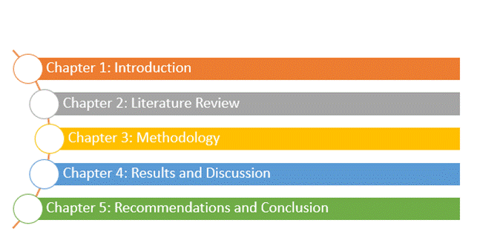
Figure 3: Dissertation Structure

1.8 Chapter Summary
This chapter has identified the background and significance of the cybersecurity threats in the hospitality segment of the UK and critically analyses its impact on Marriott and other major hotel chains. It also identified objectives, research questions, and the aim of the study.

Chapter 2: Literature Review

2.1 Introduction
Chapter 2 critically examines the previous research on cybersecurity risks affecting the UK hospitality industry and verifies digital systems for improving the system. The key themes include the financial and reputational risks, impact on service delivery, and consumer trust. This review includes empirical and case study examples from Marriott and other UK-based hotel chains and assesses the effectiveness of different mitigation strategies against cyberattacks.

2.2 Themes

2.2 1 Cybersecurity threats affecting the UK hospitality industry, such as finance and reputation
According to the interpretation of Panditharathna et al. (2024), the digital transformation has introduced certain threats, including cybersecurity within the hospitality sector, due to increased exposure of firms' systems and data to hackers. Cybersecurity risks are the threats that can significantly compromise the systems and data of an organisation. All service networks, such as distributors, suppliers, customers, and service providers, are threatened by these risks. Cybercriminals often attack hotels through phishing, Distributed Denial of Services, ransomware, and DarkHotel hacking. Cybercrime can cause significant loss to the economy. As of 2025, cyberattacks cost the UK economy 61 billion US dollars, and this figure is estimated to increase to 1.82 trillion USD by 2028. Furthermore, among the European markets and the US, the UK has experienced the highest loss, for the third consecutive year, accounting for 4.53 million USD for data breach (Statista, 2025). According to Florido-Benítez (2024), the complexity of systems that connect staff, guests, vendors, and multiple devices opens up entry points for attackers. For instance, Online travel Agencies deal with commissions for services and products hosted by different suppliers such as hotels, airlines, and travel insurance companies, making it challenging to assess potential vulnerabilities and threats. As reported, IHG also experienced a system outage due to ransomware attacks, which disrupted their bookings as a result of poor customer experiences due to disconnected payment systems where customers' data and personal information were captured by hackers (UK Hospitality, 2025). These events hurt the firm's reputation. Scholars like Tariq (2024) in his studies argued that a significant weakness of the hospitality firms stems from being reliant on digital platforms. As stated by Perera et al. (2022), they have demonstrated that after cyberattacks, firms experience significant financial loss, damage to brand identity, and legal complexity, such as fines. As reported, a hotel chain like Marriott was fined $52 million due to security breaches and failing to protect customers' privacy. This breach exposed more than 500 million customers' data globally (Securitymagazine, 2024). As elaborated by Wang et al. (2022), many organisations have started to incorporate technologies that could help them mitigate cyber threats. Despite their efforts, still cybersecurity is one such issue that persists among the small and medium-sized enterprises as they have limited resources and funds. According to Bovsh et al. (2023), the hotel and tourism sector is reliant on trust and reliability of the customers. However, weaknesses like such huge cybersecurity issues are enough to hinder the trust of clients that further lead to loss of reputation of the brands. Furthermore, economic sustainability within hotels is highly risked by the data breaches that further result in direct or indirect costs like legal fines, huge regulatory fees and in some cases, hotels have to pay hefty compensation to clients for such a theft. It is also seen on the other hand that indirect costs are highly linked with loss of loyal customers who would not purchase the same services from the particular hotel again, degrading sales as well as reputation. These are enough for a hotel to experience a loss in its practices. Hotels such as the Marriott's Starwood division database had a data breach in 2014 and discovered it in 2018. This not only compromised data of over 339 million customers but also resulted in over 16.4 million fines to the ICO for not being able to keep up with ethical standards to safeguard privacy (UK Hospitality, 2025). Thus, it is imperative for hotels of all sizes to ensure data protection.

2.2.2 Impact of cybersecurity threats on service delivery and customer trust
According to Wahab et al. (2023), the hotel industry, with a large volume of credit card transactions, loyalty programs, online payments, and Wi-fi usage at the property, offers a considerable space for cyberattacks. While data is attacked, it not only impacts reputation, but also raises concern around customer privacy, as well as damages hotel and guest relationships. When customers feel vulnerable to attacks and breaches as severe, it becomes more difficult for stakeholders to build their trust towards the organisation. Hotel company like Holiday Inn in 2022 was affected by unauthorised access to their technology systems, which led to disruption of their booking services. This hotel chain was also targeted in the year 2017, when more than 1200 of its franchisees’ hotel services were disrupted. This resulted in negative customer complaints (BBC, 2022). Kaul (2021) also stated that breaches can force organisational systems and processes to shut down, which, as a result, can cause cancellations and service delays. In a fast-paced environment, an hour of disruption can result in huge revenue loss, customer loss, and compensation. Karadayi-Usta (2024) furthermore argues that hotels are often victims of insider attacks, which are a result of insufficient awareness and training. Many companies often fail to pay attention to weak passwords or phishing. Risk of cybersecurity can also come from an organisation. For example, many times, staff, due to a lack of awareness or skills or intentionally, assess the company's data. This issue requires the organisation to ensure cybersecurity measures and training to reduce the chances of external and internal attacks that can impact brand image. It is stated by Florido-Benitez (2024) that customer loyalty is significantly aligned with their level of security and trust towards the company. Moreover, it focused on how their preferences tend to differ based on their level of security. Saputra and Paranoan (2024) had stated that customer trust is important for organisational sustainability. Hence, hotels rely on customer data that requires organisations to ensure security. In the UK, around 66% of customers are likely to avoid brands that break their trust. It is also noted that around 45% of customers target brands based on how they respond to the concerns (YouGov, 2025). This indicates that brands are required to ensure trust to sustain in a highly competitive market.

2.2.3 Differences in challenges faced by large hotels and SMEs
According to Alharbi et al. (2021), an organisation's response to cybersecurity attacks is greatly influenced by its recovery plans, the availability of resources, and organisational features. However, prominent multinational hospitality companies are more vulnerable to cyberattacks. According to the survey by Security Breaches, 31% of startups and 74% of big enterprises have more comprehensive and organised strategies for preventing online attacks (Gov. UK, 2024). Bigger hospitality chains like Marriott International are entitled to more extensive financial resources, sophisticated cyberprotection teams, and technological facilities. The Marriott cyber hack in 2018 exposed flaws in the Starwood systems that Marriott had bought, and these were caused by out-of-date software and neglected security checks during integration of the systems (Denuwan, 2023). This incident demonstrates how larger businesses use outdated systems and complex networks which impacts their uniform cybersecurity throughout their international branches.
In comparison to that, according to Chidukwani et al. (2024), small and independent hotels lack funding and skilled employees to improve cybersecurity measures. According to the Institutional theory, SMEs have usually been subjected to external forces such as regulatory compliance, industrial norms, without the internal ability to adequately respond. Cybersecurity is not adequately addressed by most SMEs because of the lack of financial resources, lack of priority, and awareness. For example, Dalmahoy Hotel and Country Club in Edinburgh fell victim to a ransomware attack that was attributed to the infamous Hunters International group (Khaitan, 2024). In 2023, around 950 GB of sensitive information of clients was breached, which underlines the fact that smaller-scale establishments are still viewed as easy targets by cybercriminals who manage to exploit the lack of cybersecurity preparedness (Khaitan, 2024). The attack has affected the operations and has revealed customer and financial information, showing that SMEs without strong security measures may suffer serious impacts. Equally, phishing attacks have been reported by other small hospitality businesses around the UK, with employees unknowingly allowing attackers impersonating as customers or vendors to access credentials to the hospitality business. According to Alabdan (2020), the impact of phishing attacks is usually in data leakage or financial fraud, which further strains the low capacity of the SMEs to establish effective cybersecurity training or surveillance within their companies.

2.2.4 Mitigation strategies adopted by firms
The UK hospitality sector faces increasing rates of data breaches between 2018 to 2024. Due to this reason, hospitality companies enhanced their cybersecurity mitigation techniques. According to the Resource-Based View (RBV) theory, bigger hotel chains like Marriott use their substantial internal resources, including financial capital, technology, and efficient cybersecurity teams, to create a defence against cyberattacks. In order to secure information about consumers and stop future invasions, Marriott International, for instance, implemented encryption techniques, multi-factor authentication, regular system audits, and an independent Incident Response Team after the 2018 malware attack. After this attack, Marriott has included advanced encryption and a network segmentation process to reduce the risks of lateral movements. Marriott International implemented MFA to reduce access to its core customer data by third-party vendors and collaborators. In addition, they have deployed a 24/7 security operations center (SOCs) to respond to risks (Marriott, 2021).
Kosutic (2021) stated that large companies might be able to build strong and scalable defence systems because of their huge resource infrastructure. This reinforces the way RBV theory views cybersecurity as a strong tactical strength. Businesses have taken huge strides like to implement multi-factor authentication at their hotels to prevent third-party access, encrypting data of clients, and even segmenting networks for isolating visitor devices. For regulatory monitoring, multiple independent hotels started to use endpoint detection and Response (EDR) systems (Fortinet, 2024). For example, the TUI group has deployed an EDR system named ‘CrowdStrike Falcon’, which has almost 50000 endpoints across the globe (CrowdStrike, 2025).
The UK hospitality sector is heavily dependent on third-party systems like property management software and online booking platforms. For this reason, firmware upgrades, access restrictions, and device isolation have become more important as hotels deploy automated systems and Internet of Things (IoT) devices more often. Additionally, Karadayi-Usta (2024) suggests that a lot of hospitality businesses purchased cyber insurance to lessen monetary damages and aid in recuperation. As per Institutional Theory, organisations largely react to external pressures like the GDPR, along with business standards, many UK-based hospitality organisations find it difficult to apply complex procedures due to funding restrictions.

2.3 Theoretical underpinning
According to institutional theory, businesses adopt cybersecurity policies mostly for compliance. However, they adopt those as a result of external constraints like the GDPR, industry standards, and client demands. RBV theory highlighted how bigger hotel chains, such as Marriott, use their internal resources, such as their funds, trained workforce, and technology infrastructure, to create extensive cybersecurity defences, which gives them a competitive edge. Both TRA and TAM theory provides detailed critical insights regarding the influence of the behavioural factors on cybersecurity measures for staff adoption. TAM identified the usefulness of technological acceptance and its impact on cybersecurity.

2.4 Conceptual framework
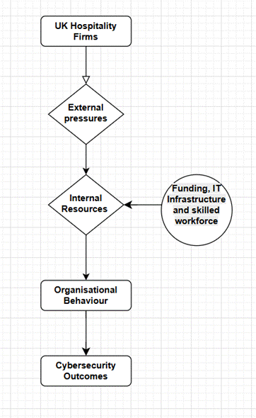
Figure 4: Conceptual Framework

2.5 Literature Gap
This research lacks a detailed theoretical analysis regarding cyberattacks and the experiences of SMEs and bigger hotel chains. There is also a dearth of empirical data on how behavioural elements like employee cybersecurity knowledge and technological adoption affect security results and different organisational levels. The fundamental causes of new cybersecurity problems in the corporate sector have not been thoroughly identified by this literature review. Although the specific methods of problem resolution and mitigation are not adequately addressed, the detrimental consequences of risks to cybersecurity are discussed thoroughly. In addition, this research did not explore how to determine the prevalence of related problems. Lastly, even if the research mentions mitigation techniques, this section does not adequately identify the implementation methodologies.

2.6 Summary of the chapter
This chapter has explored several existing literatures regarding cyberattacks on the UK hospitality industry and their mitigation strategies while using theories analytically. These viewpoints were combined in the conceptual framework, which connected organisational behaviour-mediated cybersecurity from both internal and external ends.

Chapter 3: Methodology

3.1 Systemic LR
This research has incorporated a systematic literature review to deepen understanding of cybersecurity threats. As defined by Carrera-Rivera et al. (2022), a systematic literature review is a strategy that analyses resources and studies in a systematic process. Integrating these methods within the research helped in ensuring accessibility to resources for the project through a robust search strategy.

3.2 Search Strategy
The research has used relevant keywords to search data that are available online. The research has used Boolean operators to search for topics that are relevant to the research. Furthermore, to find the relevant participants, the participants were approached to take part in the research through social media platforms. The participants were targeted based on their professions within the hospitality industry that aligns with the purposive sampling strategy. According to Shaffer et al. (2021), this strategy is considered as a process in which investigators look for individuals to participate in research relevant to the field of the topic.

3.3 Terms
The key terms used for this research had contributed positively to collect the resources. The keywords used within the search process were optimised to generate information based cybersecurity challenges.

3.4 Keywords
Category | Keywords and Phrases
Core Topic Keywords | Cybersecurity threats, cybercrime, data breaches, hacking, ransomware, phishing attacks, digital risks, information security, data protection, network security
Industry-Specific Keywords | Hospitality industry, tourism sector, hotel management, restaurants, travel and accommodation, guesthouses, hotel operations, service delivery, customer experience
Geographical Focus | United Kingdom, UK hotels, UK hospitality sector, British tourism, UK service industry
Impact and Consequences | Customer trust, brand reputation, business continuity, financial loss, data privacy, customer confidence, digital vulnerability
Organisational Focus | Large hotel chains, SMEs, independent hotels, organisational preparedness, cyber resilience, digital transformation, operational efficiency
Technology and Strategy | Cyber defence, firewalls, encryption, employee training, security awareness, IT governance, risk mitigation, data recovery, incident response
Research and Comparative Terms | Comparative analysis, case study, survey research, qualitative interviews, quantitative assessment, UK vs SMEs comparison
Table 1: Keywords used in research

3.5 Databases
The research used of reputable databases available on search engine to analyse the contemporary literature. Moreover, to access the secondary data, the research has evaluated articles that were available on cybersecurity measures.

3.6 Inclusion/Exclusion

3.6.1 Inclusion
Category | Criteria for Inclusion | Rationale
Secondary Data (Literature Review) | Peer-reviewed academic articles published between 2020 and 2025 | To ensure current and relevant findings
Secondary Data (Literature Review) | Research focusing on cybersecurity threats in hospitality, tourism, or service industries | Aligns with study scope
Secondary Data (Literature Review) | Studies in the English language | Accessibility and accuracy
Secondary Data (Literature Review) | Industry/government reports (e.g., NCSC, ICO, BHA) | Adds practical insights and real-world evidence
Secondary Data (Literature Review) | Empirical studies discussing cybersecurity impact, prevention, or digital risk | Supports comparison of findings
Primary Data (Survey/Interview) | Participants aged 18 or above working in the UK hospitality sector | Ensures ethical and professional participation
Primary Data (Survey/Interview) | Hotel managers, IT/security staff, or senior restaurant supervisors | Possess relevant operational knowledge
Primary Data (Survey/Interview) | Employees from both large hotel chains and small/medium enterprises | Enables comparative analysis
Primary Data (Survey/Interview) | Participants with prior experience or awareness of cybersecurity threats/incidents | Provides valuable insight and authenticity
Primary Data (Survey/Interview) | Participants who provide informed consent voluntarily | Ethical compliance and validity
Table 2: Inclusion

3.6.2 Exclusion
Data Type | Exclusion Criteria
Secondary Data | Studies published before 2020.  Research unrelated to the UK hospitality sector.  Non-empirical or non-peer-reviewed sources (e.g., blogs, opinion pieces).  Non-English publications.  Inaccessible full texts or duplicate studies.
Primary Data (Surveys and Interviews) | Participants not employed in the UK hospitality sector.  Incomplete or invalid survey responses.  Interviewees who withdraw consent or provide insufficient information.
Table 3: Exclusion

3.7 Search results
The research used a contemporary search approach to select the materials that are relevant to its objectives. Considering this, the search results highlighted the data which had helped in comparing these findings. As stated by Nagpal et al. (2021), combining different methods is also known as mixed methods, which allows the researcher to gain a well-rounded overview of the topic. The research has facilitated triangulation through comparing and contrasting the gathered data. This has helped in maintaining research depth and credibility. Moreover, to present the primary data, both numerical and non-numerical data were used, which helped in exploring the financial loss, brand identity, and loss of customer trust due to cyberattacks.

3.8 Ethical considerations
Ethical considerations were deemed important during the research work. The researcher has maintained academic integrity through accurate referencing under the university guidelines. Furthermore, participants were safeguarded and stayed compliant with the data protection regulations, such as GDPR. Personal information such as their name, place of work or addresses was not collected or stored in order to maintain confidentiality and anonymity. It can also be inferred that survey and interview questions were developed by focusing on the topic, rather than on the personal data of stakeholders.

3.9 Summary
The research has been focused on using primary and secondary data. It also included qualitative and quantitative data, which were further compared with the secondary data. The researcher highlighted the key terms and search strategies used in this research. Therefore, it can be concluded that ethical considerations would include to offer a consent form to the participants before participating and the confidentiality and anonymity of the participants would be of sole priority throughout the study. Furthermore, this section 3 has also started the inclusion and exclusion criteria so that the credibility of the research can be followed such as studies before 2020 were excluded whereas the studies focusing only on the hospitality sector and cybersecurity were chosen. This chapter has also outlined the usage of mixed data to be able to compare both the findings.

Chapter 4: Results and Discussion

4.1 Results

4.1.1 Presentation of Data
Primary Survey
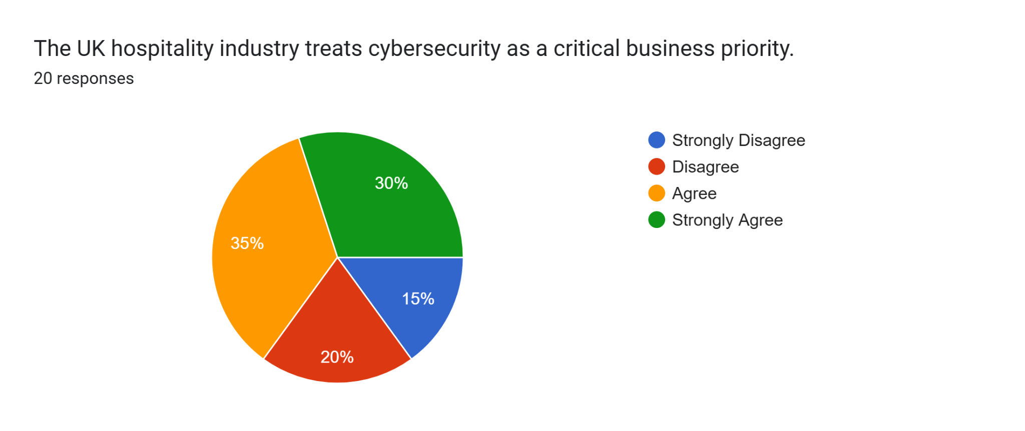
Analysis: Considering the responses of the survey, the findings had underscored that 35% of the respondents agreed on the fact that cybersecurity is a prominent priority for business. On the other hand, it was observed that 20% of the respondents disagreed while 15% of the respondents had strongly disagreed on this fact. This underscores the increasing importance of cybersecurity among large hotel chains within the UK. However, it also notes that the SMEs can lag due to the limited availability of resources
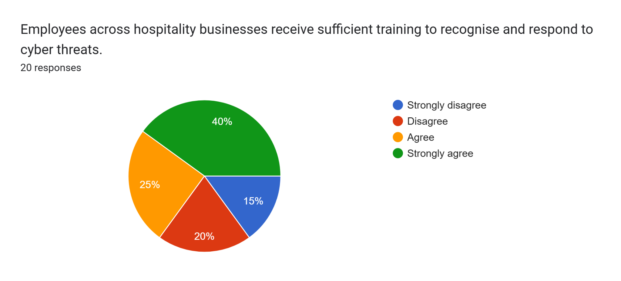
Analysis: The survey result has interpreted that a total 65% of the respondents have both agreed and strongly agreed on the factor that employees have received sufficient training on cybersecurity measures. On the other hand, 20% of the respondents had disagreed while 15% of the respondents had strongly disagreed on this factor. The findings had suggested that SMEs could rely significantly on the inconsistent practices of prioritising training of staff. Hence, there is a prominent need for a standardised training to ensure that employees can respond to the potential threats effectively.
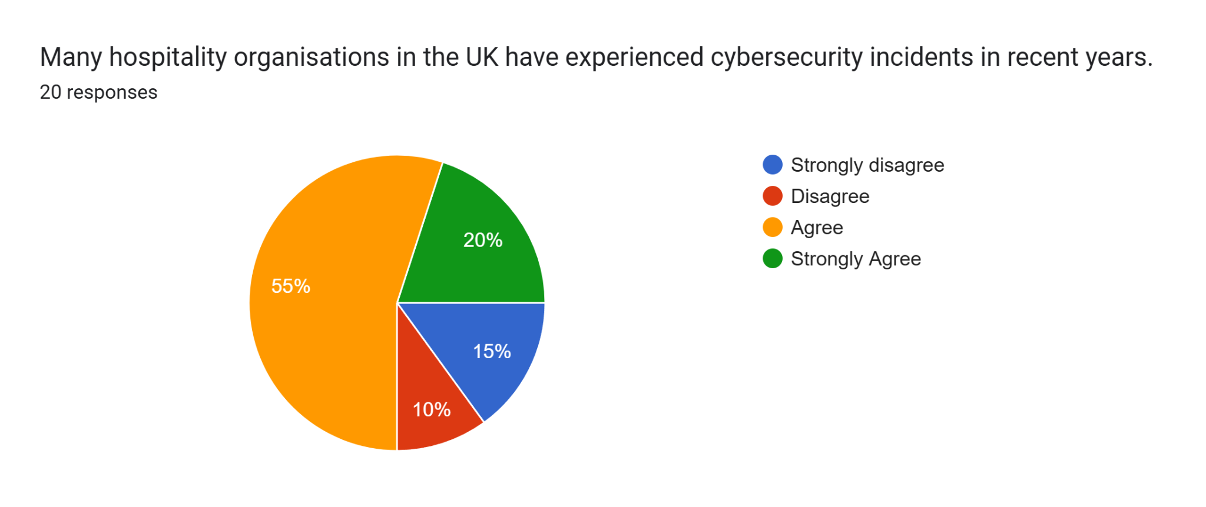
Analysis: It was observed that an average of 75% (55% agreed while 20% strongly agreed) of the respondents had agreed on the fact that hospitality businesses in the UK have faced issues related to cybersecurity incidents. On the other hand, it was observed that 15% of the respondents had disagreed while 10% had strongly disagreed on this factor. This underscores the prevalence of threats to cybersecurity within this industry as it reflects on the exposure to digital risks as organisations are exposed consistently to online systems.
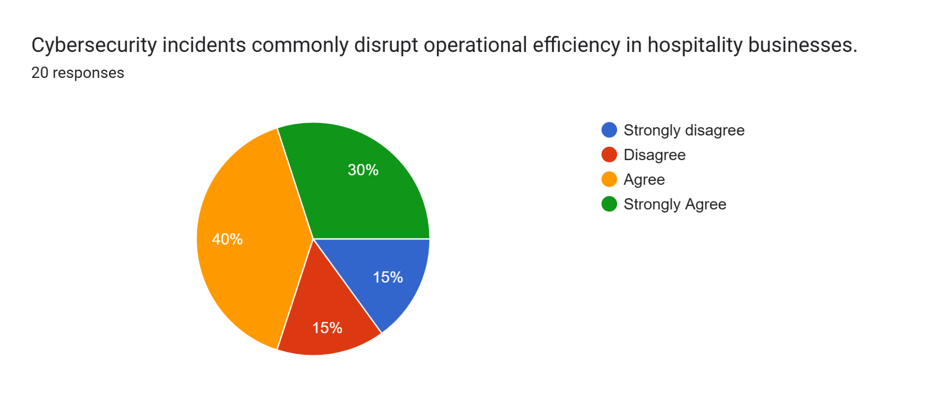
Analysis: Through the response of the survey, it was observed that 40% of the respondents had agreed on the factor that the incidents of cybersecurity breaches tend to disrupt the operational efficiency. On the other hand, 15% of the respondents had strongly disagreed and 15% of the respondents had strongly disagreed on this factor. Considering this, the findings had indicated that digital disruptions is a common instance within the hospitality sector of the UK.
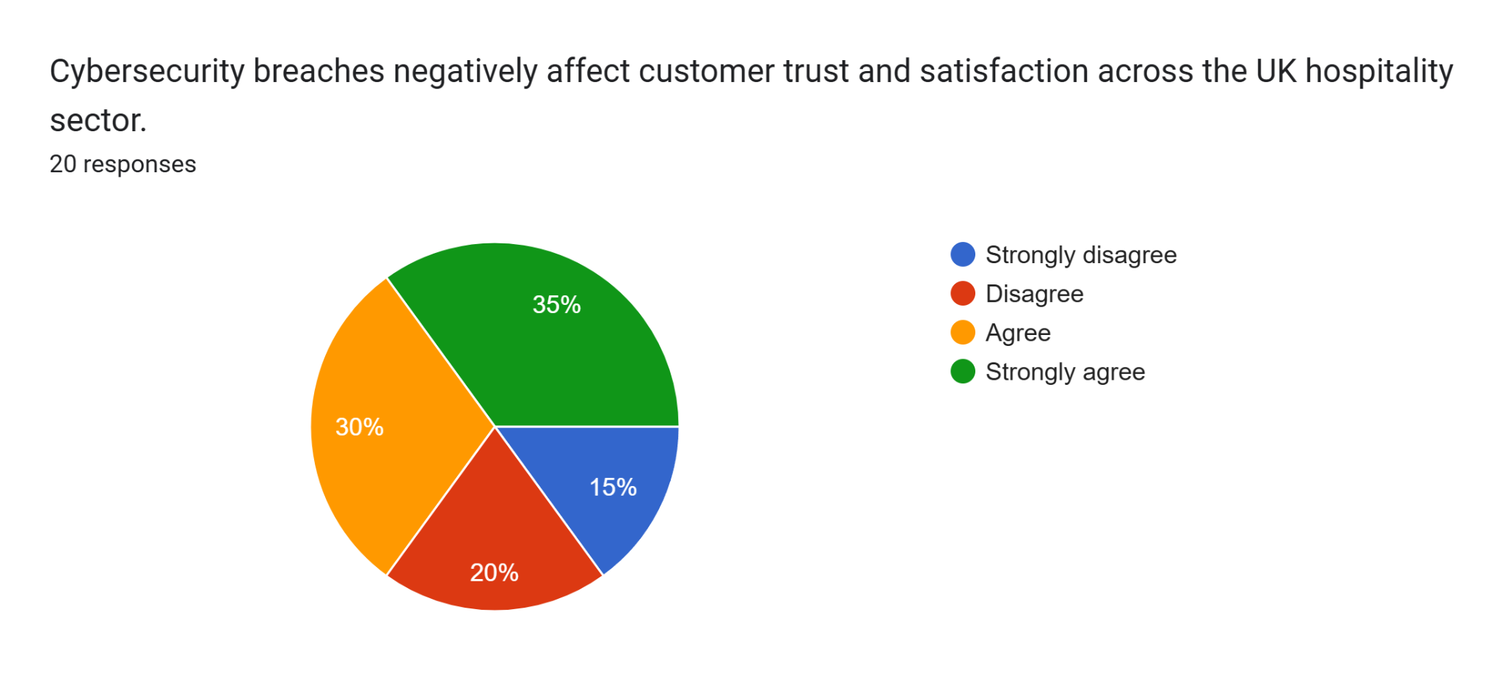
Analysis: Considering the responses of the survey, it was observed that 75% of the respondents had agreed to the fact that the breaches in cybersecurity damages the trust of customers. On the other hand, 15% of the respondents had strongly disagreed while 20% of the respondents had disagreed on this motion. This disagreement suggests that some of the businesses have strategies for effective recovery that influences the credibility of the brand.
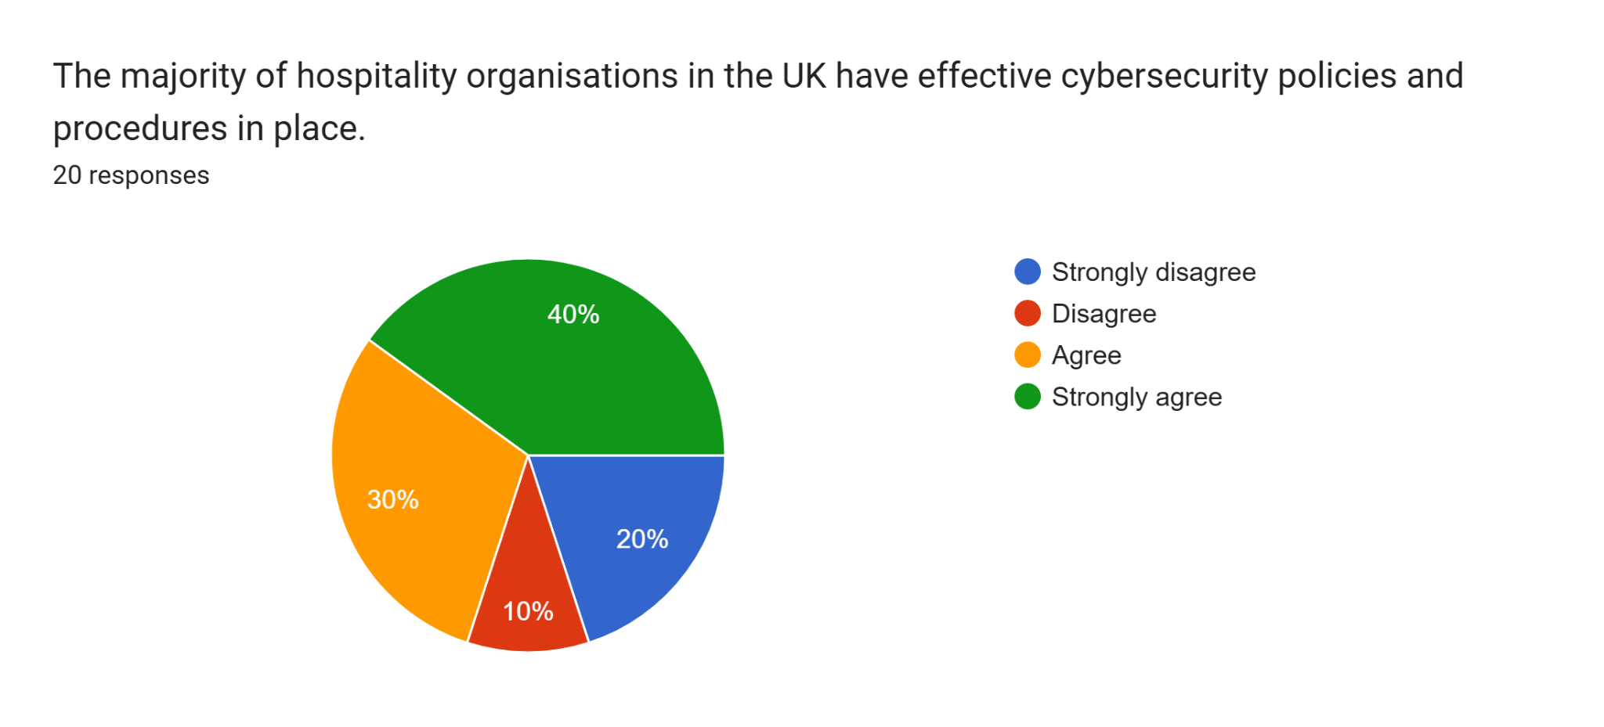
Analysis: It was observed that a total of 70% of the respondents had agreed and strongly agreed on the fact that most of the hotels within the UK have implemented an effective policy to strengthen their cybersecurity measures. On the other hand, 30% of the respondents in total had disagreed on this motion. This underscores a prominent trend towards a formalised management of digitised security. The responses have underscored a significant progress in the governance of digitised assets. However, businesses are still required to develop a comprehensive procedure.
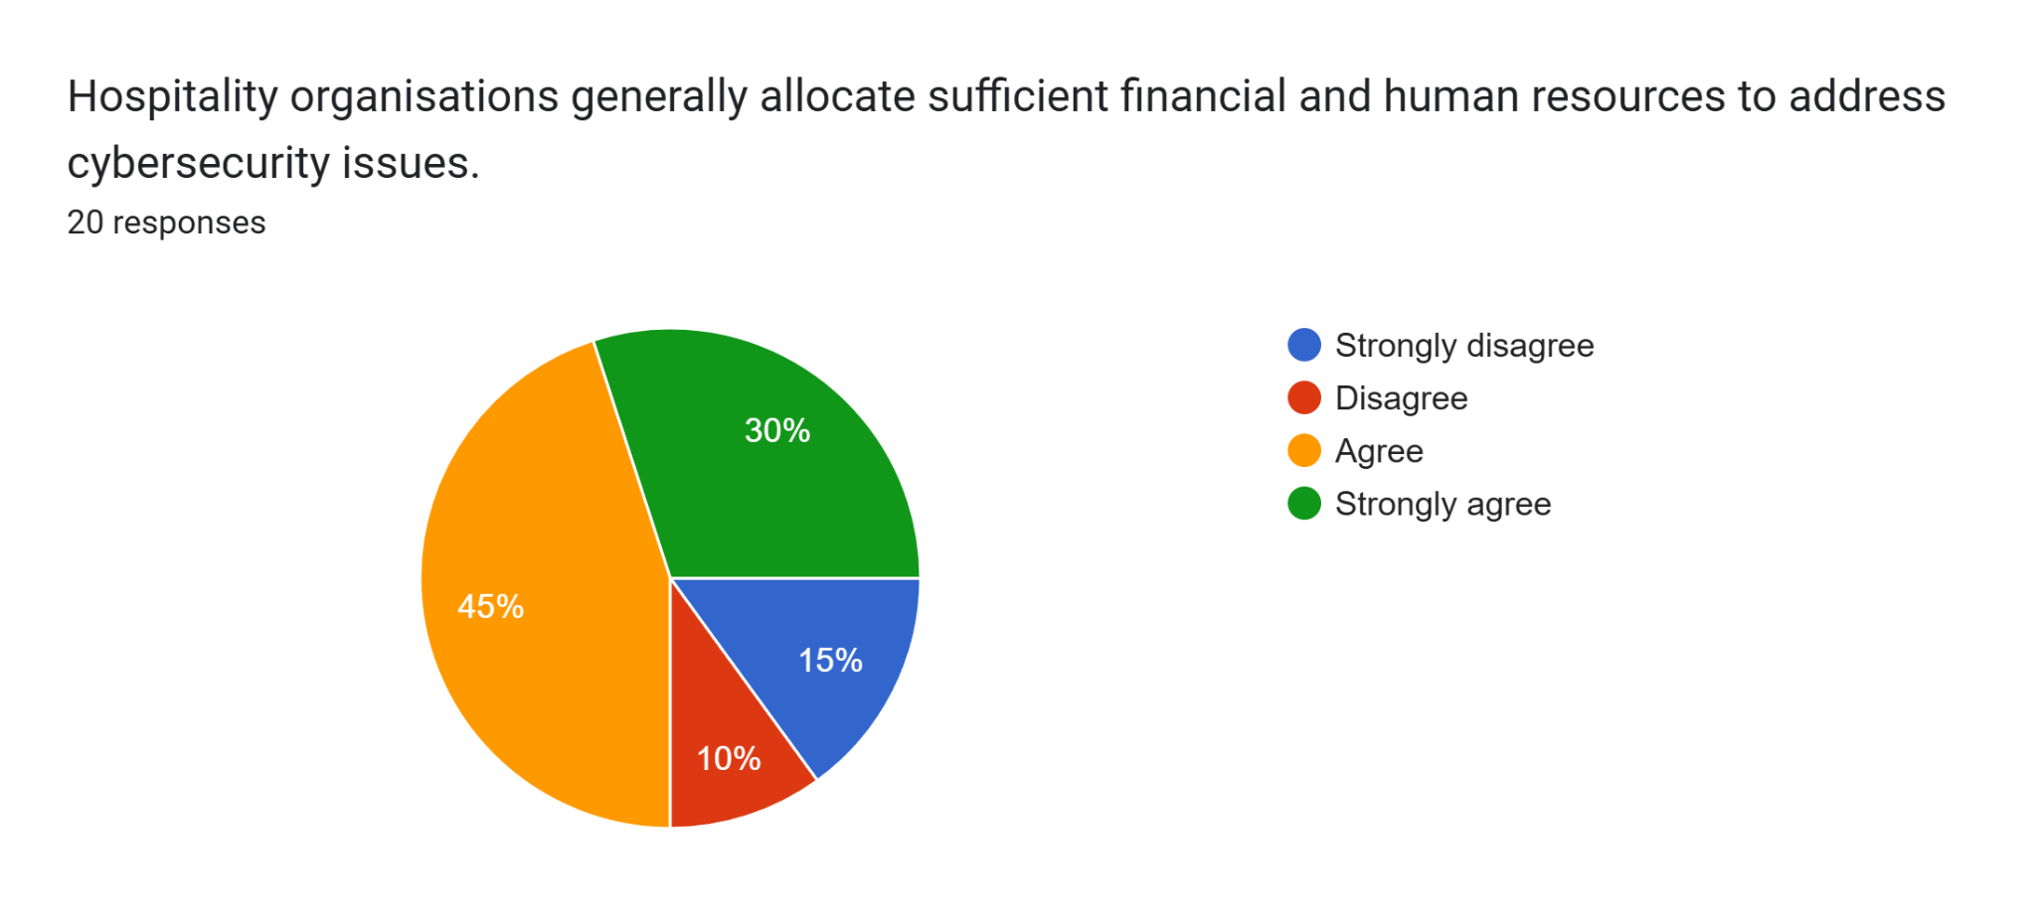
Analysis: It was observed that 75% of the respondents had agreed on the fact that the human resources are significantly dedicated by organisations towards cybersecurity. On the other hand, 35% of the respondents had disagreed that finances are strongly dedicated to this factor. However, the lack of expertise in cybersecurity have continued to hinder the implementation of cybersecurity expertise. Various businesses undermine the levels of investments that are required to maintain a secure system to protect information of customers.
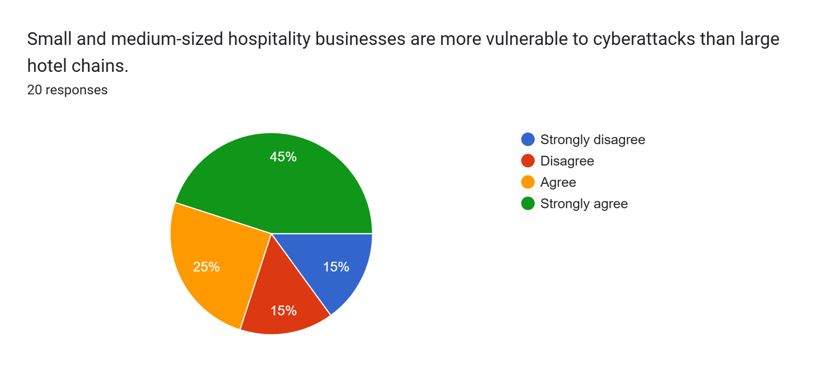
Analysis: Through the survey responses, it was observed that 70% of the respondents had agreed on the factor that SMEs are vulnerable to attacks on cybersecurity in comparison to the 30% who had disagreed on this factor. This reflects on the disparity in technological infrastructure among the hospitality sector of the UK SMEs rely on outdated systems that increase their exposure to cyber threats.
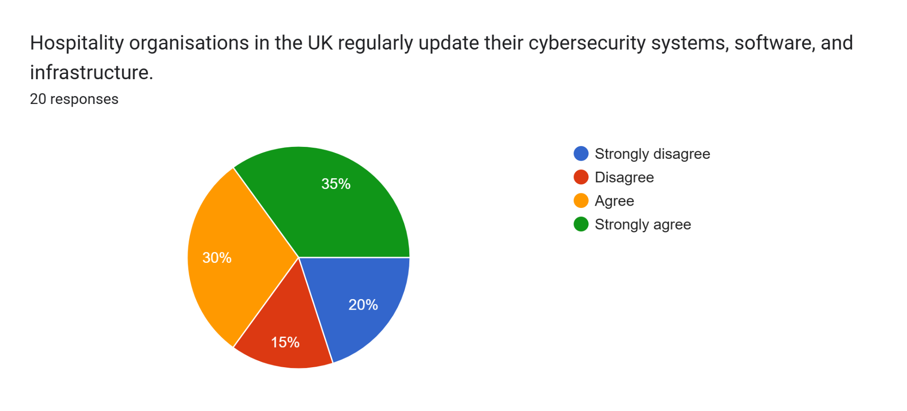
Analysis: It was observed that 65% of the respondents had agreed on the factor that hospitality organisations regularly updated their cybersecurity systems. However, 35% of the respondents had disagreed on this factor. This caters to the increasing commitment to the system maintenance within this system. The SMEs lack the technical support that are required for regular updates to mitigate the evolving cyber threats.
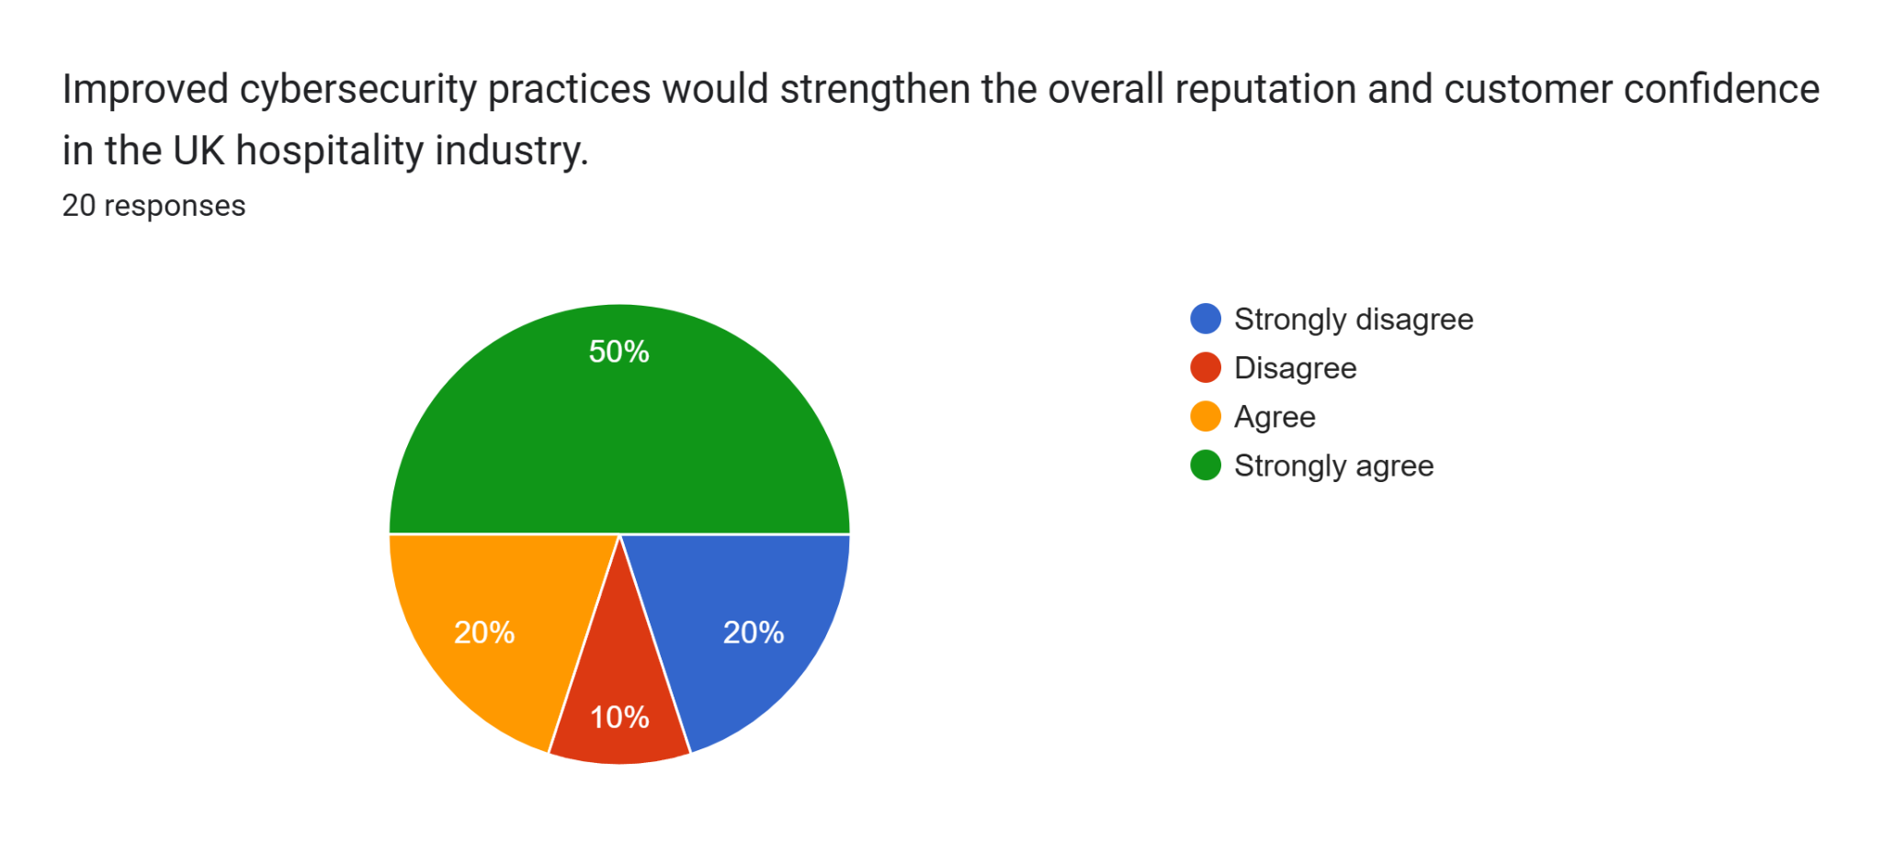
Analysis: It was observed that 70% of the respondents had on the factor that a prominent cybersecurity practice could enhance the confidence of customers. On the other hand, 30% of the respondents had disagreed on this factor that underscores cybersecurity as an important factor to enhance reputation. The respondents have recognised the need for strong data protection laws to differentiate itself from its competitors.
Primary Interview
Interview Question | Hotel Manager | IT Security Officer | Restaurant Supervisor
1. What are the most common cybersecurity threats faced in the UK hospitality industry? | At JW Marriott, I often deal with phishing emails and fake booking websites that target our guests and staff. | From my experience, ransomware and phishing are the biggest challenges. | In my role, I’ve seen fake supplier emails and card payment scams aimed at our restaurant’s point-of-sale systems. These are the most common threats we face.
2. How have cybersecurity incidents affected business operations and customer trust? | I remember a minor data breach that disrupted our online reservation system, causing temporary delays among guests. | Even a small incident can cause operational disruptions and damage customer confidence. | When our payment system was affected by a cyber issue, some guests hesitated to pay by card.
3. What measures have been implemented to prevent or respond to cyber threats? | We conduct regular cybersecurity training and limit data access to authorised staff. activity and report it immediately. | I have implemented multi-factor authentication, continuous network monitoring, and advanced firewalls to detect and prevent cyber intrusions. We also perform regular system audits. | I always remind my team to update passwords regularly and follow company guidelines.
4. How can the hospitality sector strengthen its cybersecurity resilience? | I believe consistent staff training and a strong awareness culture are essential. Everyone in hospitality should treat cybersecurity as part of their daily responsibility. | I think more collaboration with cybersecurity experts and government agencies would help. Sharing real-time threat information could protect the entire industry more effectively. | From my point of view, smaller businesses need better access to cybersecurity support. They often lack the resources that big hotel chains like ours have.
Table 4: Primary Interview

4.1.2 Data Analysis
Theme 1: The Growing Importance of Cybersecurity in the Hospitality Industry
The hospitality sector in the UK has seen a prominent transformation during the last decade, with the increase in importance of cybersecurity as a strategic concern. It has been observed that the hotel industry in the UK has been valued at over 24 billion Pounds, consisting of 9804 companies (Statista, 2025). Moreover, it has been estimated that the hospitality market in the UK is projected to grow at a rate of 4.51 CAGR by 2033 (IMARCGroup, 2025). With the increased dependency of the hotel on online bookings, the volume of transactional infrastructure has exposed them towards higher risks within the industry. This can be inferred by the fact that over 69% of the businesses in the hospitality sector in the UK have viewed cybersecurity as a prominent concern towards their efforts of digital transformation (Security Brief, 2025). Furthermore, it has been observed that the majority of the brands plan to increase their investment in technology within 2 years of their presence. This underscores how the digitised operations within their infrastructure are integrated strategically. These trends assert that cybersecurity is an integral part of the continuity of the business to enhance the trust of customers. However, it has been observed that only 58% of the hospitality businesses in the UK have considered cybersecurity as a priority within their operations (HOSPA, 2024). In comparison to the other business dynamics of the UK, the hotel sector of the country is exposed to vulnerabilities. With the growth of digital dependency, businesses within the hospitality sector are exposed to cyberattacks. These attacks are meant to collect sensitive data of guests from large hotels to process them illegally. However, the digital infrastructure for large companies such as JW Marriott is complex, which helps in increasing the opportunities for cybersecurity failures.
Theme 2: Common Cybersecurity Threats Affecting the Hospitality Sector
The threats within the hospitality sector in the UK have been subjected to intrusions due to the overreliance on the integrated payment system. It has been observed that phishing is one of the most prevalent parameters within the hotel industry, which is reported to be a prominent form of cybercrime that is reported by the UK government (Somanaic Security, 2025). Moreover, the accessibility to unauthorised has been considered as a prominent concern for large hotels operating within the country. For example, the disruption that was reported by InterContinental Group after they had faced unauthorised access to their technology stack had affected their booking channels significantly (IHGPLC, 2022). Furthermore, a higher exposure to ransomware attacks has impacted 66% of the businesses in the UK (AAG, 2025). This underscores how the state of encryption attacks can increase the cost of their recovery. The scale of risks can further be examined by the illustrations of global operators. For instance, Marriott, operating on a global scale, has an extensive footprint of customer records that spans to over 9000 properties (Skift, 2024). This extensive record can necessitate an increase in cybersecurity measures due to the potential impact of negligence towards their digital infrastructure. On the other hand, Hilton has listed 206 properties in the UK, which makes the brand vulnerable to similar patterns of attacks (Channel Futures, 2025). The weaknesses in the third-party supply chain could further be considered as the prominent threats, considering the incidents that have affected the systems of payment processes within large businesses. This underscores how the parameters of attacks increase, considering the size of an organisation. Considering the modern business situations, the increased role of third-party services underscores that with increased internal control, the systems can be exposed through third-party vendors.
Theme 3: The Impact of Cybersecurity Breaches on Business Performance
The breaches in cybersecurity have a prominent impact on the trust of customers within the hospitality sector. The overall scale of their effect differs across different groups of hotels that have verified bases of customers within the market. For instance, it has been observed that Marriott’s Loyalty Scheme has led to surpassing 200 million members in 2024. This provides the organisation with a large amount of identifiable data that could erode the confidence of customers if cybersecurity measures are compromised (IFAC, 2025). On the other hand, businesses with small loyalty programs face different exposure to profiles having similar consequences. This could also lead to a loss of direct revenue in case of unprotected customer data. Considering the aspects of commercial vulnerability, it has been observed that 75% of the customers avoid purchasing from businesses they do not trust to protect their data (Vercara, 2025). This underscores that businesses can risk their revenue if the trust of their potential customers is hampered. Moreover, the overall lifecycle of a data breach is a long-term process considering that it takes over 194 days to identify a breach and then mitigate it. Considering the financial aspect, the cost of breaches has increased in recent years, considering the incidents of cyberattacks, when the recovery costs are included. These costs can force an increase in marketing spending for restoring the bookings. Furthermore, the uneven distribution of technical resources further governs the speed of recovery. For instance, the Bonvoy Membership of Marriott can increase the risk of cybersecurity breaches. Hence, the operators with a dense footprint in the UK could suffer a scale of large losses.
Theme 4: Organisational Preparedness and Cybersecurity Strategies in Hospitality
The hospitality sector of the UK has recognised the importance of preparedness as an important business initiative. However, the readiness levels can significantly differ among brands aligned with the scale of operations. For instance, Marriott has significantly invested in their upgradation of its infrastructure across all the hotel chains in the UK. Marriott has allocated over 25 million Pounds towards modernising their IT infrastructure, which includes their enhanced security awareness (Cyber Security Dive, 2025). On the other hand, Hilton is reported to have invested over 40 million Pounds in the upgrades in the digitised system. This further the rollout of a centralised connected room platform that integrates the operational data through a cloud framework. Moreover, IHG hotels have also implemented a prominent framework for cybersecurity measures to ensure compliance with the standards of GDPR. However, there is an inconsistent preparedness that is inconsistent within the hospitality sector in the UK. Considering this, it has been observed that 46% of the operators within the SME hotels conduct a regular audit for cybersecurity (Hotel Tech Report, 2025). Various SMEs lack a dedicated team for cybersecurity, instead of relying on the outdated services of IT. This leaves them vulnerable to the delayed detection of threats that are aligned with their inadequate procedure for recovery. However, the major businesses such as Marriott, cater to a prominent organisational resilience through a dedicated staff training facility. However, the increased concern for cyber threats asserts that these organisations should evolve their defenses to maintain continuity in their operations that are driven by the competitive market of the UK.
Theme 5: Cybersecurity Practices Between Large Hotel Chains and SMEs
The overall disparities among the businesses within the hotel sector could be considered as one of the most prominent issues towards managing the cybersecurity measures. Businesses have adopted a multi-mode security level that has introduced a dedicated department for cybersecurity. However, the SMEs have been struggling due to their fragmented practices of digital adoption. Marriott had allocated over 10000 pounds to every employee towards the upgrade of data security (Csoonline, 2020). On the other hand, it has been observed that over 70% of the SMEs in the UK have spent less than 1000 Pounds on an annual scale towards cybersecurity measures (Gov.UK, 2025). They tend to over-reliance on the traditional antivirus software to safeguard against cybersecurity issues. Moreover, it has been observed that Hilton manages a prominent digital infrastructure across all of their properties in the UK by conducting vulnerability assessments every month. On the other hand, IHG has introduced mandatory training for cybersecurity for all their workforce in the UK. However, the majority of the SMEs within the hotel sector have reported having limited accessibility to the expertise of cybersecurity measures. Due to this, over 43% of the SMEs within the UK have experienced threats to their cybersecurity facilities (Gov.UK, 2025). On the other hand, the majority of the large businesses in the UK have implemented dedicated threat intelligence which are shared with the National Cybersecurity Centre in the UK. This has led to a digital divide within the organisations in the UK, as these initiatives are relatively unknown to the SMEs within the country.

4.2 Discussion

4.2.1 Interpretation of Results
The findings have evaluated a significant response towards the awareness of cybersecurity within the UK. This signifies a prominent difference between the hotels operating within the hospitality business. The results from the survey have derived that 65% of the respondents had agreed on the fact that cybersecurity is considered an important priority. This showcases an inconsistency within the strategic focus within the businesses. This aligns with the findings of the secondary research highlighting that SMEs have treated cybersecurity as a technical challenge. One of the prominent patterns that was derived from the results aligns with the training of employees. Considering this, 65% of the participants had agreed on the fact that the workforce receives training on cybersecurity measures to support businesses that underestimate the role of data protection. This can be further explained by the interview of the IT manager at Marriott, explaining that, “We significantly invest in employee awareness programs as this could expose the data of customers”. This aligns with the secondary finding that Marriott has integrated their compliance to cybersecurity compliance within their compliance functionalities, while SMEs lack a structured process, which makes them vulnerable to cyberattacks. The results from the survey have further determined that 75% of the respondents agree on the fact that breaches to cybersecurity affect the customer’s trust negatively. This underscores that data protection is aligned with the reputation of a brand. Moreover, this statement could be confirmed by the interview of Marriott’s operations manager, stating that the confidence of customers within the digitised system is important for maintaining the quality of accommodation. The overall responses could be aligned with the cybersecurity breach, considering that various businesses have experienced similar incidents. In consideration of the preparedness of an organisation, the research has identified prominent disparities in the allocation of resources. It was further observed that over 70% of the SMEs operating within the hospitality sector spend less to enhance their cybersecurity systems. This can be further asserted by the interview with the executive of Marriott, who had stated that, “We have a dedicated team for cybersecurity working 24/7 on eliminating these risks”. Furthermore, the analysis of these data sets underscored those investments in technologies do not ensure resilience. It was observed that large businesses face the risks of evolving cyber threats. For example, despite the integrated infrastructure of Marriott, there was a breach faced by the organisation in 2018. The organisation has adopted threat analysis in real-time within the properties of the UK. On the other hand, Hilton Hotels focus on their centralised encryption of data through their AI-driven detection system.

4.2.2 Comparison with Existing Literature
The alignment of the findings of the research addresses the management of threats for cybersecurity within the hospitality sector of the UK. The findings had focused on the gaps among the hospitality businesses that lay a foundation for the conclusion prior to the research. As per the views of Florido-Benítez (2024), hospitality businesses have a prominent level of engagement within their strategy to mitigate the threats of cybersecurity. This is consistent with the results, in which 65% of the respondents agreed that cybersecurity has been treated as an important priority for businesses. This asserts the trend within the hospitality sector in which cybersecurity is considered a widely implemented practice. As per the views of Chidukwani et al. (2024), the role of organisational resources play an important role in determining the resilience of cybersecurity measures. This could be determined by the example of businesses such as Marriott adopting a robust framework for cybersecurity to ensure proactive threat detection. This aligns with the findings from the interview results of Marriott, highlighting an investment in employee training programs. However, the results further determine that SMEs rely significantly on the informal IT practices for SMEs lacking the expertise to adopt a prominent framework for cybersecurity (Chidukwani et al., 2024). Moreover, the awareness of employees has emerged to be important, which supports the survey results stating that 40% of the respondents disagree on the fact that employees receive prominent training to control the cyberthreats. Asserting this, Karadayi-Usta (2024) had stated that human factors are considered as one of the most common vulnerabilities of increased cyberthreats within the service sectors. The trust of customers towards a brand could further be considered as one of the pressing consequences that stem from breaches in cybersecurity. As per the views of Alharbi et al. (2021), hotels that experience a breach suffer from decreased retention. This was evaluated in the survey results where 75% of the respondents agreed that data breaches reduced confidence among customers. These results derived that the reputational risks are important for an organisation to gain profitability in the long run. However, Aydogan et al. (2024) had stated that hotel chains are resistant to large-scale disruptions as they have a structured unit. The analysis of the findings has derived that businesses could face challenges due to the sophistication of these technologies. These processes require organisations to investments within systems are valuable.

4.2.3 Answering the Research Questions
The research has identified data breaches among the primary threats to security within the hospitality businesses. These findings align with the research that identifies the poor training of employees as the vulnerabilities within the hospitality sector. Businesses store a large amount of data sets from customers which makes them a primary target for the attackers. This further results in demonstrating that this sector lacks the protection levels against these threats. The trust of customers on a brand can get hampered due to the incident of cybersecurity. Moreover, it was observed that when there has been a breach in data, it could lead to a downtime of operation. The established businesses protect themselves against this risk through their contingency funds. However, the SMEs having limited resources fail to comply with the added risks to become proactive against these risks. The findings of this research is consistent with the research that aligns with the loss of public credibility throughout the hospitality sector. Considering this, hotel chains in the UK have a prominent governance system that train their employees regarding the practices to mitigate the cyberthreats. Organisations further engage in monitoring the threats to foster a reactive approach to prepare them against these threats. The interviews conducted as part of this study support this conclusion by confirming that both financial and technological limitations prevent SME establishments from developing the necessary level of resiliency needed against cyber-attacks.

4.2.4 Implications of the Findings
The research has demonstrated the risks of cybersecurity within the hospitality businesses in the UK. Primarily, the findings have identified that cybersecurity measure as a prominent element of modern business ethics. Furthermore, the research has demonstrated that there has been an increased digital divide among the businesses operating under the hospitality sector to respond to these threats. Considering the case of established hotel chains, they have a strong financial stability which helps them to implement a robust cybersecurity infrastructure. However, the SMEs relies on the governmental support due to limited resources available. The research further focuses on the awareness of employees as a prominent source of vulnerability. This asserts the SMEs should cater to a cultural change through training their employees as an important element for organisational resilience. Hence, cybersecurity should become an important part of business operations at every levels of an organisation.

Chapter 6: Conclusion and Recommendations

6.1 Summary of Key Findings
The research has found that the issue of cybersecurity threats has emerged as a priority in the UK hospitality industry, with large and small-scale businesses exposed to a high level of risks, including phishing, ransomware, and data breaches. The findings of this study showed that big hotel chains such as Marriott have made significant progress in developing strong cybersecurity systems. For example, the use of encryption, multi-factor authentication (MFA), and round-the-clock monitoring, the UK-based small independent hotels continue to suffer because of the lack of fiscal and technical capabilities. The main survey findings have indicated that, despite the fact that most of the surveyed individuals tend to identify cybersecurity as a major business priority, there is still a significant number of individuals who undervalue it, especially among SMEs. The interview with Marriott employees showed that cybersecurity has a direct impact on the confidence of customers, efficiency, and the image of the company. The problem of phishing and fraudulent booking sites was reported by the employees at all levels, and the cases of the breach were associated with the short-term disruptions and the loss of the option. The multi-layered strategy of Marriott, which includes employee training, rigorous access to information, and high network security, might not be able to maintain the consistency of the sector-wide requirements. The findings of the study highlighted the idea that cybersecurity in hospitality is a non-technical, but cultural and managerial problem that needs to be addressed and actively invested in to achieve long-term business viability.

6.2 Contributions to this Field
This research is relevant to existing literature on the topic, as it provides comparative insight into the issue of cybersecurity between large hotel chains and smaller independent hotels in the UK hospitality industry. Although multiple studies have been conducted in the past to deal with individual cyber-attacks, this research incorporates primary and secondary data to give a comprehensive outlook of how the threat levels influence operations, trust, and reputation. It contributes to the conceptual understanding of organisational resources and external pressures on cybersecurity responses by using such theoretical frameworks.

6.3 Practical Implications
The results have implications mainly for the SMEs operational within in the UK hospitality industry. SMEs focus on ongoing employee training program due to the major risk of breaches in human error. Cybersecurity systems that are ingrained into the operations can help to reduce vulnerabilities significantly. It is important to become vigilant for advanced tools that are available in the market. However, in the case of SMEs, the research proposes the implementation of scalable and affordable measures, including cyber insurance, joint ventures, and shared cybersecurity services with industry-led or government-led efforts. This can be assisted by the policymakers through the provision of easy guidance and financial assistance to the small businesses in fortifying their defenses. Moreover, transparent communication and reassuring the customers after any breach is an area that hospitality organisations should pay attention to because it is essential to recover customer trust for brand sustainability.

6.4 Recommendations
Improving multi-layered defense: The human factor is the major weakness because it can be mitigated through regular staff training programs to teach employees about phishing, data handling, and password management (Bovsh et al. 2023). The bigger hotel chains, such as Marriott, must keep improving their multi-layered defense systems, such as MFA, endpoint identification, encryption, and network segmentation, with a uniform application in all their branches and subsidiaries.
Adopting a tokenised payment system: For better staff engagement, SMEs need to implement phishing simulation exams to check the readiness of the workers and design training according to their performance. Moreover, to protect the data of their customers, SMEs need to adopt a tokenised payment method with a zero-trust network structure that will lower the unauthorised access (Dhanorkar et al. 2024).
Establishing a collaboration with cybersecurity organisations: In the case of SMEs, the lack of resources can be addressed by the use of affordable alternatives like cloud-based security systems, cyber insurance services, and outsourced cybersecurity services (Rawindaran et al. 2023). SMEs should foster collaboration with government programs in the UK to get assistance in the long run.

6.5 Linking with objectives
Linking with objective 1: To explore the primary cybersecurity risks impacting the hospitality industry
The research have analysed that the biggest cybersecurity risks within the hospitality sector include data breches. Due to the industry’s growing dependence on digital technology and the interconnectedness of booking and payment systems, such assaults may harm the brand image.
Linking with objective 2: To evaluate the response of big hotel chains and independent small hotels to cyber threats
This research compared the responses from the premium hospitality chains like Marriott International and small independent hotel staff regarding cyber risks and their impact. Greater hotel chains may use high-end security chains and security teams, and smaller businesses use simple security measures, constrained resources, and a lack of security infrastructure, which indicates a difference in the amount of preparedness and investment abilities in the hospitality sector.
Linking with objective 3: To highlight similarities and differences in levels of preparedness across organisations.
This study has found that there were notable differences in the level of preparedness for large hotels and well-organised cybersecurity systems and periodic training, and SMEs that have disjointed responses and lower awareness.
Linking with objective 4: To evaluate the effectiveness of existing cybersecurity strategies
It was determined that current measures, such as encryption, MFA, and staff training, can be effective provided they are implemented consistently. However, multiple organisations lack persistent monitoring, vendor risk management, and collaboration across sectors, which is influenced by organisational culture.
Linking with objective 5: To assess the impact of cyber threats on financial performance
This study has identified that the financial performance of a hospitality organisation imposes recovery expenses, fines, and also hampers the loyal customer base.
Linking with objective 6: To suggest feasible actions for improving resilience
This research has revealed that by collaborating with different cybersecurity providers SMEs could adopt scalable solutions which will strengthening customer trust.

References
AAG (2025). ‘The Latest 2025 Ransomware Statistics (updated June 2025’. Available at: https://aag-it.com/the-latest-ransomware-statistics/ (Accessed on: 1 November 2025)
Alabdan, R. (2020). Phishing Attacks Survey: Types, Vectors, and Technical Approaches. Future Internet, 12(10), p.168.
Alharbi, F., Alsulami, M., Al-Solami, A., Al-Otaibi, Y., Al-Osimi, M., Al-Qanor, F. an,d Al-Otaibi, K., (2021). ‘The impact of cybersecurity practices on cyberattack damage: The perspective of small enterprises in Saudi Arabia’. Sensors, 21(20), p.6901.
Anwar, F.A., Deliana, D. and Suyamto, S. (2024). Digital Transformation in the Hospitality Industry: Improving Efficiency and Guest Experience. International Journal of Management Science and Information Technology, 4(2), pp.428–437.
Aydogan, M., de Esteban Curiel, J., Antonovica, A. and Cetin, G., (2024). ‘Characteristics of crises resilient organizations in the hospitality and tourism industry’. International Journal of Contemporary Hospitality Management, 36(4), pp.1432-1453.
BBC (2020). Marriott Hotels fined £18.4m for data breach that hit millions. Available at: https://www.bbc.com/news/technology-54748843 (Accessed on: 16 October 2025).
BBC (2022). ‘Holiday Inn hotels hit by cyber-attack’. Available at: https://www.bbc.com/news/technology-62814943 (Accessed on: 17 October 2025)
Bovsh, L., Bosovska, M., Okhrimenko, A. and Rasulova, А., (2023). ‘Digital security of the hotel brand’. Менаџмент у хотелијерству и туризму, 11(1), pp.145-163.
Carrera-Rivera, A., Ochoa, W., Larrinaga, F. and Lasa, G., (2022). ‘How-to conduct a systematic literature review: A quick guide for computer science research’. MethodsX, 9, p.101895.
Channel Futures (2025). ‘IT Security Stories to Watch: Hilton Identifies Malware Intrusion’. Available at: https://www.channelfutures.com/security/it-security-stories-to-watch-hilton-identifies-malware-intrusion (Accessed on: 1 November 2025)
Chidukwani, A., Zander, S. and Koutsakis, P. (2024). Cybersecurity Preparedness of Small-to-Medium Businesses: A Western Australia Study with Broader Implications. Computers & Security, 145, pp.104026–104026.
CrowdStrike (2025). TUI Group - Customer Story | CrowdStrike. Available at: https://www.crowdstrike.com/en-au/resources/customer-stories/tui-group/ (Accessed on: 21 October 2025)
Csoonline (2020). ‘Marriott data breach FAQ: How did it happen and what was the impact?’. Available at: https://www.csoonline.com/article/567795/marriott-data-breach-faq-how-did-it-happen-and-what-was-the-impact.html (Accessed on: 1 November 2025)
Cyber Security Dive (2025). ‘Marriott checks out AI agents amid technology transformation’. Available at: https://www.cybersecuritydive.com/news/marriott-international-AI-strategy-agentic-cloud-cybersecurity/759384/ (Accessed on: 20 October 2025)
Denuwan, R. (2023). Marriott International Data Breach. ResearchGate.
Dhanorkar, T., Sethuraman, S. and Mani, K. (2024). Zero-Trust Tokenization: Redefining Cybersecurity for Real-Time Payments. Journal of Artificial Intelligence General science (JAIGS) ISSN:3006-4023, 3(1), pp.493–506.
Dignan, L. (2018). ​Marriott faces massive data breach expenses even with cybersecurity insurance. Available at: https://www.zdnet.com/article/marriott-faces-massive-data-breach-expenses-even-with-cybersecurity-insurance/ (Accessed on: 17 October 2025)
FAC (2025). ‘Cybersecurity Is Critical for all Organizations – Large and Small’. Available at: https://www.ifac.org/knowledge-gateway/discussion/cybersecurity-critical-all-organizations-large-and-small (Accessed on: 21 October 2025)
Florido-Benítez, L., (2024). ‘The cybersecurity applied by online travel agencies and hotels to protect users’ private data in smart cities’. Smart Cities, 7(1), pp.475-495.
Folorunso, A., Wada, I., Samuel, B. and Mohammed, V., (2024). ‘Security compliance and its implication for cybersecurity’. World Journal of Advanced Research and Reviews, 24(01), pp.2105-2121.
Fortinet (2024). What is EDR - Endpoint Detection and Response? Available at: https://www.fortinet.com/resources/cyberglossary/what-is-edr (Accessed on: 17 October 2025)
GDPR Register (2019). Radisson Hotel Suffers a Data Breach | GDPR Register – News. Available at: https://www.gdprregister.eu/news/radisson-hotel-breach-gdpr/ (Accessed on: 27 October 2025)
Gov. UK (2024). ‘Cyber security breaches survey 2024’. Available at: https://www.gov.uk/government/statistics/cyber-security-breaches-survey-2024/cyber-security-breaches-survey-2024 (Accessed on: 17 October 2025)
Gov. UK, (2025). ‘Cyber security breaches survey 2025’. Available at: https://www.gov.uk/government/statistics/cyber-security-breaches-survey-2025/cyber-security-breaches-survey-2025 Accessed on: 17 October 2025).
GOV.UK (2022). Cyber Security Breaches Survey 2022. Available at: https://www.gov.uk/government/statistics/cyber-security-breaches-survey-2022/cyber-security-breaches-survey-2022 (Accessed on: 17 October 2025)
GOV.UK (2024). Cyber security breaches survey 2024. Available at: https://www.gov.uk/government/statistics/cyber-security-breaches-survey-2024/cyber-security-breaches-survey-2024 (Accessed on: 10 October 2025)
HOSPA (2024). ‘Data threats in the hospitality industry: the impact of system failure’ Available at: https://www.hospa.org/post/data-threats-in-the-hospitality-industry-the-impact-of-system-failure (Accessed on: 25 October 2025)
Hotel Tech Report (2025). ‘75+ Hospitality Statistics You Should Know (2026)’. Available at: https://hoteltechreport.com/news/hospitality-statistics (Accessed on: 28 October 2025)
IHGPLC (2022). ‘Unauthorised access to technology systems’ Available at: https://www.ihgplc.com/en/news-and-media/news-releases/2022/unauthorised-access-to-technology-systems (Accessed on: 20 October 2025)
IMARCGroup (2025). ’United Kingdom Hospitality Market Report by Type (Chain Hotels, Independent Hotels), Segment (Service Apartments, Budget and Economy Hotels, Mid and Upper Mid-scale Hotels, Luxury Hotels), and Region 2025-2033’. Available at: https://www.imarcgroup.com/united-kingdom-hospitality-market (Accessed on: 20 October 2025)
Jowitt, T. (2019). Choice Hotels Data Breach Affects 700,000 Records. Available at : https://www.silicon.co.uk/security/cyberwar/choice-hotels-breach-700000-records-279113 (Accessed on: 22 October 2025)
Karadayi-Usta, S. (2024). Cybersecurity Risks Analysis in the Hospitality Industry: A Stakeholder Perspective on Sustainable Service Systems. Systems, 12(10), pp.397–397.
Kaul, D., (2021). ‘AI-Driven Dynamic Upsell in Hotel Reservation Systems Based on Cybersecurity Risk Scores’. International Journal of Computer Engineering and Technology (IJCET), 12(3), pp.114-125.
Kennedy-Shaffer, L., Qiu, X. and Hanage, W.P., (2021). ‘Snowball sampling study design for serosurveys early in disease outbreaks’. American Journal of Epidemiology, 190(9), pp.1918-1927.
Khaitan, A. (2024). Dalmahoy Hotel & Country Club Cyberattack Claimed By Hunters. Available at: https://thecyberexpress.com/dalmahoy-hotel-country-club-cyberattack/ (Accessed on: 27 October 2025)
Kosutic, D. (2021). The Impact of Cybersecurity on Competitive Advantage. ResearchGate.
Marriott (2021). Marriott Bonvoy Customer Service and Online Help. Available at: https://help.marriott.com/s/article/Article-34205 (Accessed on: 22 October 2025)
Mordor Intelligence (2025). Hospitality Industry in the United Kingdom - Growth, Trends, and Forecasts (2020 - 2025). Available at: https://www.mordorintelligence.com/industry-reports/hospitality-industry-in-the-united-kingdom (Accessed on: 17 October 2025)
Nagpal, D., Kornerup, I. and Gibson, M.P., (2021). ‘Mixed-method research: a basic understanding’. CODS-Journal of Dentistry, 12(1), pp.11-16.
Panditharathna, R., Liu, Y., de Macedo Bergamo, F.V., Appiah, D., Trim, P.R. and Lee, Y.I., (2024). ‘How Cyber Security Enhances Trust and Commitment to Customer Retention: The Mediating Role of Robotic Service Quality’. Big Data and Cognitive Computing, 8(11), p.165.
Perera, S., Jin, X., Maurushat, A. and Opoku, D.G.J., (2022), ‘March. Factors affecting reputational damage to organisations due to cyberattacks’. In Informatics (Vol. 9, No. 1, p. 28). MDPI.
Rawindaran, N., Jayal, A., Prakash, E. and Hewage, C. (2023). Perspective of Small and Medium Enterprise (SME’s) and their Relationship with Government in Overcoming Cybersecurity Challenges and Barriers in Wales. International Journal of Information Management Data Insights, 3(2), pp.100191–100191.
Saputra, K.A.K. and Paranoan, S., (2024). ‘Do Cyber security, Digitalisation and Data Visualisation Affect the Quality of Internal Environmental Audits?’. Australasian Accounting, Business and Finance Journal, 18(2).
Security Brief (2025). ‘UK SMEs face rise in cyber attacks with average cost GBP £7,960’. Available at: https://securitybrief.co.uk/story/uk-smes-face-rise-in-cyber-attacks-with-average-cost-gbp-7-960 (Accessed on: 20 October 2025)
Securitymagazine (2024). ‘Marriott suffers data breach due to social engineering attack’. Available at: https://www.securitymagazine.com/articles/97955-marriott-suffers-data-breach-due-to-social-engineering-attack (Accessed on: 21 October 2025)
Skift (2024). ‘Every One of Marriott’s Hotel Brands, Explained’. Available at: https://skift.com/2025/05/27/every-one-of-marriotts-30-hotel-brands-explained/ (Accessed on: 25 October 2025)
Somanaic Security (2025). ‘Why the Hospitality Sector Faces Heightened Cyber Security Risks’. Available at: https://www.somniacsecurity.com/why-the-hospitality-sector-faces-heightened-cyber-security-risks/ (Accessed on: 27 October 2025)
Statista (2025). ‘Cybercrime and companies in the United Kingdom (UK) - statistics & Facts’. Available at: https://www.statista.com/topics/8131/cyber-crime-and-companies-in-the-uk/?srsltid=AfmBOorHysquO-NlkXgFYFIWGea9ADl1r1Q0MMaeXGVPD-mlfMULHXic#topicOverview (Accessed on: 17 October 2025)
Statista (2025). ‘Hotel industry in the UK - statistics & facts’. Available at: https://www.statista.com/topics/3146/hotel-industry-in-the-united-kingdom-uk/?srsltid=AfmBOorJ4E5PeWIwhRmm5oMSPVhsJQq0KuD3WKnNw3ln5dKC796iNdWx (Accessed on: 21 October 2025)
UK Hospitality (2024). Economic contribution of hospitality. Available at: https://www.ukhospitality.org.uk/insight/economic-contribution-of-hospitality/ (Accessed on: 17 October 2025)
UK Hospitality (2025). ‘Cyberthreats and the DarkHotel: protecting hospitality businesses’. Available at: https://www.ukhospitality.org.uk/cyberthreats-and-the-darkhotel-protecting-hospitality-businesses/ (Accessed on: 17 October 2025)
Vercara (2025). Vercara Research: 75% of U.S.Consumers Would Stop Purchasing From a Brand If It Suffered a Cyber Incident. Available at: https://vercara.digicert.com/news/vercara-research-75-of-u-s-consumers-would-stop-purchasing-from-a-brand-if-it-suffered-a-cyber-incident (Accessed on: 27 October 2025)
Wahab, F., Khan, I., Hussain, T. and Amir, A., (2023). ‘An investigation of cyber attack impact on consumers’ intention to purchase online’. Decision Analytics Journal, 8, p.100297.
Wang, X., Wang, X., Liu, Z., Chang, W., Hou, Y. and Zhao, Z., (2022). ‘Too generous to be fair? Experiments on the interplay of what, when, and how in data breach recovery of the hotel industry’. Tourism Management, 88, p.104420.
YouGov (2025). ‘How brands can rebuild trust with UK consumers after losing it’. Available at: https://yougov.com/en-gb/articles/53019-how-brands-can-rebuild-trust-with-uk-consumers-after-losing-i t (Accessed on: 22 October 2025)

