University of Wales Trinity St David

Wales Institute of Science & Art
Torsion of Shafts
Mechanics and Dynamics (ACHA4026)

Thomas Shufflebotham
2320384
December 2025
Word Count: 1394
Contents
1 Table of Figures 2
2 Introduction 3
2.1 Measurable Outcomes 3
3 Background Research 4
4 Experimental Procedure 5
4.1 What is a Torsion Test? 5
4.2 Lab Experiment 6
4.2.1 Equipment 6
4.2.2 Methodology 7
5 Results 8
6 Results Analysis 9
6.1 Results Graph 10
7 Conclusion 11
8 Further Improvements 12
9 References 13

Table of Figures
Figure 1 Typical Stress-Strain Curve of Torsion Test (Collins, D, 2025) 4
Figure 2 Torsion Test Illustration (Callister & Rethwisch, 2017, p. 145) 5
Figure 3 Torsion Test Rig 6
Figure 4 Graph of TL vs Jө 10

List of Tables
Table 1 Raw Results for Brass 8
Table 2 Raw Results for Aluminium 8
Table 3 Raw Results for Steel 8
Table 4 Modulus of Rigidity from Lab Results 10
Table 5 Textbook Values for Modulus of Rigidity (UWTSD, 2025) 10

List of Equations
1 Polar Moment of Area 9

Introduction
Mechanics and dynamics is the study of the effect of forces on components that are both stationary and in motion. As engineers, it is vital to understand the fundamentals of this topic to prevent failures within structures. There are several failure modes that can occur with materials however, this report will focus on the torsion of materials.

Following a torsion test done that assessed 3 different materials: Brass, Aluminium, & Steel, this report will explain what a torsion test is, the experimental procedure behind it and the results gathered. Then, the results will be compared with the known ‘real-world’ values of each material to asses the labs accuracy and a final discussion will be had on the material properties and what scenarios each may be used in.

Measurable Outcomes
The main focus of this report is to document the lab findings and methodology whilst showing a clear understanding of the topic. To achieve this, the report should include the following:
- Background research using a relevant source to explain what the modulus of rigidity is and why it varies between materials.
- Explain the lab in full detail with relevant figures, an equipment list, and methodology
- A final discussion of the results, including a comparison between the lab results and the known property values that accredited engineers use on a daily basis.

Background Research
Materials under a torsional/tensile load behave elastically, meaning they follow Hooke’s law, which states that all materials have an elastic region where they can deform and still return to their original form. However, once this limit is exceeded, the material will yield and no longer return to its original form and will be permanently deformed.
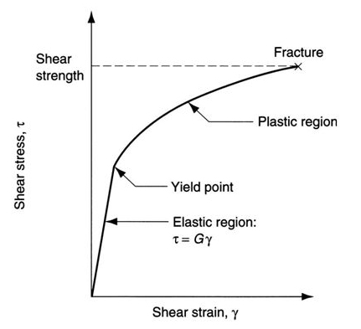
Figure 1 Typical Stress-Strain Curve of Torsion Test (Collins, D, 2025)
As shown in Figure 1, plotting a graph of shear stress vs shear strain allows for the material deformation to be observed. As previously mentioned, the yield point is the maximum force a material can take before deforming permanently. “For most metals that are stressed at relatively low levels, stress and strain are proportional to each other through the relationship $τ=Gγ$”, (Callister & Rethwisch, 2017, p. 150) in this relationship, G is the shear modulus, $τ$ is the shear stress, and $γ$ is the shear strain, similarly to Young’s Modulus, the shear modulus is the elastic component and is only present before the yield point as it is the “constant of proportionality” (Callister & Rethwisch, 2017, p. 148).

Therefore, as the aim of the experiment is to determine the modulus of rigidity for each material, the results graph is expected to be linear, as the experiment will not exceed the yield point of the material. Any non-linear results will indicate an error in the experimental procedure and impact the results comparison later.

Experimental Procedure

What is a Torsion Test?
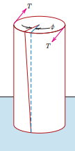
Figure 2 Torsion Test Illustration (Callister & Rethwisch, 2017, p. 145)
As seen in Figure 2, the torsion test is conducted by fixing one end of the cylindrical material to a point, whilst allowing the other end to rotate freely. Then, a rotational force (torque) is applied to the ‘free’ side, creating torsion in the material, which is then measured and used to calculate the load-bearing limits of a material in torsion.

Lab Experiment
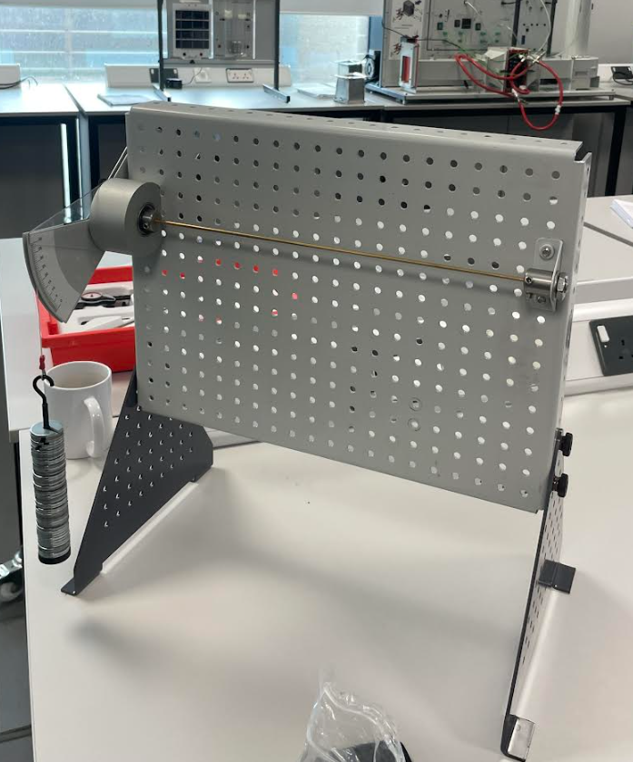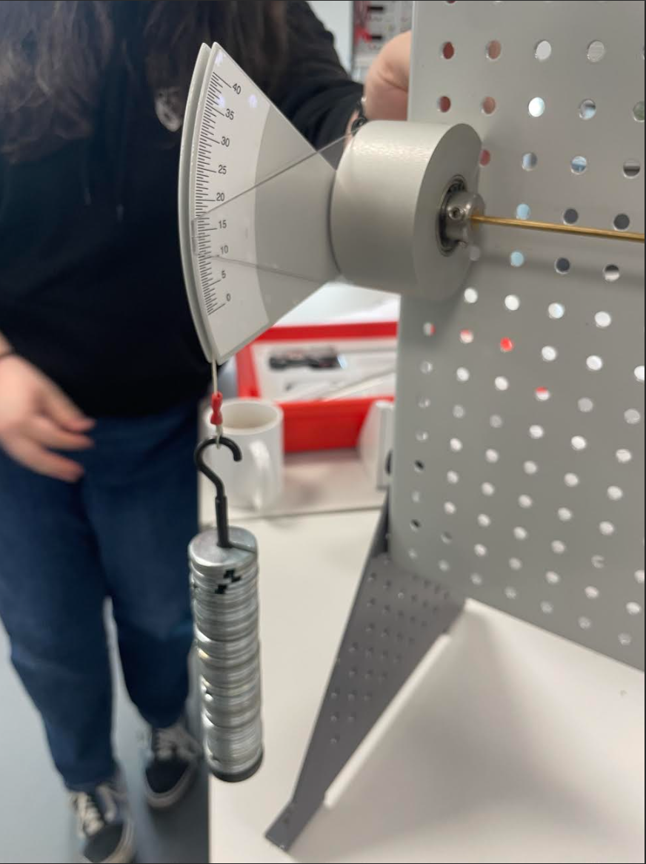
Figure 3 Torsion Test Rig
The test rig seen in Figure 3 was used to complete the torsion test. The rig used a rotating chuck, which had a scale attached to measure the rotation of the test piece and a hook to hang weights and produce a torque. For the lab, identically shaped cylinders of Brass, Aluminium, & Steel Specimens, of length: 0.34m and diameter 3.1mm were used.

Equipment
Equipment | Purpose
Vernier Calliper | To measure the diameter of each material
Hexagonal Tool | To fasten hexagonal screws on the rotating chuck and the fixed chuck
Torsion Test Rig | To carry out the experiment
Rotating and fixed chuck | To hold the material in place and produce a rotational force on the material
Torque Scale | To measure the torsion in the test piece
Weight Plates (25 grams per plate) | Attached to the rotating chuck to create a torque
Weight Stand | To hold the weights

Methodology
Assemble the Torsion test rig by attaching the feet, the fixed chuck on the right side of the board and the rotating chuck to the left side of the board. Then, insert the material test piece into the right side of the fixed chuck and slide it through into the rotating chuck, and tighten the grub screws of the fixed chuck to secure the test piece in place. Then, before tightening the grub screws of the rotating chuck, the torque scale must be zeroed. To do so, align the notch on the torque arm with the zero of the scale, tighten the grub screws to fix the test piece to the rotating end. Finally, begin the test by adding the weighted plates in increments of 100g at a time, attach 500 grams of weight to the brass and steel specimens and only 400 grams to the aluminium specimen as to not exceed the yield point of the material.

Results
Table 1 Raw Results for Brass
Shaft Modulus (Brass)
Load (m) (g) | Load (w) (N) | Torque (T) (Nm) | Twist Angle (degrees) | Twist Angle (ө) (radians) | TL (N$m^{2}$) | TL ($m^{4}rad$)
0 | 0 | 0 | 0 | 0 | 0 | 0
100 | 0.981 | 0.098 | 5.1 | 0.089 | 0.033 | 8.06E-13
200 | 1.962 | 0.196 | 11.5 | 0.201 | 0.067 | 1.82E-12
300 | 2.943 | 0.294 | 17.5 | 0.305 | 0.100 | 2.77E-12
400 | 3.924 | 0.392 | 23 | 0.401 | 0.133 | 3.64E-12
500 | 4.905 | 0.491 | 29.5 | 0.515 | 0.167 | 4.66E-12
Material: Brass |  | L = 0.34m |  | D = 3.1mm | J = 9.062E-12$m^{4}$

Table 2 Raw Results for Aluminium
Shaft Modulus (Aluminium)
Load (m) (g) | Load (w) (N) | Torque (T) (Nm) | Twist Angle (degrees) | Twist Angle (ө) (radians) | TL (N$m^{2}$) | TL ($m^{4}rad$)
0 | 0 | 0 | 0 | 0 | 0 | 0
100 | 0.981 | 0.098 | 7.5 | 0.131 | 0.033 | 1.19E-12
200 | 1.962 | 0.196 | 15.5 | 0.270 | 0.067 | 2.45E-12
300 | 2.943 | 0.294 | 23 | 0.401 | 0.100 | 3.64E-12
400 | 3.924 | 0.392 | 31 | 0.541 | 0.133 | 4.90E-12
Material: Aluminium |  | L = 0.34m |  | D = 3.1mm | J = 9.062E-12$m^{4}$

Table 3 Raw Results for Steel
Shaft Modulus (Steel)
Load (m) (g) | Load (w) (N) | Torque (T) (Nm) | Twist Angle (degrees) | Twist Angle (ө) (radians) | TL (N$m^{2}$) | TL ($m^{4}rad$)
0 | 0 | 0 | 0 | 0 | 0 | 0
100 | 0.981 | 0.098 | 3 | 0.052 | 0.033 | 4.74E-13
200 | 1.962 | 0.196 | 4.5 | 0.079 | 0.067 | 7.11E-13
300 | 2.943 | 0.294 | 7.5 | 0.131 | 0.100 | 1.19E-12
400 | 3.924 | 0.392 | 10 | 0.174 | 0.133 | 1.58E-12
500 | 4.905 | 0.491 | 13 | 0.227 | 0.167 | 2.06E-12
Material: Steel |  | L = 0.34m |  | D = 3.1mm | J = 9.062E-12$m^{4}$

Results Analysis
As seen in the results above, a value for J was calculated. J represents the polar moment of Area on the shaft. The polar moment of area is the relationship between the stiffness of the shaft in twist with the diameter, as a shaft increases in diameter, so does its stiffness, but the relationship is not directly proportional. In fact, the stiffness is proportional to the diameter of the shaft raised to the power of four. Using this relationship, Equation 1 was used to calculate the polar moment of area.

$$J= \frac{πD^{4}}{32}$$ | 1 Polar Moment of Area

Where J is the Polar Moment of Area, and D is the diameter of the material. After calculating the polar moment of area and populating the table, the following graph of TL vs Jө was plotted

.

Results Graph
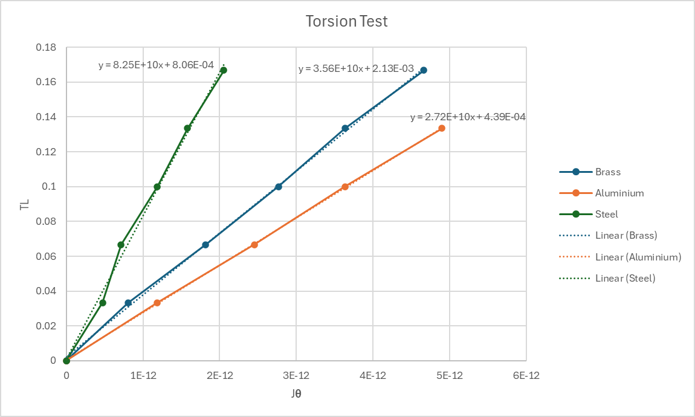
Figure 4 Graph of TL vs Jө
Figure 4 shows the graph of TL vs Jө, from the gradient of each line the Value of the Shear modulus (G) for each material can be obtained. The values obtained from the lab are as follows:
Table 4 Modulus of Rigidity from Lab Results
Material | Value in GN.$m^{2}$ (x${10}^{9}$)
Aluminium | 27.2
Brass | 35.6
Steel | 82.5

During the lab, the university supplied the following textbook values for the modulus of rigidity. The lab may be considered successful if the calculated values for G is within 10% of the textbook values
Table 5 Textbook Values for Modulus of Rigidity (UWTSD, 2025)
Material | Value in GN.$m^{2}$ (x${10}^{9}$)
Aluminium | 25.5
Brass | 38
Steel | 79.6

Conclusion
The lab was completed successfully, and every calculated value was within 10% of the provided values. However, when looking at the results graph in Figure 4 it can be seen that the results were not entirely accurate. As stated in the background research, the results should be linear as the lab is being conducted within the modulus of rigidity, where stress and strain are proportional. The results graph shows that the results for Steel do not produce a linear result, and there are two outliers. This is most likely due to either a user error in reading the torque gauge or the rotating chuck slipping due to it not being tightened enough; however, as all the other results are near perfectly linear, it is most likely the former.

However, if no outlier existed, the results would likely still not match the textbook results 100%, this can be seen with the calculated modulus of rigidity for aluminium; the results graph shows a practically perfectly linear line with no outliers, but still the value does not match that of the textbooks. There could be several causes for this; perhaps the diameter reading was incorrect when using the vernier calliper. If this is the case, the results will never match, as the modulus of rigidity results depend on the calculated value of the polar moment of area in equation 1 (J), which is calculated using $D^{4}$ hence if the measure of diameter is incorrect even slightly, the result will differ greatly. Secondly, it is likely that the textbook results were measured and calculated with computers using measuring tools that possess a much higher resolution.

To conclude, the experiment was a success, the modulus of rigidity results were within the 10% tolerance of the textbook results; however, it is clear that there were a couple of errors during the process of obtaining the results.

Reduction of Error
To reduce error as much as possible, measurements taken were peer reviewed by at least one other person before being recorded, and all setup such as zeroing the scales and adding the weights, were also double checked. However, we did not double check the tightness of the tightness of the chuck screws, which could have hurt the results.

Further Improvements
Had budget and time not been an issue, the lab could be further improved by using measuring equipment with a much higher resolution, such as a digital torque scale and a micrometre to measure material diameter. Also, a more streamlined and precise system to add a torque onto the shaft, such as a motor, would be better than hanging weights, which may move, causing an inaccurate reading on the torque scale. However, the results obtained are still satisfactory, especially when considering that a factor of safety is applied to all engineering structures, which would avoid the 10% tolerance altogether.

References
Collins, D, 2025. Mechanical Properties of Materials: Shafts in Torsion Available at: https://www.linearmotiontips.com/mechanical-properties-of-materials-shafts-in-torsion/ (Accessed: 4 January 2026)
Callister & Rethwisch (2017) Materials Science and Engineering: An Introduction. 10th edn. Wiley

