Time series prediction and classification

1.1 Research background
In order to understand the development law of a thing, people usually observe an index of the thing with a certain sampling frequency. The observation value set generated according to the time sequence is the time series. Time series are widely used in social life and engineering fields, such as the daily closing price of company stock; The temperature and humidity of the city every day; Daily turnover of the mall; The daily passenger flow of the scenic spot; The activity of sunspots; The activity of ECG of the patient; Signal data in the field of communication and so on. For example, the figure below shows the performance trend of a fund.
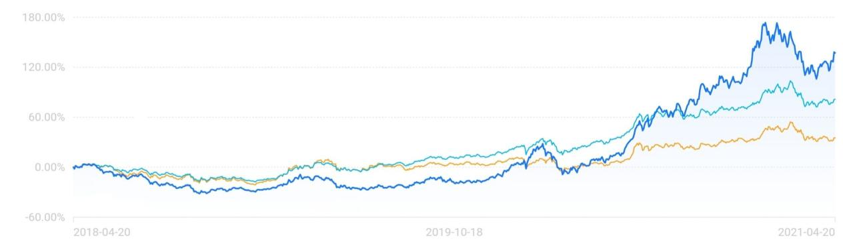
The process of analyzing the historical observation value of time series and inferring the time series value on the future time node is called time series prediction. Time series prediction exists in many fields and has important practical significance. For example, in the field of ecological environment, the daily precipitation can be predicted to guide agricultural production; In the medical field, disease transmission can be prevented by forecasting the incidence rate of diseases.
Time series classification is a branch of the problem of sequence classification. Firstly, according to the labeled sample points, a model which can learn the distinguishing features of different sequences is established, and then the model is used to classify the unlabeled sample points. The difference between time series classification and traditional classification is that in traditional classification, the attributes are order independent, while in time series classification, the attributes are order related. Therefore, how to deal with the order related attributes is the main challenge of time series classification. Like time series prediction, time series classification also exists in many fields. For example, in the field of biological science, heartbeat is classified by the shape and characteristics of ECG; In the field of agriculture, the health status of poultry is classified by the behavior data of poultry collected by sensors.
Traditional time series classification methods mainly analyze the time-domain similarity, shape similarity or change similarity between time series to achieve the purpose of classification. The classification effect largely depends on the similarity measurement between time series. In recent years, with the extensive application of deep learning in natural language processing, speech recognition and other fields, more and more researchers use deep learning method to solve the problem of time series classification.
In 1927, British statistician George udny Yule proposed autoregressive (AR) model to simulate the activity of sunspots. AR model marks the beginning of the development of traditional time series prediction methods. In 1931, British statistician Gilbert Walker proposed the moving average (MA) model. Later, Gilbert Walker further integrated AR model and MA model and proposed autoregressive moving average (ARMA) model. AR model, MA model and ARMA model constitute the basis of time series prediction, which are mainly applied to the stationary series prediction in the case of single variable, same variance and linear. ARMA model is still widely used in some fields, such as the application of ARMA model in the prediction of gear broken fault intensity in industry; In the literature, ARMA model is applied to the prediction of wind power generation under noise conditions.
George box and gwilym Jenkins proposed the autoregressive integrated moving average (ARIMA) model in time series analysis forecasting and control published in 1970. Compared with AR model, MA model and ARMA model, ARIMA model can deal with non-stationary series. The main idea is to transform non-stationary series into stationary series by difference method, and then use autocorrelation function and partial autocorrelation function to test the stationary series. According to the test results, one of AR model, MA model and ARMA model is selected to fit the stationary series. ARIMA model is widely used, such as electricity price forecasting, industrial accident mortality forecasting and so on.
AR model, MA model, ARMA model and ARIMA model require time series to be univariate, homovariance and linear. However, in reality, many time series are multivariable, heteroscedasticity and nonlinear, which can only model single variable, homovariance and linear time series.

For multivariable cases, Cox and Jenkins proposed the dynamic regression model arimax in 1976. Arimax model requires that the time series be stationary. When the time series are non-stationary or lack of stationarity, arimax is prone to false regression [17]. To solve this problem, Granger first put forward the concept of cointegration in 1981, and then put forward a complete set of cointegration theory and method with Engle in 1987. Among them, cointegration test can effectively deal with the regression problem of multivariate and non-stationary time series, and avoid false regression.

For the case of heteroscedasticity, Engle proposed the autoregressive conditional heteroscedasticity (arch) model [18] in 1982, which solved the problem that traditional time series analysis methods can not have

It can effectively deal with the problem of variable variance. Arch model can accurately simulate the volatility of time series, and has been widely used in the financial field for market decision-making and risk assessment. However, arch model is only applicable to the short-term autocorrelation process of heteroscedasticity function. In order to solve this problem, bollerslev extended arch and proposed the generalized arch model GARCH in 1985. GARCH model makes up for the shortcomings of arch and can reflect the long-term memory properties of real data.

For the nonlinear case, Tang Jiahao et al. Proposed threshold autoregressive (TAR) model in 1978. The basic idea of tar model is to combine several linear models to describe the change characteristics of nonlinear objects. Tar model belongs to parametric model. After TAR model was put forward, a series of nonparametric models were put forward, such as nonparametric autoregressive (NAR) model.
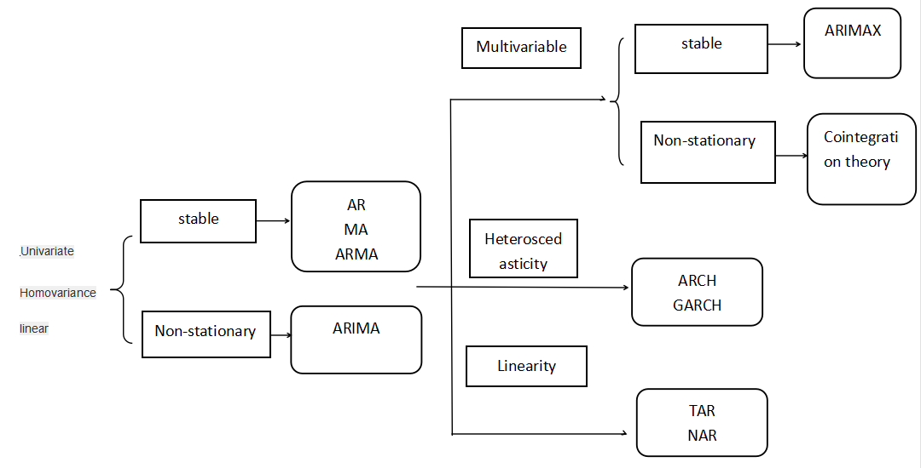

2 Time series type
Time series is a numerical series obtained by observing several variables produced by an object or system and arranging these variables in time order.From the definition of time series, we can see that time series has two basic elements: time and value. In order to describe the time series more accurately, this paper gives the definitions of single variable time series and multi variable time series from the mathematical point of view. Xuni and xmul are used to represent univariate time series and multivariable time series respectively, and t is the time step.The definitions of Xui and xmul are as follows:
$Xuni=\{p1,p2...pT\}$ (1)
$Xmul=\{q1,q2...qT\}$ (2)
For the i(i = 1,2, … , T) component Pi of Xuni, PI ∈ R represents the observed value of the observed variable at the i-th time.
For the i(i = 1,2, … , T) component of xmul, pi,pi ∈R, it means observed
The set of observed values of all n variables at the i-th time. Where qij(j=1,2...n)represents the observed value of the j-th variable at time i.
According to different classification criteria, time series can be divided into different types. The common classification criteria are: the number of variables, the type of variable value, time continuity, and sequence stationarity.
According to the number of variables to be observed, time series can be divided into univariate time series and multivariate time series. When the number of variables to be observed is one, the time series generated by the observed system is called single variable series; When the number of variables to be observed is greater than or equal to two, the time series generated by the observed system is called multivariable time series. For example, a meteorological bureau needs to observe the meteorological data of a certain city for a period of time. If only the temperature is used as the observation index, the obtained time series is a univariate time series. If the observed indexes include temperature, humidity, air pressure, precipitation, etc., the obtained time series is a multivariate time series.
According to the types of the values of the variables to be observed, time series can be divided into absolute number time series, relative number time series and average number time series. Absolute number time series is composed of a series of absolute numbers arranged in time, which is the most basic form of time series. It reflects the absolute level of the observed variables at different times. Absolute number time series can be subdivided into period series and time point series. Period series represents the order of the total amount of variables in a period of time, The time point sequence represents the sorting of the total amount of variables at a certain instant. Relative number time series and average number time series are a series of relative number and average number time series arranged in time order respectively.
Time series can be divided into discrete time series and continuous time series according to whether the time of recorded observation variables is continuous or not. For discrete time series, each data is based on the value recorded at a specific time, such as the daily sales volume of a clothing store; For continuous time series, data are continuously recorded along each time interval. For example, the temperature monitoring chart records continuous time series.

1.3 Pretreatment method
The introduction of the characteristics of time series shows that there must be some regularity behind the numerical changes of time series data points, and this regularity may be the result of a variety of factors. Time series decomposition method is trying to analyze the regularity of a time series, and decompose the regularity, so as to find out the factors that affect the original time series. There are four types of common influencing factors: long-term trend, seasonal variation, cyclical variation and irregular variation.
Long term trend influencing factors refer to the trend and state that the observed time series show a continuous rise or decline in a period of time due to the influence of some objective reasons. For example, with the development of the national economy, the gross national product has been increasing.
The influencing factors of seasonal variation refer to the periodic changes of the observed time series with the alternation of four seasons. There are natural factors and human factors that cause seasonal changes. For example, the sales volume of down jacket will change periodically with the change of season; For another example, the passenger flow of a scenic spot will reach the peak in the Spring Festival and national day, and the passenger flow is relatively small in other periods.
The influence factor of cyclic variation refers to the wave type variation of the observed time series with a period of several years. The main feature of this wave type variation is that the time series alternately rises and falls over a period of time. The business cycle in the market economy is more in line with this situation.
The influence factors of irregular changes refer to the irregular and unpredictable numerical changes caused by some random factors on the observed time series. A time series may have the above four factors at the same time, or only one or several, or even none, depending on the specific situation.
Although the time series decomposition method can qualitatively analyze a certain time series to a certain extent, the actual situation is often very complex. Sometimes it is not possible to directly analyze which factors are working from the time series diagram. In this case, using the time series decomposition method will greatly reduce the accuracy of the analysis. Based on the above situation, statisticians from the time series itself, through the establishment of early data as independent variables, late variables as dependent variables of the model to quantitative analysis of time series. This paper selects four classic models to introduce, which are AR model, MA model, ARMA model and ARIMA model. According to the introduction of traditional time series prediction methods, AR model, MA model and ARMA model are usually used to deal with single variable stationary time series, while ARIMA model can deal with single variable non-stationary time series by difference.
The scientific rationality of training sample set and the rationality of data expression have a very important impact on the later prediction. Data preparation includes the collection of original data, data preprocessing, variable selection and data processing. There are two methods of data preprocessing, scale transformation and distribution transformation.
Scale transformation is to limit the input network data to the interval of [0,1] or [- 1,1] through transformation processing. The main reason for scaling is that the input data of the network often have different physical meanings. Moreover, the neurons of RNN adopt symmetric S-type excitation function, which can prevent the saturation of neuron output due to the excessive absolute value of net input, and then adjust the value into the flat area of error surface.The common distribution transformation is mainly through the normalization processing, so that the value of the input data falls within the interval (0,1), and the conversion formula is:
$I(t)=\frac{d(t)−min(d(t))}{max(d(t))−min(d(t))}$ (3)
Where I (t) is the network input and D (t) is the sample data. After using the trained network to output the predicted value, the output data should be de normalized,the formula is as follows:
$O(t)=o(t)∗(max(d(t)−min(d(t)))+min(d(t))$ (4)
Where o (t) is the predicted value and O (t) is the predicted value after the inverse normalization.
When the distribution of network training samples is more uniform, the distribution curve of samples is relatively flat. When the distribution of samples is not ideal, the distribution transformation is generally carried out. Because the transformation is nonlinear, the results not only compress the range of data change, but also improve its distribution.

2.Application of CNN and RNN in time series prediction and classification

2.1 RNN
RNN is a kind of network model characterized by ring appearing in the network, and it can store the dependence between the input of neuron at this time and the output of neuron at the previous time. A lot of previous studies have proved that the forward static neural network has good approximation ability to nonlinear functions, and the characteristics of the actual system can be simulated by the forward static neural network. In addition, the structure and algorithm of forward static neural network are relatively simple. Therefore, it has been widely used in the modeling, control and prediction of nonlinear systems. According to incomplete statistics, 90% of the networks in the 1990s belong to BP networks. However, when people use these networks for forecasting, they find that they have a fatal weakness, that is, they are not dynamic. Most systems not only have nonlinear characteristics, but also have dynamic characteristics, that is, the output of the system at a certain time is not only related to the input of the current time, but also related to the input or output of the past time. Therefore, if the forward static neural network is used to simulate the data with dynamic characteristics, the result must be distorted, so the recurrent neural network RNN is introduced.

The difference between RNN and forward static network is that the signal from one neuron to another will not disappear immediately, but will live for a period of time. Theoretically, the lifetime can be infinite. Therefore, the ability of network to solve complex and dynamic problems is improved. Therefore, RNN has higher modeling ability than forward static network. RNN has many important characteristics that forward network does not have, such as dynamic characteristics and information dynamic storage. And in most cases, the RNN time series prediction model uses fewer parameters to get more accurate results. The following figure shows the RNN model.
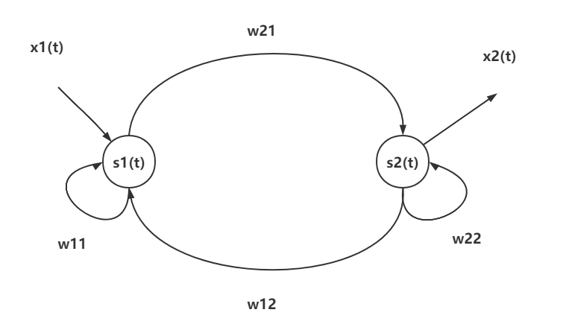

As shown in the figure, there are two fully connected neurons, one input connected to one neuron and one output connected to another neuron.
The function of hidden layer neurons is to extract and store the internal rules from the sample data. Each hidden layer neuron has several weights, and each weight is a parameter to enhance the network mapping ability. The number of neurons in the hidden layer is too many, so it is possible to memorize the noise data in the sample data set, thus the problem of "over fitting" will be raised and the training time will be increased. The number of neurons set depends on the number of training samples, the size of sample noise and the complexity of the rules in the samples. The most common method to determine the number of neurons in the hidden layer is to try and join. The training network with fewer neurons is set first, then the number of neurons is gradually increased. The same sample set is used for training, and the results are compared and the optimal number of neurons is determined. Some empirical formulas can also be used to determine the number of neurons in the implied layer, as follows:
$n=c+\sqrt{m+l}$ (5)
$n=\log_{2}{m}$ (6)
$n=\sqrt{ml}$ (7)
n is the number of hidden layer nodes, m is the number of input layer nodes, l is the number of output layer nodes, and c [1,10] is the previous constant.
The network with deviation and at least one S-type hidden layer plus one linear output layer can approximate any rational function. This has actually given a basic principle for designing RNN networks. Increasing the number of layers can further reduce the error and improve the accuracy, but it also makes the network complex, thus increasing the training time of network weights. Only when learning unconnected functions, two or more hidden layers are needed. Generally, only one hidden layer is considered first. For RNN, the number of network layers of recurrent network is related to the complex program of the system. If a system is complex, multiple hidden layers can be considered.
In recent years, it will inevitably lead to the increase of network parameters and the extension of network training time. Therefore, it is necessary to balance the accuracy of network prediction with the complexity of network parameters. The RNN model designed in this paper includes an input layer, a fully connected hidden layer and an output layer.
The learning rate of network has an important influence on the training of network. The learning rate determines the change of weights in each training cycle. If the learning rate is too high, the network will be unstable. If the learning rate is too low, the training time will be too long and the convergence speed will be slow, which can not guarantee that the error of the network will eventually tend to the minimum. Therefore, in the choice of learning rate, generally tend to choose a smaller learning rate to ensure the stability of the network, the selection range of learning rate is generally in the range of [0.01,0.8]
In order to show the nonlinear approximation ability of recurrent networks, S-type transfer function is usually used to achieve the goal. It can be located in the hidden and output layers of recursive networks. If S-type transfer function is introduced into the network output layer, the speed of network training can be accelerated, but the output of the network is limited between (- 1,1), so the input and output of the system should be normalized first.

2.2 CNN
Convolutional neural network is a kind of neural network which is specially used to process data with similar network structure. It can extract features from original data by imitating the mechanism of biological vision. Because it has the characteristics of weight sharing, it effectively reduces the complexity of the network, avoids the over fitting problem caused by too little data, and avoids the complexity of data reconstruction in multi-dimensional data feature extraction. The network layers generally include convolution layer, activation layer, pooling layer and full connection layer. Convolution layer is the most important layer in the whole network. This layer mainly uses convolution check input data to do convolution operation, uses neurons to observe data (each neuron only pays attention to one feature), and then extracts features. The convolution process is shown in the figure.
In order to describe the process of convolution operation more clearly, the read data elements are numbered, Xi，j are the elements in the i-th row and j-th column, Wm，n are the weights in the m-th row and n-th column, Wb is the bias term of the filter, and f is the activation function：
$a_{i,j}=f(\sum_{m=0}^{2}{\sum_{n=0}^{2}{W_{m,n}X_{i+m,j+n}+W_{b}}})$ (8)
The function of the activation layer is to make nonlinear mapping to the output of the convolution layer and change the weight appropriately. The commonly used functions are "sig moid", "relu" and so on.
Pooling layer is also known as "down sampling layer". The main function of this layer is to compress the number of data and parameters and reduce over fitting. There are two common pooling methods: maximum pooling and average pooling.

2.3 Comparison between CNN and RNN
CNN：
1. CNN uses fixed size input and generates fixed size output.
2. CNN is a feedforward artificial neural network - a variant of multi-layer perceptron designed to use the least amount of preprocessing.
3. CNN uses the connection pattern between neurons and is inspired by the visual cortex of animals. Individual neurons in the visual cortex of animals are arranged in such a way that they respond to the overlapping areas of the tiled visual field.
4. CNN is an ideal choice for image and video processing.
RNN：
1. RNN can handle any input / output length.
2. Unlike feedforward neural network, RNN can use its internal memory to process any input sequence.
3. Recurrent neural network uses time series information. For example, what I said last time will affect what I will talk about next.
4. RNN is an ideal choice for text and speech analysis

natural language processing
As a sub field of artificial intelligence, NLP focuses on the realization of information interaction between human and computer, so that the computer can understand and use human language. As an important tool for people to communicate, natural language is commonly used in English, Chinese, Russian and so on. Natural language processing mainly deals with words, paragraphs or chapters. The main methods are rule-based and statistics based. The rule-based method is to process the text data manually according to the language related rules; The method based on statistics is to process the text data through the statistical analysis of large-scale data sets. The quality of data set has a great influence on the performance of natural language processing model. Therefore, with strong data support, we can better process and analyze the text. The main research contents of Chinese based natural language processing include word segmentation, part of speech tagging, word sense disambiguation, text classification and language modeling.

3.1 Natural language processing flow
The process of natural language processing can be divided into five steps
(1) Get text through web crawler or local import.
(2) Preprocess the text, segment the text and remove the modal particles and stop words.
(3) The text is characterized, and the words are mapped to the corresponding word vector form by using hot coding or word embedding technology. The unique hot code is also called one bit effective code, that is, n-bit register corresponds to N states one by one, and only one bit in the register is effective; Word embedding technology quantifies words into low dimensional dense vector space with fixed dimension, which is more efficient than hot coding.
(4) For model training, support vector machine, decision tree and neighborhood algorithm can be used machine learning model algorithms such as convolution neural network or recurrent neural network can also be based on deep learning.The model and algorithm are given.
(5) Test set is used to verify the training model and evaluate the model algorithm.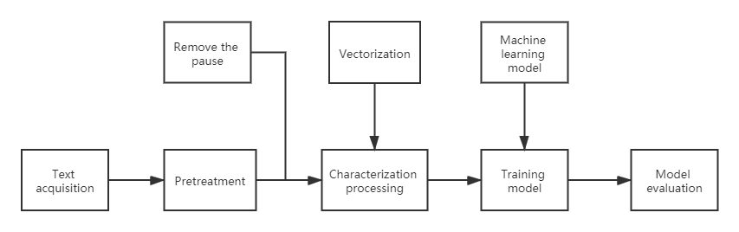

This paper briefly introduces the above five steps: corpus collection mostly uses web crawler or local text data set. The corpus preprocessing stage mainly includes the operation of corpus cleaning, word segmentation, part of speech tagging and removing pause words. In the process of characterization, it is necessary to vectorize the preprocessed text and express the words into vector form so that the computer can calculate them. This operation helps to find the similar relationship between different words through vector expression. In the model training phase, the training methods used include traditional supervised, unsupervised and semi supervised learning models. The specific models need to be selected according to different application scenarios. For the evaluation of the effect after modeling, the commonly used effect evaluation indicators are accuracy rate, recall rate and so on.

3.2 Statistical model of natural language processing
In natural language processing, words, characters or bytes are often regarded as marked entities according to the design features of different models. N-gram language model is a discriminant model based on probability. The N in n-gram represents a set of N words. Taking the text sequence composed of these N words as the input, the joint probability of these N words will be output after the processing of N-gram language model. N words need to be input in sequence, but repetition is allowed between words. In the common N-gram model, when N = 1, it is called unigram; When N = 2, it is called bi-gram; When N = 3, it is called tri-gram.
Suppose a sentence s is composed of n words $w_{1}$,...,wn to calculate the probability of its occurrence, we can use the chain rule of conditional probability:
$P(S)=P(w_{1},...,w_{n})=P(w_{1})P(w_{2}|w_{1})...P(w_{n}|w_{n−1},...,w_{1})$ (9)
This formula has a defect in calculation. The complexity of $P(w_{n}|w_{n−1},...,w_{1})$ is O (n), which is a huge order of magnitude. In order to solve this problem, we need to introduce the Markov hypothesis, which assumes that the probability of a word is only related to the N words before the word:
$P(w_{1},...,w_{n})=\prod_{i=2}^{n}{P(w_{i}|w_{i−1},...,w_{1})}≈\sum_{i=2}^{n}{P(w_{i}|w_{i−1},..,w_{i−N+1}}$ (10)
In equation (10), N represents the parameter corresponding to N in the N-gram model, and the appearance of the word $w_{i}$ depends on several words appearing in front of it.
The larger the number of N in the N-gram model, the more other words it depends on when calculating the probability of a word, the better the effect of the model. However, when the value of N becomes larger, the data will become sparse and zero probability problem will appear. In addition, the larger the value of N, the larger the parameter space and the disaster of dimension.

3.3 Word vector technology
Word vector technology is the general name of language modeling and feature learning technology in natural language processing. Its main purpose is to transform human natural language into data convenient for computer operation, and to establish the mapping relationship between words and real vector. This section mainly introduces two kinds of word vectorization technology, the first is hot coding technology, the second is word embedding technology.
The hot coding technology is a kind of vectorization technology of natural language through discrete feature values. It has a good effect in the vectorization of discrete feature or classification value data. The unique hot coding uses n-bit register to correspond with N states one by one, and only one bit in the register is valid, which is also called one bit valid coding. When using unique hot coding for natural language processing, a typical usage is to express a feature of an attribute through unique hot coding. For example, when recording students' achievements, we can code "excellent", "good", "up to standard" and "not up to standard" into "1000", "0100", "0010" and "0001". In coding, only one bit is 1, which means that there is only one effective coding bit in the exclusive hot coding. According to this example, we need to count the number of words in the text when we code the words in the text, which will determine the dimension of the vector after the hot coding. then. In this paper, we encode a word vector with only one bit of 1 and the product of each other is 0. After the construction of the word vector, the vector set can be used to represent a sentence or a text. The hot coding solves the problem that the data attribute in the classifier is not easy to deal with, and expands the characteristics of the data to a certain extent. When the number of data attributes or lists is large, the feature space will become large, and the space-time complexity of hardware operation will also increase. The principle of exclusive hot coding is simple and easy to understand, which is suitable for the application scenarios with small amount of text data. However, when there are too many words in the text data set, it will bring some problems when using hot coding for word vectorization. For example, after the words are individually encoded, because all the encoded word vectors have only one digit of 1, the vector distance between words is the same, which can not reflect the relevance between words. At the same time, when using hot coding to vectorize words, it is default that the relationship between words is independent of each other, but in most cases, the relationship between words is mutual influence. In order to solve these problems, word embedding technology based on dense space arises at the historic moment.
Word embedding technology is the mainstream word vectorization technology when experts and scholars study natural language processing in recent years. The feature of this technique is that all words are represented as low dimensional dense vectors, and the similarity between words can be evaluated through a fixed dimension continuous vector space. Among them, the greater the similarity of words, the smaller the angle of the word vector in the vector space. The fixed vector dimension will greatly improve the efficiency of computer data processing compared with the only hot coding. As an important foundation of applying neural network model to the field of natural language processing, many technology companies have created different word embedding tools. Among them, word2vec tool proposed by Google is a milestone invention in this industry. The tool also includes two training models of word vector relevance, one is SGM (skip gram model), the other is cbow (continuous bag of words) model.

3.4 Skip word model
The main function of SGM model is to generate several words around a word based on a word in the text. During the training of SGM model, all the word vectors will be expressed as two fixed dimension word vectors to calculate the conditional probability. Before word vector training, we need to set the window size of background words in advance. In the process of word vector training, each word will act as the head word and background word, and the vector size as the head word and background word will be stored in the corresponding two word vectors. For example, suppose that a text sequence consists of { $w_{1}$,...,$w_{n}$}, n words. Set the size of the background window to 2. The training process of jump word model is to generate the joint probability of background words $w_{c+1}$,$w_{c+2}{,w}_{c−1}$and ${,w}_{c−2}$ whose distance from the head word $w_{c}$ is no more than two words,the calculation formula is as follows:
$P(w_{c+1},w_{c+2}{,w}_{c−1}{,w}_{c−2}|w_{c})$ (11)
According to the skip word model, when the head word $w_{c}$ has appeared, the occurrence probability of background words $w_{c+1}$,$w_{c+2}{,w}_{c−1}$and $w_{c−2}$ is independent of each other. According to the product rule of conditional probability, it can be written in the form of multiplying four conditional probabilities.
In the process of building SGM model, each word will be expressed as two fixed dimensional vectors to calculate conditional probability. Let the index of a word in the corpus be I. when the word is trained as the head word, its word vector is expressed as $C_{i}∈R$, and when the word is trained as the background word vector, it is expressed as $B_{i}∈R$. Where R is a fixed dimension space, that is, the word vector corresponding to a word must belong to the dimension space. Suppose the head word $w_{a}$, index a, a background word $w_{b}$ of the word, index b. The conditional probability of generating background word $w_{a}$from head word $w_{b}$ is as follows:
$P（w_{b}|w_{a}）=\frac{exp(B_{b}^{T}C_{a})}{\sum_{i∈V}{exp(B_{i}^{T}C_{a})}}$ (12)
V = {1,..., n} denotes a set of word indexes in a text set. $C_{a}$ and $B_{b}$ are used to represent the vectors corresponding to the head word $w_{a}$ and the background word $w_{b}$ respectively, and $B_{i}$ is used to calculate the frequency of other words and head words. Exp is an exponential function with a natural constant at the base of e.
Suppose that in a text sequence of length n, set the size of the background window as m and the word $W^{(t)}$ of index t. Assuming that the head word and the background word are independent of each other, when the window size of the background word is m, the probability of generating 2m background words from the head word is calculated as follows:
$\prod_{t=1}^{n}{\prod_{−m≤j≤m,j≠0}{P(}}W^{(t+j)}|W^{(t)}$) (13)
t is from 1 to n, which means to traverse all the words in the dataset. At the same time, ${P(W}^{(t+j)}|W^{(t)}$) from${P(W}^{(1+j)}|W^{(1)}$) to ${P(W}^{(n+j)}|W^{(n)}$) calculated the probability of all the words as the center to generate background words.
The training process of SGM model needs to learn the model parameters through maximum likelihood estimation, that is, the minimization of loss function. The loss function is as follows:
$−\prod_{t=1}^{n}{\prod_{−m≤j≤m,j≠0}{\log{{P(W}^{(t+j)}|W^{(t)})}}}$ (14)
If stochastic gradient descent is used for optimization, a short subsequence will be randomly sampled in each iteration of the training set statement, and the gradient will be calculated by calculating the loss of the subsequence, so as to update the model parameters. By taking logarithm of conditional probability, the gradient of the vector of the head word and the background word is calculated. Substituting (12) into formula (14), we can get:
$\log{P(w_{b}|w_{a})=B_{b}^{T}C_{a}−\log{(\sum_{i∈V}{exp(B_{i}^{T}C_{a}))}}}$ (15)
(15) After differentiation, we can get the gradient of $C_{a}$:
$$\frac{∂\log{P(w_{b}|w_{a})}}{∂C_{a}}=B_{b}−\frac{\sum_{j∈V}{exp(B_{j}^{T}C_{a})B_{j}}}{\sum_{i∈V}{exp(B_{j}^{T}C_{a})}}=B_{b}−\sum_{j∈V}{(\frac{exp(B_{j}^{T}C_{a})}{\sum_{i∈V}{exp(B_{j}^{T}C_{a})}})B_{j}=B_{b}−\sum_{j∈V}{p(w_{j}|w_{c})B_{j}}}$$
(16)
The parameter j is introduced to prevent j and i from being reduced in the process of calculation.

3.5 Continuous bag of words model
The biggest difference between the CBOW model and the SGM model is that the CBOW model generates the head words from a given number of background words in the text. Suppose that $w_{c}$ is taken as the center word and the size of the background window is set to 2. The focus of CBOW model research is to calculate the conditional probability of generating the center word $w_{c}$ by giving the background words${ w}_{c+1}$,$w_{c+2}{,w}_{c−1}$ and$w_{c−2}$, the calculation formula is as follows:
$p(w_{c}|w_{c+1},w_{c+2}{,w}_{c−1}{,w}_{c−2})$ (17)
Classification is a very important method in natural language processing. The principle of classification is to sum up a classification function or build a classification model based on the existing data, which is what we usually call a classifier. Through the classification function or classifier, the data in the database can be classified into a specific category according to its characteristics, and finally applied to the data prediction. With the research of machine learning and deep learning, many classifier algorithms have been invented, including NBC (naive Bayes classifier), KNN (k-nearest neighbor), SVM (support vector machine) and classification model based on convolutional neural network. The following figure shows the flow chart of text classification, which is mainly divided into five steps:
(1) The data set is divided into training set and test set. The training set is responsible for model training, and the test set is responsible for verification and evaluation.
(2) Preprocess the data set text, segment the text and remove the modal particles and stop words.
(3) In the stage of feature extraction, we need to first vectorize the words, and then extract the feature words with strong ability to distinguish text categories. The common way of word vectorization is hot coding or continuous coding, which maps words into fixed dimension word vector form. The common methods of extracting feature words are information gain, TF-IDF, chi square check and so on.
In the model training stage, machine learning model algorithms such as support vector machine, decision tree, proximity algorithm or logical regression can be used, and deep learning model algorithms such as convolution neural network or recurrent neural network can also be used. A classifier model is selected to train the training set data and adjust parameters in the process of training, so as to achieve better classification results.
Test set is used to verify the training model and evaluate the model algorithm.

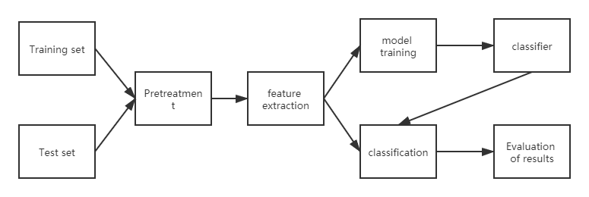

3.6 RNN algorithm
Recurrent neural network (RNN) is an important variant of neural network, which has been widely used in natural language processing.
Conceptually, they are different from standard neural networks because the standard input in RNN is a word, not the whole sample in standard neural networks. This makes the network flexible to deal with sentences of different lengths, but the standard neural network can not do this because of its fixed structure. It also provides an additional advantage to share features learned in different text locations that are not available in standard neural networks.
RNN regards each word in the sentence as a separate input for the occurrence of time "t", and uses the activation value at "t-1" as an input other than the input at time "t". The following figure shows the detailed structure of RNN architecture.
The architecture described above is also called many to many architecture (Tx = Ty), that is, the number of inputs = the number of outputs. This structure is very useful in sequence modeling.
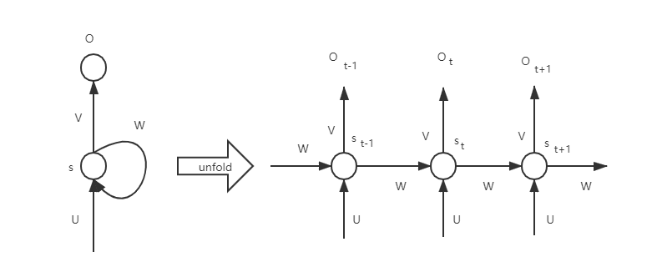

The limitations of RNN are as follows
1. The RNN architecture example described above can only capture dependencies in one direction of the language. Basically, in the case of natural language processing, it assumes that the following words have no effect on the preceding words. Based on our experience with language, we know that this is definitely not true.
2. RNN can not capture the long-term dependence, and the problem of gradient disappearance reappears in RNN.

