FEASIBILITY STUDY
STAGE COACH THEARTRE SCHOOL – MERTHYR TYDFIL
(PHASE 1 OF MASTERPLAN CONCEPT)
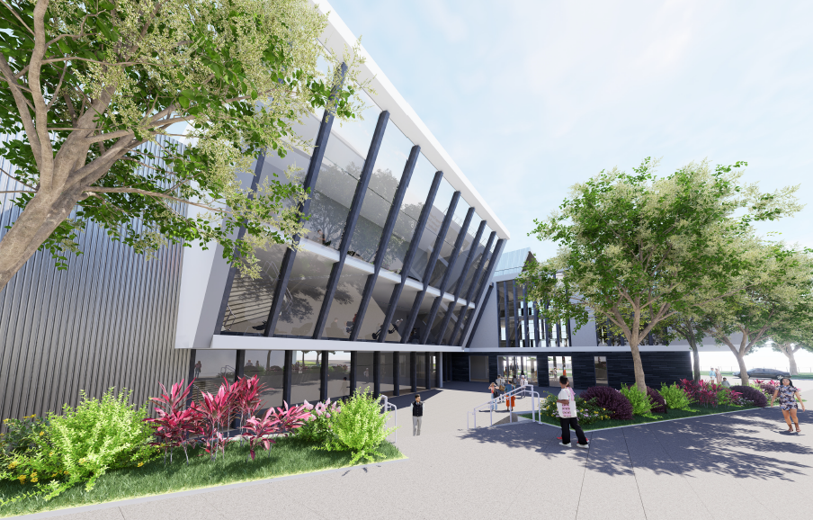

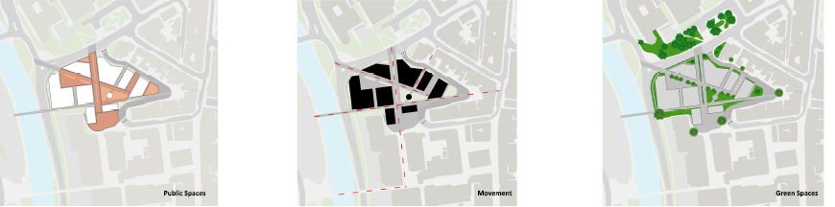

Client: Ace Capital Projects Ltd
M.E.S.S Construction Services Ref: SCT001

Version: A
Date: December 2024
DOCUMENT CONTROL

Project Name Stage Coach Theatre School Project Number 001
Date of Issue 11/12/2024 Version Number 01
Reason For Issue Feasibility Study

Document Authors Position
Max James Commercials & BIM
Eleanor Black Materials & Fabric
Shalom Joseph Design & Structural
Sam Williams Health & Safety

Signatures
Mjames
Eblack
SJoseph
Swilliams

Approved By
Project Team

Security Classification
Confidential

Distributed to
ACE Capital Projects Ltd

Executive Summary

Purpose of Report

This report is intended for use solely by ACE Capital Projects Limited as part of the review of the Phase 1 of constructing the overall masterplan of developing the Glebeland site within Merthyr Tydfil (Previous occupation the bus terminal). The Phase 1 element comprises of the construction of a Stagecoach Performing Arts Centre within the vicinity of the site.

Various surveys and site information has been obtained as part of this feasibility study to enable an understanding of the site conditions and create a recommendation on how to proceed with the build. The associated recommendations are listed within the body of the report. It is not intended for this document to be exhaustive in detailing all the design elements due to the RIBA Stage the information is at however; it does provide a guide to the potential extent of the works and as to whether the client would like to proceed on the basis of the findings.

Where there have been assumptions and exclusions listed within the report, they will be clearly stated and referenced as the above.

Contents
1.0 INTRODUCTION 8
1.1 Project Background 8
1.2 Scope of Feasibility Study 8
1.3 Input of Feasibility Study 9
1.4 Project Team 10
1.5 Feasibility Project Program 11
2.0 BACKGROUND INFORMATION 13
2.1 Client Supplied Information 13
3.0 OUTLINE BRIEF 15
3.1 Clients Requirements 15
3.2 Proposed Occupancy 15
3.3 Schedule of Accommodation 16
4.0 SITE LOCATION 18
4.1 Site Location Description / Overview 18
4.2 Historical Information Relating to the Site 19
4.3 Site Investigation 21
4.4 Existing Statutory Services 22
4.41 Electricity 22
4.42 Water & Sewer 23
4.5 Archaeology 24
4.6 OS Data 24
5.0 DEVELOPMENT CONSTRAINTS 26
5.1 Conservation Area & Associated Information 26
5.11 CADW Information 27
5.12 Tree Preservation Orders (TPO) 28
5.2 Flood Consequence Assessment 30
5.21 Pollution Prevention 31
5.3 Environmental Protection 31
5.31 Radon Protection 31
5.32 Contaminated Land 33
5.33 Previous Development 34
5.4 Party Wall Act 35
6.0 ACCOMODATION REQUIREMENTS 36
6.1 Schedule of Areas 37
6.2 Plans 37
6.3 Precedent Studies (Supplied by Client) 38
7.0 DESIGN SPECIFICATION 40
7.1 Design Specification 40
7.2 Building Regulation Standards 43
7.2 Building Regulation Standards (Specific Systems) 47
8.0 COST REPORT 52
8.1 Cost Report 52
60
9.0 PROJECT PROGRAMME 61
9.1 Project Programme 61
10 CONCLUSION / REOMMENDATIONS 64
10.1 Conclusion 64
10.2 Recommendations 64
11 DRAWINGS & ASSOCIATED INFORMATION / APPENDICIES 66
11.1 Initial Master Plan 66
11.2 Developed Master Plan 67
11.3 Single Stage Feasibility Programme 68
11.4 Two Stage Feasibility Programme (D&B) 68
11.5 Schedule of Surveys 70
11.6 Pre-Construction Services Organisational Chart 71
11.7 Planning Applications within Area 72

1
Introduction
This feasibility report has been prepared for ACE Capital Projects Ltd to explore options in relation to the first phase of a wider development / master plan of the old bus station site situated in Merthyr Tydfil.

INTRODUCTION

1.1 Project Background
M.E.S.S Construction Services Ltd have been commissioned by client ACE Capital Projects Ltd to deliver full services for the construction of a Stagecoach Performing Arts centre within Merthyr Tydfil. The construction of the Stagecoach Performing Arts centre forms a wider scope of works to which a masterplan of the site has been developed. M.E.S.S Construction Services Ltd scope is only to deliver the Stagecoach Performing Arts centre element. This report details the key elements of the site, listing out all the background information, outlining the brief, identifying the site/location and any development constraints associated with it, accommodation requirements and design specifications, a cost estimate, an indicative programme followed by a recommendations section at the end of the report.

1.2 Scope of Feasibility Study
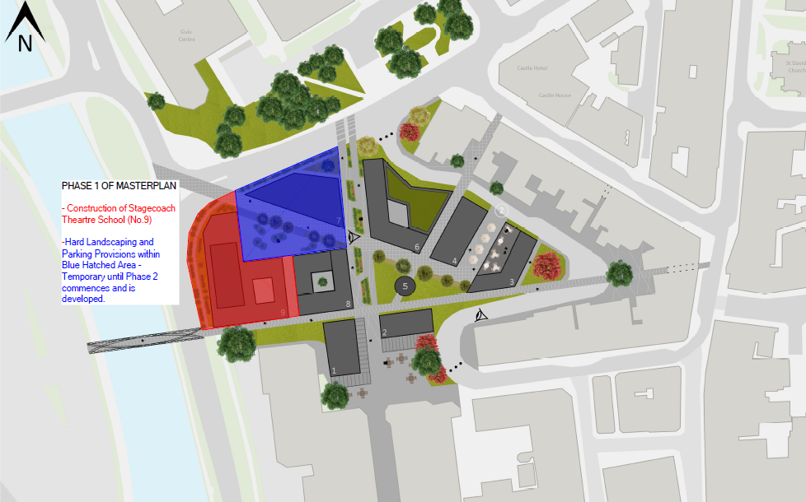
The scope of the feasibility study details the first phase of an overall masterplan for the site detailed above. As an identification of area, below lists the areas of the overall masterplan which are being developed within this first Phase:

Figure 1 – Identifies areas being developed / considered as part of this feasibility report

1.3 Input of Feasibility Study
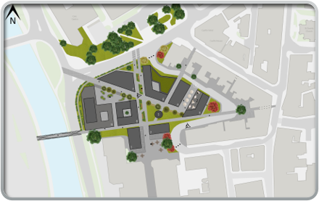
This report is based upon the information submitted by the client, within the information provided there was a discrepancy between the original masterplan and the developed Phase 1 proposal. The discrepancy lies within the GIFA of the StageCoach building, with the GIFA being larger than the original masterplan. After confirmation from the client, M.E.S.S Constriction Services Ltd are proceeding with the most up to date proposals, which would result in the overall masterplan not being achievable with the sacrificial element being the Gym / Office Spaces.

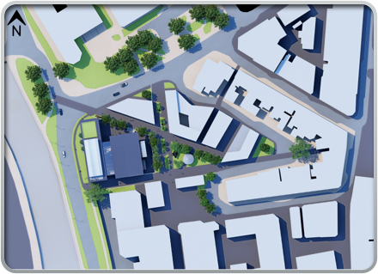
Figure 2 – Initial Masterplan with the sacrificial element highlighted in red.

Figure 3 – Proposal carried forward by M.E.S.S Construction Services Limited, with the red showing the sacrificial element to the original masterplan.

1.4 Project Team
The Project Team for Stagecoach Performing Arts Centre are as follows:
Funding
Welsh Government and ACE Capital Projects Ltd (40/60 Match Funding)

Client
ACE Capital Projects Ltd - Founded in 1822 ACE Capital Projects Ltd are a leading property developer company with head offices in Kings Road SA1. They have an extensive portfolio of urban regeneration schemes, master planning and landmark redevelopment projects with a key focus on sustainability, innovation and social value.
Contractor

M.E.S.S Construction Services Ltd

Design Team
Commissioned by Client
A Pre-Construction Services Organisational Chart has been produced listing out roles & responsibilities, this has been included as an appendix to the report.

1.5 Feasibility Project Program
As part of the feasibility exercise, a program was generated in order for the study to be conducted in a timely manner for the client. Below indicates the program which the client was informed of throughout the duration of the production of this report:
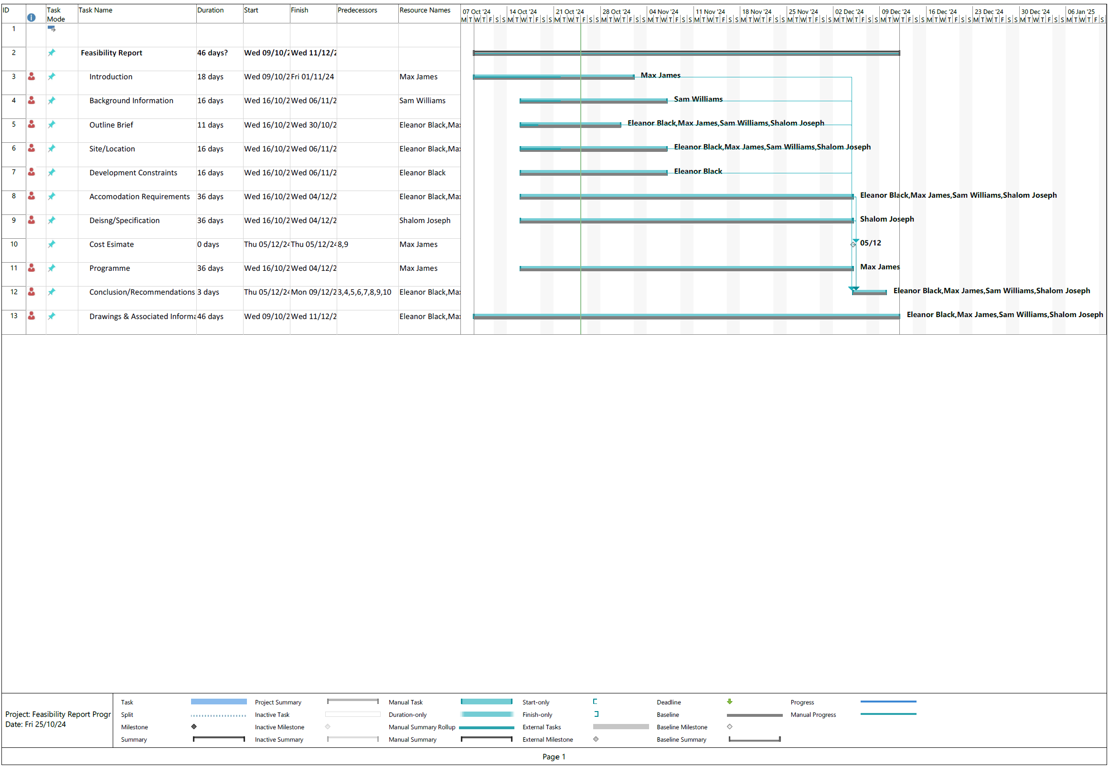

Figure 4 – Feasibility Project Program

2
Background Information
The background information details the information supplied by the client, with the aspirations and details being listed. The use of the building and the proposal is identified, with the occupancy also being a factor of consideration.

2.0 BACKGROUND INFORMATION

2.1 Client Supplied Information
The client has supplied information to date to which the basis of the feasibility report is based upon, as a summary the information provided to inform this feasibility is listed below:
02/10/24 – The client had presented a overall masterplan of the site, to which they wanted to develop the first Phase pf the development which is the Performing Arts Centre.
08/10/24 – Initial information was provided by the client which consisted of a site Masterplan and an early concept design of the Performing Arts Centre. ​
21/10/24 – Client had uploaded EIR’s and AIR’s into the project file for review.​
06/11/24 – The client received confirmation that a package containing several architectural drawings were ready to be reviewed.

3
Outline Brief
The brief provided by the client is listed within this section of the report, as well as the client’s requirements and the interpretation of the brief, listing out the deliverables.

3.0 OUTLINE BRIEF

3.1 Clients Requirements
The clients’ requirements are set out within the project brief, to which the brief provided is summarized into the clients’ aspirations as follows:

- Mixed use theater for both local and visiting groups to perform – Achieved by adherence to brief and design​
- Respectful to surrounding buildings & planning – Achieved by study into surrounding area, included within this report​
- Safe spaces for children – Achieved by consideration such as access control, building orientation, included within this report​
- Outdoor areas – Achieved by allowance of courtyard within building, included within BCIS cost/m2 rate ​

3.2 Proposed Occupancy
M.E.S.S Construction Services Limited aims to transform the once vacant area into a comfortable and safe space that will welcome people of all ages within the community. ​
This proposed development will act as a small contribution to achieving a much larger objective which is to improve the overall reputation and appearance of Merthyr Tydfil's town center. By incorporating modern architectural aesthetics with the natural environment, the area can become visually appealing thus attracting more positive attention.
The proposed occupancy has been scheduled out within the client’s brief provided to M.E.S.S Construction Services Limited. The client / end users are StageCoach Theatre School and are a performing arts group who at present use two schools to host their lessons. The Phase 1 of the masterplan in which M.E.S.S Construction Services Limited are going to deliver will include a mixed-use theatre and performance centre which will be accessible for both local and visiting groups to study and perform. The space will be flexible to allow other types of entertainment to create another form of revenue, with dedicated spaces to a café or bar. The building will include safe spaces for children to relax in between sessions, as well as amenities.

3.3 Schedule of Accommodation
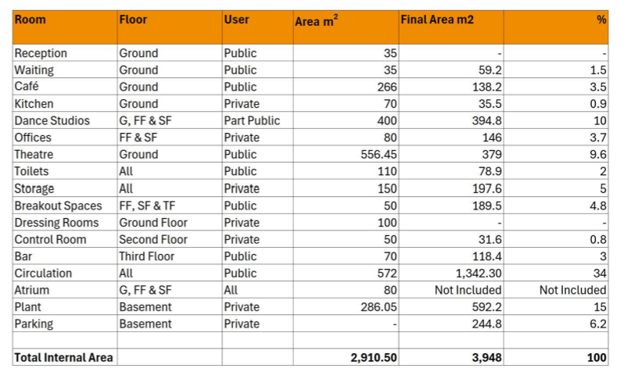
A schedule of accommodation was provided by the client, which the cost plan has been based upon. This has resulted in the overall GIFA of the building being bigger than the initial masterplan, which is referred to within section1.3 of the report. Below references the schedule of accommodation:

Figure 5 – Schedule of Accommodation
GIFA design & construction being based upon

4
Site / Location
A description of the site is provided within this section of the report, with all relevant details of ownership, site investigation, relevant surveys etc being listed.

4.0 SITE LOCATION

4.1 Site Location Description / Overview
The site situated within Merthyr Tydfil referred to as the Glebeland. The site itself is adjacent to the Merthyr Tydfil County Borough Council offices and is situated to the east side of the River Taff. The Glebeland site for redevelopment was formally a bus terminus within the heart of the Merthyr Tydfil town centre. Based off street view camera imagery, the ground surface on this site appears to be relatively flat consisting of mixed aggregate along with small vegetation patches that have grown near the boundary lines.
Preliminary information concerning the site’s historical nature suggests that there is a possibility of contamination present within the soil as visible plant life seems to be lacking and showing signs of discoloration. This is due to the likelihood of previous industrial activity carried out on the land which caused pH fluctuations in the soil.​
Surrounding the site’s perimeter, a combination of different heavy-duty fencing with a vehicle access gate and a single-entry gate both located at the North side has temporarily been installed with concrete block reinforcement. Security fencing selected comprises of close boarded panels and clear view mesh for both fencing and entry points which are all potentially made from steel.​
Satellite imagery of the site indicates that vehicular access is only limited to the North elevation, but it provides adequate space for manoeuvrability. A public footpath lies outside of the perimeter fencing to the West and could potentially be used for alternate purposes such as single-entry access and evacuation. ​
- There is a mixture of residential along with commercial properties and footpaths adjacent to the site’s perimeter line at the South – Southeast elevation.​
- From East – West, the natural landscape appears to slightly slope in a downwards direction while the hill from West.
- Satellite imagery shows the River Taff running along the valley. ​

Historical Information Relating to the Site
1786
Remnants of a Roman auxiliary fort such as bricks and a tessellated pavement was unearthed upon constructing the former Penydarren House.
1820’s
At the height of the Industrial Revolution, iron production in Merthyr had made up 40% of Britain’s iron exports.
1902-1904
Before the football ground was built at Penydarren Park, excavation work revealed additional remains connected to the Roman fort which included a granary and a well as seen in Figure 1:

1960’s
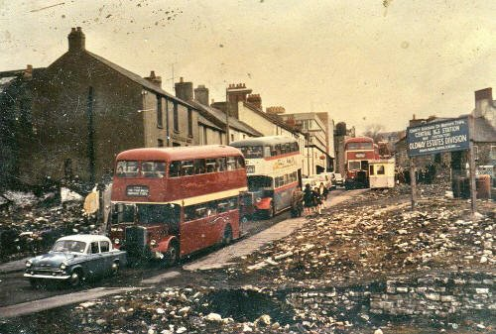
Records indicate that the central bus station located on Castle Street had been built in the late 1960’s. Figure 2 partially shows the site before construction works commenced:

Late 1950’s-1970’s
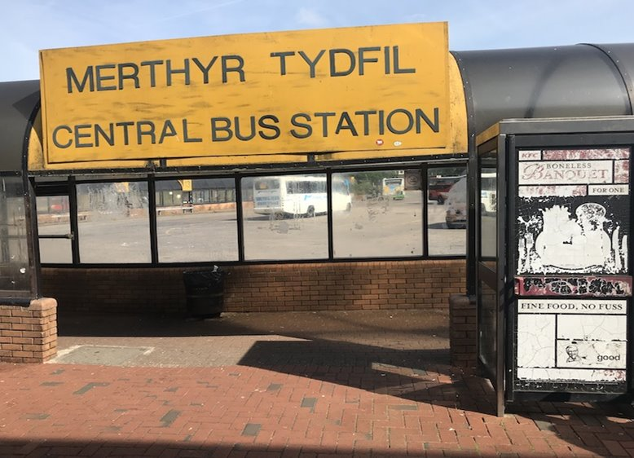
To improve the county’s infrastructure, Merthyr Tydfil had experienced major changes as large areas of the built environment were demolished in order to expand the town centre and create space for new road layouts. Many 18th – 19th century residential buildings were demolished during this time and would explain the remaining debris shown below:
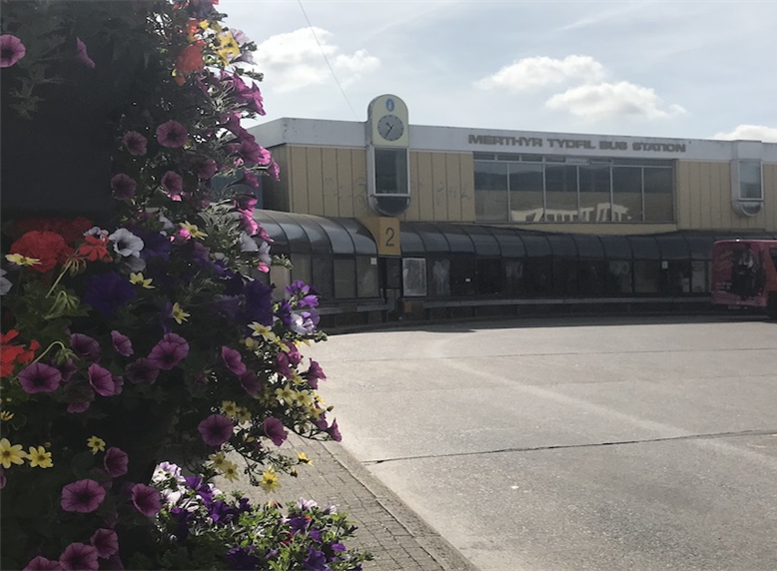
Late 2021
Aberdare demolition were instructed by Merthyr Tydfil’s county council to carefully dismantle the disused bus station on the Glebeland site in a safe manner.
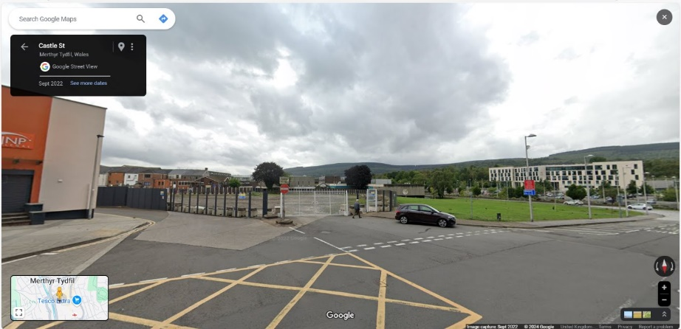

Site Investigation
In order to obtain and establish the strata / ground conditions of the site, a report has been downloaded from the Merthyr Tydfil planning portal of the most recent works which commenced on the site of hard landscaping, after the bus terminal was demolished. Section 5.0 refers to the ground conditions and lists out all the constraints the site poses.

Existing Statutory Services
Upon the demolition of the bus terminal, statutory information was obtained for the demolition planning application referenced ‘P/23/0032’. Below identifies key statutory information for the site, with further survey details being identified where applicable.

4.41 Electricity
There has been no information collated on electricity and power. There is nothing listed within previous developments listing this data, we will consult with Wales and West and also Western Power to retrieve this data. An allowance has been made within the cost reported.

4.42 Water & Sewer
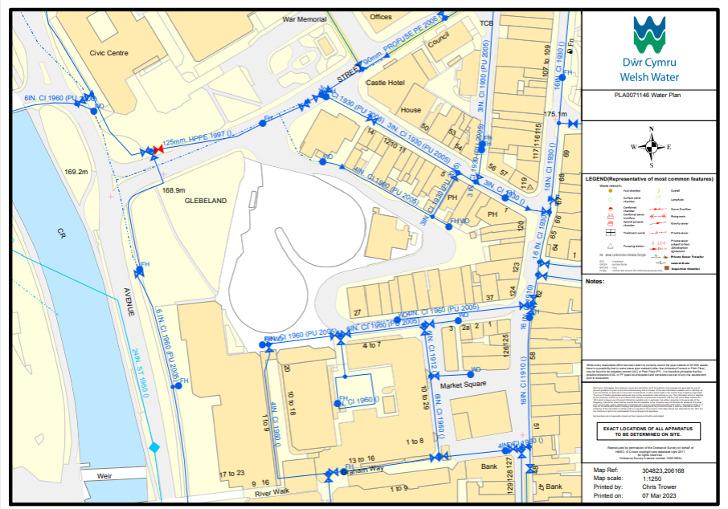
From the Welsh Water statutory information provided for the demolition, it is evident that there are no water mains or sewer runs that feed into the site. Below identifies the areas of the water mains & sewer runs adjacent and surrounding the site:

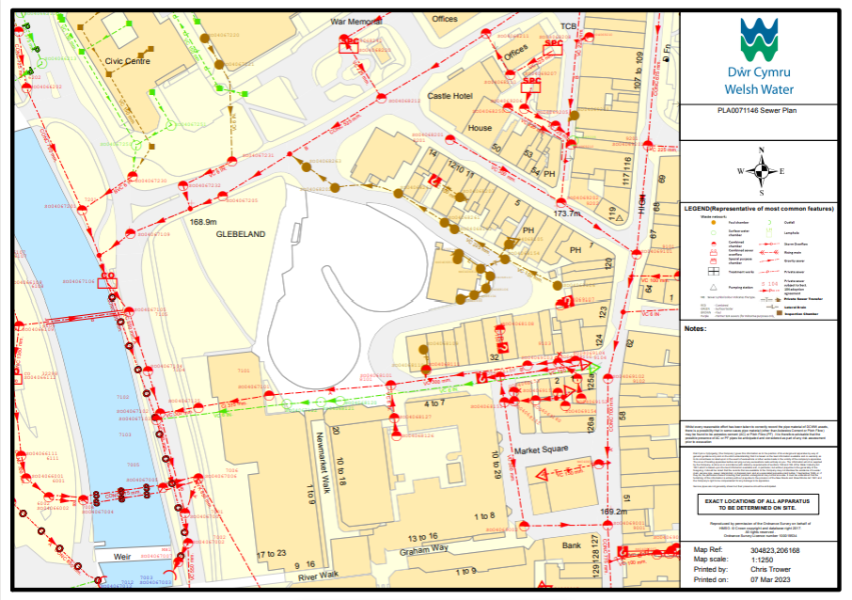
Figure 6 – Water Plan identifying services within site boundary

Figure 7 – Sewer Plan identifying services within site boundary
Further to the information provided, we at M.E.S.S Construction Services Ltd would undertake a utility survey as well as the desktop survey which has commenced to scan for any undefined services. An allowance has been made within the cost report for these items.

Archaeology
The site is not within a conservation area, or within close proximity of a scheduled ancient monument however, a Heritage Impact Assessment (HIA) has been allowed for within the survey schedule, which would inform the archaeological status. There may be the need for a watching brief during excavation works but all would be determined by the HIA.

4.6 OS Data
The OS Data has been collated for the site, including site levels and historic mapping. All of which will inform the ground investigation survey and at present remains a desktop survey. An allowance has been made for a GPR survey to be undertaken to obtain site levels and also produce a topographical survey of the site.
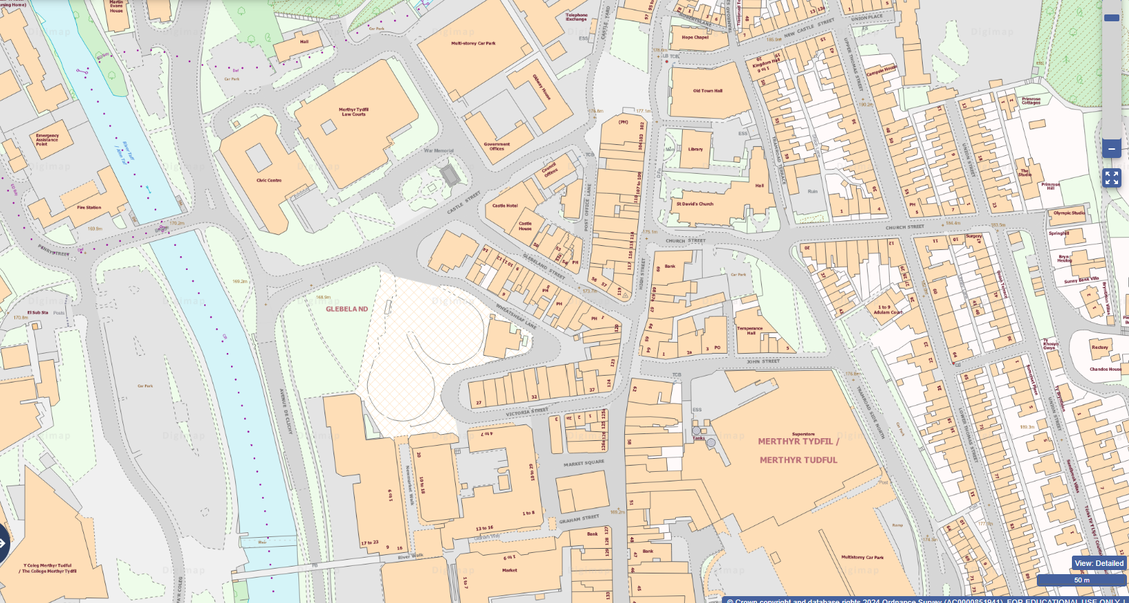Figure 8 – OS Map of the Site
5
Development Constraints
Details of the development constraints are listed within this section of the report, based upon the findings to date.

5.0 DEVELOPMENT CONSTRAINTS

5.1 Conservation Area & Associated Information
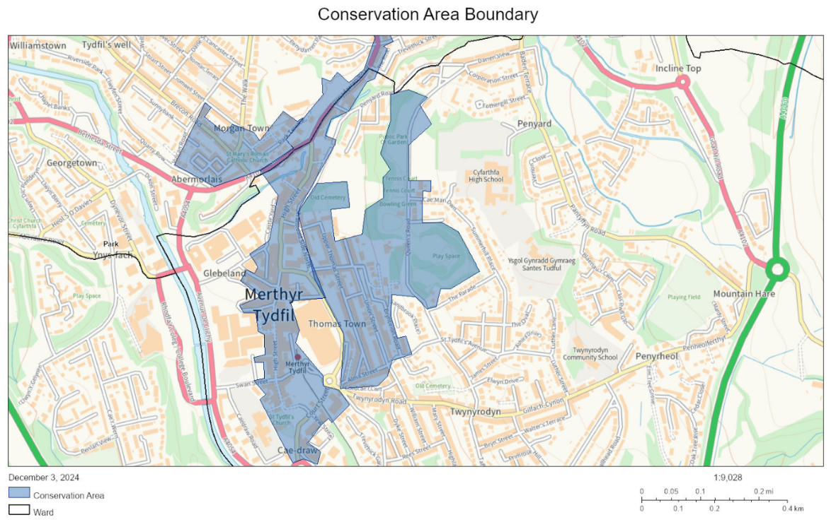
The area of development is not within a conservation area, the below map has been obtained identifying the conservation area within Merthyr to which the Glebeland site is not incorporated within this boundary.

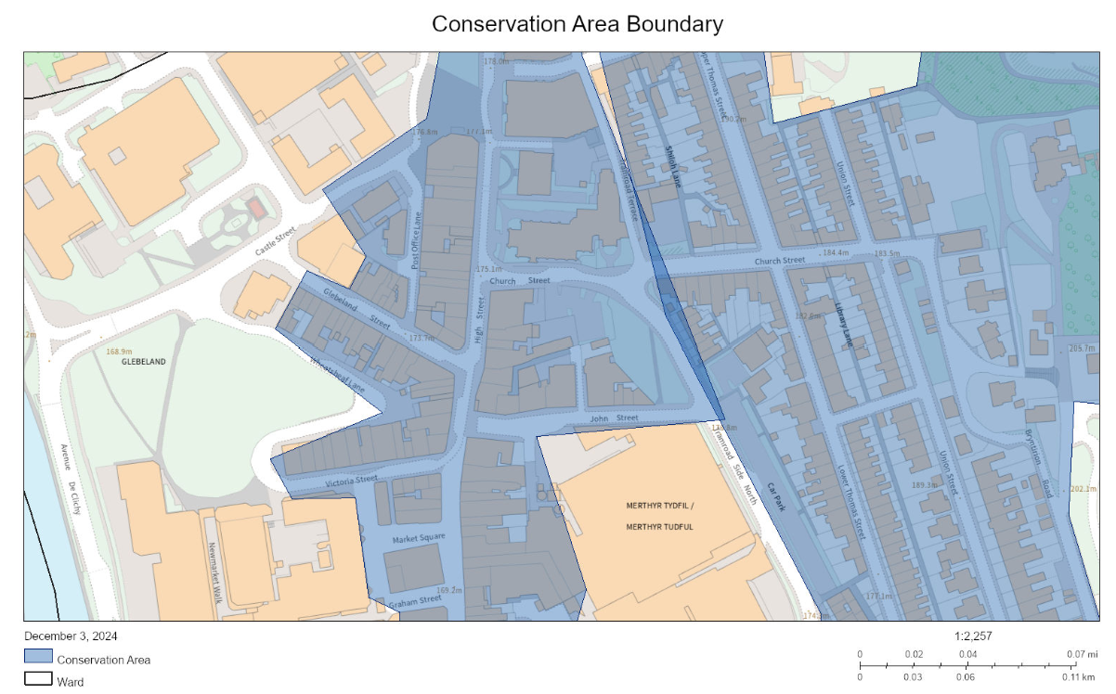
Figure 8 – Conservation Area Boundary

Figure 9 – Conservation Area (Site Identification)

5.11 CADW Information
Identified above that the development site is not within a conservation area, information has still been obtained from CADW which will be of benefit within the design / planning process. The listed buildings and scheduled ancient monuments adjacent to the site have all been identified:
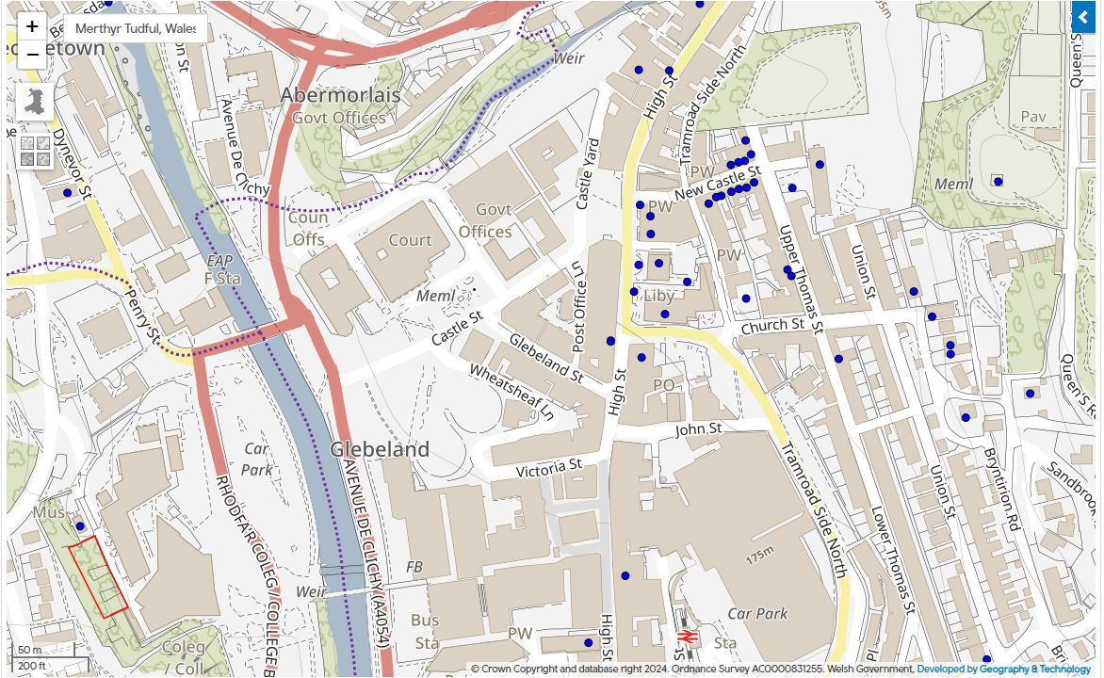
Figure 10 – Listed Buildings & Scheduled Ancient Monuments
Key:
Listed Buildings
Scheduled Ancient Monuments

5.12 Tree Preservation Orders (TPO)
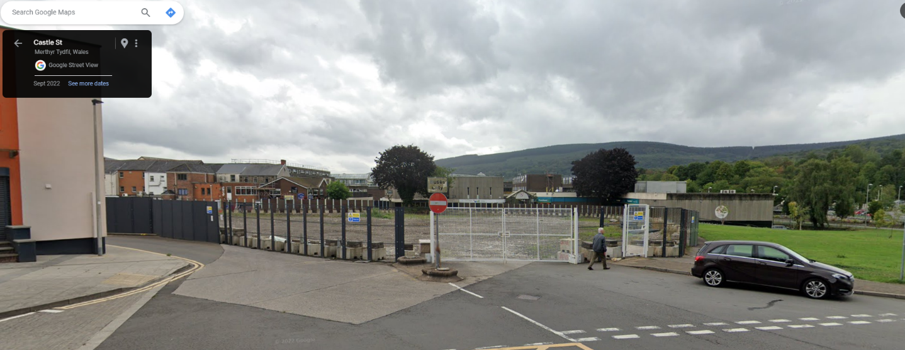
Within the site, there are currently two trees which would require taking down as part of the enabling works. Identified below is a view from Castle Street of the site with the trees being identified:
Figure 11 – Castle Street, Identification of trees on site
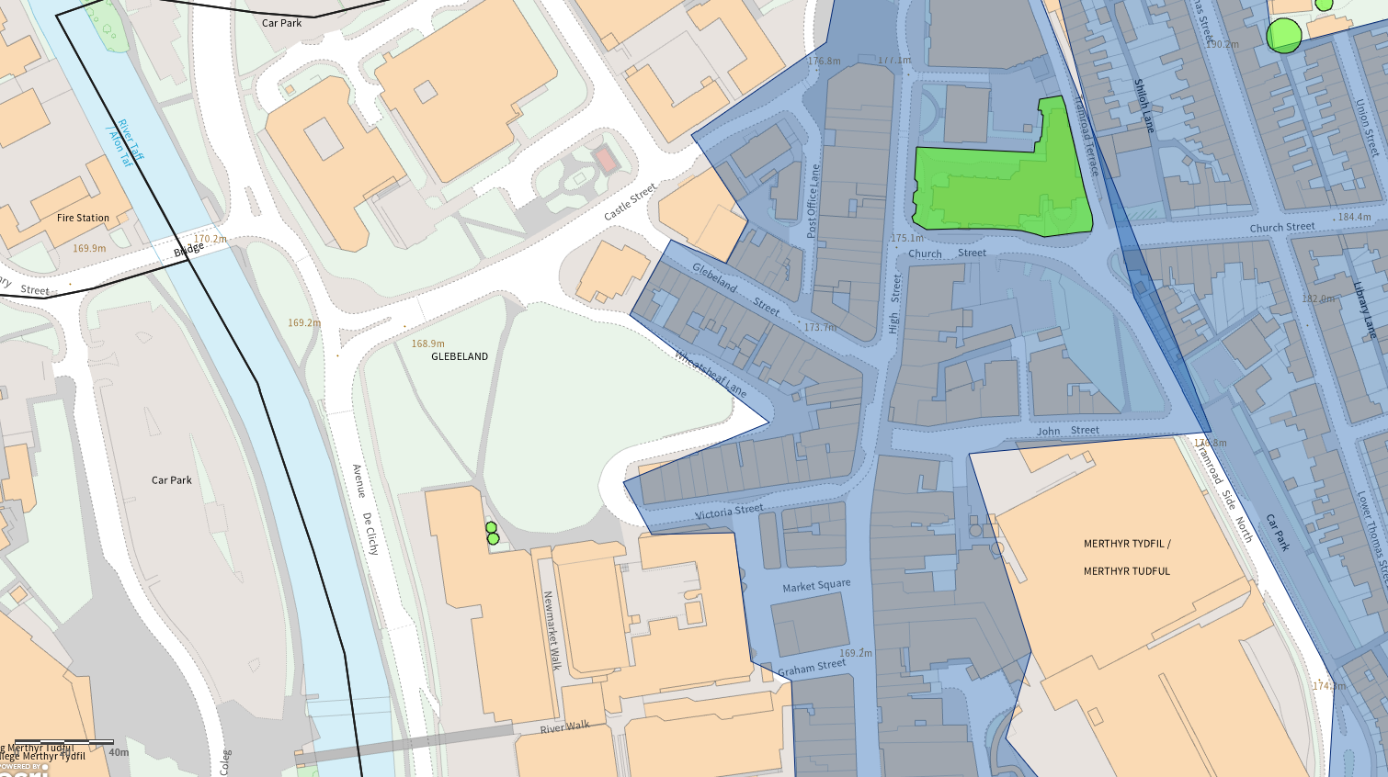
It has been investigated via a desktop TPO survey, that these trees do not have any preservation orders on them, which is identified from the map below. Within proximity and towards the South of the site, there are two trees with preservation orders on them to which consideration would be undertaken upon completion of the ground works that the roots are not disturbed:
Figure 12 – Tree Preservation Orders
There have been four established trees noted to be on the site and following BS5837 a tree survey must be carried out to assess the impact redevelopment has and to minimise risk and protect the trees. The site is not in a conservation area and the trees do not fall under the protected trees category, according to the MTCBC TPO map. It should be noted, however, that the adjacent land to the South, where Poundland is located does have a TPO for the 2 trees located there. The tree survey will note any issues that the strengthening of foundations for the adjacent property will have on these trees and further works when carried out.

5.2 Flood Consequence Assessment
Adjacent to the West of the site being the A4054 road, to which the River Taff is the Western Boundary of this road it would be a requirement for a flood consequence assessment to be undertaken. An allowance has been made for this within the cost report, and any change in levels would need to be identified for sufficient drainage to be incorporated within the design. As part of the most recent hard landscaping of the site following the demolition of the bus shelter, a flood consequence technical note was produced and formed part of the planning application referenced ‘P/23/0023’. The conclusion of the technical note was that the current hard landscaping of the works has no detrimental effect on the site, and that a slight increase in flood depth may occur to the West of the site but could be managed accordingly. A further flood consequence assessment will be undertaken upon completion of the design.
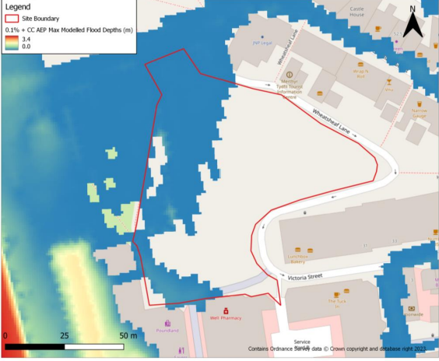

Figure 13 – Flood Depths on current site (upon completion of the hard landscaping)
The above identifies the flooding areas within the current site upon completion of the hard landscaping works. It is identified that the West of the site has a small increase of flood depths, which a small part of the proposal would be affected by. This would be managed accordingly and factored into the design and further developed by an updated flood consequence assessment.

5.21 Pollution Prevention
The site is adjacent to the River Taff therefore pollution prevention throughout construction is of consideration. In order to comply with pollution prevention throughout the construction stages, a Construction Environmental Management Plan (CEMP) will be completed and attached to the planning application submitted. M.E.S.S Construction Services Limited would consult with the correct statutory authorities in which case would be NRW throughout this process. The most recent NRW statement has been obtained for the recent hard landscaping of the site to identify any conditions which were required as part of that, to inform ourselves of the relevant considerations.

5.3 Environmental Protection
In accordance with the above, environmental protection requirements are of consideration and currently been incorporated within the cost plan for the relevant measures to be put in place.

5.31 Radon Protection
Radon protection measures have been considered and factored into the cost plan. The site is within a radon area and on both previous planning applications for the site, has been listed as a constraint which is identified below:
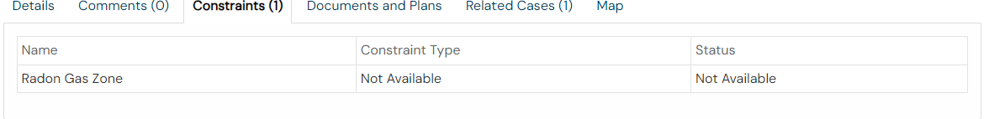
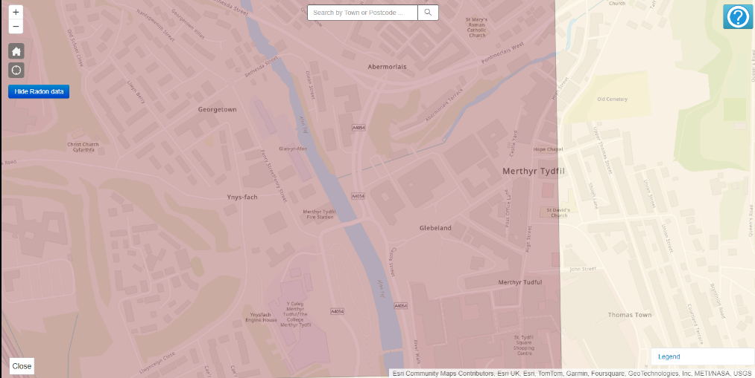
Figure 14 – Constraints on planning applications on site indicating radon zone

Figure 15 – Highlights the site is within the a radon protection zone
The site is in an area of elevated radon gas (5-10%) according to the UKradon map, therefore a site-specific radon report should be carried out. Approved document C and BR 211 outline the basic protective measures that need to be taken for higher risk sites. These include a 1200-guage DPM and sealing of all joints and service penetrations to ensure no radon is leaking into the building.

5.32 Contaminated Land
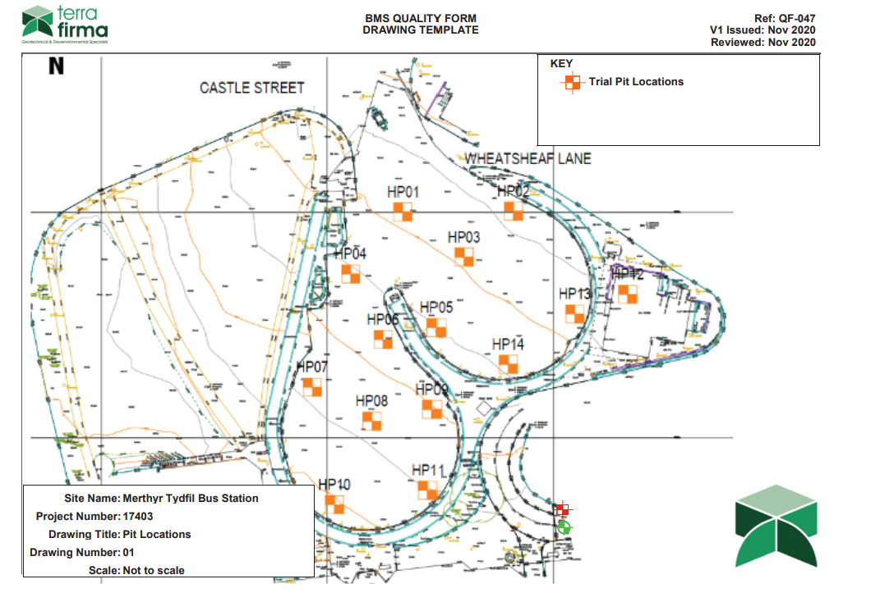
A geotechnical report was produced for the hard landscaping works, after the demolition of the former bus stop occurred. 14 trial pits were excavated, with the extent of the soil within these areas being analysed. Below identifies the areas in which these trial pits were undertaken:

Figure 16 – Highlighting the trial pit locations to the most recent works undertaken on the site
The trial pits were dug at 1.2m, to which the findings identified most of the ground was ‘made ground’. This identifies that the likelihood is upon demolition, a lot of the excess material was used to landscape the site. This poses a risk, as the former bus stop being a post 2000 building, asbestos would have been a material used. Although there would have been an asbestos strip undertaken, the risk of asbestos within the site remains very high. Various trial pits have a high content of cobble, which we are led to believe would be from the demolition of the bus stop. There was no asbestos detected within the trial holes, but remains a high risk and has been accounted for within the cost plan.

5.33 Previous Development
Within the previous development of the site which included hard landscaping of the site, there was only a certain section of the site which was landscaped. This has been highlighted as a risk and will be factored into the cost plan, as the section of the site which was not developed is the footprint of the StageCoach building. Below identifies the areas which were landscaped, showing that the Western elevation had no proposed works complete therefore is a risk and the relevant allowances have been made:
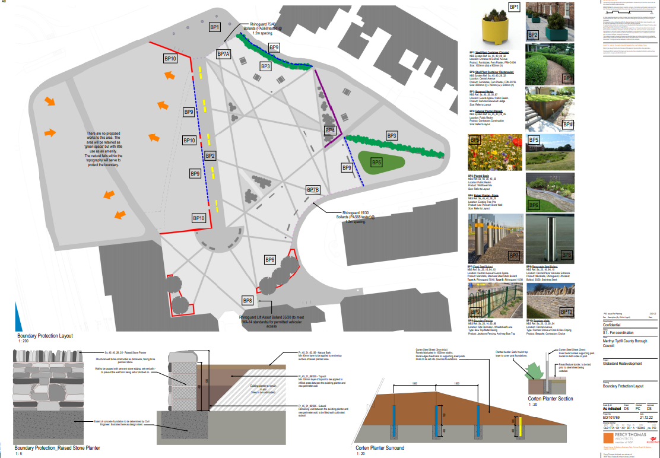
Figure 17 – Highlighting the areas developed as part of the most recent works, to which the area which is being developed as Phase 1 of the masterplan having not been developed

5.4 Party Wall Act
The proposed development is within 3 metres of an existing adjoining structure; therefore the owner must be served a notice indicating the proposals and confirmation of either underpinning or otherwise strengthening the foundations of the adjoining structure.

6.0 ACCOMODATION REQUIREMENTS
6
Accommodation Requirements
The accommodation requirements are scheduled within the clients brief, this area will be developed further upon throughout the process of design within the RIBA Stages.

6.1 Schedule of Areas
The schedule of areas has been identified below:

6.2 Plans
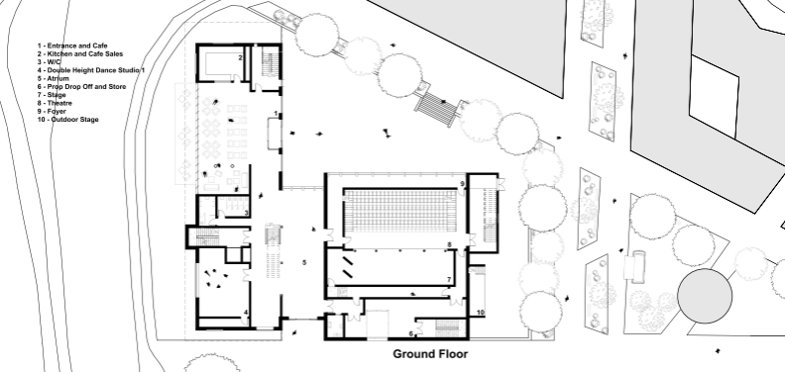

6.3 Precedent Studies (Supplied by Client)
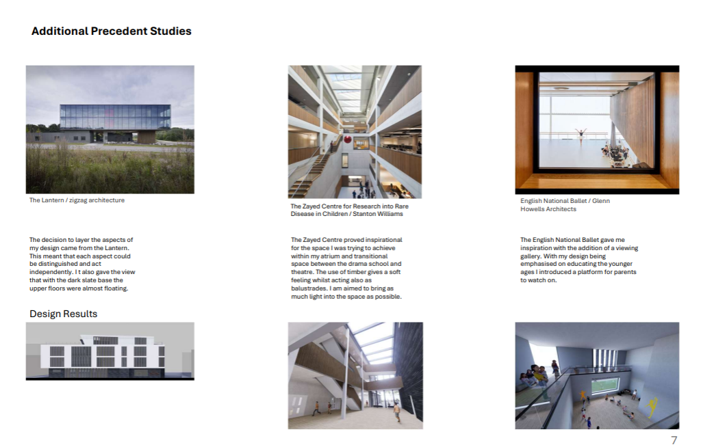
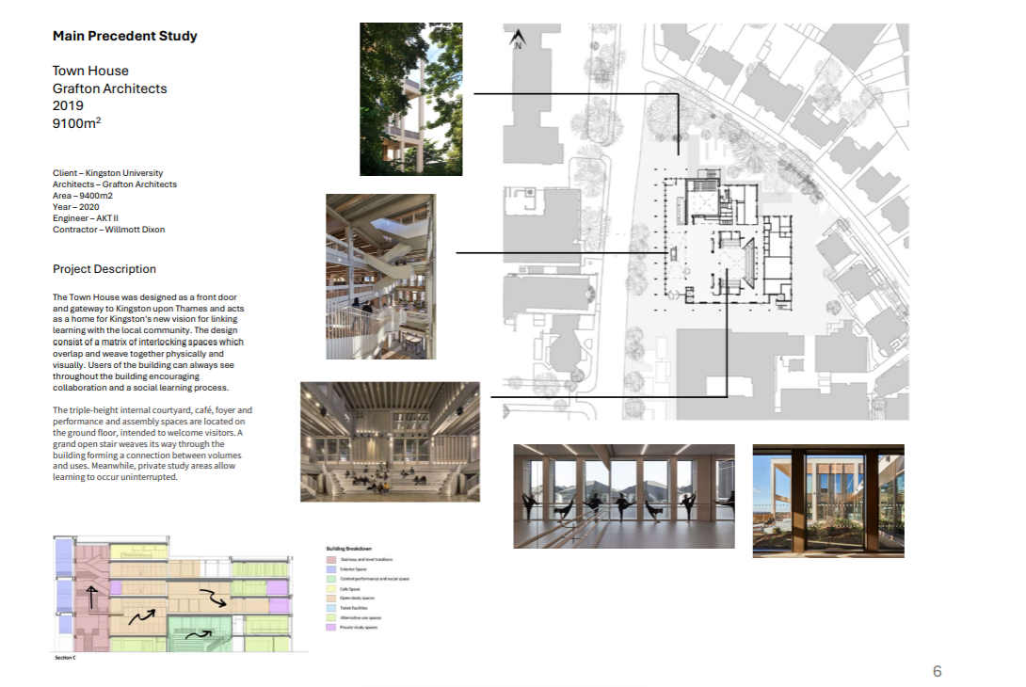
7
Design Specification
The adherence to design standards which the build will comply with will be listed out within this section of the report.

7.0 DESIGN SPECIFICATION

7.1 Design Specification
Project Overview
- Client: Stagecoach Theatre School (Merthyr Tydfil)
- Project Type: Mixed-use theatre and performance centre
- Location: Brownfield site, formerly Merthyr Tydfil bus station
- Key Users: Primarily children (for classes and performances), with facilities for visiting groups, families, and the community.
Objectives and Vision
- Purpose:
  - Create a permanent space for the performing arts for local and visiting groups.
  - Provide flexible spaces that allow for a variety of entertainment types, ensuring versatility for future events.
  - Establish a safe, engaging, and community-driven environment for children and youth interested in the dramatic arts.
  - Respect the site’s heritage while fostering a playful and inviting atmosphere.
Site and Context
- Site Conditions: The design should utilize the existing brownfield and grassed areas, creating a connection between the site and the surrounding town.
- Architectural Design Intent:
  - Respect historical surroundings but introduce modern, flexible designs.
  - The design should be child-focused, engaging and fun, but also adaptable to various community uses, such as performances and social events.
  - Include outdoor spaces to connect the facility to the surrounding urban fabric and provide additional community engagement.
Functional Spaces and Requirements
- Main Theatre:
  - Flexible seating arrangements (for both small and large performances).
  - State-of-the-art acoustics and lighting systems to support performances.
  - Adaptable stage for diverse event types (drama, music, dance).
- Rehearsal/Studio Spaces:
  - Multiple soundproof rehearsal rooms designed for individual or group practice.
  - Mirror walls and appropriate flooring for dance and movement rehearsals.
- Private Relaxation Areas:
  - Private spaces specifically for children to relax and feel safe between performances.
  - Child-safe design elements, such as non-toxic materials and furniture suitable for younger audiences.
- Public Areas:
  - Welcoming lobby and waiting areas for parents and visitors, potentially including a café or bar for generating additional revenue.
  - Designated entry and exit points to ensure smooth flow of large groups during events.
Aesthetic and Interior Flow
- Design Language:
  - Playful yet respectful of the surrounding heritage.
  - Bright, engaging colors and interactive design elements for children.
  - Use of natural materials where possible to promote a sense of calm and connection to nature.
  - Smooth transitions between public and private spaces to ensure security for child performers.
- Interior Layout:
  - Seamless connection between performance spaces, rehearsal rooms, and audience areas.
  - Flexibility in design to allow for multiple activities or performances occurring simultaneously.
  - Clear delineation between areas accessible to the public and private spaces for performers and staff.
Building Systems
- Security and Surveillance:
  - Include sufficient security measures to protect children and visitors, such as controlled access points and CCTV cameras in public areas.
  - Ensure privacy in relaxation areas away from the public view.
- Sustainability:
  - Prioritize sustainable materials and energy-efficient systems throughout the building.
  - Utilize natural lighting wherever possible to reduce energy consumption.
  - Incorporate green building standards that align with local regulations and sustainable building certifications.
Technical Specifications
- Construction Materials:
  - Use durable, low-maintenance materials suitable for high-traffic areas.
  - Acoustic insulation in rehearsal and performance spaces to ensure sound control.
  - Child-friendly finishes (e.g., soft edges, anti-slip floors, and non-toxic paints).
- Information Management:
  - Conform to the UK BIM Framework standards for design and construction.
  - Follow information exchange requirements outlined in the EIR document, ensuring compatibility of all models and technical data.
- Accessibility:
  - Ensure all areas of the building are fully accessible to people with disabilities.
  - Include wheelchair access, tactile wayfinding, and appropriate restrooms for all visitors.
Conclusion
The design should create a vibrant and flexible space that supports the needs of children, performers, and the broader community, all while integrating seamlessly into the urban fabric of Merthyr Tydfil. Balancing public and private areas, security, and playfulness are key, as is the focus on sustainability and heritage respect.

7.2 Building Regulation Standards
The UK Building Regulations are mandatory for all construction projects. For this specific project, the following regulations are particularly important:
- Part A – Structure: Ensures the building's structural integrity to prevent collapse. The design should account for the loads and stresses the building may face, including those for performance areas with large crowds.
- Part B – Fire Safety:
  - Fire safety provisions, including escape routes, alarms, and sprinklers, are critical for large public spaces like theatres.
  - Fire-resistant materials and compartmentation are required for controlling fire spread in performance spaces and backstage areas.
- Part M – Access to and Use of Buildings:
  - Ensures that the building is accessible to everyone, including people with disabilities. This includes ramp access, wide corridors, disabled toilets, and hearing loops in performance spaces.
  - Clear signage and safe evacuation routes must be in place.
- Part L – Conservation of Fuel and Power:
  - Focuses on energy efficiency in building design, construction, and operation. The building needs to comply with insulation, lighting, and heating requirements to reduce energy consumption.
- Part F – Ventilation:
  - Ventilation is important for public spaces. Theatres and performance spaces must have adequate mechanical ventilation, particularly in spaces with high occupancy.
- Part K – Protection from Falling, Collision and Impact:
  - Safeguards against falling from heights (e.g., balconies or staircases) and ensures the safety of glass in public areas.

- Part E – Resistance to Sound:
  - Addresses soundproofing requirements for both internal and external noise. Rehearsal spaces, performance areas, and public spaces must minimize sound transmission.
Key Standards
In addition to the Building Regulations, the following British Standards (BS) and International Standards (ISO) are relevant for this project:
- BS EN ISO 19650 Series (Information Management using BIM):
  - The project should comply with this standard to ensure efficient data management throughout the design and construction phases using Building Information Modelling (BIM).
- BS 8300-1:2018 and BS 8300-2:2018 (Accessibility Standards):
  - These standards offer guidance on designing accessible and inclusive environments. They align with Part M but provide more detailed requirements for public buildings.
- BS 9999:2017 (Fire Safety in the Design, Management, and Use of Buildings):
  - Provides fire safety design solutions and risk-based approaches specific to public buildings such as theatres, ensuring fire exits, alarms, and smoke control are well planned.
- BS 5449 (Performance Spaces):
  - Sets out standards for the design and construction of performance spaces, including acoustics, seating arrangements, and performance lighting.
- BS 1192-4:2014 (COBie Data Requirements):
  - For delivering COBie data (Construction Operations Building Information Exchange), which is a requirement for ensuring that asset data is usable post-construction.
BREEAM Assessment
The Building Research Establishment Environmental Assessment Method (BREEAM) is the UK's most widely used sustainability assessment method. For this project, aiming for a BREEAM rating would ensure sustainability performance in the following categories:
- Management:
  - Encourage a collaborative design process and efficient project management.
  - Ensure a commissioning plan and long-term aftercare for building performance.
- Health and Wellbeing:
  - Ensure good indoor air quality, acoustics (particularly for performance spaces), and natural lighting.
  - Provide suitable temperature control, ventilation, and glare protection in performance areas.
- Energy:
  - Design energy-efficient lighting, heating, and cooling systems, adhering to Part L standards. Renewable energy sources should also be considered (e.g., solar panels).
  - Smart building management systems (BMS) to monitor energy use and efficiency.
- Transport:
  - Provide sustainable transport solutions, including electric vehicle charging points, bike storage, and public transport access.
- Water:
  - Design water-efficient systems, including low-flow fixtures and rainwater harvesting, to reduce water consumption.
- Materials:
  - Use low-impact, sustainably sourced materials (e.g., timber from FSC-certified sources) with low embodied carbon.
  - Ensure that materials have a low environmental impact during their lifecycle.
- Waste:
  - Develop a waste management plan during construction to minimize landfill waste.
  - Provide adequate recycling facilities for building occupants.
- Pollution:
  - Control pollution during construction and operation, with particular attention to noise, air quality, and light pollution, especially in the context of performances and rehearsals.
- Land Use and Ecology:
  - Enhance biodiversity on the brownfield site by incorporating green spaces, vegetation, and possibly green roofs.
  - Mitigate the impact on local ecosystems and create a positive connection between the building and its natural surroundings.
- Innovation:
  - Opportunities to score additional points by adopting innovative solutions, such as smart energy systems, carbon-neutral construction techniques, or advanced waste-to-energy solutions.
A BREEAM "Excellent" rating should be achievable for this type of project if sustainability is prioritized throughout the design and construction phases
Additional Welsh Specific Standards
Since this project is in Wales, Welsh regulations and sustainability programs (e.g., Well-being of Future Generations (Wales) Act 2015) may also apply:
- The design must promote long-term well-being, environmental sustainability, and social value.
- Consideration should be given to how the building will support local communities, culture, and the environment in the long run.

7.2 Building Regulation Standards (Specific Systems)
Curtain Walling, Framed Glazed, and Window Systems
- Building Regulation Part L: Conservation of Fuel and Power (energy efficiency of windows and facades)
- Building Regulation Part B: Fire Safety (for fire-rated curtain walling and windows)
- BS EN 13830: Curtain Walling – Product Standard
- BS 6262: Code of Practice for Glazing
Fire, Smoke Curtains, and Door Systems
- Building Regulation Part B: Fire Safety (for smoke and fire curtain systems)
- BS EN 12101-1: Smoke and Heat Control Systems
- BS 9999: Code of Practice for Fire Safety in Design, Management, and Use of Buildings
- BS EN 16034: Pedestrian Doorsets – Fire and Smoke Control
Traffic Barriers and Access Systems
- Building Regulation Part M: Access to and Use of Buildings (barrier-free access for disabled persons)
- BS 6180: Barriers in and About Buildings
- BS EN 13241: Industrial, Commercial, and Garage Doors and Gates
Roof Systems (Pitched, Flat, Glass, Metal, etc.)
- Building Regulation Part L: Energy Efficiency (thermal insulation for roofs)
- Building Regulation Part A: Structure (loading considerations for roof systems)
- BS EN 636: Plywood Specifications for Roofing Systems
- BS EN 1999: Eurocode 9 for Aluminium Roof Systems
Stair and Ramp Systems
- Building Regulation Part M: Access to and Use of Buildings (requirements for stairs and ramps)
- BS 5395: Code of Practice for the Design of Stairs
- BS 8300: Design of Buildings for Accessibility and Usability
Signage Systems (Fire, Safety, Electrical, etc.)
- Building Regulation Part B: Fire Safety (fire safety signage)
- BS ISO 3864: Safety Colors and Safety Signs
- BS 5499: Code of Practice for Escape Route Signing
Sanitary and Toilet Systems
- Building Regulation Part G: Sanitation, Hot Water Safety, and Water Efficiency
- Building Regulation Part M: Accessibility (accessible toilet design)
- BS 6465: Sanitary Installations
Roof Drainage and SuDS (Sustainable Drainage Systems)
- Building Regulation Part H: Drainage and Waste Disposal
- BS EN 12056: Gravity Drainage Systems Inside Buildings
- CIRIA SuDS Manual: Guidance on sustainable drainage design
Wastewater, Solid Waste Systems
- Building Regulation Part H: Drainage and Waste Disposal (waste treatment and disposal systems)
- BS EN 12056: Wastewater and Rainwater Drainage
- WRAP: Guidance on Waste Management in Buildings
Mechanical Systems (Heating, Cooling, Ventilation, etc.)
- Building Regulation Part L: Energy Efficiency (HVAC systems)
- BS EN 12831: Heating Systems in Buildings
- BS EN 13779: Ventilation and Air Conditioning Systems
- BS EN 12097: Ductwork for Ventilation
Electrical Systems (Power, Lighting, Alarms, etc.)
- Building Regulation Part P: Electrical Safety
- BS 7671: Requirements for Electrical Installations (IET Wiring Regulations)
- BS EN 50173: Structured Cabling Systems for Data
- BS EN 62305: Protection Against Lightning
- BS 5839: Fire Detection and Alarm Systems
Passenger and Goods Lift Systems
- Building Regulation Part M: Access to and Use of Buildings (lift access for all users)
- Building Regulation Part B: Fire Safety (firefighter lifts)
- BS EN 81: Safety Rules for the Construction and Installation of Lifts
Flora and Fauna Control, Living Roof Systems
- Building Regulation Part L: Conservation of Fuel and Power (energy benefits of living roofs)
- BS 8616: Specification for Living Roofs
- BREEAM: Credits related to biodiversity and green infrastructure

8
Cost Estimate
A preliminary cost plan has been created to give the client a high-level budget estimate of the build, based on the information to date. There are a range of assumptions and exclusions incorporated within the cost plan, all of which have been identified.

8.0 COST REPORT

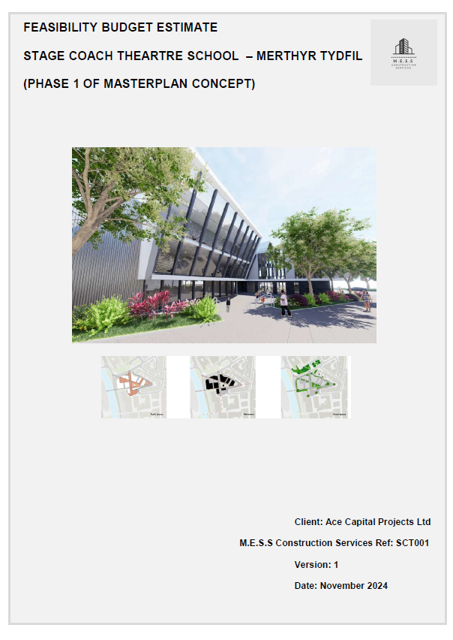
8.1 Cost Report
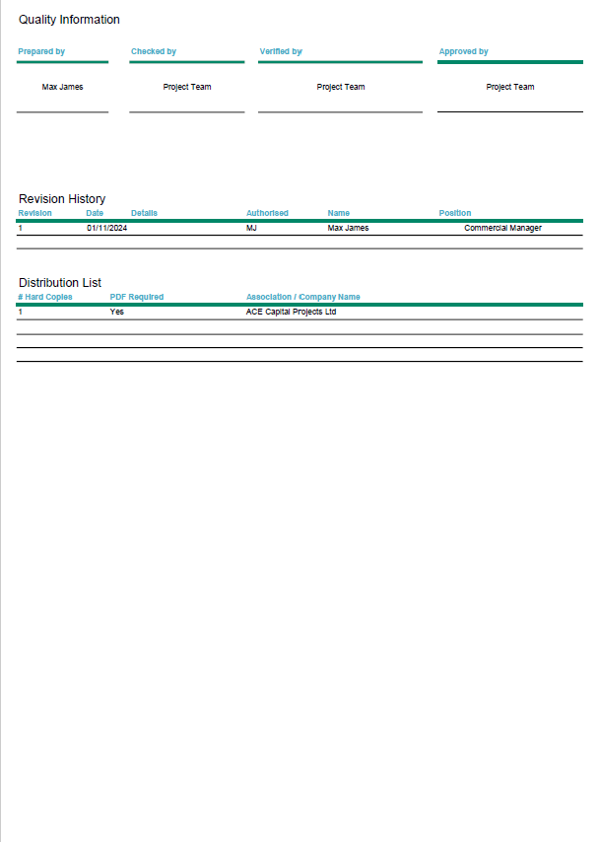
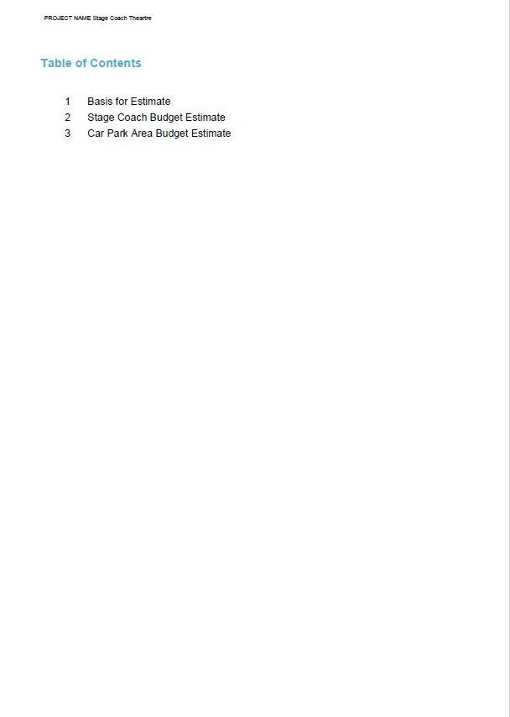
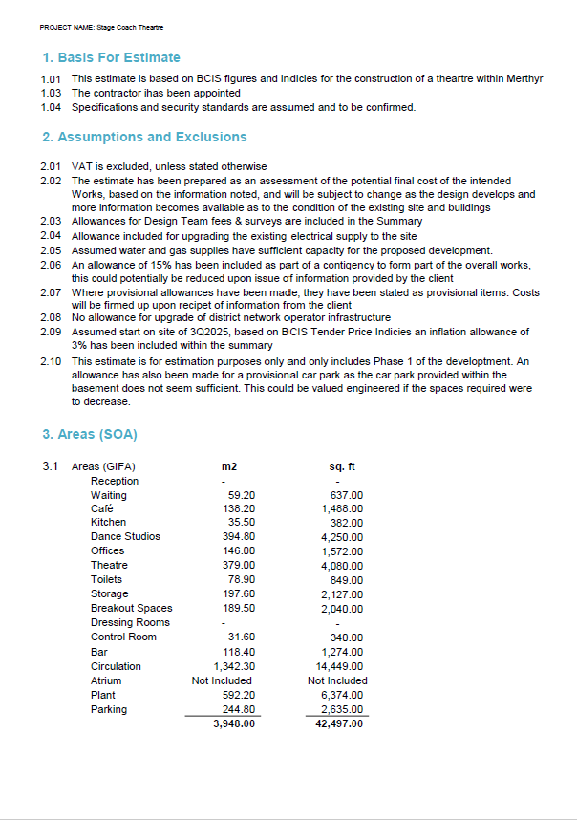

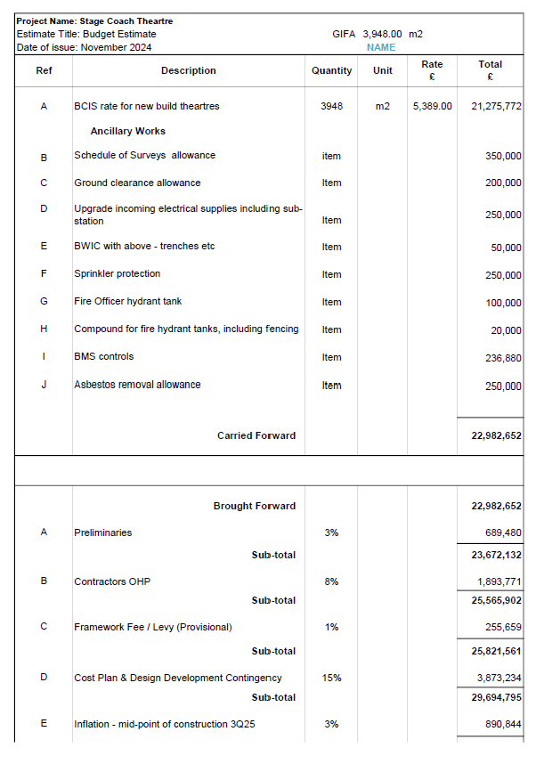

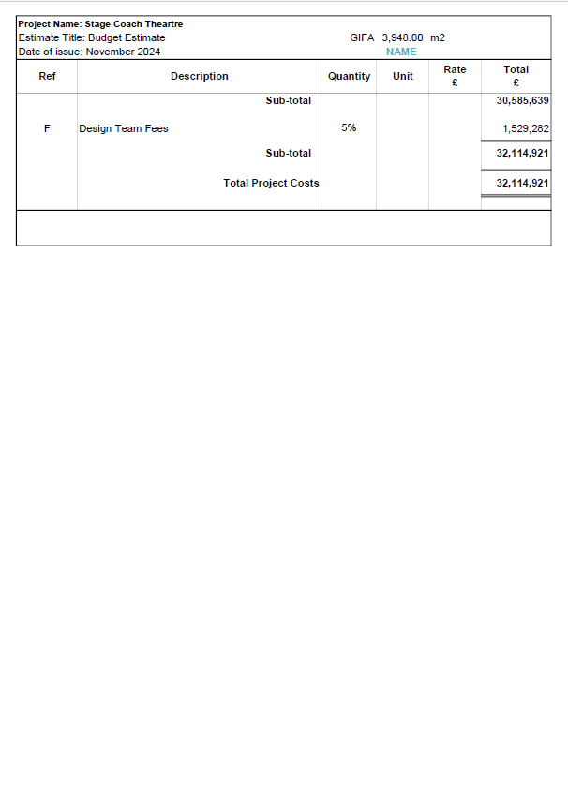
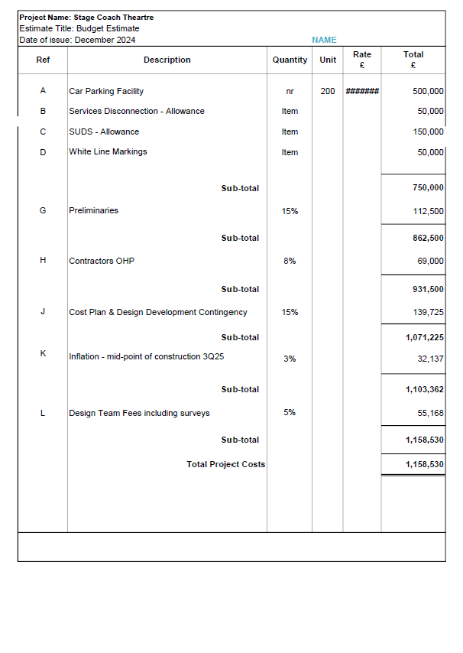


9
Project Programme
A project programme has been created to give the client indicative timescales of the build, based on the information to date.

9.0 PROJECT PROGRAMME

9.1 Project Programme
A project programme has been created for the project, with the clients’ aspirations being identified. Upon creation of the project programme, it is clear that the clients’ aspirations would not unfortunately be able to be achieved. The two project programmes are included within the appendices, but below gives an indicative overview of both:
Single Stage Program:
Start Date: 02/10/2024
Riba Stage 0 Completion: 13/11/2024
RIBA Stage 1 Completion: 18/12/2024
RIBA Stage 2 Completion:19/03/2025
RIBA Stage 3 Completion: 18/06/2025
RIBA Stage 4 Completion: 17/09/2025
RIBA Stage 5 Completion (Based from BCIS Below): 24/03/2027
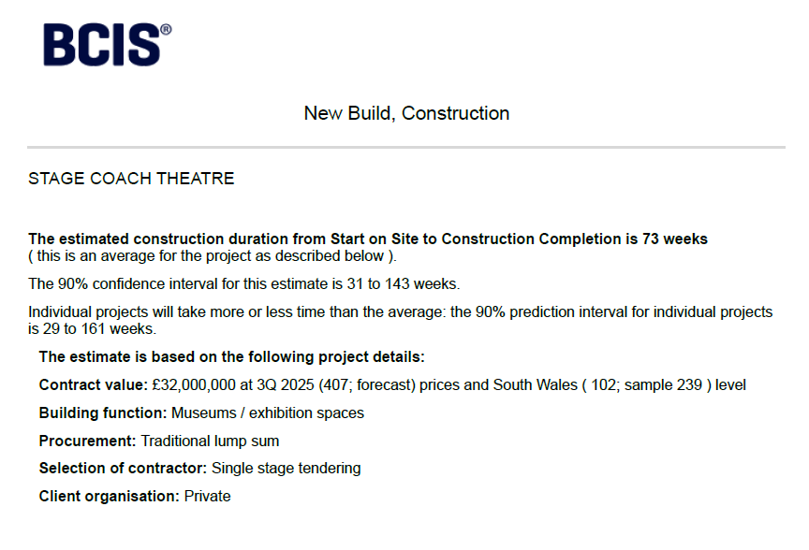
Figure 18 – BCIS Indicative Single Stage Construction Period
RIBA Stage 6 Completion: 31/03/2027
Two Stage
Start Date: 02/10/2024
Riba Stage 0 Completion: 13/11/2024
RIBA Stage 1 Completion: 18/12/2024
RIBA Stage 2 Completion:19/02/2025
RIBA Stage 3 Completion: 23/04/2025
RIBA Stage 4 Completion: 25/06/2025
RIBA Stage 5 Completion (Based from BCIS Below): 04/11/2026
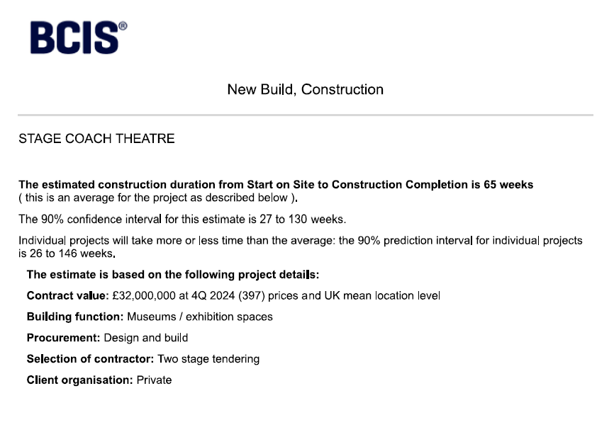
Figure 19 – BCIS Indicative Single Stage Construction Period
RIBA Stage 6 Completion: 11/11/2026
Overall there has been a CIRCA 4 month saving if reverted to a design and build contract. The RIBA Design stages within the single stage have had 12 weeks allowed for, to which we as the contractor are not in control of so any delay would extend the programme. We believe that we could undertake these stages within 8 weeks as a pose to 12, and also reduce the construction period due to the design being ours, and all details being in accordance with our design standards.

10
Conclusions / Recommendations
Within this section of the report, a indicative overview of the findings to date are listed, with our recommendations on how to proceed

10 CONCLUSION / REOMMENDATIONS

10.1 Conclusion
As a conclusion of the report, we at M.E.S.S Construction Services feel we would be fully competent to deliver the Phase 1 of the Masterplan, in accordance with the clients brief and what has been presented to date. All the exclusions and recommendations have been listed out within the report, but below gives an overview of the feasibility and findings to date:

10.2 Recommendations
Our recommendations are listed out as follows:
- Proceed with the latest design, the report has been based upon the increased GIFA resulting in a sacrificial element of the overall masterplan. Although this element will be sacrificed, we believe the GIFA of this building needs to remain at CIRCA 3,000m2 to which this report and cost plan has been based upon.
- Intrusive surveys are required to inform parties of more accurate information, within the report there is a lot of desktop / high level surveys produced purely as assumptions however, as this report is signed off, we would require more intrusive surveys to mitigate risk. It has been highlighted that previous works to the site could contain hazardous material such as asbestos, although an allowance has been made these factors need to be identified. All the surveys within the survey schedule are required.
- Proceed with the two phases, being the construction of the Stage Coach, and also the car park which has all been allowed for in the cost plan. This will generate a complete scheme.
- Proceed on a two-stage design and build basis. We as a contractor believe that the scheme would sit better with us taking the design forward. This has been evidenced by the quicker build time, which doesn’t meet your requirements however it has been identified within the cash flow that if there is a spend cap on the Welsh Government funding, this can be facilitated. The construction duration has also been backed up by BCIS projected programme figures on projects of similar nature.
11
Drawings & Associated Information
Within this section of the report, the drawings and associated information provided by the client has been included to which the feasibility report is based upon.

11 DRAWINGS & ASSOCIATED INFORMATION / APPENDICIES

11.1 Initial Master Plan
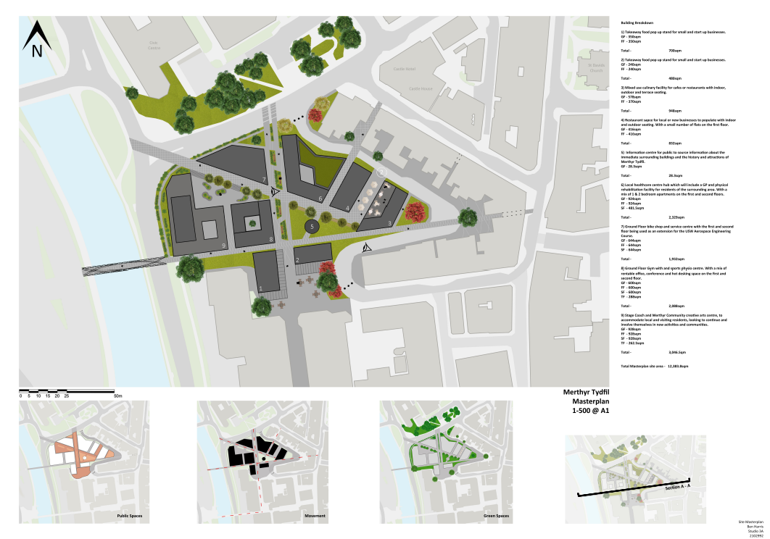

11.2 Developed Master Plan
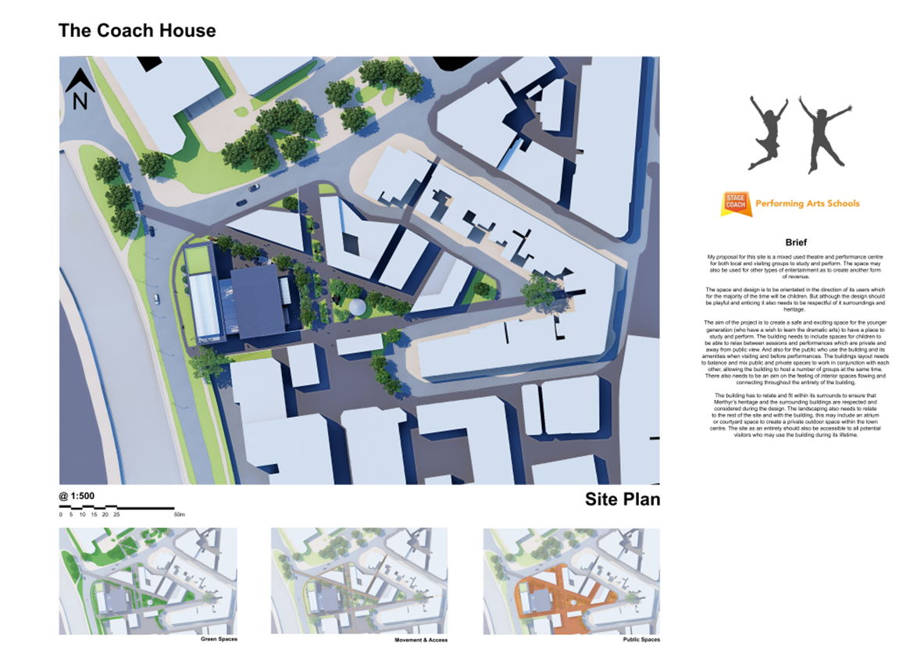

11.3 Single Stage Feasibility Programme

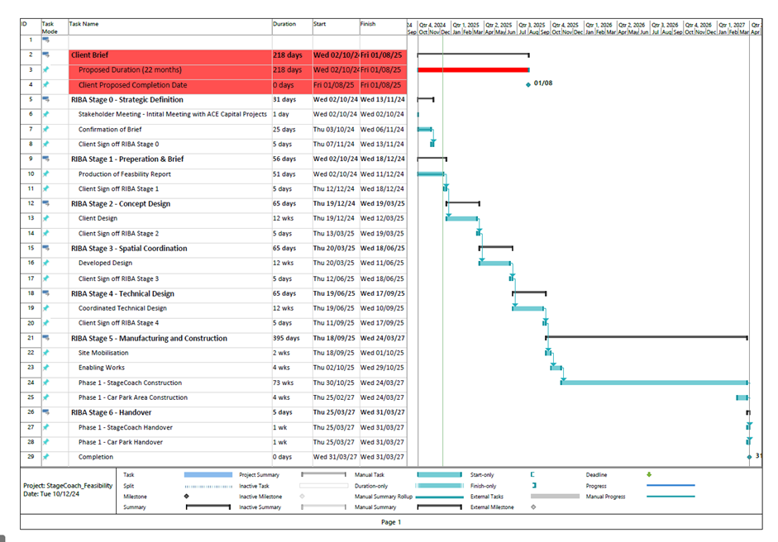
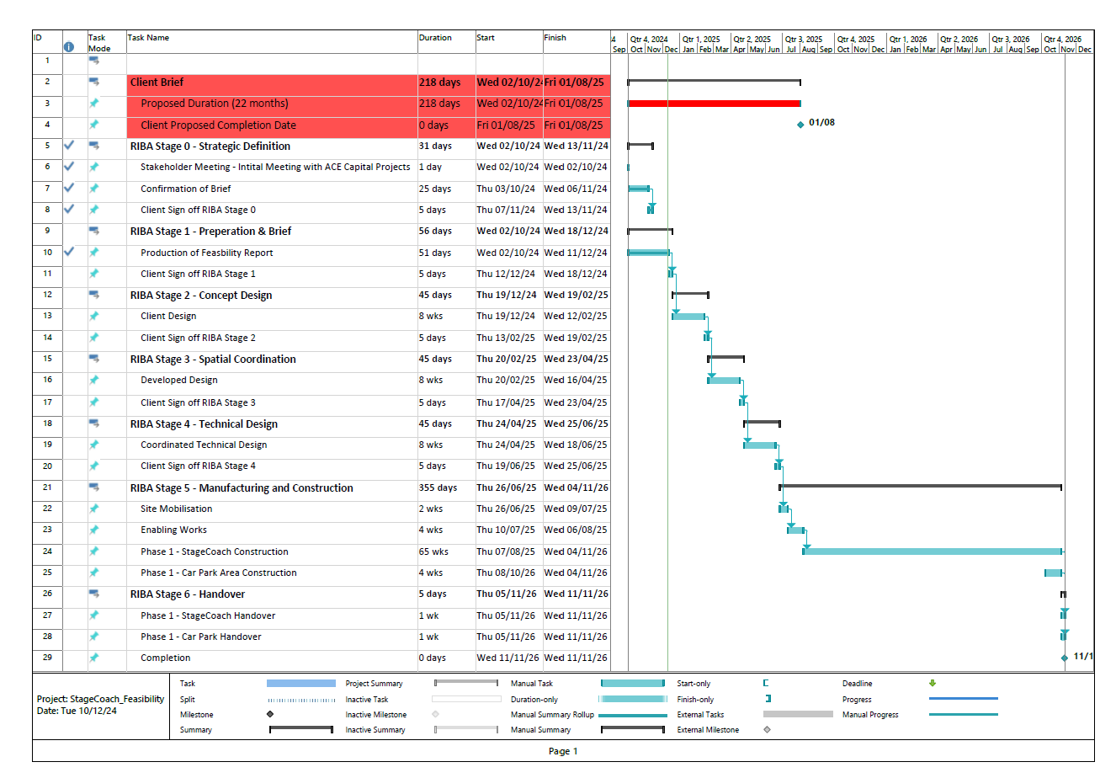
11.4 Two Stage Feasibility Programme (D&B)
)

11.5 Schedule of Surveys

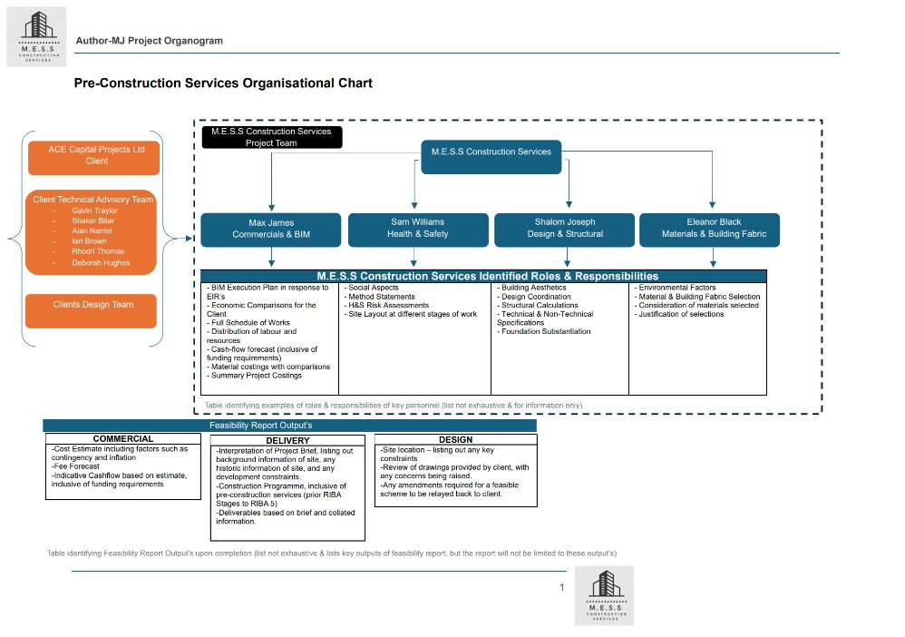
11.6 Pre-Construction Services Organisational Chart

11.7 Planning Applications within Area


