BSc health and social care
Assignment Title- Component 2: Report: Career Development & Personal Brand
Job Role: Children & Young People Support Worker (NHS Band 3)
Module code- BMHP5015
Student Name- Babita Masih
Student Number- 2409655
Submission deadline- Sunday 19th July 2026
Words counts- 2000 words
Introduction
The job responsibilities of a Children and Young People Support Worker in NHS Community Services in the West Midlands is the subject of this report. This position's primary goal is to provide safe, person-centred care and emotional support to children, youth, and their families. To enhance children's wellness, the position also entails strong collaboration with social care services, schools, and medical specialists (NHS England, 2024).
I intend to finish Level 6 Health and Social Care before beginning my profession. I am now enrolled in Level 5. I can communicate with people from a variety of backgrounds because I speak Urdu, Punjabi, Hindi, and English. By offering excellent services, I hope to assist kids, teens, and their families. This report assesses my present knowledge and experience, analyses the abilities required for this position, and outlines my plans for skill development and career success (NHS Jobs, 2026).
Job Advertisement and Person Specification
The NHS Birmingham and Solihull Shared Care Board job posting for a Children and Young People Support Worker (Band 3) at the Sandwell and West Birmingham Community Health Centre was chosen for this study. Working collaboratively with families and other health and social care providers, the role entails supporting children and young people with physical, emotional, and learning needs. According to the job description, applicants should be able to give person-centred care, understand safeguarding, and have strong communication skills. Additionally, it emphasises the value of collaboration, equality, diversity and inclusion, and fostering good relationships with kids and their families (NHS Jobs, 2026).
Source: NHS Jobs, 22 June 2026, West Midlands CAMHS & Community Children’s Services
Job Title: Children & Young People Support Worker – Band 3
Employer: NHS Birmingham and Solihull Integrated Care Board
Location: Sandwell & West Birmingham Community Health Centre
Reference: NHS-2026-12457
Salary: £24,928 – £26,281 p.a.
Hours: 37.5 per week, including occasional evenings/weekends
Key Responsibilities:
- Support children aged 0–18 with physical, emotional, and learning needs
- Follow safeguarding, health & safety, and infection control policies
- Work in multidisciplinary teams; write clear, accurate progress notes
- Communicate effectively with children, families, interpreters, and professionals
- Promote equality, diversity, and inclusion; respect cultural backgrounds
Essential Criteria:
- GCSEs English & Maths (Grade 4/C or above)
- Level 2 Diploma in Health and Social Care (or working toward Level 3)
- Understanding of safeguarding children (Working Together to Safeguard Children, 2023)
- Ability to communicate clearly, listen actively, and build trusting relationships
- Enhanced DBS check and eligibility to work in the UK
Desirable Criteria:
- Level 3 Diploma in Health and Social Care / Children & Young People
- Experience with diverse communities or language skills
- Knowledge of person-centred and trauma-informed care
- Experience in care, education, or voluntary settings
Harvard reference: NHS Jobs. (2026). Children and Young People Support Worker – Band 3. Birmingham and Solihull ICB. Available at: https://jobs.nhs.uk/job/12457 (Accessed: 12 July 2026). 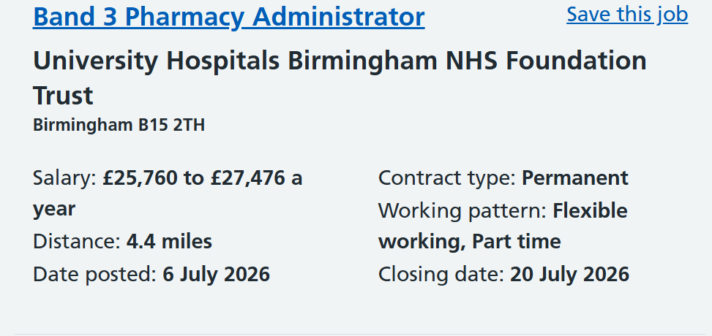
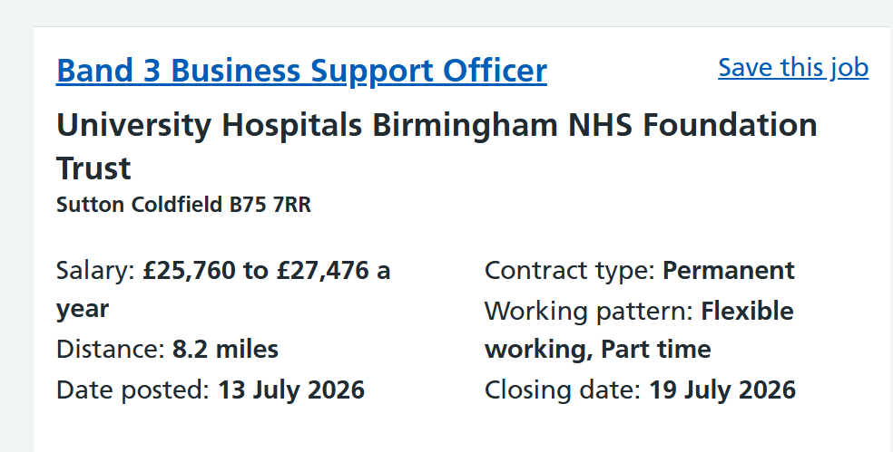
NHS Jobs. (2026). Children and Young People Support Worker – Band 3. Birmingham and Solihull Integrated Care Board. Available at: https://jobs.nhs.uk/job/12457 (Accessed: 12 July 2026).Analysis of Employability Skills
To help children, young people, and their families with safe, efficient, and person-centred care, a Children and Young People Support Worker needs a variety of professional and personal abilities (The Open University, 2024).
Communication is one of the most crucial abilities. When interacting with kids, parents, carers, and other medical experts, support workers need to be explicit in their communication. Additionally, they must establish trustworthy relationships, listen attentively, and communicate facts in a way that kids can comprehend. Speaking many languages can help families feel included and lower communication barriers in diverse places like Sandwell (NHS Jobs, 2026).
Safeguarding is another crucial ability. Support workers are legally and professionally responsible to report concerns, identify signs of abuse or neglect, and follow to national safeguarding guidelines. This keeps kids safe and guarantees they get the aid they require (Department for Education, 2023).
Because support workers work together closely with nurses, physicians, educators, social workers, and therapists, teamwork is also crucial. Professionals may exchange information and give children and their families the greatest care possible when they collaborate (NHS England, 2024).
Additionally, this job calls for patience, emotional strength, and understanding. Support professionals must maintain composure, compassion, and professionalism when offering emotional support because many children suffer from trauma, anxiety, or disability (SCIE, 2025).
Record-keeping and effective time management are equally crucial. To guarantee that children receive consistent care, support professionals must plan their workload, show up on time for appointments, and keep accurate records (The Open University, 2024).
Lastly, support staff must treat every kid and family equally, regardless of their culture, religion, or language, to respect equality, diversity, and openness. The Equality Act 2010 and NHS values are reflected in this (Equality and Human Rights Commission, 2020; NHS England, 2024).
Self-Evaluation and SWOT Analysis
This section assesses my present knowledge, abilities, and experience in relation to the qualifications needed to work as a Children and Young People Support Worker. My strengths, weaknesses, opportunities, and threats have all been determined using a SWOT analysis.
SWOT Analysis

Fluent in English, Punjabi, Hindi and Urdu; good communication skills; Level 4 qualification; currently studying Level 5 with plans to complete Level 6; caring and motivated.

NHS apprenticeships, volunteering with local charities, university careers support, additional training and work placements.
Competition for NHS jobs, employers may prefer experienced candidates, and shift work may be challenging for new staff.
Strengths | Weaknesses | Opportunities | Threats
fluent | No paid or voluntary experience; no formal safeguarding or first aid certificates; limited professional network.

qualification; c

I aim to finish Level 6 before beginning my profession, and I am currently enrolled in Level 5 of the BSc in Health and Social Care. I've learned about safeguarding, equality, diversity, person-centred care, and important laws like the Mental Capacity Act of 2005 and the Children Acts of 1989 and 2004 thanks to my studies (Department for Education, 2023; SCIE, 2025).
I can communicate with people from diverse cultural backgrounds and overcome language difficulties because I speak English, Punjabi, Hindi, and Urdu. Additionally, my studies have improved my teamwork, communication, and organisational abilities (Equality and Human Rights Commission, 2020; NHS England, 2024).
In between obtaining real-world experience, I must finish official first aid and safeguarding training. I've applied for a volunteer position at Sandwell Hospital, and I'll keep earning my degree. honing my abilities while my degree.
All things considered, I think that my language skills, cultural sensitivity, and dedication to education will adequately equip me for a job as a Children and Young People Support Worker (The Open University, 2024).
Personal Brand and Professional Identity
Kindness, respect, dependability, and a sincere desire to enhance the lives of children and youth are the foundations of my personal brand. I can establish trusting relationships with families from diverse cultural backgrounds since I speak English, Punjabi, Hindi, and Urdu (Equality and Human Rights Commission, 2020).
I'll make a LinkedIn profile, write a CV and cover letter in the NHS style, and emphasise my Level 5 coursework, intentions to finish Level 6, language proficiency, and career objectives to enhance my professional identity. I'll keep up a polished online persona and keep learning new things through volunteer work and training. By taking these actions, I will be able to establish a good reputation and get ready for a job as a Children and Young People Support Worker (Montoya and Vandehey, 2008; Shepherd, 2005).
Networking for Employment
Building a successful career in health and social care requires networking since it offers chances to hear about employment openings, improve skills, and receive advice (The Open University, 2024).
I plan to sign up with NHS Jobs and keep an eye out for job openings, career events, and recruitment possibilities. To be informed about local job openings, I will also monitor the NHS Birmingham and Solihull Integrated Care Board (NHS Jobs, 2026; NHS England, 2024).
I plan on becoming a volunteer with charities like Barnardo's, NSPCC, or Home-Start to obtain real-world experience, where I may hone my abilities and build professional connections. To enhance my resume, interview techniques, and career planning, I will also ask my university instructors and job advisers for assistance. My professional network will grow and my employability as a Children and Young People Support Worker will increase if I use my language abilities to assist families from various backgrounds (Shepherd, 2005; Montoya and Vandehey, 2008).
Five-Year Timetable and Task Plan
My biggest professional goals are to finish my BSc in Health and Social Care before applying to work for the NHS as a Children and Young People Support Worker (Band 3). To be ready for this position, I intend to expand my professional experience, practical abilities, and knowledge over the following five years.
Timeline | Actions | Resources Needed
Year 1 | Successfully complete my Level 5 studies. Complete Safeguarding Children, First Aid and Infection Control training. To get a real-world experience, start volunteering with a local youth organization or children's charity. | University support, online training courses, charity organisations, DBS check.
Year 2 | Earn a BSc in Health and Social Care after completing Level 6. Revise my LinkedIn profile and resume. Participate in interview workshops and NHS career events to get ready for upcoming job applications. | University careers service, tutors, NHS Jobs website and careers events.
Year 3 | Apply for positions as a Children and Young People Support Worker (Band 3). After getting a job, finish the required NHS training and keep studying through on-the-job training. | NHS employer training, supervision, mentoring and professional development opportunities.
Year 4 | Develop your experience and confidence in the position. Finish extra courses including Positive Behaviour Support and Trauma-Informed Care. I'll keep going to events for professional growth and grow my professional network. | Employer-funded  training, CPD courses  and guidance from  experienced colleagues.
Year 5 | Depending on my professional goals, I may apply for a promotion to a senior support worker position or start making plans to pursue additional education in fields like social work or children's nursing. Maintain my skill development through lifelong learning. | Employer support, professional  development  funding and  career guidance.
As I continue to improve my communication, knowledge, and practical skills, I will prove my success by finishing assess acquiring experience and landing an NHS position.
Conclusion
My interests, abilities, and long-term professional objectives are compatible with a career as a Children and Young People Support Worker. I have a solid basis for working with children, youth, and their families thanks to my Level 5 Health and Social Care studies, language proficiency, and cultural awareness (The Open University, 2024; NHS England, 2024). I want to finish Level 6, continue honing my professional abilities, and gain real-world experience by volunteering at Sandwell Hospital. I will be well-prepared for a career in the NHS and dedicated to delivering high-quality, person-centred care if I stick to my action plan, grow my professional network, and keep studying (SCIE, 2025).

Reference
Care Quality Commission. (2024). The Fundamental Standards. London: CQC.
Department for Education. (2023). Working Together to Safeguard Children. London: DfE.
Business Stand Out in a Crowded Marketplace. New York: McGraw-Hill.
NHS England. (2024). The NHS Constitution for England. London: NHS England.
NHS Jobs. (2026). Children and Young People Support Worker – Band 3. Birmingham and Solihull Integrated Care Board. Available at: https://jobs.nhs.uk/job/12457 (Accessed: 12 July 2026). Equality and Human Rights Commission. (2020). Equality Act 2010: Guidance for Health and Social Care. London: EHRC.
Montoya, P. and Vandehey, T. (2008). The Brand Called You: Make Your
Prospero Health & Social Care. (2026). Key Skills for Children's Support Workers. Available at: https://prosperohealthandsocial.com/blog/2026/02/key-skills-you-need/ (Accessed: 10 July 2026).
SCIE. (2025). Person-Centred Care for Children and Young People. London: Social Care Institute for Excellence.
Shepherd, I.D.H. (2005). 'From Cattle and Coke to Charlie: Meeting the Challenge of Self Marketing and Personal Branding', Journal of Marketing Management, 21(5–6), pp. 589–606.
Skills England. (2026). Occupational Standard: Children, Young People and Families Practitioner. Available at: https://skillsengland.education.gov.uk/standards/st0088 (Accessed: 11 July 2026).
Social Care Wales. (2025). Developing Your Professional Identity. Cardiff: SCW.
Success at School. (2026). Care Assistant: Children – Entry Requirements. Available at: https://successatschool.org/advice/care-assistant-children (Accessed: 9 July 2026).
The Open University. (2024). Employability Skills for Health and Social Care. Milton Keynes: OU Press.
West Midlands Integrated Care Board. (2025). Local Workforce Strategy: Children and Young People's Services. Birmingham: WMICB.

