ECYW4005
Darrel Williams

Young People and Society 1:
Advocacy, Empowerment, Participation and Rights.
Group work poster presentation.

Laura Davies (1908100)
Dean James Boswarthack (2003506)
Kirsty Allen (2014114)

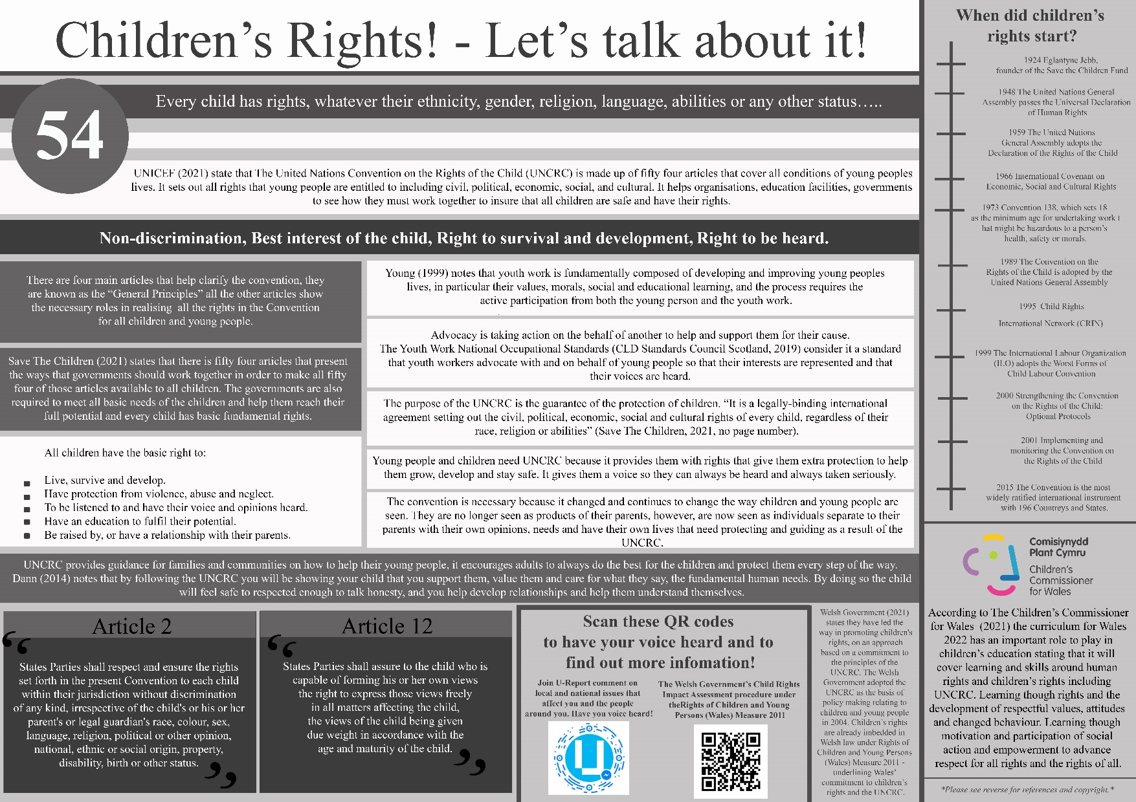
Front of Poster.

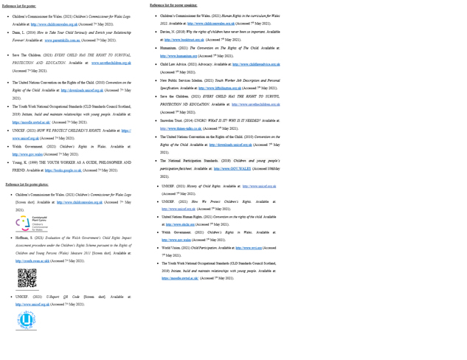 Back of poster.

On the poster:
What is the UNCRC? What the convention is?
UNICEF (2021) state that The United Nations Convention on the Rights of the Child (UNCRC) is made up of fifty four articles that cover all conditions of young people lives. It sets out all rights that young people are entitled to including civil, political, economic, social, and cultural. It helps organisations, education facilities, governments to see how they must work together to insure that all children are safe and have their rights.
There are four main articles that help clarify the convention, they are known as the “General Principles” all the other articles show the necessary roles in realising all the rights in the Convention for all children and young people.
Non-discrimination, Best interest of the child, Right to survival and development, Right to be heard.
All children have the basic right to:
- Live, survive and develop.
- Have protection from violence, abuse, and neglect.
To be listened to and have their voice and opinions heard.
- Be raised by, or have a relationship with, their parents.
- Have an education to fulfil their potential.

What is the role of a youth worker?
Young (1999) notes that youth work is fundamentally composed of developing and improving young people’s lives in particular their values, morals, social and educational learning, and the process requires the active participation from both the young person and the youth work.
What is the role of a youth workers as advocates for young people?
The Youth Work National Occupational Standards (CLD Standards Council Scotland, 2019) consider it a standard that youth workers advocate with and on behalf of young people so that their interests are represented and that their voices are heard.
What is the purpose of it?
The purpose of the UNCRC is the guarantee of the protection of children. “It is a legally-binding international agreement setting out the civil, political, economic, social and cultural rights of every child, regardless of their race, religion or abilities” (Save The Children, 2021, no page number).
Why is there a need for it?
Young people and children need UNCRC because it provides them with rights that give them extra protection to help them grow, develop, and stay safe. It gives them a voice so they can always be heard and always taken seriously.
Why is the convention necessary?
The convention is necessary because it changed and continues to change the way children and young people are seen. They are no longer seen as products of their parents, however, are now seen as individuals separate to their parents with their own opinions, needs and have their own lives that need protecting and guiding as a result of the UNCRC.
What does it mean for young people and their families?
UNCRC provides guidance for families and communities on how to help their young people, it encourages adults to always do the best for the children and protect them every step of the way. Dann (2014) notes that by following the UNCRC you will be showing your child that you support them, value them and care for what they say, the fundamental human needs. By doing so the child will feel safe to respected enough to talk honesty, and you help develop relationships and help them understand themselves.
Where did it come from/ when did it start? (TIME LINE)
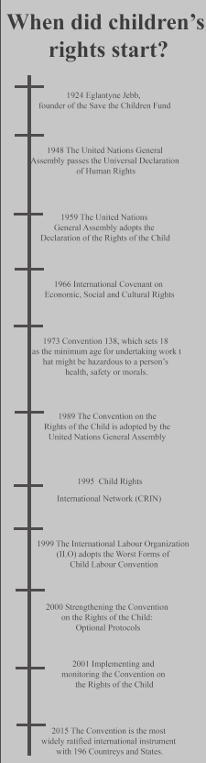

Examples of articles 2 and 12.
Article 2:
The United Nations Convention on the Rights of the Child states that acritical twelve:
1. States Parties shall respect and ensure the rights set forth in the present Convention to each child within their jurisdiction without discrimination of any kind, irrespective of the child's or his or her parent's or legal guardian's race, colour, sex, language, religion, political or other opinion, national, ethnic, or social origin, property, disability, birth, or other status.
2. States Parties shall take all appropriate measures to ensure that the child is protected against all forms of discrimination or punishment on the basis of the status, activities, expressed opinions, or beliefs of the child's parents, legal guardians, or family members.
(The United Nations Convention on the Rights of the Child, 2010, p. 4)
Article 12:
The United Nations Convention on the Rights of the Child states that acritical twelve:
- States Parties shall assure to the child who is capable of forming his or her own views the right to express those views freely in all matters affecting the child, the views of the child being given due weight in accordance with the age and maturity of the child.
- For this purpose, the child shall in particular be provided the opportunity to be heard in any judicial and administrative proceedings affecting the child, either directly, or through a representative or an appropriate body, in a manner consistent with the procedural rules of national law.
(The United Nations Convention on the Rights of the Child, 2010, p. 5)

QR CODES
Scan these QR codes to have your voice heard and to find out more information!
- Join U-Report comment on local and national issues that affect you and the people around you. Have you voice heard!
- The Welsh Government’s Child Rights Impact Assessment procedure under the Rights of Children and Young Persons (Wales) Measure 2011.
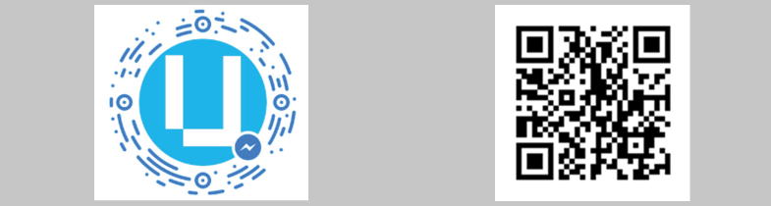

UNCRC in the curriculum?
According to The Children’s Commissioner for Wales (2021) the curriculum for Wales 2022 has an important role to play in children’s education stating that it will cover learning and skills around human rights and children’s rights including UNCRC. Learning though rights and the development of respectful values, attitudes and changed behaviour. Learning though motivation and participation of social action and empowerment to advance respect for all rights and the rights of all.
Current Welsh Policy?
Welsh Government (2021) states they have led the way in promoting children's rights, on an approach based on a commitment to the principles of the UNCRC. The Welsh Government adopted the UNCRC as the basis of policy making relating to children and young people in 2004. Children’s rights are already imbedded in Welsh law under Rights of Children and Young Persons (Wales) Measure 2011 - underlining Wales’ commitment to children’s rights and the UNCRC.

*Please see reverse for references and copyright.*

Reference list for poster:
- Children’s Commissioner for Wales. (2021) Children’s Commissioner for Wales Logo. Available at: http://www.childcomwales.org.uk (Accessed 7th May 2021).
- Dann, L. (2014) How to Take Your Child Seriously and Enrich your Relationship Forever! Available at: www.parentskills.com.au (Accessed 7th May 2021).

Save The Children. (2021) EVERY CHILD HAS THE RIGHT TO SURVIVAL, PROTECTION AND EDUCATION. Available at: www.savethechildren.org.uk (Accessed 7th May 2021).
- The United Nations Convention on the Rights of the Child. (2010) Convention on the Rights of the Child. Available at: http://downloads.unicef.org.uk (Accessed 7th May 2021).
- The Youth Work National Occupational Standards (CLD Standards Council Scotland, 2019) Initiate, build and maintain relationships with young people. Available at: https://moodle.uwtsd.ac.uk/ (Accessed 7th May 2021).
- UNICEF. (2021) HOW WE PROTECT CHILDREN’S RIGHTS. Available at: https:// www.unicef.org.uk (Accessed 7th May 2021).
- Welsh Government. (2021) Children’s Rights in Wales. Available at: http://www.gov.wales (Accessed 7th May 2021).
- Young, K. (1999) THE YOUTH WORKER AS A GUIDE, PHILOSOPHER AND FRIEND. Available at: https://books.google.co.uk (Accessed 7th May 2021).

Reference list for poster photos:
- Children’s Commissioner for Wales. (2021) Children’s Commissioner for Wales Logo [Screen shot]. Available at: http://www.childcomwales.org.uk (Accessed 7th May 2021).
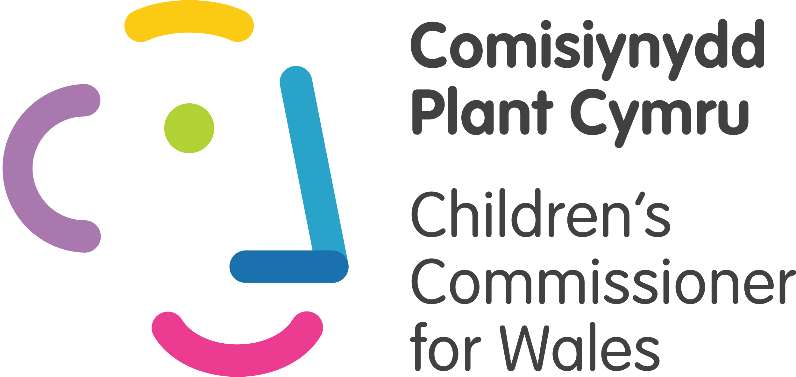
- Hoffman, S. (2021) Evaluation of the Welsh Government’s Child Rights Impact Assessment procedure under the Children’s Rights Scheme pursuant to the Rights of Children and Young Persons (Wales) Measure 2011 [Screen shot]. Available at: http://cronfa.swan.ac.ukk (Accessed 7th May 2021).

- UNICEF. (2021) U-Report QR Code [Screen shot]. Available at: http://www.unicef.org.uk (Accessed 7th May 2021).


Verbal presentation of poster:
Kirsty Allen (2014114)
Hello, today Laura, Dean and myself Kirsty will be presenting to you our poster presentation on children’s rights, advocacy, and participation, we will be covering a range of topics from what is a youth worker, The United Nations Convention on the Rights of the Child, Children’s basic rights, general principles and what you can do to support all young people and children when it comes to their rights.
Let’s start with what is the UNCRC is?
The United Nations Convention on the Rights of the Child (UNCRC) applies to all young people and adults under the age of eighteen. It is made up of fifty four articles that are put in place to protect the children by being non discriminative, looking out for the best interests of the child, giving them the right to develop, survive and to be heard.
Save the Children (2021) explain that the UNCRC also makes sure that all children’s basic rights are met, to help them reach their full potential. Basic needs are essential fore children to survive and thrive. They believe that understanding these needs are extremely important to providing children with an excellent quality of life. These basic rights are:
Live, survive and develop.
Have protection from violence, abuse, and neglect.
To be listened to and have their voice and opinions heard and taken seriously.
Have an education to fulfil their potential.
Be raised by, or have a relationship with, their parents.
What the convention is?
The convention is a set of agreed and accepted standards that are developed usually from particular matters and concerns in this case, the rights of children. Save the Children (2021) notes that the UNCRC started one hundred years ago where two sisters founded the UNCRC when Jebb wrote the Declaration of the Rights of the Child, the first inter-governmental human rights treaty, informing the United Nations Convention on the Rights of the Child, Since then the convention as developed and over the years continuing to fight for children’s rights.
What is the role of a youth worker?
A youth worker is a someone that helps young adults and children develop their personal, social, and educational development and skills. They help make a positive impact for the young person and help them access the additional support they need. When both the young person and the youth worker actively participate and build rapports, positive changes can be made for the young person and their quality of life.
New Public Services Isledon (2021) describe the role of the youth worker as not only promoting the developments of young people and children however, to hold a safe environment where they can learn how to treat themselves and others with kindness, help them discover new activities and exciting new things to try they might not experience elsewhere. To encourage them to laugh and learn and allow them to make their own mistakes and help them where needed to thrive and experiment with their learning. Finally, to help them grow into positive, resilient citizens who are motivated.
What is the role of a youth workers as advocates for young people?
Advocacy is taking action on the behalf of another to help and support them for their cause. It is part of the youth workers role to speak in favour of the young person or young people. To help support and or defend them, to access the help and support they need and to make sure their voice or voices are heard.
The Youth Work National Occupational Standards (CLD Standards Council Scotland, 2019) notes that encoring young people to become involved and take part is such a big part of the youth worker role. And that by supporting them you are helping develop their communication skills to represent their own thoughts, feelings, ideas and views to their peers and community.
How can you help advocate for young people and their rights?
There are many ways that you can help advocate on behalf of young people and children. Child Law Advice (2021) explain that the role of the child advocate is to offer advice and support them and that the purpose of the child advocate is to is to enable young people and children to express their feelings, emotions and wishes and to support them, encourage them an give them the empowerment to uphold their rights.
Here is a few ways that you can help do this:
- Make sure the child or young person’s thoughts feelings, views, emotions, and wishes are known. Get their voice heard.
- Make sure that all children and young people are treated fairly. Make sure their rights are upheld.
- Always try and give impartial and correct information to help them understand and take the right steps.
- If need be work together with other parties, such as social services or police to insure that they are safe and protected.
- Assist children and young people to communicate in a constructive manner, teaching them how to be effective.
- Communicate and ask questions on behalf of the child or young person, make sure all their questions are answered and their thoughts and quires are taken seriously.
What is the impact of rights on young people’s participation?
World Vision describes the impact of rights on young people’s participation as:
Child participation is one of the core principles of the Convention on the Rights of the Child (CRC), which asserts that children and young people have the right to freely express their views and that there is an obligation to listen to children’s views and to facilitate their participation in all matters affecting them.
(World Vision, 2021, no page number)

The link between children’s rights and participation encourage that the more you show that you respect, listen and value young people and children the more they feel valid and included. It promotes confidence and self esteem that they are head and what they say, and how they think, feel and value are important, encouraging them to take part and enjoy all aspects of their life.
UNICEF (2021) explain that non-discrimination is noted at the first ‘General Principle’ that all children are to be treated with equality and are all entitled to the same rights without discrimination of any kind.
The United Nations Convention on the Rights of the Child States in acritical two of the convention:
Parties shall take all appropriate measures to ensure that the child is protected against all forms of discrimination or punishment on the basis of the status, activities, expressed opinions, or beliefs of the child’s parents, legal guardians, or family members.
(The United Nations Convention on the Rights of the Child, 2010, p. 4)

By enforcing Article two of the UNCRC you are supping all children to have the same opportunities, support, and education by not discriminating against them. This will increase their participation as young people and children will feel safe, included, and valued by having the same opportunities and want to participate.

Verbal presentation of poster:
Dean James Boswarthack (2003506)
What is the purpose of it?
Humanium (2021) notes that the purpose of the UNCRC is to legally binding international instruments for the guarantee and the protection of children’s and young people’s rights. It is the most comprehensive international convention written for children’s rights. All fifty four articles provide a clear standard and cover all aspects of children’s rights. It also provides a purpose of advocating and protecting children as well as promoting the needs and development of young people and children. It not only protects them, however, insures that their development and education is protected too.
Why is there a need for it?
We need the UNCRC to ensure that every child is protected, so that their voices are heard and so that they can enjoy and participate in all aspects of their life.
Snowdon Trust (2014) explained that the UNCRC ensures that children and young people receive four main principles; they explain it as a triangle with the best interest of the child, participation and non-discrimination being on the three corners all working together and pushing for the survival and development in the middle. They state the UNCRC is needed for the survival and development of every child.
Why is the convention necessary?
The convention is necessary as it explains how governments and adults must work together to ensure that all children and young people have their rights, and they understand them. It is necessary as it applies to all under the age of 18; being under this age entitles them to ‘special’ rights to ensure they re protected, have an education, and develop their skills. It is necessary, as it allows them to have a voice, be listened too and be taken seriously. The convention is necessary as it make sure that adults and governments follow what is needed for the best interests of the child.
Davies (2019) notes that the UNCRC is necessary as “it is an international agreement to protect the rights of all children. Every country who has signed the UNCRC is bound by international law to give children the rights set out in it” (Davies, 2019, no page number).
What does it mean for young people and their families?
All adults, organisations and governments should do what they can to insure that all children’s rights are met. By doing so, the family’s and societies of young people and children experience a better relationship with each other and help understand each other better. By providing a better environment for children to grow, develop and learn while feeling valued and not being discriminated against, they grown up learning what society and family can do for them and what they can do in return.
United Nations Human Rights (2021) explain that society and family have the biggest impact on children’s development and they by them recognising the children and protecting them they should grow up in a happy, loving, understanding environment and this will fully able them to assume their responsibilities within the community.
Where did it come from/ when did it start? Time line
UNICEF (2021) children’s rights started in 1924when the founder of Save the Children Fund, Eglantyne Jebb, drafted the Declaration on the Rights of the Child. Then in 1948 the United Nations General Assembly passes Universal Declaration of Human Rights; this entitles mothers and children to ‘special care assistance’ and ‘social protection’. Then then adopt the Declaration of the Rights of the Child that recognises the child’s rights to education, play supportive environment and health care.
As you can see in our timeline children’s rights continue to grown though out the years including education and protection for all children, setting eighteen as the minimum age for any work that might be considered hazardous.
UNICEF explains that in in 1989:
The Convention on the Rights of the Child is adopted by the United Nations General Assembly and widely acclaimed as a landmark achievement for human rights, recognising the roles of children as social, economic, political, civil, and cultural actors. The Convention guarantees and sets minimum standards for protecting the rights of children in all capacities.
(UNICEF, 2021, no page number)

Children’s rights grow from here, continuing to put the best interests of the child first, keeping them involved and giving them a voice.

Verbal presentation of poster:
Laura Davies (1908100)
Current Welsh Policy?
Welsh Government (2021) states they have led the way in promoting children's rights, on an approach based on a commitment to the principles of the UNCRC. The Welsh Government adopted the UNCRC as the basis of policy making relating to children and young people in 2004. Children’s rights are already embedded in Welsh law under the Rights of Children and Young Persons (Wales) Measure 2011-underlining Wales’ commitment to children’s rights and the UNCRC. Also, the National Participation Standards (2019) alongside Young Wales have set out a factsheet with seven points explaining how children and young people can be supported to be able to participate in all aspects of their lives, from education to decision making. Such as:
1.Information: You have the right to information that is easy to understand and allows you to make an informed decision. We will: Provide information that is good quality, clear and accessible. Inform you about who is going to listen and let you know what difference your involvement could make.
2.You have the right to be involved and work on things that are important to you. We will: Give you enough support and time to choose if you want to get involved.
(The National Participation Standards factsheet, 2019)
All of these points echo the rights that are set out by the UNCRC.
UNCRC in the curriculum?
According to The Children’s Commissioner for Wales (2021) Children’s rights are the freedoms and protections to which all young people and children are entitled, and these are specific human rights guaranteed by the United Nations Convention on the Rights of the Child (UNCRC). They state that the curriculum for Wales 2022 has an important role to play in children’s education stating that it will cover learning and skills around human rights and children’s rights including UNCRC. Learning though rights and the development of respectful values, attitudes and changed behaviour. Learning though motivation and participation of social action and empowerment to advance respect for all rights and the rights of all.
Examples of articles: 2
The United Nations Convention on the Rights of the Child (2010) states that acritical two of the convention is that young people and children should not be discriminated against in anyway including their race, colour, sex, language, religion, political or other opinion, national, ethnic, or social origin, property, disability, and birth.
This article is put in place to reinforce that the appropriate measures are always taken to insure that every child is always protected against any form of discrimination or punishment. It also allows young people and children to participate freely and fully enjoy their development and activities without being discriminated against.
Examples of articles: 12
The United Nations Convention on the Rights of the Child states that acritical twelve:
States Parties shall assure to the child who is capable of forming his or her own views the right to express those views freely in all matters affecting the child, the views of the child being given due weight in accordance with the age and maturity of the child.
(The United Nations Convention on the Rights of the Child, 2010, p. 5)

This article insure that all young people and children have the right to express themselves and to have their voice listened too and to be taken seriously. It also insures that children all supported in expressing themselves and their views are taken into account during the decision making prosses when affecting them. It also give them the opportunity to shar and take responsibility for decision making, helping them gain life experience, confidence, and important live skills in their development.
QR CODES:
These are the two QR codes that we’ve put in our poster, simply scan them with your phone and it will take you to the relevant sites full of additional information.
The first will take you to UNICEF’s website where you can down load an app called U-Report. U-Report gathers opinions and information from young people about issues that affect them, from homelessness to climate change to the government's policies and laws. This allows children and young people to have their voice heard and their opinions taken seriously. It also allows them access the UNCRC, support and additional information on matters concerning them.
The Second QR code will take you to an evaluation of the Welsh Government’s Rights Scheme pursuant to the Rights on Children and Young Persons (Wales) Measure (2011). It is a PDF booklet that can be downloaded and read in the viewers own time including information on the UNCRC and includes review of principles of CRIA procedure, and recommendations for improvement.
About the poster and references.
Making this poster presentation came with its challenges, we think that most of these stem from the restrictions put in place by current guidelines with covid. Putting restrictions on meeting together in one place, as a result of this all our progress was done on line via teams and emailing documents back and forth to each other over email.
Our poster was made on photoshop and is A1 size, although we have zoomed in to show you the details of the poster, we would like to assure you that printed out on full size the sizes would be displayed well.
We decided to cover these fifteen main points as we feel these help understand the UNCRN, advocacy and participation best. We have designed this poster from an academic point of view however, we have tried to keep the language and straight forward so it can be beneficial for young people and their families too.
We have included in the bottom corner, ‘Please see the reverse for references* and we have made a separate document to show what would be the back of the poster, showing how it would look and what references we have included.
We hope that you have enjoyed our poser presentation, is there any questions?

Reference list for poster speaking:
- Children’s Commissioner for Wales. (2021) Human Rights in the curriculum for Wales 2022. Available at: http://www.childcomwales.org.uk (Accessed 7th May 2021).
- Davies, N. (2019) Why the rights of children have never been so important. Available at: http://www.booktrust.org.uk (Accessed 7th May 2021).
- Humanium. (2021) The Convention on The Rights of The Child. Available at: http://www.humanium.org (Accessed 7th May 2021).
- Child Law Advice. (2021) Advocacy. Available at: http://www.childlawadvice.org.uk (Accessed 7th May 2021).
- New Public Services Isledon. (2021) Youth Worker Job Description and Personal Specification. Available at: http://www.liftislington.org.uk (Accessed 7th May 2021).
- Save the Children. (2021) EVERY CHILD HAS THE RIGHT TO SURVIVL, PROTECTION ND EDUCATION. Available at: http://www.savethechildren.org.uk (Accessed 7th May 2021).
- Snowdon Trust. (2014) UNCRC! WHAT IS IT? WHY IS IT NEEDED? Available at: http://www.thines-talks.co.uk (Accessed 7th May 2021).
- The United Nations Convention on the Rights of the Child. (2010) Convention on the Rights of the Child. Available at: http://downloads.unicef.org.uk (Accessed 7th May 2021).
- The National Participation Standards. (2019) Children and young people’s participation factsheet. Available at: http://www.GOV.WALES (Accessed 10thMay 2021).
- UNICEF. (2021) History of Child Rights. Available at: http://www.unicef.org.uk (Accessed 7th May 2021).
- UNICEF. (2021) How We Protect Children’s Rights. Available at: http://www.unicef.org.uk (Accessed 7th May 2021).
- United Nations Human Rights. (2021) Convention on the rights of the child. Available at: http://www.ohchr.org (Accessed 7th May 2021).
- Welsh Government. (2021) Children’s Rights in Wales. Available at: http://www.gov.wales (Accessed 7th May 2021).
- World Vision. (2021) Child Participation. Available at: http://www.wvi.org (Accessed 7th May 2021).
- The Youth Work National Occupational Standards (CLD Standards Council Scotland, 2019) Initiate, build and maintain relationships with young people. Available at: https://moodle.uwtsd.ac.uk/ (Accessed 7th May 2021).

