Analysing the best practices of community engagement in a project/ business environment
A1

Student Name: Oana Manuela Olaru

Student ID: 2019298

Table of Contents
Introduction 2
Analysis of the project/organization's best practices 2
Stakeholder’s participation in community engagement 6
Challenges of community engagement and mitigation process 10
Conclusion 10
References 11

Introduction
The main theme of the research project is to select a social program or an organization and therefore reflecting the whole study on the core community issues. These issues are emerging due to the lack of community as well as employee engagement within the organizational culture. In this research study, the mitigation of the challenges that have been faced by the organization and also producing evaluative management reports are described in the study. Moreover, the study also will depict that how the employee values can be added to the project or the organization with the help of outstanding interpersonal skills. Therefore, the research study will wholly describe the best practices of the company that are related to the community engagement values and purposes along with the elaborative stakeholder's participation.
Tesco PLC has been chosen as the primary organization and it is noted as the largest retailer in the country for many years. It has thousands of retail stores and shops all around the world. In the case of Tesco PLC, it is noted that social media and Facebook pages are the most important regions for exploring the community engagement between the customers and employees. Social media is considered as one of the effective tools for marketing and therefore this medium has converted the internet as one of the important platforms that influence normal customers as well as the target customers at the same timeframe.

Analysis of the project/organization's best practices
The best practices of community engagement involve some of the useful consequences that are described below
The setting of utmost expectations
It can be observed that the first practice which is done by Tesco PLC is the setting of the expectations in the minds of the customers. The laying out of the service hours is very important because there are many traditional communication channels, but there are many posts regarding the organization on the Social media platforms, where the customers are getting wrong messages.
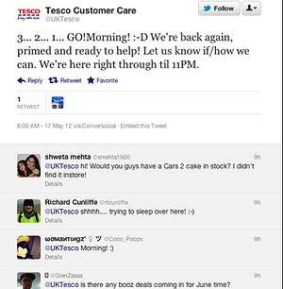
With the help of this community engagement, on the official page of Tesco PLC, they are announcing their opening hours for the secured customer assistances in their personalized and private Facebook timeline as well as a Twitter timeline (Peeroo, 2019). Proactively doing the task, and also letting all the target customers and followers know about the core activities are considered commendable tasks, where the company builds trust in the minds of the customers.
Stopping the re-direction patterns
Redirecting the customers to another platform or channel is considered to be one of the hassles from the customer side. Therefore, the organization has decided to strengthen the community engagement landscape by not redirecting the comments and waiting for a stand of the customers to a different channel (Johnson et al. 2018). It can be noticed that for sensitive information, customers prefer to message on the Facebook page of the organization without commenting in the Twitter box. The customer engagement panel of the company notably replies to all the queries rather than redirecting them to a corrupt page or an unimportant page for neglecting the query of the customer.
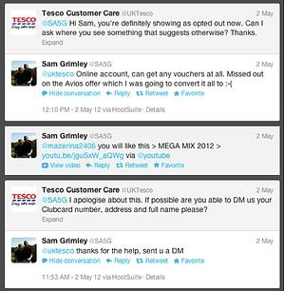
The fixation of the customer service points is very helpful for both sides and therefore all the relevant details are sent to the customers in a private manner (Alam and Raut-Roy, 2019). In this manner, Tesco PLC cyber cell leaves no consumers in doubt and that is why they are recognized as delivering the best post-sales service to the customers of the country and also international customers.
Real help deliverance in the first chat
It can be observed that delivering real help in the first contact is considered as one of the main attributes of Tesco PLC in case of community engagement. "The first contact solution" is one of the important factors and it comes while ascertaining the most "positive consumer experiences". Many customers are new and they are contacting Tesco for the first time, gets real help and wholesome solutions in the fastest manner (Peeroo et al. 2019). The deliverance of the solution is done through messages, Facebook chat as well as electronic mailing system. It can be understood that knowledge of the staffs are distributed within different departments and therefore customers are reaching out to the social media platforms and communicate with the real service agents of Tesco PLC for conversing about the "real values of the product and also gaining knowledge about offers as well as complete valuation or importance about the product".

Domestic service
It can be noted that domestic services are also performed by Tesco PLC. It is done through the branded Twitter account that is connected to the head office at the main "contact center". In this case, generic supports are not offered directly (Wood et al. 2017). In case of the community engagement, domestic services play a significant role, where the company empowers knowledgeable agents and therefore supporting networks to the store level, where the company is allowed to deliver the value as well as intricate services to the customers in the most deliberative manner.
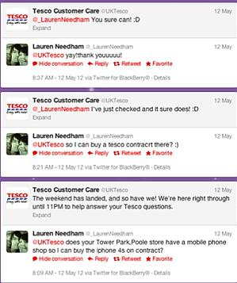
In the usual manner, customers do engage with the customer excellence department through Twitter, when in the continuous shopping phase. It can be observed that connecting with the whole business internally and delivering the solution to the target customers can form the core baseline of the community engagement modules of Tesco PLC.
Personable Engagement
In the case of the personable engagement, it can be observed that there are some conversational tones, at the time of working with the social platforms. The mobilization of the customer care line has found out some of the clinical routes as well as problems, where the teams are much active in delivering the real and combined support to each consumer.
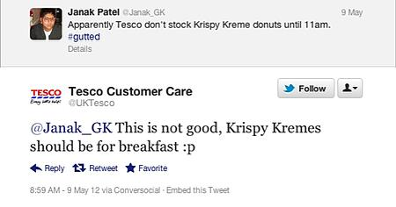
Effective support is delivered with friendly conversation and also engaging a community that looks out very sensitive in every message deliverance. Sometimes, it is found that Tweet is diverse and it is targeted at both the companies and customer, where the sense of humor is present along with the corporate interference (Gericke, 2019).

Stakeholder’s participation in community engagement
In the case of the stakeholders of Tesco PLC, it can be understood that there are five categories of stakeholders those are customers, suppliers, creditors, competitors, and also pressure groups. In recent years, it can be understood that stakeholders are highly participative and they have a keen interest in the actual business processes and operations. The enhancement of the effectiveness of community engagement is also maintained by Tesco, where the stakeholders are judged with the help of power and interest. The approximate power of the stakeholders helps in analyzing the shareholders based on a high level of power to the interest that are much dependent on the core operations and strategies (Li, 2018). On the other hand, there are also some stakeholders those are having interest but not the power. It can be known that these groups of stakeholders are much communicative and supportive to the organizational structure than the power-possessive stakeholders.
Through the application of the power interest matrix, the participation of the stakeholder in the community engagement planning can be noticed. The power-interest matrix has four quadrants those are keep satisfied, keep informed, managing closely, and monitor. In the case of the community engagement of Tesco shareholders, it can be understood that "manage closely" means that shareholders those are having high influence or power on the program. These are the board of directors and the management team along with some intervening government departments. The monitoring department is the project members (Li, 2018). Keeping an informed quadrant also signifies a group of shareholders those are having low power but they are having a high level of interest in the community engagement program. The high interest in the program can be shown by the investors, the local community, and the customers.
In the below section, the Medlow grid will be showcased for identifying the participation level of the stakeholders and therefore understanding the power and interest in a simultaneous manner. It has a direct impact on the core business and operations in the most definite manner. The third quadrant indicates low power, as well as low interest, and this group, include the product developers and the public in general.
The stakeholder matrix is designed below
Stakeholder | Internal and External | Influence | Support/Opposite/Neutral | Interest | Importance
Executives | Internal | High | S | High | Objectives achieving of retailing to the community engagement success schemes
Sponsors of the project | External | High | S | High | Receiving higher returns in the monetary as well as the non-monetary scheme
Employees | Internal | Low | N | Medium | Getting rewards for the maintaining community engagement guidelines
Customers | External | Medium | N | High | Securing the best support from the team and a higher value proposition
Local community or pressure groups | External | High | O | High | Providing value and security to the community
Competitors | External | Low | O | Medium | Reducing the profit percentage of the project
Creditors | External | High | S | High | Meeting of the daily targets for community engagement and securing long term relationship
Suppliers | External | Medium | S | High | Outstanding amount from the company by building the trust value
Government | External | High | O | High | Governing the organization of the ethical features is showcasing for community engagement programs
Table 1: Stakeholder Matrix of Tesco PLC for a community engagement program
(Source: Prowse et al. 2017)

Challenges of community engagement and mitigation process
It can be observed that there are some specific challenges for the community engagement and the mitigation processes that need to be monitored in a specific manner. In the case of Tesco PLC, it can be understood that misappropriation of cost while continuing the community engagement programs can be observed most distinctively. It is noticed overcoming prior differences between the community and academics has been also performed by the Tesco customer service department in the most definite manner.
In recent years, it can be understood that Tesco has also shown preferences while working with non-traditional communities. The non-traditional communities have some specific issues and problems, where the communities are not able to understand the heritage and specific systems or modules of the organization (Prowse et al. 2017). This results in the non-initiating with the project and also not developing the community advisory board are the main issues. It can only be solved with the help of overcoming the "competing priorities and also institutional differences" in a simultaneous manner.

Conclusion
It can be concluded that Tesco’s best practices include a series of practice for the community engagement programs that helps to strengthen the engagement between the consumers and employees in the most accurate manner. Simultaneously, it can be understood that the stakeholder’s engagement has also been much crucial for Tesco PLC, where the influence and interest of the stakeholders are much important for the development of the local community program. The organization needs to connect with the organized board of members and communities, where they can be able to reach maximum domestic and international customers.
References

Alam, S. and Raut-Roy, U., 2019. Evaluating the Effectiveness of Reward Strategy at Tesco: Evidence from Selected Stores in UK. Indian Journal of Industrial Relations, 55(1).
Gericke, A., 2019. Sport sponsorship as a community engagement tool: Spinneys Dubai 92 Cycle Challenge (Doctoral dissertation, University of Pretoria).
Johnson, S., Robertson, I., Cooper, C.L., Dickinson, J. and Jones, N., 2018. Tesco Bank Wellbeing Case Study. In WELL-BEING (pp. 179-188). Palgrave Macmillan, Cham.
Li, S., 2018. Building Community Resilience in Hounslow Using Community Engagement (Doctoral dissertation, Worcester Polytechnic Institute).
Peeroo, S., 2019. Customer-initiated conversations on Facebook pages of Tesco and Walmart. In Information Systems Design and Intelligent Applications (pp. 43-51). Springer, Singapore.
Peeroo, S., Samy, M. and Jones, B., 2019. Trialogue on Facebook pages of grocery stores: Customer engagement or customer enragement?. Journal of Marketing Communications, 25(8), pp.861-883.
Prowse, P., Lopes, A. and Fells, R., 2017. Community and union-led living wage campaigns. Employee Relations.
Wood, S., Wrigley, N. and Coe, N.M., 2017. Capital discipline and financial market relations in retail globalization: insights from the case of Tesco plc. Journal of Economic Geography, 17(1), pp.31-57.

