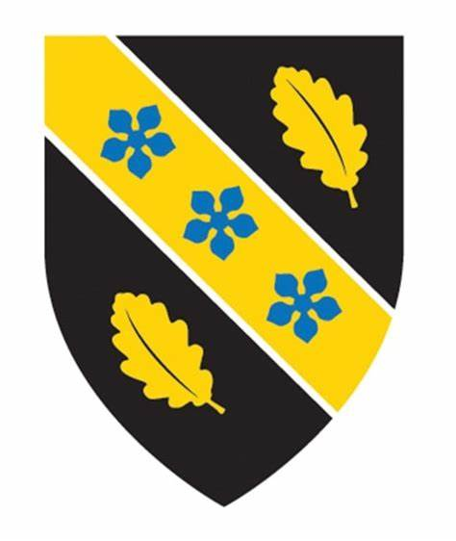
PORTFOLIO

Course: Writing for Heritage (HPHE7010)
Assessment

Question: Drawing on material from the module and your own reading and research, compile a portfolio of creative writing pieces appropriate for use within the heritage sector. The portfolio might include pieces such as: a museum exhibit trail narrative; a script for a tour guide; a magazine article aimed at a heritage publication; a pitch for a heritage-themed documentary; web copy for a heritage institution or venue; a pyschogeographical essay with a focus on heritage.

Name: Olatunji Offeyi
Student number: 2214724
Professional Doctorate Heritage
Institute of Education and Humanities
University of Wales Trinity Saint David
Lecturer: Dr Sarah Reynolds
Word count: 4365

TABLE OF CONTENTS

Section A: Exhibition Narrative……………………………………………………3
Exhibition Title and Details…………………………………………………3
About the Narrator……………………………………………………………4
Introduction……………………………………………………………………5
Narrative Guide Series………………………………………………………

Section B: Travel Article ...…………………………………………………………16
Section C: Travel Guide Lagos....…………………………………………………21

SECTION A: EXHIBITION NARRATIVE

Exhibition Title: The legendary story of revolutionary Nigerian musician Fela Kuti with pictures
Targeted Audience: Africans in the diaspora and the wider members of the public interested in African Civil Rights agitation and consciousness that Fela stood for.
Venue: The Africa Centre, 66 Great Suffolk Street, Southwark, London
Type of Label: Narrative
Listening Device: Yamaha HPH-50 Headphones
Duration: 15–31 December 2022

Languages: Nigerian English (deliberately preferred to retain the uniqueness, Afrocentrism and originality of the stories) and Yoruba (to read in Yoruba, select Y at the bottom of the screen)

Braille: For people with a visual impairment

Location: In the left-hand corner of the exhibition space

Lighting: Pictures are mounted in front of a solid, contrasting background, with a 75% contrast between foreground and background. The fluorescent lighting also removes shadows for visitors with poor vision.

About the Narrator:
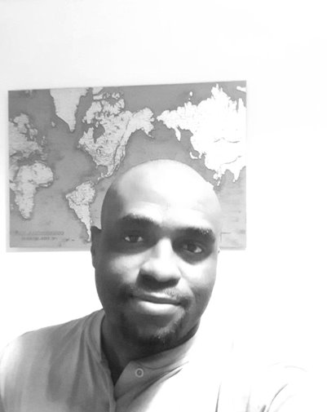
I am Tunji Offeyi, a Nigerian-British journalist, and formerly a departmental Student Union activist and leader at the Lagos State University (2000–2004). Why am I interested in Fela Kuti’s story? When I was young, my father JK Offeyi, a former journalist, had the privilege of interviewing Fela at his Kalakuta Republic many years ago. Although I couldn’t locate the published story, his verbal rendition of the interview gave me a glimpse into the mystique of the man Fela and his struggles. So when I started writing for the now defunct The Week magazine, I was tasked with visiting ‘The New Afrika Shrine’ (Femi Kuti’s club) (Femi Kuti is Fela’s eldest son, an accomplished Afrobeat musician in his own right).
Armed with this background and knowledge of the Nigerian political debacle, military rule and oppression, as a journalist and former student activist, I value the person of Fela Kuti, his music, and his struggle against tyranny all the more, having lived this experience myself.
I am convinced to tell you that the Nigerian political activism story is incomplete without mentioning the one who refers to himself as ‘Anikulapo’ (‘The man who has death in his pouch’) – the musical prodigy and civil rights icon Olufela Anikulapo-Kuti, simply known as Fela Kuti. Come with me as I take you on a journey and introduce him to you.
INTRODUCTION
A Rebel is Born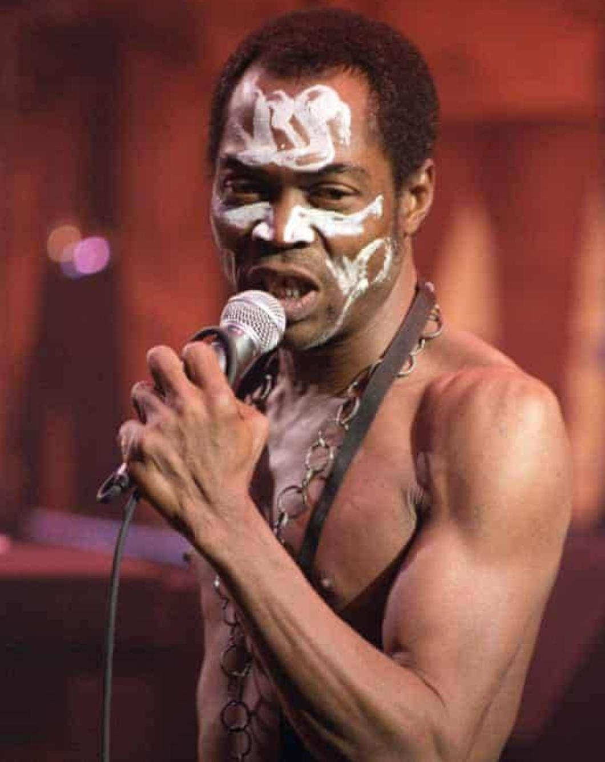

In the year 1938 – 15th October to be precise – something defining happened: Fela Ransome-Kuti was born to Reverend Oludotun Ransome-Kuti and Mrs Funmilayo Ransome-Kuti. However, little did the Egba people of Abeokuta know that a ‘Messiah’ was born. Come with me, into the world of an innocent child who would grow up to become the champion of the people. As a little boy, Fela was just like a normal child raised in the Church, where he learned how to play the piano and drums, and was the lead singer in his school choir at Abeokuta Grammar School. It is on record that Fela’s mother was the first woman to drive a car in Nigeria.
Fela’s family were elites. However, they were anti-oppression on all fronts: his father once challenged a colonialist headmaster, an act that was seen as an abomination in colonial times. His mother also led several women’s rights protests through the Abeokuta Women’s Union (AWU), which led to the deposition and exile of the Egba Monarch, Alake of Egba land, Oba (King) Ademola II. As they say, the apple doesn’t fall too far from the tree. Young Fela didn’t appear serious or intellectual enough in his early years to suggest he would become a historic warrior in the Nigerian civil rights context. However, he was said to be so stubborn that his parents never spared the cane, as was the practice then. Another hint of Fela’s rebellious nature materialised when the young Kuti told his parents to send him to England to study Medicine, like his brothers.
Do you believe Fela was going to keep his promise? Far from it! When he reached England he made a U-turn and enrolled at the Trinity College of Music; here he studied classical music and became interested in American jazz. Fela’s choice of music did pay off, as it was through music fused with activism that he wrote his name into Nigerian folklore. ​

A Date with Destiny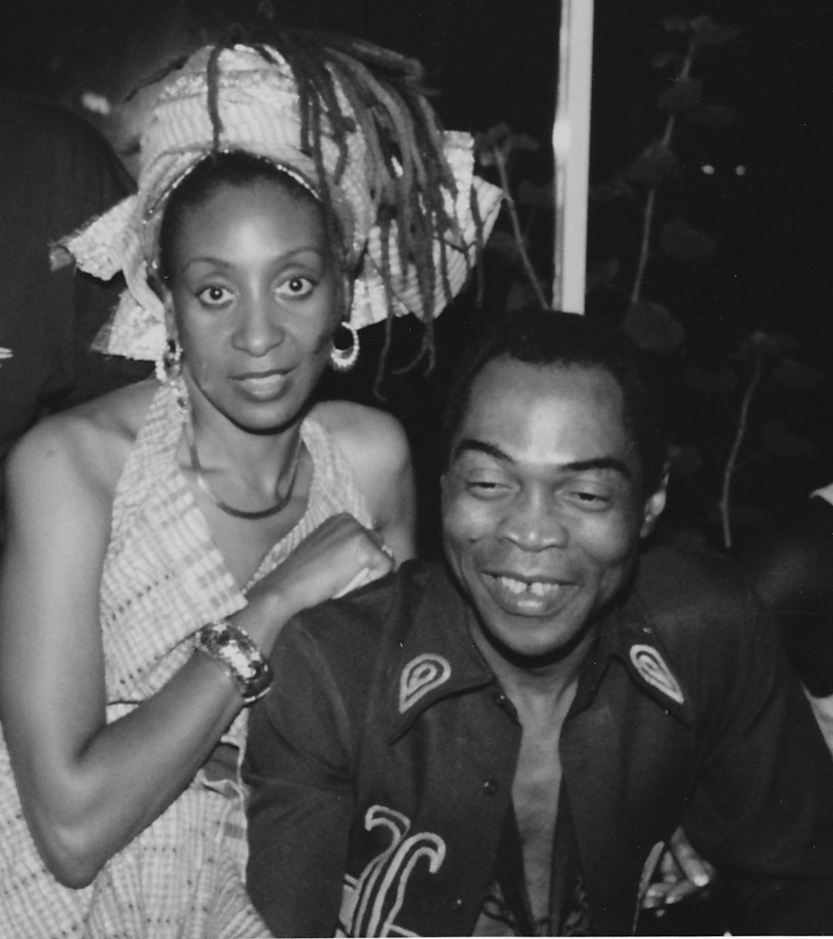

According to Fela’s famous cousin, the Nobel laureate Wole Soyinka, after Fela graduated from Trinity College, he would do a few gigs here and there, and simply play his saxophone at a private hostel they both shared. Then he eventually returned to Nigeria to play the Hi Life genre of music, whilst frequenting neighbouring Ghana for music tours and concerts. However, something defining happened to Fela in Los Angeles, in his music and his life. Guess what? The sleeping giant in this African revolutionary had finally awoken. This was thanks to jazz musician Juno Lewis, who introduced him to Sandra Izsadore (Sandra Smith) – an African American singer and activist who later became his live-in-lover – who awakened his political consciousness. She introduced him to the Black Power movement, and also through her influence, he read civil rights books about Malcolm X, Eldridge Cleaver, and the like. Seeing how musically gifted he was, Sandra suggested he use music not just for entertainment, but as a tool for greater societal change and a vehicle to set his people free. In Fela’s words, ‘Sandra gave me the education I needed; she was the one who opened my eyes’. Fela would later incite Ghanian students to challenge Colonel Ignatius Acheampong’s brutal regime, through a defining address he gave at Accra Apollo Theatre, which led to a nationwide riot in that country. Having already escaped from Nigeria for inspiring Nigerian students to riot against the Federal Military Government, he was immediately deported back to Nigeria. At this juncture, I will let you listen to a tune from Fela, titled ‘Teacher Don’t Teach Me Nonsense’. See you in the next chapter.
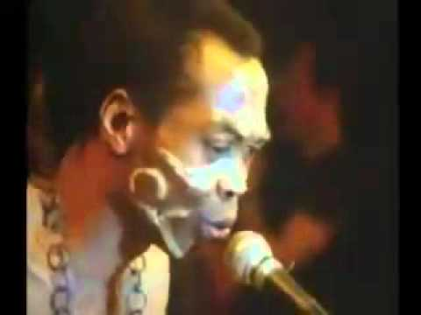https://youtu.be/RgJ-VC-IOrg

Kalakuta Burns
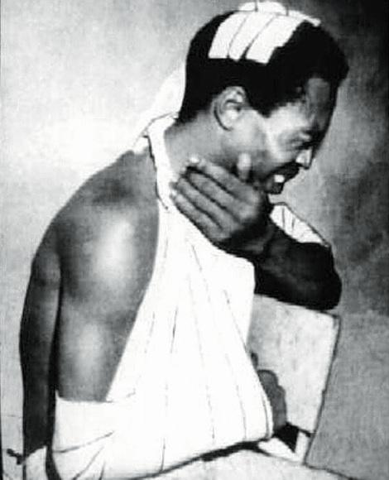
Fela’s communal compound he’d named Kalakuta republic (his imagined free world), where all inhabitants were treated equally regardless of background or social class. Simply put, Fela’s republic – shall we say, the house – was open for all; children rejected by the society found a shelter in his abode. However, trouble was soon to knock on the door of Kalakuta republic.
When Fela released the song ‘Zombie’, fans loved it; the old and the young sang along. But the Military Junta, headed by General Olusegun Obasanjo at the time, were outraged that Fela’s ‘Zombie’ was a metaphor describing their brutal nature, lack of restraint, and disdain for Nigeria’s civilian population. So, in the early morning of 18th February 1977, around a thousand soldiers stormed his abode, destroying virtually everything in sight – they allegedly raped some of his dancers and wounded many people; but Fela fought back. He switched on his electric fence to stop the invaders from jumping in, but that only worked for a while. Soon they got to the second floor of his house and found his mother, Funmilayo Ransome-Kuti. Boom! They threw her out of the window. Sadly, a few days later in the hospital she passed away due to the injuries she sustained. Eventually, they got to Fela on the last floor and pounced on him, beating him black and blue. This angered Fela all the more. A few days after recuperating, he again fought back by driving an empty coffin to deposit at the then seat of power, Dodan Barracks – narrowly escaping being shot alongside his ladies (dancers and lovers) in the process. He didn’t stop there: he composed the song ‘Coffin for Head of State’ to let the world know that the Nigerian army had killed his mother, although they denied it. It must be pointed out that despite his bravery, it’s reported that he sometimes got depressed about the terrible situation of the Nigerian state – poor Fela! Do you think the Nigerian state will one day apologise to the Kuti family? Your guess is as good as mine.
Zombie
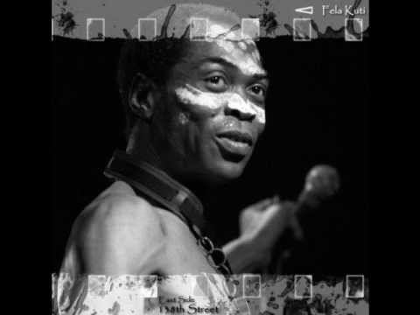https://youtu.be/xVd6RaJfpkQ
Coffin for Head of State 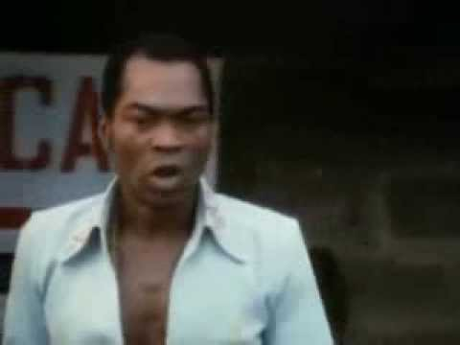https://youtu.be/9Hxyk1m2w54

Fela Marries 27 Women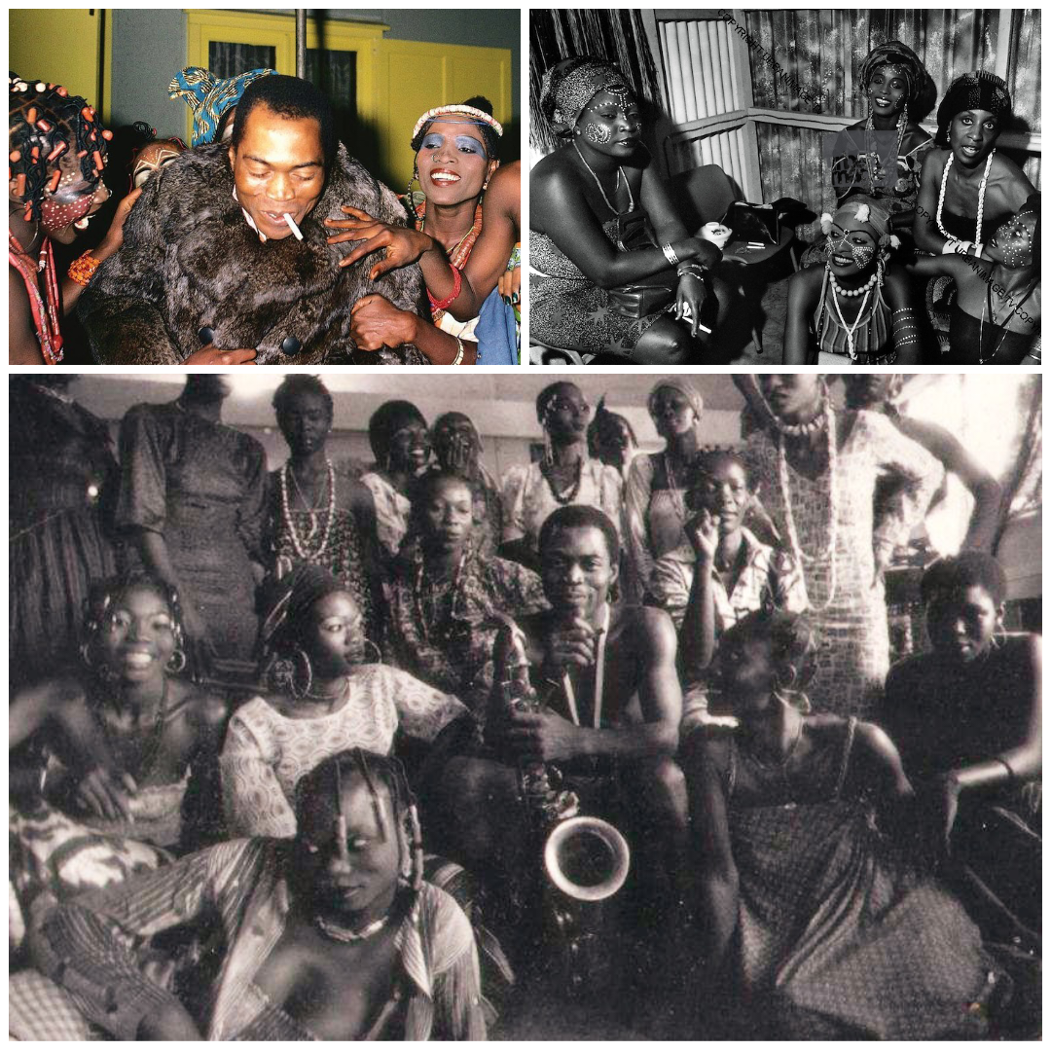

Ladies and gentlemen, do you know that aside from Fela’s many struggles and travails with the then military rulers of Nigeria, there have been so many controversies hovering over him – such as smoking jumbo-sized marijuana in excess, and keeping a harem of ladies in his empire, who were also his dancers at Kalakuta republic. However, rumours began to circulate that Fela was holding these ladies captive against their wishes, so to dispel this rumour Fela asked if the ladies would marry him – and they all answered yes! So, on 20th February 1978, this happened at Parisona Hotel at Anthony, Lagos. Despite protests against the mass marriage from the women’s families, 12 African traditional religion priests presided over the wedding and pronounced Fela the husband of 27 wives: namely, Fehintola Kayode (Seun’s mum), Damiregba (Naijite, Motun’s mum), Keuwe Oghomienor (Kewe), Folake Oladeinde (Alake), Folake Oladejo, Ronke Edason, Laide, Emaruagheru Osawe, Ihase, Shade Shodeinde, Suru Eriomola, Tejumade Adebiyi, Omolola Osaeti, Tokunbo Akran, Ronke (another one), Adejonwo, Lamiley, Funmilayo, Adunni, Remilekun, Kikelomo, Lara and Bose. Shocking! Yet it was not frowned upon by the African society of Fela’s time, who saw it as a heroic feat by a man who had potentially ‘rescued’ a large number of women from being single and unmarried. Fela then showered the ladies with money, by placing Naira notes on their foreheads and presenting them with copies of their ‘marriage certificates’. Afterwards, they went on a honeymoon in Ghana.
However, the honeymoon didn’t last, as Fela was once again imprisoned by the Military on a trumped-up charge of ‘Drug Possession’, which was never proven in court. Rather, it was clear to Nigerians that this was due to his relentless lyrical activism, which continued to ideologically embolden, enlighten and empower the people on their rights – leading to many riots on campuses and political squares, like never seen before. Fela was finally released in 1986, but by then his worldview had changed yet again: he no longer believed in marriage. He simply divorced all 27 wives at once. Besides, most of these women had already moved on during his imprisonment, so the divorce was a bit of an academic exercise.

End of an Era
As the saying goes, everything that has a beginning must have an end. It was a Black Saturday, 2nd August 1997, in Lagos, when the news rent the air that Abami Eda (‘The Strange One’) Fela Anikulapo-Kuti had joined his ancestors. The next question was, what had killed the man of the people? His elder brother, Professor Olikoye Ransome-Kuti – a former Minister of Health and paediatrician – called a press conference and stated the cause of Fela’s death as AIDS. The street went wild! The people wailed. Fela’s fans refused to believe that; hence, so many controversies and conspiracy theories were the order of the day. Even in death, controversies did not depart from Fela’s tale of bravery, insurrectionism, anti-western imperialism, activism, excessive marijuana use, sex, and good music. Fela’s civil rights achievements are immense – redefining Nigeria’s socio-political discourse through lyrical warfare, and inspiring several protests against the Military Regime; being unjustly jailed several times, for as long as 20 months in 1984 for daring to speak against the junta; and his music icon status. And yet he was naïve: for instance, he believed in magic over modern medicine, and was said to never use any pharmaceutical products – instead preferring to drink African herbs, which certainly is no remedy to fight a virus as deadly as HIV/AIDS.
Hmm, what a man, what a life! What a legacy of influencing many activists, such as his lawyer Femi Falana, Omoyele Sowore, Segun Oke-Owo of the Ali Must Go protest fame, Femi Borisade, Mike Ozekhome – and in particular, the National Association of Nigerian Students (NANS), whom he addressed at many rallies. On many occasions they have attributed their activism to the influence of the many conscious lyrics of Fela’s music, such as ‘Beast of no Nation’, ‘Confusion Break Bones’, ‘Ikoyi Blindness’, ‘I Go Shout Plenty’, ‘Shuffering and Shmiling’, ‘Authority Stealing’, ‘International Thief-Thief’, etc.
Interestingly, these were the activists who eventually defeated the Military Government through the NADECO movement. Although Fela didn’t live to witness the victory, he would be proud that his adherents won democracy back for the people in 1999; and while his call for a United African Republic is yet to materialise, it remains a dream for many Pan-Africanists. The moral of the story is this: like Fela, we must all learn to speak against injustice and inequality, regardless of the consequences. Fela lives on! He lives in all who refuse to keep silent in the face of oppression.
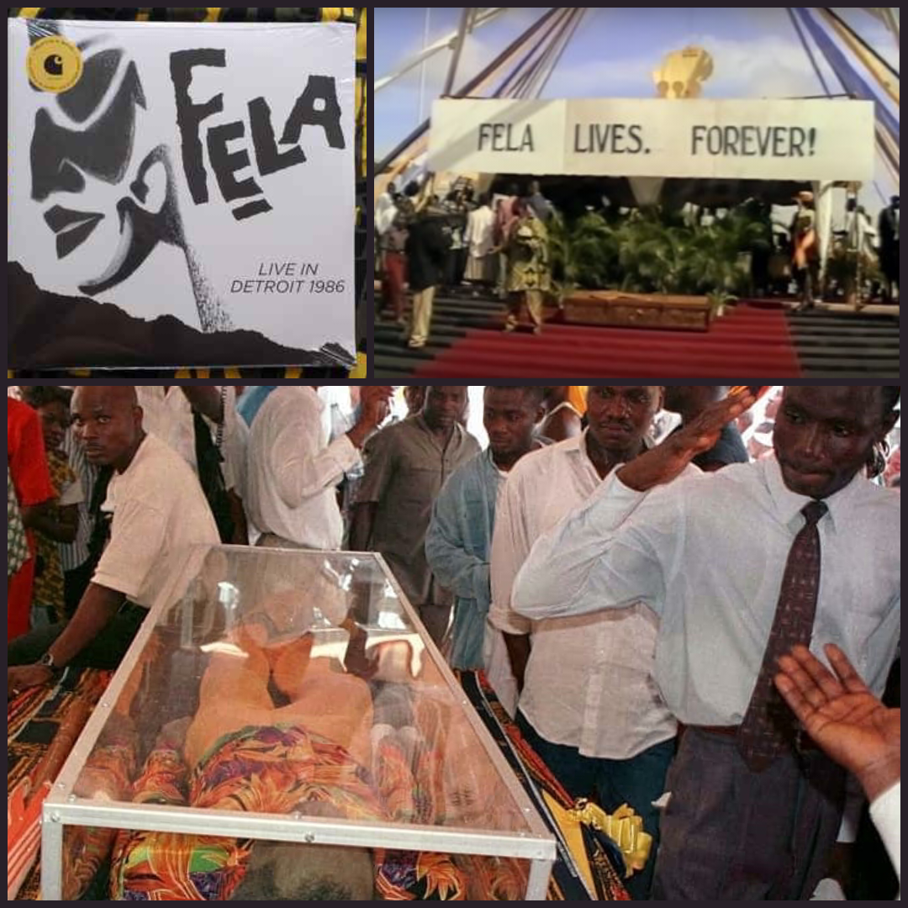

SECTION B: TRAVEL ARTICLE
See The Travel Magazine guidelines The Travel Magazine Authors - Writer's Guidelines

The best restaurants in Bauchi, Northern Nigeria
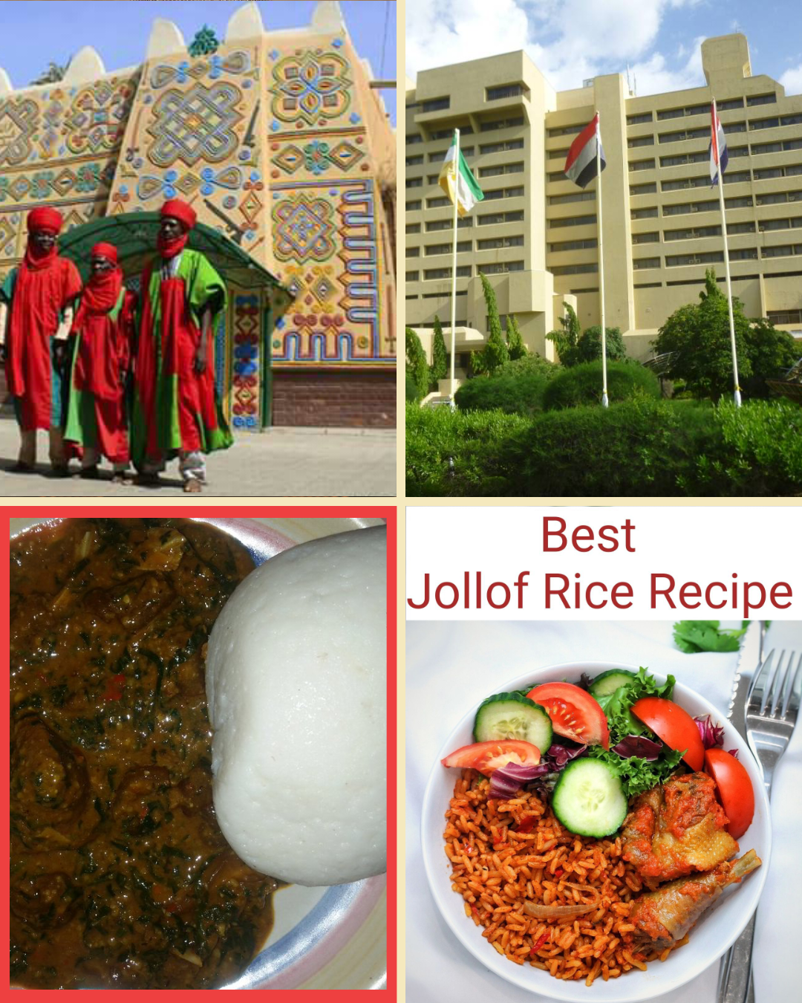
My first time in Bauchi State, Northern Nigeria was as a 27-year-old National Youth Service Corp member, when I served Nigeria in a compulsory one-year paramilitary training and community engagement and outreach service. I have recently visited again in a private capacity, and one thing that struck me is the many improvements in the cities: gone are the dusty roads and beggars who used to sit by the roadside – things have changed. I am told it has to do with the dynamic new governor of the state, Gov. Bala Mohammed. I couldn’t believe how many high-rise buildings, beautiful roads, avenues – and most importantly, new restaurants – had sprung up in different parts of the city. As I was spending seven days there, I decided to visit different restaurants at different times: I managed four in total.

Zaranda Cafeteria
Tucked away at the back of Hotel Zaranda, the Zaranda Cafeteria boasts a wealth of various cuisines, both local and international. I was captivated by the finely detailed artworks that filled the wall, almost as if they were competing for space; some of them told stories about the bravery of historical warriors of the land of Bauchi. The first to attend to me was a pot-bellied man named Silas – he was a bit talkative, jumping from one topic to another in a flash. Within the space of 15 minutes, he’d told me the summary of his life – how he used to be a mechanic, fixing the hotel vehicles, until one day the restaurant chef didn’t show up at work, and he volunteered to prepare a native dish called Tuwo Shinkafa – a thick pudding made from maize, soft and sticky. It was so delicious that the hotel had to move him to the kitchen permanently. So, I wasted no time in requesting the same meal, sitting in a corner where the music speaker was blaring one of my favourite tracks: ‘Return of The Mack’ by Mark Morrison. I settled for a bowl of Tuwo with okra soup, garnished with beef and gulped down with a local drink called Zobo. In between meals the kitchen assistant kept checking if everything was ok for me, greeting me with Rankadede (live long) in the Hausa language. I warmly returned their greetings and left them with a tip that made them smile.

Mama Oluchi Pepper Soup Joint
This is a restaurant I have a personal connection with: it was owned by an Ibo woman named Comfort Emeka, popularly known as Mama Oluchi – an alias earned for being the mother of little Oluchi. I walked quietly into the now modernised restaurant, which locals often refer to as a ‘joint’ because it serves as a sort of melting pot for all kinds of people from different strata of life. In short, if you want to know the latest gist in town, this is where you need to be. It sure serves more than good dishes of pepper soup. I was soon spotted, and one of the staff immediately recognised me: ‘Oh Uncle Tunji!’ she exclaimed (never mind that we are not related), ‘Oh, since you passed out from the Youth Corp you never remembered us, what are you up to now? Are you working for a TV station, a big bank? I know you will do well.’ She answered her own questions. ‘Mama Oluchi, come and see Uncle Tunji o!’, she screamed. Mama Oluchi too, feeling flabbergasted, couldn’t believe it was me – so many dramas that day.
‘I can see your restaurant has really expanded, and it’s well decorated with beautiful flowers and ornaments, well done!’ I said. ‘It is the work of God,’ she replied humbly in her usual Christianity-flavoured utterances. ‘What shall we offer you?’ ‘Anything not expensive,’ I said, giggling. ‘Noooo!’ she yelled, ‘you choose whatever you want free of charge, you are a guest, not a customer; we have goat meat pepper soup with assorted beef, chicken pepper soup, cow head, leg or tail pepper soup, fish pepper soup.’ So, I settled for the fish pepper soup – a warm and soothing West African soup, simmered in a flavourful, spicy broth made up of catfish, vegetables, and spices. It was so delicious that I left no particles in the plate. Sensing I had enjoyed the food so much, Blessing (one of the staff) jokingly teased me: ‘Uncle Tunji, don’t be shy, if you want second round just say so.’ ‘I think so,’ I responded diplomatically, with a laugh. Honestly, I rate this ‘joint’ a 5-star – not because I ate ‘double rations’ for free, but they sure know how to make good pepper soups. When next you are in this part of the world, I recommend you visit Mama Oluchi’s joint: a taste will convince you.

Taiwon Mein
Turning left off Market Road, you will find a new bright-red colour restaurant with huge dragons painted all across its walls, run by a Chinese couple named Ai and Gui. How they managed to get to Nigeria, let alone Bauchi state, remains a mystery. They are of few words and business-like, shy and polite – they speak little English, which is enough to conduct business. Their menu consists of Peking roasted duck, Beijing roasted duck, Kung Pao chicken, sweet and sour pork, hot pot, dim sum, Cantonese dim sum, and black bean sauce. I ordered a plate of white rice with black bean sauce: widely used in Chinese cooking, black bean sauce is made from fermented, salt-preserved soya beans. It’s a cooking sauce rather than a table sauce or condiment, and has a subtle, deeply savoury taste. Actually, the soya beans used in black bean sauce can either be black or yellow; the sauce’s colour is a result of the beans darkening due to the enzymes released when they are dried at high temperatures during the fermentation process. Although this was not my first time savouring a black bean sauce, I was nevertheless impressed by the cooking skills. Although quite taciturn and introverted, they made up for their shyness with great cooking talent – which, let’s face it, is about the most important for a restaurateur to possess – the rest, they say, is secondary. So, if good Chinese cuisine is your thing, if or when you do visit Bauchi state, don’t hesitate to check out Taiwon Mein run by Ai and Gui, whose simplicity, politeness and business-like approach would particularly suit someone hungry enough, with little desire for chit-chat. Stomach first!

Cuisine Africana Delight
Tucked inside the Bauchi Motor Park, Cuisine Africana Delight is like an oasis in the desert, considering it is the only restaurant in that location. So, I decided to ‘refill’ my stomach while the Luxury bus to Lagos loaded up. Here you have to wait for the food to be specially prepared for you; in my case, it was cooked by the master chef, John. He explained that two of his regular chefs were under the weather, hence he had to take charge of preparing the meals for everyone –- usually, he only cooks meals for the VIPs. Ably assisted by his Ghanaian wife Patricia, they seemed to have found a solution to the agelong ‘Jollof rice’ debate between Nigeria and Ghana, on who cooks it better. Therefore, the menu included both Nigerian Jollof and Ghana Jollof. I settled for the familiar Nigerian Jollof, as the meals were just too expensive to experiment with – ordinarily, as a frugal person, I would have avoided this over decorated, extreme air-conditioned costly restaurant, but I couldn’t risk leaving the park and missing my bus. The prices are comparable to airport-style pricing, clearly recognising that customers have little or no choice. That said, the food was excellently prepared – no complaints about that; therefore, I included it on my list. I strongly recommend you check out the prices below before deciding. A plate of rice can cost up to £16! However, if you feel priced out, you can settle for a home-made version by yourself. Various recipes for cooking a Nigerian Jollof include rice, tomatoes, pimento peppers, tomato paste, Scotch bonnet chili, onions, salt, and other spices. The choice is yours.

SECTION C: TRAVEL GUIDE LAGOS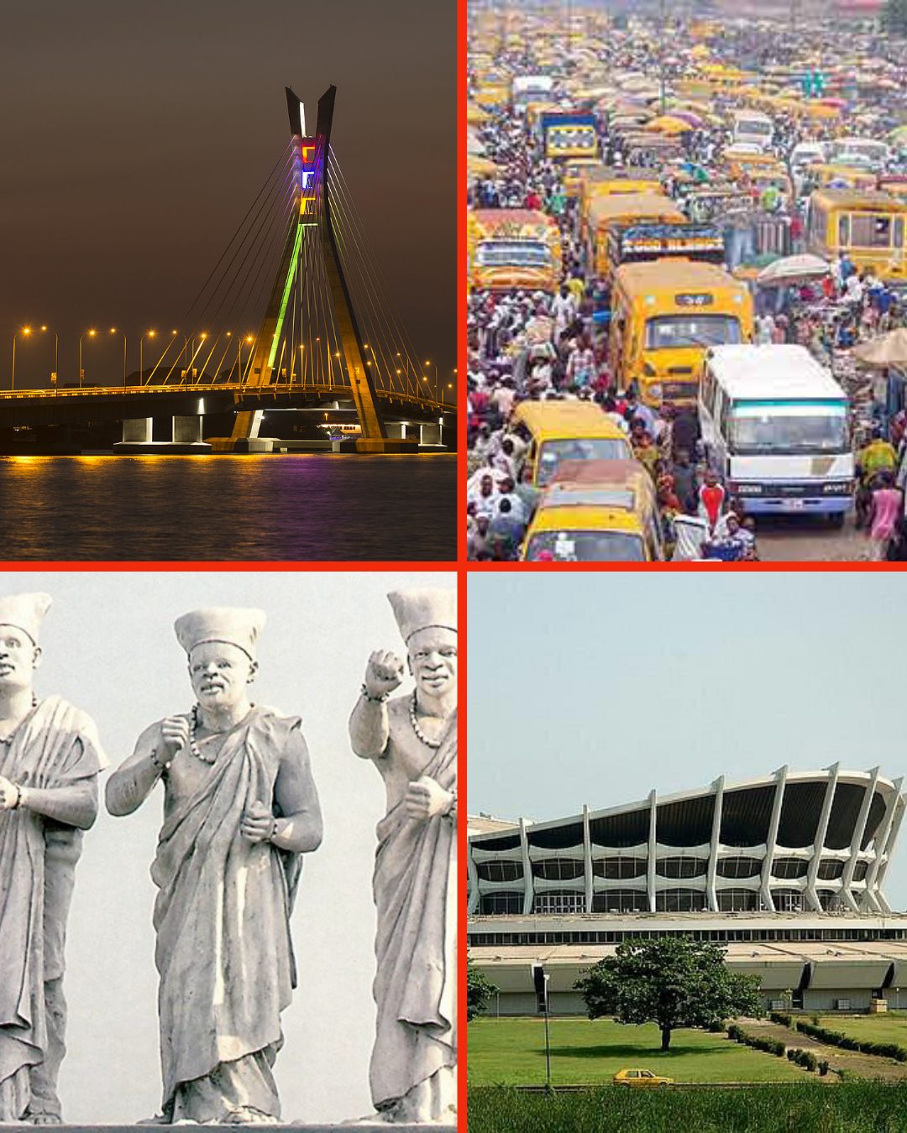
People often describe Lagos as a ‘no man’s land’, but that is far from the truth. There are indigenous Lagosians scattered across Nigeria’s most populous city, from Isale Eko (Lagos Island) to Ikorodu, Epe, Agbowa, and the riverine areas. Despite being densely populated. Lagos's landmass of 1,171 km² makes it the smallest city and state in Nigeria, and a little smaller than London in the United Kingdom – and yet, the journey from Lagos in Southern Nigeria to, say, Bauchi in Northern Nigeria is almost thrice the journey time from London to Edinburgh. Talk about a small city in a big country called Nigeria. Lagos is roughly divided between the Mainland and Island. The mainland is the abode of the regular people, while the rich live on the Islands, of Victoria and Banana Island, including Ikoyi.

LAGOS FACT FILE
By far the most prosperous city in Nigeria, and largest in terms of population and human capital development, Lagos sprawls inland from the Gulf of Guinea across Lagos Lagoon. Victoria Island is the financial district of the city. Lagos is known for its unique and breathtaking beach resorts, from Tarkwa Bay in the west to Eleko beach in the east, and La Campagne Tropicana, Whispering Palms, and Badagary Beach on the outskirts. The north of Lagos hosts the iconic National Museum Lagos, with a large collection of cultural artifacts and crafts. Also on Lagos Island is the ever-busy Freedom Park – a former colonial-era prison turned concert and events venue.

GET IN
By plane: Murtala Muhammed International Airport (LOS) is a major hub, connecting Africa, Europe, and the Middle East, along with internal links to Abuja, Benin, Port Harcourt, Enugu, Ibadan, Ilorin, Kano, and regional connections across West African states. International carriers such as British Airways operate a service from London Heathrow. Air France, KLM, and Lufthansa are major players in the Lagos route.
By train: The massive rejuvenation of the Nigeria Railway Corporation and opening of new stations and rail networks means Lagos can be accessed by regional commuter trains from Abuja, Ibadan, and Kano. The NRC publishes timetables on their site NIGERIAN RAILWAY CORPORATION (nrc.gov.ng)

TOURING BY CAR
Lagos’ best attractions are spread across the metropolis, so if you can afford the modest prices the thing to do is hire a car and driver to take you around. Travel companies such as Trojo and Flicks offer drivers who also serve as well-informed guides.
If you desire an SUV or a sedan there are plenty of inexpensive options, as some of the best tour drivers earn only about £20 a day in Lagos. You can book directly from local rental companies in big hotels, such as the Sheraton, Bogobiri, and Hilton. Cars are available at short notice, but if you want a van or SUV, it is recommended to book in advance. Rates for a car and driver is about £2 an hour. For £20, you can book 10 hours. Rates increase though if you leave metropolitan Lagos, which is fair because the road network outside the centre is poor, so that the drivers constantly must visit mechanics for repair work. If, however you get tired of being driven, there are other options such as, bicycles, boats, and on foot for short distances in a safe neighbourhood (always check security alerts in Lagos).

WHERE TO VISIT IN LAGOS
Bar Beach: If you are going to be staying on the Islands, this is the main beach, alongside Ahmadu Bello Way, and one of the more popular beaches in Lagos State. Bar Beach is the main (inner city) beach, and runs from the Institute of Oceanography in the west to the Eko Hotel in the east. Silver Bird Galleria is only a few steps away. Bar Beach is named after the sand bars that characterise the coastline of Lagos, not because of the myriad of bars that run along the beach itself – a common misconception!
Lagos Bar Beach’s accessibility makes it the most visited beach in Lagos, especially during Yuletide and the holiday seasons. It has somewhat lost most of its attractions due to the massive construction works being done along the coastline. However, if you don’t mind its new artificial look, you will still find the environment soothing. Horse riding, swimming, beach volleyball, and picnic activities still go on at the beach, and those who are prepared to venture further down to the Kuramo beachside will find it relatively calm, with some privacy that is not available at the Bar Beach.
Lekki Conservation Centre: If you are a fan of conservation, flora and fauna, take a walk around the longest canopy in Africa. You will see monkeys, peacocks, crocodiles, snakes, and other wild animals, at this reserve without having to travel on a safari in Northern Nigeria. At the same time, you will find different species of plants, as if you were in Kew Gardens! For just £2 you can stroll, wander and explore the Lekki Conservation Centre while holding hands with your loved ones.
Other interesting places to visit in Lagos are the Badagary Slave Museum, National Theatre, Onikan Stadium, and Muson Centre, and if you like street football, head to Maracana Stadium in Ajegunle – the biggest ghetto in West Africa, located in downtown Lagos, which is a nurturing ground for many of Nigeria’s football and music stars.

