Modelling of Shaped Charges

James Howe
1910319

L5 - Advanced Physics of OME (ACDA5015)

Wales Institute for Science and Art
University of Wales Trinity Saint David



Abstract
A shaped charge is an explosive device that uses its detonation products to cause a conical liner to collapse in on itself whilst accelerating it in a target direction. A high velocity jet is created that is extremely capable of penetrating metal, concrete and armour. They are used both in the military as weapons and by the mining industry to sheer off large parts of rock.
This paper discusses the effect the choice of explosive material and liner material have on the peak velocity of the jet, using ABAQUS Finite Element Analysis (FEA) software. The three models used are TNT with copper as a baseline, RDX with copper and RDX with glass.
The RDX with glass model provided the highest peak velocity at 9840 m/s also with the highest acceleration. The velocity improvement over the TNT model was 3.3x.

Table of Contents
Abstract 1
1. Introduction 2
1.1 Shaped Charges 2
2. Modelling Method 4
2.1 Simulation Setup 4
2.1.1 TNT and Copper 6
2.1.2 RDX and Copper 6
2.1.3 RDX and Glass 6
2.1.4 JWL Equations of State 6
3. Results 7
3.1 Simulation Breakdown 7
3.2.1 TNT and Copper 9
3.2.2 RDX and Copper 10
3.2.3 RDX and Glass 10
3.2.4 Velocity Comparison 11
4. Discussion 11
5. Conclusion 12
6. References 13
7. Appendix A 14

1. Introduction
This essay will document the procedure and findings of altering the materials used in a shaped charge explosive device. Finite element modelling software will be used to model the shaped charge, its explosive properties and the jet formed. The aim is to produce a better performing shaped charge in this software by researching the properties of alternative materials.

1.1 Shaped Charges
A shaped charge is a cylindrically shaped explosive device with a cavity in one end and a detonator in the other. This cavity in the explosive (hollow charge) can take the form of a hemisphere or a cone which focusses the energy from the detonated explosive material. This is beneficial as it provides more penetration into a target than a standard cylinder of explosives, even with less material available due to the cavity which is known as the Munroe effect. [1]
The introduction of a thin solid liner, such as a metal or glass, that adheres to the geometry of the cavity in the explosive can form a jet. The liner is enveloped by the detonation wave causing it to accelerate away from the detonator and to collapse in on itself, this can cause velocities in excess of 10,000 m/s. When this jet strikes a metal plate, a cavity is formed that is even deeper than that of a hollow charge. The cavity is generated by laterally displacing the metal due to the incredible pressures.
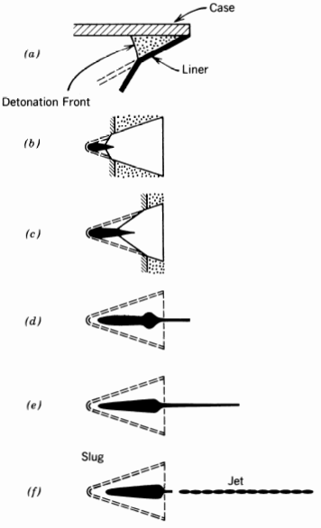
Figure 1 Liner geometry and collapse [1]
The first step in Figure 1 shows how the explosive material wraps around the conical liner, this adds to the acceleration out of the charge but also provides the tangential force pushing the liner material inwards causing it to collapse. The later steps show the formation of the jet (dashed lines show original position) and finally the jet breaking apart slightly to form a chain of jagged particles.
Another important performance factor for shaped charges is the standoff, which is the distance between the end of the charge and the target. [2] Getting this distance correct can have a further improvement on the charge’s penetrative capability. A final comparison can be seen in Figure 2 below where the penetration depth increases as the techniques are added from the cavity charge to a lined cavity charge with standoff.
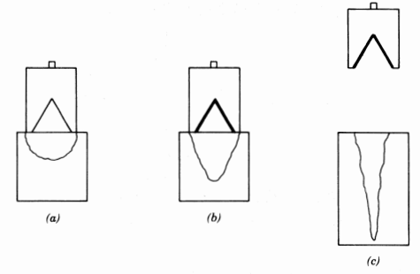
Figure 2 Cavity charge, lined cavity charge and lined cavity charge with standoff

2. Modelling Method

2.1 Simulation Setup
Figure 3 through Figure 5 show cross sections of the individual components that make up a shaped charge and Figure 6 displays the final 3D model combining the previous elements. These have been modelled in Abaqus which is a Finite Element Analysis (FEA) suite and computer aided engineering tool.
The FEA method is used to find solutions to complicated problems by replacing it with multiple simpler problems, this is known as a mesh. This is generated across each object that allows the software to breakdown the calculations into areas instead of considering the full system for each calculation [3]. At the end of each simulation ($1×{10}^{-4}$ seconds or 0.1ms), the furthest point was selected to have its velocity graphed against time, which allows the comparison of the effectiveness of each explosive and liner. The same properties and geometry are used for the casing in each simulation except for 3.2.3 RDX and Glass where the liner’s material is changed.
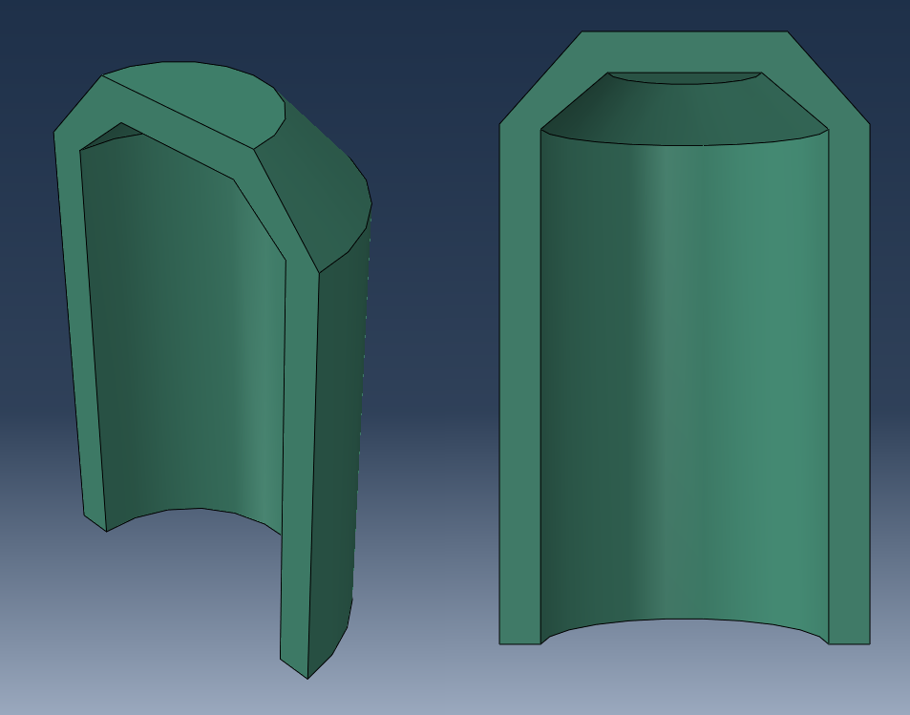
Figure 3 Shaped charge casing
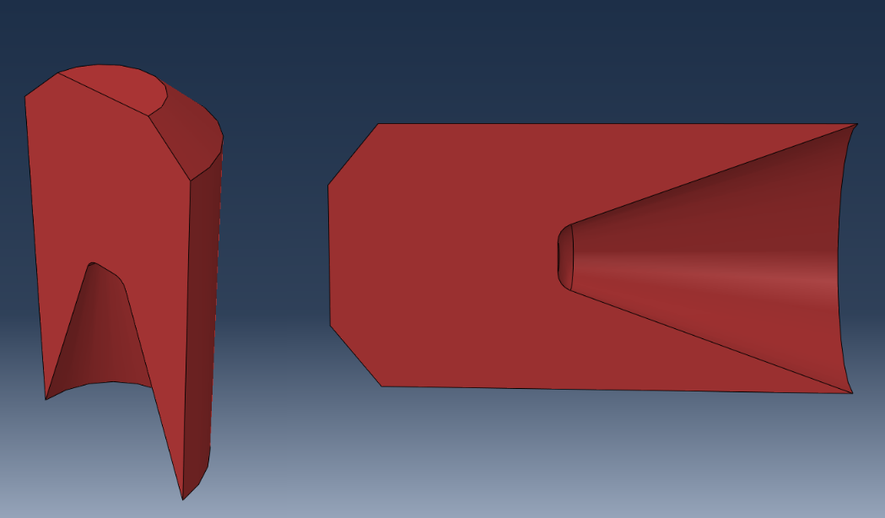
Figure 4 High Explosive (HE) material with cavity
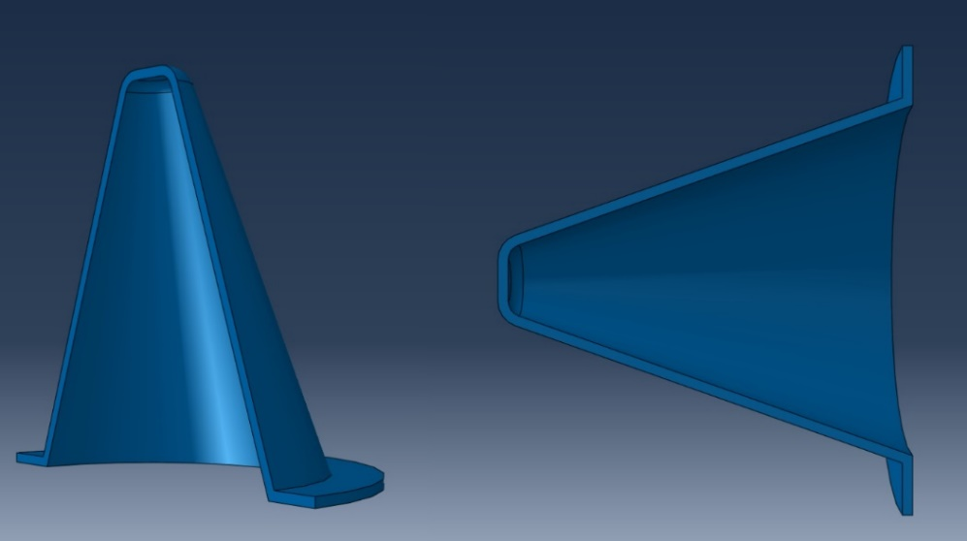
Figure 5 Conical liner
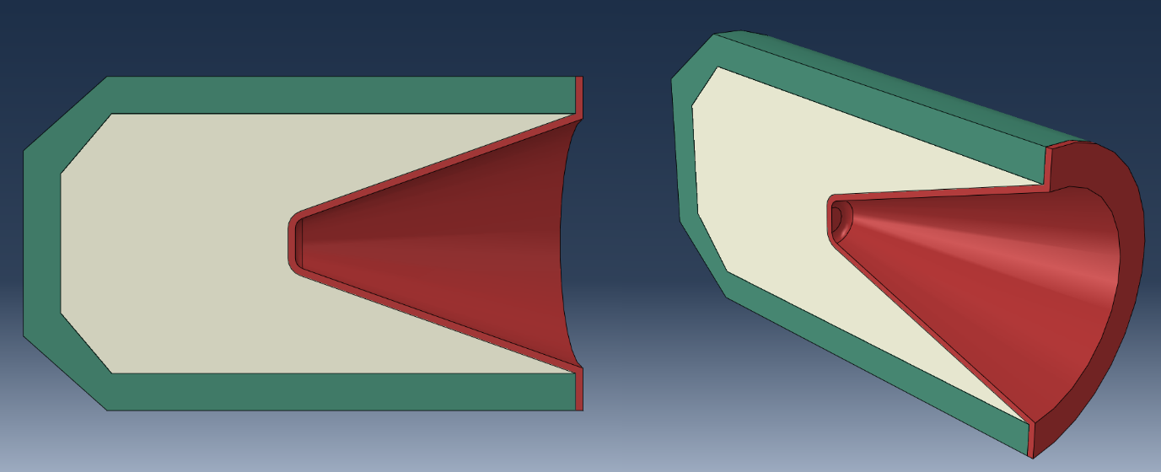
Figure 6 Combined shaped charge 3D model

2.1.1 TNT and Copper
In the first model, the explosive material is Trinitrotoluene (TNT) and is used as a baseline in this experiment. TNT has been made widely available from before World War I to the present day due to its low manufacturing costs, thermal stability and low volatility whilst providing a fairly high explosive power with a detonation velocity of 6930 m/s [4]. It is an important explosive for blasting charges and has been used in commercial purposes with a lower grade and in the military with a very pure grade. The military has often used TNT in shells as it can be loaded into the casings by casting and pressing [5]. The other models intend to present better results.
A copper liner is used in this model as it can provide a much larger penetration depth than other metals or alloys [1] and is a standard liner material.

2.1.2 RDX and Copper
The second model also uses a copper liner but switches out the TNT for an RDX explosive charge. In World War II RDX was added to TNT shells and bombs to increase their explosive power. Using this for the explosive material should provide an increase in jet velocity as RDX has a detonation velocity of 8239 m/s [6], an around 20% increase from TNT.

2.1.3 RDX and Glass
The final model uses the same RDX explosive material as the first but changes the liner material to glass. Explosively compressed and heated gas becomes a jet that has less fractures than metal liners and can similarly punch through steel and rolled homogeneous armour. An example of this is C4 and a wine bottle in Discovery UK’s video, The Science Behind Shaped Charges [7].

2.1.4 JWL Equations of State
The setup for the liner material is straight forward using the Density, Young’s Modulus (elasticity) and Poisson’s ratio. However to model the explosive reaction, the Jones-Wilkins-Lee (JWL) Equation of State (EoS) are additionally required [8] as it allows the calculation of the pressure of the detonation products and therefore the program can exert the correct force on the explosives surroundings, both the casing and liner [9].

The properties required for the explosive material:
- Density, d (kg/m³)
- Velocity of Detonation / Detonation Wave Speed, v (m/s)
- Pressure Coefficients, A, B (MPa)
- Fractional part of the energy that contributes to pressure, ω
- Principal Eigen value, R1
- Secondary Eigen value, R2
- Detonation Energy Density / Specific Energy, E (J/kg)

3. Results

3.1 Simulation Breakdown
The RDX with the copper liner model is used to illustrate the collapse of the liner and the formation of the jet.
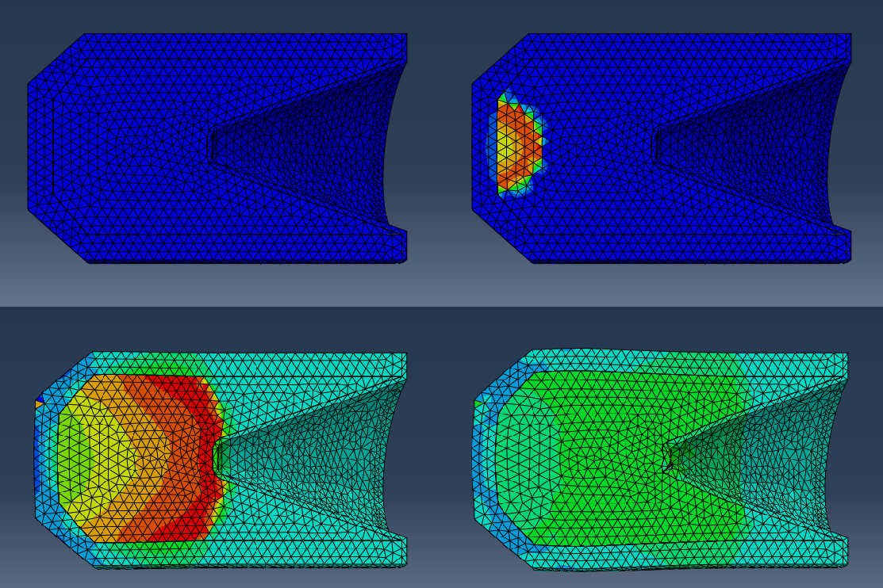
Figure 7 Top left + right: $0$ seconds, $2.5×{10}^{-6}$ seconds. Bottom left + right: $8.5×{10}^{-6}$ seconds, $1.25×{10}^{-5}$ seconds
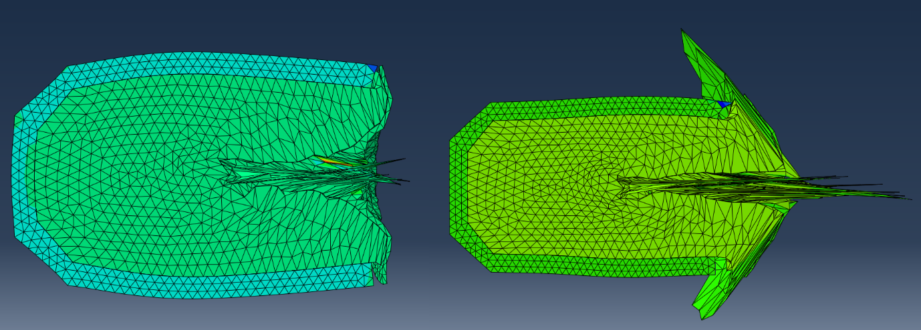
Figure 8 Left: $3.0×{10}^{-5}$ seconds. Right: $4.5×{10}^{-5}$ seconds
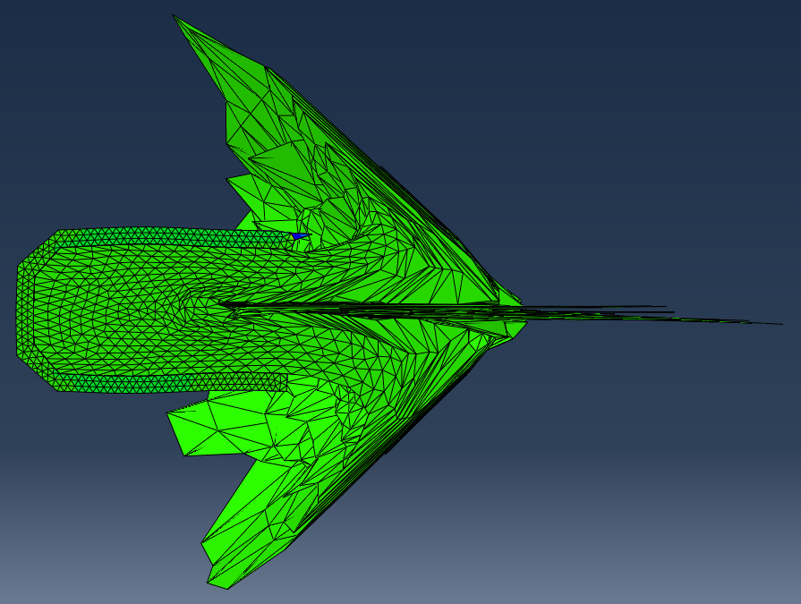
Figure 9 $7.5×{10}^{-5}$ seconds
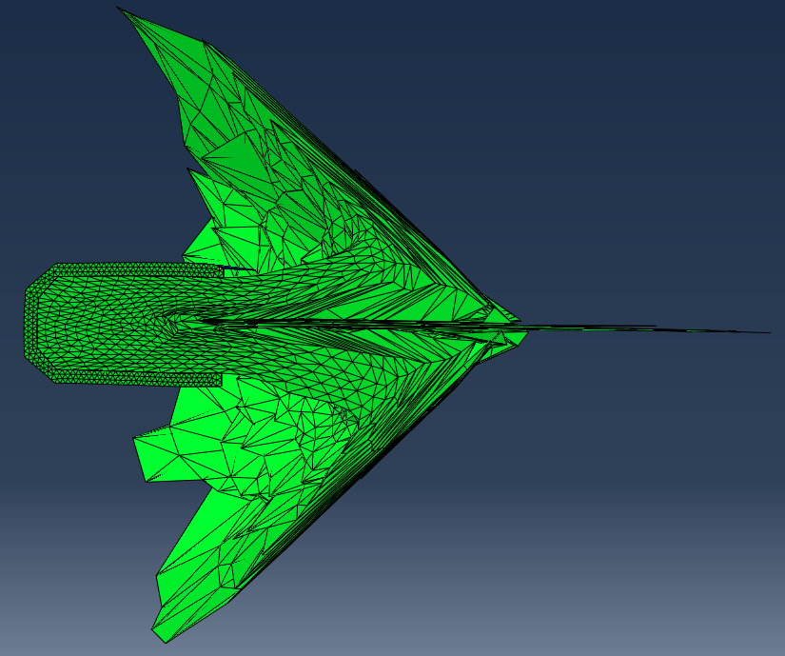
Figure 10 $1.0×{10}^{-4}$seconds
Figure 7 to Figure 8 shows the beginning of the collapse of the liner and Figure 10 shows the full formation of the jet. At this point in time, the TNT model’s jet hadn’t moved out as far and the RDX with glass model’s jet was even further out from the charge’s base, this is illustrated in the following velocity graphs.

3.2.1 TNT and Copper

The peak velocity displayed in the TNT explosive and copper liner simulation was 2924.44 m/s.

3.2.2 RDX and Copper

The peak velocity displayed in the RDX explosive and copper liner simulation was 5804.86 m/s.

3.2.3 RDX and Glass

The peak velocity displayed in the RDX explosive and glass liner simulation was 9839.70 m/s.

3.2.4 Velocity Comparison
9839.70
5804.86
2924.44
Figure 11 Jet velocity comparison

4. Discussion
The detonator is initiated at t=0 seconds so each graph shows the delay of the detonation wave before reaching and accelerating the selected mesh node on the liner. From here each explosive accelerates the liner rapidly towards a peak velocity which then gradually declines as the jet draws away from the charge and as time elapses. This can be seen in Figure 7 as the high pressure area (detonation wave) moves from the centred detonation point and radiates outwards until it reaches the liner material at around $2.5×{10}^{-6}$ seconds and has a visually noticeable movement by $1.25×{10}^{-5}$ seconds. Figure 8 shows the transition into the jet as the tapered end of the cone is accelerated first by the energy of the detonation products.
A case is used in a shaped charge to primarily contain the extremely high pressure generated from the explosive charge. However, it can have secondary benefits such as providing an anti-personnel effect using the fragmentation of the casing material and to assist in the explosive casting explosive where the explosive material can be directly poured into the munition. The casing drastically changes shape in Figure 8 when compared to its pre-detonation cylindrical form. The pressure from the explosive detonation causes the steel case to bow outwards which means the gases have expanded outwards to a degree instead of following the desired trajectory. A thicker case or an alternative material could boost the performance of the shaped charge by better directing the explosive energy [1].
The 3.2.1 TNT and Copper graph shows a peak velocity of 2924 m/s at $4.7×{10}^{-5}$ seconds, undergoing $3.2×{10}^{-5}$ seconds of acceleration. The gradient of the graph is fairly shallow relative to the other results due to the lower velocity of detonation (m/s), density (kg/m³) and specific energy (J/kg). The velocity of the jet gradually slows down over time to 1867 m/s at the end of the 0.1 second simulation time, this is due to drag from the air resistance. This simulation is the most effected this as it loses 36% of its velocity in this time. This is potentially due to the jet having a larger surface area for more drag as the cone is accelerated less leading to a less stretched out profile.
Changing the energetic material in 3.2.2 RDX and Copper has a significant effect on the performance where the peak velocity is 5805 m/s at $2.75×{10}^{-5}$ seconds, a two-fold velocity improvement over the TNT model and a 14% decrease in time taken. This is mainly attributed to the higher density and specific energy of RDX making more energy available in the detonation products and the increased density allowing for more material in the same volume. Over the course of the simulation the velocity decreases to 4729 m/s, an 18.5% loss.
For the final simulation 3.2.3 RDX and Glass, the liner material is changed instead of the explosive material. A jet is also formed when glass is used instead of a metal which was developed in the United Sates after World War II in models such as the M2A3 and jet penetrators for oil well applications, where the holes were larger but the penetration depth was reduced [1]. The peak velocity in this simulation was 9840 m/s at $1.9×{10}^{-5}$ seconds, an increase of over 3.3x the TNT simulation and reaching this velocity 40.6% faster. The increased explosive power of RDX coupled with the reduced density (Figure 12) of the glass liner allows the peak velocity to be higher in comparison to 2.2.2 RDX and Copper as the mass and hence the density is inversely proportional to the velocity squared.
$$Kinetic Energy= \frac{1}{2}mv^{2}$$
Unfortunately due to the time constraints, this model was unable to complete the full simulation as the mesh was distorted to such a degree that it could not be rendered further, this results in the graph in Figure 11 and 3.2.3 RDX and Glass only displaying data up to $5.2×{10}^{-5}$ seconds instead of the full $1×{10}^{-4}$ seconds. However, I believe enough data is available to show at minimum the general trend of the glass liner but also using the data from the previous simulation the gaps can be filled in as the velocities of the other two both slowly tail off. With more time a finer mesh could be constructed for the liner that would take longer to simulate but provide a higher accuracy and avoid distortion, preventing a simulation crash.

5. Conclusion
The simulated models and results describe a clear correlation between the explosive power (specific energy and detonation wave speed) and peak jet velocity. The RDX charge’s jet reached a higher peak in a shorter time than the TNT, showing an increase in acceleration also. Changing the liner material from copper to glass provided further improvement to both the peak velocity and acceleration resulting in a 3.3x velocity increase in ~40% less time. However, it could be argued that the glass jet’s velocity is counteracted by its decreased mass which would adhere to the conservation of momentum as the RDX with copper has the same energy as the RDX with glass simulation. This has been verified as the glass jets tend to produce slightly wider but less deep cavities.
Further investigation with a larger variety of explosives such as Polymer Bonded Explosives (PBXs) and High Melting Explosives (HMXs) would provide more data points to further establish which properties effect the peak velocity and penetration of a shaped charge. Similarly, using a wider range of liner materials to visually understand how they are formed into jets and which of these aid the more powerful explosives in their penetration capability. Copper is most commonly used however ceramics and graphite can have penetrative ability into steel [10], a common target for military applications.
The modelling software, Abaqus, has limitations both in the number of elements it can analyse and the time it takes to run high element count simulations. A further investigation could be carried out by increasing the density of the mesh, most notably on the cone end of the liner, such that distortion errors do not occur and the accuracy of the behaviour and location of a chosen point is increased.
As noted with the glass liner, a shaped charge’s primary performance indicator is its penetration capability not necessarily its peak velocity. Therefore introducing and modelling a target block that the jets interact with would provide a better overview of a given explosive and liner combination than purely the jet velocity.

6. References

[1] | W. P. Walters and J. A. Zukas, Fundamentals of shaped charges, New York: Wiley, 1989.
[2] | Z.-X. Zhang, “Chapter 25 - Special Blasting Techniques,” in Rock Fracture and Blasting, Svalbard, Butterworth-Heinemann, 2016, pp. 483-491.
[3] | S. S. Rao, The Finite Element Method in Engineering Fith Edition, Miami: Butterworth-Heinemann, 2011.
[4] | R. Tiwari and T. Chakraborty, “Dynamic Analysis of Underground Tunnels Subjected to Interal Blast Loading,” in Advances in Structural Engineering, Delhi, Springer, 2015, pp. 342-354.
[5] | J. Akhavan, The Chemistry of Explosives 3rd Edition, Swindon: RSC, 2011.
[6] | Y. Liu and J. Yin, “The EFP Formation and Penetration Capability of Double-Layer Shaped Charge with Wave Shaper,” Materials, vol. XIII, no. 20, 2020.
[7] | T. E. Show, “How Can Glass Punch A Hole Through Steel? The Science Behind Shaped Charges | The Explosion Show,” Discovery UK, New Mexico, 2020.
[8] | R. Menikoff, “JWL Equation of State,” United States, 2015.
[9] | S. Koli, “Study on JWL equation of state for the numerical simulation of near-field and far-field effects in underwater explosion scenario,” Engineering Science and Technology, an International Journal, vol. XXIII, no. 4, pp. 758-768, 2020.
[10] | A. Doig, “SOME METALLURGICAL ASPECTS OF SHAPED CHARGE LINERS,” Journal of Battlefield Technology, vol. I, no. 1, pp. 1-3, 1998.
[11] | E. Vitz and J. W. Moore, “Glass Density Evidence,” Chemical Education Digital Library, 2021.

7. Appendix A
[4] [6]
Explosive | Density, d (kg/m3) | Velocity of Detonation, v (m/s) | Pressure Coefficient A (MPa) | Pressure Coefficient B (MPa) | Pressure Energy, ω | Eigen Value R1 | Eigen Value R2 | Specific Energy, E (J/kg)
TNT | 1630 | 6930 | 373.8 | 3.747 | 0.35 | 4.15 | 0.9 | 3680000
RDX | 1836 | 8239 | 201 | 5.2 | 0.8867 | 12.4 | 1.24 | 6300000
Table 1 JWL EoS properties of TNT and RDX
Mass density | 2500
Youngs Modulus | 47000000000
Poisons Ratio | 0.3
Yield 1 | 7000000
Yield 2 | 17000000
Plastic 1 | 0
Plastic 2 | 0.3
Figure 12 Glass properties [11]

