Student Number – 1806166
Course – Historical and Contextual Studies (Contextual Practices)
Module - Ways of Perceiving
Module code - ADAD4010
Word count – 1438
Tutors - Julia Lockheart, Ryan Moule, Scott L Smith, Gwen Beynon, Rob Jones, Martin Bush

I have chosen to make my exhibition with different artists that all link with how comics/manga’s have changed the people’s views on the world. My exhibition will be full of different types of work created by the artists as well as the art work I use to explain my exhibition.

I did some research into the spaces used for conventions associated with comics for example; ‘Comic con’, Japanese comic markets and you can really see the different within the feel of the convention within the space used. I looked at these different types of conventions to see what kind of space I would need to fit both American comics and Japanese manga into one common ground.

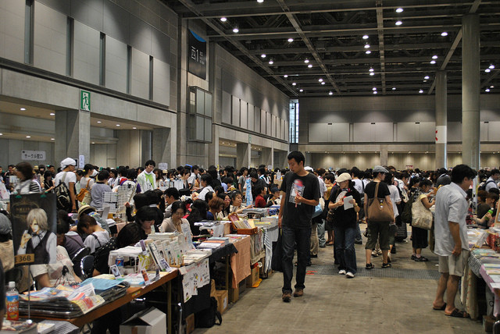
This is a comic market in Japan, this gave me the idea of creating stalls as well as just art work on the walls for people to be engaged with, especially being comics/manga, the audience want to be able to hold and read them.

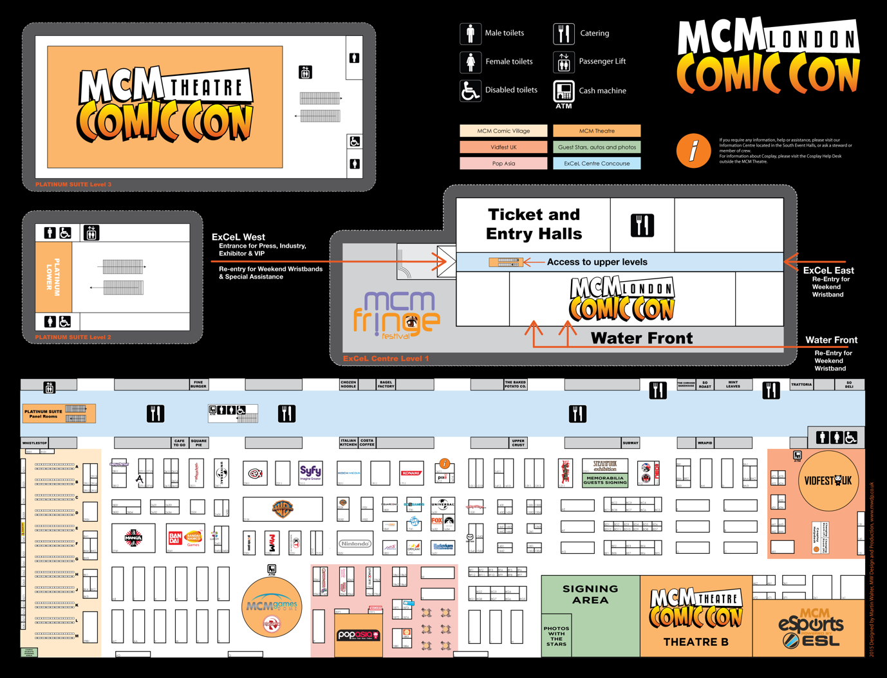

This is an image of ‘Comic con’ floor plan in London 2015, I had a look and it was just too big for what theme and feel I wanted for my audience. But you can see the where I have got the ideas of having stalls for people to be able to interact with the comics/manga’s.
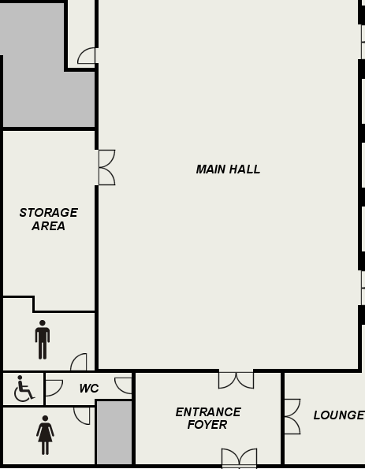

I created the space to be a big rectangle where people can have space to take pictures if they decided to dress as a character as people do a lot of in ‘comic con’ to keep the feel of the culture of comic conventions but small enough to have the relevant images I have written about where it is very personal for the people. In the middle of the main hall there will be the stalls and relevant images plotted around, also figures of the characters/superhero’s. The lounge is converted into a green screen back drop of your choice to enjoy taking pictures with iconic scenes from the comics/manga’s. I choose to keep it rectangle because of the sound as well whereas like other exhibition will have to feature sound, mine doesn’t at all expect the square lounge where the green screen is provided.

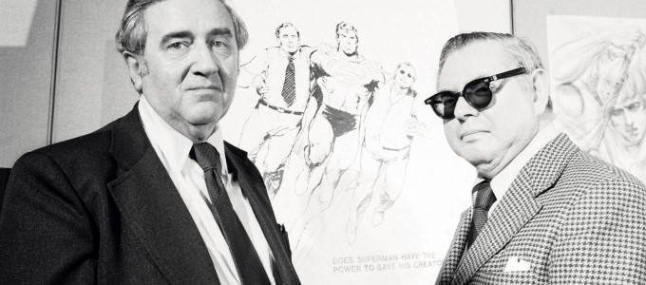

‘Jerry Sigel’ who is the creator of the first Dc comic book in June, 1938 alongside the artist ‘Joe Shuster’. Since 1933 both ‘Jerry’ and ‘Joe’ had been developing the famous comic book character ‘Superman’. At first both of the creators wanted to use their comic strip in a syndicated newspaper but with a lot of the newspapers not taking it, they decided to publish ‘Superman’ into a comic book. The comic book was named; ‘Action comics#1’ which was a series of a range of different superhero characters including the first steps into learning about ‘Superman’.

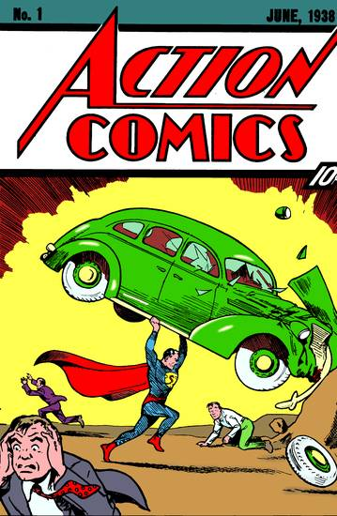

In the 1930s in America a lot of changes where happening, which was why ‘Superman’ was seen as a strong Protagonist. This was both ‘Jerry’ and ‘Joes’’ main goal as they wanted to create someone fictional that would be a better representation of America. You can see this has been a success as ‘Superman’ is still one of the most loved comic character of this generation. They also have made ‘Superman’ white American which includes in the year of this written and with the history of what was happening within the country.

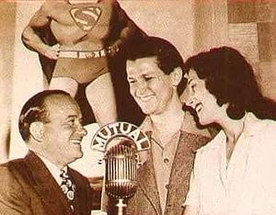

‘Superman’ became a successful protagonist which opened up a level of different media platforms to introduce the iconic hero this included radio, movies and tv shows. During World War 2 there was an iconic slogan created in 1942 on behalf of ‘Superman’ – ‘The American Way’, this ended up changing the peoples idea of ‘Superman’ being an alien, to the radio creating ‘Superman’ a voice which was American, so people started to believe in ‘The American way’ this then acted as a way of propaganda for helping each other during the war. ‘Superman’ fits perfectly into my exhibition because of the amazing historical context it has behind it and the way the character was created for positivity and peace. You can also see how ‘Superman’ has been culturally changed from just being a hope to becoming an American hope a sense of changing to fit the people’s stability.

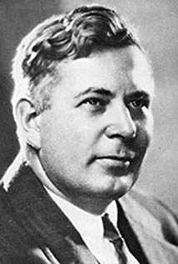

‘William Moulton Marston’ was the creator of ‘Wonder women’ in 1941, she first appeared in ‘All-star comics #8’ where William Moulton had a strong belief in making this a powerful women character who in his idea would be a love leader. ‘Wonder women’ in 1942 had her own solo comic released. ‘Wonder women’ was created in a light to show what women really are, strong and powerful individuals who have the gift of producing life itself and ‘William Marston’ had a strong belief in that himself, he wanted to change the ignorant views of the males living in the 1940s.

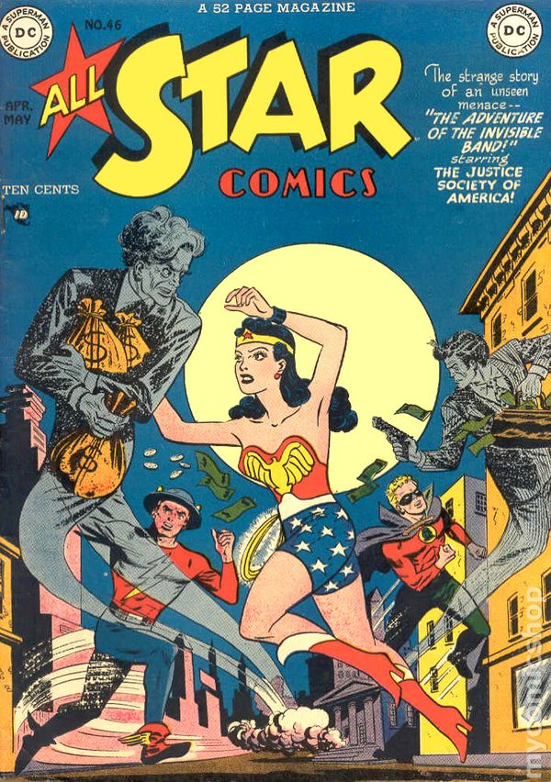

‘William Marston’ also a psychologist who was famous for inventing the polygraph, he believed women where more trust worthy and honest, women were not the stereotypes males were creating. Women were not allowed to vote in the 1940s and that’s where ‘William Marston’ based his idea around the suffragette, how powerful they were not so much in a group but just as one women by themselves. He captured the rawness of how the suffragettes risked their lives for the equality for men and women.
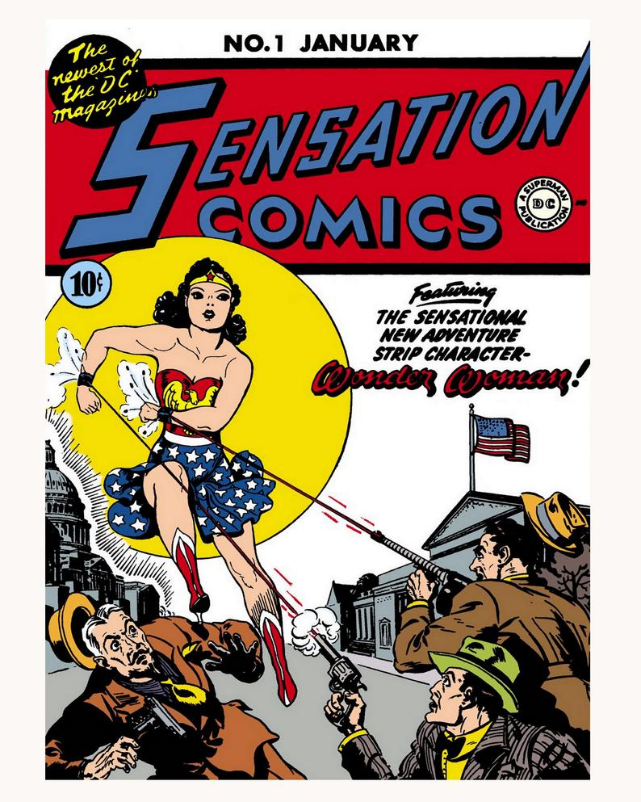
‘Wonder women’ is a perfect comic character for my exhibition because of the power, the love and the womanly instinct and how it connects you to so much of what was happening in our own history. It gave women a role model to connected with more than look up to but not all women could, when you think about the number of different things like racism which was a massive part of the American history, they would never think to include a different race or religion, they would prefer to make the character alien or god like but still taking elements from different cultures.

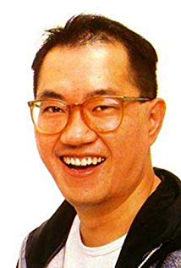

‘Akira Toriyama’ created a manga named ‘Dragon ball z’ which was created in 1984. It was first created as volumes in the ‘Weekly Shonen’ which turned out to be a massive hit especially worldwide. ‘Akira Toriyama’ inspiration came from the famous film ‘Bruce Lee, Enter the Dragon 1973’, also ‘Jackie Chan’. ‘Akira Toriyama’ wanted to make a manga that could feel relatable in some sense, where the characters are young but we go through the important stages of their lives with the development of respect and power.
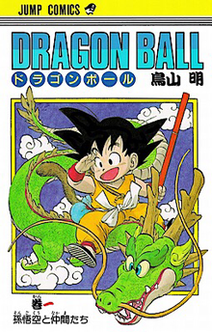
‘Akira Toriyama’ focused mainly on creating characters who have the ability to become stronger than normal, he created ‘Dragon ball z’ to be a strong male dominated manga where the women just look after the kids. This is a massive stereotype which he has decided to add within this manga, it shows that all women are good for is looking after the kids while the man is at work. The way it is perceived in ‘Dragon Ball Z’ is there are two main women characters who are seen to be very strong with powers such as; one being a genius who creates a time machine and one who has practised in martial arts. My view on this is very sexist as despite the two women have amazing ability to be a main character none of them are.

‘Dragon Ball Z’ was one of the first manga recognised worldwide, which is a shame in the sense the main characters in this manga are men and them men are god like characters called ‘Super Saiyan’ who have abilities to become a lot stronger from powering up. ‘Akira Toriyama’ has made a gender reparation within this manga as he could have made a woman a ‘Super Saiyan’ or at least a stronger and more powerful women character.

To conclude, this assignment has addressed a number of significant issues which shows that in a lot of comics/manga’s they come from a dark place of the past, with many issues including the way gender is viewed, stereotypical views, propaganda, discrimination it’s something we need to change, I am happy to include these keywords into my exhibition. Gender equality and gender representation and how we perceive differently according to out genders is a key example of why I am creating my exhibition and making sure people think more than they see when coming. I hope you can see the usage of stereotypes within all three comics/manga as they are all the stereotypical representation from the culture within the country of it made and I am very passionate about changing this. I hope you can understand the space I have chosen for my exhibition and why I have chosen the artists I have written about.

- http://logcchs.com/jerry-siegel-joe-shuster-men-behind-superman - ‘Jerry Sigel’ and ‘Joe Shuster’.
- https://www.dccomics.com/comics?seriesid=223539#browse – Dc
- https://www.theguardian.com/culture/2013/jan/05/why-is-superman-so-popular – Evidence superman still popular
- https://www.dccomics.com – Dc comics
- https://www.mcmcomiccon.com/london/2015/05/15/floor-plan-preview/ - Comic con floor plan
- http://www.unmissablejapan.com/events/comic-market – Japanese comic market
- https://tvtropes.org/pmwiki/pmwiki.php/Main/ShonenDemographic?from=Main.Shonen – Shonen
- https://www.imdb.com/name/nm0868066/ - ‘Akira Toriyama
- http://www.dragonballz.com – Dragon Ball Z
- https://kentonhall.co.uk/floor-plan.html - Floor plan
- https://www.imdb.com/name/nm0551376/ - ‘William Moulton Marston’
- https://www.cbsnews.com/pictures/wonder-woman-through-the-years/2/ - Wonder women
- https://www.comic-con.org – Comic con
- https://brucelee.com – Bruce Lee
- https://www.imdb.com/name/nm0000329/ - Jackie Chan
- https://asexualfeminist.wordpress.com/tag/akira-toriyama/ - Behind Akira

