Rail tourism: developing the tourism offer on the Heart of Wales line
Strategic Travel and tourism management
Mhairi Price (1708315)
2019
Table of Contents
Executive Summary 2
Introduction 3
Heart of Wales Line 4
Is the Heart of Wales line strategic? 4
Scotland’s West Highland Line 5
Integration modes 5
Traws Cymru 6
Recommendations 7
References 9

Executive Summary
The Heart of Wales line is set for expansion in 2022. This report investigates the Heart of Wales line’ current strategies and proposes further strategies ahead of the expansion in 2022. Other transport networks like the Heart of Wales line are used to identify the recommendations proposed further on in the report.
Two strategies were identified in the report and therefore a further three strategies were recommended to help boost tourism in mid Wales. West Highland line was seen to be operating much better than the Heart of Wales line and has a clear target market and caters for tourists providing them with loads of information and itineraries for them to plan their trip. Traws Cymru was the other network provider that was used to showcase how they work well as an integrated mode of transport and some of the strategies they have in place to help further develop recommendations for the expansion of the Heart of Wales line in 2022.
The final part of this report is the conclusion summarising the report and the three recommendations for the Heart of Wales line.

Introduction
The aim of this assignment is to recommend strategic developments to politicians and transport planners for the Heart of Wales line, in order to further develop rail-based tourism and boost tourism in areas along the Heart of Wales line. The line is set for expansion in 2022, this expansion will double the passenger capacity offering the opportunity for further tourism along the route of the Heart of Wales line. This report will refer to transport integration modes which are modes of transport that all operate as one continuous unit for the benefit of the customer. Rail services like the Heart of Wales line will be used to compare and used to look at possibilities for further future developments for the line. Recommendations will be put forward at the end of the report to help the line expand, improve the facilities on board, help the line to get more passengers and attract more tourism to this part of Wales.

Heart of Wales Line
The Heart of Wales line runs through the beautiful scenery of mountains, forests, rivers and little villages between Swansea and Shrewsbury for 121 miles. With thirty-four stops along the way, sixteen of these stops are requested stops where passengers branch their hand out of the train for the train to stop. The Heart of Wales line train journey is very different to a typical train journey from Swansea to London for example, where you would see tall buildings, busy streets and full car parks, with rubbish scattered along the pavements and graffiti on the walls of the train station. The scenery and the characteristics of the villages you go through on the Heart of Wales line is the complete opposite.
Transport for Wales operate the train services, Network rail look after the tracks and infrastructure. The Heart of Wales line is run by the Heart of Wales line Development Co. They work to promote and develop the HOW line in order to benefit the people who live locally, support local businesses and for visitors old and new. It is also part of Community Rail Wales, who are supported by councils, the rail industry and the Welsh Government.
Alongside the HOW line there is a Heart of Wales foot trail. The foot trail was launched in 2018, taking two/three years to develop aimed to attract ramblers to mid Wales. The trail is not as well known as the rail line, but it is hoping to increase in popularity especially when the line expansion happens in 2022 with the hope that the train line gets busy and the trail gets used by many more.

Is the Heart of Wales line strategic?
Firstly, a strategy according to (Chandler, 2003) is “the determination of the long-run goals and objectives of an enterprise and the adoption of courses of action and the allocation of resources necessary for carrying out these goals”.
One strategy the Heart of Wales line currently performs, is what they advertise on their website heartofwalesline.co.uk as “special offers and rails cards”. From October 1st until March 31st all Welsh bus holders (pensioners) can travel the line for free. This strategy works as a way of allowing the older generation to travel free of charge, somewhere new and providing them with a mode of transport for them to be independent. By running this promotional strategy, it is helping the local communities and businesses economically along the route of the train line as it is bringing in expenditure from these visitors.
Another strategy was the creation of the Heart of Wales line Trail. This was the first step that they took in developing the train line to bring more tourists to the area. However, now more needs to be done to the trail to attract more tourists. Developing a cycling path could be an possibility as statistics for cycling in wales according to cyclinguk.org “Wales: the proportion of people who own or have access to a bike is: 63% amongst 16-24 year-olds; 63% amongst 25-44 year-olds; 58% amongst 45-64 year-olds; 44% amongst 65-74 year-olds; and 30% amongst 75+ year-olds.” This shows that a large percentage of people from all age groups in Wales have access to a bike, therefore having a cycling track in the rural area of Wales can give locals and tourists the motivation to use what is there for their enjoyment. Not only is this good for the HOW line but it also helps improving people’s health as it is a form of exercise.

Scotland’s West Highland Line
The West Highland Line runs from Glasgow to Oban to Fort William and finally to Mallaig. This train connects the rural destinations of Scotland to the busy city of Glasgow. Very similar to the HOW line this has a very scenic route throughout the rail journey and “Considered by many to be the most scenic rail journey in the world” scottrail.co.uk. The line from Fort William and Mallaig is well known and recognised for its coverage in the Harry Potter films and has gained many tourists for this reason. On the Scottrail website, they advertise many of the popular tourist attractions that you can go and see along the line in the different destinations. To name a few are Arrochar & Tarbet – for Loch Lomond cruises and Falls of Cruachan on the Oban line – for a free tour of the hydro-electric power station inside Ben Cruachan, the ‘Hollow Mountain’. Discovered on the VisitScotland.com website they even have a four-day itinerary mapping out and planning the trip on the West Highland Line for visitors making is easy and stress free for tourists who wish to make the most out of train journey.
There is an option for passengers who travel on the train to pre-order at Glasgow Queen Street Station a tasting box to accompany them on the train journey. The tasting box is filled up with Scottish treats such as oatcakes, shortbread, pate and a glass of scotch.
Seat61.com is an online website with masses of helpful information on train times, fares, tickets, local area, food and accommodation available for tourists who are specifically travelling along the West Highland Line. This shows that the line is obviously popular and the need for such websites is essential for travellers and tourists to access.

Integration modes
Integrated transport according to Givoni and Banister, 2010 “normally required where a system is made up of several parts and the elements need to complement each other so that the whole system can work more effectively.” Integration modes of transport can be seen to significantly reduce congestion meaning people getting to the places they need to be faster and easier. The main aim of integrated transport modes taken from (Poliakova, B 2013) “space coordination – the safe and comfort transfer nodes. All these measures have the main aim – to decrease time of journey from the origin to the destination.” A brilliant example of an integration mode is traffic lights. Traffic lights are designed to stop, hold and release traffic in a strategic pattern to help the flow of traffic in all directions. Applying integration modes to the Heart of Wales line could require bus routes/ timings to coincide with train times and work together effectively for the benefit of consumers.

Traws Cymru
Traws Cymru is a bus service that travels longer distances than a normal bus and is a vital part of public transport in Wales, as it gives people taken from trawscymru.co.uk “accessible, affordable and environmentally friendly option for exploring the scenic beauty of the country.” This statement suggests that for travelling longer distances within Wales it is better to use this mode of transport as it enables passengers to travel easily and affordably. While advertising this mode of transport it is also being strategic by minimising the number of cars on the roads. This bus service is an important part of the integrated transport systems in Wales, which is funded by the Welsh Government. It is important because as mentioned previously it gives people access to different parts of Wales. One of the bus services runs from Cardiff city centre to Cardiff airport, targeting those who are travelling abroad who are using both transport modes train and bus to get to their desired destination. From Cardiff central and then on to a Traws Cymru bus to get to the airport, a perfect example of how this service works well as an integrated mode of transport.
Another strategy they have in place to appeal to more is that on weekends every Saturday and Sunday everyone travels for free however on the website it does state “subject to availability”.
The graph below displays and compares the number of journeys by bus services across the UK taken from 2015/2016 until 2018. As shown on the graph the pattern displays the decrease of passengers using bus services throughout the four years, which indicates more needs to be done to public transport for it to appeal to more people. Graph taken from (Sonnichsen, 2019).
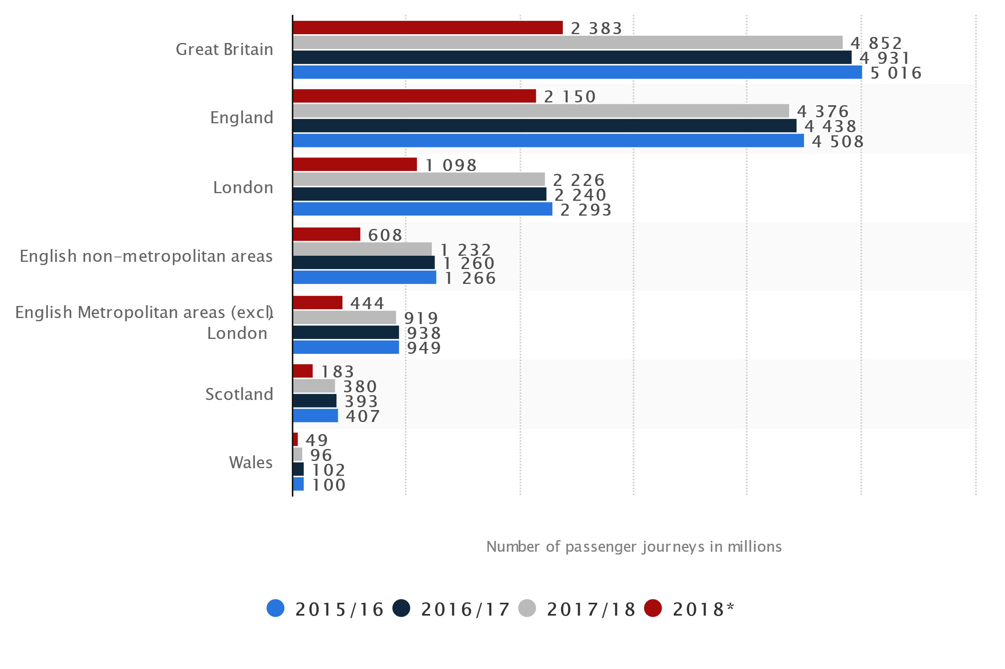
Conclusion
In conclusion this report has produced an overview of the Heart of Wales line what it is, how it is run and a brief overview of the Heart of Wales line trail. The current strategies of the Heart of Wales line have been discussed and more strategies need to be put in place in order to boost tourism along the line. From the research gathered it is clear to see there was only two strategic targets and therefore at the end of this report there will be new proposed strategic recommendations to increase tourism. The West Highland Line is very similar to the HOW line, but their strategies are clearer, and their line is more popular and busier. They have an itinerary available for tourists who plan on using the train line making it easy for tourists to plan their trip beforehand. For this reason, the West Highland line can be seen as a tourist attraction as well as a mode of transport. The line is considered a tourist attraction because of the history, the views and the iconic Harry Potter scenes. Traws Cymru is a bus service that was identified and used to demonstrate how integration modes of transport is important to boost tourism in destinations.
The next section will be recommendations for the Heart of Wales line which is aimed to further develop rail-based tourism and enhance tourism along the route of the line.

Recommendations
For the Heart of Wales line to increase tourism here are three strategic recommendations that can be introduced before the expansion in 2022.
Recommendation one would be to have a buffet service on board. On most train’s there is a food and drink cart, especially when travelling long distances. Instead of having a normal buffet service this recommendation is to have unique and locally sourced produce on offer on board. This will help promote local businesses and introduce people to welsh delicacies such as welsh cakes, laverbread and bara brith, as well as create revenue on board the train. If people enjoy, they will want more and potentially visit the shops the product originally came from. Another recommendation inspired by the West Highland Line service is to create and offer a locally sourced product hamper for passengers, that they could pre order and pick up from their chosen train station along the line. This can either be enjoyed by them on the train journey or as a perfect gift that they can take home if they have travelled far. Included in the hamper small local businesses leaflets could be put in to promote accommodation providers, camp sites and tourists’ attractions.
Second recommendation is to create a “hop on hop off” service with audio on board. Most city break destinations offer a “hop on hop off” to help get around busy cities at an affordable price. When travelling around you have the option to listen to an audio talking you through the history of the cities and landmarks you go past when on board. This recommendation is to bring the service with audio to the Heart of Wales line. This would be for an extra fee and would only be available in certain areas of the train carriage as not everyone on board will be travelling for leisure and will not want to pay extra for an audio service. This would make the train line a tourist attraction as well as a mode of transport and offers a knowledgeable, personal and informative guide to add value to the train service.
The last recommendation is to work alongside the trail line to create a mountain biking route between the train stations on the Heart of Wales line. Mountain biking is popular around the country and brings a lot of viewers and sponsorships to a destination. One of the biggest mountain biking competition is the Welsh Gravity Enduro which brings the best mountain bikers in the country together to race at a series of locations. By working on a mountain biking route, it gives the Heart of Wales line an opportunity to bring new tourists to mid Wales and gives the line and trail another selling point which overall will boost the Welsh economy.

Word Count: 2,192

References
Agarwal, A. (2004). A Comparison of Weekend and Weekday Travel Behaviour Characteristics in Urban Areas. Unpublished thesis. University of South Florida. Available at: http://scholarcommons.usf.edu/cgi/viewcontent.cgi?article=1935&context=etd. [2019, December, 2].
Chandler, A.D. (2003). Chapters in the History of the AMERICAN INDUSTRIAL ENTERPRISE, Washignton: Beard Books.
Citytransport. (2017). Transport Integration. [Online] Available at: http://www.citytransport.info/Integ.htm. [2019, December, 2].
Cyclinguk. (2019). Cycling UK’s cycling statistics. [Online]. Available at: https://www.cyclinguk.org/statistics. [2019, November, 24].
Dalling, R. (2018). ‘14 stunning sights from one of Wales’ most beautiful train journeys.’ Wales Online. Available at: https://www.walesonline.co.uk/whats-on/travel/wonderful-sights-seen-one-wales-14480932. [2019, December, 1].
Givoni, M & Banister, D. (2010). Integrated Transport From Policy to Practice, Oxon: Routledge.
Heart of Wales. (2019). The Heart of Wales Line Trail. [Online]. Available at: https://www.heart-of-wales.co.uk/ [2019, November, 23].
Imeche. (2016). INTERGRATED TRANSPORT. [Online]. Available at: https://www.imeche.org/policy-and-press/reports/detail/integrated-transport. [2019, December, 2].
Poliakova, B. (2013). KEY SUCCESS FACTORS OF INTERGRATED TRANSPORT SYSTEMS. Unpublished thesis. University of Zilina. Available at: http://www.tsi.lv/sites/default/files/editor/science/Publikacii/RelStat_13/session_3_ed_poliakova_ok.pdf. [2019, December, 2].
Scotrail. (2019). West Highland Line. [Online]. Available at: https://www.scotrail.co.uk/scotland-by-rail/great-scenic-rail-journeys/west-highland-line-glasgow-oban-and-fort-williammallaig. [2019, November, 25].
Seat61. (2019). Britain’s most scenic train route The West Highland Line… [Online]. Available at: https://www.seat61.com/WestHighlandLine.htm. [2019, December,1].
Sonnichsen, N. (2019). Number of passenger journeys on buses in Great Britain (UK) from 2015/2016 to 2018, by region (in million journeys). [Online]. Available at: https://www.statista.com/statistics/300821/bus-passenger-journeys-by-region-uk/. [2019, December, 2].
Trawscymru. (2016). Fares. [Online]. Available at: https://www.trawscymru.info/fares/. [2019, December,1].
Visitscotland. (2019). OUTDOORS WEST HIGHLAND LINE ITINERARY. [Online]. Available at: https://www.visitscotland.com/see-do/tours/railway/west-highland-line-itinerary/. [2019, November, 26].
Visitwales. (2019). Heart of Wales Line is completed. [Online]. Available at: https://www.visitwales.com/search?search=heart+of+wales+line+. [2019, November, 26].
Welsh gravity enduro. (2019). GENERAL INFO. [Online]. Available at: http://welshgravityenduro.com/race-info/. [2019, December,2].

