University Of Wales

Trinity Saint David

Marketing Fundamentals Analysis And Evaluation (LSBB4004) –

Assessment 2

Name: Ivan Medarev
Student Number: 1920485
Module Title: Marketing Fundamentals
Module Lecturer: Tushara Balendran
Assignment Title:
The Role Of Marketing In Creating Value For Customers And Stakeholder Engagement In Marks And Spencer

Table of Contents
Introduction 3
Main Body 3
Conclusion 11
Reference List 12

Introduction
Marketing plays is the process by which an organisation not only creates a good relationship with the consumers but also earn better place and picture in the market among the competitors. The better sue of marketing with the help of stakeholder engagement achieve better progress and competing recognitions as well. The study is to understand the impact of various marketing tools along with stake holders on the betterment of the Marks and Spenser (M&S). M&S is a successful retail firm of UK which performs in various parts of the world. The firm is formed in the year 1884 by Michael Marks and Thomas Spencer. M&S sells different kinds of goods and services like clothes, electronics, home appliance, foods and so on. At present it has 80,000 staffs who work hard to satisfy the consumers and betterment of the firm (marksandspencer.com, 2020).

Main Body
As stated by the Gabriel (2018), societal marketing is related with both the CSR and sustainability and to some extent profitability. It even inspires a firm and its managers to perform various social responsibilities resulting in better success and image in the market. The proper understanding of it helps a firm like M&S to improve the society by satisfying various needs and desires of the consumers. It even encourages a firm to perform better in the present market while creating the capability to fulfilling future needs. The firm M&S performs various kinds of CSR activities leading to improving the living standards of the people and the living beings.
As explained by Brychkov and Domegan (2017), the societal marketing focuses of three important aspects like society, customers and a firm itself. The proper execution of societal marketing inspires M&S management to make decisions which can fulfil the organisational and staffs goals while accomplishing the long term societal goals. In societal or human welfare, M&S develops products and services for the betterment of the society. It uses better technologies. The better goods increase consumer satisfaction and need leading to maximising their support. M&S focus to make strong relationship with the consumers but solving problems with proper solutions. It is also easier to increase their efficiency and effectiveness in the market by maintaining good revenue and profit.
As per Fallatah and Syed (2018), the hierarchy of needs theory given by Maslow explains that various kinds of needs, desires, perceptions and feelings inspire a person to perform better and achieve success as well. The better fulfilment of various psychological, social, safety needs improves the personal life while the self esteem and self actualisation needs improves chances in the professional life. The fulfilment of various needs is good for a firm like M&S as it is able to attain better progress in different situations by working for the betterment of society and its staffs. The better wages, safety, health and lifestyle motivate the M&S staffs to give best and help in improving society by making good relationship with other. The safety and security tools of M&S such as fresh raw materials, reusable goods and so on increases the efficiency of the staffs to use better marketing tools and increase the success level in the market.
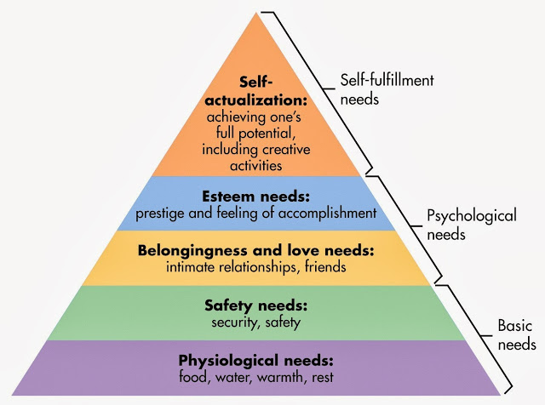
Figure 1: Maslow Hierarchy of Needs
(Source: Tuten, 2019)
According to Singh and Behera (2016), social needs such as good relationship with the staffs, consumers, stakeholders increase M&S performance and productivity in the market. The staffs work cooperatively with the firm to fulfil various societal activities and increases place in the market. The self esteem techniques inspire to learn and improve better skills and ideas and perform various types of activities and goals nicely. The better skills help to fulfil the societal needs nicely resulting in increasing recognition and achievement in the competitive market. The self actualisation tools increases the learning abilities that helps to improve the society a lot leading to increasing the lifestyle along with the environment of the country. It is possible by using rights skills and decisions at the right time. The advantage is that M&S can increases profitability and sustainability by using correct marketing tools. The weakness is to motivate the staffs easily as they are different from others.
As explained by Deepak and Jeyakumar (2019), the proper use of marketing tools increases the success and the progress level of a firm like M&S by using better technologies effectively and successfully. The better technologies increase the production, proficiency and the success level of the staffs in the competing market. M&S get better opportunity to improve the society and the consumers. It is easier to compete better and achieve better competing recognition and success among the rivals while maintaining better financial growth and strong consumer loyalty.
According to Charter (2017), better marketing provides various kinds of information, education and knowledge about the performance, activities and proficiency of a firm like M&S. The better use of marketing research tools helps to understand the consumer needs so as to fulfil consumer needs successfully leading to maximising success and growth for M&S. A good marketing tool helps the people to understand about the activities nicely and if they are happy and satisfied then only they will buy the products and services of a firm like M&S. However, if not, then they will shift resulting in bad performance, and profitability in the market making it difficult to work for the benefit of the society,
As claimed by Shiu (2017), good marketing and along with CSR activities motivates a firm to fulfil customer need and accomplish their goals and targets successfully. The better services, goods and good relationship and behaviour with them helps to maintain consumer expectations nicely. It is also easier to create a better place, image, loyalty and support for the firm in the market. It is also easier to earn better revenue, sales, share and profits while increasing loyalty and support for the firm M&S in the market. The better revenue and sales increase the sustainability and profitability of M&S while creating better job opportunities for the society and the country as a whole.
As opined by Adams et al. (2019), good marketing not only helps a firm to receive better customer support and loyalty by providing better shopping experiences but also helps in the monetary success of a country as a whole. For instance- better marketing and communicating tools helps M&S to create a better place for itself in the market by earning better revenue and profit. It is also easier to maximise brand image with the help of better finance and sales. The staffs also get encouragement to learn and implement new skills, tactics and knowledge to perform better and fulfil consumer preferences by maintaining better relations with them.
As per Beverland (2018), branding is an important technique of marketing concept that helps a firm to create a positive idea about itself by the consumers. The clear perception about a firm and its goods and services or both increases the sustainability and profitability in the competing changing scenario. The better branding increases the value, place and picture of a firm like M&S among the rivals leading to maximising sales, share and profit in the market. A good branding with the help of better marketing technologies and interacting tools increases awareness about the brand making it easier for the consumers to identify better products and services leading to maximising trust, support and confidence for the firm M&S as a whole. The better branding and marketing creates customer value as well. It helps M&S to improve its brand value and sustainability among the rivals by satisfying the customer’s needs with better quality goods and services. It even increases the commitment and the productive level of the staffs as they get better opportunities to perform different kinds of activities with efficiency leading to better success for M&S in the market.
The Growth Vector Matrix strategy framework proposed by Ansoff describes four distinct strategies that businesses use to grow and expand their reach in the existing or new markets. These strategies play a key role in helping a business to achieve its marketing objectives. Market penetration is used when companies aim to create demands for their existing products in the current markets by reducing costs without affecting quality. Product development deals with launching new products in the existing markets to attract the attention of the existing customer base (Loredana, 2016). The market development strategy is used when companies seek to create new demands for its already existing goods in new markets. Lastly, diversification involves venturing into new markets with new line of goods in order to expand customer base and boost brand image.
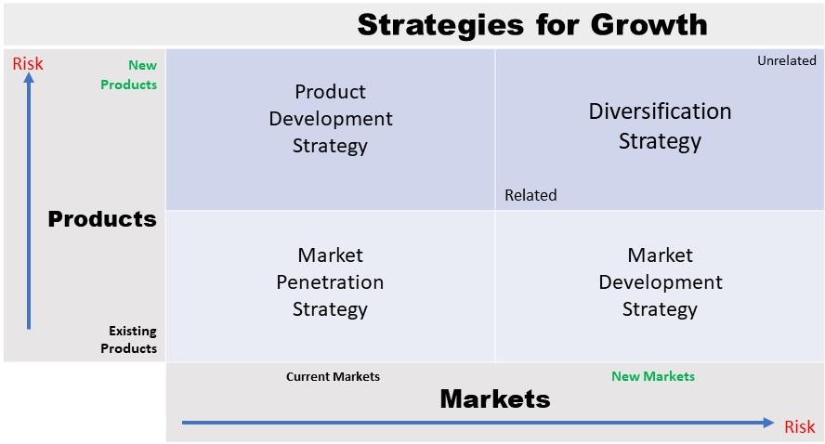
Figure 2: Ansoff's Growth Strategies
(Source: Loredana, 2016)
Based on the operations of M&S to market its products, it can be said that the company is more inclined towards the market development and market penetration strategies to boost its demands and sales. The company’s marketing department comes up with new and innovative marketing campaigns and promotional strategies to create demands for its products in existing and new markets. In this way, the company and its marketing activities are creating value for its customers and providing them with products and customer service at affordable price range without compromising on their quality.
As has been discussed, marketing activities are of various types and have varied purposes. However, it cannot be denied that they are focused on one major objective: to create value for the customers. Relationship marketing is one such aspect of the vast marketing function which refers to the activities that are undertaken by a company in order to create and maintain profitability and long-standing relationship with customers (Sheth, 2017). These activities are heavily dependent upon retaining and satisfying customers that results in the long-term relationship and repeated sales.
It can be ascertained that M&S indeed uses relationship marketing as over the years, it has continued to be among the most trusted retailers in Britain. The company achieves this feat by focusing on its own-label range of products rather than an older, middle-class segment (Blackley et al., 2017). M&S has managed to become a leader in the market in semi-prepared, own brand dishes that are supported through high profile television advertisements.
In order to analysis the impact of stakeholders on the organisation, it is important to conduct a stakeholders’ analysis. The key stakeholders at M&S are the board members, directors, investors, employees, suppliers, customers, community and the government. The board members and directors are the senior management at M&S and the power to make key decisions lies in their hands. The investors invest in the company with the aim to make profits. This helps to manage the monetary requirements to run the business. Employees are key stakeholders because the quality of the business operations and processes are contingent on their performance. Suppliers are the individuals or businesses who supply the equipments or materials that are necessary for running the daily business operations. Customers are also important stakeholders as they invest in the products offered by the company by purchasing them. The government also has stake in the company in the form of disclosures, tax liability and compliances. Lastly, the community invests in the business by helping it to thrive and flourish.
Interest
Low
High
Power
High
Low
- Board member
- Directors

- Government
- Customers
- Community

- Investors
- Employees
- Suppliers

Figure 3: Stakeholder Analysis
(Source: Created by the learner)
The senior management has high power and interest in M&S and are therefore managed closely. The investors have low power but high interest in the finances of the business and are kept informed about the profits and position of the company. Employees and suppliers have low interest and power and are monitored regularly. The government, customers and the community have low interest and high power and are thus kept satisfied.
According to Ndlela (2019), stakeholder’s engagement is the technique with the help of which an organisation is able to interact, understand and analyse the needs and the desires of various types of stakeholders. The better understanding and good relationship with them not only maximises the progress level by decreasing various costs but also maximises better sustainability in the market. They help the firm to identify and use the marketing and branding tools effectively resulting better profitability and competing success in the market. It is also easier to make and implement better plans to achieve and maintain better reputation, place and picture in the market. The engagement of several stakeholders with the firm like M&S increases the proficiency level in the competing rivalry leading to maximising better success while improving the society successfully. They even help to minimise risks and challenges leading to better performance and productivity for the firm in the business world. The different stakeholders of M&S use the marketing tools differently so that M&S can maintain place in the market.
As opined by Muff (2017), the stakeholders affect the marketing activities of a firm differently resulting in better performance, sustainability and efficiency in the market and among the competitors. The board of members and the directors of a firm not only select and implement better marketing tools but also monitor their affect on the particular product, service and overall growth as a whole. For instance- the higher officials of M&S motivates the staffs to use advanced marketing tools and evaluate their impact as well. If the affects are positive leading to increasing performance then the marketing team use the tools differently with new ideas. The investors are important stakeholders who invest their money after proper interaction with the leaders of a firm. The proper information and good strategies motivates them to invest money leading to improving image and performance of the firm in the market. In M&S, the investors invest money which helps to maintain better production quality of the goods and the services. The better interaction increases the progress level of the firm in the retail industry.
As explained by Shams et al. (2019), the suppliers also play an essential role in effectiveness of a firm. The delivery of good quality raw materials not only improves the production and inventory level but also increases the trust level of the purchasers as well. It is because accomplishment of works within time minimises development costs leading to better use of marketing tools. The advanced marketing tactics increases the trust and support of the consumers on M&S as it is able to deliver the goods in time. The employees or staffs selects and use better marketing, promotional and advertising tools to attract and convey the messages nicely to the customers leading to increasing brand value. The M&S staffs use modern technologies to fulfil customer expectations by increasing their experience and satisfaction level. The market techniques helps the consumers to identify the best products to satisfy their needs resulting better revenue, sales and support for M&S in the market.
According to Tran et al. (2019), government and the communities guide a firm to use the correct marketing tools so that it can perform better by paying correct taxes at the correct time. They even monitor the performance of a firm like M&S so as to safeguard the customers from any type of malpractices. M&S has good place in front of the government as it follows all the policies while working for the betterment of the society. The communities increase the performance level by increasing the financial position of M&S in the market with the help of interactive marketing tools.
Conclusion
Thus, it is clear that good marketing and branding are significant in better development and performance of M&S in the present competing scenario. The firm not only uses various marketing techniques to attain the targets successfully but also works for better growth of the society and the people as well. The good branding helps the staffs to fulfill their various needs and desires explained in Maslow’s Hierarchy model while implementing better tactics of Ansoff matrix. It is also clear that various stakeholders not only engage themselves with the betterment of M&S but also helps it to attain good progress by performing efficiently.

Reference List
Adams, P., Freitas, I.M.B. and Fontana, R., 2019. Strategic orientation, innovation performance and the moderating influence of marketing management. Journal of Business Research, 97, pp.129-140.
Beverland, M., 2018. Brand management: Co-creating meaningful brands. Sage.
Brychkov, D. and Domegan, C., 2017. Social marketing and systems science: past, present and future. Journal of Social Marketing.
Blackley, N., Resnick, S.M. and Cassidy, K., 2017. Improving UK retail academic-practitioner research: insights from relationship marketing. International Journal of retail & distribution management.
Charter, M. ed., 2017. Greener marketing: A responsible approach to business. Routledge.
Deepak, R.K.A. and Jeyakumar, S., 2019. Marketing management. Educreation Publishing.
Fallatah, R.H.M. and Syed, J., 2018. A critical review of Maslow’s hierarchy of needs. In Employee Motivation in Saudi Arabia (pp. 19-59). Palgrave Macmillan, Cham.
Gabriel, M.L., 2018. Sustainability as a Key Component of Marketing Strategy: A Societal Approach. Handbook of Advances in Marketing in an Era of Disruptions: Essays in Honour of Jagdish N. Sheth, p.119.
Loredana, E.M., 2016. The Use Of Ansoff Matrix In The Field Of Business. In MATEC Web of Conferences (Vol. 44, p. 01006).
marksandspencer.com. 2020. Welcome To Marks & Spencer. [online] Available at: <https://www.marksandspencer.com/> [Accessed 3 August 2020].
Muff, K. ed., 2017. The collaboratory: A co-creative stakeholder engagement process for solving complex problems. Routledge.
Ndlela, M.N., 2019. Crisis Communication: A Stakeholder Approach. Cham: Palgrave Macmillan.
Shams, S.R., Vrontis, D., Weber, Y., Tsoukatos, E. and Galati, A. eds., 2019. Stakeholder Engagement and Sustainability. Routledge.
Sheth, J., 2017. Revitalizing relationship marketing. Journal of Services Marketing.
Shiu, E. ed., 2017. Research Handbook of Innovation and Creativity for Marketing Management. Edward Elgar Publishing.
Singh, T. and Behera, M.P., 2016. Application of the Maslow's hierarchy of need theory: Impacts and implications on employee's career stages. Training & Development Journal, 7(2), pp.43-52.
Tran, H., Smith, D.A. and Buckman, D.G. eds., 2019. Stakeholder Engagement: Improving Education through Multi-level Community Relations. Rowman & Littlefield Publishers.
Tuten, T.L., 2019. Principles of Marketing for a Digital Age. SAGE Publications Limited.

