Foreign Languages & Cultural Awareness
BMIH 5003
Marinela Covasneanu
Student number 1920078
Foreign Languages & Cultural
Intercultural Competence Report

Lecturer: GIULIA CHIFARI

Executive Summary



A report was necessary after visiting an Italian hotel branch part of Multicultural Hotel & Spa from London, to outline the key difference between England and Italy. Some of the employees from the Italian branch will be join London hotel so the preparation for their arrival in order to meet their customs, chain operations, brand standards and to make them feel integrated as part of the team, need to be done.

Contents table.
Executive Summary 1
Introduction 3
Main body 3
Key differences between England and Italy 3
England 3
Italy 5
Globe project’s culture and leadership comparison 5
Cultural practices 6
Societal values 6
Leadership 7
Challenges of intercultural leadership in hospitality industry 7
Conclusion 10
References 11

Introduction

This paper summarises the key differences between England and Italy, comparison made by using the Hofstede comparation tool. It outlines the similarities and the contrasts between these two countries regarding culture, customs, and behaviours. Also, an analyse based on the Globe project culture and leadership study reveilles the differentiations in their practices and values. Additionally, it gives an abstract about the challenges of intercultural leadership in the hospitality industry.

Main body
Prior to the personnel from the Italian an evaluation of the difference between the countries must be done. Their culture, behaviours and traditions must be researched in order to understand their practices and etiquette, to adapt to their values, make them feel included and avoid any cultural misunderstandings.

Key differences between England and Italy

England
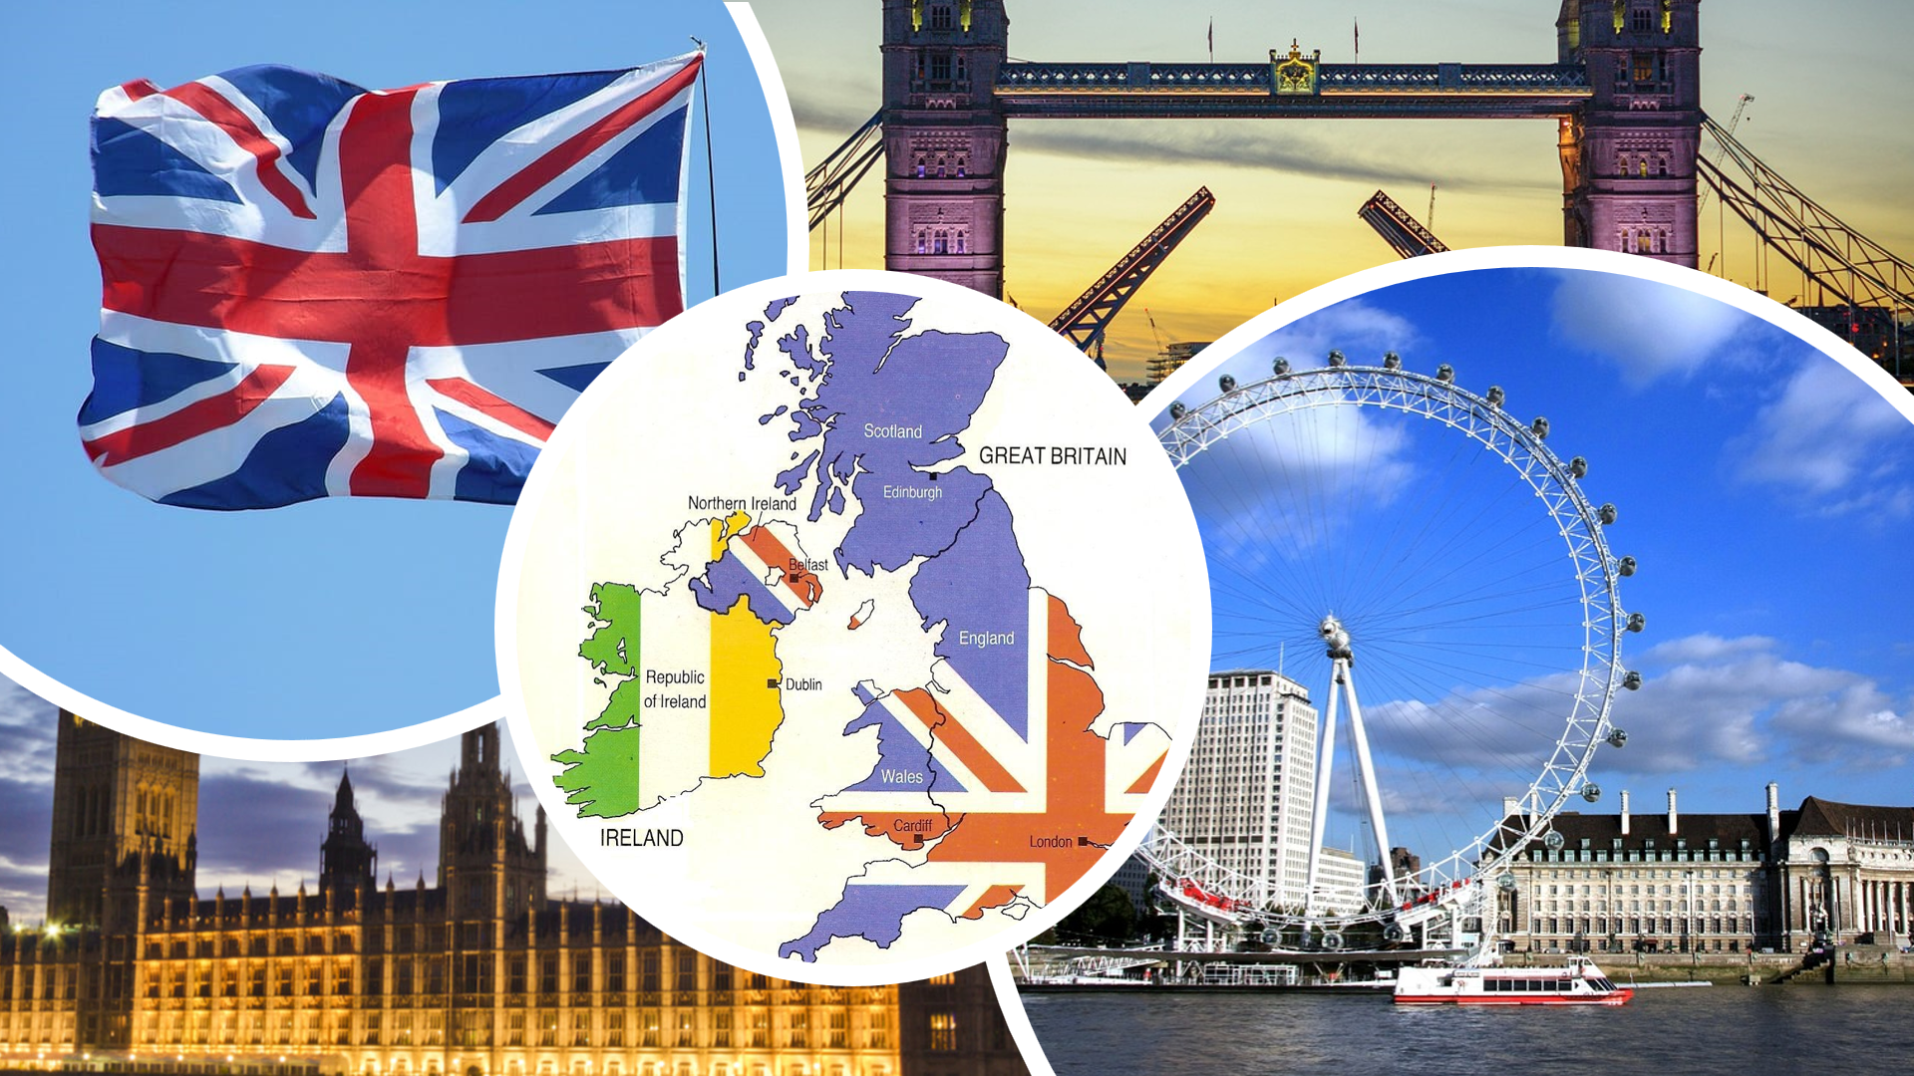
(Online pictures, 2024)
England culture is vast and the most prominent in the world. When thinking at English people drinking a lot of tea comes to mind. Also, some other stereotypes like: English people have a sense of humour full of sarcasm and banter and they eat greasy foo, and the pubs are their second home. Additionally, they are considered to have bad teeth, prefer to speak only their own language, and have an antisocial behaviour abroad (GB Mag, 2024) (Chifari, 2024). On top of that they apologise all the time as a sign of politeness with the risk sometimes of become confusing.

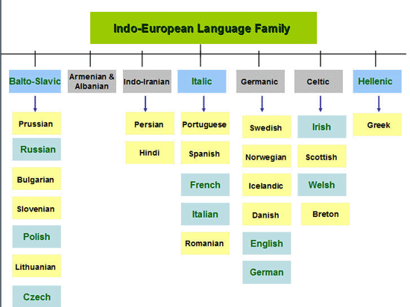

English language is a lingua franca, a west Germanic language, part of the Indo-European family that is official in 67 countries. Most talked language in the world, having two variations: American and British, both using the same alphabet but with different grammar, vocabulary, and pronunciation (Project Britain,2024)

Italy

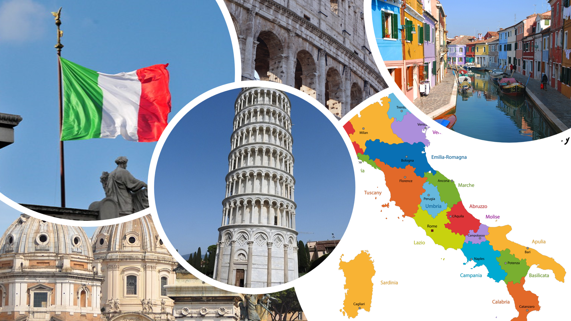
(Online pictures, 2024)
Country part of Southern Europe, epicentre of the Roman Empire, has a rich heritage in history, religion, cuisine cars and fashion (Just landed, 2017). Its language is a Latin language spoken by 63 million people with an alphabet of 21 letters and additional five, official in Itali, Vatican San Marino and Switzerland. Italian stereotypes hard working, focused in north and lazy, inefficient in south, loving pasta, pizza, football and to have alcohol. Also, no having coffee with food, no breaking pasta, no cheese with food. Declining a dinner offer is offensive and always try a little from everything. Titles are really important as a proof of academic credential as a form of respect (Bertocco, 2022)

Globe project’s culture and leadership comparison

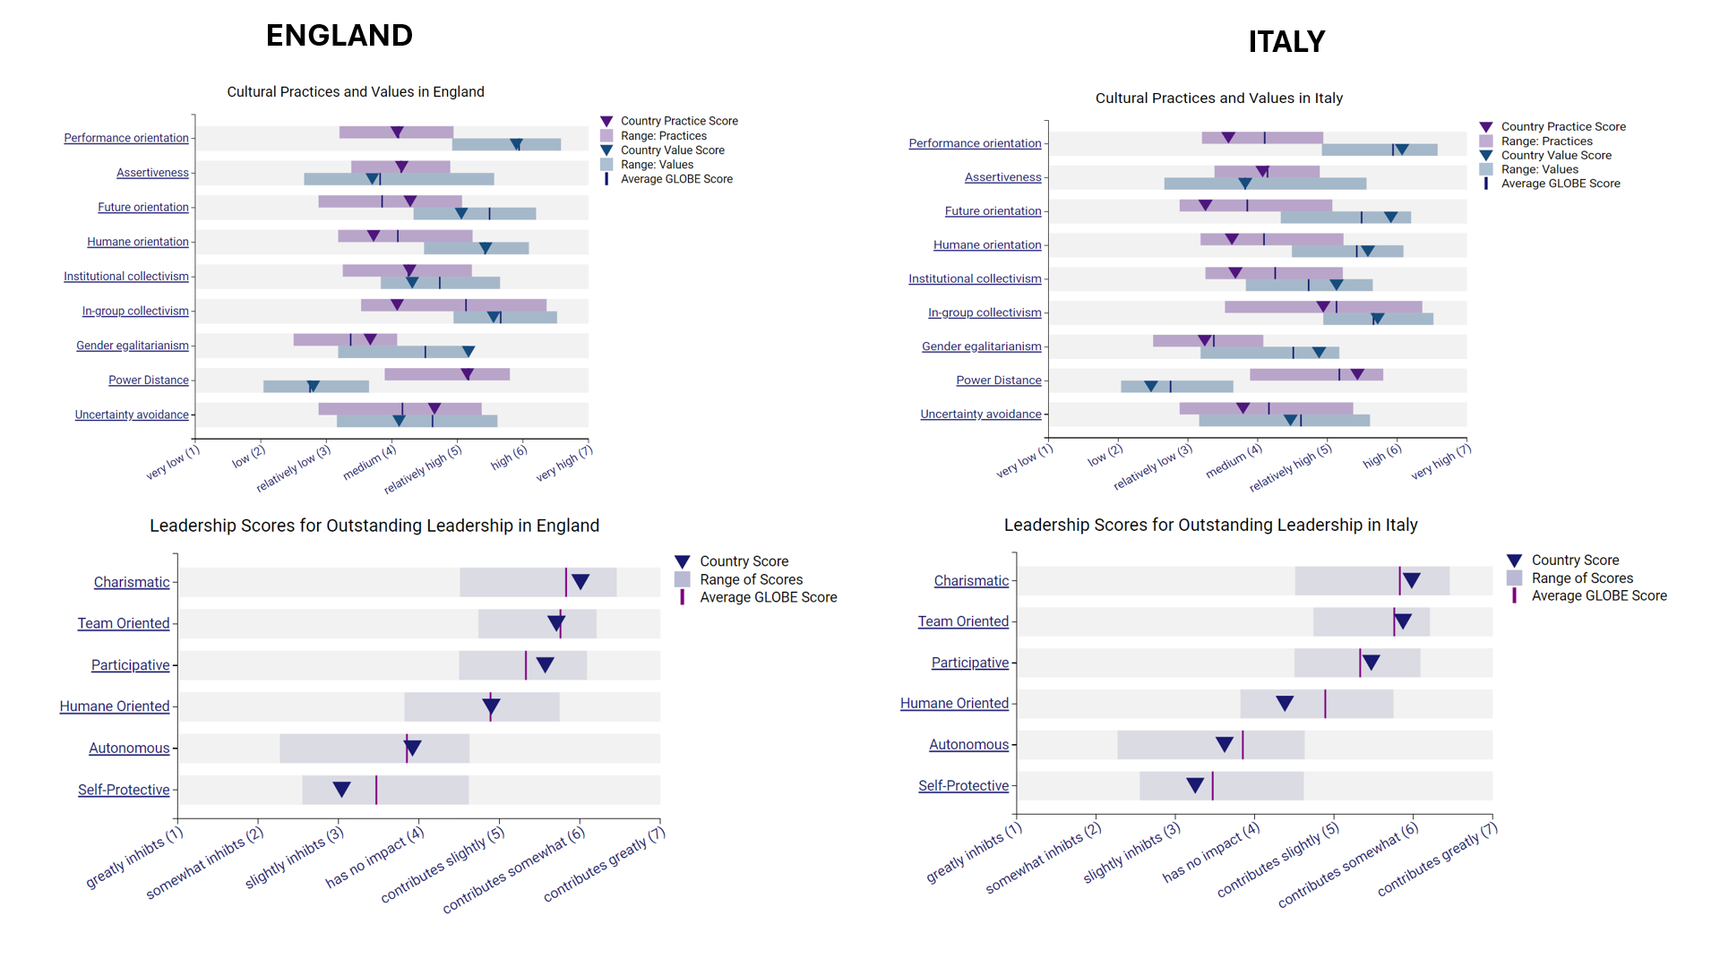
(Globe, 2020)

Cultural practices
England is part of high scores in Performance Orientation and rewarding performance and valuing competitiveness is important for its people. They have tendency to individualism, accomplishments orientation and acceptance of authority, status privileges and social inequality (Javidan, 2006).
Italy has medium scores with the exception of high on Power Distance and low on Human Orientation. Its community accepts authority and social differences. They are uncertain about evenly distributed power along individuals and no rewards for its kindness. Italy is average male dominated, family orientated and not a collective allocation of resources (Schlösser et al, 2013)

Societal values
England’s people prefer gender equality, less rules and more human society, desire for collectivism is similar with the existing one, while Italy’s wants more loyalty and find the actual norms and structure acceptable, prefers reduction on power differences, more rewards and supports the collective distribution of resources (Schlösser et al, 2013).

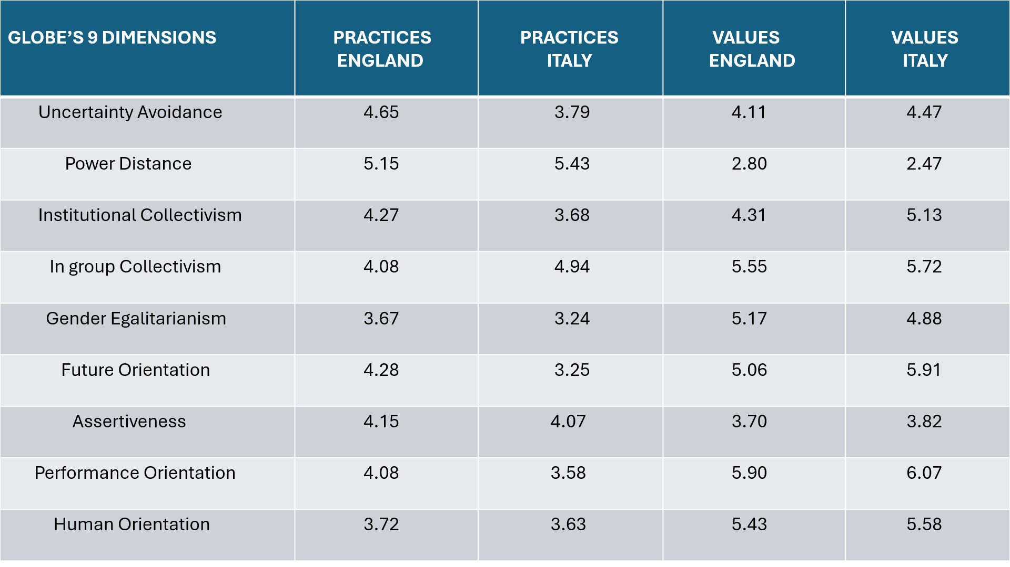
(Globe, 2020)

Leadership
England’s leaders are focused on encouraging employees to inclusion, decision making, working as a team, providing inspiration, encouragement, valuing freedom and delegating. Italy has charismatic, valued based leadership, with people having truth-built vision, thriving to high performance, preferring teamwork, and using their skills to create perfect working groups. Also, society rejects leaders who are self-centred accepting participating ones (Miller, 2016)

Challenges of intercultural leadership in hospitality industry
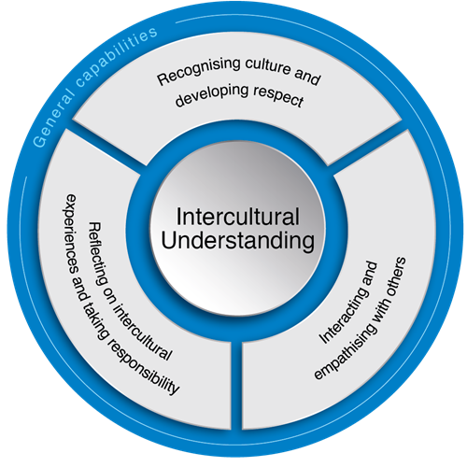

To reveal the challenges of intercultural leadership first it must be determined the countries cultural differences.

Conducting a research trough the Hofstede country comparation tool, England’s and Italy’s cultural differences are:

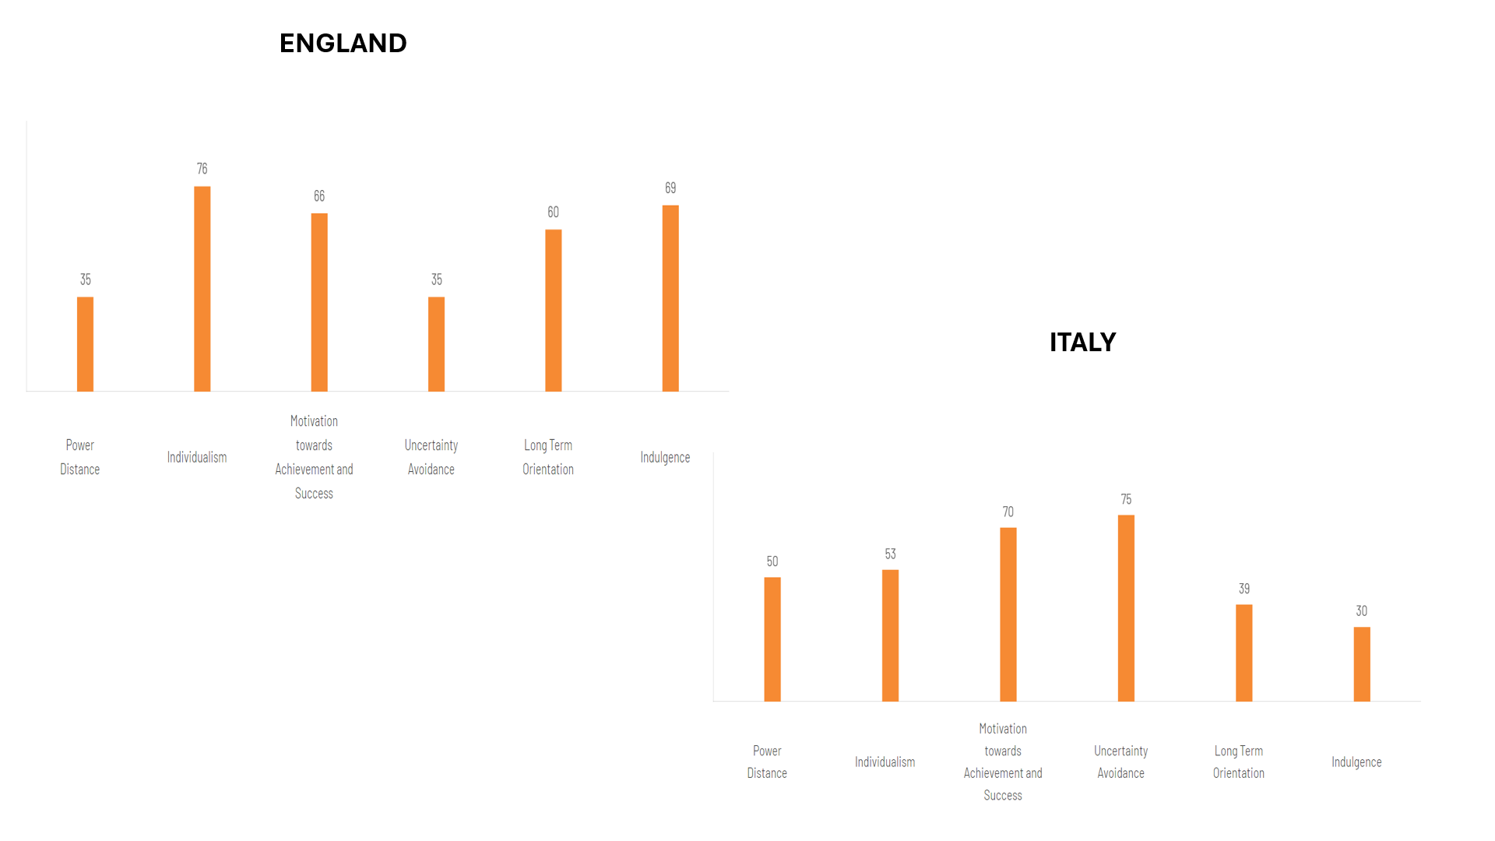
(Hofstede, 2023)

In England society believes that people must be treated as equals without taken in consideration where or when they are born. They are private people, working for achieving only their goals and success, willing to adapt to recent changes but nor detailed orientated, just wining driven. Pragmatic culture but with a positive attitude towards investing in their future but also eager for leisure time. (Hofstede, 2023) (Beugelsdijk & Welzel, 2018)
In Italy it is a difference between south and north parts of the country. While northerns prefer equality, young generation chooses teamwork, being individualists fighting for achieve personal satisfaction, southern are opposite, being collectivists, family is really important and having a less “warm” approach to relationships. Italian society is not comfortable with ambiguous situations and being formal is significant. They have a profound respect for traditions focusing on quick results and with leisure out of the table. The principal challenges are:
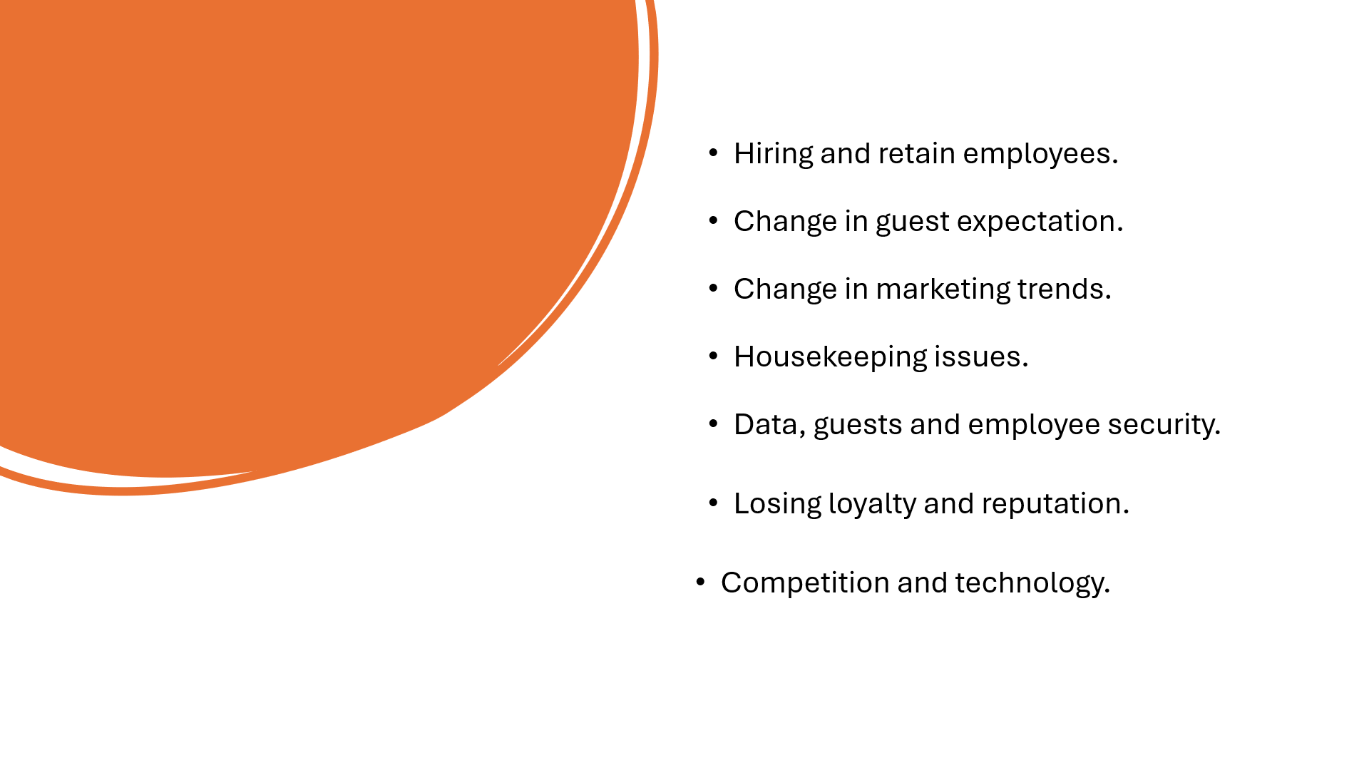 (Malik et al, 2017)
Evolving, adapting and innovate by optimising the operations ensures the business to stay alive. Once discovered all cultural differences and intercultural leadership challenges a number of procedures must placed in place to adapt and include the new Italian staff and avoid any misunderstandings. First the leaders need to know its perfect leadership style and lead by example asking questions and improve its knowledge.
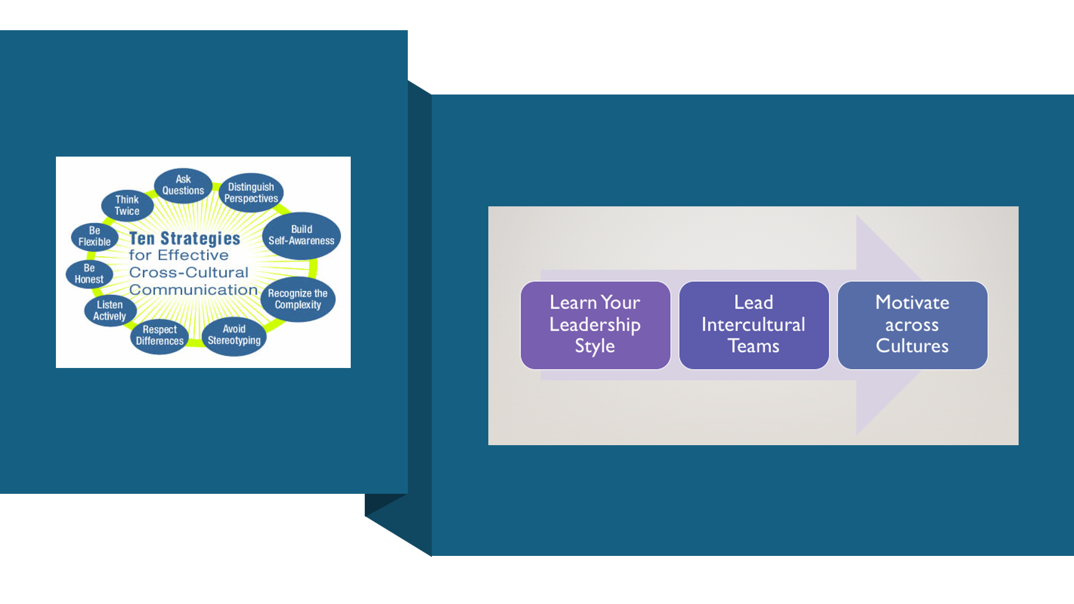
(Miller, 2016)
Essential strategies are:

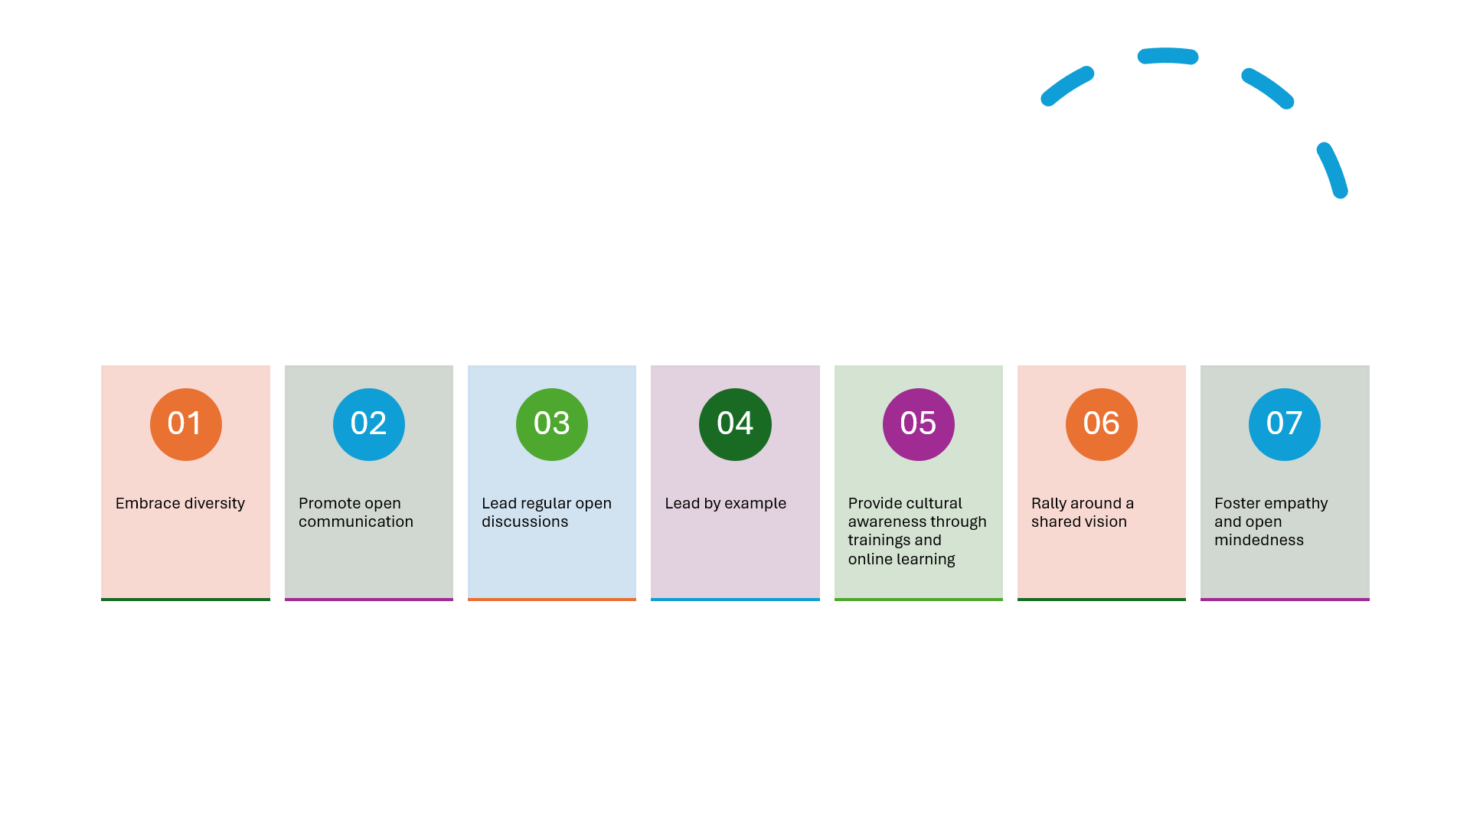
(Brat, 2022)
In hospitality industry and in a multicultural hotel case in order to overcome any potential conflicts of interest between old and new generations or culture differences it must have innovative approaches in which leaders exhibits culturally responsive organisational practices (Brown et al, 2019). The presence of Italian coworkers can be a source of conflict and misunderstandings. Being culturally diverse can lead to barriers between team members. Can be related to language, stereotypes and prejudice, sign and symbols, behaviours, beliefs, or egocentrism. All these can be avoided by creating effective culturally responsive learning environments (Dreamson et al, 2017)

Conclusion
Leading a multicultural hotel, need skills to identify the cultural differences and anticipate and manage intercultural challenges. Leaders can leverage cultural diversity by developing strategies based on recognising and valuing different backgrounds, encouraging team to embrace diverse norms and behaviours. Also, lead by example and set a tone for inclusivity and invest time in training and discussions to unite the team with a common goal “to be aware of one’s own cultural biases.”

References

Bertocco, M. (2022) ‘Storia Culturale del Made in Italy [The cultural history of ’Made in Italy’] by Carlo Marco Belfanti (review)’, Technology and Culture, 63(2), pp. 537–538. Available at: https://doi.org/10.1353/tech.2022.0100. Accessed 01.06.2024.
Beugelsdijk, S., & Welzel, C. (2018). Dimensions and Dynamics of National Culture: Synthesizing Hofstede with Inglehart. Journal of Cross-Cultural Psychology, 49(10), 1469-1505. https://doi.org/10.1177/0022022118798505, Accessed 29.05.2024.
Brat, M. (2022) ‘Mindfulness of Inclusivity and Belonging: Taking Refuge in a Multicultural Community’, Western journal of communication, 86(2), pp. 259–266. Available at: https://doi.org/10.1080/10570314.2021.1949031.,
Brown, M., Altrichter, H., Shiyan, I., Rodríguez Conde, M. J., McNamara, G., Herzog-Punzenberger, B., Vorobyeva, I., Vangrando, V., Gardezi, S., O’Hara, J., Postlbauer, A., Milyaeva, D., Sergeevna, N., Fulterer, S., García, A. G., & Sánchez, L. (2022). Challenges and opportunities for culturally responsive leadership in schools: Evidence from Four European countries. Policy Futures in Education, 20(5), 580-607. https://doi.org/10.1177/14782103211040909, Accessed 01.06.2024.
Carras, C. (ed.) (2024) The Handbook of Cultural Work. 1st ed. London: Bloomsbury Visual Arts. Available at: https://doi.org/10.5040/9781350359499. Accessed 02.06.2024.
Chifari Giulia, (2024), Foreign languages & cultural awareness, University of Wales Trinity Saint David, (Reader BMIH5003)
Dreamson, N. et al. (2017) ‘Policies on and practices of cultural inclusivity in learning management systems: perspectives of Indigenous holistic pedagogies’, Higher education research and development, 36(5), pp. 947–961. Available at: https://doi.org/10.1080/07294360.2016.1263830. Accessed 02.06.2024.
Hofstede Insights, (2023), Country Comparison Tool, Available at: https://www.hofstede-insights.com/country-comparison-tool?countries, Accessed 25.05.2024.
GB Mag, (2024), 10 things you should know about UK culture, Available at: https://greatbritishmag.co.uk/uk-culture/10-things-you-should-know-about-uk-culture/, Accessed 25.05.2024.
Globe, (2020), Global Leadership and Organisational Behaviour Effectiveness, Available at: https://globeproject.com/results/clusters/anglo%3Fmenu=list.html#list, Accessed 31.05.2024.
Javidan, M., House, R.J., Dorfman, P.W., Hanges, P.J. and de Luque, M.S. (2006) 'Conceptualizing and measuring cultures and their consequences: a comparative review of GLOBE’s and Hofstede’s approaches', Journal of International Business Studies, Vol. 37, pp.897-914.
Just Landed. (2017). Social Customs in Italy. Retrieved from https://www.justlanded.com/english/Italy/Articles/Culture/Social-customs-in-Italy, Accessed 27.05.2024.
Malik, R., Madappa, T. and Chitranshi, J. (2017) ‘Diversity management in tourism and hospitality: an exploratory study’, Foresight (Cambridge), 19(3), pp. 323–336. Available at: https://doi.org/10.1108/FS-12-2016-0058. Accessed 31.05.2024.
Miller, M.J. (2016) International Librarianship: Developing Professional, Intercultural, and Educational Leadership, SUNY Press. Albany: State University of New York Press.
Nazarian, A. et al. (2024) ‘Determinants of Intention to Revisit in Hospitality Industry: A Cross-Cultural Study Based on Globe Project’, Journal of international consumer marketing, 36(1), pp. 62–79. Available at: https://doi.org/10.1080/08961530.2023.2192537. Accessed 30.05.2024.
Online pictures, (2024), Available at: https://www.bing.com/search?q=bing%20online%20pictures&msbd, Accessed 28.05.2024.
Project Britain, (2024), British Life and Culture, Available at: https://projectbritain.com/, Accessed 26.05.2024.
Schlösser, O. et al. (2013) ‘Humane Orientation as a New Cultural Dimension of the GLOBE Project: A Validation Study of the GLOBE Scale and Out-Group Humane Orientation in 25 Countries’, Journal of cross-cultural psychology, 44(4), pp. 535–551. Available at: https://doi.org/10.1177/0022022112465671. Accessed 31.05.2024.

