University of Wales Trinity St David
Wales Institute of Science and Art



Energy in a Flywheel
Further Science (ACHA4007)

Joanna Lousie Shand
2411040
23rd March 2024

Table of content

Table of content 2
Introduction – Experiment aim 2
What is a Flywheel? 3
Experimental procedure and setup 3
Results 6
Analysis 7
Evaluation 8
Further work 8
References 9

Introduction – Experiment aim
The aim of this assignment is to carry out a practical experiment for Energy in a Flywheel, using a potential and kinetic energy kit ES9 in the university engineering science laboratory. By conducting this practical experiment, the aim was to find the relationship between potential and kinetic energy in a flywheel.
The aim of this experiment is to prove the theory for energy in a flywheel, by using a bearing block, flywheel and work panel. Using string attached to the flywheel and a weight hanger with 10g weights added.

What is a Flywheel?
A Flywheel is a mechanical component used to store rotational energy. It is commonly a round disk made of metal, positioned on the engine's crank shaft. A Flywheel is connected to a vehicle's starter motor, which helps initiate engine rotation when starting the vehicle. In manual transmission vehicles, the Flywheel also plays a major role in clutch operation. When the clutch is engaged the fly wheel helps transmit power from the engine to the transmission smoothly. There are 4 different types of flywheels – Solid disk, Rimmed, High-velocity and Low-velocity.
During the engine's power stroke, the flywheel stores energy when the engine is producing excess torque. The energy is released during the other stages in the engines cycle to keep the crankshaft turning smoothly, especially during the intake and exhaust strokes. The Flywheel also enables a smoother delivery of engine output. Internal combustion engines produce power in pulses. By the flywheel creating a smooth technique, these pulses create a more consistent rotational motion, ensuring the engine runs smoothly.
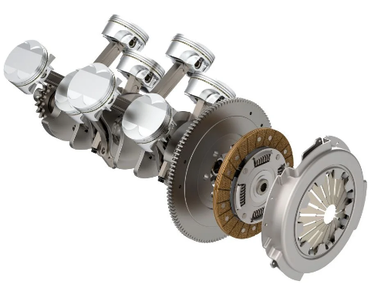
Figure 1- What is a flywheel? (Noaman Adenwala, 05/09/22)

Experimental procedure and setup

Before starting the experiment, I gathered all the equipment needed to complete this investigation. This included – weight hanger, work panel, bearing block, Flywheel, magnetic engineers rule, 10g increment weight, stopwatch and 3 strand string.
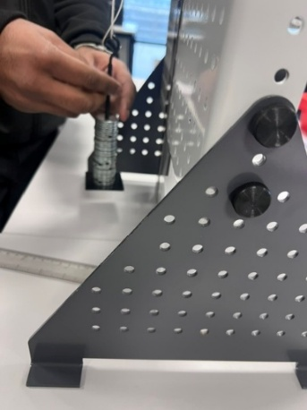
Firstly, the equipment set up. The work panel was placed on a flat horizontal flat surface. With the science labs equipped with on desk plug sockets, using the edge of these is a great way of ensuring a flat surface. Following the attachment of the Flywheel to the work bench, counting the holes to ensure the Flywheel was at the center of the work bench. Using three thumb screws to attach the Flywheel, ensuring they were tight and secure to avoid any movement that could cause inaccurate results.

Figure 2 - (Jo Shand, 12/02/25)

The 3-strand string was gathered and cut with care, ensuring the bottom of the weight hanger to travel through a vertical drop of just under 290mm. Creating a small loop at the end to attach the weight hanger.
The weight hanger was then attached to the end of the string, allowing it to fall to the bottom of its travels; ensuring it was able to move freely. Following, 9 10g of increment weights were added to the weight hanger. Equaling a weight of 100g, with the weight hanger containing a weight of 10g.
The magnetic engineer's rule was placed behind the weight hanger on the work panel, with its 0mm edge aligned with the bottom of the weight hanger. Being magnetic, this proves a more accurate reading compared to holding it. A plastic ruler against the bottom of the weight hanger to ensure advanced accuracy.
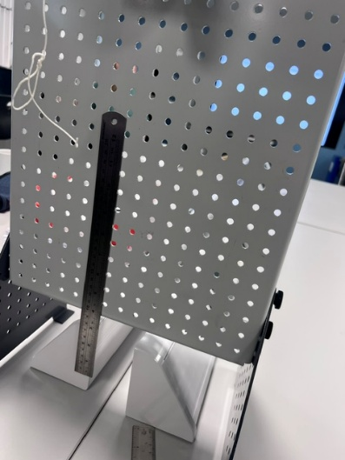
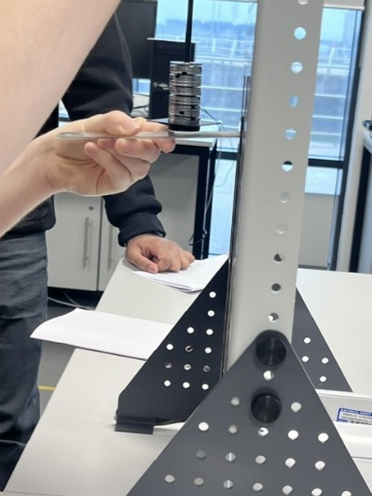
Figure 3 - (Jo Shand, 12/02/25)
Figure 4 - (Jo Shand, 12/02/25)

The Flywheel was then slowly rotated by hand, lifting the hanger upward until it reached 280mm on the steel rule. By visually inspecting this at eye level, accuracy was ensured.
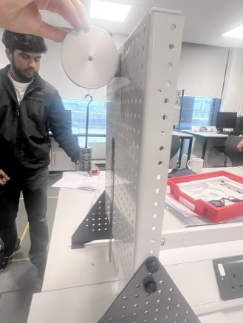
Figure 5 - (Jo Shand, 12/02/25)

A digital stopwatch was used to measure how many seconds the weight hanger took to fall from 280mm to 0mm and back up to its maximum height. This was done three times, to create a good average value for time and height.
This was conducted five times, re doing three times to gather a good average. Adding nine 10g weights to increase the volume of mass to the weight hanger.

Results

The aim of this practical experiment was to find the relationship between potential and kinetic energy in a flywheel. Throughout the experiment, measurements of angular velocity, height and rotational energy were taken at various stages of the flywheels motion.
During this project, raw data was collected. Each test from 100mg – 500mg was tested three times, to gather a good results average. Thde data obtained is presented in the following section, where we examine the relationship between the potential energy at the starting height and the kinetic energy at different points during the flywheels motion.
The consistency of these results with theoretical predictions will be discussed in detail.

Table 1 – Raw data of results collected in the lab of fall and rise time ($t_{t}$), fall (m) and weight (mg) (Jo Shand).
Weight (mg) | Time to fall and rise (seconds) | Fall (m)
100mg | 4.05 | 23.2
 | 4.61 | 23.6
 | 4.54 | 23
200mg | 3 | 25
 | 2.99 | 25.3
 | 3.23 | 25.5
300mg | 2.98 | 25.3
 | 2.39 | 25.3
 | 2.38 | 25.5
400mg | 2.06 | 25.8
 | 2.09 | 26
 | 1.96 | 25.5
500mg | 1.86 | 24.3
 | 1.83 | 24.5
 | 1.74 | 23

Analysis

The aim of this practical experiment was to find the relationship between potential and kinetic energy in a flywheel. Below is a table of results gathered from the experiment.

Table 2 – Results table (Jo Shand)

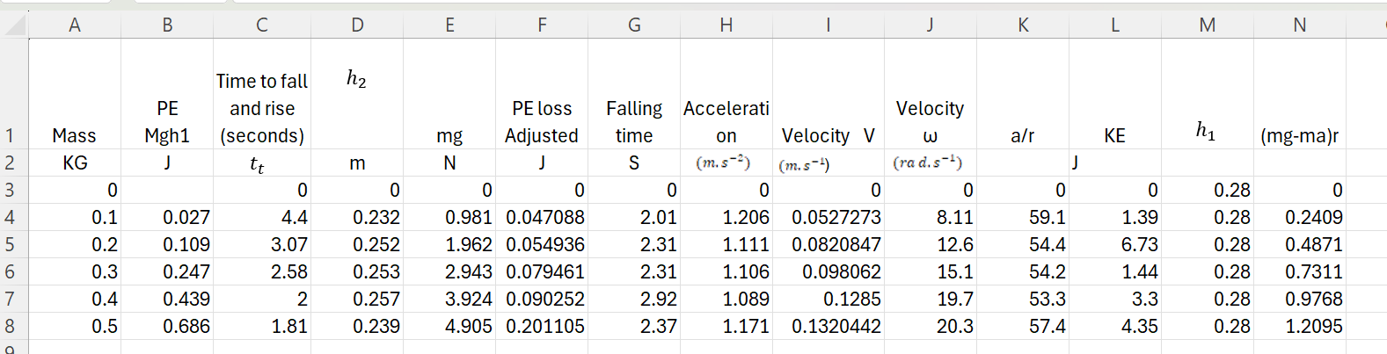

Table 3 – Results graph (Jo Shand)

Evaluation
During this experiment precautions were taken to minimize the account of errors, ensuring accuracy and reliability. To achieve this, a spirit level was used to ensure surfaces where flat. Ensuring precise measurement of the 3-strand string used, by laying it alongside a ruler. Maintaining a clean and organized workspace, minimizing the risk of procedural mistakes and obstruction.
To ensure accurate results, a student was sat at eye level with the bottom of the ruler. Counting down to start the stopwatch, ensuring everyone was ready. Two stop watches where used to ensure the time to fall and rise was correct.
Three strand string was used, due to its strength and weight tolerance. Compared to other materials such as wire or rope. If wire or rope was used, this could cause inaccurate results. Due to their weight and rigidness. String being lightweight and flexible, this was great for this experiment.

Further work
This experiment can be advanced further with the use of a high-speed camera, enhancing precision, data collection, and analysis. A high-speed camera has many beneficial features, such as capturing detailed motion, track flywheel interactions and data synchronization. The camera can be used to record the flywheel's motion in great detail, allowing for the capture of the flywheel's rotational speed, acceleration, and deceleration over time. A high-speed camera can also observe any vibrations, wobbling, or other inconsistencies in the flywheel's motion that might indicate energy losses due to friction or air resistance. By using the camera, high-quality footage can be created, providing a clearer, more detailed view of the flywheel's dynamics. This enables the identification of errors, refinement of calculations, and improvement in the overall accuracy of the experiment.

References
Admin (2024) Newton’s laws of motion - three laws of motion explanation, examples, BYJUS. Available at: https://byjus.com/physics/laws-of-motion/ (Accessed: 04 March 2025).
Author links open overlay panelXiaojun Li a b et al. (2021) A review of Flywheel Energy Storage Systems, Journal of Energy Storage. Available at: https://www.sciencedirect.com/science/article/pii/S2352152X2101255X (Accessed: 04 March 2025).
Bitesize, B. (2023) Potential energy diagrams - controlling the rate - higher chemistry revision - BBC Bitesize, BBC News. Available at: https://www.bbc.co.uk/bitesize/guides/z2gccdm/revision/6 (Accessed: 07 March 2025).
Kumar, Er.A. (2021) Flywheel: Definition, function, construction, working principle, material, advantages, application [Notes & PDF], THEMECHANICALENGINEERING.COM. Available at: https://themechanicalengineering.com/flywheel/ (Accessed: 06 March 2025).
Newton’s laws of Motion (2025) Encyclopædia Britannica. Available at: https://www.britannica.com/science/Newtons-laws-of-motion (Accessed: 06 March 2025).

Figure 1- (Noaman Adenwala, 05/09/22)
Figure 2 - (Jo Shand, 12/02/25)
Figure 3 - (Jo Shand, 12/02/25)
Figure 4 - (Jo Shand, 12/02/25)
Figure 5 - (Jo Shand, 12/02/25)

Table 1 – Raw data of results collected in the lab of fall and rise time ($t_{t}$), fall (m) and weight (mg) (Jo Shand).
Table 2 – Results table (Jo Shand)
Table 3 – Results graph (Jo Shand)

