
Date: 15 December 2021
Student name: Ana Maria Stanciu
Student number: 1909953
Lecturer name: Bianca Sanfilippo
Supporting paper
Mental Disorders and Psychopathology (BMHP6006_LON)
Table of Contents
Introduction 1
Depression 4
Postnatal depression 7
Case Study 7
Mental Health Services 8
Principals when treating patients suffering from depression 8
Conclusion 9
Reference list 9
Appendix 9

Introduction

Mental health is the balance between the well-being of the mind and body, the ability of an individual to handle daily life stress and pressure (Manwell, L. A. et. al, 2015).

Stigma and discrimination have formed curtains that have hidden people suffering from mental health disorders for many years (WHO, 2003).

The notion of mental health has existed since the beginning of human history and it goes back as far as the stone being referred to as supernatural, photogenic, and pathogenic (Farreras, I. 2013).
Supernatural hypotheses attribute mental illness to possession of devil spirits, gods displeasure, eclipses, planetary gravitation, curses, and sin. Photogenic hypotheses refer to the individual state of mind due to stress or the ability to perceive and adapt to a specific environment or situation. Yet the pathogenic hypotheses it was a way through antiquity physicians determined what type of treatment a mentally ill individual was going to have (Farreras, I. 2013).
Further, Farreras, I. (2013), suggests that the first traces of mental health illness, as well as treatment, were firstly discovered in 6500 BC for example Trephination was the method used to release evil spirits, treating epilepsy and head traumas by drilling holes into the individual's cranium as it can be noticed in Figure 1.

  - Figure 1.

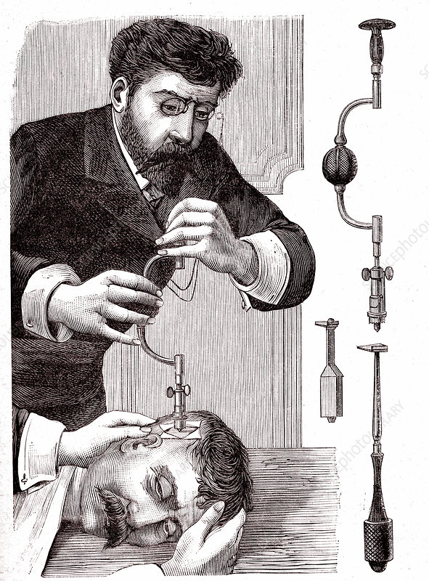

Source: https://www.sciencephoto.com/media/1160214/view/19th-century-trepanning-treatment-illustration.

Later Hippocrates has tried to separate the mental illness from Church believes and superstition introducing the theory that due to an excess or deficiency of the three bodily fluids phlegm, yellow bile and black bile was the cause of physical and mental disorders, therefore, calling them epilepsy, mania, melancholia, and brain fever. However, until the late 16th beginning of the 17th century, mentally ill individuals were physically and emotionally maltreated by procedures such as drilling holes in their skulls, burning women on the sticks accused of witchery, physical beatings, blood draining and many more, eventually, people began to be deprived of their liberty by being closed in so-called ‘asylums’, institutions special build to imprison criminals. Yet they were deprived of their liberty because they were considered a threat to society not because they were ill. The most popular ‘asylums’ at that time was in London St. Mary of Bethlehem in London, known as Bedlam, and the Hôpital Général of Paris and many more after that until mid-20th-century administering treatments such as electroconvulsive chairs and cathartic methods as it is illustrated in Figure 2. (Farreras, I. 2013).

  - Figure 2.

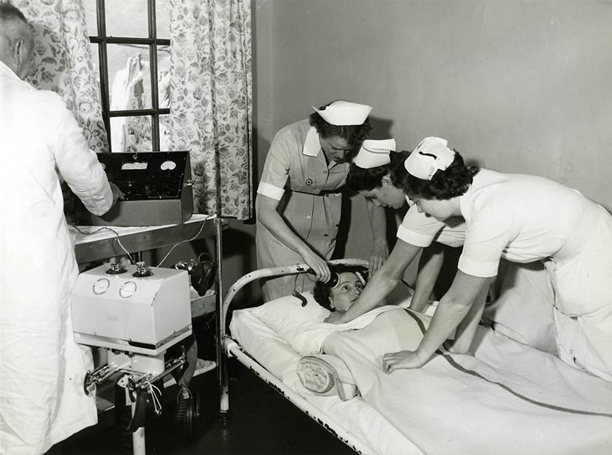

Source: https://teara.govt.nz/en/photograph/29415/ect-treatment-1956.

Nevertheless, lately, the world has become further knowledgeable of this tremendous impediment and the possibility for mental health improvement, creating a difference by exploiting existing knowledge ready to be applied, medications and lows were implemented to treat the illnesses accordingly (Connolly. G.,2017). The first parliamentary act was enforced in 1959 (Connolly. G., 2017).

Unfortunately, the drastic changes due to urbanisation development become the main fuel to the growing burden of chronic diseases and mental illness (Hidaka, B. H. 2012). Our World in Data (2020) indicates that approximately one in seven people have one or more cognitive or substance use illnesses with a higher prevalence in some regions of the world as can be seen in Figure 3. Furthermore, the most common mental disorder which affects approximately 5.0% of people globally is depression (WHO, 2017). Therefore, this report aim is to explore depression in detail.

  - Figure 3.

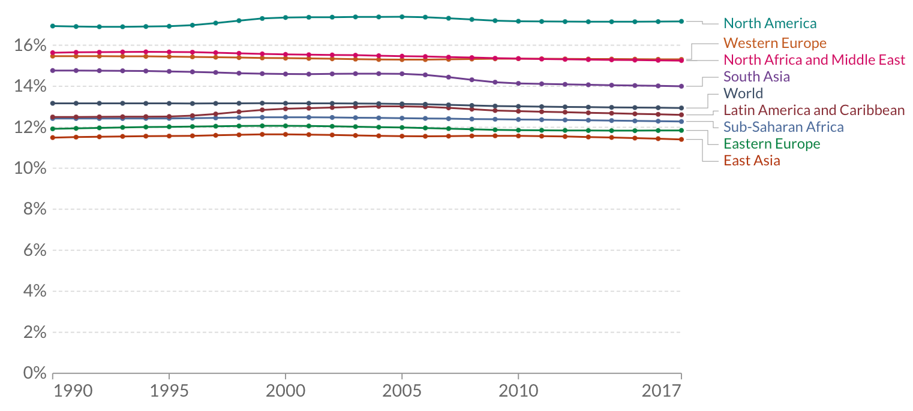
Source: https://ourworldindata.org/global-mental-health.

Depression

Depression was firstly mentioned in the second millennium in Mesopotamia, described as a spiritual instead of a physical condition and like other mental illnesses was believed to be caused by devilish possession. It was treated by preachers rather than doctors using methods such as beatings, physically constraining’s and hunger in a try to push devils out of people’s bodies and minds (Schimelpfening, N. 2020).

Today, depression is defined as a poor emotional state that persists for a long length of time and impacts the everyday life of an individual (Mind, 2019).
ICD-10 (2010) defines depression as a decreased energy and the individual reduced capability of achievement, attention and engagement in everyday life and it can be found in chapter five, under Mood affective disorders (F30-F39).
Yet, ICD-10 is a multinational class of illnesses designed by WHO and is used as a diagnostic method for epidemiology, health supervision and clinical purposes (WHO, 2010). Moreover, depression can be found in DSM-5, which is a Mental Illness manual for diagnostic and statistics used for classification purposes as well as ICD-10 but is only used in the United States, unlike ICD-10 which is the authorized international criterion in psychiatry (Gaebel, W. 2015).

Depression is the most common illness in the world affecting 5.0% of the adult population with a higher preponderance among women and is different from usual personality instabilities particularly when it's frequent and with moderate and severe intensity, depression can come to be a serious health situation affecting individuals with work, school, and family function. Likewise, depression can lead to suicide killing more than 700 000 people around the world every year (WHO, 2021).
In the UK however, mixed anxiety and depression are the following substantial factor for the burden of disorders costing the National Health approximately £105 billion every year and affecting 7.8% of the population yet, depression accounts for 4-10%. (MHFA England, 2020).
On the other hand, the UK Parliament (2021), suggests that the COVID-19 pandemic had a significant impact on adult’s mental health on posttraumatic stress disorder and a significant impact on women and children suffering from depression.

Furthermore, depression can be caused by a variety of different factors such as hereditary and biological, bad nourishment, exorbitant pressure, abuse, relationship difficulties, low self-esteem, alcohol and drug abuse, physical illness and hormonal imbalance during childbirth and it can occur in different categories (NHS, 2021).

- Mild depression is usually described as a temporary depressive episode and is treated by physical activity well understood and recommended by specialists, healthy diets, vitamins, and herbs such as John’s Wort which can be boiled and drink as a tea (MHFA England, 2020).

- Moderate depressive episodes persist longer than two weeks and it involves counselling in some cases in the treatment (NHS, 2021).

- Server depression, nevertheless, persists for more than two weeks and starts affecting the individual function, therefore, medicated treatment is indicated. The most prescribed drug to treat depression is selective serotonin reuptake inhibitors (NHS, 2021).

All the above-mentioned depressive episodes can be diagnosed by a specialist within NHS and are usually done by a self-assessment questionnaire that can be found on the NHS sites, but the GP will recommend to patients as well.
‘The Patient Health Questionnaire (PHQ)-9’ is the main depressive disease module of the whole PHQ and is utilized to temporary interpret depression and the severity degree (HHS, 2021). A questionnaire example can be seen in Figure 4.

  - Figure 4.

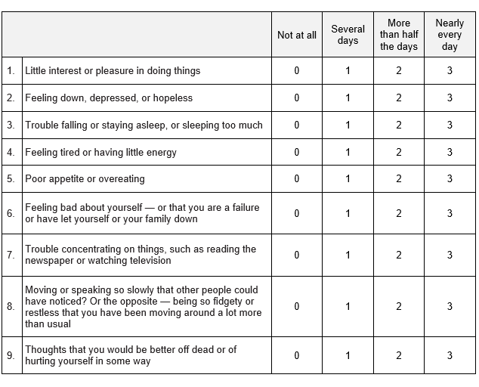
Source: https://help.greenspacehealth.com/article/85-depression-phq-9
Yet the depression severity is evaluated by analysing the scorers as can be seen in Figure 5.

  - Figure 5.
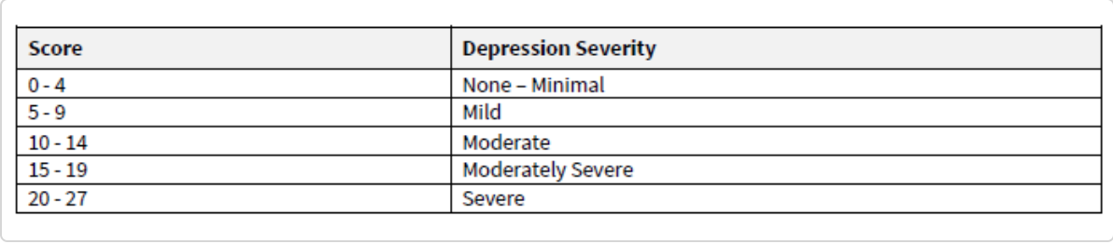
Source: https://help.greenspacehealth.com/article/85-depression-phq-9

Postnatal depression

In the UK 12% of new mothers develop depressive disorders after giving birth. Although the probability of developing severe mental illness such as postnatal psychosis is relatively low in England (1-2 in 1000 women), left untreated, depression can oversee to bad cognitive conditions (Public Health England, 2019).
Any woman can develop mental health problems during pregnancy but those experiencing deprivation, migration, extreme pressure, susceptibility to physical and mental misuse, insufficient social assistance is at threat of developing postnatal depression (Public Health England, 2019). Yet, it can be diagnosed by a specialist by checking the level of thyroid hormone as well as by identifying symptoms in patients such as extreme tiredness, overwhelming, doubts, extreme stress, ideological desires to be excellent mothers and it can be treated by the same methods explained above (OASH, 2019).

Besides, it is particularly important to correctly diagnose and treat postnatal depression because in this case not only does this affect the mother self-stigma, but it also affects the mother-infant relationship as well as the cognitive and behavioural development of the child (Public Health England, 2019).

Case Study

The following case study illustrates how untreated or lack of information on the treatment can affect not the mother and the infant regarding depressive symptoms.

Abby was a 25-year-old who have suffered depressive disorder in the past but at the time when she was 6 months pregnant, she was physically ill with persistent cough and repetitive cold which stopped her sleeping. She has kept it a secret from family and friends until she had the little girl, Bethany. After giving birth she was feeling overwhelmed by the image of the perfect mother, and she became physically incapable of taking necessary care of the baby as well as herself. It was her husband that called and asked for medical treatment, Abby was given medicated treatment which is decided not to take be living that will affect her breastfeeding. Eventually, she ended up in a psychiatric ward staying away from her daughter as well as her daughter staying away from her mother (Tommy's, 2021).

Mental Health Services

In the United Kingdom, mental health services are usually free on the National Health Services but in some cases, there is a necessity for a referral from the GP (NHS, 2021). There is also Mind which is a mental health charity established in 1946 and offers information and advice to individuals suffering from mental illness as well as lobbies government and local authorities on their behalf. It also offers services with neighbourhood mental health committees, civil supervision, residential supervision, emergency interventions and hospital therapy (Mind, 2021).

Principals when treating patients suffering from depression

Since 2008 when the final ‘Mental Health Act 1983: Code of practice’ was introduced, substantial changes have been made. This Act evaluates and ingrains the intention of constraining interventions, isolation, adopting the strategies’ ability to secure people in safe locations and the intention of neighbourhood rules (Department of Health, 2015). For example, in 2013-2014 there have been over 53. 000 incarcerations in the UK under this Act, that's why the revision of policies regarding mental health is extremely important (Department of Health, 2015).

In other to tackle social inequalities associated with mental health such as employment, housing, social solitude as well as suicide and infants’ cognitive development due to mothers’ postnatal depressions patients need to be treated using a holistic approach such as person-centred care. Likewise, practitioners need to involve the patient in the treatment, explain and make sure they fully comprehend the pharmacological risks and benefits, doing so in a respectful and non-discriminatory manner by honouring legislation such as The Equity Act 2010, Human Rights Act 1997, Mental Health Act 1983 as well as Data Protection Act 2018 (Legislation. Gov. UK, 2018).

Conclusion

Finally, the urbanisation and technology advancement, as well as science progression on medical care can treat mental health accordingly. As it can be seen through historical data there is a significant change in the way patients who suffer depressive episodes are treated nowadays. Acceptance, esteem, safety and physiological become a priority in the treatment procedures, however, they are nonetheless problems with bureaucracy especially in the National Health Service England. As a recommendation, it should be less paperwork to be filed by patients which will reduce the waiting time. Please find attached the power point slides of the debate on depression which took place in the classroom.

Reference list

- Connolly. G. (2017) The Mental Health Act. Available at: https://www.ashtonshospitalpharmacy.com/blog/2017/01/the-mental-health-act. (Accessed: 12 December 2021).
- Department of Health. (2015) Mental Health Act 1983: Code of Practice. Available at: https://assets.publishing.service.gov.uk/government/uploads/system/uploads/attachment_data/file/435512/MHA_Code_of_Practice.PDF. (Accessed: 14 December 2021).
- Farreras, I. (2013) ‘History of mental illness’. ResearchGate. 1(1).
- Gaebel, W. (2015) ‘ICD-11 and DSM-5 – Similarities and Differences’. European Psychiatry. 30(1), pp.115.
- Hidaka, B. H. (2012) ‘Depression as a disease of modernity: explanations for increasing prevalence’. NCBI. 140(3), pp. 205-214

ICD-10 (2010) International Statistical Classification of Diseases and Related Health Problems 10th Revision (ICD-10) Version for 2010. Avalable at: https://icd.who.int/browse10/2010/en#/F30-F39. (Accessed:10 December 2021).
- Manwell, L. A. et. al, (2015) ‘What is mental health? Evidence towards a new definition from a mixed methods multidisciplinary international survey’, BMJ, 10(1136).
- Mind. (2019) Depression. Available at: https://www.mind.org.uk/media-a/2935/depression-2019.pdf. (Accessed: 10 December 2021).
- MHFA England. (2020) Mental health statistics. Available at: https://mhfaengland.org/mhfa-centre/research-and-evaluation/mental-health-statistics/. (Accessed 15 December 2021).

Mind. (2021) Mental health problems – an introduction. Available at: https://www.mind.org.uk/information-support/types-of-mental-health-problems/mental-health-problems-introduction/support-services/#CommunityMentalHealthTeamsCMHTs. (Accessed: 14 December 2021).

NHS. (2021) Depression treatment. Available at: https://www.nhs.uk/search/results?q=depression%20treatment. (Accessed: 15 December 2021).

Our World in Data. (2020) Global mental health: five key insights which emerge from the data. Available at: https://ourworldindata.org/global-mental-health. (Accessed: 12 December 2021).
- OASH. (2019) Postpartum depression. Available at: https://www.womenshealth.gov/mental-health/mental-health-conditions/postpartum-depression. (Accessed: 14 December 2021).
- Public Health England. (2019) 4. Perinatal mental health. Available at: https://www.gov.uk/government/publications/better-mental-health-jsna-toolkit/4-perinatal-mental-health. (Accessed: 14 December 2021).

Schimelpfening, N. (2020) The History of Depression. Available at: https://www.verywellmind.com/who-discovered-depression-1066770. (Accessed: 1 December 2021).
- Tommy's. (2021) Antenatal and postnatal depression- Abby’s story. Available at: https://www.tommys.org/pregnancy-information/blogs-and-stories/im-pregnant/mental-health-and-wellbeing/antenatal-and-postnatal-depression-abbys-story. (Accessed: 10 December 2021).
- UK Parliament. (2021) Mental health impacts of the COVID-19 pandemic on adults. Available at: https://researchbriefings.files.parliament.uk/documents/POST-PN-0648/POST-PN-0648.pdf. (Accessed: 13 December 2021).
- WHO. (2003) Investing in Mental Health. Available at: https://www.who.int/mental_health/media/investing_mnh.pdf. (Accessed: 10 December 2021).
- WHO. (2017) Depression and Other Common Mental Disorders. Available at: https://apps.who.int/iris/bitstream/handle/10665/254610/WHO-MSD-MER-2017.2-eng.pdf. (Accessed: 12 December 2021).
- WHO. (2021) Depression. Available at: https://www.who.int/news-room/fact-sheets/detail/depression. (Accessed: 10 December 2021).

Appendix

