c.440 The Doryphoros

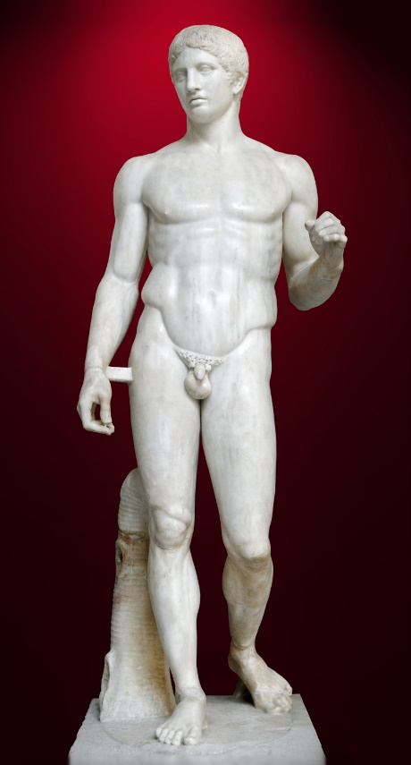
Sculpted by Polykleitos around 450-440 BCE the statue is a 6.11-foot marble roman copy of the original bronze statue that like a lot of Polykleitos works has been lost.
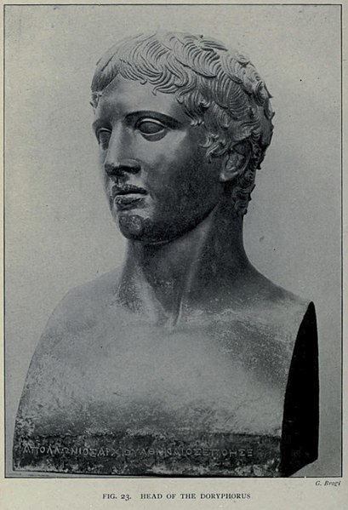
“Polykleitos made The Doryphoros as a demonstration piece to accompany his treatise on the ideal statue of a nude man” (Gardner and Kleiner, 2017, p.68). Although most Greek sculptor around this period was to honour the gods and goddesses Polykleitos demonstrates “the values of Greek society in the classical age” (Lovano, 2020, p.74). The statue originally held a spear in his left hand hence it often being called The Spear bearer this allows the statue to convey “the balance of Polykleitos new system as the figure is balanced between stepping and standing still, between motion and rest” (Tuck, 2015, p.116).
Figure 1: A well-preserved Roman period copy of the Doryphoros of Polykleito (Image from: https://en.wikipedia.org/wiki/Polykleitos)
Polykleitos aim in sculpting was “to produce the perfect human figure using a mathematical equation” (Megaessays.com, 2020). Polykleitos believed and proved that “based on mathematical ratios found in nature, could produce an ideal male form” (Spielvogel, 2019b).
Figure 2: Head of Doryphoros excavated at the Villa of the Papyri.) (Image from: (Barker, 2017)
.

Bibliography
Figure 1: tetraktys (talk) (1797). File: Doryphoros MAN Napoli Inv6011-2.jpg - Wikimedia Commons. [online] Wikimedia.org. Available at: https://commons.wikimedia.org/wiki/File:Doryphoros_MAN_Napoli_Inv6011-2.jpg [Accessed 19 Jan. 2020].
‌Gardner, H. and Kleiner, F.S. (2017). Gardner’s art through the ages: a concise global history. Boston, Ma: Cengage Learning, p.68.
‌Lovano, M. (2020). The world of ancient Greece: a daily life encyclopaedia. Illustrated ed. Santa Barbara, California: Greenwood, An Imprint of Abc-Clio, Llc, p.74.
‌Tuck, S.L. (2015). A history of Roman art. Chichester: Wiley Blackwell, p.116.
‌Barker, E.R. (2017). File: Head-of-Doryphoros-Villa-of-the-Papyri-Herculaneum-Barker-1908.jpg - Wikimedia Commons. [online] Wikimedia.org. Available at: https://commons.wikimedia.org/wiki/File:Head-of-Doryphoros-Villa-of-the-Papyri-Herculaneum-Barker-1908.jpg [Accessed 19 Jan. 2020].
‌Megaessays.com. (2020). Doryphoros by Polykleitos essays. [online] Available at: https://www.megaessays.com/viewpaper/41738.html [Accessed 19 Jan. 2020].
Spielvogel, J.J. (2019b). Western civilization: a brief history. Volume I, To 1715. Belmont: Wadsworth.

