

Name – Joseph Humphreys

Student Number – 2504075

Course – HNC Quantity Surveying

Module – Health and safety

Contents Page
- Introduction ..................................................................................... 3
- Glossary of Terms, Acronyms and Abbreviations ............................ 3
- Site Overview and Safety Challenges ............................................. 4
- The Building Safety Act 2022 and Building Safety (Wales) Bill ...... 4
4.1 Fire Safety Requirements ............................................................ 5
4.2 Resident Engagement and Communication ................................ 5
4.3 Impact on the Croft Street Block 2 Project .................................. 5
- Health and Safety Legislation Relevant to the Project .................... 5
5.1 Health and Safety at Work etc. Act 1974 ...................................................... 6
5.2 Management of Health and Safety at Work Regulations 1999 ............ 6
5.3 Work at Height Regulations 2005 ............................................... 6
5.4 Control of Substances Hazardous to Health Regulations 2002 (COSHH) .................................................................................... 6
5.5 Manual Handling Operations Regulations 1992 ............................. 7
5.6 Provision and Use of Work Equipment Regulations 1998 (PUWER) .................................................................................... 7
5.7 Workplace (Health, Safety and Welfare) Regulations 1992 ........ 7
- Construction (Design and Management) Regulations 2015 ............ 7
6.1 Pre-Construction Phase .............................................................. 8
6.2 Construction Phase .................................................................... 8
6.3 Worker Competence and Training .............................................. 8
6.4 Health and Safety File ................................................................. 8-9
- Conclusion ...................................................................................... 9
- References ..................................................................................... 10

Introduction-
The construction industry involves many health and safety risks, especially when working on large buildings where people are still living during the construction work. The planned refurbishment of Croft Street Block 2 in Swansea includes installing new kitchens and bathrooms, fitting fire sprinkler systems, and adding external cladding to improve energy efficiency. These works will take place in a high-rise residential building, which makes safety management more challenging because both workers and residents could be exposed to hazards. Risks such as working at height, fire, dust, noise, falling materials, and restricted access routes will need to be carefully managed throughout the project to ensure the safety of everyone involved.
Glossoary-
Risk assessment | A process used to identify hazards and decide how risks can be reduced or controlled.
Method Statement | A document explaining how a task will be completed safely.
Toolbox Talk | A short safety briefing given to workers about specific hazards or safe working practices.
PPE (Personal Protective Equipment) | Protective clothing or equipment such as hard hats, gloves, goggles, and safety boots used to reduce injury risks.
Control of Substances Hazardous to Health Regulations 2002 (COSHH) | Regulations controlling exposure to hazardous substances such as dust, chemicals, and fumes.
Work at Height Regulations 2005 | Regulations aimed at preventing injuries and deaths caused by falls while working at height.
Manual Handling Operations Regulations 1992 | Regulations that reduce risks from lifting, carrying, or moving heavy objects.
Provision and Use of Work Equipment Regulations 1998 (PUWER) | Regulations ensuring that work equipment and machinery are safe to use and properly maintained.
Management of Health and Safety at Work Regulations 1999 | Regulations covering welfare facilities such as toilets, washing areas, and rest facilities on site.
HSE | Health and Safety Executive, the UK regulator responsible for enforcing workplace health and safety laws.
Construction (Design and Management) Regulations 2015 (CDM Regulations) | Regulations that set out duties for clients, designers, and contractors to manage health and safety during construction projects.
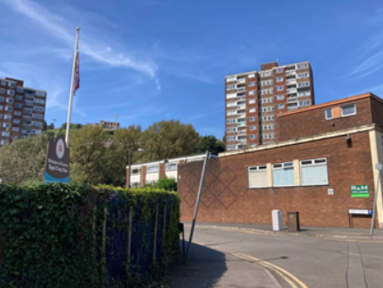


From the images provided, the site is located in a busy urban area with roads, pavements, parked vehicles, and nearby buildings close to the construction zone. This means there are risks not only to workers but also to residents, pedestrians, and members of the public passing through the area. There is also limited space available for deliveries, waste storage, and construction equipment, which can increase hazards such as congestion, blocked access routes, and vehicle movements. In addition, because residents may remain inside the building during refurbishment work, extra precautions will be needed to control noise, dust, and fire risks while always maintaining safe emergency escape routes. (HSE, 2023).
The Building Safety Act and Building Safety (Wales) Bill-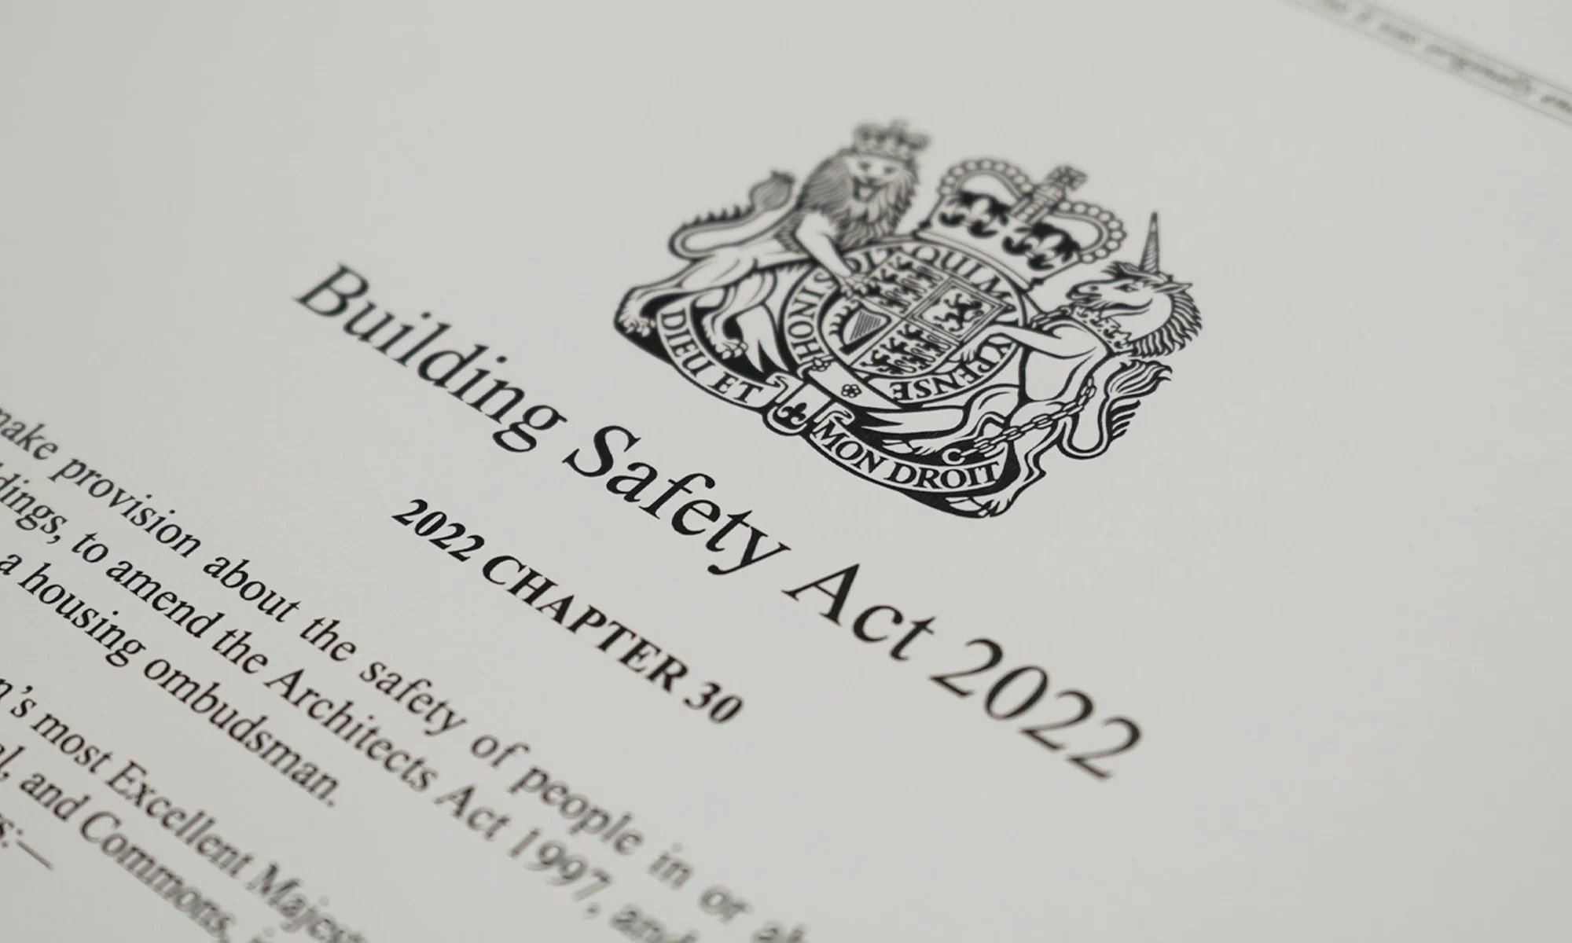
(The, 2024)
The Building Safety Act 2022 and the Building Safety (Wales) Bill are highly relevant to this retrofit project due to the building’s classification as a high-rise residential structure. These legislative frameworks were introduced to address significant failures in building safety management, particularly in relation to fire risks, and they impose stricter requirements on all parties involved in the design, construction, and management of buildings. (UK Government, 2022). This building is classed as a high-rise building, meaning that enhanced safety controls and regulatory oversight are required. The planned installation of fire sprinklers and replacement of cladding directly aligns with the legislation’s emphasis on improving fire safety and preventing the spread of fire.
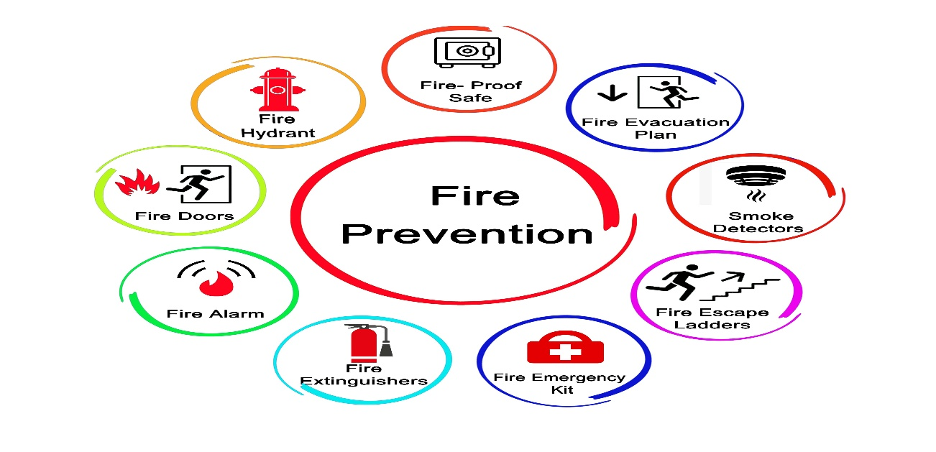
(Fire safety, 2023)
Fire safety is a central concern within this legislation, and it has direct implications for the proposed works. All materials used in the retrofit must meet strict fire resistance standards, and the design must minimise the risk of fire spread. This is particularly important for cladding systems, which have been identified as a major hazard in previous building safety failures. Furthermore, because the building is likely to remain occupied during construction, temporary fire risks must be carefully managed, including maintaining clear escape routes and ensuring that fire detection and alarm systems remain operational. Another important aspect of the legislation is the requirement for resident engagement. Residents must be informed about the nature of the works, the risks involved, and the safety measures in place. Effective communication is essential in ensuring that residents understand how to respond in the event of an emergency and can cooperate with site restrictions. Overall, the Building Safety Act and the Building Safety (Wales) Bill will have a significant impact on how this project is planned and managed, requiring a proactive and highly structured approach to safety. (UK Government, 2022). (Welsh Government, 2024).

(Mitchell, 2023) Health and safety legislation- For a retrofit project such as Croft Street Block 2, a residential tower block in Swansea, There are many different safety laws that apply to this type of construction. The Health and Safety at Work etc. Act 1974 is the main law and requires employers to protect the health and safety of workers and anyone affected by the work. On this site, this includes residents and the public. Because the building is close to roads and walkways, it is important to prevent unauthorised access and protect people from hazards. This can be done by using fencing, warning signs, and safe pedestrian routes. However, from a managerial perspective, the most important focus is how these laws are implemented in practice rather than simply knowing what they are.
The Management of Health and Safety at Work Regulations 1999 require risks to be identified and controlled before and during construction work. Managers must carry out risk assessments and create method statements explaining how work will be completed safely. For the Croft Street Block 2 project, work inside occupied flats should be carefully planned to avoid overcrowding and reduce accidents such as slips, trips, and collisions between workers and residents. Managers should also review risks regularly as the project changes and provide site inductions, toolbox talks, and supervision to make sure workers understand safe working procedures. (UK Government, 1974)

Additionally, the working at heights regulation 2005 are very important for this project due to the use of cladding on the outside of the building. As we know, working at heights can be very dangerous, so a manager on this project must ensure that all work at height is properly planned, supervised, and carried out using suitable equipment -so professional equipment such as scaffolding must be used. The required scaffolding should be checked regularly by a trained person, including before use, every seven days, and after bad weather (HSE, 2023). Also, due to the height of the building and the amount of work needed, Safety features such as guardrails and netting should also be used to prevent falls and falling objects. (Mitchell, 2024) (HSE, 2023).
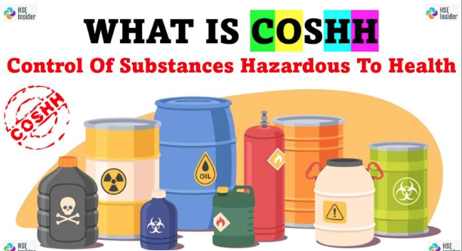
Next, The Control of Substances Hazardous to Health Regulations 2002 are also significant in a retrofit environment where materials such as asbestos (if present in older buildings), adhesives, paints, and dust are likely to be encountered. Construction work often creates dust that can be dangerous to breathe in, so control measures such as water sprays and good ventilation should be used. Workers should also be provided with protective equipment like masks and gloves (HSE, 2023). (HSE Insider, 2024)

After that, The Manual Handling Operations Regulations 1992 are important because workers will need to move heavy materials such as kitchen units and plasterboard. To reduce the risk of injury, lifting equipment such as trolleys, hoists, or lifts should be used where possible. Risk assessments should identify tasks that involve repetitive or heavy lifting, and workers must be trained in correct lifting techniques to prevent musculoskeletal injuries. Supervisors should monitor manual handling practices on site to ensure safe behaviour is consistently applied. (HSE, 2023). (Manual work, 2023)
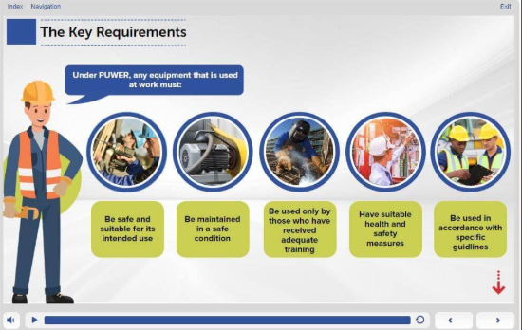
The Provision and Use of Work Equipment Regulations 1998 make sure that tools and equipment are safe to use. this involves implementing routine inspection schedules, maintaining equipment registers, and removing faulty tools immediately. Training is essential so workers understand how to safely operate equipment such as drills, saws, and cutting machines (HSE, 2023). The Workplace (Health, Safety and Welfare) Regulations 1992 require that workers have access to basic facilities such as toilets, washing areas, and places to rest. This project is expected to last quite a while; managers should regularly inspect these welfare areas to ensure they remain clean and stocked to its required level. (Reed.co.uk, 2026)
Overall, compliance with the health and safety legislation relies heavily on the management of the project rather than just the awareness of the laws provided. Effective risk assessments, clear communication, proper training, supervision, and coordination between all parties are essential to ensure the safety of workers, residents, and the public throughout the construction process.
CDM Regulations 2015
The CDM (Construction design and management) regulations 2015 are used to manage health and safety throughout construction projects. These regulations set out clear roles for the client, principal designer, and principal contractor (HSE, 2015).
Before the project begins, risks must be identified in the proposed building area. This would include existing building drawings, asbestos surveys, fire safety details, and information about underground or hidden services such as gas, water, and electricity. Reviewing this information helps managers plan the work safely and reduce unexpected dangers on site.
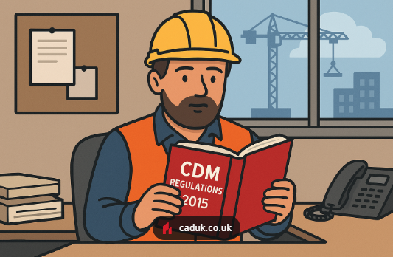
After any hazards are identified, managers should complete risk assessments and create method statements explaining how the work will be carried out safely. These documents should include control measures such as scaffolding inspections, PPE requirements, traffic management plans, emergency procedures, and dust control systems. This process helps reduce accidents and ensures the project is planned safely before construction work begins.
(admin, 2025)
After this, during the construction phase. Any risks should have been picked up through regular site inspections, and communication between everyone involved in the project. As this is quite a large project, many different trades will work together, including plumbers, electricians, scaffolders, and cladding installers. Risks and any changes can be discussed in toolbox talks and site meetings, where workers can report hazards, near misses, or unsafe behaviour directly to managers. However, construction sites change daily as work progresses. For example, on the Croft Street Block 2 project, risks may increase when scaffolding is altered, new contractors arrive on site, or different trades begin working in the same area. Due to this, a construction phase plan must be created. This plan explains how safety will be managed, including site rules and emergency procedures. It should be updated if anything changes during the project. Good communication reduces confusion and helps prevent accidents caused by poor coordination between contractors. (HSE, 2023).
In addition, CDM places strong importance on worker competence and training. Managers must ensure all workers have the correct qualifications, skills, knowledge, and experience to carry out their work safely. For example, scaffolders should hold CISRS qualifications, while workers operating machinery may need CPCS or NPORS training cards. Site inductions should also be provided to explain hazards specific to the building, such as working in occupied residential areas, fire risks, and emergency procedures.
Finally, at the end of the project, CDM regulations require a health and safety file. This file will need to contain important information about the building and any risks that future contactors or maintenance workers may face. A s for this required building (Croft Street Block 2), the file may include information about the sprinkler systems, cladding materials, electrical systems, and maintenance requirements. This helps ensure the building can continue to be managed safely after construction work is completed. (UK Government, 2015).
Conclusion-
In conclusion, the retrofit of Croft Street Block 2 presents a range of significant health and safety challenges, particularly due to its high-rise structure, urban location, and continued occupancy. The Building Safety Act and Building Safety (Wales) Bill introduce stricter requirements for accountability, fire safety, and information management, all of which are directly applicable to this project. In addition, compliance with key health and safety legislation requires a proactive and systematic approach to risk management, supported by effective training, supervision, and communication. The CDM Regulations 2015 provide a structured framework for managing these risks throughout the project lifecycle, ensuring that safety is integrated into every aspect of the work. By adopting a comprehensive and well-managed approach to health and safety, UWTSD Construction can ensure the protection of workers, residents, and the public, while also achieving full legal compliance.

References-
admin (2025). CDM Regulations. [online] CADUK. Available at: https://caduk.co.uk/cdm-regulations-2015/. (Accessed: 7 May 2026).
Building Safety Act 2022 (2022) Building Safety Act 2022. London: HMSO. Available at: https://www.legislation.gov.uk/ukpga/2022/30/contents/enacted (Accessed: 7 May 2026).
Building Safety (Wales) Bill (2024) Building Safety (Wales) Bill. Cardiff: Welsh Government. Available at: https://www.gov.wales/building-safety-wales-bill (Accessed: 7 May 2026).
Construction (Design and Management) Regulations 2015 (2015) Construction (Design and Management) Regulations 2015. London: HMSO. Available at: https://www.legislation.gov.uk/uksi/2015/51/contents/made (Accessed: 7 May 2026).
Control of Substances Hazardous to Health Regulations 2002 (2002) Control of Substances Hazardous to Health Regulations 2002. London: HMSO. Available at: https://www.legislation.gov.uk/uksi/2002/2677/contents/made (Accessed: 7 May 2026).
Fire safety 2023 (2023) Available at: Fire Safety (Accessed: 7 May 2026).
Health and Safety Executive (2023) Construction - HSE Guidance. Available at: https://www.hse.gov.uk/construction/ (Accessed: 7 May 2026).
Health and Safety Executive (2023) COSHH: A Brief Guide to the Regulations. Available at: https://www.hse.gov.uk/coshh/ (Accessed: 7 May 2026).
Health and Safety Executive (2023) Manual Handling at Work. Available at: https://www.hse.gov.uk/msd/manualhandling.htm (Accessed: 7 May 2026).
Health and Safety Executive (2023) Working at Height: A Brief Guide. Available at: https://www.hse.gov.uk/work-at-height/ (Accessed: 7 May 2026).
Health and Safety at Work etc. Act 1974 (1974) Health and Safety at Work etc. Act 1974. London: HMSO. Available at: https://www.legislation.gov.uk/ukpga/1974/37 (Accessed: 7 May 2026).
HSE Insider (2024). What is COSHH??? [online] LinkedIn. Available at: https://www.linkedin.com/posts/hse-insider_what-is-coshh-control-of-substances-hazardous-activity-7258183519481307136-5eJQ (Accessed: 7 May 2026).
Management of Health and Safety at Work Regulations 1999 (1999) Management of Health and Safety at Work Regulations 1999. London: HMSO. Available at: https://www.legislation.gov.uk/uksi/1999/3242/contents/made (Accessed: 7 May 2026).
Manual Handling Operations Regulations 1992 (1992) Manual Handling Operations Regulations 1992. London: HMSO. Available at: https://www.legislation.gov.uk/uksi/1992/2793/contents/made (Accessed: 7 May 2026).
Manual work 2023. (Manual work, 2023) Available at: https://ar.inspiredpencil.com/pictures-2023/manual-work-cartoon (Accessed: 7 May 2026).

Mitchell, D. (2023). Understanding the Importance of the Health and Safety at Work Act 1974. [online] envicourse.com. Available at: https://www.envicourse.com/blogs/news/health-and-safety-at-work-act-1974. (Accessed: 7 May 2026).
Mitchell, D. (2024). Understanding the Working at Height Regulations 2005 in the UK. [online] envicourse.com. Available at: https://www.envicourse.com/blogs/news/understanding-the-working-at-height-regulations-2005-in-the-uk. (Accessed: 7 May 2026).
Provision and Use of Work Equipment Regulations 1998 (1998) Provision and Use of Work Equipment Regulations 1998. London: HMSO. Available at: https://www.legislation.gov.uk/uksi/1998/2306/contents/made (Accessed: 7 May 2026).
Reed.co.uk. (2026). PUWER - Provision and Use of Work Equipment Regulations Course. [online] Available at: https://www.reed.co.uk/courses/puwer-training-provision-and-use-of-work-equipment-regulations-course/270103 (Accessed 7 May 2026).
The (2024). Spicer Surveys. [online] Spicer Surveys. Available at: https://www.spicersurveys.com/blog/building-safety-act (Accessed: 7 May 2026).

Work at Height Regulations 2005 (2005) Work at Height Regulations 2005. London: HMSO. Available at: https://www.legislation.gov.uk/uksi/2005/735/contents/made (Accessed: 7 May 2026).
Workplace (Health, Safety and Welfare) Regulations 1992 (1992) Workplace (Health, Safety and Welfare) Regulations 1992. London: HMSO. Available at: https://www.legislation.gov.uk/uksi/1992/3004/contents/made (Accessed: 7 May 2026).

