BSC Health and Social care
Creativity and Value Creation
BMHP5014 Component 2
Robina Kousar 2409093

Pitch for Early Sense: A Community-Centred Innovation to Improve Early Detection of Stomach Cancer
Introduction
Stomach cancer remains a significant public health challenge in the United Kingdom, with many individuals diagnosed at advanced stages due to delayed recognition of early symptoms. Despite advances in oncology, survival outcomes continue to be shaped by the timing of diagnosis, with early detection strongly associated with improved treatment options and quality of life (Cancer Research UK, 2024). Early Sense is a community-centred innovation designed to address this challenge by improving awareness, enhancing access to screening, and supporting earlier help-seeking behaviours. This pitch outlines the need for Early Sense, its design, implementation strategy, and its potential to contribute meaningfully to the common good.
The Problem: Late Detection and Inequality
Stomach cancer often develops silently, with early symptoms such as persistent indigestion, bloating, early satiety, and unexplained weight loss frequently dismissed as minor digestive issues. Many individuals normalise these symptoms or attribute them to lifestyle factors, resulting in delayed help-seeking. According to the World Health Organization (2023), stomach cancer remains one of the leading causes of cancer-related mortality globally, largely due to late diagnosis.
Health inequalities further compound this issue. Individuals living in deprived communities face additional barriers, including limited access to screening services, cultural stigma, language barriers, and reduced awareness of risk factors such as Helicobacter pylori infection, smoking, alcohol use, and dietary patterns (Public Health England, 2022). The Office for Health Improvement and Disparities (2023) highlights that socioeconomic disadvantage continues to influence cancer outcomes, with deprived populations experiencing poorer access to early diagnostic pathways.
These disparities demonstrate the need for an innovation that is not only medically effective but also socially responsive and accessible to diverse populations. EarlySense directly addresses these gaps by combining technology, community engagement, and targeted screening to ensure individuals receive timely information and support.
Innovation Overview: What Early Sense Offers
Early Sense is a multi-component initiative designed to improve early detection of stomach cancer through three core elements:
1. Digital Awareness Tools
Accessible, multilingual digital resources—including symptom checkers, educational videos, and interactive guides—will be integrated into the NHS App. These tools aim to empower individuals to recognise early symptoms and understand when to seek medical advice. Digital health interventions have been shown to improve patient engagement and support earlier diagnosis (Health Foundation, 2023).
2. Mobile Screening Units
Mobile units will visit underserved communities, offering non-invasive screening and consultations. This approach reduces geographical and socioeconomic barriers, ensuring individuals who may not regularly engage with healthcare services still have access to early detection opportunities. Evidence from community-based cancer programmes demonstrates that mobile screening improves uptake among high-risk groups (Macmillan Cancer Support, 2024).
3. AI-Supported Triage
An AI-driven triage system will support health professionals by analysing symptom patterns and risk factors, helping guide patients toward appropriate diagnostic pathways. NICE (2023) emphasises the importance of timely referral for suspected cancer, and AI tools can support consistent decision-making and reduce delays.
Together, these components create a holistic, human-centred approach to early detection.
Human Impact: Why Early Sense Matters
Early Sense places human experience at the centre of its design. Early detection not only improves clinical outcomes but also reduces emotional distress, supports independence, and enhances quality of life. Individuals who receive timely diagnosis can access treatment sooner, maintain their daily routines, and experience less disruption to family life.
Families also benefit from clearer information, reassurance, and support navigating the healthcare system. NHS England (2023) highlights the importance of empowering communities to recognise symptoms and seek help early, particularly in populations experiencing health inequalities. Early Sense’s emphasis on culturally sensitive communication ensures individuals feel understood, respected, and empowered.
Implementation Strategy
Early Sense will be implemented through a partnership model involving GP practices, community organisations, local authorities, and national cancer charities. The strategy includes:
- GP Practices: Offering symptom-awareness consultations and distributing educational materials.
- Community Centres: Hosting workshops tailored to cultural and linguistic needs.
- Mobile Screening Units: Providing accessible screening in high-risk and underserved areas.
- NHS App Integration: Delivering digital tools and AI triage support.
- Professional Training: Ensuring staff communicate in an empathetic, trauma-informed, and culturally sensitive manner.
This multi-layered approach ensures Early Sense is embedded within existing health and social care structures while also expanding reach into communities that are often overlooked.
Timeline
Early Sense will be delivered in four phases:
- Months 1–3: Planning, stakeholder engagement, and co-design with communities.
- Months 4–9: Pilot launch in two local authorities, with ongoing feedback collection.
- Months 10–12: Evaluation and refinement based on pilot data.
- Year 2: National rollout through NHS England and partner organisations.
This timeline ensures Early Sense is tested, refined, and scaled responsibly.
Regulation and Ethical Considerations
Early Sense complies with GDPR, NHS data-protection standards, and ethical guidelines for AI use in healthcare. The Department of Health and Social Care (2023) emphasises the importance of safeguarding patient data in digital innovation. All digital and printed materials follow accessibility standards, ensuring inclusivity for individuals with disabilities, language barriers, or low digital literacy. Ethical approval will be sought for the use of AI triage tools, ensuring transparency, safety, and accountability.
Dissemination Strategy
To maximise reach, Early Sense will be promoted through:
- Social media campaigns using #EarlySenseUK
- Posters and leaflets in GP surgeries, pharmacies, and community hubs
- Local radio and community newsletters
- Partnerships with faith-based organisations and cultural groups
- QR codes linking to multilingual educational resources and screening locations
This strategy ensures Early Sense reaches individuals across diverse backgrounds and communication preferences.
Conclusion
Early Sense offers a compassionate, evidence-based solution to the challenge of late-stage stomach cancer diagnosis. By combining technology, community engagement, and accessible screening, it empowers individuals to recognise symptoms earlier and seek help confidently. The initiative strengthens the health and social care system, reduces inequalities, and contributes meaningfully to the common good. Early Sense is not only an innovation—it is a commitment to improving lives, supporting families, and building healthier communities across the UK.

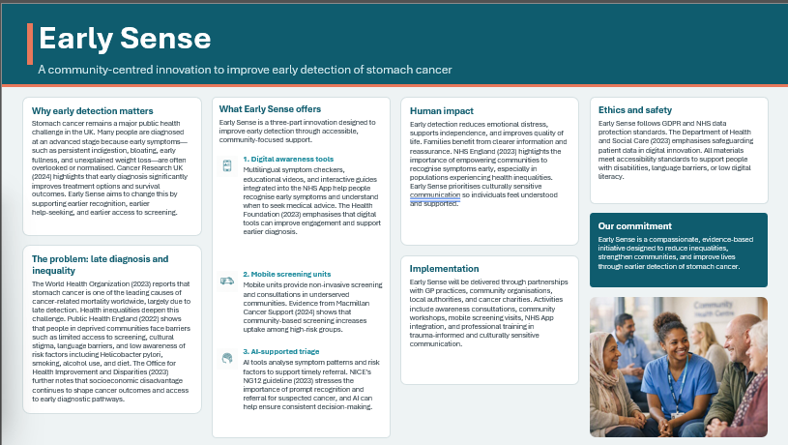

References (Harvard)
- Cancer Research UK (2024) Cancer Research UK (2024) Stomach cancer statistics. Available at: https://www.cancerresearchuk.org (Accessed: 8 July 2026). → summarise this source
- NHS England (2023) NHS England (2023) Early diagnosis strategy. Available at: https://www.england.nhs.uk (Accessed: 8 July 2026). → explain NHS early diagnosis
- World Health Organization (2023) World Health Organization (2023) Gastric cancer: key facts. Available at: https://www.who.int (Accessed: 8 July 2026). → summarise WHO gastric cancer
- Public Health England (2022) Public Health England (2022) Health inequalities: annual report. London: PHE. → summarise PHE inequalities
- Macmillan Cancer Support (2024) Macmillan Cancer Support (2024) Understanding stomach cancer. Available at: https://www.macmillan.org.uk (Accessed: 8 July 2026). → summarise Macmillan stomach cancer
- National Institute for Health and Care Excellence (NICE) (2023) NICE (2023) Suspected cancer: recognition and referral (NG12). London: NICE. → explain NICE NG12
- Office for Health Improvement and Disparities (2023) Office for Health Improvement and Disparities (2023) Community health and inequalities report. London: Department of Health and Social Care. → summarise OHID report
- British Society of Gastroenterology (2022) British Society of Gastroenterology (2022) Guidelines for the diagnosis and management of gastric cancer. Gut, 71(4), pp. 567–589. → summarise BSG guidelines
- Health Foundation (2023) Health Foundation (2023) Digital technology and the future of UK healthcare. London: Health Foundation. → summarise Health Foundation digital report
- Department of Health and Social Care (2023) Department of Health and Social Care (2023) Data protection in health and social care: guidance for digital innovation. London: DHSC. → summarise DHSC data protection

