A Report Focusing On:
Site Investigation Case Study

Prepared for:

A. Nantel

Created by:

J. Hughes

Date Completed:

December 14th, 2022

Table of Contents
Page Number
- Summary 3
- Site Details 3-4
- Historical Appraisal 4
- Geological Appraisal 5
- Environmental Appraisal 5-6
- Conceptual Ground Model 7
- Foundation Recommendation 7-8
- Site Summary 8
- References 8-9

1.0 Summary
In this assignment I will be assuming the role of a junior construction professional. I will be initiating a preliminary study, involving a full site investigation, as a part of the feasibility stage of the ‘Innovation Matrix’ project being built in SA1. My aim is to research the area in which this project is to be built, finding as much relevant information as possible, to provide the contractor advice on the various elements within the site investigation, and their significance. This research is intended to identify the greatest potential risks when building on the site and help to find remedies or solutions.

2.0 Site Details
2.1 Surrounding Buildings
The ‘Y Fforwm’ and the ‘IQ Building’ are very close to the site, both will be associated with the new project as they will be used to host University of Wales Trinity Saint David students. Both buildings are recently built and have similar features to the new ‘Innovation Matrix’ structure. The new project is likely to encounter the same issues faced during the construction of the other university buildings. When studying the area, you would need to consider these examples of issues and action taken to overcome them.

2.2 Site Access
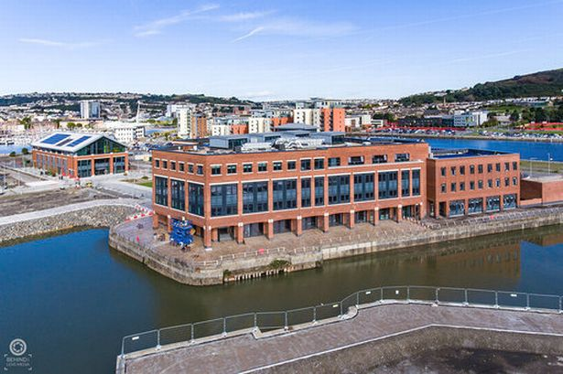
Due to the site location being surrounded by a university campus, site access could become an issue due to the number of other buildings and the land around them. Access options will be limited due to the waterways that surround the site, the area is less accessible for construction vehicles than projects in built-up areas. A major factor to be considered and accounted for when considering access to the site, is that current university buildings will still be in use when construction begins. Noise issues will also have to be considered, and the need for carrying out loud works outside of regular working hours is a realistic possibility. The construction of the project will also have a negative effect on the air quality of the area, this is potentially a serious issue given the number of people regularly visiting the location. As shown in the image above, access to the site would likely have to be from behind the ‘Y Fforwm’ building. The other two buildings currently on the site will still be in use. Easy and safe access for visitors regularly moving between the two buildings will need to be considered and maintained, ruling out some of the potential access points. A positive is there is no apparent issue when it comes to overhang from other buildings, meaning the project can use any form of high lifting machinery without constraints sometimes created by surrounding buildings. However, the sea that surrounds the area could potentially create challenges to the use of certain machinery in the construction of the new building. The erection of the building would have to be carefully planned as parts of the building could become inaccessible further into the project without strategic planning.
Y Fforwm
Image obtained from: https://www.walesonline.co.uk/news/wales-news/inside-stunning-new-university-campus-15214794

3.0 Historical Appraisal
3.1 Railway System in Area
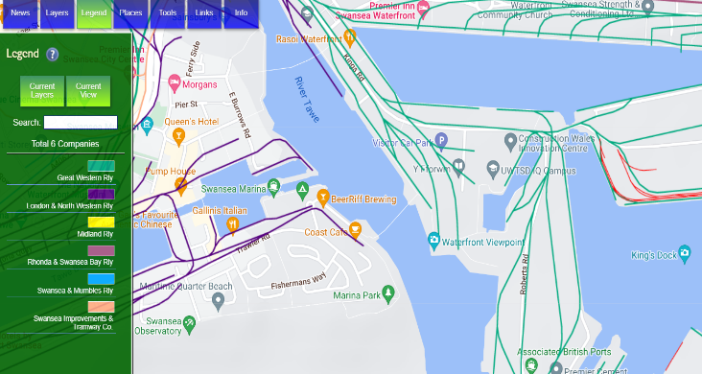
The land on which this project is going to be built, used to have railway systems that carried coal and limestone from the area to the rest of the United Kingdom. As shown on the map on Rail Map Online, the green lines represent the railway system that previously occupied the area where the project is going to be. This use of the area for railway systems could have potentially polluted the ground it was built upon. The railway system being in use here provides evidence that it is a suitable location for the construction. This is because the ground would have endured heavy loads upon it and suffered no subsidisation.
Image taken from Rail Map Online. Available from: https://www.railmaponline.com/UKIEMap.php

3.2 Docklands Site History
The area in which the Innovation Matrix is to be built was surrounded by Swansea’s docklands, this also being the case for the ‘IQ Building’ near to where the Innovation Matrix will be built. According to NEC the “Building on the former dockland site involved removing, cleaning and replacing the top 1.8m of contaminated filled ground prior to installing concrete piles.” (NEC, 2022). This indicates that the new project will have very similar, if not the same contamination levels as other buildings nearby. The docklands were back filled with anything that could be found at the time of its closure with risks of contaminants in the area being extremely high. The geotechnical contractor should investigate the areas levels of contamination when investigating the site, this should form a large part of the investigation as this helps to determine the materials used. This would also help decide the feasibility of the project.

4.0 Geological Appraisal
4.1 Borehole Logs
After studying borehole logs for the area, I have found there is a minimal chance of subsidisation. A 22 metre deep hole was previously drilled into the ground near the area in which this project is going to be built. The findings of the drilling showed there was artificial ground to almost 5 metres deep and this would have to be accounted for before construction begins. The ground below the artificial ground encases around a metre of sand and then becomes clay, the clay getting stiffer as the depth increases. The clay continues until around 18 metres. At 18 metres grey mudstone was discovered and continued from there to the bottom of the hole. This information was provided during a lecture and was obtained from the BGS website. BGS ID: 370246 : BGS Reference: SS69SE345
4.2 Mining History
I researched the area of the project on BGS Geology Viewer. I found that the bedrock geology is South Wales Middle Coal Measures Foundation. This is made up of mudstone, siltstone, and sandstone. The sedimentary bedrock was said to have been formed between 309.5 million and 318 million years ago. There are no mining areas on record near the site. The water surrounding the area would cause an issue when mining and therefore the area would have been avoided for that kind of works. The nearest area in which mines were used is in Port Tennant, about 0.5 kilometres from the site. This distance seems small, but the Prince of Wales Dock separates the project area and the mines closest to it. On the BGS website I discovered that the ground that the project is to be built on has a high level of clay content. A concern that will need to be considered when the project begins is that clay shrinks over time. As it absorbs water it shrinks and can pull on the foundations of structures. Due to this I would recommend that the site investigation focuses on the clay levels and the affect that it can have upon the project when completed.
Information obtained from:
- https://mapapps2.bgs.ac.uk/coalauthority/home.html
- https://geologyviewer.bgs.ac.uk/?_ga=2.239008384.161006693.1670975089-1605912574.1670975089

5.0 Environmental Appraisal
5.1 Coastal Erosion
Due to the project being so close to the sea it could suffer from coastal erosion. Although this is an issue that will become more apparent over an extensive period of time, the land will still suffer from this. Coastal erosion is the process in which waves crash upon the shore and slowly take parts of it away with it. This is the impact of pebbles and other solid materials within the water regularly crashing in to the surface surrounding the water. Climate Change Post claim that “Some 28% of the coast in England and Wales experiences erosion at rates higher than 0.1 m/year” (Climate Change Post, 2022). This figure is evidence to the fact that coastal erosion is an issue that must be considered with this project. The site being this close to the sea also means that the site will be at the highest risk in terms of sea levels rising. The Royal Society state that “Long-term measurements of tide gauges and recent satellite data show that global sea level is rising, with the best estimate of the rate of global-average rise over the last decade being 3.6 mm per year (0.14 inches per year)” (The Royal Society, 2020). These figures highlight that although the risk is not very evident right now, it could be a serious issue in the future.

5.2 Saltwater Contamination
The building will suffer a very enhanced exposure to saltwater environment compared to buildings far from the sea. NJ Architects state that “Exposure to a saltwater environment can have a serious effect on a building because salt crystallisation can form in stone walls and rust in metal materials” (NJ Architects, 2018). The effect of the sea on the building must be accounted for and should result in materials resistant to salt crystallisation being used. A known way to counteract the salt having an effect on metals is using galvanized steel, the material is reliable and long lasting due to the tough coating of the steel.

5.3 Flora/Fauna Risks
The area is clear of any wildlife and the construction of this project will have little to zero impact on nature in its surrounding area. The building will be close to the sea so that must be considered in regards to materials being used and brought near to the site. Various dangerous chemicals will be used to produce the building, this is also the case for how machinery is fuelled. Bill Noakes states that “The day-to-day activities on the site will almost always involve chemicals, paint, or waste that is discharged into the surrounding environment after use” (Bill Noakes, Atlantic Pumps, 2021). This will be an issue that must be minimised as much as possible as sea pollution is dangerous and will affect areas much further away from the site.

5.4 Weather Issue
Swansea and Wales are reputable for their poor weather conditions. According to Weather Atlas “Throughout the year, in Swansea, there are 201 rainfall days, and 999mm (39.33") of precipitation is accumulated.” (Weather Atlas, 2022) This is a very high figure and can slow the progress of projects massively. The land does have a good drainage system as it is so close to the sea, but the consistent rainfall will prevent the drying of materials, and on occasions, stop works completely. The rainfall could cause flooding in the area so the careful examination of the area must account for this.

6.0 Conceptual Ground Model
6.1 Radon Inspection
There is a radon map of the United Kingdom. Using this map I have discovered that the maximum radon potential for the area is less than 1%. This low level of radon is a success for the project as it is a dangerous substance. WebMD say that “When you breathe in radon, it gets into the lining of your lungs and gives off radiation. Over a long time, that can damage the cells there and lead to lung cancer” (WebMD, 2022). This is another positive and an advantage of the building being constructed in this location as the risk of radon affecting anyone is low.
Map accessible from: https://www.ukradon.org/information/ukmaps

6.2 Unexploded Ordnances
When looking to build in the Swansea area, consideration must be given to the history of the town and the fact it was hit heavily by bombs during World War Two. There is a potential for unexploded ordnance from bombs that did not explode when they were supposed to, resulting in the bomb possibly still being dangerous. If any situation arises where an unexploded ordnance is found, the area must go through further examination and the bomb will need to be disposed of. From my research on the area, I discovered that there were no unexploded ordnance findings within 3.4 kilometres of the site location. The location for the new building, and nearby area, was a heavy target for the Luftwaffe so an extensive search of the area will still be necessary as there is a possibility that unexploded ordnance remains close to the site. (Zetica UXO, 2022) I would suggest to the geotechnical subcontractor that deep ground radar investigations should be undertaken. Although the risk would have been assessed when constructing the ‘IQ Building’, there is still a possibility that it could be found in this location.

7.0 Foundation Recommendation
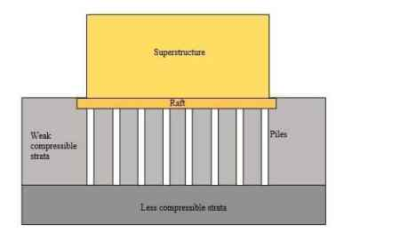
After doing my research on the area and other buildings close to it I have come the conclusion that for this building I would recommend a Pile foundation. A pile foundation would suit this area as the ground conditions are often going to be wet. The pile foundation is a deep foundation that is formed by long columns of either reinforced concrete or steel. This type of foundation helps to provide a greater stability for a structure due to it being deep into the ground. The deeper the columns, the more stability, meaning that the foundations can support the large structure that is to be built upon it. The piles are versatile in that they can be prefabricated and then drilled into the ground or formed at the location they are required for usage. As mentioned before, there could be contaminated soil in the area so that would have to be cleaned and replaced prior to construction. The IQ building has set the precedent by using this foundation system in the same area. This is excellent evidence that the piles foundation type is suitable for the area and is stable enough to support buildings in this area.
Image obtained from: https://theconstructor.org/geotechnical/raft-foundations-types-advantages/7184/

8.0 Site Summary
From the Research on the area of the ‘Innovation Matrix I have come to the conclusion that the main focus of the site investigation should be the underground and above ground contamination levels. The previous usage of this location could have lessened the stability of the area and cause issues with the building in the future. As mentioned before the ‘IQ Building’ had a 1.8m depth of contaminated ground that was required to be removed and replaced. This is likely to be the case with the ground where this project is going to be.

9.0 References
Bill Noakes, Atlantic Pumps (2021). Common Construction Site Water Pollutants and How to Stop Them. Available from: https://atlanticpumps.co.uk/blogs/news/common-construction-site-water-pollutants-and-how-to-treat-them [Accessed on 14/12/2022]

Climate Change Post (2022). Coastal erosion United Kingdom. Available from: https://www.climatechangepost.com/united-kingdom/coastal-erosion/ [Accessed on 12/12/2022]

NEC (2022). SA1 Swansea Waterfront campus, University of Wales Trinity Saint David. Available from: https://www.neccontract.com/projects/sa1-swansea-waterfront-campus-university-of-wales-trinity-saint-david [Accessed on 10/12/2022]

NJ Architects (2018). The challenge of designing coastal buildings. Available from: https://www.njarchitects.co.uk/conservation/the-challenge-of-designing-coastal-buildings/#:~:text=Exposure%20to%20a%20saltwater%20environment,effects%20of%20the%20surrounding%20environment [Accessed on 12/12/2022]

The Royal Society (2020). How fast is sea level rising? Available from: https://royalsociety.org/topics-policy/projects/climate-change-evidence-causes/question-14/#:~:text=How%20fast%20is%20sea%20level%20rising%3F,-Climate%20change%3A%20evidence&text=Long%2Dterm%20measurements%20of%20tide,(0.14%20inches%20per%20year). [Accessed on 11/12/2022]

Weather Atlas (2022). Climate and monthly weather forecast – Swansea, United Kingdom. Available from: https://www.weather-atlas.com/en/united-kingdom/swansea-climate [Accessed on 11/12/2022]

WebMD (2022). Radon: How It Can Affect Your Health. Available from: https://www.webmd.com/lung-cancer/radon-health-effects [Accessed on 12/12/2022]
Zetica UXO (2022). Risk Maps. Available from: https://zeticauxo.com/downloads-and-resources/risk-maps/ [Accessed on 8/12/2022]

