Stacey hopkins human development EAEE40031C
A guidance handbook of transition during early years for keyworkers.

A children develop to grow they go through many transitions throughout their life.
(Clarke, 2020)



(Source: Hinton, 2018)

Contents Page

1.Introduction: Transition in early years 3
2.How to use this handbook 5
3.The role of the adult 6
4.The needs of the child 8
5.Partnerships 10
6.Interventions 12
7.Proposed outcomes 13
8.Reference list 14

Introduction

Transition- often referred to as change. A journey throughout a child’s life that as they develop throughout life from a baby to going in to their first setting then on to starting a school or even a change from one class to another whilst at school. Transitions are all part of a growing and learning process which are a part of a child’s milestone. (early years matters, 2020).

Throughout the course of life we experience many of transitions daily down to the very beginning of our life’s. Transitioning into a school is said to be one of the biggest transitions a child goes through but the child will experience many of transitions before they reach their first setting. Transitions come in many of forms from a small transition to multiple transitions, also the readiness of a child or even the lack of transition in a child but transitions come as a challenge. (Dunlop 2018).

Each child is unique and should be accessed as a individual like those of special educational needs or even a child that is coming to a setting from care as these children will need additional support throughout there transition. For a child to adjust and settle into their new setting environment then a child will need to be prepared for change which is extremely important for a positive transition. Positive relationships between a child’s carer/guardian and other professional’s such as listening to one another and working together throughout a child’s transition can ease transitioning from one setting to another, even the sharing of information between professional’s and the child’s carer/guardian involved can make the process easier. The child can also benefit during transition if opportunities could be provided for the people involved in the child’s life such as a open day or even a newsletter. (Oxfordshire county council 2017)

As Brooker states professional’s in the child care industry whiteness overwhelmingly transitions with children that learn in the modern society. (p1).Transitions are a big change in a child’s life and he or she will experience many of different transitions from birth whether it’s a pleasure or even a painful transition each individual will go through many of changes with different experiences as a individual. Transitions can also be a child having a younger sibling arriving to the world or even a death of someone close to them are a huge part of a life changing time for both a child and a adult. (p3). Transitions can knock ones self-confidence or even ones self-esteem by memories they encounter as a individual throughout life. Transitions also can make a individual feel quite insecure which could happen at any age throughout life as they have a long lasting effect. So really you can understand the venerability of a child in the world experiencing transitions. (Brooker 2008).
As each child grows and develops than the experiences they occur as small young children have a big impact on the rest of their life’s. Frobel believes in the importance of play weather it is a practical hands on approach in to learning or even learning through nature gives a big impact throughout a child’s development.

In the 20th century John Bowlby stated a attachment theory of how a young child reacts from being away from his/her guardian/carer/parent and how it later affects the way they develop to grow and a clear understanding of the personality and relationships formed by the infant. Bowlby continuously uses the word ‘attachment’ other than ‘dependency’. (Wilson-Ali, Barratt-Pugh, Knaus p2 2019).

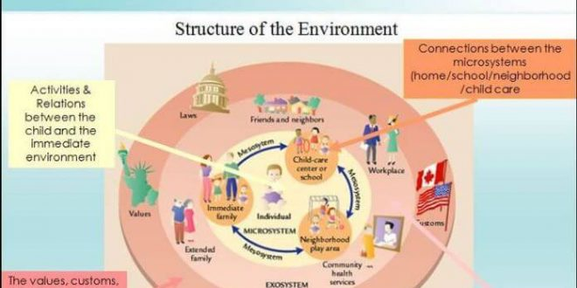

(source: Bronfenbrenner no date)

How to use this handbook.

This handbook is pacifically targeted at staff in a early years setting and any keyworkers involved as a guide to improve their understanding of the importance of communication while working alongside a child at a pre school setting as the child transitions. This handbook is to provide a guide of how to help a child encounter a smooth transition from home to their first setting also to help ease their transition from pre school to primary school. (flying start 2017).
Good relationships between the practitioner and parents make the transition of going to setting positive for a child’s transition. (Patel no date).

How should this handbook be used?
- Each section provides resources that may be useful during a chlds transition
- It is recommended that all sections are covered by being read in deep depth
- Helps the understanding of children transitioning in to a pre school setting, their time throughout setting also preparing them to leave setting
- Offers advice in areas that practitioners frequently come across

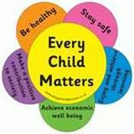
(Colden-early years no date)

The role of the adult.

As a child transitions from their home in to a setting you will need to provide them with reassurance for them to feel safe and you will also need to provide each individual child with familiar resources and experience’s to enable a smooth transitioning for them to each have a sense of belonging whilst at a setting. Providing each child with a bond between them and their key worker is extremely important fr the child to adapt into their new setting. (Patel No page).

Keyworkers will need to recognise the individuality of each individual child in their care and gave them the individual care they need. This will need careful planning from the keyworker. (Brooker p55). As practitioners you will need to understand the different backgrounds and cultures of each child to help each child transition from home in to a school setting. (Brooker p56).

The key person involved with the child will need a plan put in place for a child that is coming in to a new setting. The plan will need a good procedure for each childs individual needs.
The key persons role includes:
- Taylor each child’s individual needs
- Familiarise each child with his/her new setting
- Build a strong bond between yourself and the child
- Build a relationship between yourself and the child’s parent/career
- Plan learning activities for each individual child and observe them in setting to see if they are making progress whilst they transition
- Extremely important that you as a key worker are organised with notes of each child’s development, progress, accidents, daily activities and if a child is on medication then it is strongly advised to also keep record of this
- Always have another member of staff at setting known to the child/children in your care as a backup plan
- Reports of the child’s progress helps the child’s guardian get a clear understanding of the progress taking place
(Croner-I 2017)

As a keyworker building a learning relationship with a child Carlina rinalai explains that listening to a child is the main factor of what a child need to develop. Mainly parents are often better at this than a keyworker or teacher in a placement or school setting as the parent would have built a strong relationship with the child over the years and they tend to have a clear interest of what the child is saying/doing. (Smidt 2nd edn).

As a keyworker while working with the child you will need to ensure the child has plenty of play to suit their individual needs as this will help the child interact more with other children or even a choice of them playing alone but this all will benefit a child’s transition from home in to setting and throughout setting on to transitioning in to school this is why play is so beneficial for children. You will need to ensure you plan a range of play activities whether it is natural resources such as leaves, plants or even insects, you could also even use building activities as everything involving play will help you get a better understanding of what the child likes and familiarities in the child’s life. Play is essential! (Welsh government 2014 p18).

Members of the flying start setting are highly advised to engage with the surrounding family and other supporting agencies involved with the child to ensure the needs of each child are met throughout their transition in setting. (flying start 2012 p7).

Whilst at setting you yourself are responsible for the safeguarding of the children whilst they are in your care so if you observe anything that is a concern involving the child then you must not hesitate but to talk about it with the designated person, you would have had training and made aware regarding child protection so it is your responsibility to familiarise yourself whilst at setting with the agencies polices to ensure the welfare of the children and make it your job every detail is noticed. (early years handbook no date).

In order for the child to feel safe and secure whilst at setting in the absence of the parent/guardian whom Bowlby refers to these as ‘primary figures’ the child will need to form a close relationship with a ‘secondary attachment figure’ and a close bond will need to be formed with the ‘secondary figure’ to meet the needs of the child in the absence of the ‘primary figure’. (Bowlby, 1969).

As the professional keyworker you will need to provide a significant amount of care as the child transitions with a close bond will need to be formed in order to achieve a high level of trust to form a close relationship between the child and his/her family members as starting a new setting not only has impact on the child but everyone involved around the child. (Elfer, p3 2012)

As the professional you will need a close relationship with the children in your care but will also need to ensure that the relationship do not become over-attached as this is known to happen to educators. If the educator do become too involved then this can lead to mis judgement and is often referred to as ‘favouritism’. (Dali 2009).

The needs of the child.

Play for children is the most important resource to help them grow, learn and connect with the people and surroundings around of them. Children should not be pushed in to learning but should be left to adapt to do things at their own individual pace and be free to practise new skills. It will all help towards a child’s growth and learning abilities, this will need to be recognised as things a child can do instead of picking up on only what a child can not do. Childhood should be enjoyable and a child should be left to have a childhood. As Frobel states play is the main part of human development in childhood for every child to express themselves as a individual. Also a child that is free to have hands on experience can learn surficial better. (Louis and Powell 2020).

As Frobel states children thrive over security and close relationships between family members and others in the wider community. Frobel saw children as extremely creative thinkers with play and self-reflection as the best way for each child to learn. Frobel believes that in order for a child to make good choices and think for themselves than they will need to be given the freedom to do so. Children need to be free to explore, move and participate at their own individual pace with the guidance from an adult.

- Play helps children reflect on understanding of the big world around them as well as the people in their life and most importantly themselves
- Play develops awareness of objects and people around them and also symbolic thought
- It is extremely important that allowing a child to choose their own play activities as this helps develop determination
- Play is amazing for a child’s development towards his/hers social skills and building strong friendship’s also it helps them with the understanding and care for others
(Tovey. No date).

The welsh government prompts play and the importance that play has to offer to each individual child as they have a right to be able to play as this is a major part of the child’s learning process and extremely enjoyable throughout learning and transitioning. Play is important towards a child’s growth cognitive, physical and social development and it is a lot of evidence to support how beneficial play is not only for the child also the community and the families wellbeing. The child’s creative skills comes through play so it makes play a vital subject for infants. (Welsh government 2014 p6)
Each child should be freely able to participate in activities that meet their needs which leads to the child opening up and makes being at a setting more enjoyable and play gives them great potential with their social needs even down to their choices throughout life. (Welsh government 2014 p18)
A child’s behaviour changes when they leave their attachment figure it could go any way from them smiling, crying or even they could become rather clingy towards their attachment figure to keep them close. (Ainsworth and Bell, p2, 1970).
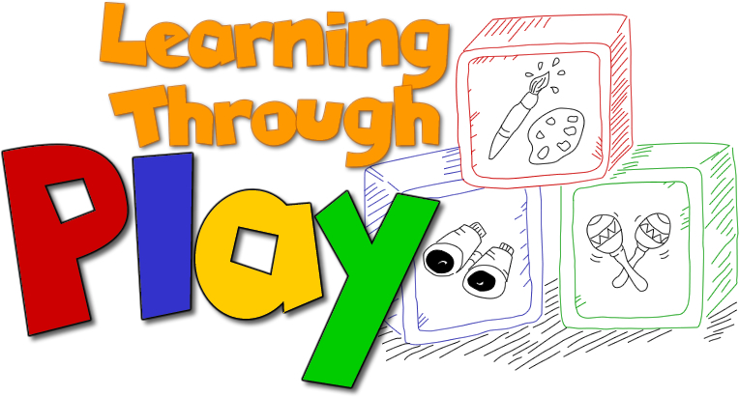(Bing search. No date)
Partnerships.

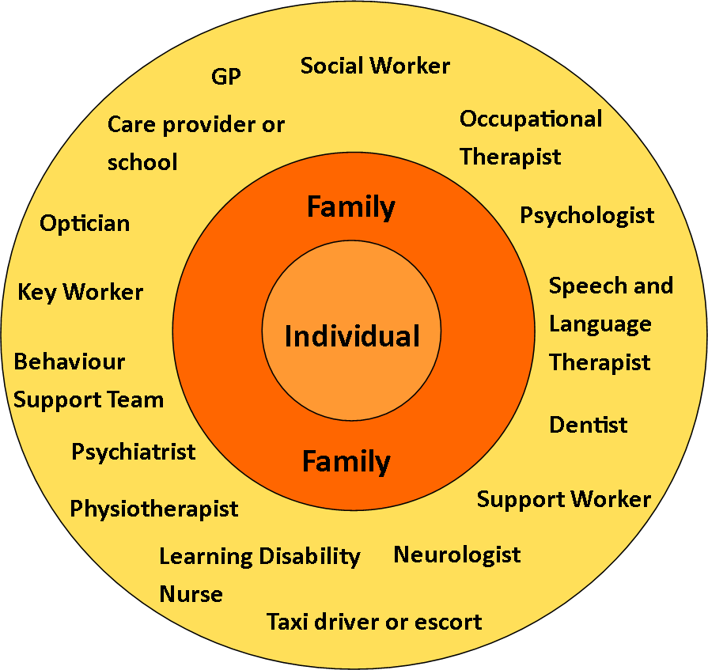
(Weebly No date).

Whilst working in partnership between yourself (the keyworker) and other practitioners involved around the child, you will all need to communicate closely to get a good understanding of the child’s home environment to get a clearer understanding of how to help the child in your setting to develop, support his/hers wellbeing and basically support them throughout the whole learning process. (Trodd and Goodlife p13).

It is believed that a parent is a child’s first educator and it is necessary to form a bond not only with the child but with the parent/guardian of the child and make regular contact between you both to get a better understanding of the home life of the child. No matter what the circumstances are time needs to be made for communication as the parent of the child will need a big level of trust in the practitioners who are left to take care of their child as this is not only a big step for the child it is also a huge step for any adult involved in the Childs life as both parents and child can get anxiety or even separation orders so to help ease the progress there needs to be a high level of communication between all. (Langston p60).

To ensure the correct plan is in place and the neccisary support is gave to each child it is vital and expected of you to pull together and work as a team by the sharing of relevant information is gave between the childs family and other agencies involved as all this helps while working in partnership is proven for a childs transition to be smoother for the child and also the surrounding people involved. (Flying start 2012 p8)

All proffessionals involved including the childs family will all need to work together with the sharing of information to ensure the needs of the child are met during transition to make it a smooth and steady transition and to keep the child settled and calm. (Elfer, p3 2012)

Interventions

Kalil and ziol state that children from more of a poorer family have a lower achievement level to others, so in order to prevent the children who are at risk of a poor outcome you will need to provide extra effective support for each individual to identify their needs. Families also benefit from early interventions of the child’s needs being met down to a early age and through to the rest of the child’s life whether it is extra support to prompt the parent or child on self-hygiene down to oral hygiene or even the wellbeing or physical needs of the child (p9).
Early intervention services can help change a child’s development path during pre-school and improve outcomes for the child, practitioners and family around the child whom needs that extra support in the areas they need. Before problems occur or get worst it is beneficial to tackle them straight away as soon as they are noticeable to provide a effective early invention which can be effective in helping the majority of children make progress and increase the readiness (p10).
(Reynolds, Rolnick and Temple 2014)

To achieve a development of high standards it is stated (Bowlby, 2007) that a positive experience supported by a good act of education and care that children in early years settings achieve better outcomes by the experiences they go through at a setting which includes a positive relationship between all professionals that work with the individual. (Wilson-Ali, Barratt-Pugh, Knaus, 2019).

Proposed outcomes

Within the wellbeing (wales)act 2014 the proposed outcomes of well being for young children are:
- To promote the behaviour, physical and mental health needs and the development of the individual child and to ensure their emotional well being
- Observe the child and its surroundings to ensure the child is protected from and form of neglect and abuse
(welsh government part 6 p7)

Involving the children as much as possible with any work, project and activities you come across will show significant improvement towards the childs development and will help the child blossom in to the little human he/she is growing in to whilst gaving the child a voice of their own. (welsh government 2019 p7)

Reference list.

https://blogs.edweek.org/edweek/early_years/2018/06/connecticut_provides_resources_to_help_make_transition_to_kindergarten_easier.html

https://www.twinkl.co.uk/blog/different-types-of-transitions-in-child-development

https://www.earlyyearsmatters.co.uk/eyfs/positive-relationships/transitions/

https://www.oxfordbibliographies.com/view/document/obo-9780199756810/obo-9780199756810-0204.xml

https://www2.oxfordshire.gov.uk/cms/sites/default/files/folders/documents/childreneducationandfamilies/informationforchildcareproviders/Toolkit/goodpractice/EYTransitionPack.pdf

https://ebookcentral.proquest.com/lib/trinity/reader.action?docID=369495

https://www.bing.com/images/search?view=detailV2&ccid=zKdeyw0d&id=9B843929273DACB6FD1622B1A49CB0A381A2C1D9&thid=OIP.zKdeyw0doKb4hmLmQvyVgwHaDt&mediaurl=https%3a%2f%2fpsycologyfacts.com%2fwp-content%2fuploads%2f2018%2f05%2fEcological-Systems-Theory-By-Bronfenbrenner-660x330.jpg&exph=330&expw=660&q=transition+in+early+years+bronfenbrenner&simid=608002584555816428&ck=11F29C7801DC964DCA61437626E97E87&selectedIndex=1&FORM=IRPRST&ajaxhist=0

https://gov.wales/sites/default/files/publications/2019-07/flying-start-transition-guidance-for-professionals.pdf

https://www.teachearlyyears.com/a-unique-child/view/supporting-transitions-in-the-early-years

https://app.croneri.co.uk/feature-articles/settling-supporting-transition-home-childcare

https://ebookcentral.proquest.com/lib/trinity/reader.action?docID=3569303

https://www.froebel.org.uk/

https://www.froebel.org.uk/about-friedrich-froebel

https://www.froebel.org.uk/uploads/documents/FT-Froebels-principles-and-practice-today.pdf

http://wordpress.megacentrerayleigh.co.uk/wp-content/uploads/2016/08/Learning-Through-Play.jpg

https://www.bing.com/images/search?view=detailV2&ccid=qEH1sOZD&id=169E38335FAAE2ED8D57284E1A474D7725EA5B7E&thid=OIP.qEH1sOZDAEblHUsOPMWkCAHaHA&mediaurl=http%3a%2f%2fwww.challengingbehaviour.org.uk%2flearning-disability-images%2fProfessionals-involved-3.png&exph=847&expw=895&q=partnerships+in+early+years+education&simid=608011737171101879&ck=4C778126DA379981CEDCB0B1EB53A335&selectedIndex=10&FORM=IRPRST&ajaxhist=0

https://ebookcentral.proquest.com/lib/trinity/reader.action?docID=820180&query=theorist+on+partnership+in+early+years

https://ebookcentral.proquest.com/lib/trinity/reader.action?docID=287795&query=theory+of+partnership+in+early+years

https://r1.vlereader.com/Reader?ean=9781316080054

https://gov.wales/sites/default/files/publications/2019-06/review-and-monitoring-of-a-child-or-young-persons-care-and-support-plan.pdf

https://gov.wales/sites/default/files/publications/2019-11/improving-outcomes-for-children-annual-report-2019_0.pdf

https://gov.wales/sites/default/files/publications/2019-07/wales-a-play-friendly-country.pdf

https://gov.wales/sites/default/files/publications/2019-07/flying-start-strategy-guidance-for-local-authorities.pdf

https://moodle.uwtsd.ac.uk/pluginfile.php/86467/mod_resource/content/1/Transitions%20handbook.pdf

https://www.colden-earlyyears-nursery.org/parent-guide-to-the-eyfs.html

https://moodle.uwtsd.ac.uk/pluginfile.php/439071/mod_resource/content/1/1836939119855214.pdf

https://moodle.uwtsd.ac.uk/pluginfile.php/192908/mod_resource/content/0/How%20educators%20define%20their%20role%20building%20professional%20relationships%20with%20children%20and%20parents%20during%20transition%20to%20childcare%20a%20case%20study.pdf

