EFECTFECTIVE TEAMWORK AND COMMUNICATION (SKILLS IN THE WORKPLACE)

JENNIFER AMANING
1817753
ANITA NAN
EFFECTIVE TEAMWORK AND COMMUNICTION (SKILLS FOR THE WORKPLACE)
BMSW4002

Contents
Introduction 2
WHAT IS COMMUNICATION? 2
MODELS OF COMMUNICATION 3
TYPES OF COMMUNICATION 3
EFFECTIVE COMMUNICATION 5
IMPORTANCE OF EFFECTIVE COMMUNCATION 6
Communication in a business organisation? 6
BARRIERS OF EFFECTIVE COMMUNCATION 7
CONCLUSION 8
References 8
Attachment 8

Introduction
The aim of this assignment is to go over a wide range of topics in how to communicate in the workplace and the different types of communications like verbal, non-verbal and written communication. I will be discussing about effective communication in a business organisation, different models of communications like the Shannon and weaver, Schram, and the Berol’s. In order or communication to flow be sent and received effectively all staff members of the company must have strong teamwork when it comes to making decisions as well as being able to problem solve in an effective manner. It is vital especially when working with a negotiation that all the aims and objectives of that meeting are met. The ways in which this is done is crucial to the working relationship that will be developed between team members and management, this can also aid in ethics. (businessqueensland, 2019)

WHAT IS COMMUNICATION?

The definition of Communication is the process of sharing information between individuals. There are 5 different ways of communication in an effective manner which are verbal, nonverbal, written, formal/informal and visual. Communication is very important especially when there is a cultural difference between the sender and receiver. Different languages can affect the way information is received between individuals.

MODELS OF COMMUNICATION
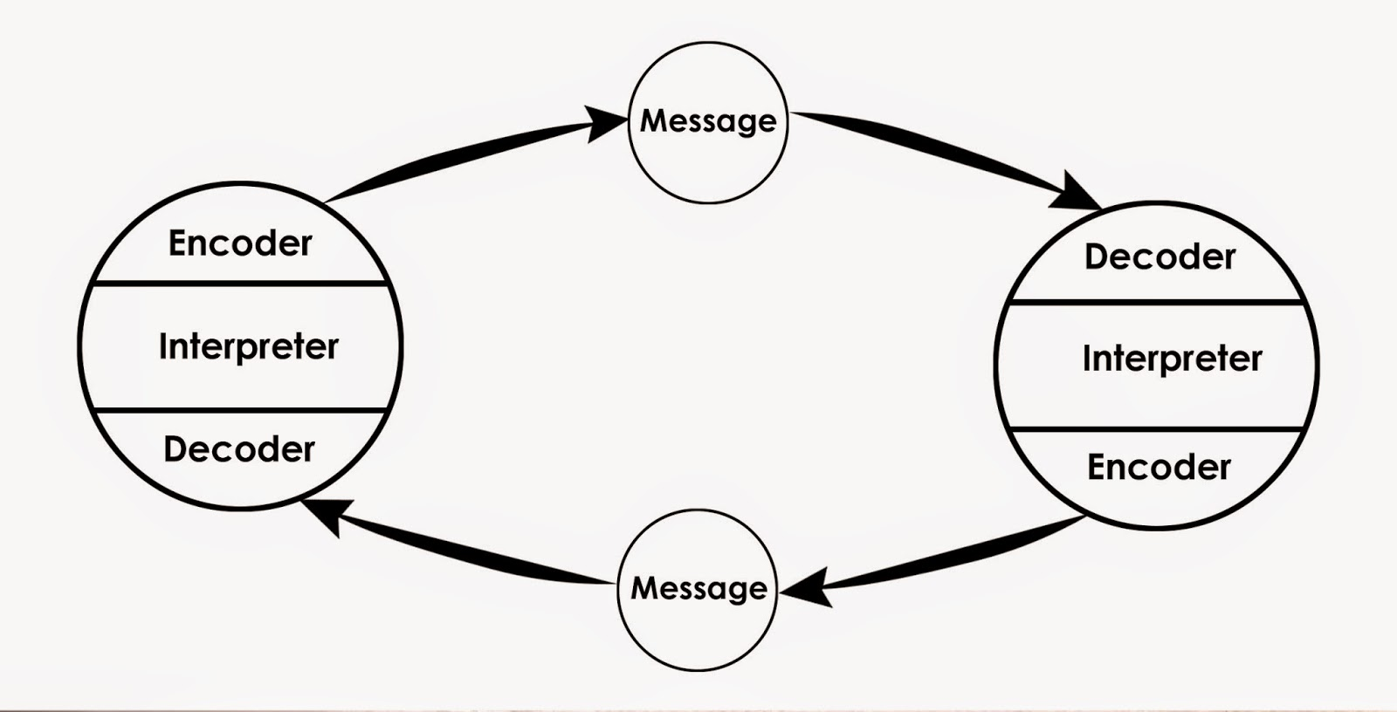
Shannon weaver
- Models of communication are conceived models that is used to interpret the communication process. The Shannon-Weaver model was one of the first models that was created to help the function of radio and telephone technology. The character of this model is made out of four elements: sender, message, channel, and receiver. The sender is the person that encodes, the channel is the telephone that is used to send the message itself, and the receiver decodes the message that is sender.

Berol’s
- The Berlo's model of communication process applies through person-to-person communication, which are communications through, encoder, message, channel, decoder, and the receiver. These methods of communication have key influence of communication through two individuals. These are made up on how well one communicates in the level of awareness, cultural, attitudes and social interactions nivedita-sharma.blogspot.com/2014/12/models-of-communication.html

TYPES OF COMMUNICATION

Verbal Communication
- Verbal communication is a type of communication that is oral within transmitting a message through spoken words. The sender gives their feelings in word expressions such as ideas and opinions these are express in the form of discussions, presentations and conversation. It is the most used way to send and receive information. Verbal communication is the most efficient way written and spoken to send clear messages that is received clearly.
- When speaking, as I learnt in a recent presentation, I was involved in its that speaking voices must be projected and bold, this way everyone in the room can hear what is being said and the information being presented is understood. On the flip side of speaking we must listen being that the biggest part of communication is speaking and listening, and this helps you grow in confidence and experience.

Non-verbal
- Nonverbal communication is expressed through body language, motion and gestures and facial expressions in order to aid understanding thoughts and feelings of the individual you’re speaking to. A lot can be shown through this method of communication closed and open body language. Closed body language shows anxiety, anger or nerves and open forms of body language displays positivity and ease of mind to openly give information. Emotions also play a vital part in communication; anxiety could make you overly aware of what you need to say as well as your surroundings. For this reason, it is necessary to try harder or make a conscious effort to project positivity in your body language and if you find yourself struggling having an extra person beside you to present or asking the crowd questions. You can also use mirroring positive body language with whomever you are speaking with.

Written Communication
- Written communication is a type of communication that involves written words such as emails, letters or sending a text messages with information to person to person. this leaves a paper trail that can be referred to at any given time. Communication in writing is commonly used worldwide, this is used a lot in personal life and in many businesses to communicate to their employees. Written communication is used to verbalise thoughts and ideas through words that and individual can read. Written communication can be sending messages of instruction from different in different methods of writing witch can help in development of a business.

EFFECTIVE COMMUNICATION

Effective communication is many and are clear with many benefits which can help with personal and professional lives. Effective communication in our personal lives can course a lot of misunderstanding and conflict because it consists of emotional language which can course relationship breakdowns if not communicated properly. Effective communication in our professional lives can also be impacted if not received clearly can course a lot of problems. In my workplace effective communications is very important because clear communication can produce the correct results. Verbal communication is used a lot, so it needs to be delivered clearly so it’s received clearly. Effective Communication in business helps achieve business goals and general relaying of information such as sending and receiving information. This can happen within a company or along management levels or staff hierarchy levels. Effective Communication is very important because it helps individuals in achieving productivity also maintains a strong relationship between individuals whether its personal or work related. This also helps build trust and respect amongst individuals, it helps individuals to share their input on certain topics. When communication is not clear between individuals it can cause a lot of confusion and conflicts amongst each other whether it’s through verbal communication or non-verbal communication.

IMPORTANCE OF EFFECTIVE COMMUNCATION

It is important to have good communication because it is a necessary means to perform effectively and sustain sturdy work relationships at different stages of a company.
Effective communication is the most important life skills that humans learn. Communication is transferring information to person to person to get a greater understanding therefore it is done in many ways to exchange information. Strong communication skills help in every aspect of our personal and professional life’s. Good communication skills are important because it helps individuals understand information correctly whereas can communication can course misunderstanding between peers. Communication such as body language, eye contact, gestures and tone of voice is important because this keeps the audience connected and interested in the information that is being given.
ttps://corporatefinanceinstitute.com/?msclkid=8e72f7fd27c51a95377caa9bd8c95dfe
.

Communication in a business organisation?

Communication helps customers develop a good repour with the company between staff. In enables the employees to understand what is required and expected from them so that deadlines are clear and met. It also helps management listen and reply to any suggestions or complaints insufficient conns can lead to demotivation in staff too much can lead to overload and therefore cannot meet required deadline. Communication is important as failure leads to unclear and misunderstanding resulting to inference. It is important to have a clear and accurate information sent and received to allow opportunity for feedback.
Communication helps to better instruct staff and reduces confusion; it allows employers to instruct employees on given tasks and perform and expectations, it is vital on all levels to get work done quickly, professionally and effectively.

BARRIERS OF EFFECTIVE COMMUNCATION

Barriers of communication comes in different ways such as misunderstandings in the format environmental of cultural differences. People of different cultural backgrounds often have different values and beliefs. The difference in cultures leads to individuals feeling uncertain which leads to misunderstanding of communication with others. At times values and beliefs can also be different from person to person because of their cultural difference. The use of jargon can also be a key factor that can course communication to be unclear of unfamiliar to people of different background. Lack of attention can be a major barrier in communication sometimes people can be distracted by thinking to themselves or noise which can course individuals lose focus. The barriers of commutations between different cultures can affect how they send and receive
information may not be received the same way as it was sent. It is then important for the sender to get feedback from the receiver to make sure that they understand the message.
Jenifer, R.D. and Raman, G.P., 2015. Cross-cultural communication barriers in the workplace. International Journal of Management, 6(1), pp.348-351.
.

CONCLUSION

In conclusion communication is an important factor in individuals because it is used day-to-day and in different ways such as verbal, nonverbal or written. This is a vital part of our lives as communication is used to interact our emotions to one another. It is important that when commutating to one another that it is clear for the receiver to understand exactly what you are saying. Communication is the most impactful way to build strong relationships in one’s personal and professional lives. Sharing ideas and information with one another comes in wide variety of communication. There are stages when all the different types of communication are used together to make a bigger impact. Communication is vivacious in guaranteeing that the messages are received correctly. It is important to have good listening skills and it helps in understanding the purpose of the message sent using different methods of communication so that one can get a positive feedback.
When communication is received negatively it can prevent the outcome that the sender is trying to obtain. It is important to use the right choice of words to express what you want to say and how you would like it to be received, if your delivery is not clear it will alter the meaning of the information. Negative communication frequently brings problems instead of solutions and it can course complications in understanding. In reference to our class exercise (Pedro and Maria) it clear that there was a misunderstanding in their communication which could have been coursed by noise or Pedro not having good listening skills, so he received that information that Marie sent him. When people do not have good listening skills for one another they are not able to receive information correctly.
Positive communication is vital because it enable the understanding of exactly what is being transmitted between individuals. Positive communication can turn something negative into a positive when the delivery is clear it can get great resorts.
Overall the type of communication I feel is impactful in my workplace is verbal communication also body language communication. I use this in giving and receiving feedback from individuals, I find that It is a clear and easy way to express to one another. Having a clear way of communication helps delivery the correct and positive outcome. The difference between my industry and communications in an office environment is that in an office environment use other types of communications, I use verbal and body language the communication but the method best suited in an office would be emails, telephone which are written communication.

References
businessqueensland. (2019, 08 28). Retrieved from queensland government : www.business.qld.gov.au
shannon, c. (n.d.). a mathematical theroy of coomunication.
Jenifer, R.D. and Raman, G.P., 2015. Cross-cultural communication barriers in the workplace. International Journal of Management, 6(1), pp.348-351.
nivedita-sharma.blogspot.com/2014/12/models-of-communication.html
ttps://corporatefinanceinstitute.com/?msclkid=8e72f7fd27c51a95377caa9bd8c95dfe
https://www.inc.com/
Madera, J.M., Dawson, M. and Neal, J.A., 2014. Managing language barriers in the workplace: The roles of job demands and resources on turnover intentions. International Journal of Hospitality Management, 42, pp.117-125. Rathel, J.M., Drasgow, E. and Christle, C.C., 2008. Effects of supervisor performance feedback on increasing preservice teachers' positive communication behaviors with students with emotional and behavioral disorders. Journal of Emotional and Behavioral Disorders, 16(2), pp.67-77. Jablin, F.M. and Putnam, L.L., 2004. The new handbook of organizational communication: Advances in theory, research, and methods. Sage.

Attachment

file:///C:/Users/RFI-Spare2/Documents/Scanned%20Documents[957]%20coomunication%202.pdf

