The University of Wales Trinity Saint David
School of Applied Computing
Wales Institute of Science and Art

Object Orientated Programming (C++)

Advanced Software Development (ACCB5011)
Robert Iwan Jamieson (2004728)
Date of submission: 10.12.2021
Contents
List of figures 3
Chapter 1 Introduction 4
Chapter 2 Testing the Noughts and Crosses game 5
Chapter 3 Object Orientated Programming 17
3.1 The main aspects of OOP 17
3.2 The importance of OOP 17
3.2.1 Classes, attributes and methods 18
3.2.2 Objects 19
3.2.3 Constructors and destructors 20
3.2.4 Inheritance (parent and child classes) 20
3.2.5 Polymorphism 21
Chapter 4 Conclusion 23
Chapter 5 References 24
Chapter 6 Appendix – All code from the Noughts and Crosses game 25

List of figures
Figure 1: Player class 18
Figure 2: _score can be incremented by 10 via a method. 18
Figure 3: _score can be reset via a method. 19
Figure 4: IncrementPlayerScore() method in use 19
Figure 5: ResetScore() method in use 19
Figure 6: player objects are created in the main source file 20
Figure 7: Constructor and Destructor used in the Board class 20
Figure 8: Inheritance from "MainMenu" class 21
Figure 9: WelcomeMenu child class of MainMenu 21
Figure 10: WelcomeMenu child class inheriting and making use of parent class' methods 21
Figure 11: The ShowMainMenu method makes use of polymorphism 22
Figure 12: EndMenu child class making use of polymorphism 22
Figure 13: EndMenu code executed via polymorphism 22
Figure 14: DrawMenu code executed via polymorphism 23

Chapter 1 Introduction
This report will be discussing the importance of Object-Oriented Programming (OOP) [1]. Its main aspects shall be illustrated from the game Noughts and Crosses, created in C++. Before this however, the Noughts and Crosses game will be thoroughly tested to ensure there are no errors and that all scenarios within the program are working as intended. The report will finish by concluding the importance of OOP.
OOP is a different and more complex way of coding when compared to the procedural programming style that programmers may first use. It mainly makes use of classes, objects, inheritance and polymorphism [2]. Within classes, methods, constructors, destructors (special methods) and attributes [3] are used. OOP is primarily used because it is a lot more efficient than procedural programming style as code is often reused instead of repeated [1]. The main aspects of OOP are briefly discussed in Chapter 3.1 and the importance of them are highlighted in Chapter 3.2.
Note: The game is included in a separate file and its code is also available in the appendix. The video demo of the game and its code is available on YouTube via this link:
https://youtu.be/A9QiBUFax_A

Chapter 2 Testing the Noughts and Crosses game
Below are tests of the game Noughts and Crosses. This testing is necessary to ensure that the program runs correctly in all instances and scenarios. Any failed tests have been resolved and retested.
Test no | Test description | Input | Expected Output | Actual Output | Pass/Fail | Comments
1 | Testing to see if game runs and loads welcome menu | N/A | Welcome menu displays. Program asks for input. | Welcome menu displays. Program asks for input. | Pass | N/A
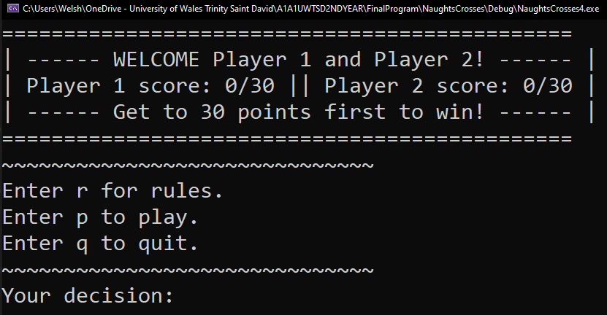



2 | Testing to see if rules appear | “r” | Rules display | Rules display | Pass | N/A
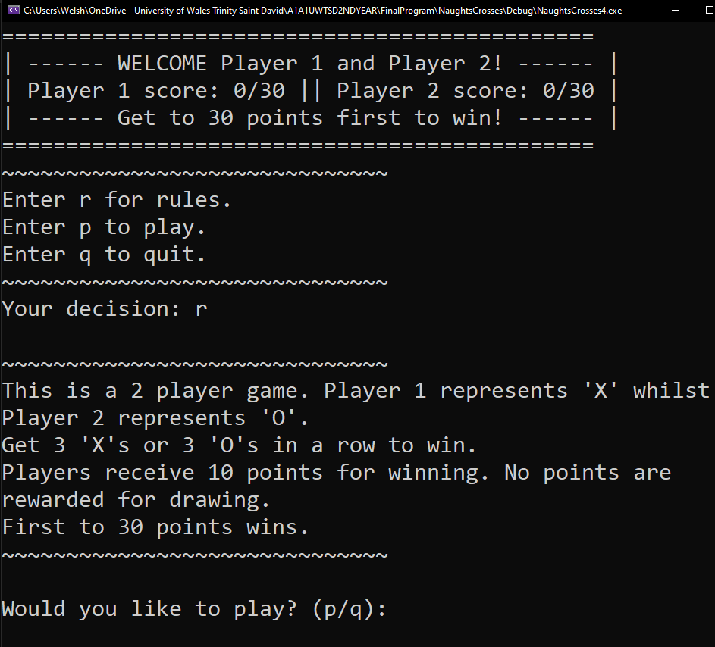

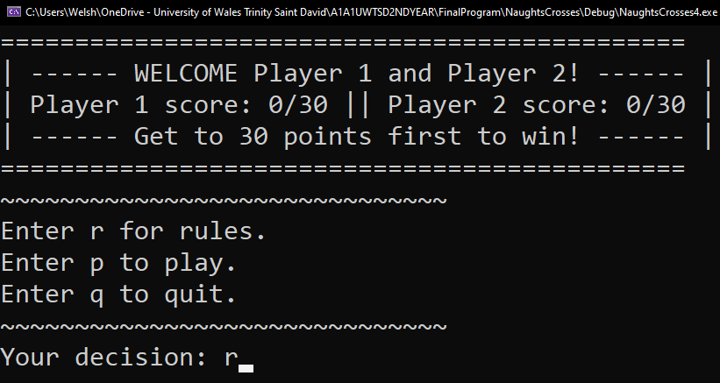

3 | Testing to see whether the game ends when player enters “q” in WelcomeMenu | “q” | Game ends | Game ends | Pass | N/A
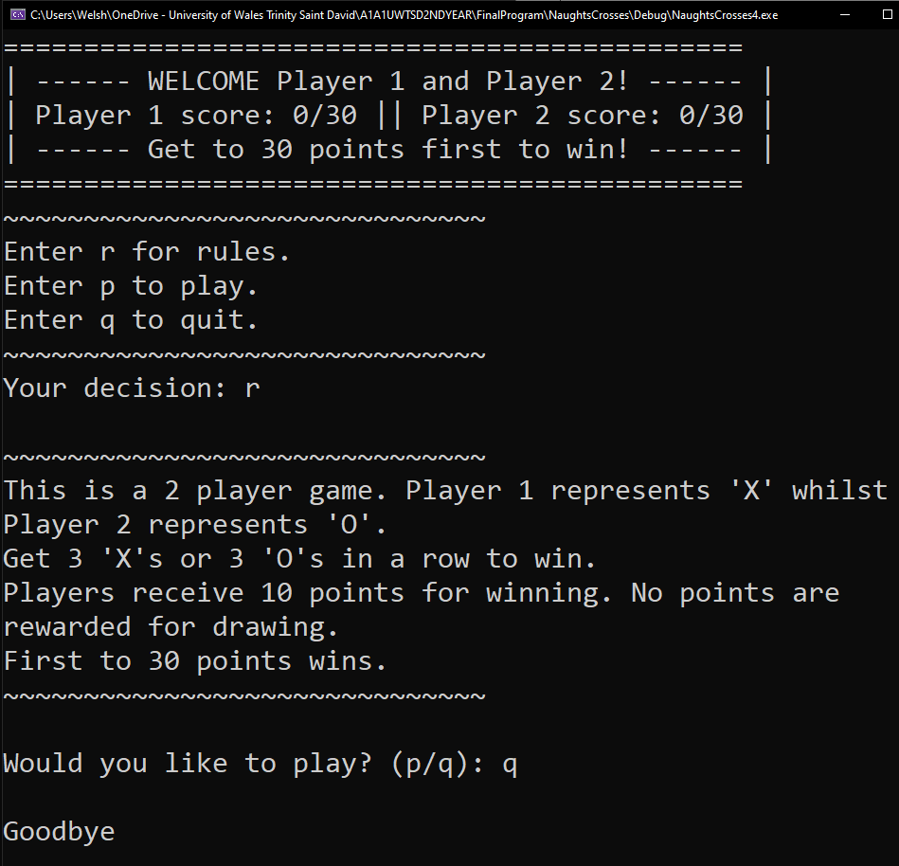
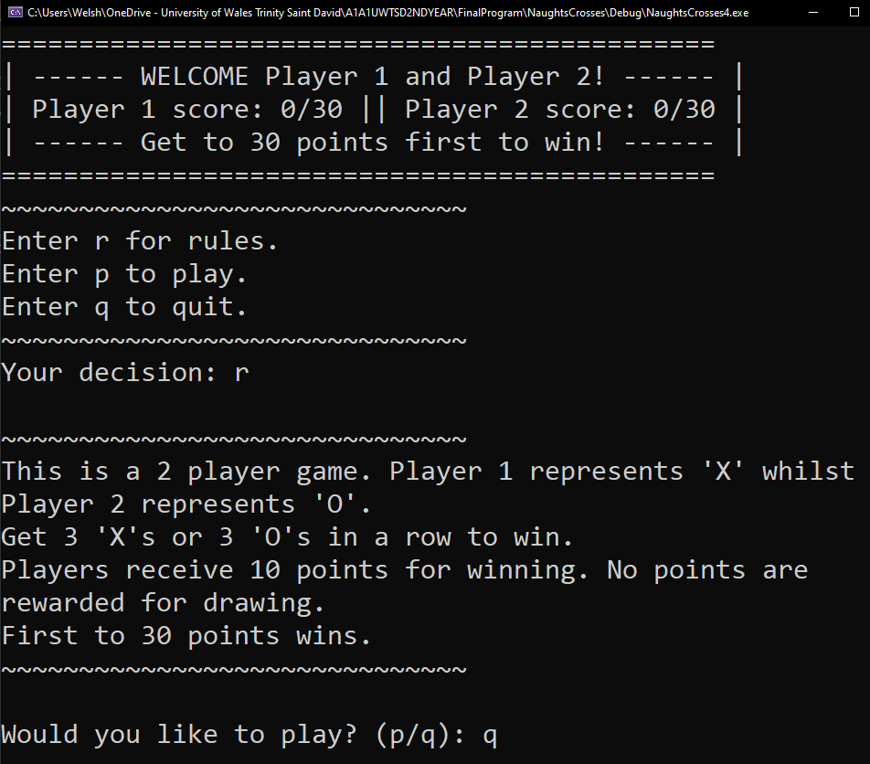

4 | Testing to see if game begins | “p” | Game begins | Game begins | Pass | N/A
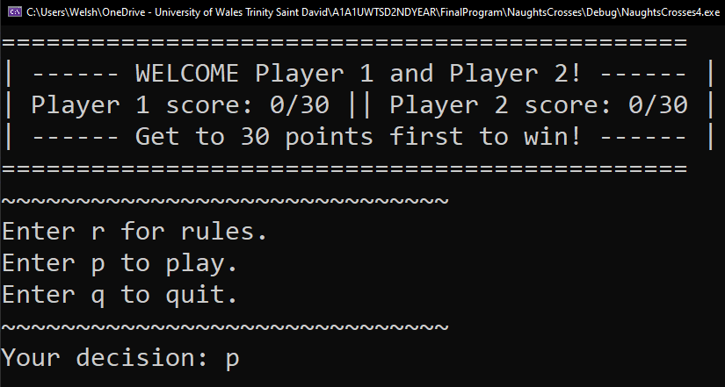
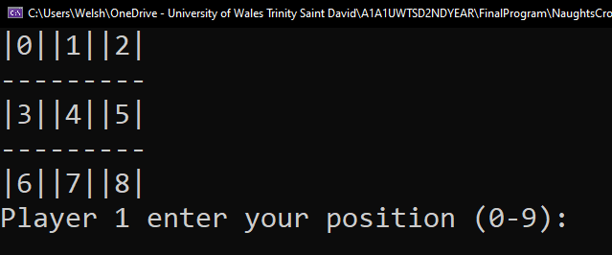

5 | Testing to see if program asks user for input again when invalid input is entered. | “nope” | Program asks for user input again. | Program asks for user input again. | Pass | N/A
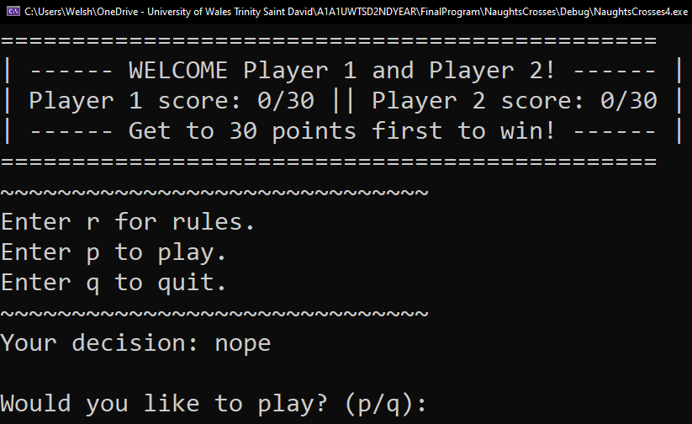
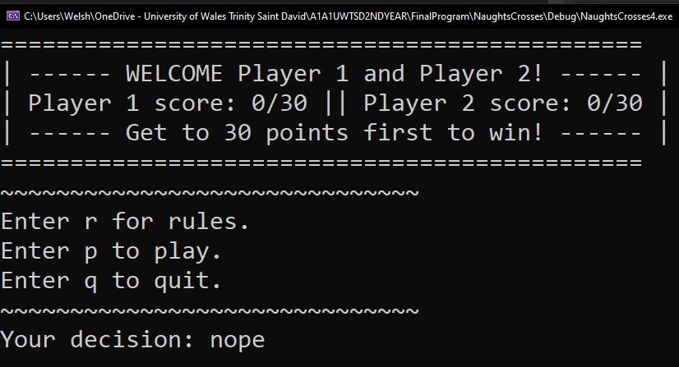

6 | Testing to see if program identifies out of range input | “9” | Program outputs “Invalid input” and asks user to enter position again. | Program outputs “Invalid input” and asks user to enter position again. | Pass | N/A
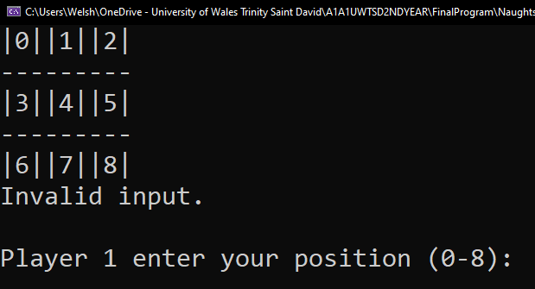
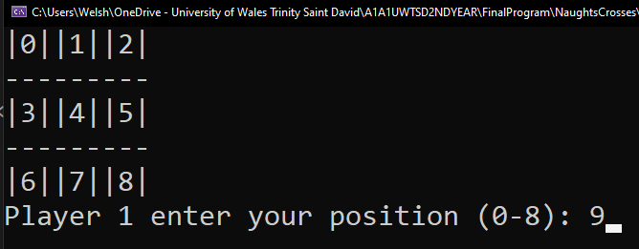

7 | Testing to see whether number 0 is accepted, whether the board will update with an “X” in the correct position and whether it will change to player 2. | “0” | Board updates correctly corresponding to the number entered and for the symbol representing the player. Game then switches to player 2. | Board updates correctly corresponding to the number entered and for the symbol representing the player. Game then switches to player 2. | Pass | N/A
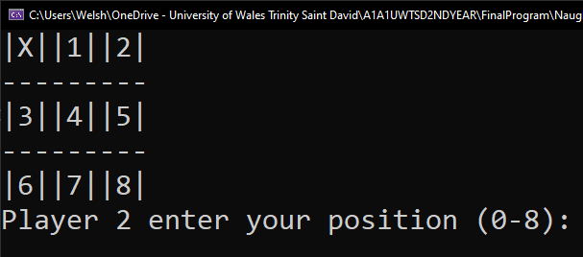
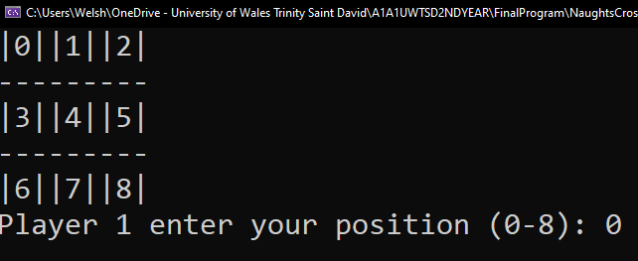

8 | Testing to see whether number 1 is accepted, whether the board will update with an “O” in the correct position and whether it will change to player 1. | “1” | Board updates correctly (corresponding to the number entered and for the symbol representing the player). Game then switches to player 1. | Board updates correctly (corresponding to the number entered and for the symbol representing the player). Game then switches to player 1. | Pass | N/A
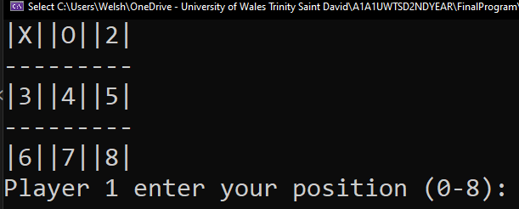
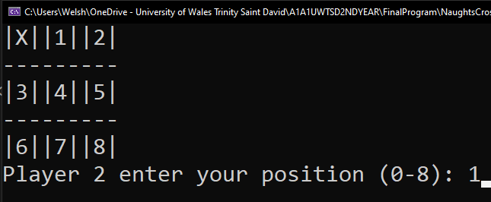

9 | Testing to see if Player 1 will win when the next number entered (6) means they SHOULD win by having 3 X’s in a row (vertically). The virtual method ShowMainMenu() will reveal the CongratsMenu menu. Scores are updated and printed. | “6” | Player 1 wins the round. CongratsMenu appears with correct scores shown. | Player 1 wins the round. CongratsMenu appears with correct scores shown. | Pass | N/A
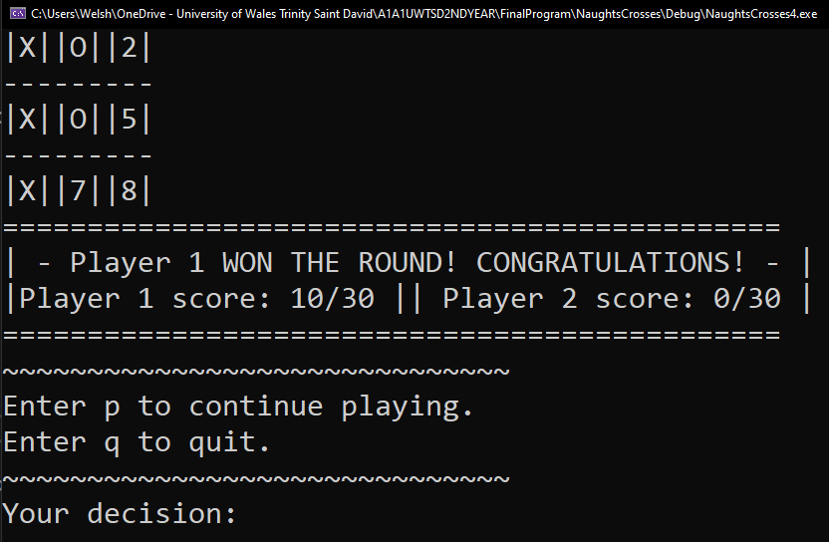
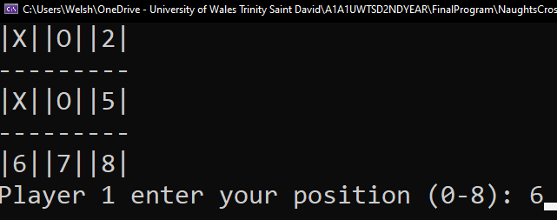

7 | Testing to see if player 2 wins this round once 5 is entered (they should win by having 3 O’s horizontally). | “5” | Player 2 wins the round. Congrats menu is revealed, and scores are updated. | Player 2 wins the round. Congrats menu is revealed, however player 2’s score is not updated to 10 like it should be. | FAIL | The test updated player 1’s score but not player 2’s score as it should have. See incorrect and corrected code below.
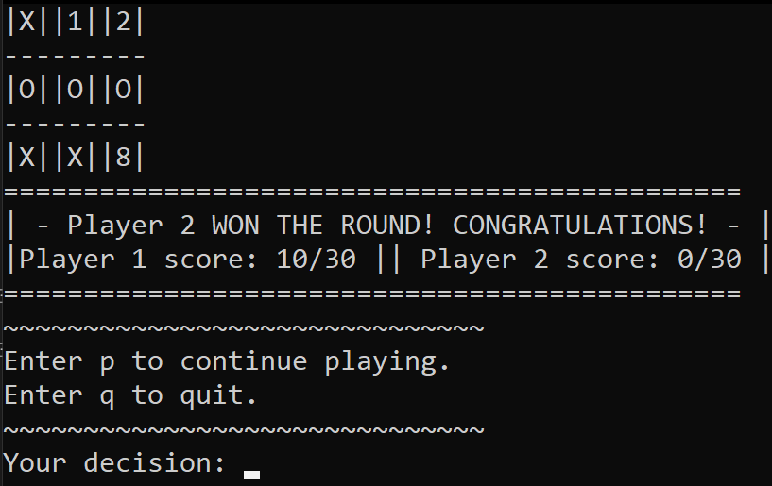
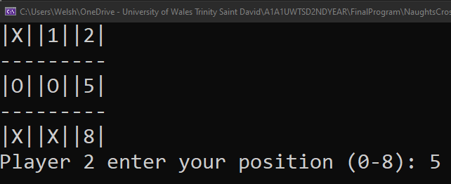

Incorrect code:

8 | Testing AGAIN to see if player 2 wins this round once 5 is entered (they should win by having 3 O’s horizontal to each other). | “5” | Player 2 wins the round. Congrats menu is revealed and scores are updated. | Player 2 wins the round. Congrats menu is revealed and scores are updated. | Pass | The code has now been corrected and the scores are updated as expected. “playernum” now represents whichever player is playing on that turn.
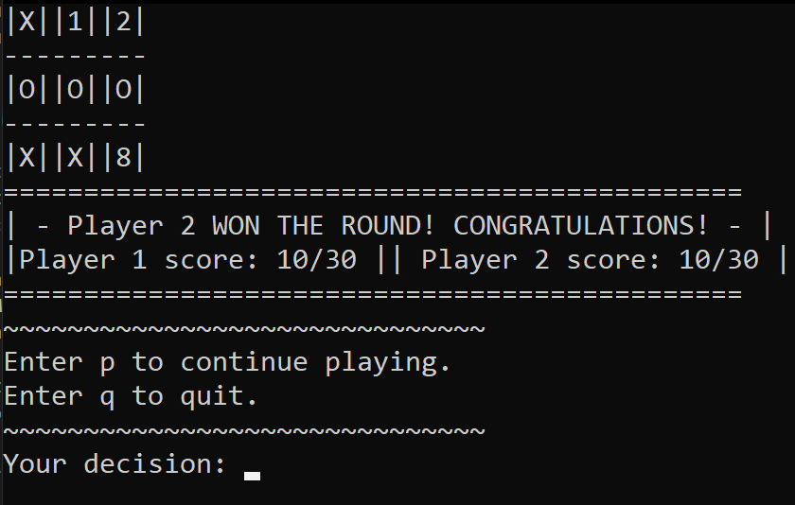
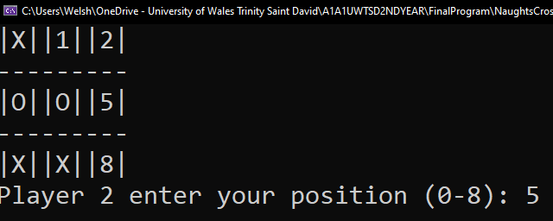

Corrected:

9 | Testing to see if player 1 wins this round once 8 is entered (they should win by having 3 X’s diagonally). | “8” | Player 1 wins the round. Congrats menu is revealed. Player 1 has score of 20. Player 2 has score or 10. | Player 1 wins the round. Congrats menu is revealed. Player 1 has score of 20. Player 2 has score or 10. | Pass | N/A
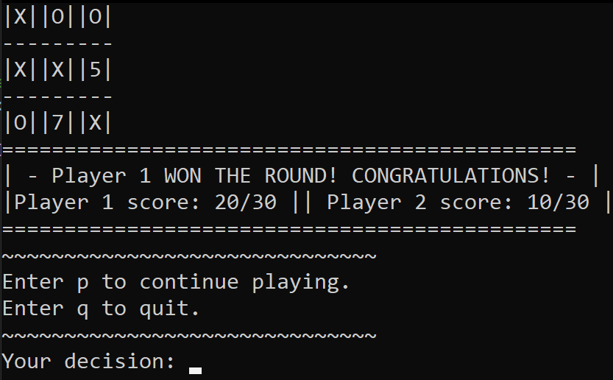
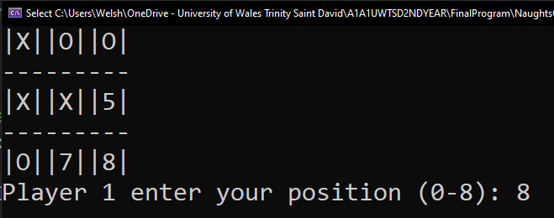

10 | Testing to see whether the game will recognize the draw once “8” is inputted. | “8” | Draw menu appears. Scores stay the same. | Draw menu appears. Scores stay the same. | Pass | N/A
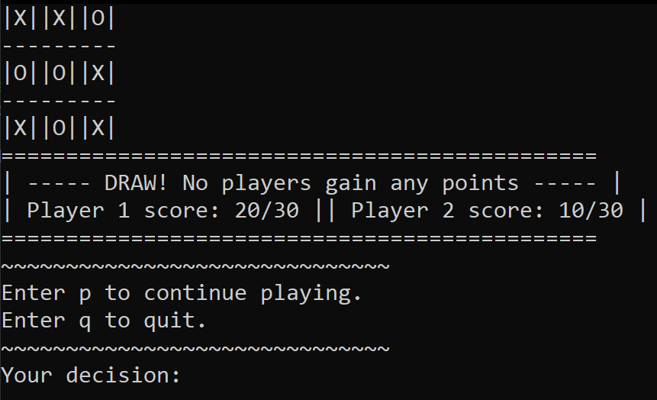
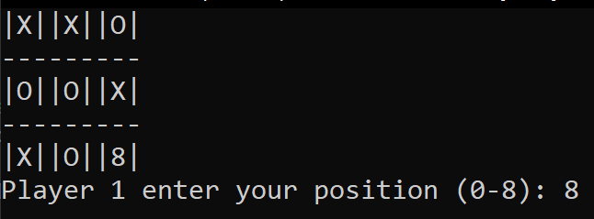

11 | Player 1 should win the entire game once “6” is entered as they already have 20 points. | “6” | Player 1 wins, EndMenu is revealed showing player scores and congratulating the player. | Player 1 wins, EndMenu is revealed showing player scores and congratulating the player. | Pass | N/A
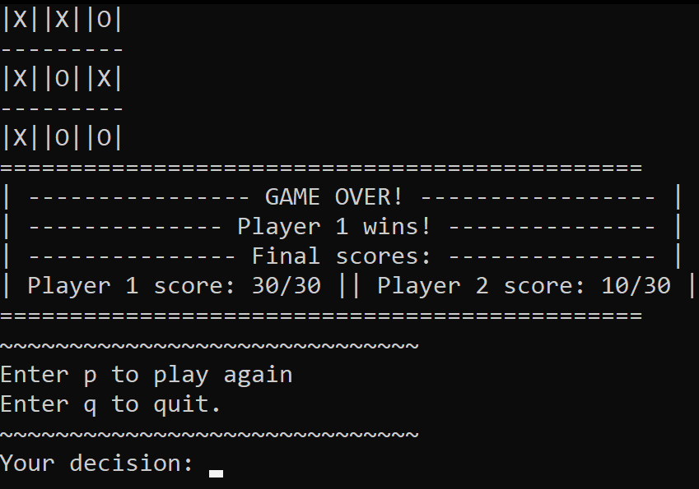
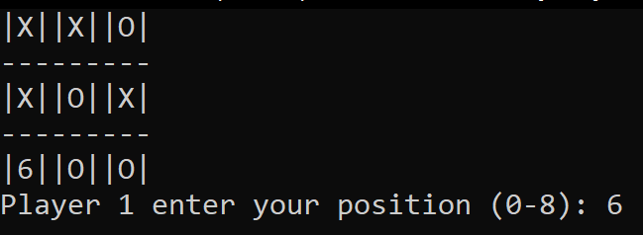

12 | Testing to see whether the previous game’s scores are reset when the next game’s scores are revealed. | Inputted appropriate values to win a round. | Scores are reset, therefore player 1’s score is 10 and player 2 score’s is 0 after round 1. | Scores are not reset. Player 1 score should be 10, whilst player 2’s score should be 0. However player 1’s score is 40, whilst player 2’s score is 10. | FAIL | After a player wins a game, ALL scores should be reset. However as seen below, they have not been.
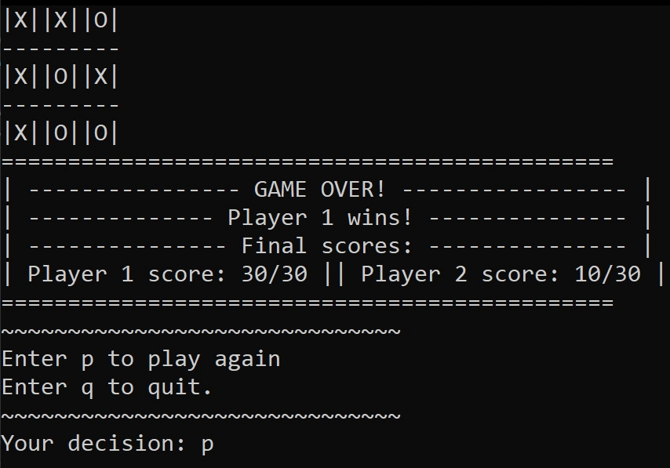

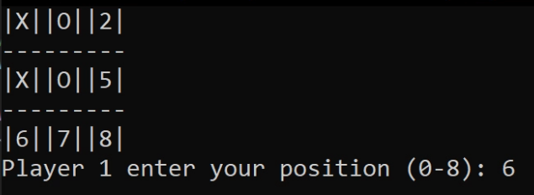

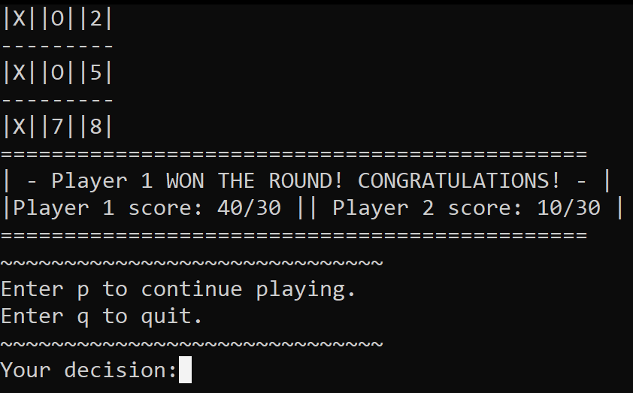

13 | Testing AGAIN to see whether the previous game’s scores are reset when the next game’s scores are revealed. | Inputted appropriate values to win a round. | Scores are reset, therefore player 1’s score is 10 and player 2 score’s is 0 after round 1. | Scores are reset, therefore player 1’s score is 10 and player 2 score’s is 0 after round 1. | Pass | N/A
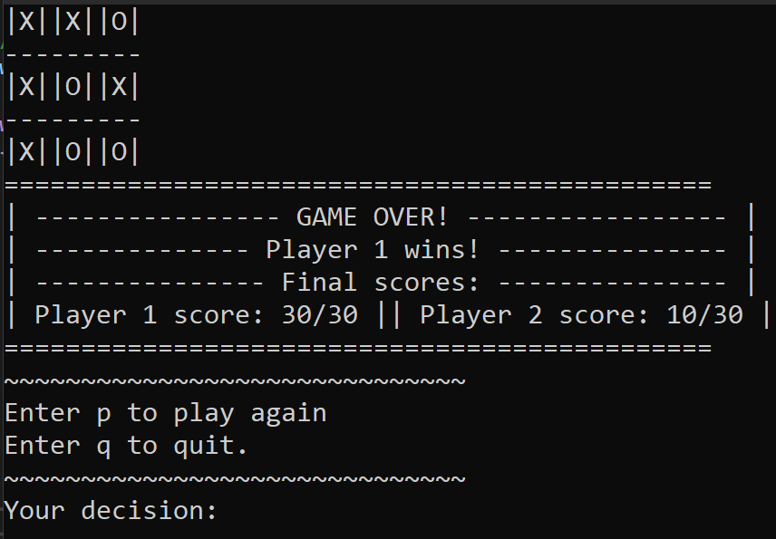

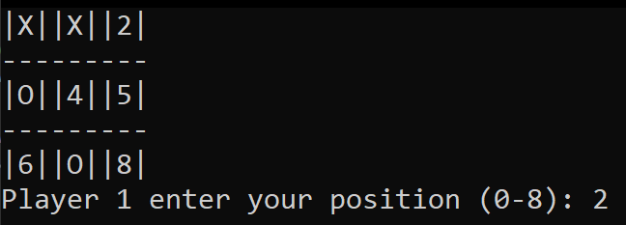

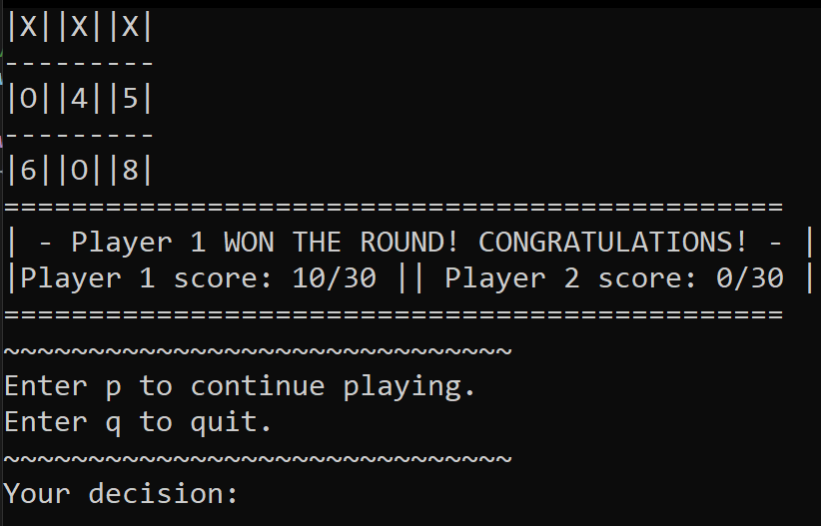

Added this code to ensure the scores are reset after a player wins the entire game:
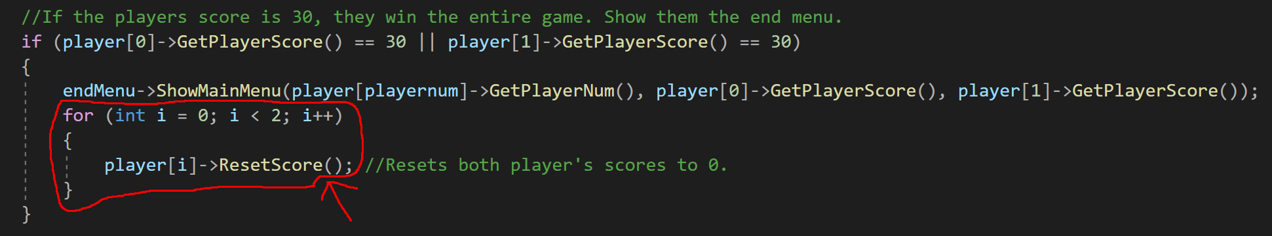

14 | Testing to see what happens when a player inputs a number that has already been inputted (in this case number 4). | “4” | The game instructs the player that their input is invalid and to choose a different position. | The game instructs the player that their input is invalid and to choose a different position. | Pass | N/A
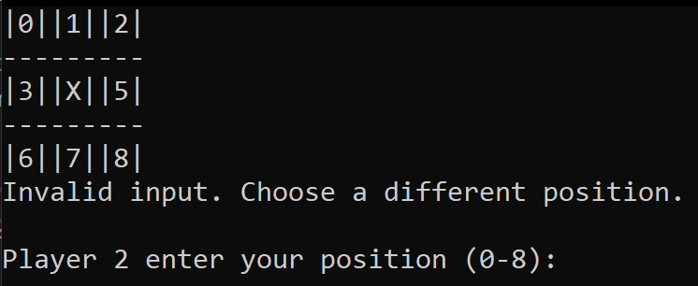
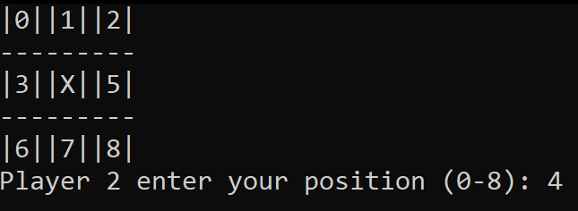

15 | Testing to see what happens when a user enters letters instead of a number between 0 and 8. | “Hello” | The game recognizes the invalid input and asks the user to input again. | The game recognizes the invalid input and asks the user to input again. | Pass | N/A
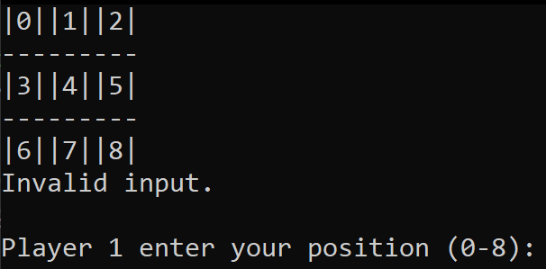
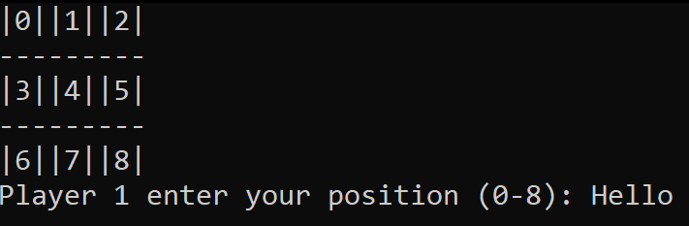

16 | Testing to see if Player 2 can win an entire game once 30 points are reached. | “7” | EndMenu should display that “Player 2 wins!” and display the final scores. | EndMenu should display that “Player 2 wins!” and display the final scores. | Pass | N/A
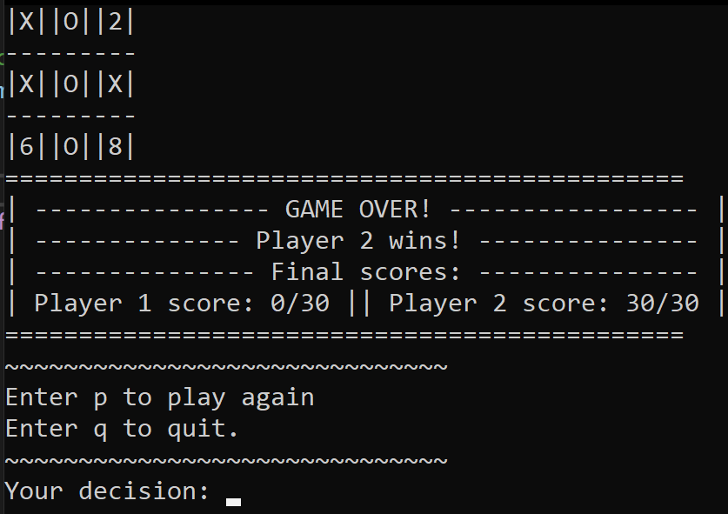
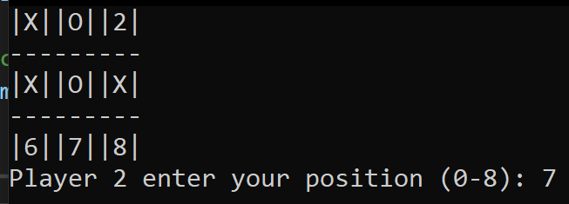

17 | Testing to see if Player 1 can win an entire game once 30 points are reached. | “6” | EndMenu should display that “Player 1 wins!” and display the final scores. | EndMenu should display that “Player 1 wins!” and display the final scores. | Pass | N/A
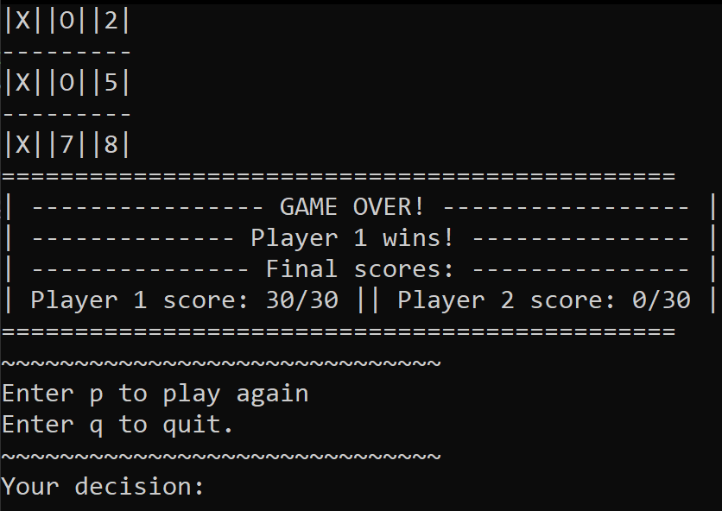
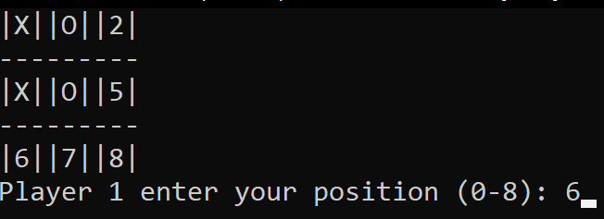

18 | Testing to see what happens when the player decides to quit when in the EndMenu screen. | “q” | The game outputs “Goodbye” and game ends. | The game outputs “Goodbye” and game ends. | Pass | N/A
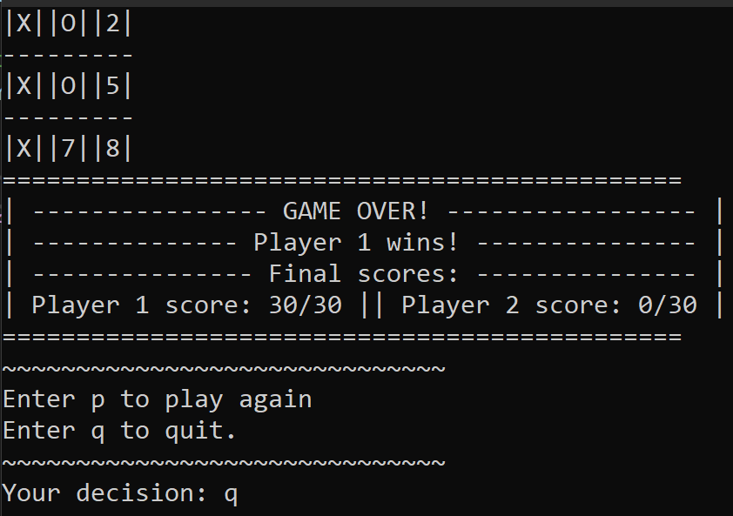
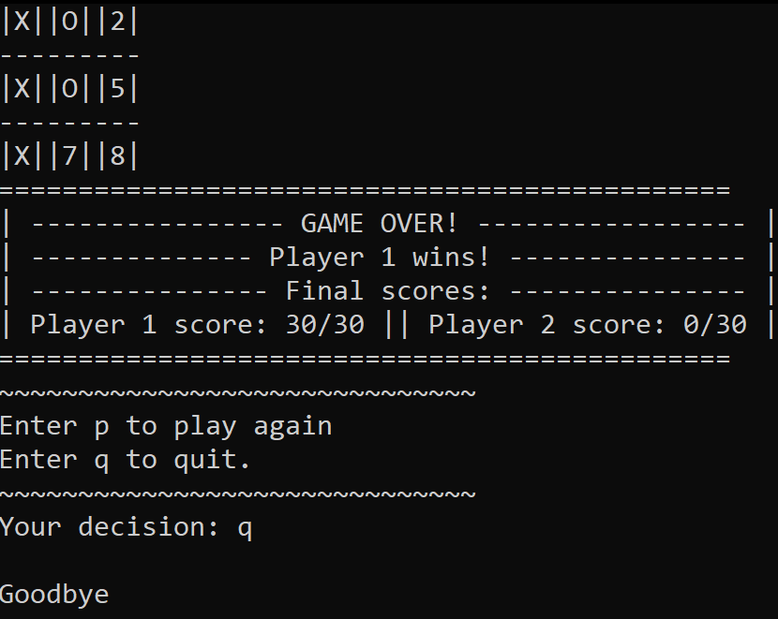

19 | Testing to see what happens when incorrect input is inputted in the EndMenu screen. | “TEST!!!!” | The game asks the player again if they want to quit or keep playing. | The game asks the player again if they want to quit or keep playing. | Pass | N/A
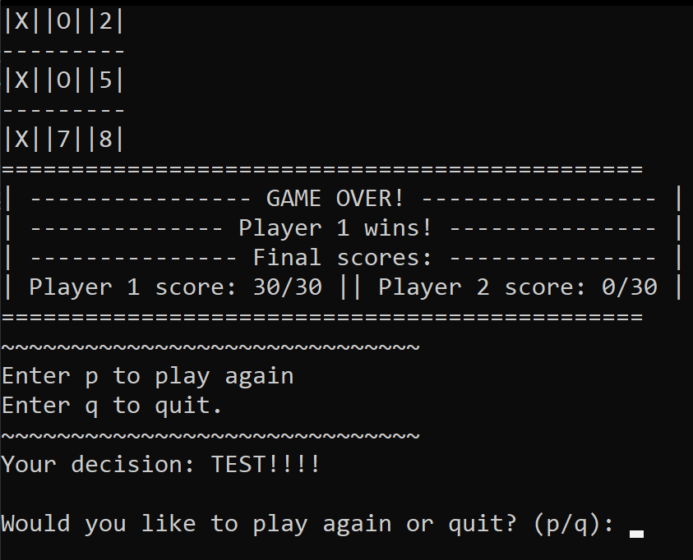
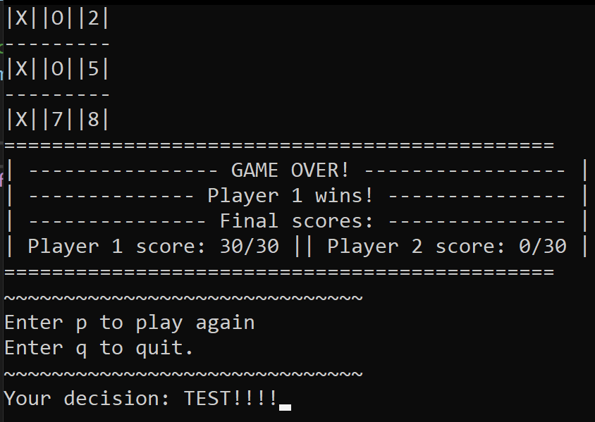

20 | Testing to see if the game will reset once a player types “p” to play again in the EndMenu screen. | “p” | Game resets and is playable again. | Game resets and is playable again. | Pass | N/A
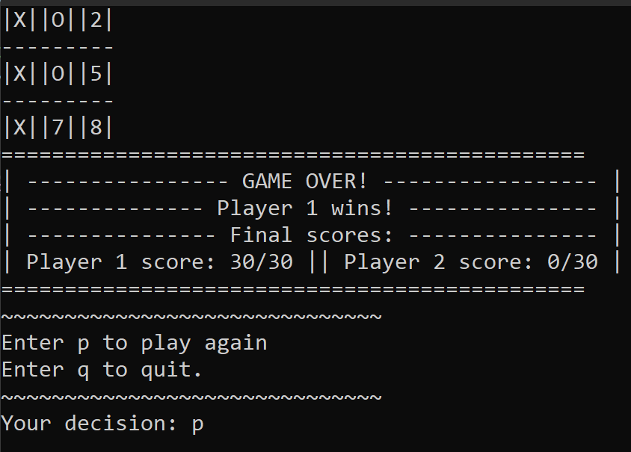

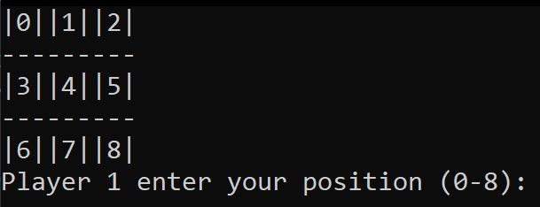

21 | Testing to see what happens when the player tries to quit once in the DrawMenu screen. | “q” | The game outputs “Goodbye” and game ends. | The game outputs “Goodbye” and game ends. | Pass | N/A
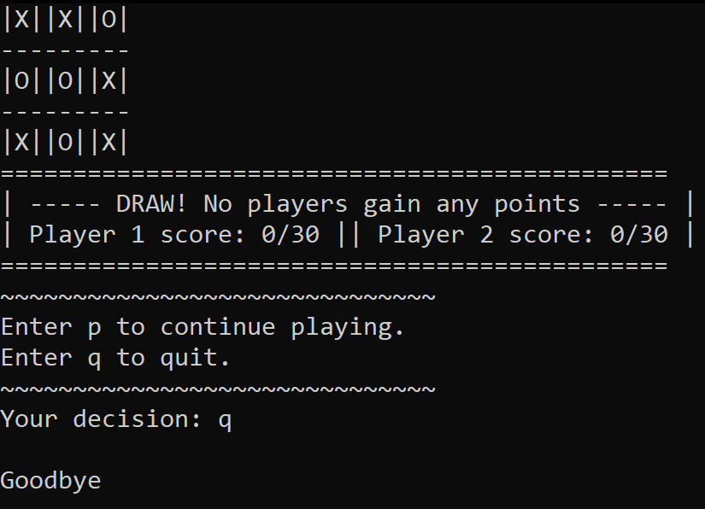
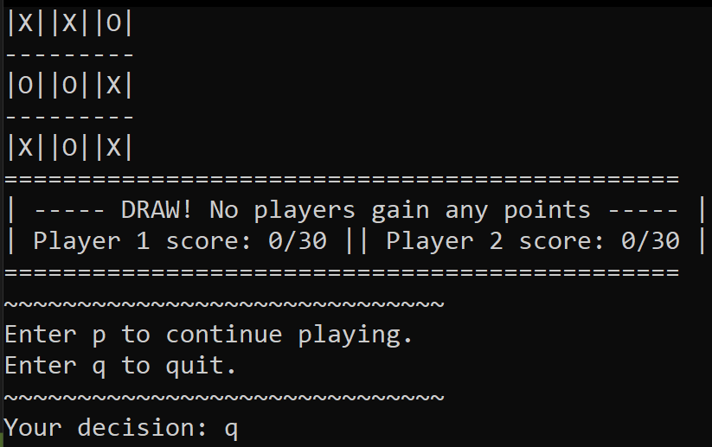

22 | Testing to see what happens when incorrect input is inputted in the DrawMenu screen. | “1d9a” | The game asks the player again if they want to quit or keep playing. | The game asks the player again if they want to quit or keep playing. | Pass | N/A
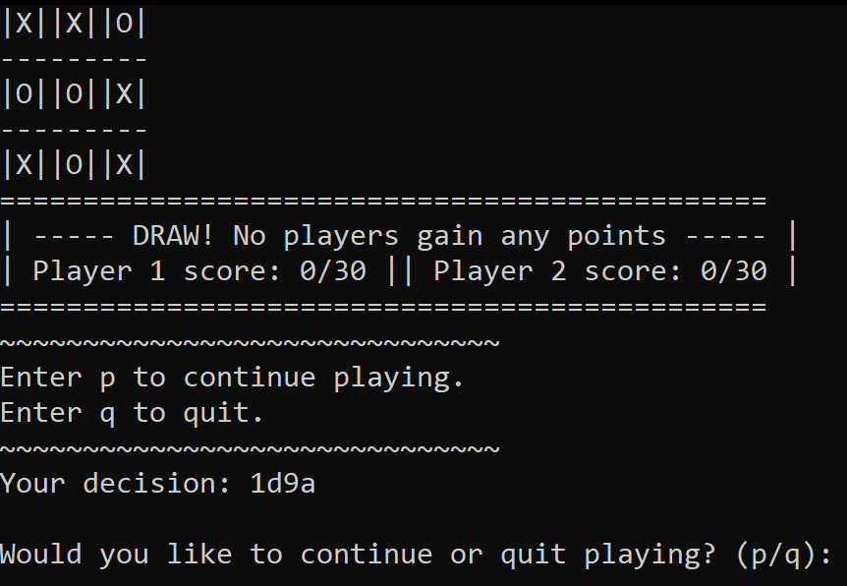
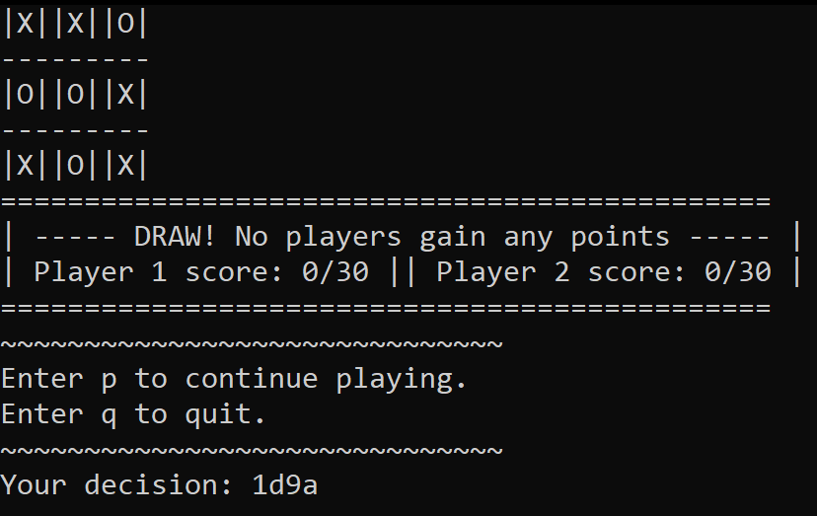

23 | Testing to see if the game will carry on to the next round when the player enters “p”. | “p” | Board is reset and next round begins. | Board is reset and next round begins. | Pass | N/A
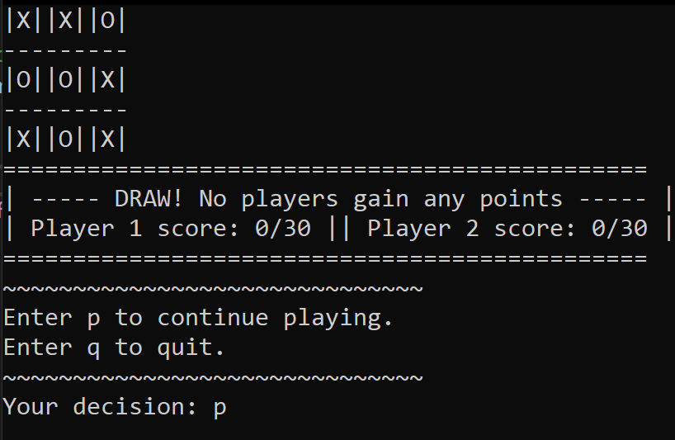

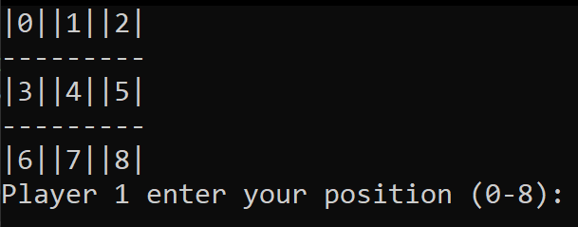

Chapter 3 Object Orientated Programming
This chapter will briefly cover the main aspects of OOP and shall then highlight and illustrate the importance of them.

The main aspects of OOP
The main aspects of OOP include:
- Classes – Classes are a structure for attributes and methods and enable every other object-oriented aspect such as objects, inheritance and polymorphism [2].
- Objects – Objects are “an instance of a class” [1]. Any number of objects can be created and make use of the same attributes and methods within a class, often from the use of pointers.
- Inheritance – Inheritance is also known as parent and child classes. Inheritance is used to reduce the duplication of data. Essentially, instead of different classes repeating the same attributes and methods such as “GetName()” or “SetName(…)”, the child classes instead inherit [3] those methods from the parent class.
- Polymorphism – Polymorphism is yet again another way to reduce repeating code. Polymorphism is used alongside inheritance. It allows the same method to execute different code relating to child classes depending on the circumstance [4].
- Constructors – Constructors are a method which are named the same as the class name. They are used whenever a new object of the class is created [5].
- Destructors – Destructors similarly to constructors are named the same as the class name, except they have a tilde before them. Destructors are used in programming languages such as C++ and automatically identify when objects and classes are no longer in use. They then deallocate [5] the memory relating to the object to free up system memory.
- Attributes – Attributes are similar to variables although reside within a class and are often private to only that class [3].
- Methods – Methods are essentially functions; however they are created within a class [3] and allow the private attributes within that class to be interacted with outside of the class in a limited way. They are often seen as getters or setters – methods can ‘get’ and read the attribute’s value and they can ‘set’ and modify the attribute’s value [3].

3.2 The importance of OOP
In this section the importance of Object-Oriented Programming (OOP) will be discussed and illustrations will be provided to demonstrate how they have been applied in the Noughts and Crosses game.
Classes, objects, attributes, polymorphism, methods and inheritance all contribute to the goals of OOP:
- They help reduce redundant code and promote using the same code to ensure the program is efficient as possible [1].
- They better structure and organization code, thus making it easier to understand [1].
- They help ensure a smooth development process [6] – you can add things to a well-made object-oriented program such as a new job role in a child class and quickly inherit already existing methods from the parent class, such as ‘GetName()’ or ‘SetName()’.

3.2.1 Classes, attributes and methods
Classes are important because they give developers a space to create private attributes, of which can be used in other areas of the program via methods, in limited ways as specified by the programmer [7]. This ensures they are only modifiable in the way the original programmer intended them to be.
As seen in Figure 1 below, there are 3 attributes, named: “_playernum”, “_symbol” and “_score”. They are private to the Player class. However, in the public class, they have corresponding methods:
- “_playernum” can be read by the method: “GetPlayerNum()”.
- “_symbol” can be read by the method: “GetSymbol()”.
- “_score” can be read by the method: “GetPlayerScore”. It can also be modified by the methods: “IncrementPlayerScore(int score)” and “ResetScore()”.
class Player
{
private:
int _playernum;
char _symbol;
int _score;

public:

Player();
~Player();
Player(int playernum, char symbol, int score);

int GetPlayerNum();
char GetSymbol();

int GetPlayerScore();
void IncrementPlayerScore(int score);

void ResetScore();

};
Figure 1: Player class
The “_score” attribute has a method called “IncrementPlayerScore(int score)” allowing the value to be modified in a limited way. In this case its value can be incremented by 10 whenever the method is called as seen in Figure 2.
void Player::IncrementPlayerScore(int score)
{
_score = score + 10;
}
Figure 2: _score can be incremented by 10 via a method.
The attribute can also be reset to a value of 0 whenever the “ResetScore()” method is called as seen in Figure 3.
void Player::ResetScore()
{
_score = 0;
}
Figure 3: _score can be reset via a method.
The private “_score” attribute (along with the rest of the attributes) has been encapsulated [7] - the critical data in the class is hidden away. When the attribute is accessed outside of the class, it can only be used in the way it has been intended to be used via a public method [7]. The benefit of this as Alex Allain mentions, is that “it makes the class easier to use” [7]. Encapsulation also ensures that data is more secure [3].
As seen in Figure 4, the method to increment the player’s score has been used outside of the class. The player’s score is incremented whenever they win.
if (board->GetGameOver() == true) //When the game is won by a player:
{
//Increment the winning player's score by 10
player[playernum]->IncrementPlayerScore(player[playernum]->GetPlayerScore());
Figure 4: IncrementPlayerScore() method in use
Similarly, the method to reset the player’s score has been used outside of the class. When the player reaches the end game score of 30, the method is called and both player’s scores are reset. See figure 5.
//If the players score is 30, they win the entire game. Show them the end menu.
if (player[0]->GetPlayerScore() == 30 || player[1]->GetPlayerScore() == 30)
{
endMenu->ShowMainMenu(player[playernum]->GetPlayerNum(), player[0]->GetPlayerScore(), player[1]->GetPlayerScore());
for (int i = 0; i < 2; i++)
{
player[i]->ResetScore(); //Resets both player's scores to 0.
}
}
Figure 5: ResetScore() method in use

3.2.2 Objects
Objects have access to the same attributes in their designated class via public methods, which can be used to hold independent values for every object created [8]. This allows many objects to “co-exist” [6], meaning the same set of attributes can be used repeatedly via methods. Therefore, less code is used and the program is more efficient.
As seen in Figure 6, “player” objects have been created of which interact with the player class. Two instances of the player object are created in an array, of which have different values thanks to the initialization constructor. Player 1 is represented by “1” and “X” and starts with a score of 0. Player 2 is represented by “2” and “O” and also starts with a score of 0.
Player* player[2];

//Creating the objects
player[0] = new Player(1, 'X', 0);
player[1] = new Player(2, 'O', 0);
Figure 6: player objects are created in the main source file
In Figure 4 above the “player” object can be seen in use. Once a player has won a round, the “player” object points to a set method in the “Player” class to increment the score by 10. Whereas in Figure 5 above, the object is used in an if statement. It uses a get method to check if a player’s score is equal to 30 and if it is, that player has won the game.

3.2.3 Constructors and destructors
Constructors are important as they allow objects to be created [5]. Destructors are important because they free up memory when objects and classes are no longer used [5]. This is essential because otherwise programs may use up more and more memory until there is none left to use. Meaning a computer could crash or slow down considerably. It is easy to forget to free up memory, which is why large programs can suffer from memory leaks [9]. Destructors help mitigate this issue.
As seen below in Figure 7, the constructor “Board()” and the destructor “~Board()” are found. The constructor will be used at the start of the program, whilst the destructor will be used whenever the class and objects are no longer used.
public:

Board();
~Board();
Figure 7: Constructor and Destructor used in the Board class

3.2.4 Inheritance (parent and child classes)
Inheritance is an important aspect of OOP because it removes the need to repeat data such as attributes and methods from being created again and again [3]. Instead, the same data is used. It has been an important aspect in the Noughts and Crosses game.
The game has 4 child classes inheriting features from the parent class “MainMenu”:
- “WelcomeMenu”
- “CongratsMenu”
- “EndMenu”
- “DrawMenu”
As seen below in Figure 8, an attribute named “_play” is private to the MainMenu class. However, a get method named “GetPlay()” and a set method named “SetPlay(string play)” are found in the public class. They enable the manipulation of the attribute. Note: the attribute is used to gather user input on whether they want to play, quit or read the rules.
class MainMenu
{
private:
string _play;
public:

MainMenu();
~MainMenu();
MainMenu(string play);

string GetPlay();
void SetPlay(string play);

virtual void ShowMainMenu(int playernum, int player1score, int player2score) = 0;
};
Figure 8: Inheritance from "MainMenu" class
Figure 9 reveals the code found in the child class “WelcomeMenu”. It has no attribute established itself or any established methods relating to an attribute. This is because it has inherited the methods from the parent class “MainMenu” (as seen in Figure 8).
#include "MainMenu.h"
class WelcomeMenu : public MainMenu
{
public:
WelcomeMenu();
~WelcomeMenu();
void ShowMainMenu(int playernum, int player1score, int player2score);
};
Figure 9: WelcomeMenu child class of MainMenu
Figure 10 showcases the inherited methods established in the “MainMenu” class, being used within the “WelcomeMenu” class.
if (GetPlay() == "r")
{
cout << endl << "~~~~~~~~~~~~~~~~~~~~~~~~~~~~~~" << endl;
cout << "This is a 2 player game. Player 1 represents 'X' whilst " << endl << "Player 2 represents 'O'." << endl;
cout << "Get 3 'X's or 3 'O's in a row to win." << endl;
cout << "Players receive 10 points for winning. No points are " << endl << "rewarded for drawing." << endl;
cout << "First to 30 points wins." << endl;
cout << "~~~~~~~~~~~~~~~~~~~~~~~~~~~~~~" << endl;
}

while (GetPlay() != "p" && GetPlay() != "q")
{
cout << endl << "Would you like to play? (p/q): ";

getline(cin, temp);
SetPlay(temp);
}
Figure 10: WelcomeMenu child class inheriting and making use of parent class' methods
The methods are inherited and used in a similar way in all of the other child classes mentioned earlier. This means instead of having to establish the attribute “_play” and its related methods four times, they are only established once.

3.2.5 Polymorphism
Polymorphism is important in regards to OOP because the same method can be used repeatedly to e.g., output different pieces of code [10]. Hence, making the program more efficient, better organized and thus “Saves a lot of time” [10].
In Figure 11 below, the virtual method named “ShowMainMenu” is the method the program first looks to before overriding it [3] and executing the appropriate child class method.
class MainMenu
{
private:
string _play;
public:

MainMenu();
~MainMenu();
MainMenu(string play);

string GetPlay();
void SetPlay(string play);

virtual void ShowMainMenu(int playernum, int player1score, int player2score) = 0;
};
Figure 11: The ShowMainMenu method makes use of polymorphism
There are 4 child classes that make use of polymorphism in the Noughts and Crosses game, one of which is the class “EndMenu” class. All scenarios show a menu to the user, although show differing messages depending on if a user won a round, drew, just started the game or has won the entire game. As seen in Figure 12 below, the “EndMenu” class uses the same method as its parent class, except it does not include the word virtual.
#include "MainMenu.h"
class EndMenu : public MainMenu
{
public:
EndMenu();
~EndMenu();
void ShowMainMenu(int playernum, int player1score, int player2score);
};
Figure 12: EndMenu child class making use of polymorphism
As seen in Figure 13 below, polymorphism has been used to display the end screen menu when a player reaches 30 points.
void EndMenu::ShowMainMenu(int playernum, int player1score, int player2score)
{
cout << endl << "==============================================" << endl;
cout << "| ---------------- GAME OVER! ----------------- |"<< endl;
cout << "| -------------- Player " << playernum << " wins! --------------- |" << endl;
cout << "| --------------- Final scores: --------------- |" << endl;
cout << "| Player 1 score: " << player1score << "/30 || " << "Player 2 score: " << player2score << "/30 |" << endl;
cout << "==============================================" << endl;
Figure 13: EndMenu code executed via polymorphism
As an additional example, as seen in Figure 14 below, polymorphism has been used to execute the draw menu when the game results in a draw:
void DrawMenu::ShowMainMenu(int playernum, int player1score, int player2score)
{
cout << endl << "==============================================" << endl;
cout << "| ----- DRAW! No players gain any points ----- |" << endl;
//cout << endl << "==============================================" << endl;
cout << "| Player 1 score: " << player1score << "/30 || " << "Player 2 score: " << player2score << "/30 |" << endl;
cout << "==============================================" << endl;
Figure 14: DrawMenu code executed via polymorphism

Chapter 4 Conclusion
In conclusion, a Noughts and Crosses game has been implemented using key OOP principles, such as classes, objects, inheritance and polymorphism. The game includes two players which take turns; it includes menus as well as scores that are updated and displayed for the players to see. It has been thoroughly tested and any errors or mishaps found have been resolved and re-tested.
This report has highlighted the importance of OOP and its main aspects. Essentially it removes the need to repeat data, allows for code to be more readable and organized and improves the security of sensitive data by making it private to a class. Sections of the Noughts and Crosses game have been used to illustrate the different aspects of OOP and to demonstrate how they are applied in practise. Furthermore, a narrated video demo of the game has been recorded to walkthrough the programs code and to showcase that the game is working as intended.

Chapter 5 References
[1] | W3Schools, "C++ OOP," W3Schools, [Online]. Available: https://www.w3schools.com/cpp/cpp_oop.asp. [Accessed 2 Dec 2021].
[2] | Isaac Computer Science, "Computer science learning," Isaac Computer Science, [Online]. Available: https://isaaccomputerscience.org/topics/object_oriented_programming?examBoard=all&stage=all. [Accessed 2 Dec 2021].
[3] | E. Doherty, "What is Object Oriented Programming? OOP Explained in Depth," Educative, 15 Apr 2020. [Online]. Available: https://www.educative.io/blog/object-oriented-programming. [Accessed 3 Dec 2021].
[4] | W3Schools, "C++ Polymorphism," W3Schools, [Online]. Available: https://www.w3schools.com/cpp/cpp_polymorphism.asp. [Accessed 3 Dec 2021].
[5] | geeksforgeeks, "Difference Between Constructor and Destructor in C++," geeksforgeeks, 8 Oct 2021. [Online]. Available: https://www.geeksforgeeks.org/difference-between-constructor-and-destructor-in-c/. [Accessed 3 Dec 2021].
[6] | geeksforgeeks, "Advantages and Disadvantages of OOP," geeksforgeeks, 14 Sep 2021. [Online]. Available: https://www.geeksforgeeks.org/benefits-advantages-of-oop/. [Accessed 4 Dec 2021].
[7] | A. Allain, "Introduction to Classes in C++," Cprogramming.com, [Online]. Available: https://www.cprogramming.com/tutorial/lesson12.html. [Accessed 4 Dec 2021].
[8] | Tutorialink.com, "C++ Classes and Objects," Tutorialink.com, [Online]. Available: https://tutorialink.com/cpp/cpp-classes-and-objects.cpp. [Accessed 4 Dec 2021].
[9] | Y. Goyal, "Destructor in C++," EDUCBA, [Online]. Available: https://www.educba.com/destructor-in-c-plus-plus/. [Accessed 6 Dec 2021].
[10] | Tutorials Point , "Functional Programming - Polymorphism," Tutorials Point , [Online]. Available: https://www.tutorialspoint.com/functional_programming/functional_programming_polymorphism.htm. [Accessed 6 Dec 2021].

Chapter 6 Appendix – All code from the Noughts and Crosses game
//MAIN
#include <iostream> //For cin, cout and getline()
#include <string> //So string variables are useable
#include <sstream>

using namespace std;
#include "Board.h"
#include "Player.h"
#include "MainMenu.h"
#include "WelcomeMenu.h"
#include "CongratsMenu.h"
#include "EndMenu.h"
#include "DrawMenu.h"

int main(int argc, char** argv)
{
Player* player[2];

//Creating the objects
player[0] = new Player(1, 'X', 0);
player[1] = new Player(2, 'O', 0);

WelcomeMenu* welcomeMenu = new WelcomeMenu();
CongratsMenu* congratsMenu = new CongratsMenu();
EndMenu* endMenu = new EndMenu();
DrawMenu* drawMenu = new DrawMenu();
Board* board = new Board();

int playernum = 1;

//Welcome menu
welcomeMenu->ShowMainMenu(player[playernum]->GetPlayerNum(), player[0]->GetPlayerScore(), player[1]->GetPlayerScore());

while (board->KeepPlaying() == true) //Keeps looping the game
{
if (board->GetGameOver() == true) //When the game is won by a player:
{
//Increment the winning player's score by 10
player[playernum]->IncrementPlayerScore(player[playernum]->GetPlayerScore());

//If the players score is 30, they win the entire game. Show them the end menu.
if (player[0]->GetPlayerScore() == 30 || player[1]->GetPlayerScore() == 30)
{
endMenu->ShowMainMenu(player[playernum]->GetPlayerNum(), player[0]->GetPlayerScore(), player[1]->GetPlayerScore());
for (int i = 0; i < 2; i++)
{
player[i]->ResetScore(); //Resets both player's scores to 0.
}
}

//Show the round winning menu when the score is not 30.
else if (board->GetDraw() == false && player[0]->GetPlayerScore() != 30 && player[1]->GetPlayerScore() != 30)
{
congratsMenu->ShowMainMenu(player[playernum]->GetPlayerNum(), player[0]->GetPlayerScore(), player[1]->GetPlayerScore());
}

//Resets variables for the next round/game.
board->SetGameOver(false);
playernum = 1;
}

//If it's a draw:
else if (board->GetDraw() == true)
{
//Show draw menu
drawMenu->ShowMainMenu(player[playernum]->GetPlayerNum(), player[0]->GetPlayerScore(), player[1]->GetPlayerScore());

//Resets variables for the next round/game.
board->SetDraw(false);
playernum = 1;
}

//Rotates between player 1 and player 2 every round
playernum = playernum + 1;
if (playernum > 1)
{
playernum = 0;
}

board->DisplayBoard();
board->MakeMove(player[playernum]->GetSymbol(), player[playernum]->GetPlayerNum());
system("CLS"); //Clears board
board->CheckWin(player[playernum]->GetSymbol(), player[playernum]->GetPlayerNum());
board->CheckDraw();
}

cin.get(); // Pause program to stop it exiting immediately
return 0;
}
+++++++++++++++++++++++++++++++++++++++++++++++++++++++++++++++++++++++++++
//Board.h
#pragma once
#include <iostream> //For cin, cout and getline()
#include <string> //So string variables are useable
#include <sstream>

using namespace std;

class Board
{
private:

char _board[9];
char _boardHistory[9];

string _sboardpos;
int _iboardpos;

bool _keepplaying;

bool _gameover;
bool _draw;

int _calcdraw;

public:

Board();
~Board();

bool KeepPlaying();

bool GetGameOver();
bool GetDraw();

void SetGameOver(bool gameover);
void SetDraw(bool draw);

void DisplayBoard();
void MakeMove(char symbol, int playernum);

void CheckWin(char symbol, int playernum);

void CheckDraw();

void GameOver(char symbol, int playernum);

void ValidationCheck(char symbol, int playernum);

void ResetBoard();
};
+++++++++++++++++++++++++++++++++++++++++++++++++++++++++++++++++++++++++++
//Board.cpp
#include "Board.h"

Board::Board()
{
ResetBoard();
}

Board::~Board()
{
}

bool Board::KeepPlaying()
{
return _keepplaying;
}

bool Board::GetGameOver()
{
return _gameover;
}

bool Board::GetDraw()
{
return _draw;
}

void Board::SetGameOver(bool gameover)
{
_gameover = gameover;
}

void Board::SetDraw(bool draw)
{
_draw = draw;
}

void Board::DisplayBoard()
{
for (int i = 0; i < 9; i++)
{
cout << "|" << _board[i] << "|";

if (i == 2 || i == 5)
{
cout << endl;
cout << "---------";
cout << endl;
}
}
}

void Board::MakeMove(char symbol, int playernum)
{
cout << endl << "Player " << playernum << " enter your position (0-8): ";
getline(cin, _sboardpos);

//Validation ensuring numbers between 0-8 are typed. Repeat whilst not true.
while (_sboardpos != "0" && _sboardpos != "1" && _sboardpos != "2" && _sboardpos != "3" && _sboardpos != "4" && _sboardpos != "5" && _sboardpos != "6" && _sboardpos != "7" && _sboardpos != "8")
{
system("CLS");
DisplayBoard();
cout << endl << "Invalid input." << endl;
cout << endl << "Player " << playernum << " enter your position (0-8): ";
getline(cin, _sboardpos);
}

_iboardpos = stoi(_sboardpos); //Convert string number to integer number

ValidationCheck(symbol, playernum); //Further validation
}

void Board::CheckWin(char symbol, int playernum)
{
//------------------------------------------------------------------
if (_iboardpos == 2 || _iboardpos == 5 || _iboardpos == 8)
{
//Checking horizontally for winner.
if (_board[_iboardpos] == symbol && _board[_iboardpos - 1] == symbol && _board[_iboardpos - 2] == symbol)
{
DisplayBoard();
GameOver(symbol, playernum);
}
//----------------------------------
//Ensuring vertically for 2, 5 and 8 count as win.
else if (_iboardpos == 2 && _board[2] == symbol && _board[_iboardpos + 3] == symbol && _board[_iboardpos + 6] == symbol)
{
DisplayBoard();
GameOver(symbol, playernum);
}
//----------------------------------
else if (_iboardpos == 5 && _board[5] == symbol && _board[_iboardpos - 3] == symbol && _board[_iboardpos + 3] == symbol)
{
DisplayBoard();
GameOver(symbol, playernum);
}
//----------------------------------
else if (_iboardpos == 8 && _board[8] == symbol && _board[_iboardpos - 3] == symbol && _board[_iboardpos - 6] == symbol)
{
DisplayBoard();
GameOver(symbol, playernum);
}
//----------------------------------
//Diagonal
else if (_iboardpos == 8 && _board[8] == symbol && _board[_iboardpos - 4] == symbol && _board[_iboardpos - 8] == symbol)
{
DisplayBoard();
GameOver(symbol, playernum);
}

else if (_iboardpos == 2 && _board[2] == symbol && _board[_iboardpos + 2] == symbol && _board[_iboardpos + 4] == symbol)
{
DisplayBoard();
GameOver(symbol, playernum);
}

}
//------------------------------------------------------------------

//------------------------------------------------------------------
//Checking vertically for winner.
else if (_board[_iboardpos] == symbol && _board[_iboardpos - 3] == symbol && _board[_iboardpos + 3] == symbol)
{
DisplayBoard();
GameOver(symbol, playernum);
}
//----------------------------------
else if (_board[_iboardpos] == symbol && _board[_iboardpos + 3] == symbol && _board[_iboardpos + 6] == symbol)
{
DisplayBoard();
GameOver(symbol, playernum);
}
//----------------------------------
else if (_board[_iboardpos] == symbol && _board[_iboardpos - 3] == symbol && _board[_iboardpos - 6] == symbol)
{
DisplayBoard();
GameOver(symbol, playernum);
}
//------------------------------------------------------------------

//------------------------------------------------------------------
//Horizontal check
else if (_board[_iboardpos] == symbol && _board[_iboardpos + 1] == symbol && _board[_iboardpos - 1] == symbol && _iboardpos != 3 && _iboardpos != 6)
{
DisplayBoard();
GameOver(symbol, playernum);
}
//----------------------------------
//Lots of validation to ensure only horizontal symbols in a row equal a win.
else if (_board[_iboardpos] == symbol && _board[_iboardpos + 1] == symbol && _board[_iboardpos + 2] == symbol && _iboardpos != 4 && _iboardpos != 1 && _iboardpos != 7)
{
DisplayBoard();
GameOver(symbol, playernum);
}
//------------------------------------------------------------------

//------------------------------------------------------------------
//Diagonaly checking win:
else if (_iboardpos == 0 && _board[0] == symbol && _board[_iboardpos + 4] == symbol && _board[_iboardpos + 8] == symbol)
{
DisplayBoard();
GameOver(symbol, playernum);
}
//----------------------------------
else if (_iboardpos == 6 && _board[6] == symbol && _board[_iboardpos - 2] == symbol && _board[_iboardpos - 4] == symbol)
{
DisplayBoard();
GameOver(symbol, playernum);
}
//----------------------------------
//Ensuring Diagonal wins when last chosen number is 4 still count as a win.
else if (_iboardpos == 4 && _board[4] == symbol && _board[_iboardpos - 2] == symbol && _board[_iboardpos + 2] == symbol)
{
DisplayBoard();
GameOver(symbol, playernum);
}
//----------------------------------
else if (_iboardpos == 4 && _board[4] == symbol && _board[_iboardpos - 4] == symbol && _board[_iboardpos + 4] == symbol)
{
DisplayBoard();
GameOver(symbol, playernum);
}
//------------------------------------------------------------------
}

void Board::CheckDraw()
{
//Cycles through the board. If all values = X or O it is a draw.
for (int i = 0; i < 9; i++)
{
if (_board[i] == 'X' || _board[i] == 'O')
{
_calcdraw = _calcdraw + 1;
}

if (_calcdraw > 8)
{
DisplayBoard();
ResetBoard();
SetDraw(true);
}
}
_calcdraw = 0;
}

void Board::GameOver(char symbol, int playernum)
{
ResetBoard();
SetGameOver(true);
}

void Board::ValidationCheck(char symbol, int playernum)
{
//Stops players from choosing the same coordinate.
if (_boardHistory[_iboardpos] == 'X' || _boardHistory[_iboardpos] == 'O' && _board[_iboardpos] == 'X' || _board[_iboardpos] == 'O')
{
system("CLS");
DisplayBoard();
cout << endl << "Invalid input. Choose a different position." << endl;
MakeMove(symbol, playernum); //Makes the player make their move again.
}
//Updating board history and current board once validation checks have been completed.
_boardHistory[_iboardpos] = symbol;
_board[_iboardpos] = symbol;
}

void Board::ResetBoard()
{
//Resets all variables to their default values.
_board[0] = '0';
_board[1] = '1';
_board[2] = '2';
_board[3] = '3';
_board[4] = '4';
_board[5] = '5';
_board[6] = '6';
_board[7] = '7';
_board[8] = '8';

for (int i = 0; i < 9; i++)
{
_boardHistory[i] = -10;
}

_sboardpos = "";
_iboardpos = -1;
_keepplaying = true;
_gameover = false;
_draw = false;
_calcdraw = 0;
}
+++++++++++++++++++++++++++++++++++++++++++++++++++++++++++++++++++++++++++
//CongratsMenu.h
#pragma once
#include "MainMenu.h"
class CongratsMenu : public MainMenu
{
public:
CongratsMenu();
~CongratsMenu();
void ShowMainMenu(int playernum, int player1score, int player2score);
};
+++++++++++++++++++++++++++++++++++++++++++++++++++++++++++++++++++++++++++
//CongratsMenu.cpp
#include "CongratsMenu.h"

CongratsMenu::CongratsMenu()
{
}

CongratsMenu::~CongratsMenu()
{
}

void CongratsMenu::ShowMainMenu(int playernum, int player1score, int player2score)
{
cout << endl << "==============================================";
cout << endl << "| - Player " << playernum << " WON THE ROUND! CONGRATULATIONS! - |" << endl;
cout << "|Player 1 score: " << player1score << "/30 || " << "Player 2 score: " << player2score << "/30 |" << endl;
cout << "==============================================" << endl;

cout << "~~~~~~~~~~~~~~~~~~~~~~~~~~~~~~" << endl;
cout << "Enter p to continue playing." << endl;
cout << "Enter q to quit." << endl;
cout << "~~~~~~~~~~~~~~~~~~~~~~~~~~~~~~" << endl;
cout << "Your decision: ";
string temp;

getline(cin, temp);
SetPlay(temp);

while (GetPlay() != "p" && GetPlay() != "q")
{
cout << endl << "Would you like to continue or quit playing? (p/q): ";
getline(cin, temp);
SetPlay(temp);
}

if (GetPlay() == "q")
{
cout << endl << "Goodbye" << endl;
cin.get();
}
system("CLS");
}
+++++++++++++++++++++++++++++++++++++++++++++++++++++++++++++++++++++++++++
//DrawMenu.h
#pragma once
#include "MainMenu.h"
class DrawMenu : public MainMenu
{
public:
DrawMenu();
~DrawMenu();
void ShowMainMenu(int playernum, int player1score, int player2score);
};
+++++++++++++++++++++++++++++++++++++++++++++++++++++++++++++++++++++++++++
//DrawMenu.cpp
#include "DrawMenu.h"

DrawMenu::DrawMenu()
{
}

DrawMenu::~DrawMenu()
{
}

void DrawMenu::ShowMainMenu(int playernum, int player1score, int player2score)
{
cout << endl << "==============================================" << endl;
cout << "| ----- DRAW! No players gain any points ----- |" << endl;
//cout << endl << "==============================================" << endl;
cout << "| Player 1 score: " << player1score << "/30 || " << "Player 2 score: " << player2score << "/30 |" << endl;
cout << "==============================================" << endl;

cout << "~~~~~~~~~~~~~~~~~~~~~~~~~~~~~~" << endl;
cout << "Enter p to continue playing." << endl;
cout << "Enter q to quit." << endl;
cout << "~~~~~~~~~~~~~~~~~~~~~~~~~~~~~~" << endl;
cout << "Your decision: ";
string temp;

getline(cin, temp);
SetPlay(temp);

while (GetPlay() != "p" && GetPlay() != "q")
{
cout << endl << "Would you like to continue or quit playing? (p/q): ";
getline(cin, temp);
SetPlay(temp);
}

if (GetPlay() == "q")
{
cout << endl << "Goodbye" << endl;
cin.get();
}
system("CLS");
}
+++++++++++++++++++++++++++++++++++++++++++++++++++++++++++++++++++++++++++
//EndMenu.h
#pragma once
#include "MainMenu.h"
class EndMenu : public MainMenu
{
public:
EndMenu();
~EndMenu();
void ShowMainMenu(int playernum, int player1score, int player2score);
};
+++++++++++++++++++++++++++++++++++++++++++++++++++++++++++++++++++++++++++
//EndMenu.cpp
#include "EndMenu.h"

EndMenu::EndMenu()
{
}

EndMenu::~EndMenu()
{
}

void EndMenu::ShowMainMenu(int playernum, int player1score, int player2score)
{
cout << endl << "==============================================" << endl;
cout << "| ---------------- GAME OVER! ----------------- |"<< endl;
cout << "| -------------- Player " << playernum << " wins! --------------- |" << endl;
cout << "| --------------- Final scores: --------------- |" << endl;
cout << "| Player 1 score: " << player1score << "/30 || " << "Player 2 score: " << player2score << "/30 |" << endl;
cout << "==============================================" << endl;

cout << "~~~~~~~~~~~~~~~~~~~~~~~~~~~~~~" << endl;
cout << "Enter p to play again" << endl;
cout << "Enter q to quit." << endl;
cout << "~~~~~~~~~~~~~~~~~~~~~~~~~~~~~~" << endl;
cout << "Your decision: ";
string temp;

getline(cin, temp);
SetPlay(temp);

while (GetPlay() != "p" && GetPlay() != "q")
{
cout << endl << "Would you like to play again or quit? (p/q): ";
getline(cin, temp);
SetPlay(temp);
}

if (GetPlay() == "q")
{
cout << endl << "Goodbye" << endl;
cin.get();
}
system("CLS");
}
+++++++++++++++++++++++++++++++++++++++++++++++++++++++++++++++++++++++++++
//MainMenu.h
#pragma once
#include <iostream> //For cin, cout and getline()
#include <string> //So string variables are useable
#include <sstream>
using namespace std;

class MainMenu
{
private:
string _play;
public:

MainMenu();
~MainMenu();
MainMenu(string play);

string GetPlay();
void SetPlay(string play);

virtual void ShowMainMenu(int playernum, int player1score, int player2score) = 0;
};
+++++++++++++++++++++++++++++++++++++++++++++++++++++++++++++++++++++++++++
//MainMenu.cpp
#include "MainMenu.h"

MainMenu::MainMenu()
{
_play == "";
}

MainMenu::~MainMenu()
{
}

MainMenu::MainMenu(string play)
{
_play = play;
}

string MainMenu::GetPlay()
{
return _play;
}

void MainMenu::SetPlay(string play)
{
_play = play;
}
+++++++++++++++++++++++++++++++++++++++++++++++++++++++++++++++++++++++++++
//Player.h
#pragma once

#include <iostream> //For cin, cout and getline()
#include <string> //So string variables are useable
#include <sstream>

using namespace std;

class Player
{
private:
int _playernum;
char _symbol;
int _score;

public:

Player();
~Player();
Player(int playernum, char symbol, int score);

int GetPlayerNum();
char GetSymbol();

int GetPlayerScore();
void IncrementPlayerScore(int score);

void ResetScore();

};
+++++++++++++++++++++++++++++++++++++++++++++++++++++++++++++++++++++++++++
//Player.cpp
#include "Player.h"

Player::Player()
{
_playernum = 1;
_symbol = '?';
_score = 0;
}

Player::~Player()
{
}

Player::Player(int playernum, char symbol, int score)
{
_playernum = playernum;
_symbol = symbol;
_score = score;
}

int Player::GetPlayerNum()
{
return _playernum;
}

char Player::GetSymbol()
{
return _symbol;
}

int Player::GetPlayerScore()
{
return _score;
}

void Player::IncrementPlayerScore(int score)
{
_score = score + 10;
}

void Player::ResetScore()
{
_score = 0;
}
+++++++++++++++++++++++++++++++++++++++++++++++++++++++++++++++++++++++++++
//WelcomeMenu.h
#pragma once
#include "MainMenu.h"
class WelcomeMenu : public MainMenu
{
public:
WelcomeMenu();
~WelcomeMenu();
void ShowMainMenu(int playernum, int player1score, int player2score);
};
+++++++++++++++++++++++++++++++++++++++++++++++++++++++++++++++++++++++++++
//WelcomeMenu.cpp
#include "WelcomeMenu.h"
#include <iostream>

WelcomeMenu::WelcomeMenu()
{

}

WelcomeMenu::~WelcomeMenu()
{
}

void WelcomeMenu::ShowMainMenu(int playernum, int player1score, int player2score)
{
cout << "==============================================" << endl;
cout << "| ------ WELCOME Player 1 and Player 2! ------ |" << endl;
cout << "| Player 1 score: " << player1score << "/30 || " << "Player 2 score: " << player2score << "/30 |" << endl;
cout << "| ------ Get to 30 points first to win! ------ |";
cout << endl << "==============================================" << endl;

cout << "~~~~~~~~~~~~~~~~~~~~~~~~~~~~~~" << endl;
cout << "Enter r for rules." << endl;
cout << "Enter p to play." << endl;
cout << "Enter q to quit." << endl;
cout << "~~~~~~~~~~~~~~~~~~~~~~~~~~~~~~" << endl;
cout << "Your decision: ";
string temp;

getline(cin, temp);
SetPlay(temp);

if (GetPlay() == "r")
{
cout << endl << "~~~~~~~~~~~~~~~~~~~~~~~~~~~~~~" << endl;
cout << "This is a 2 player game. Player 1 represents 'X' whilst " << endl << "Player 2 represents 'O'." << endl;
cout << "Get 3 'X's or 3 'O's in a row to win." << endl;
cout << "Players receive 10 points for winning. No points are " << endl << "rewarded for drawing." << endl;
cout << "First to 30 points wins." << endl;
cout << "~~~~~~~~~~~~~~~~~~~~~~~~~~~~~~" << endl;
}

while (GetPlay() != "p" && GetPlay() != "q")
{
cout << endl << "Would you like to play? (p/q): ";

getline(cin, temp);
SetPlay(temp);
}

if (GetPlay() == "q")
{
cout << endl << "Goodbye" << endl;
cin.get();
}
system("CLS");
}

