THE GLOBAL BUSINESS ENVIRONMENT
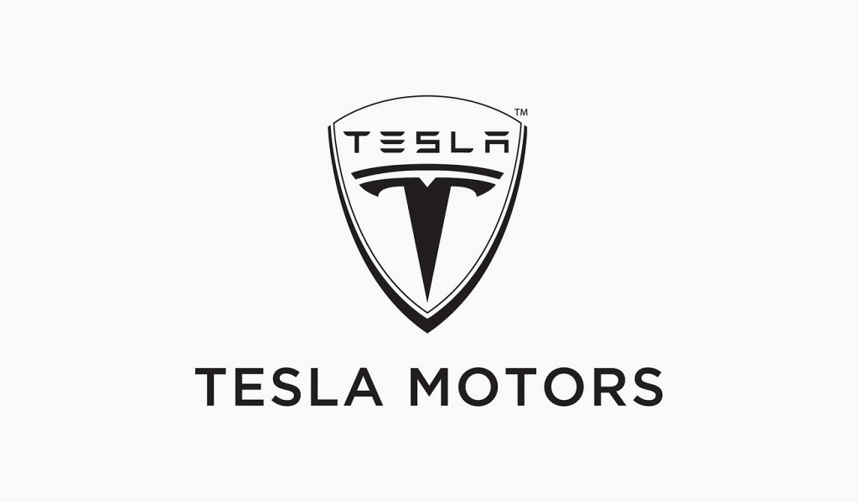

Executive Summary
This report has been critically evaluated about the global business growth in the context of the electric car industry. Porter’s value chain has been analyzed and described in the electric car industry’s model. Tesla Inc is the number one leading brand in the electric car industry with its innovative creation and lucrative models.

Table of Contents
Introduction 4
Porter’s Value Chain Analysis 4
Chosen Brand 9
Conclusion 10
Reference List 12

Introduction
The most significant and dramatic trending of the world in the last two decades has been the fleeted, sustainable development of global business. Global markets are becoming more effective for advanced technologies products, financial instruments, many services, and products. The trading of world products has enlarged with more than 6% per year from 1950. More than 50% of the fast development of output is the most theatrical growth in the era of globalization that is enhancing the financial market. The market of the global forex and the transduction of billion dollars are running every day. The global business is included with any kind of business movement which is running across the national border. Global business can be defined as a company operating its business activities in several countries. In this report, the growing market for electric cars is illustrated. The theory of Porter’s value chain has been applied and discussed in this report effectively. The sustainable growth of the electric car industry and the trending of it have been described in this report with critical evolution. The organizations that are manufacturing these electric cars have been mentioned in this report. In this present era, electric cars are the most significant word to the entire world for reducing some percentage of pollution. The value chain analysis of the electric car industry has been described in this report with major key components.

Porter’s Value Chain Analysis
Michael Porter discussed the value chain system for any company in his book “Competitive Advantages” in 1985. The value chain is combined with several activities which an organization is carrying out for creating effective values for its consumers. Porter has introduced a normal purpose of the value chain that the organizations can apply to run their business operations effectively and to see their interconnections (Tallman, Luo and Buckley, 2018). The way effective value chain movements are performing to determine effects and costs profits.
Primary Activities
The primary movements are directly correlated to service or product support, maintenance, sale, physical creation.
- Inbound Logistics: These processes are correlated to internal distribution, storing, receiving inputs. The supplier relationship is the most fundamental aspect to create value in the inbound logistics.
- Operations: As per Porter’s value chain model these activities are transformed which are altering the inputs within outputs that are sold to the consumers (Zamora, 2016). In this context, the operational systems can create sustainable value.
- Outbound Logistics: These movements can deliver the services or products of a company to the consumer. These types of components are such as systems of distribution, storage, collection, and so on. It can be external or internal of an organization.
- Sales and Marketing: These kinds of processes an organization can use to win over the clients for buying from them, not from its rival companies. The main value resources of the sales and marketing strategy of a company are entirely dependent on the communication and offered benefits.
- Service: Service is the most fundamental component for an organization (Simatupang, Piboonrungroj and Williams, 2017). These kinds of movements are correlated to maintain the service or product value to the consumers once after their purchase.
Support Activities
These kinds of movements used to play a supporting role in the above mentioned primary activities.
- Procurement: This is a kind of movement of an organization that is required to get the provisions for operating. This is correlated to bargain the best costs and finding for the vendors.
- Human Resource Management: Human resource management is the most managerial issue for every organization. Human resource management is an effective way of a company for some processes which are regarded with rewards, retains, motivations, training, hiring, recruitments of the employees (Benito, Petersen and Welch, 2019). Human beings are the most crucial value source so the business of an organization can create a transparent benefit with an effective human resource practice.
- Technological Development: The technological development movements are correlated with processing and managing information and giving protection to the knowledge base of an organization. Information technology’s cost reduction and staying with present advanced technology and maintaining excellence of technology is the key resource of creating value.
- Infrastructure: Infrastructure is a significant system of support for an organization and the infrastructural activities are allowing an organization to operate its daily functions. General management, administration, legal, accounts are the most required and fundamental infrastructure for an organization for its benefits.
In this report, the electric car industry has been chosen and the above-described theory can be applied in the context of the electric can manufacturing industry (Kumar and Rajeev, 2016). There are few steps discussed by the following.
Step 1 Identifying Sub Activities for every primary activity
Each primary activity is determined with the sub-activities which are creating value.
- Direct Activities: The direct movements used to create values by itself (Koc and Bozdag, 2017). An electric car manufacturer company’s sales and marketing movements and the direct sub-activities are included with making sales by showrooms, advertising, and sales.
- Indirect Activities: Indirect movement used to allow direct movements for running easily. An electric car manufacturer organization marketing and sales movements and indirect sub-activities are included in managing the sales force and keeping records for customers.
- Quality Assurance: The activities of ensuring indirect and direct movements for meeting up required standards. The electric car manufacturing company marketing and sales activity can be included with edit advertisements and proofreading.
Step 2 Identifying Each Support Activities
Human resource management, procurement, Technology development all are the support activities and determined with sub-activities which are creating value into all privacy activities. The human resource management of an electric car manufacturing organization is considering additional value outbound and inbound logistics, operations, and many more. The company of the electric car manufacturer should focus on indirect, direct, and quality sib activities sub assurances (Pierce and Cleary, 2016). After that, identification of the several values making sub-activities inside an electric car manufacturing organization’s infrastructure. Normally, this will be more cross-functional in the environment than exactly each of the primary activity and again looking for indirect, direct, and quality activities assurances.
Step 3 Identifying Links
Finding the correlations between all kinds of activity values has been identified by the management of the electric car company. This is a long time process and the links are the main key to develop rivalry benefits with the help of a value chain skeleton. Inside the workplace of an electric can manufacturing company, there is a link to increase the sales force and sales volume with the help of the human resource management department (Hsiao and Chuang, 2016). The other connection within the order turnaround period, phone call service from the disappointed consumers who are not satisfied with the models of the electric cars.

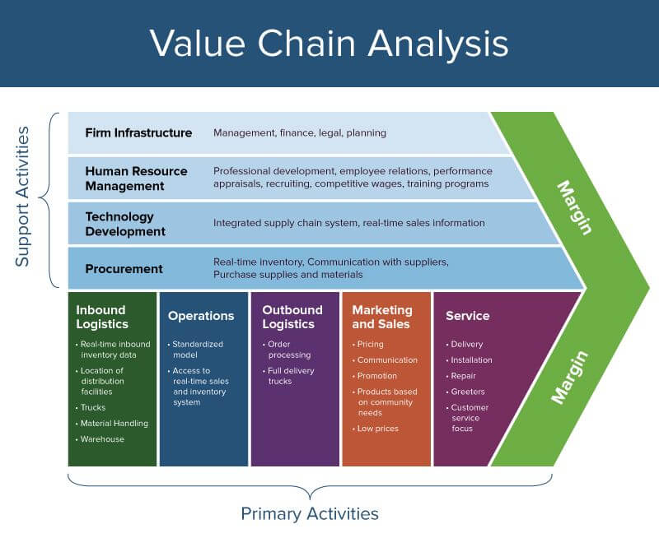
Figure 1: Value Chain Analysis
(Source: Hsiao and Chuang, 2016)
Step 4 Looking For Chances to Develop Value
The other sub-activities and links have been reviewed which have been identified in this report in the context of the electric car industry. An electric car organization can enhance or change or reduce the value than the past offer to the consumers. In this process, the values can be developed for the changes.

The rapid growth of the electric car market and industry can be conducted in this market with the various sources of information. For the last few years, the market of the electric car industry has enlarged more effectively. The regions of Asia Pacific, Europe, and North American countries are the main market of the electric car industry. Several electric car manufacturing companies are producing various kinds of insane electric cars. The main advantage of electric cars is that it is helping to create an eco-friendly nature by reducing air pollution with the help of battery engines. There are several ranges of electric cars such as normal sedan cars, mid-range cars, sports cars, and luxurious cars. Some companies are producing passenger and commercial electric vehicles also. The automakers are investing in the production of electric vehicles immensely. The governments of several countries have introduced some regulations and acts to reduce the rate of CO2 from the air. Those governments are offering some facilities and subsidies to electric car manufacturing companies. The people of the whole world have become concerned about the growing rate of global warming for the growth rate of pollution (Hildermeier, 2016). Those people are willing to buy electric vehicles to reduce some of the rate of pollution by them.

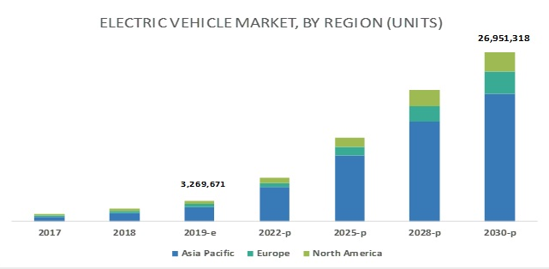
Figure 2 : Growth Chart of Electric Car Market
(Source: Hildermeier, 2016)

Chosen Brand
Tesla Inc started to build electric cars from its incorporation in 2003 and after eleven years this company ranked top in the list of electric motor companies in 2019. Tesla has left so many giant car manufacturing companies in these years. This company is operating its multiple assembly and production plants in several countries. The main engine of the electric cars of this company used to run with batteries. This is helping to reduce the air pollution rate from fossil fuels certainly. Model 3 of Tesla Inc is the most delivered electric car in the world ranking and the amount was 500,000 as a plug-in electric car. Tesla Inc also produces electric sports cars and the models are insane as per their looks and usefulness. These electric cars of the Tesla company are delivering to their consumers in low amounts compared to other electric car manufacturers' organizations which are the most advantageous for Tesla. Tesla is a public limited company and Elon Musk is the major shareholder of this company with a 20.8% share. The main objective of Tesla to create a large number of electric car owners from the beginning. Tesla is producing affordable cars that most kinds of people can obtain. In 2019 the total revenue of Tesla was around 24.578 billion US Dollars (Jiang and Lu, 2018). Tesla is mainly working for eco-friendly products and they are also producing several kinds of batteries.

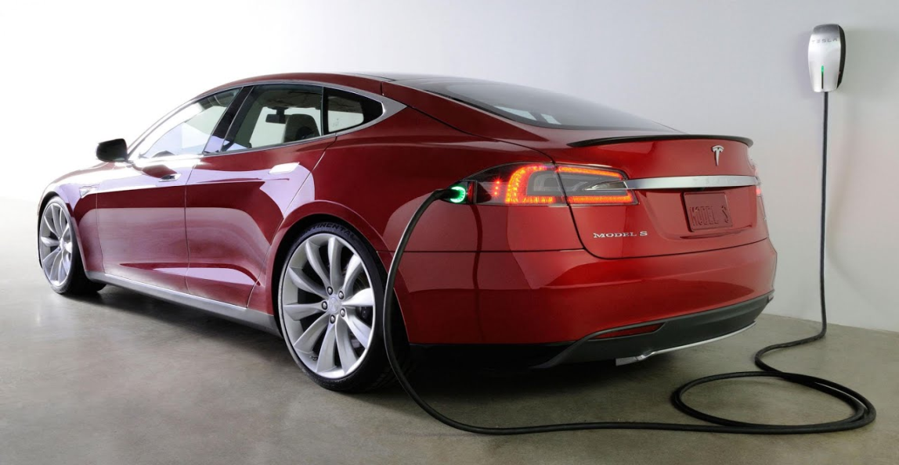
Figure 3: Electric Car of Tesla
(Source: Jiang and Lu, 2018)

Conclusion
The electric car industry has become a new trend in this era of globalization in the twenty-first century. There is a huge demand for electric cars in the global market and it has been described with the theory of Porter’s value chain in this report. Tesla is an automotive organization which is manufacturing insane models of electric cars. Present-day, multinational companies are dealing with global financial methods full of complexities, risks, and challenges. Treasurers and financial managers play a significant role in operating global finance matters. This is significant for global marketers for processing acumen within global accounting and finance functions. However, these business functions are having a crucial impact usually in the business context. At last, the decisions of all businesses which have involved financial investment or another range of lengthy monitorial commitment on the part of the procreator organization should be reviewed in global financial policies and finance. The monitorial power of an organization is immensely affected by foreign investment which is deciding the actions when it spreads business globally. Several automotive manufacturer organizations are looking for the electric car industry in the global market and also the investors are looking for investment scopes. The key benefit of electric cars is that it is highly compatible to reduce air pollution. Electric cars are the main key component in this modern era of globalization and it is affecting nature and global warming is growing. The strategy is to emulate product-technological life cycles and initial targeted affluent buyers, and move to a larger market and to lower price points. Each person in this universe who is willing to buy a car should choose the electric car for helping to reduce air pollution.

Reference List
Benito, G.R., Petersen, B. and Welch, L.S., 2019. The global value chain and internalization theory. Journal of International Business Studies, 50(8), pp.1414-1423.
Hildermeier, J., 2016. Which role should the electric car play in Europe's cities? An analysis of publicly funded demonstration projects 2007-2013. International Journal of Automotive Technology and Management, 16(1), pp.90-107.
Hsiao, T.Y. and Chuang, C.M., 2016. Creating shared value through implementing green practices for star hotels. Asia Pacific Journal of Tourism Research, 21(6), pp.678-696.
Jiang, H. and Lu, F., 2018. To be friends, not competitors: A story different from Tesla driving the Chinese automobile industry. Management and Organization Review, 14(3), pp.491-499.
Koc, T. and Bozdag, E., 2017. Measuring the degree of novelty of innovation based on Porter's value chain approach. European Journal of Operational Research, 257(2), pp.559-567.
Kumar, D. and Rajeev, P.V., 2016. Value chain: a conceptual framework. International Journal of Engineering and Management Sciences, 7(1), pp.74-77.
Pierce, G.L. and Cleary, P.F., 2016. The K-12 educational technology value chain: Apps for kids, tools for teachers and levers for reform. Education and Information Technologies, 21(4), pp.863-880.
Simatupang, T.M., Piboonrungroj, P. and Williams, S.J., 2017. The emergence of value chain thinking. International Journal of value chain management, 8(1), pp.40-57.
Tallman, S., Luo, Y. and Buckley, P.J., 2018. Business models in global competition. Global Strategy Journal, 8(4), pp.517-535.
Zamora, E.A., 2016. Value chain analysis: A brief review. Asian Journal of Innovation and Policy, 5(2), pp.116-128.

