
Applied Leadership and Management in the Workplace
Module Assignment Submission
Student Name: | Helen Grandin
Student Number: | 1708671
Module Code: | BMSK5012
Module Title: | Understanding and Engaging in the Customer Experience

Statement of Confirmation of Authenticity
By the act of making this submission, the student declares that this is the work of the student named above. The work has not, in whole or in part, been knowingly presented elsewhere for assessment, or where assessment has been built on a previous assessment, this has been identified. Where materials have been used from other sources it has been properly acknowledged. If this statement is untrue, the student acknowledges that an assessment offence has been committed.
Attention is drawn to the plagiarism and unfair practice policies of the University.
Table of Contents
Introduction 3
Section 1 4
Critically analyse the factors that impact on your organisation’s ability to maximise customer value. 4
Section 2 9
Critical understanding of your organisation’s quality processes and its effectiveness in meeting customer requirements. 9
Conclusion 14
References 15
Appendix A 18
Appendix B 19
Appendix C 20
Appendix D 21
Appendix E. 22
Appendix F 23

Introduction

In this report I will be analysing factors that can have an impact on organisations ability to maximise customer value and what can be done to alleviate these impacts. The use of models, theories, and research. I will be researching where these theories developed from, the people behind them, and how they can help with quality processes. I will demonstrate what quality processes the organisations have and how effective they are in meeting the customers’ requirements, do they work and how they work. Do customers stay out of habit or loyalty. Why problem solving and decision making play an important part in effectively meeting the customers’ requirements. Investigating the reasoning behind the customer’s choice to use you as their supplier. How customer complaints are dealt with and ways of obtaining feedback to ensure expectations are always met.

Section 1

Critically analyse the factors that impact on your organisation’s ability to maximise customer value.

There are factors that impact on your organisation when trying to maximise customer value.
- Accessibility
- Market change
- Quality of the product/service
- Pricing
- Training
- Communication

(Green, 2021)
Customer value has two sides, what we give them and what they give us are both key elements to a successful organisation. So, what is customer value.
Customer value has 3 major reasons why it is important.
- The generation of more resources by giving you customers more value will allow to generate greater financial resources leading to a sustainable growth for the company,
- Offering a better assortment of products based on your ideal customers allows you to evaluate what are your best-selling products in line with your customer’s preferences.
- Capital Access the greater the customer value the greater the customer lifetime value of purchase cost ratio.
Value is defined by customer perception of the service or product we are supplying and is based on four components. (See appendix D).
The customer needs waterfall was created by Winston Royce in the 1960s and designed the simplify the process of development ensuring each phase is complete before moving on to the next. However, the customer needs waterfall is designed to allow us to understand the customer and the customer’s purchase journey.
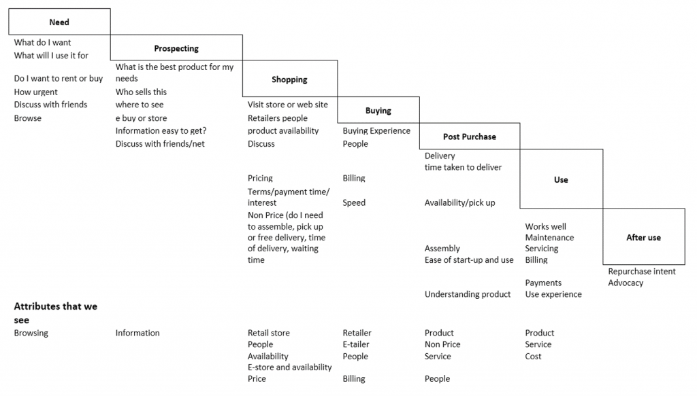
Customer value is what we give them and what we as an organisation offer to customers, we can influence customers’ using a combination of price, how well our product functions, uniqueness, quality, customer service both pre-purchase and post-purchase, marketing strategies and the customers’ personal preferences. If we appreciate the customers, listen to them, understand their needs, and maintain a friendly environment we are more likely to retain them as loyal customers. When a customer is looking at buying a product there are elements that they consider during this process for example, a customer is looking at buying a new hairdryer, they will consider how big the hairdryer is, whether it is heavy, does it has attachments, how long is the lead, is it suitable for long hair and also look at reviews from people who have purchased the same item then making a decision based on their findings, so it is vital that we market the product with as much information as possible to secure sales.
Professor Morris Holbrook did extensive research and taught in areas of consumer behaviours, marketing strategies, sales management, and commercial communication. He has created many journals from his research with some compelling arguments about marketing strategies and sales management. (Holbrook et al.)
We must create customer value it does not just happen. Chris Daffy the founder of The Academy of Service Excellence stated, “If you ask the wrong questions, you won't get the information you require to make the right decisions and improve customer experience and loyalty”. (Daffy, 2019). According to Daffy there five subjects to base your questions on which are: -

- Delivery against expectations.

- Was your experience what you expected or different in any way?
- Were your expectations not met?
- Were you treated in the way you expected to be treated?
- Were your expectations exceeded in any way?

- Feeling/emotions experienced.

- How did you feel throughout your experience with us?
- How valued as a customer did you feel?

- Ease of doing business with you.

- How easy did you find us to do business with us?
- How easy was it to navigate our website/order process?
- How easy was it to get any information you needed?

- Memories/stories that you have created.

- What do you remember most about your experience with us?
- Is there anything you will never forget about your experience with us?
- Did you share your experience with us with family, friends, or colleagues?
- How would you describe your experience with us to others if asked?

- Likelihood of future loyalty.

- Based on your experience with us how likely are you to recommend us to family, friends, or colleagues?
- Have you already recommended us to family, friends, or colleagues?

(Phelps, 2017) published an article called “Stew Leonard And The Greatest Marketing Story Ever Told” reporting on the customer service excellence of a dairy store owner from Connecticut called Stew Leonard, the store became very popular and started to expand even being recognised by Ronald Reagan after an incident over some egg nog, and after an ear bashing from his wife for the way he dealt with the situation, realizing his mistake the next day he called into a stone mason and ordered a 6,000-pound slab of granite and had a very powerful message engraved onto it saying “Our Policy Rule 1: The customer is always right. Rule 2: If the customer is wrong, reread Rule 1!” this was placed at the store’s entrance sending a powerful message to the customers. It is believed that this made his customers feel safe and valued making them valued customers.
Implementing good customer relationship management (CRM) in your organisation to create customer value and maximize it is very important. Customer value maximizations are actions and techniques to enable your organisation to entice customers in the hope of increasing the length of time they stay as active customers. Once a new customer is obtained, the ultimate goal is to ensure they return to your organisation to make further purchases or use your service. This can be achieved by having competitive prices and great customer service. However, there are actions an organisation can take to ensure the customer stays long-term and continues to buy from them. We can achieve this by using a combination of actions which include: -

- Customer segmentation – putting customers into small groups allows us to concentrate on the customer’s individual purchase behaviours instead of assuming that their purchase behaviours will be the same as another customer with a close comparison of purchase behaviours.
- Tracking your customers over time – this is critical, to monitor how customers move between each segment, known as dynamic segmentation which measures classification to target customers based on their recent purchases.
- Accurately predicting the future of customers’ behaviour – the use of predictive behaviour modelling a mathematical and statistical technique (See Appendix A) enables marketers to target customers specifically with marketing actions that are specifically targeted at them to achieve the best impact.
- Customer lifetime value – this should be based on calculations
- Marketing action optimization – by using objective metrics the marketer will now know exactly what marketing actions to take next for every individual customer to maximize the customer’s long-term value.
A study by the Budapest International Research and Critics Institute – Journal in 2018 aimed to discover and analyse what influences customer value and what impact it has on their loyalty using a quantitative method from conducting surveys to use as verification, using SEM (Structural Equation Modeling) analysis (See Appendix B) which examines the impact of purchase intentions from customers. The study concluded that focusing on the optimal service element of making customers feel comfortable along with customer psychology it has a positive impact on customer value.
Customer profitability is very important to the company and in defining the theory of customer relationship management. There is a framework to help evaluate what profitability a customer is expected to generate, this is done by conjecturing the probability of the customer responding to marketing strategies enabling the generation of customer-specific profitability scores.
Customer Relationship Management (CRM) is also important in maximizing a customer’s value. CRM strategy’s history dates to the 1950s (See Appendix C) with the introduction of Rolodex a rotating contacts filing device developed by Arnold Neustadter and Hildaur Neilson in 1956 and were available to buy by 1958 and by the 1980s they were a popular feature in many offices worldwide.
CRM strategy is a framework used by organisations to evaluate their customer relationship management practices, there are six stages in this framework which are: -
Stage 0 – Non-existent, no management process is in place to achieve the desired outcome.
Stage 1 – Initial/Ad Hoc, only a few managers apply the practices to produce the outcomes desired, but there are no format management processes in place.
Stage 2 – Repeatable but intuitive, is formally applied and understood to produce the outcomes desired, but no formal management processes are in place.
Stage 3 – Defined Process, management processes do exist to implement the practice, but not throughout the whole company.
Stage 4 - Managed and Measurable, standard management are in place which are monitored.
Stage 5 - Optimized, management processes apply, and the practices are at the heart of the company and are being improved constantly.

Section 2

Critical understanding of your organisation’s quality processes and its effectiveness in meeting customer requirements.

An organisations quality processes are in place to ensure that all aspects of the customers’ requirements are met every time with focus on exceeding the expectations of the customer. Quality Management Processes known as QMP is a procedure within your organisation that ensures the quality of work is maintained throughout the whole processes of dealing with your customers, keeping everything coordinated and in sync. QMP also enhances the team’s efficiency, coupled with a Quality Assurance Process that maximizes the company’s quality output by implementing short-term initiatives with a focus on long-term goals.
Satisfying customers by supplying great products is the goal for companies. Product Management is essential. How is satisfaction measured and how can satisfaction become delight? A tool to assist in answering these questions is the Kano Model.

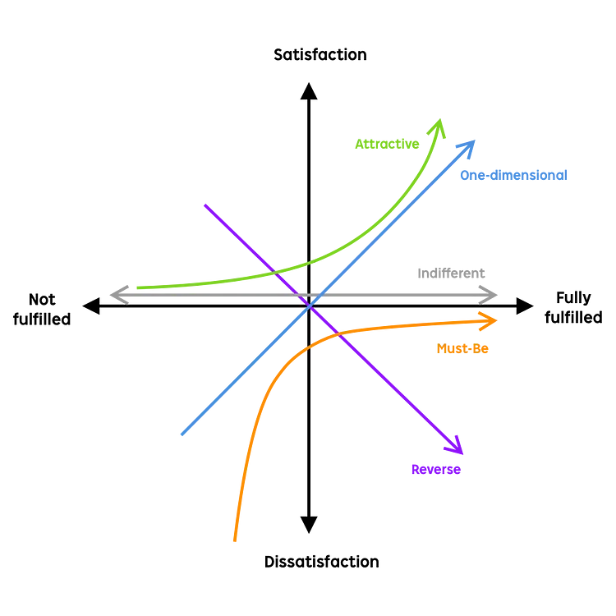(Lin, 2019)

In an article by Daniel Zacarias, he states “You cannot build everything right now”, while this is true, it is some peoples expectation, and they demand it. The Kano Model can be used to help to prioritises any outstanding orders with the intention to maintain customer satisfaction. Satisfying customers with the products we create is the goal everyone strives to meet and there is nothing more rewarding than achieving this. However, how are going to measure the satisfaction? The Kano Model’s five categories can be used to measure satisfaction with data from customer questionnaires. (Zacarias, 2022).
Example of a questionnaire for a customer who purchased an Apple iPhone.

 | I like it | I expect it | I am neutral | I can tolerate it | I dislike it
Functional
How would you feel if the product had good battery life? |  | 
How would you feel if the product had a bigger screen?

Dysfunctional
How would you feel if the product did not have a good battery life?

How would you feel if the product had a smaller screen?

Functional |  | Dysfunctional |  | Category
I expect it | + | I dislike it | = | Must-be
I like it | + | I dislike it | = | One-dimensional
I like it | + | I am neutral | = | Attractive
I am neutral | + | I am neutral | = | Indifferent
I dislike it | + | I expect it | = | Reverse

Must be attributes – are what features a customer expect in their product.
Performance attributes (one-dimensional) – are what features a customer would like in their product.
Attractive attributes – are features that elevate delight or excitement.
Indifferent attributes – are features that are unimportant to the customer.
Reverse attributes – are undesired features that can cause customer dissatisfaction.
Customer's perceptions change and so will their expectations. Daniel Zacarias refers to this as “the natural decay of delight.”.
Analysing the answers to the questionnaire, we can see that the customer is categorised as a must-have and performance.

There are great benefits to be had by implementing QMP. Not only do they do it to provide customer satisfaction they also assist in meeting all your customer’s needs. It increases economic performance by speeding up the production of quality products improving the company’s efficiency. Employee efficiency is also increased by having the ability to see mistakes before the production process has gone too far, reducing the risk of having to redo the work. With employees having to interact more closely, coordination and communication among them are improved. The implementation of QMP enables high production and reduces errors, this decreases the amount of waste the company creates.
When we talk about waste we automatically think of rubbish, however, in organisations, waste means a lot more than just rubbish. In the 1890s Fredrick Taylor investigated factory work and the methods that were in place, in his findings, he mentioned concepts such as operations, work method efficiency, work standardization, and processes, he did, however, turn a blind eye to work behaviours which created criticism regarding his investigations.
A case study Criticism of Scientific Management Theory (Taylorism) (Francis, 2019) showed that not everyone had criticism for Taylor’s work he also influenced several theorists, Henry Gantt was one of them, and he also preferred empirical methods in deciding what procedures were more efficient.
In an article by Ted Hessing, he discusses how Henry Ford prospered into lean history when he established his well-known strategy in manufacturing. The company was arranged so all products, people, equipment, tools, and machines, being used at Ford’s manufacturing site, promoted a continuous flow of production. Using this process, he succeeded in producing the Model T, making him the richest man in the world. Unfortunately, the world changed and the demand in the market for newer models of cars started a downward spiral for Ford as they could not change their work methods, inevitably Ford's success started to diminish and by the mid-1930s were no longer the dominant car manufacturer in the market. (Hessing, 2023).
In the corporate industry, the principles of Lean are often used. Lean is defined as greater customer value using fewer resources (See Appendix E).
There are 8 wastes associated with Lean.
- Defects – supplying the wrong product.
- Overproduction – supplying more than the customer needs.
- Transport – carbon footprint.
- Waiting – taking too long to produce and deliver.
- Inventory – holding too much stock.
- Motion – employees having to move to different locations to complete tasks.
- Processing – delays through unnecessary processing stages.
- Skills – basic tasks over casting employee’s ability to give maximum value.
My understanding of the quality processes in place at this organisation I believe is not fully understood, my research found that communication between the main departments was not in sync and therefore the customer’s needs were not being met. However, the company is in its infancy and has been implementing procedures to rectify the mistakes made. Employees are now being given clear job specifications, work instructions, and training in specific areas. Customer service employees have a manageable database of customers that they deal with providing a more personal experience and alleviating the annoyance of having to repeat themselves to each person they communicate with, this was stated in a customer review and was implemented to improve the customer service process. Also mentioned in the customer review was the dependability of the courier service used and the service they were providing, this has also now been rectified.
Having a strategic quality plan in place can allow aspects to be monitored. When creating your strategic plan there are some elements to bear in mind.
- Understanding of the customers' needs and desires.
- Understanding of what the company's views on quality are.
- Establish how vital quality is to the company's operation.
- Identify methods by which the company can evolve from where they are to where they need to be in the future.
(Furterer & Wood, 2021).
In the 1950s William Edwards Deming started to covey the idea of continuous improvement, a vast philosophy with differential approaches which assisted the innovation of cultures. Today, it is a primal concept in many project management philosophies such as total quality management, agile and Six Sigma, an ongoing process to identify opportunities, make changes to personnel, products and the processes used, and analyse performance.
Agile methods are adaptable, focus on customer needs, and foster collaborative teamwork.
12 principles in Agile methodology:
- Satisfying customers with continuous improvement and accurate delivery. This creates happier, satisfied customers.
- Embracing changing requirements. The Agile framework is centred on adaptability.
- Delivering value frequently, lowers the possibility of the customer becoming agitated.
- Elevate the status quo of your projects. Collaboration is fundamental in the Agile framework. The aim is to get people to move out of their comfort zones and embark on their own individual projects encouraging them to collaborate more frequently.
- Establish projects aimed at motivated individuals. Agile best works when the teams are committed and are actively working towards a goal.
- Face-to-face communication is the most effective way.
- What teams should endeavour for with the Agile framework is the product.
- Establish a sustainable working pace. The aim is to keep sustainability throughout the project.
- Continuous excellence enhances agility. The continuation of creating good work enables the teams to move faster on future projects.
- Keep it simple. Sometimes it’s the simplest solutions that work best. The agile aim is to not overcomplicate the project and seek simple answers to complex problems.
- Self-organisation generates the most value. Proactive teams are valuable assets to the company.
- Regularly reflecting and adjusting the way you work to boost effectiveness. Agile practices frequently involve retrospective sessions. Teams use this opportunity to reflect on their performance from the previous iteration and modify their behaviour going forward.
Quality Trilogy, also known as The Juran Trilogy was produced by Dr Joseph M Juran in 1986 as a way of managing quality, at that time the traditional look on quality was based on quality control, now many global best practices for quality management now stem from the Trilogy. (See Appendix F). (DeFeo, 2019).

Conclusion

On conclusion of this report my research has provided me with interesting insights why these processes are in place and how valuable they are to the company. Discovering the people behind the processes and how they moulded their company and allowed them to strive in competitive markets, also the mistakes that were made which resulted in the Ford Motor Company declining in the market proved the importance of the company's abilities and willingness to embrace change and move in line with customers’ needs and expectations. The theories combined with models are valuable tools and the findings from my research showed that companies who used the processes to be more successful than those who did not. It has shown that customer value is what drives the company and without that a company will inevitably struggle.

References

(2022). Retrieved from https://www.qualtrics.com/uk/experience-management/research/kano-analysis/?rid=ip&prevsite=en&newsite=uk&geo=GB&geomatch=uk.
Almquist, E., Bloch, N., & Senior, J. (2021, November 10). The 30 elements of consumer value: A Hierarchy. Retrieved April 11, 2023, from https://hbr.org/2016/09/the-elements-of-value
Anastasia. (2022, November 27). Explain lean management principles with visuals. Retrieved May 6, 2023, from https://blog.infodiagram.com/2019/03/explain-lean-management-with-visuals.html.
Daffy, C. (2019, March 21). Measuring customer experience, expectations, and loyalty: What questions should you ask? Retrieved April 22, 2023, from https://www.mycustomer.com/experience/loyalty/measuring-customer-experience-expectations-and-loyalty-what-questions-should-you.
DeFeo, J. A. (2019, April 15). The Juran Trilogy: Quality Planning. Juran. October 28, 2023, https://www.juran.com/blog/the-juran-trilogy-quality-planning/
Efficy. (2022, September 26). What is a CRM? learn how a CRM system helps boost your business. efficy. Retrieved April 21, 2023, from https://www.efficy.com/crm-meaning/.
Francis, A. (2019). Retrieved from https://www.mbaknol.com/management-principles/criticism-of-scientific-management-theory-taylorism/.
Furterer, S. L., & Wood, D. C. (2021, January 25). What is Quality Planning? quality control plans | ASQ. ASQ Learn about Quality. https://asq.org/quality-resources/quality-plans
G. M., By, & -. (2017). Retrieved from https://customerthink.com/components-of-customer-value-how-to-build-a-waterfall-of-needs-and-attribute-trees/.
Green, S. (2021, July 26). 12 Factors that Influence Customer Satisfaction. HubSpot. October 28, 2023, https://blog.hubspot.com/service/customer-satisfaction-factors
Hessing, T. (2023). Retrieved from https://sixsigmastudyguide.com/history-of-lean/.

Holbrook, Addis, A., Chaudhuri, Holbrook, A., Johar, Kuwahara, A., . . . Capon. (n.d.). Morris Holbrook. Retrieved April 22, 2023, from https://business.columbia.edu/faculty/people/morris-holbrook.
Lin, H.-J. (2019). Retrieved from https://uxplanet.org/kano-model-analysis-in-product-design-7a3cca3e51ed.
Marc J. Epstein, M. (2008, December 01). Managing customer profitability. Retrieved April 11, 2023, from https://www.journalofaccountancy.com/issues/2008/dec/managingcustomerprofitability.html
Phelps, S. (2017, April 25). Stew Leonard and the greatest marketing story ever told. Retrieved April 22, 2023, from https://www.forbes.com/sites/stanphelps/2017/04/25/stew-leonard-and-the-greatest-marketing-story-ever-told/.
Predicting customer behavior with Big Data. Share and Discover Knowledge on SlideShare. (n.d.). Retrieved April 21, 2023, from https://www.slideshare.net/Pactera_US/predicting-customer-behavior-with-big-data
Ranjhaa, S. (2021, April 04). What is customer value & why is it important? [components & examples]. Retrieved April 22, 2023, from https://www.marketingtutor.net/customer-value/
Rehkopf, M. (n.d.). What is continuous improvement and which tools are needed? Atlassian. https://www.atlassian.com/agile/project-management/continuous-improvement
richardson , nigel. (2020). Retrieved from https://blog.i-nexus.com/the-history-and-future-of-lean-management.
Simplilearn. (2023). Retrieved from https://www.simplilearn.com/what-is-quality-management-process-article.
Structural equation model of customer satisfaction and consumer ... (n.d.). Retrieved April 21, 2023, from https://www.researchgate.net/figure/Structural-equation-model-of-customer-satisfaction-and-consumer-retention_fig2_265919343
The factors that affect customer value and its impact on ... - researchgate. (n.d.). Retrieved April 21, 2023, from https://www.researchgate.net/publication/329964833_The_Factors_That_Affect_Customer_Value_and_Its_Impact_on_the_Customer_Loyalty/fulltext/5c262b7b92851c22a34b5846/The-Factors-That-Affect-Customer-Value-and-Its-Impact-on-the-Customer-Loyalty.pdf
The history of the Rolodex. Durakis Executive Search. (2021, March 19). Retrieved April 21, 2023, from https://durakis.com/the-history-of-the-rolodex/

Verhoef, P. C. (2003). Understanding the effect of customer relationship management efforts on customer retention and customer share development. Journal of Marketing, 67(4), 30–45. https://doi.org/10.1509/jmkg.67.4.30.18685
What is customer value maximization. Optimove. (2023, March 26). Retrieved April 21, 2023, from https://www.optimove.com/resources/learning-center/customer-value-maximization
Zacarias, D. (2022). Retrieved from https://foldingburritos.com/blog/kano-model/

Appendix A

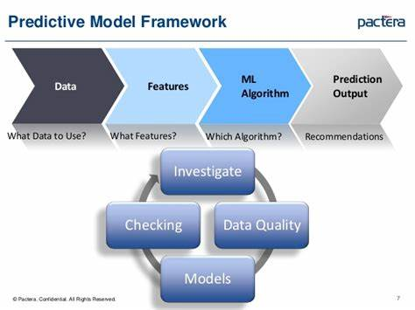

Appendix B

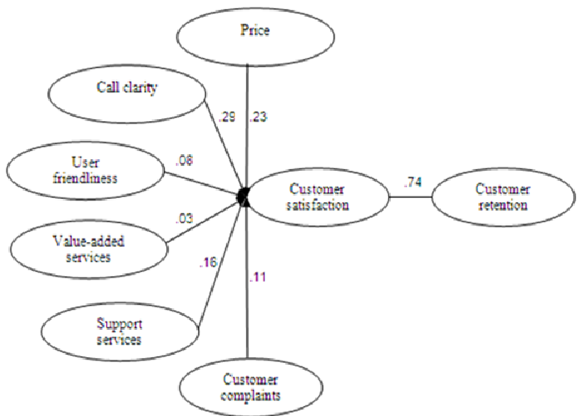

Appendix C

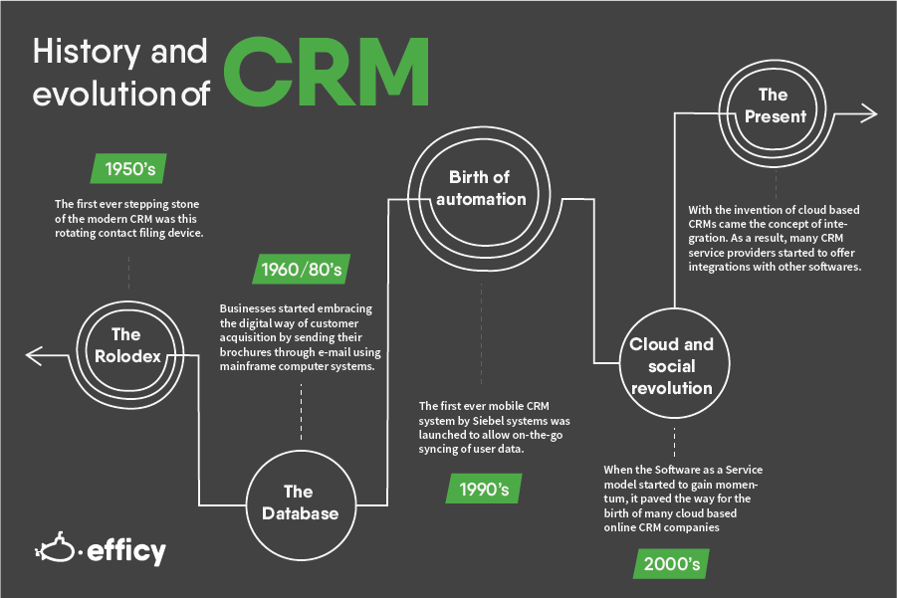

Appendix D

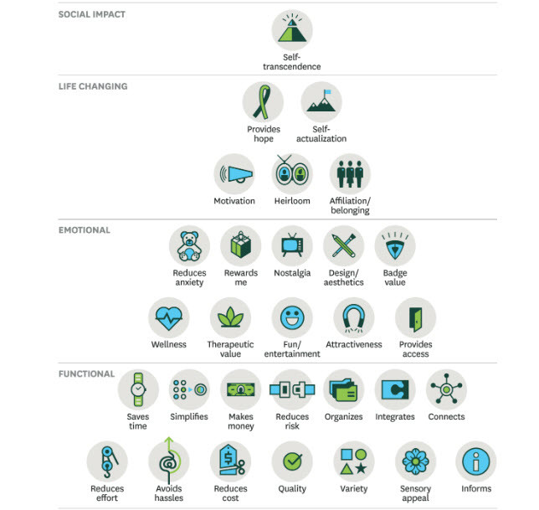

Appendix E.

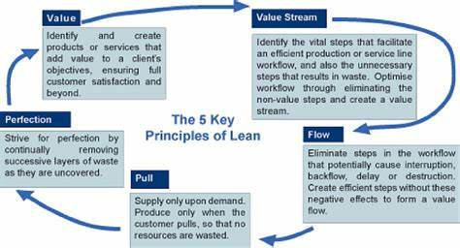

Appendix F



