

Student name: Mariana Adriana Iancu
Student ID number: 2530098
Lecturer’s Name: Muhammad Aliyu
Certificate of Higher Education Skills for the Workplace (Health & Social Care)
Introduction to Health and Social Care
LCHS4003

Task 1: Poster Presentation
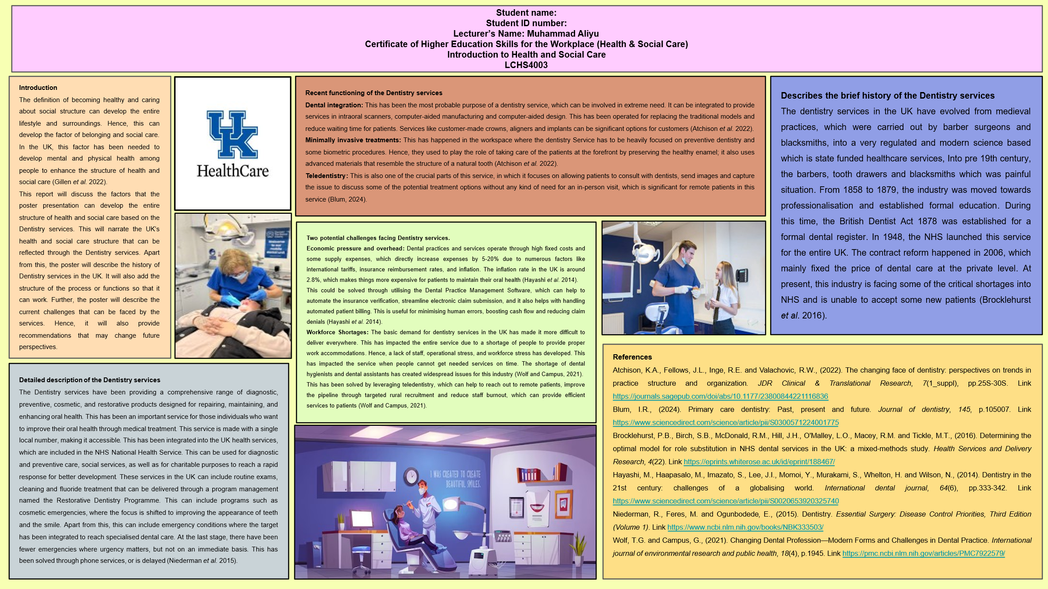
Task 2: Essay
Evaluating the origins of the Community disability services and exploring the historical context
The services of Community disability services have been developed with the transformation from hospitals to the local neighbourhood. This has been more work as a pledge-based structure where the service made people’s lives better through giving the proper services by including them in a local environment. This thing started with the law or act where the government has taken the process to give better welfare to disabled people. This has been developed through implementing the National Assistance Act in the year of 1948. This has removed the poor older law and encouraged local people or governments to provide welfare to enhance the lives of disabled people (Needham and Hall, 2023).
This has evolved from the strict system-based hospital care to deinstitutionalised care. It has led to the inclusion of home care and personalised care from an individual perspective. It can be included to develop the older processes into the new tech-based digital processes. This has been aligned with the institutional area since the 1960s, and then moved on based on the UK’s governmental process. To enhance this, the use of the NHS and Community Care Act 1990 has been developed to enhance the historical transaction to enhance future perspectives. This has been used to develop the local care procedure to enhance the life of an individual who may face any disabilities. It can act as a more forceful event context (Bramwell et al. 2023).
The Health Checks have been implemented within the service in the UK to support disabled people. It can generally be included to enhance the concept of health check-ups by visiting the home and then providing needed support. This can drive through the implication of the NHS’s teams, where they can provide specialised personnel to enhance therapies. Here, they can provide speech therapy, physiotherapy and give mental health support. To enhance disabled people's mental state, their mental health and reduce stress factors, the team can work hard to enhance their situation and progress. This can include checkups and monitoring while motivating people who need extreme care and support (Wigham et al. 2022).
The Care and Daily Support has been integrated into the regular support system by solving daily day-to-day operations. Here, people have been given support to disabled people who can not accommodate their daily living, household, or work. Hence, they provide washing clothes, bathing, cooking and taking care of their everyday work aspects. This can act more like a nursing service to enhance people’s lifestyle in a better form who need care. Where people with disabilities can live alone, they need proper care and support from the team members of the NHS. Here, they can provide the kind of people to operate household work (Esteban et al. 2023).
Having a strong implication of community support for disabled people, the inclusive support system has been added. Here, people who give support to disabled people can enhance their daily lifestyles by making them feel normal and a part of everyone’s social lifestyle. Apart from this, the day centres and groups have been creating friend circles to address the loneliness of people due to changing social needs. This makes them feel valued and important as a part of society. It can give them the narrative to make friends by sharing thoughts and information to reduce loneliness (Boland and Guerin, 2023).
The Job Support NHS-based teams have been nurturing skill development and health condition enhancement to give disabled people exposure to work and job development. This has given the people financial support to enhance their lifestyle and better living standards. Here, the service-based team members indulging to the community can improve the disabled people's lifestyle. They provided needed practices and learning activities to enhance the workforce and give them jobs to become productive (Chumo et al. 2023).

References
Boland, G. and Guerin, S. (2023). Supporting social inclusion in neighbourhoods of adults with intellectual disabilities: Service providers’ practice experiences. Journal of Intellectual Disabilities, 27(2), pp.291-314. https://journals.sagepub.com/doi/abs/10.1177/17446295221085479
Bramwell, D., Checkland, K., Shields, J. and Allen, P. (2023). Community nursing services in England: An historical policy analysis. Springer Nature. https://books.google.com/books?hl=en&lr=&id=M9WkEAAAQBAJ&oi=fnd&pg=PP5&dq=Historical+context+of+Uk+based+community+disability+services+included+with+NHS+and+Community+Care+Act+1990&ots=l83i2ktLvJ&sig=8xYz8DHb3yOePsp3YsZecKzjOpw
Chumo, I., Kabaria, C. and Mberu, B. (2023). Social inclusion of persons with disabilities in employment: what would it take to socially support employed persons with disabilities in the labour market?. Frontiers in rehabilitation sciences, 4, p.1125129. https://onlinelibrary.wiley.com/doi/abs/10.1111/bld.12378
Esteban, L., Navas, P., Verdugo, M.Á., Iriarte, E.G. and Arias, V.B., (2023). A community living experience: Views of people with intellectual disability with extensive support needs, families, and professionals. Research in developmental disabilities, 137, p.104503. https://www.sciencedirect.com/science/article/pii/S0891422223000811
Needham, C. and Hall, P. (2023). Dealing with drift: Comparing social care reform in the four nations of the UK. Social Policy & Administration, 57(3), pp.287-303. https://onlinelibrary.wiley.com/doi/abs/10.1111/spol.12858
Wigham, S., Bourne, J., McKenzie, K., Rowlands, G., Petersen, K. and Hackett, S. (2022). Improving access to primary care and annual health checks for people who have a learning disability: a multistakeholder qualitative study. BMJ open, 12(12), p.e065945. https://bmjopen.bmj.com/content/12/12/e065945.abstract

