Management Economics
LCBB5003

Student name: Lucian Pop
Student number: 2023565, Year 2, Assessment2, Term 3
Business management (Weekend classes)

Content

Introduction
- Intel. The business description……………………………………………..3
- Demand and market equilibrium………………………………………………………………………5
Fig. 1
- Price elasticity of demand……………………………………………………6
- Variables in demand
Fig.2………………………………………………………………………………7
Recommendations
Conclusion………………………………………………………………………9
References………………………………………………………………………10

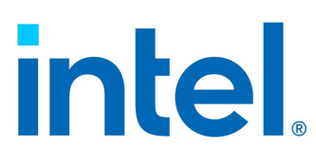

Introduction
The analysis made in this report is about an international company, and the most important institution in high technology, producing microprocessors from 1960’s playing an important role during the last decades in its industry. It is about a model of dynamic oligopoly with goods which are durable, and based on innovation, and in this work, we’ll focus on the relationship between market structure and the quality evolution of the products produced, and the relation of non-collusive oligopoly between Intel and its direct competitor AMD, two companies which dominated the market for decades. In the oligopoly competition the few firms recognise the rivalry and interdependence, and are fully aware that any action on their part is likely to result in counter-action from rivals. Firm will therefore be drawn into devising strategies and counterstrategies taking into account their rivals expected actions and reactions. (Wall, 2011)
- Intel-The business description
Founded in 1968, Intel is an American multinational technology company, that develops, manufactures, and sells computer hardware and software and creates technology that enable global progress. The history of the most important institution in high technology started 18 July 1968 when Gordon Moore and Robert Noyce, both best known in semi-conductor industry Silicon Valley at that time, decided to open a company together. 1970s-Several technologies that changed the industry and introduced by Intel, open the way for inexpensive computers to become indispensable for modern life. They’ve also introduced the first programable microprocessor, followed by several improved generations. 1980s- In 1981 the first IBM personal computer was launched which started a decade on which the personal computer would become a business tool, and semiconductors produced by Intel reached areas from cars to supercomputing. 1990s-W.W.W. (World Wide Web) and web browsers advent started to produce a massive use of a computer and in the new market created Intel secured its position as a leader. 2000s- In the period between 2001 and 2008 period characterised through a big decline, Intel invested in R&D and new production processes. Wireless computing and multicore processors were developed in that period. 2010s- The company concentration was in developing ‘’smart devices’’ connected to the cloud servers and performing tasks which standalone devices would not be able to do. 2020s-Intel is ready to continue to change the way of humans relate to technology. Intel is continuously developing new technologies and products for a broad spectrum which includes 5G network, Artificial Intelligence, autonomous driving, cloud technology. The range of product contain processors, accelerators, boards and systems, connectivity chips, memory and storage. The chips produced are the most complex devices ever made, their manufacturing requiring a high level of technology, delivering performance, improved energy efficiency, and lower cost per transistor with each generation. For decades Intel has made the most trusted CPUs, but the range of family contain names as Core, Xeon, Pentium, and Celeron. They also come in multiple generations like 9th, 10th, 11th, 12th also called Coffee Lake, Comet/Ice Lake, and Rocket/Tiger Lake. Each generation delivering an upgrade in performance, with improvements for the speed clock, battery life, connectivity, and transfer speed, and supporting better screen resolution. (Intel, 2023). Due to high variety of subcategories contain by these products and limited space the product produced by Intel on which we’ll try to concentrate will be processors. Latest Intel processors: Celeron- Celeron N(2021), Celeron G5(2019-2020), Celeron 6305(2019-2020), Celeron G4(2018-2019); Intel Pentium: Pentium Silver(2021), Pentium Gold(2019-2020); Intel Xeon: Xeon Gold, Xeon Platinum(2020-2021), Xeon W(2020-2021), Xeon Silver, Xeon Bronze(2019-2020), Xeon E(2018-2019); Intel Core processors: 8th Generation(2017-2019), 9th Generation(2018-2019). 10th Generation(2019-2020), 11th Generation(2020-2021), 12th Generation(2021-2022). Released in 2006 the Core family is the flagship for Intel processors. Available in different models like Core i3,i5,i7,i9, and X, they bring every 1-2 years a new generation on market. Ranked by performance the supremacy is obviously hold by the newest produced 12th Generation Intel Core family which are up to 16 cores and 24 threads, which support USB 3.2, Wi-Fi 6E, real time capabilities IoT and mainstream applications, addition of a fourth display pipe up to 8K video, etc. (Intel, 2023)
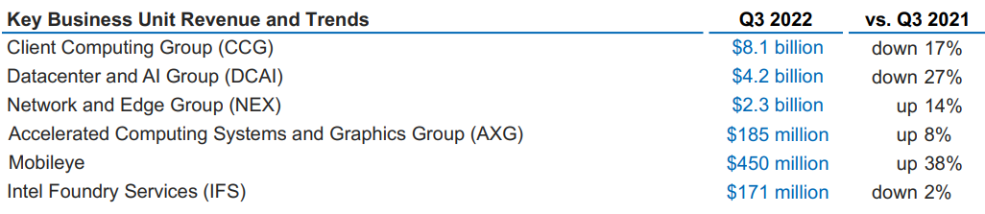
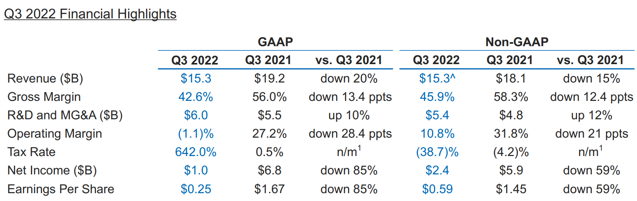
Financial data (Source Intel Report 2022)

- Demand and market equilibrium
Being a market leader due to its products supremacy, Intel price strategy it is according to this. Offering the best processors for desktops and laptops in the industry Intel it has not been challenged on price during the years, as the main competitor and the next follower AMD couldn’t reach the same performance. According to Alan Griffiths and Stuart Wall, the shift in supply is associated with new technologies, which also can bring shifts in demand which is a quantity of a product or service that consumer seek at any price point cause by changes in economic factors others than price.
The substitutes in consumption seen in this case as alternatives for the processors produce by Intel are those produced by AMD. Other components necessary to build a personal computer or personal computers and printers, or operating systems and other software necessary for a personal computer to run will be a few examples of complement in consumption. The data resulted from a comparison made by ‘’Technica’’ about the history of Intel vs. The process of buying a new computer may be challenging especially when we talk about CPU. In the process of choosing the right processor factors as cost, performance and purpose of use must be considered. AMD desktop performance showed the direct product competition in the last years: 2017- Core i7-8700k vs. Ryzen 7 1800X; 2018-Core i9-9900K vs. Ryzen 7 2700X; 2019- Ryzen 9 3950X; 2020-Core i9-10900K vs. Ryzen 9 5950X; 2021-i9 12900k vs. Ryzen 5950X; 2022-Core i9 12900KS vs. AMD Ryzen 9 7950X. Although both Intel and AMD launched a wide range of processors in the last years, desktop processors are considered at the top and according to the same comparison, the processors made by Intel in terms of speed, game experience, multitasking etc. have reached better performance than the rival AMD. (Salter, 2020) For the same reason at similar range AMD processors were found cheaper than Intel Processors. According to Statista.com, the share of Intel and AMD processors on the second quarter of 2022, a percent of 63.55 of X86 CPU tests recorded were from processors made by Intel while 36.4 were from AMD. In terms of CPU market for desktops Intel is well ahead of its competitors the only real one being AMD, however in the ‘’budget friendly’’ market segment range AMD is a very close market competitor being able to offer very similar performance. The X86 family refers the way a CPU handles information being a predominant hardware platform for laptops, desktops, and servers globally. The revenue generated by the global semiconductor industry reached 550 bn. U.S. in 2021and more than 600 bn. U.S. in 2022. However, these values cannot be only attributed for desktops and laptops components as the smartphones are expected to command an important part of the semiconductor market especially because these devices become an important opportunity. (Alshop, 2022) In order to reach the market equilibrium AMD sold their products with a lower price. If the price for a premium product is too high, the consumer would buy less quantity and use the competitors’ products instead which have an inferior quality.
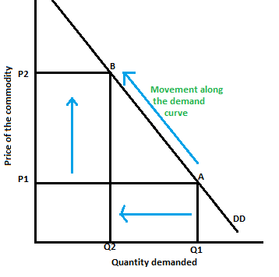
Fig 1. Movement along the demand curve
- Price elasticity of demand
Definition: A measure of the responsiveness of quantity demanded to a change in price (John Sloman, 2019)
PED=percentage change in quantity demanded/percentage change in price
If a substitute of a product can be obtain easy the more the price will fall.
A successful business must be able to predict the product strength on demand and be to quickly respond to any consumer tastes changes.
Demand under conditions of risk and uncertainty
When you buy something which will last for long time you look further in the future. As example if you buy a computer which has a price and in twelve months you will have to repair ii, to the initial price you need to add the repairing price. Buying durable products involve uncertainty as you are uncertain by the price will be paid over lifetime of that computer which is a risk. A way of removing the risk is using an insurance.
The quantity of product X demanded per unit of time (Qx) relation is expressed by the variables involved in in the movement of the demand curve and other possible variables. This includes the price of product X (Px) and several other variables representing conditions of demand. The demand function is often shown as follows:
Qx=F(Px,P0,Y,T,Ax…) where Qx represents the quantity demanded of product X, which depends upon its own price (Px), the price of other products (Po)real income, (Y), tastes (T), advertising expenditure (Ax) etc.
As is well known that consumer income may be one of the variables, the consumer tastes and preference is equally important factor in demand movements.
Market structure and Oligopoly Theory- In oligopoly markets a few firms dominate the market. They will recognise the rivals and be aware of any changes from their part will result on a counteraction by rival companies. Product differentiation is another characteristic of an oligopoly market. Due greater uncertainty this type of markets it is difficult to predict situations of short-run and long-run equilibrum. Other characteristics of oligopolistic market: Large barriers to entry, factors that will descurage new entrants due to costs, bureacratic and economical dificulties.
- Variables in demand
Demand for Intel’s products can be higly variable and depends on factors like economic conditions, confidence, the economic level, availability, pricing presures. Covid-19 pandemic affected a signifficant portion of the business this as a result of measures imposed by authorities in restricting the transportation, creating disruptions in supply with impact of Intel’s worforce and operations.
Political or social conditions in contries where Intel or its suppliers operates including natural disasters, immigration, tax policy, sanctions, military disputes, movements on silicium market, changes in ability of U.S. government to get export licenses, are another conditions that can create uncertainty and afect Intel’s products demand.
The next graph shows the long run equilibrum for monopolies which is similar for oligopolies where ATC=average total cost, MR-marginal revenue, MC-marginal cost
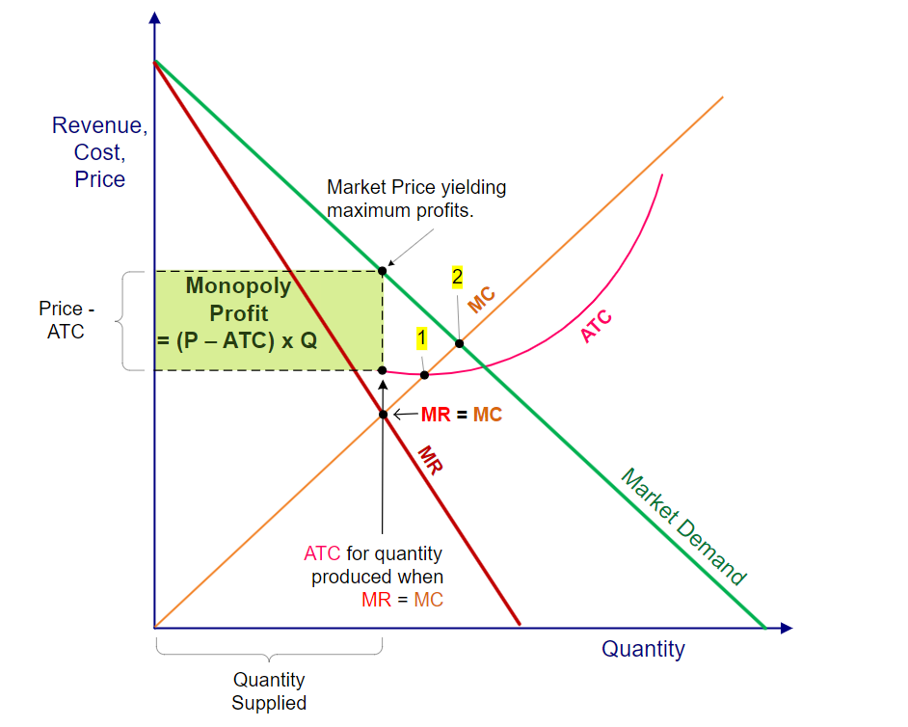
Fig.2
Oligopoly Profit=(Price-ATC) x Quantity
The companies are setting the price, meaning that they influence the market share of the product by setting their product prices.
Other variables which can cause an increase in demand: Advertising- Plays an important role in giving the custumers the information about available products, generating sales but sustaining the advertising campaigns would generate cost which may be end in increasinh the price. Also helps firms when they are introducing new products. The efect of advertising for the demand in consume is brand layality. Altough succesful campaigns effect can reduce the bariers for new entrants, by establishing brand loyalty on the other side would make difficult for new entrants to enter a market.
Technology-When a new product is discovered and is allowed to be prodeced at a lower cost, the supply curve will shift to the right, as the technology brings an increase in efficiency of production process.
Credit availability and credit price- important but often neglected variables can have an important influence on the demand for a produs are the availability of credit (Ca) and price of credit (Cp). Any reduction in acces to credit or an increasement in the cost of securing such credit will have a major impact on the ability of individuals and businesses to pay their debts and continue to spend. (Wall, 2011)
Factors that can limit the price in oligopoly include foreign competition, and advance of technology. Altough many technological advances originate in oligopolies, due to the greater amount of money to be invested in (R&D), over time technological advance eroded even a monopoly power forcing investition in R&D to be able to maintain the pricing power.
The rise in global inflation -Due to the rise in global inflation the living standars may be affected. Acording to the guardian.com, the U.S. inflation reached 7.5% in January in 2022, the highest in last 40 years; Italy 4.2 in December, same year; Germany 4.9%, Australia 3.5% at the end of 2021; Pakistan 13% in January 2022. (The Guardian, 2022)
This will trigger the prices to rose which will hit everybody. As many people would spend more on rent, fuel and food which are the basic for living they may spent lesss for other products as computers. Inflation is hitting the market of personal computers directly creating uncertainty and lack of investment, making difficult for firms to predict the costs and revenues which may reduce the rate of economic growth.
Interdependence of the firms
With a large market share due to fewer firms in the market, the action of one will affect the other firms under oligopoly which means they are dependent. This interdependence actuaaly is representing the diference between oligopolies and other markets. If the price or the way is advertised a product are changing, this will affect the sales of rivals which will tent the firms to take one of the next two directions: -to collude each other and act as a monopoly and maximise sector profit which can be split between them or compete to gain a bigger market share.
Government intervention
The Government trough its institution sometimes will intervene to enforced regulations, solve disputes.
In 2007 AMD was acusing Intel of monopolising the market. Using a study made by ERS Group, an economic and financial consulting firm, they support the ideea that the monopoly profit extracted by Intel from microprocessors sales reached the amount of over 60bn. between 1996-2006. (AMD, 2007)
In 1998 The Federal Trade Commision of U.S. charged Intel Corporation due to the illegaly use of monopoly power to dominate the market of microprocessors by denying three of its custumers on accessing technical information necessary to develop systems based on microprocessors produced by Intel. FDT motivation was that Intel can compete by producing more attractive products which are better and cheaper and cannot use its monopoly to prevent other firms to challenge the company dominance which also is not in public interes. (Federal Trade Commission, 1998)
This may suggest a form of non-collusive oligopoly relation betweeen the two.
Recommendations
An opportunity for Intel to improve its performance is business diversification. This can be made also by the acquisition of other firms as diversification is an opportunity which haven’t been fully exploited. The increasing of processors flexibility will widen their potential use. Intel may consider to develop products for smaller devices as mobiles phones. The rapid market shift to mobiles is a threat against the company. Moreover, the principal competitor AMD has an increasing potential on capturing bigger market share. Other partnership establisment will also reduce the dependency on Microsoft. Having a dominant position is showing that Intel is still unshaken against the competitors and new entrants. However weaknesses can make it vulnarable to some threats.
Conclusion
In this analysis we tried to highlight some points which are in interdependency and established the equilibrum on a market as presented above, identified as oligopoly market. The focus was on two companies which are far market leaders providing components for desktops and laptops and both driven by highly rate of succes regarding the products they produce, respectivelly microprocessors, without any computer will not be able to work. The product range of the two is impressive, as microprocessors are only one of them, but due to the high volume of information we concentrated more on them. Research and Development represent the priority in this market as the activities undertaken to introduce new products or improved version of a product are maintaing the interes for this kind of products.

References
Alshop, T., 2022. statista.com. [Online]
Available at: https://www.statista.com/statistics/735904/worlwide-x86-intel-amd-market-share/?fbclid=IwARYLV1IDtooMYy9poBTutm7yKem1066JG3L7IYxolWgCwKL1C0t4m0qmJ0
[Accessed 07 January 2023].
AMD, 2007. New Economic Study Finds Intel Extracted Monopoly Profit of $60bn. since 1996. [Online]
Available at: https://l.facebook.com/l.php?u=https%3A%2F%2Fir.amd.com%2Fnews-events%2Fpress-releases%2Fdetail%2F114%2Fnew-economic-study-finds-intel-extracted-monopoly-profits%3Ffbclid%3DIwAR3yiONmmjciFKAFHCtLpT3wMEssLDh80IEn9B9jAfDXhSWsAhA-snVPfkk&h=AT3tXUS0rL40MkQoQF
Baye, M., 2016. Managerial economics and business strategy. ninth edition ed. New York: McGraw-Hill Education.
Federal Trade Commission, 1998. Intel Abuses its Monopoly Power in Violation of Federal Law. [Online]
Available at: https://l.facebook.com/l.php?u=https%3A%2F%2Fwww.ftc.gov%2Fnews-events%2Fnews%2Fpress-releases%2F1998%2F06%2Fftc-intel-abuses-its-monopoly-power-violation-federal-law%3Ffbclid%3DIwAR3cPN6Ui1ssuwsJHTdXqRRdtobEf59sxyyD0o7qLC6wlkUCaBo-Gc5eWjM&h=AT3tXUS0rL40M
[Accessed 09 Ianuary 2023].
Intel Corporation, 2022. Intel Reports Third-Quarter 2022 Financial Results, Santa Clara: Intel.
Intel, 2023. 12th Generation Intel Core Processors. [Online]
Available at: intel.co.uk/content/www/uk/en/products/docs/processors/embedded/12th-gen-iot-desktop-processors-brief.html
[Accessed 07 January 2023].
Intel, 2023. Explore Intel's history. [Online]
Available at: https://timeline.intel.com
[Accessed Friday January 2023].
John Sloman, E. J., 2019. Essential Economics for Business. Sixth edition ed. Harlow: Pearson.
Salter, J., 2020. A history of Intel vs. AMD desktop performance. [Online]
Available at: arstechnica.com/gadgets/2020/11/a-history-of-intel-vs-amd-desktop-performance-with-cpu-charts-galore/
[Accessed 07 01 2023].
Samuelson William, F. M. S. G., 2015. Managerial economics. eight edition ed. Hoboken, NJ: Wiley.
Sloman John, D. G. J. G. E. J., 2019. Economics for business. eight ed. Harlow: Pearson Education.
The Guardian, 2022. The rise in global inflation, the hit to living standards across the world. [Online]
Available at: https://l.facebook.com/l.php?u=https%3A%2F%2Fwww.theguardian.com%2Fbusiness%2F2022%2Ffeb%2F10%2Fthe-rise-in-global-inflation-the-hit-to-living-standards-across-the-world%3Ffbclid%3DIwAR1Jj5FwXgRRRk9nLY6ixbFBMTnybaArUekbCSbb1ZxqnDjGHHmxRa0yOsA&h=AT3tXUS0rL
[Accessed 09 January 2023].
UWTSD, 2022. UWTSD Course.
Wall, A. G. &. S., 2011. Economics for Businrss & Management. 3rd ed. Harlow: Pearson Education Limited.

